Internship Task Report: Week 3
Unsupervised Learning and Clustering Analysis
Task Title: Week 3 Task – Unsupervised Learning and Clustering Analysis
Dataset: Cleaned Practo Doctor Consultation Dataset (practo_1000_plus.csv)
Algorithms Used: K-Means Clustering, Standard Scaling, Elbow Method, Silhouette Analysis
1. Introduction & Objectives
While exploratory data analysis (EDA) in Week 2 uncovered bivariate trends and summary statistics, unsupervised learning allows us to discover natural, hidden groupings within healthcare provider data without relying on predefined class labels.
The primary objective of Week 3 is to apply unsupervised clustering techniques—specifically K-Means Clustering—to segment the Practo doctor dataset into distinct practitioner profiles based on numerical features (Experience_in_years, Consultation_Fee, Patient_Rating, and Reviews). By categorizing doctors into behavioral and operational clusters, healthcare platforms and patients can better understand practitioner tiers, pricing strategies, and market positioning.
2. Data Preparation and Feature Scaling
Because K-Means clustering relies on Euclidean distance calculations to form centroids, features with larger numerical magnitudes (such as Consultation_Fee ranging up to ₹3,000+ and Reviews numbering in the thousands) would disproportionately dominate features with smaller scales (such as Patient_Rating percentage or Experience_in_years).
To prevent scale bias, features were standardized using Scikit-Learn’s StandardScaler, transforming each variable to have a mean of 0 and a standard deviation of 1:
$$z=\frac{x-μ}{σ}$$
import os
os.environ["OMP_NUM_THREADS"] = "1" # Prevent Windows OpenMP memory warning
import pandas as pd
import numpy as np
from sklearn.preprocessing import StandardScaler
# Load dataset and select numerical features for clustering
df = pd.read_csv("practo_1000_plus.csv")
features = ['Experience_in_years', 'Consultation_Fee', 'Patient_Rating', 'Reviews']
X = df[features].dropna().copy()

# Standardize features
scaler = StandardScaler()
X_scaled = scaler.fit_transform(X)

3. Determining Optimal Clusters ($K$) via Elbow & Silhouette Analysis
To determine the optimal number of clusters, two rigorous techniques were employed:
- The Elbow Method (WCSS): Plotting Within-Cluster Sum of Squares against a range of $K$ values (2 to 6) to identify the point of inflection.
- Silhouette Score Analysis: Measuring cluster cohesion and separation across $K$ values.
from sklearn.cluster import KMeans
from sklearn.metrics import silhouette_score
import matplotlib.pyplot as plt

wcss = []
sil_scores = {}
K_range = range(2, 7)

for k in K_range:
kmeans = KMeans(n_clusters=k, random_state=42, n_init=10)
labels = kmeans.fit_predict(X_scaled)
wcss.append(kmeans.inertia_)
sil_scores[k] = silhouette_score(X_scaled, labels)

# Plotting Elbow Curve
plt.figure(figsize=(8, 4))
plt.plot(K_range, wcss, marker='o', color='teal', linewidth=2)
plt.title('Elbow Method for Optimal K', fontsize=14, fontweight='bold')
plt.xlabel('Number of Clusters (K)', fontsize=12)
plt.ylabel('WCSS', fontsize=12)
plt.grid(True, linestyle='--', alpha=0.7)
plt.savefig('elbow_curve.png', dpi=300, bbox_inches='tight')
plt.show()

print("Silhouette Scores:", sil_scores)
Analytical Observations on Optimal $K$:
- Elbow Curve Analysis: The WCSS plot exhibits a steady downward trajectory with an inflection point (elbow) around $K=4$, indicating diminishing returns in variance reduction beyond four clusters.
- Silhouette Score Evaluation:
  - $K=2$: $0.3236$
  - $K=3$: $0.3302$
  - $K=4$: $0.3525$ (Optimal balance of cluster cohesion and separation)
  - $K=5$ & $K=6$: Show a drop or degradation in cohesion ($0.2751$ at $K=6$), confirming that $K=4$ provides the most robust and interpretable segmentation.
4. K-Means Clustering Implementation & Cluster Profiling
With $K=4$ established, the K-Means algorithm was executed on the scaled dataset, and cluster statistics were aggregated.
Cluster Summary Statistics ($K=4$):
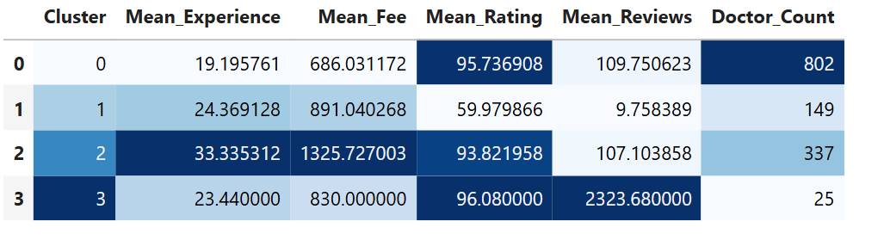
5. Detailed Cluster Interpretations & Scatter Plot Analysis
- Cluster 0 (Mainstream Practitioners — 802 Doctors): Represents the largest foundational cohort of the marketplace. Features moderate professional experience ($≈19.2$ years), standard consultation fees ($≈₹686$), high patient recommendation ratings ($95.7\%$), and steady review volumes ($≈110$ reviews). On the scatter plot, they form the dense foundational core spanning 2 to 35 years of experience with fees under ₹1,500.
- Cluster 1 (Low-Engagement Cohort — 149 Doctors): Consists of mid-to-senior practitioners ($≈24.4$ years experience) with moderate pricing ($≈₹891$). Distinctly characterized by a significant drop in patient satisfaction ratings ($≈60.0\%$) and very minimal digital feedback volume ($≈10$ reviews), indicating potential digital profile optimization gaps.
- Cluster 2 (Senior / Premium Consultants — 337 Doctors): Comprises highly seasoned practitioners ($≈33.3$ years experience) who command premium consultation fees ($≈₹1,325$). Maintains strong patient recommendation trust ($93.8\%$) alongside healthy, consistent review engagement ($≈107$ reviews). On the scatter plot, they cover the widest experience spread (up to ~60 years) and capture the highest fee tiers and pricing outliers (reaching up to ₹5,400).
- Cluster 3 (High-Popularity Elite Specialists — 25 Doctors): A small, highly influential elite group with moderate experience ($≈23.4$ years) and standard pricing ($≈₹830$). Exceptionally distinguished by massive digital visibility, averaging over $2,323$ patient reviews while preserving top-tier satisfaction ($96.1\%$).

