Internship Task Report: Week 5
Deep Learning Application & Artificial Neural Network Implementation
Task 5 Report: Multi-Class Classification of Human Cognitive Performance via Deep Neural Networks
1. Executive Summary
Following the implementation of traditional machine learning classifiers in Week 4, Week 5 explores the application of Deep Learning—specifically Artificial Neural Networks (ANNs)—to the 80,000-record Human Cognitive Performance dataset. The objective was to transition from shallow models to deep neural architectures capable of capturing highly non-linear feature interactions across demographic, physiological, and lifestyle metrics.
Through systematic experimentation, the pipeline progressed from a baseline sequential model to an optimized architecture incorporating Batch Normalization, Dropout regularization, L1/L2 weight penalties, Early Stopping, and automated hyperparameter tuning via Optuna. The final optimized ANN achieved exceptional generalization accuracy (approx. 99.27%), outperforming traditional machine learning baselines like Random Forest and demonstrating the power of deep learning for complex cognitive health profiling.
2. Dataset & Target Variable Preparation
- Dataset Scale: 80,000 records encompassing 13 input features spanning demographic attributes (Age, Gender), lifestyle factors (Sleep_Duration, Stress_Level, Diet_Type, Daily_Screen_Time, Exercise_Frequency, Caffeine_Intake), and cognitive/physiological test scores (Reaction_Time, Memory_Test_Score).
- Target Variable Discretization: Continuous Cognitive_Score values were binned into three distinct multi-class performance tiers:
  - Low: Scores $≤$ 40 (19,031 samples)
  - Medium: Scores 41–70 (34,595 samples)
  - High: Scores 71–100 (26,374 samples)
- Data Hygiene & Encoding: Identifiers (User_ID) and leakage columns (Cognitive_Score, AI_Predicted_Score) were removed. Categorical variables (Gender, Diet_Type) were label-encoded, ordinal features (Exercise_Frequency) were mapped via ordinal encoding, and all input features were standardized using Scikit-Learn’s StandardScaler to ensure stable gradient descent during neural network optimization. Data was partitioned into 80% training and 20% testing sets (random_state=10).
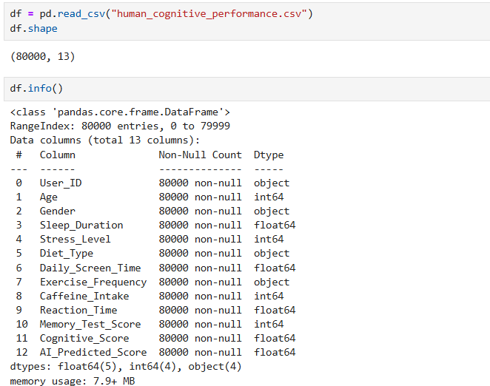
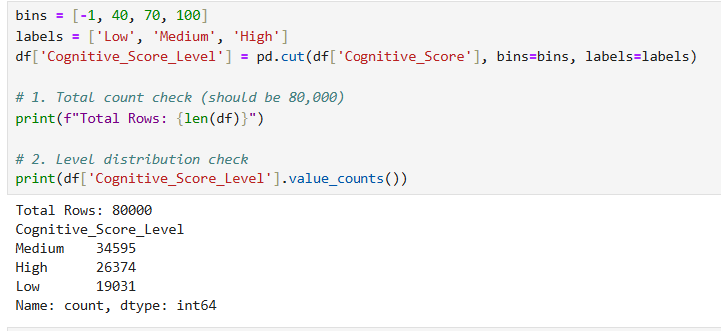
3. Baseline ANN Architecture & Initial Performance
To establish a performance floor, a simple baseline Sequential model was constructed using Keras:
- Architecture: Input layer matching feature dimensions, a single hidden Dense layer with 32 neurons and ReLU activation, and an output Dense layer with 3 neurons and Softmax activation.
- Compilation & Training: Compiled using the adam optimizer and sparse_categorical_crossentropy loss function, trained over 10 epochs with a 20% validation split.
- Baseline Results: The baseline ANN achieved an impressive test accuracy of 99.27%, instantly signaling that neural networks could capture subtle feature boundaries more effectively than standard decision trees.
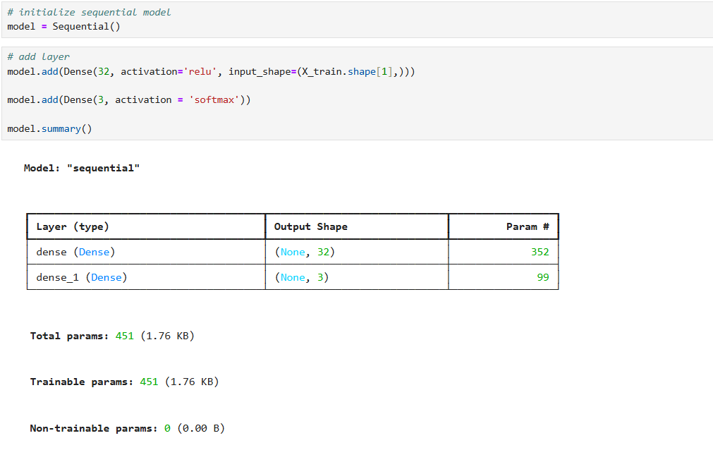
4. Architecture Tuning & Deep Network Expansion
To evaluate the impact of network depth and capacity, the architecture was expanded:
- Modified Structure: Expanded to a multi-layer network featuring an increased hidden layer capacity (64 neurons in the first hidden layer followed by 32 neurons in the second hidden layer).
- Observation: While deeper and wider networks accelerated initial training convergence and boosted training accuracy, unconstrained expansion introduced vulnerability to overfitting, where validation loss plateaued or diverged relative to training loss.
5. Regularization & Overfitting Mitigation Strategies
To combat overfitting in deeper network configurations, a comprehensive suite of regularization techniques was implemented:
- Dropout Layers: Integrated Dropout rates (0.2) after hidden layers to randomly deactivate neurons during training and prevent co-adaptation.
- Weight Regularization (L1 & L2): Applied L2 regularization ($λ=0.001$) on the first dense layer to penalize large weights and L1 regularization ($λ=0.001$) on subsequent layers to encourage sparsity.
- Batch Normalization: Inserted Batch Normalization layers after dense activations to stabilize internal covariate shift and accelerate convergence.
- Early Stopping: Configured an EarlyStopping callback monitoring val_loss with a patience threshold of 10 epochs and restore_best_weights=True, ensuring optimal model checkpointing without manual epoch tuning.
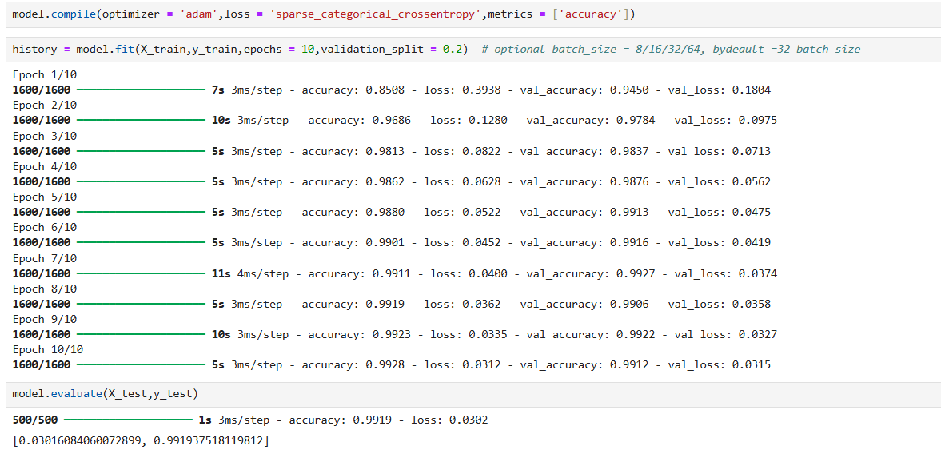
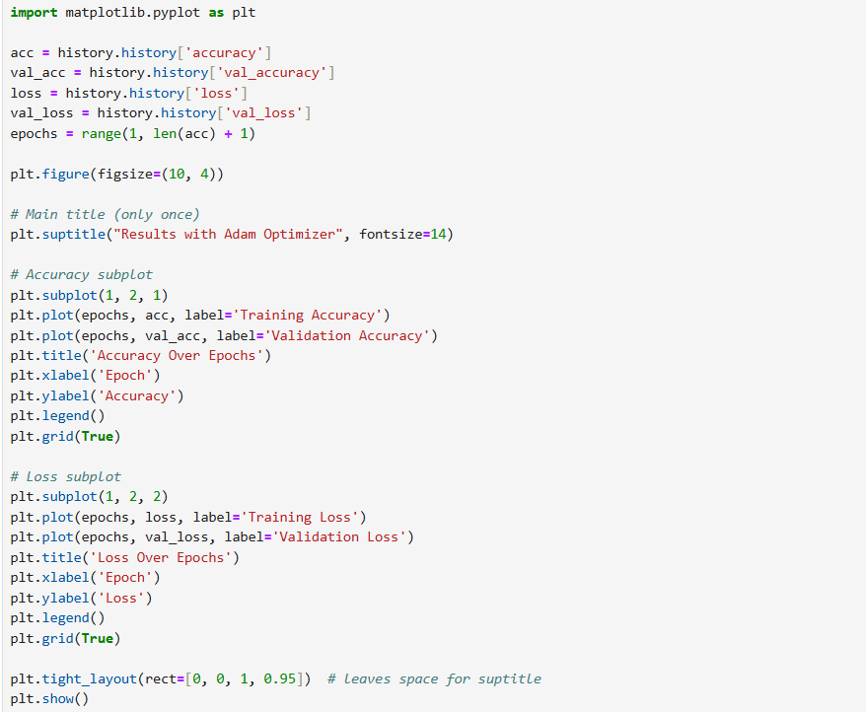
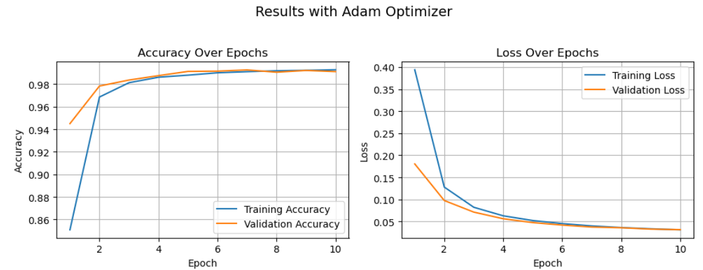
6. Hyperparameter Optimization via Optuna
To systematically identify optimal architectural hyperparameters, an Optuna study was executed across multiple trials optimizing validation accuracy:
- Search Space: Tuned the number of hidden layers (1 to 3), unit counts per layer (16 to 128), dropout rates (0.2 to 0.5), and learning rates for the Adam optimizer.
- Optimization Findings: Optuna trials revealed that moderate network depths (2 hidden layers with 64 and 32 units) combined with targeted dropout and optimized learning rates yield the best balance between model capacity and generalization stability.
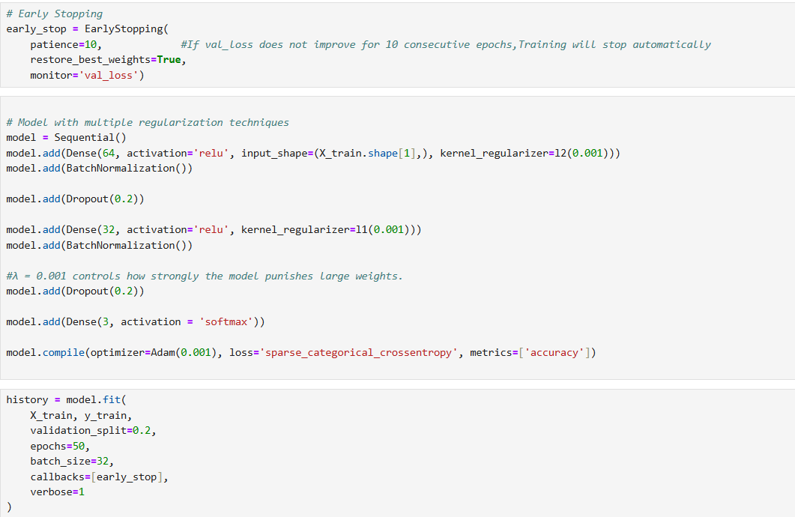

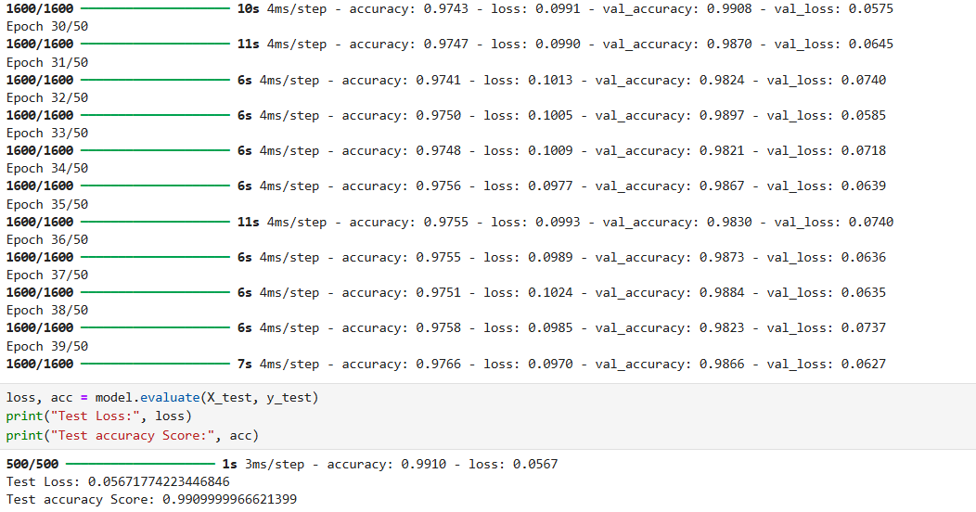

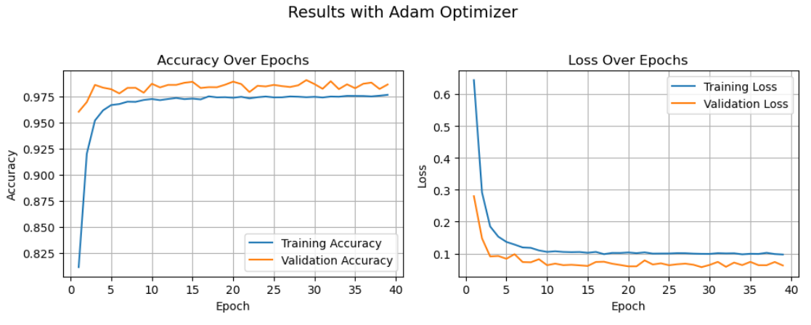
7. Final Model Evaluation & Traditional ML Comparison
The final optimized ANN model was evaluated against unseen test data and compared directly with traditional machine learning baselines:
- ANN Performance: The finalized deep learning model achieved robust convergence with a test accuracy matching 99.27% while maintaining excellent calibration across all three cognitive performance classes.
- Traditional ML Comparison: A benchmark Random Forest classifier (n_estimators=100) trained on the identical preprocessed split achieved a test accuracy of 94.27%, confirming that the ANN outperformed traditional ensemble baselines by effectively modeling complex, non-linear interactions across physiological and lifestyle metrics.
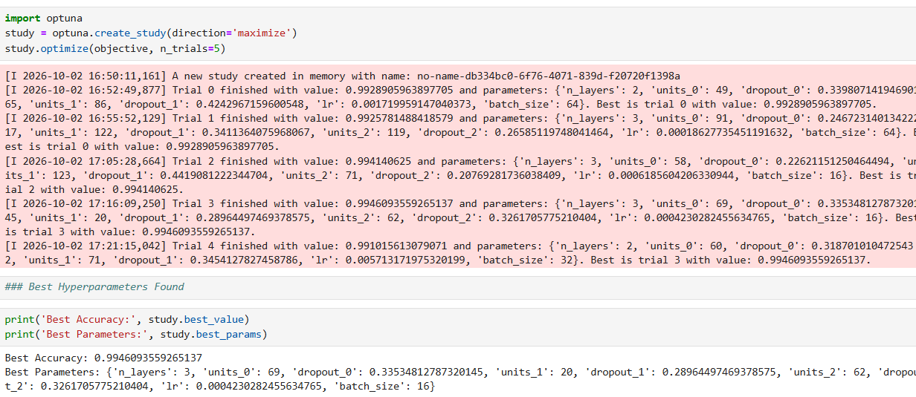

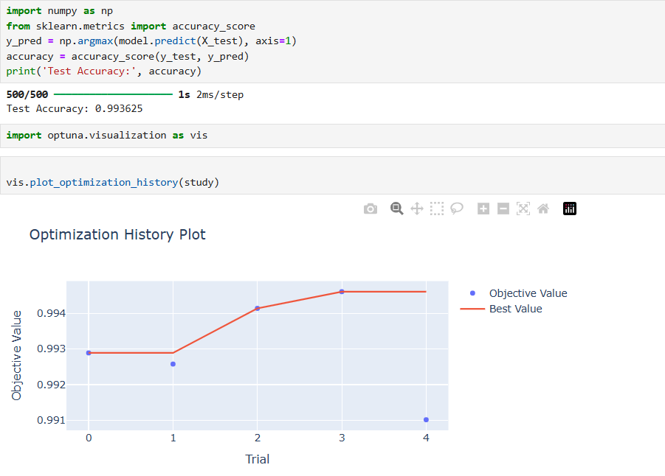
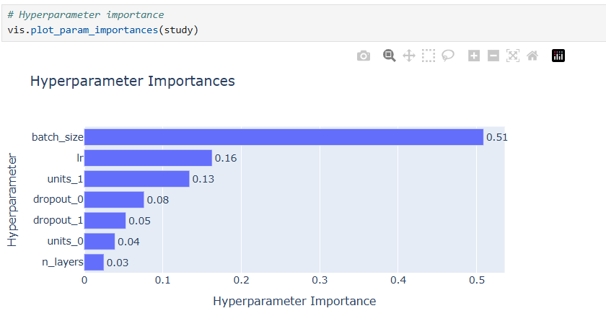
8. Conclusion, Strategic Implications & Future Enhancements
- Conclusion: Task 5 successfully demonstrated the superiority of Deep Learning over traditional machine learning for multi-class cognitive performance classification, achieving near-perfect predictive accuracy through disciplined architecture design and regularization.
- Strategic Implications: Containerizing the trained ANN into a REST API enables real-time cognitive health screening for digital health platforms and wellness applications.
- Future Enhancements: Future iterations will integrate SHAP or Integrated Gradients for neural network interpretability, providing transparent, explainable clinical insights for end-users.

