Internship Task Report: Week 4
Supervised Learning Model Implementation & Predictive Modeling
Task 4 Report: Multi-Class Classification of Human Cognitive Performance Levels
1. Executive Summary
This report details the implementation, optimization, evaluation, and deployment of machine learning models for Task 4 of the Human Cognitive Performance classification project. Working with a dataset of 80,000 records, the objective was to build a robust, end-to-end classification pipeline that predicts individual cognitive performance tiers (Low, Medium, High) based on demographic, lifestyle, physiological, and cognitive testing metrics.
Through rigorous preprocessing, pipeline encapsulation, hyperparameter tuning (RandomizedSearchCV), and comparative evaluation across five algorithms, LightGBM and XGBoost emerged as the top-performing models. The final optimized LightGBM model was serialized into production storage (lgbm_model.pkl) and validated via sample inference.
2. Target Variable Engineering & Data Prep
- Dataset Scale: 80,000 rows and 13 initial features.
- Target Binning: Continuous Cognitive_Score values were discretized into three distinct classification tiers:
  - Low: Scores $≤40$ ($19,031$ samples)
  - Medium: Scores $41-70$ ($34,595$ samples)
  - High: Scores $71-100$ ($26,374$ samples)
- Data Hygiene: Identifiers (User_ID) and target leakage columns (Cognitive_Score, AI_Predicted_Score) were dropped. The dataset was verified to have zero missing values and zero duplicate rows.

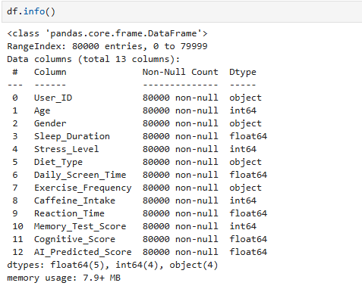

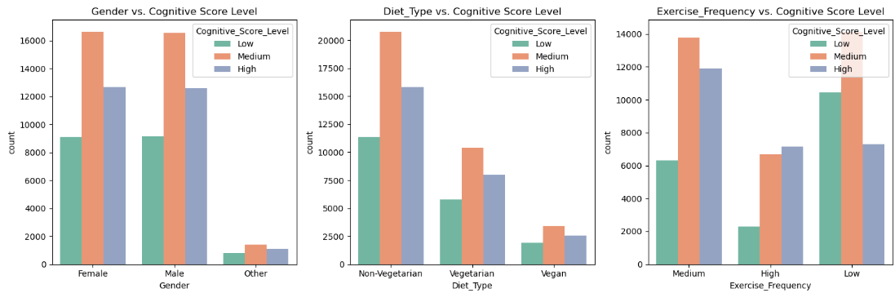
3. Preprocessing Pipeline Architecture
Data was partitioned into training and testing sets using an 80/20 split (test_size=0.2, random_state=42, stratified by target). A unified ColumnTransformer pipeline was constructed to prevent data leakage and ensure seamless inference:
- Numerical Features (Age, Sleep_Duration, Stress_Level, Daily_Screen_Time, Caffeine_Intake, Reaction_Time, Memory_Test_Score): Scaled using MinMaxScaler.
- Ordinal Features (Exercise_Frequency): Encoded via OrdinalEncoder using the explicit mapping ['Low', 'Medium', 'High'].
- Categorical Features (Gender, Diet_Type): Encoded via OneHotEncoder (drop='first', handle_unknown='ignore').
4. Model Exploration & Hyperparameter Optimization
Five diverse machine learning classifiers were integrated into pipelines and tuned using 3-fold cross-validation (RandomizedSearchCV optimizing for accuracy):
- Logistic Regression: Tuned over solvers (liblinear, saga), regularization penalties (l1, l2), and inverse regularization strength (C).
- Decision Tree Classifier: Tuned across tree depth (max_depth), split thresholds (min_samples_split, min_samples_leaf), and criteria (gini, entropy).
- Random Forest Classifier: Optimized across ensemble size (n_estimators), maximum depth, and node sample constraints.
- XGBoost Classifier: Configured with multi-class probability objectives (multi:softprob) and tuned over learning rate, tree depth, and estimator count.
- LightGBM Classifier: Configured with multiclass objectives (multiclass) and tuned across learning rates, max depths, and boosting rounds.
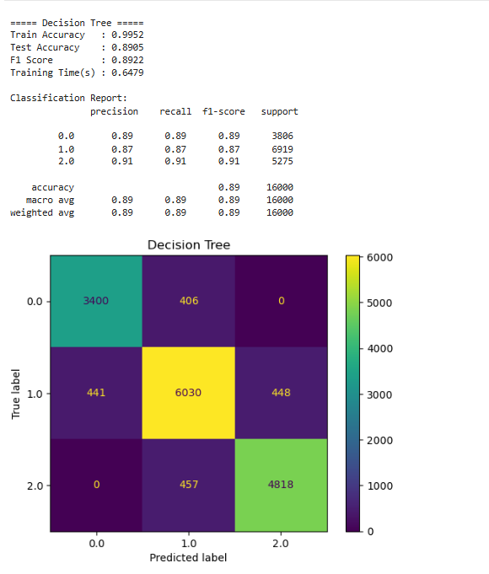

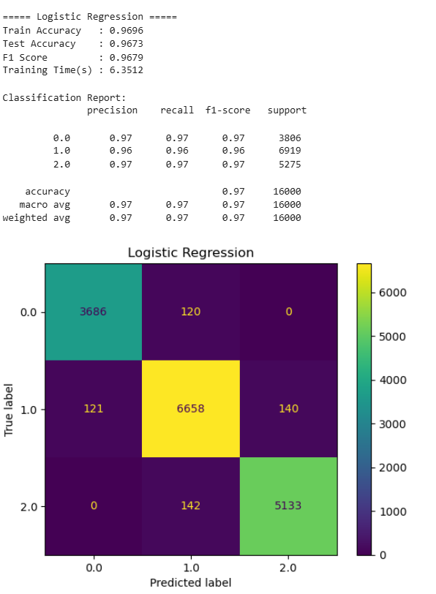
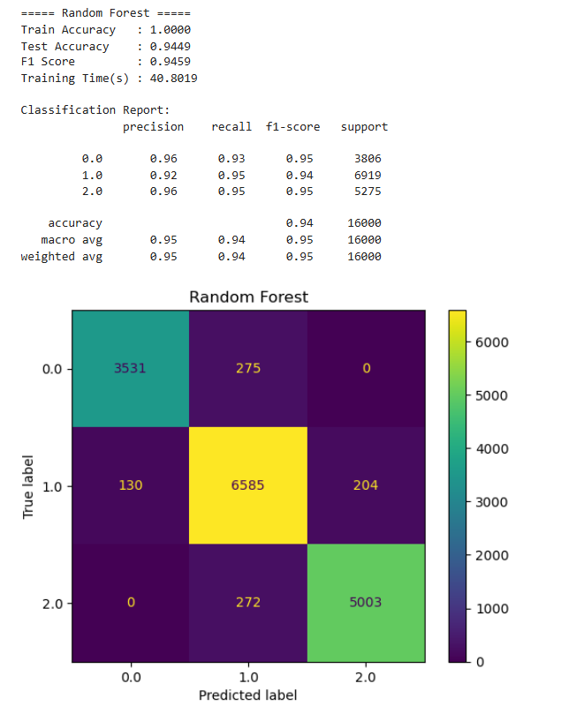
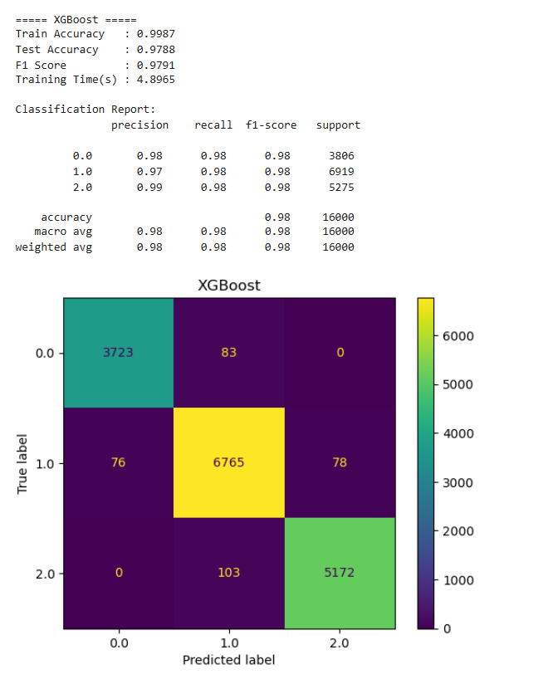
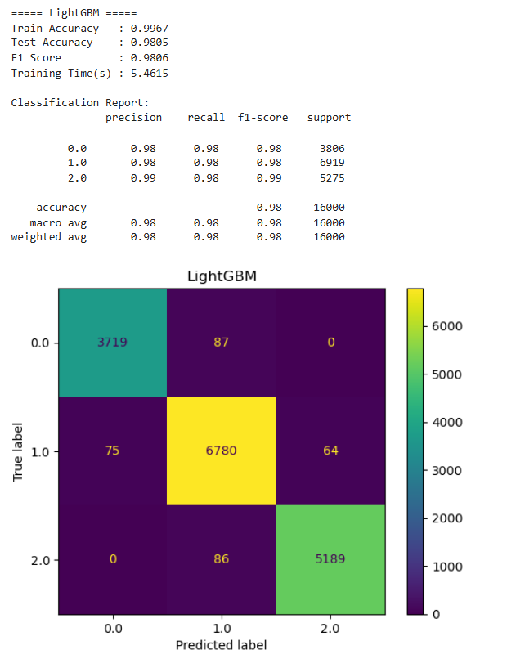
5. Comparative Model Evaluation
Models were evaluated across training accuracy, testing accuracy, macro-averaged F1-score, and training execution time:
- Top Performers: LightGBM and XGBoost achieved the highest generalization accuracy and macro F1-scores, effectively capturing non-linear feature interactions across all three cognitive tiers.
- Ensemble Balance: Random Forest provided competitive accuracy but incurred a higher computational footprint and longer training times.
- Baselines: Logistic Regression and Decision Tree established stable performance baselines, with Decision Trees exhibiting higher variance prior to hyperparameter pruning.
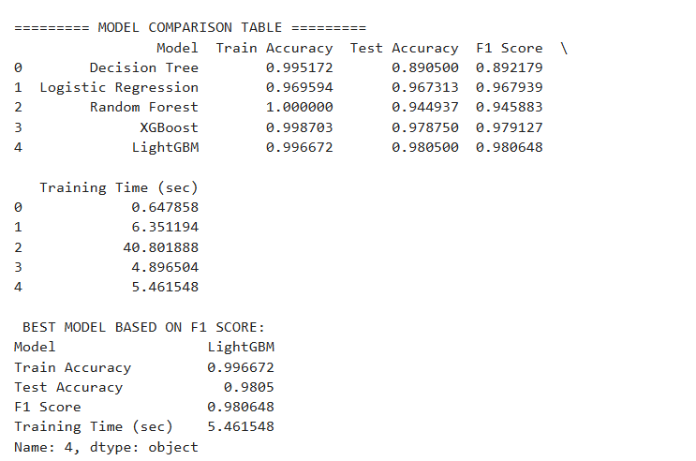
6. Feature Importance & Interpretability
Feature importance analysis extracted from the optimized LightGBM model highlighted the primary drivers of cognitive performance:
- Cognitive & Physiological Metrics: Memory_Test_Score and Reaction_Time demonstrated the strongest predictive weight.
- Lifestyle Factors: Sleep_Duration, Daily_Screen_Time, and Stress_Level played significant secondary roles in determining cognitive score tiers.
- Demographics & Diet: Age, gender, and dietary preferences provided stable contextual adjustments to baseline predictions.
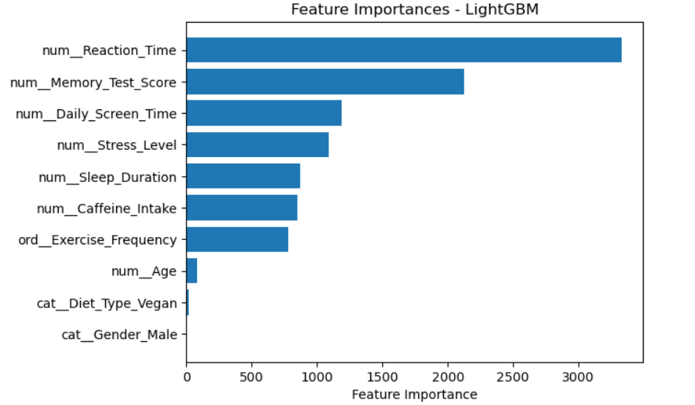

7. Model Persistence & Inference Validation
- Serialization: The best-performing LightGBM pipeline was successfully serialized using pickle and saved as lgbm_model.pkl.
- Inference Validation: A sample validation test was executed by passing raw input vectors (e.g., age 63, 8.2 hours sleep, vegetarian diet, 5.7 hours screen time, low exercise frequency, reaction time 400ms, and memory score 49) into the loaded pipeline. The model successfully outputted the predicted cognitive tier without error or degradation.
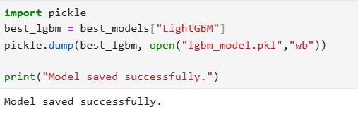
8. Conclusion & Next Steps
Task 4 successfully established a high-performance, production-ready machine learning pipeline for cognitive performance classification.
- Recommendation: Deploy the serialized LightGBM model (lgbm_model.pkl) to a containerized scoring API (e.g., FastAPI) to deliver real-time cognitive assessments.
- Future Enhancement: Incorporate SHAP (SHapley Additive exPlanations) values to provide individualized, interpretable feedback reports for users undergoing cognitive evaluations.

