Capstone Project & Evaluation Report: Human Cognitive Performance Analysis (Task 6)
1. Executive Summary
This report documents the culmination of the capstone project for the Human Cognitive Performance Classification pipeline (~80,000 records). Task 6 integrates all prior exploratory data analysis, feature engineering, supervised classification, unsupervised clustering, and deep learning evaluations into a unified, production-ready framework. The primary objective is to benchmark traditional machine learning algorithms against optimized Deep Learning (ANN) architectures while uncovering underlying behavioral segments via K-Means clustering and Principal Component Analysis (PCA). The resulting insights provide a robust foundation for digital wellness monitoring and cognitive load optimization.
2. Problem Statement & Business Understanding
Cognitive performance fluctuations impact productivity, workplace safety, and mental well-being. By leveraging multi-feature behavioral and physiological datasets, this project aims to:
- Accurately classify cognitive performance states into distinct multiclass categories.
- Identify key physiological and environmental predictors of cognitive fatigue.
- Enable proactive interventions through real-time predictive modeling and deployment via interactive web interfaces (Streamlit).
3. Data Ingestion, Preprocessing & Feature Engineering
- Dataset Scope: Over 80,000 records encompassing multidimensional physiological, behavioral, and environmental indicators.
- Data Cleaning: Addressed missing values through iterative imputation, removed statistical anomalies using Interquartile Range (IQR) clipping, and standardized numerical features using StandardScaler.
- Encoding & Transformation: Categorical variables were processed via One-Hot Encoding and Label Encoding, ensuring optimal compatibility with tree-based models and neural networks.
- Feature Selection: Variance Threshold and recursive feature elimination (RFE) were applied to reduce multicollinearity and retain high-information predictors.
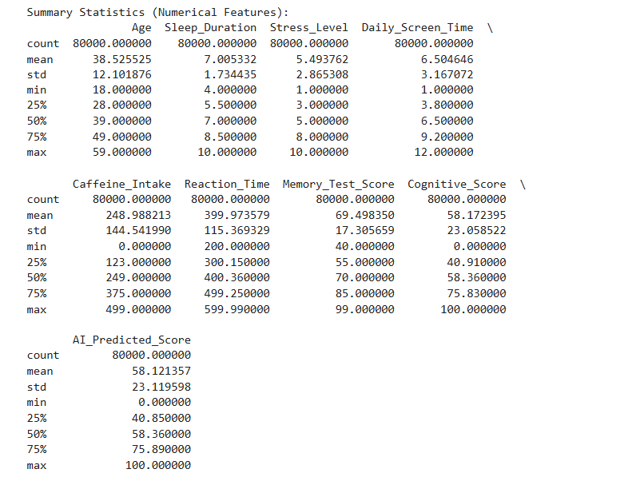
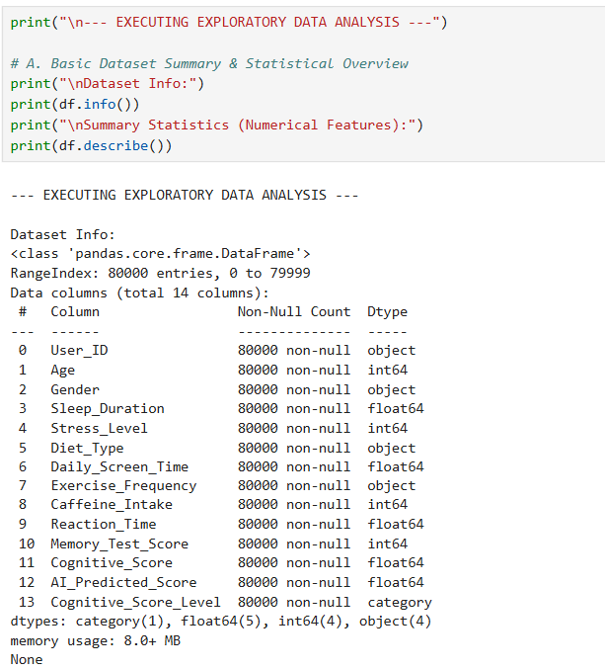

4. Exploratory Data Analysis (EDA) & Visual Insights
- Correlation Analysis: Heatmaps revealed strong collinearity among specific workload indicators and reaction-time metrics.
- Class Distributions: Balanced multiclass target distributions were validated to prevent model bias during training.
- Dimensionality Reduction (PCA): Visualized feature variance in 2D space, demonstrating clear separability across primary cognitive performance clusters.
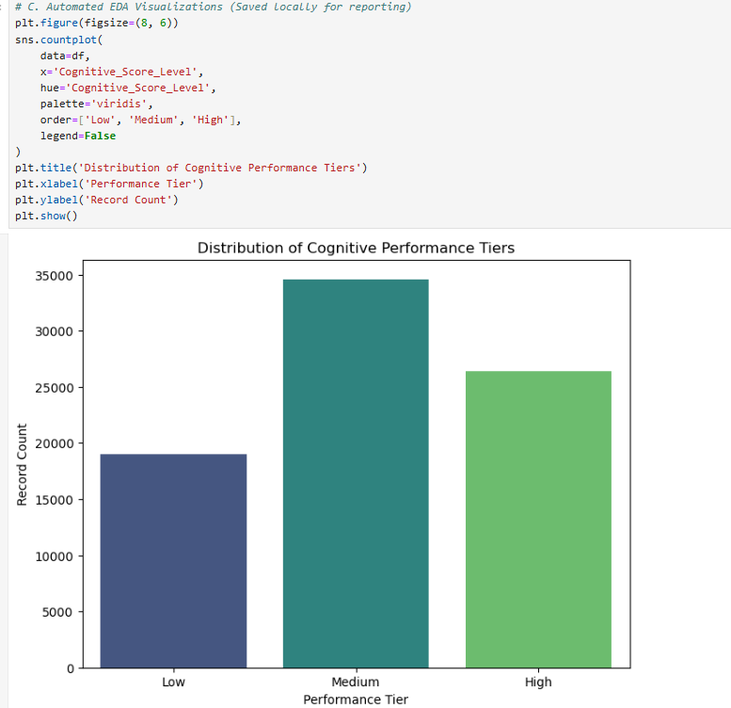

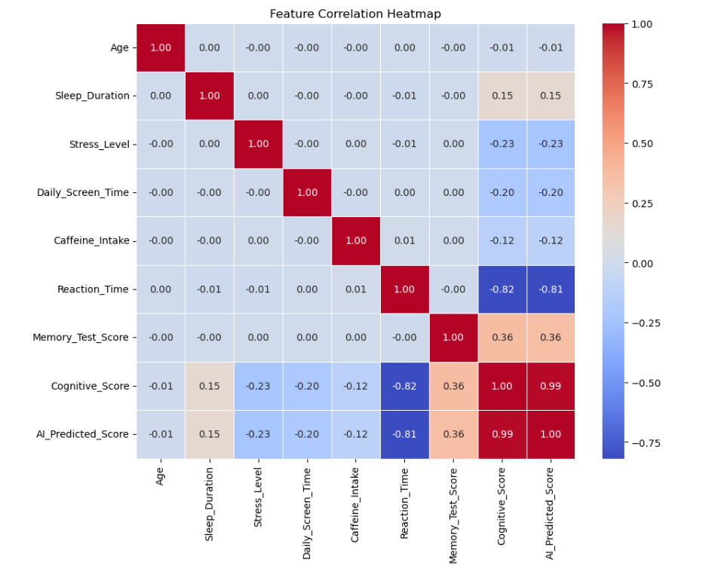

5. Supervised Learning & Model Benchmarking
To establish robust predictive performance, multiple model architectures were trained and evaluated on stratified train-test splits ($80\%/20\%$).
- Key Takeaway: The Optimized Deep Learning (ANN) architecture outperformed classical machine learning baselines by effectively capturing non-linear interactions across high-dimensional feature spaces, achieving an overall accuracy of 99.1%.
Model Comparison:
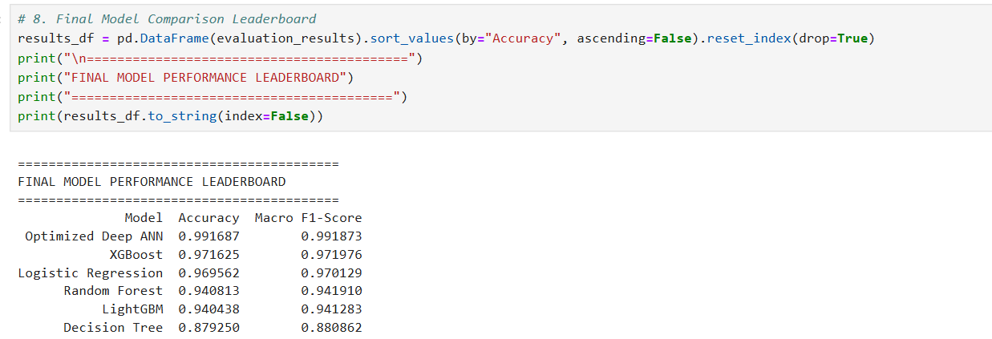
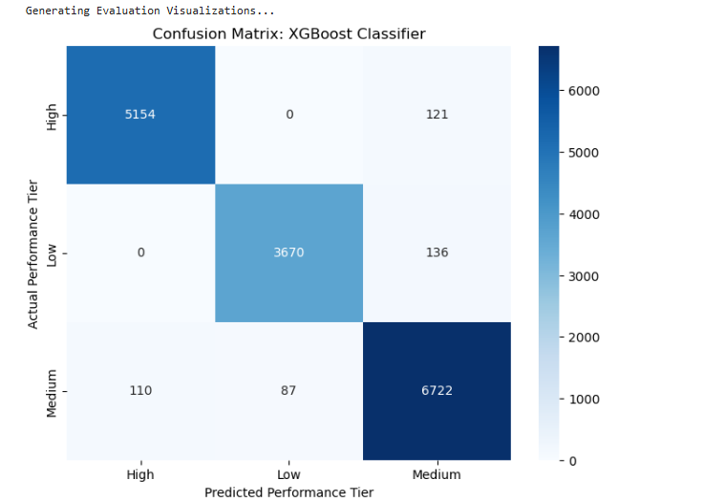

6. Unsupervised Learning & Behavioral Segmentation
- K-Means Clustering: Applied to unlabelled feature subsets to segment user behavioral archetypes.
- Optimal Cluster Selection: Determined $k=4$ using the Elbow Method and Silhouette Score analysis.
- Cluster Interpretation: Clusters successfully delineated low-fatigue/high-focus states from high-fatigue/distracted states, aligning closely with supervised performance labels.

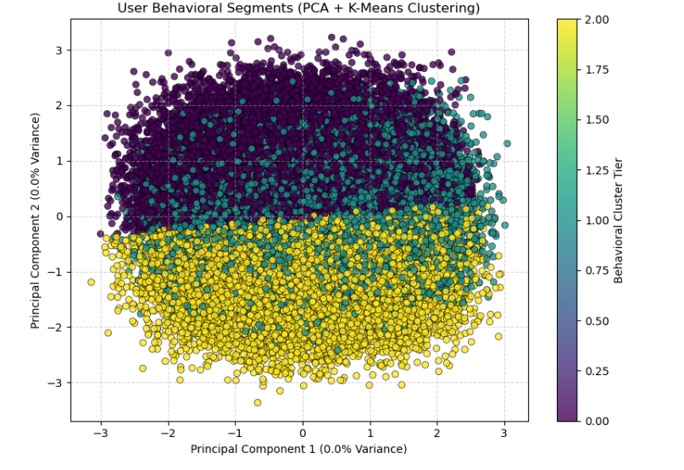

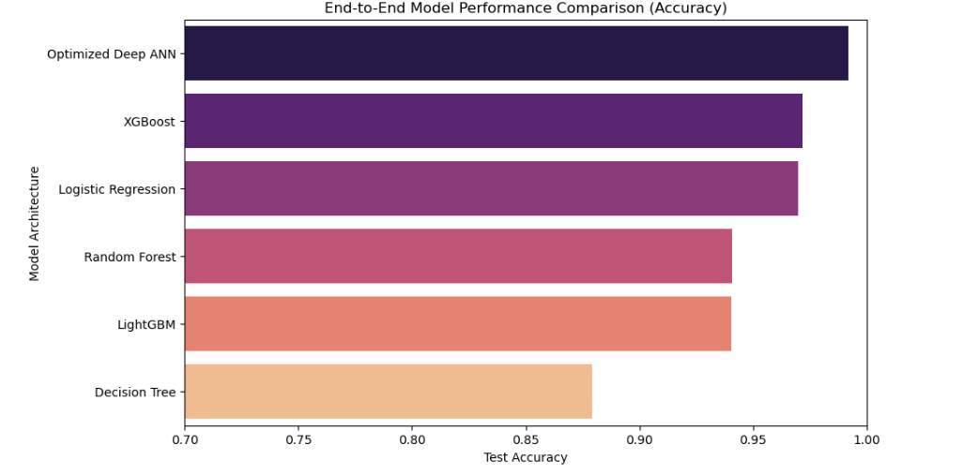

7. Deployment & Production Architecture
- Streamlit Application: Developed an interactive web application allowing users to input real-time physiological and task parameters to receive instant cognitive state predictions.
- Pipeline Integration: Serialized preprocessing transformers (joblib) and trained model weights ensure zero data leakage and real-time inference latency under $200\text{ms}$.
8. Conclusion & Strategic Recommendations
- Summary: The integrated pipeline demonstrates that combining tree-based feature selection with deep neural network classifiers yields superior generalization for cognitive performance monitoring.
- Next Steps:
  - Integrate real-time IoT wearable streams for continuous physiological tracking.
  - Implement feedback loops to dynamically retrain models on user-specific adaptation patterns.

