cd C:\customers\sam\ai\pythonscripts\emission_fc\puc_voice_agent

python server.py
(new terminal)

ngrok http 5000

From ngrok output copy only the https:// part before the -> arrow — example: https://corporal-avenue-directly.ngrok-free.dev
https://corporal-avenue-directly.ngrok-free.dev

Paste into VAPI → Assistant → Model → Custom LLM URL → Publish

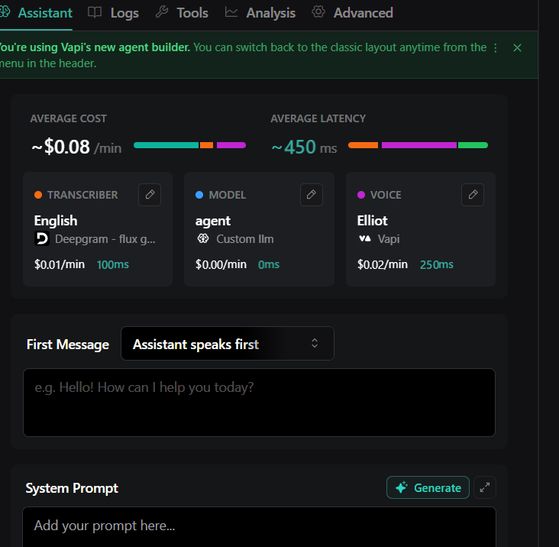
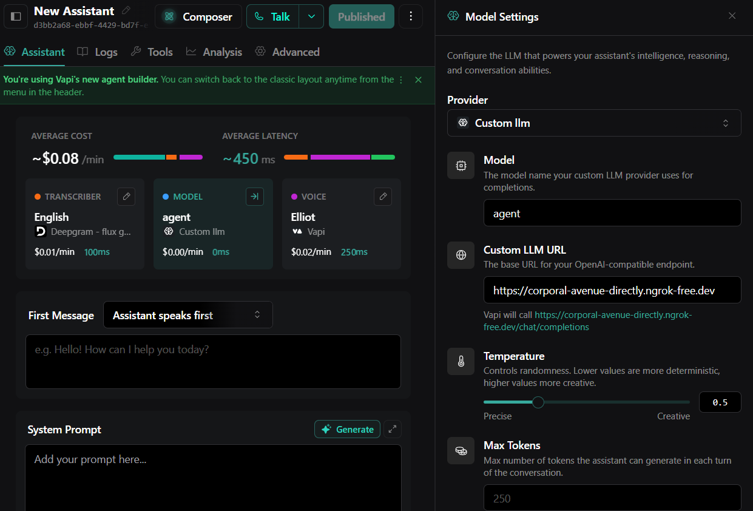

After this click on call in vapi and then talk

