Suvash Baskota  Officer  ________________________________________________  PROFILE  Experienced microfinance professional with practical exposure in branch management and internal audit. Proven ability to lead branch operations, maintain portfolio quality, ensure policy compliance and strengthen internal control systems. Seeking an Officer-level opportunity to utilize professional skills, leadership ability and audit experience for organizational growth and operational excellence.  WORK EXPERIENCE  Branch Manager  Asha Lagubitta Bittiya Sastha Limited | 2078 - 2081  • Managed daily operations and reporting.  • Worked with teams and clients professionally.  • Achieved company goals and targets.  Branch Manager  Aviyan Laghubitta Bittiya Sastha Limited | 2082- Present  • Managed daily operations and reporting.  • Worked with teams and clients professionally.  • Achieved company goals and targets.  Internal Audit  Aviyan Laghubitta Bittiya Sastha Limited| 2082- Present  • Credit and Portfolio Auditing.  • Fraud Detection and Prevention.  • Compliance Assurance  • Operational and Process Evaluation  • Internal Control Assessment  EDUCATION  Bachelor Degree  Tribhuwan University  AD 2021 - 2024  +2 / Higher Secondary  National Infotech  BS 2069 – 2070  Cap-2(,Institute of Chartered Accountants of Nepal (ICAN))  Elite CA  AD 2026-Running | 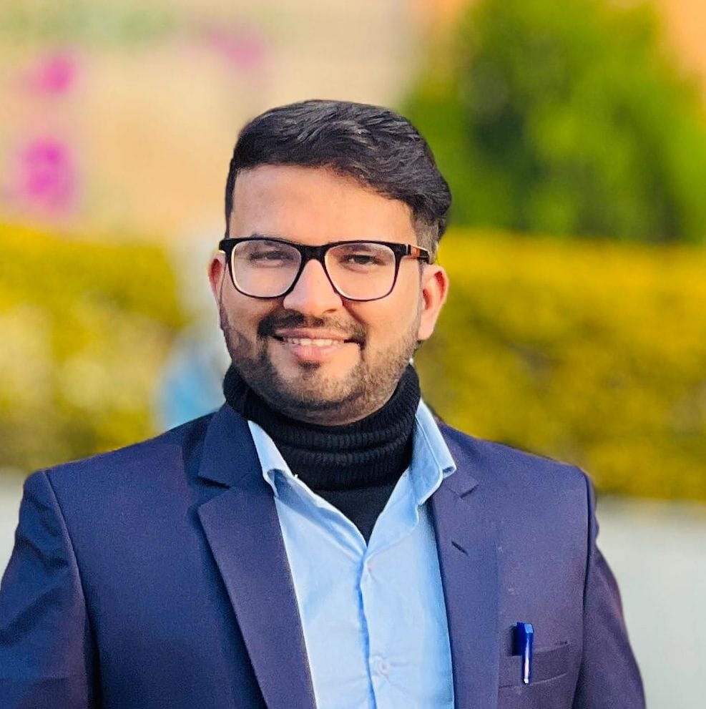  CONTACT  Phone: +977-9861173924  Email: suvashbaskota456@gmail.com  Address: Kalaiya , Bara, Nepal  SKILLS  • Leadership  • Communication  • Computer Skills  • Team Management  LANGUAGES  • Nepali  • English

