Git Version Control System – Coding Assignment-

Student Details Name: Suvarna Parihar
Roll No: 95788
Batch / Course: MERN Internship
Date of Submission: 13/01/2026
—--------------------------------------------------------------------------------------------------------------------

Question 1.
Verify that Git is correctly installed on your system and record the version displayed.
Answer-
$ git --version
git version 2.52.0.windows.1

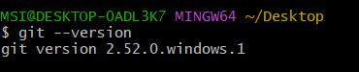

Question 2.
Configure Git with your global username and email ID, and verify that the configuration has been applied successfully.
Answer:
MSI@DESKTOP-0ADL3K7 MINGW64 ~/Desktop
$ git config --global user.name
suvdiliparihar1998-source

MSI@DESKTOP-0ADL3K7 MINGW64 ~/Desktop
$ git config --global user.email
suvdiliparihar1998@gmail.com

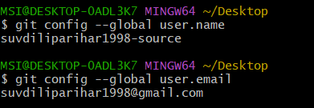

Question 3.
Create a new local Git repository named git-assignment and initialize version control in it.
Answer-
Mkdir git-assignment
Cd git-assignment
Git init

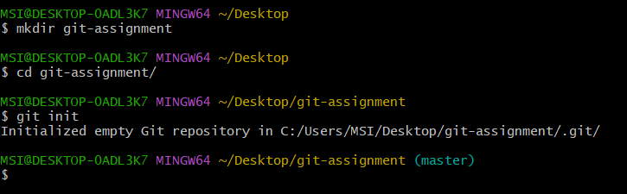

Question 4-
Create a README.md file inside the repository, add relevant project information, and commit the file to the repository.
Answer -
Touch README.md
File created: README.md
Commit message used: git commit -m "Readme file added"

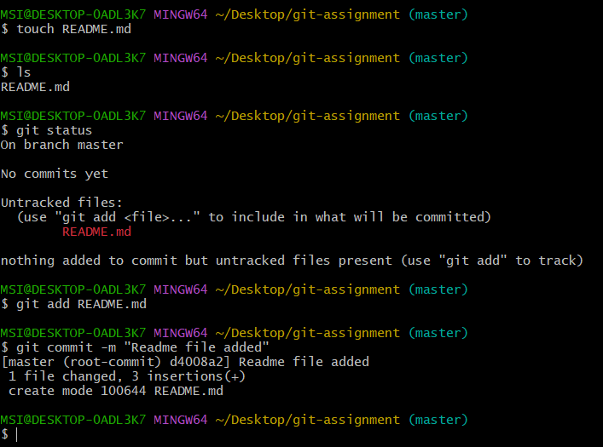

Question 5.
Modify the existing README.md file and create a new file named index.html. Track the changes and commit them with an appropriate commit message.
Answer -
Modified file: README.md
New file created: index.html
Commit message used:” updated readme and added index.html”
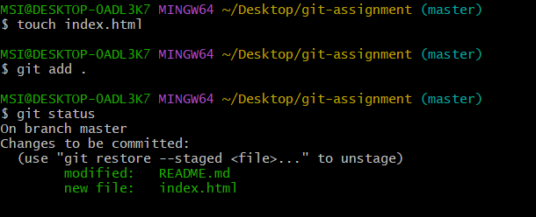

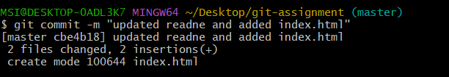

Question 6.
Display the commit history of the repository and identify the commit hash, author, and commit message.
Answer -
Command - git log
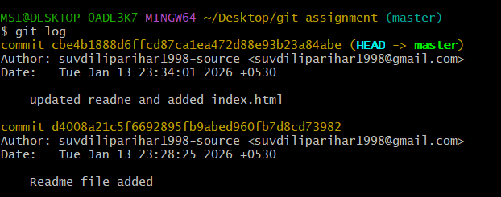

Question 7.
Create a new branch named feature-branch, switch to it, add a new file named feature.txt, and commit the changes.
Answer:
Branch created: feature-branch
File added: feature.txt
Commit message used: “Added feature.txt in feature-branch”

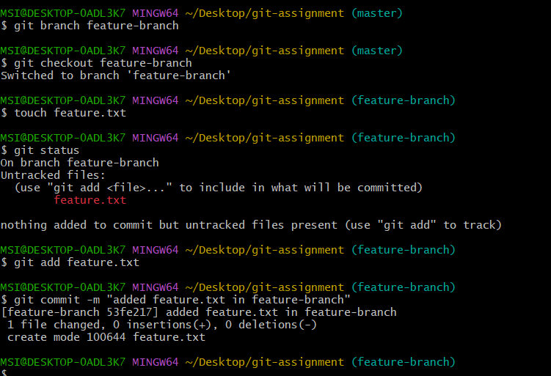

Question 8
Switch back to the main branch and merge the feature-branch into it. Ensure the merge is completed successfully
Answer-
Git checkout master
Git merge feature-branch
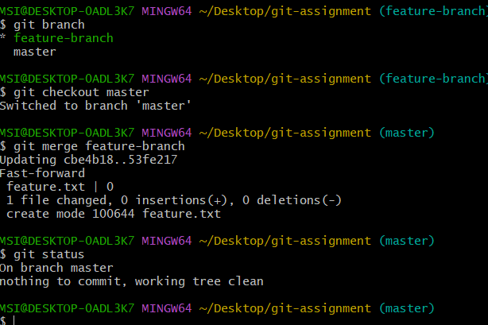

Question 9
Create a new remote repository on GitHub named git-assignment and push the complete local repository to GitHub.
Answer -

Create new repo in github : get-assignment
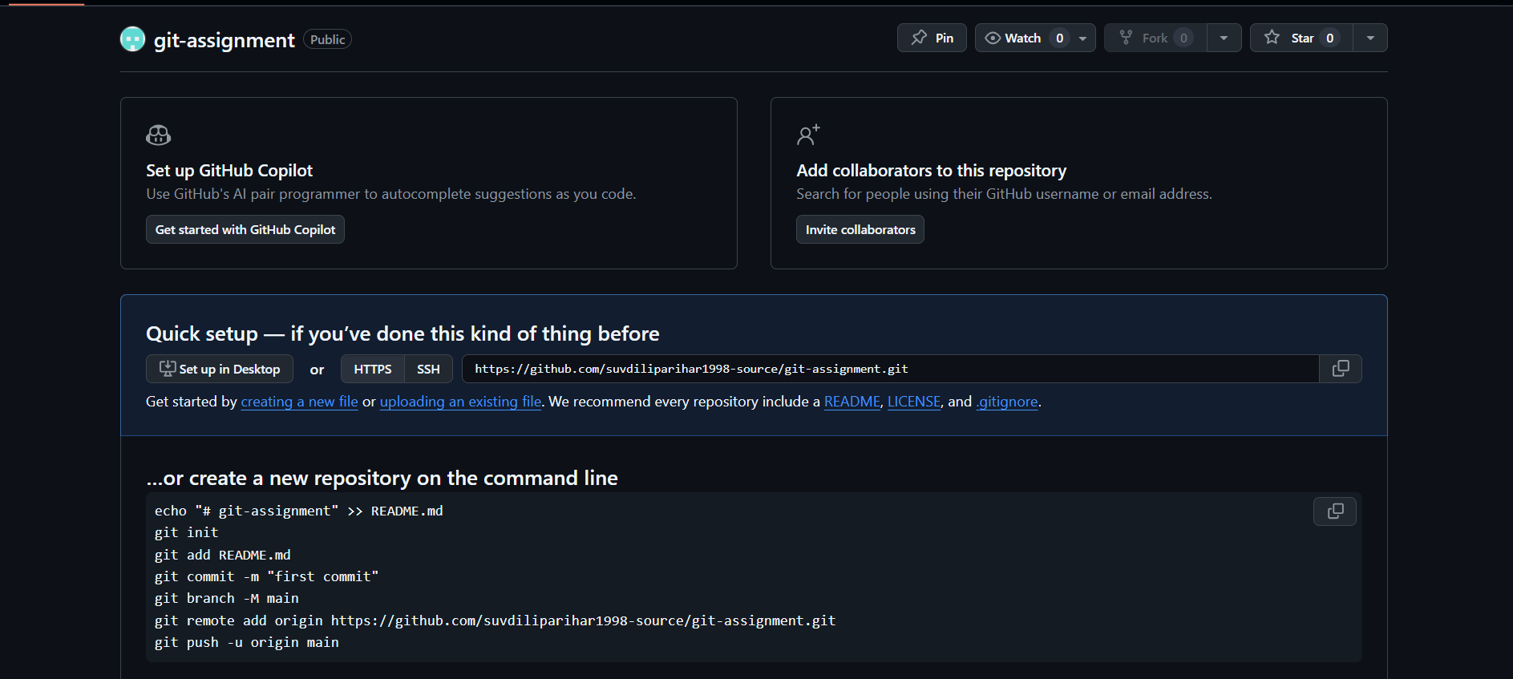

Add remote repo to local folder
Push local repo to Github
