Engineering Report
WhatsApp Payment Verification Agent — Prototype Design & Implementation

1. How the Solution Works
The system verifies bank-transfer payments submitted as slip images over WhatsApp, without a direct bank API integration. It moves each submission through three gated pipeline stages — intake and visual screening, OCR extraction, and validation — producing a final decision of APPROVED, REJECTED, or NEEDS_VERIFICATION, along with a specific reason and a proposed next step. Each stage only runs once the previous one has passed, so the system never spends an expensive step (OCR, cross-referencing) on a submission that a cheap check has already ruled out. The diagram below summarizes the flow and what each stage checks.
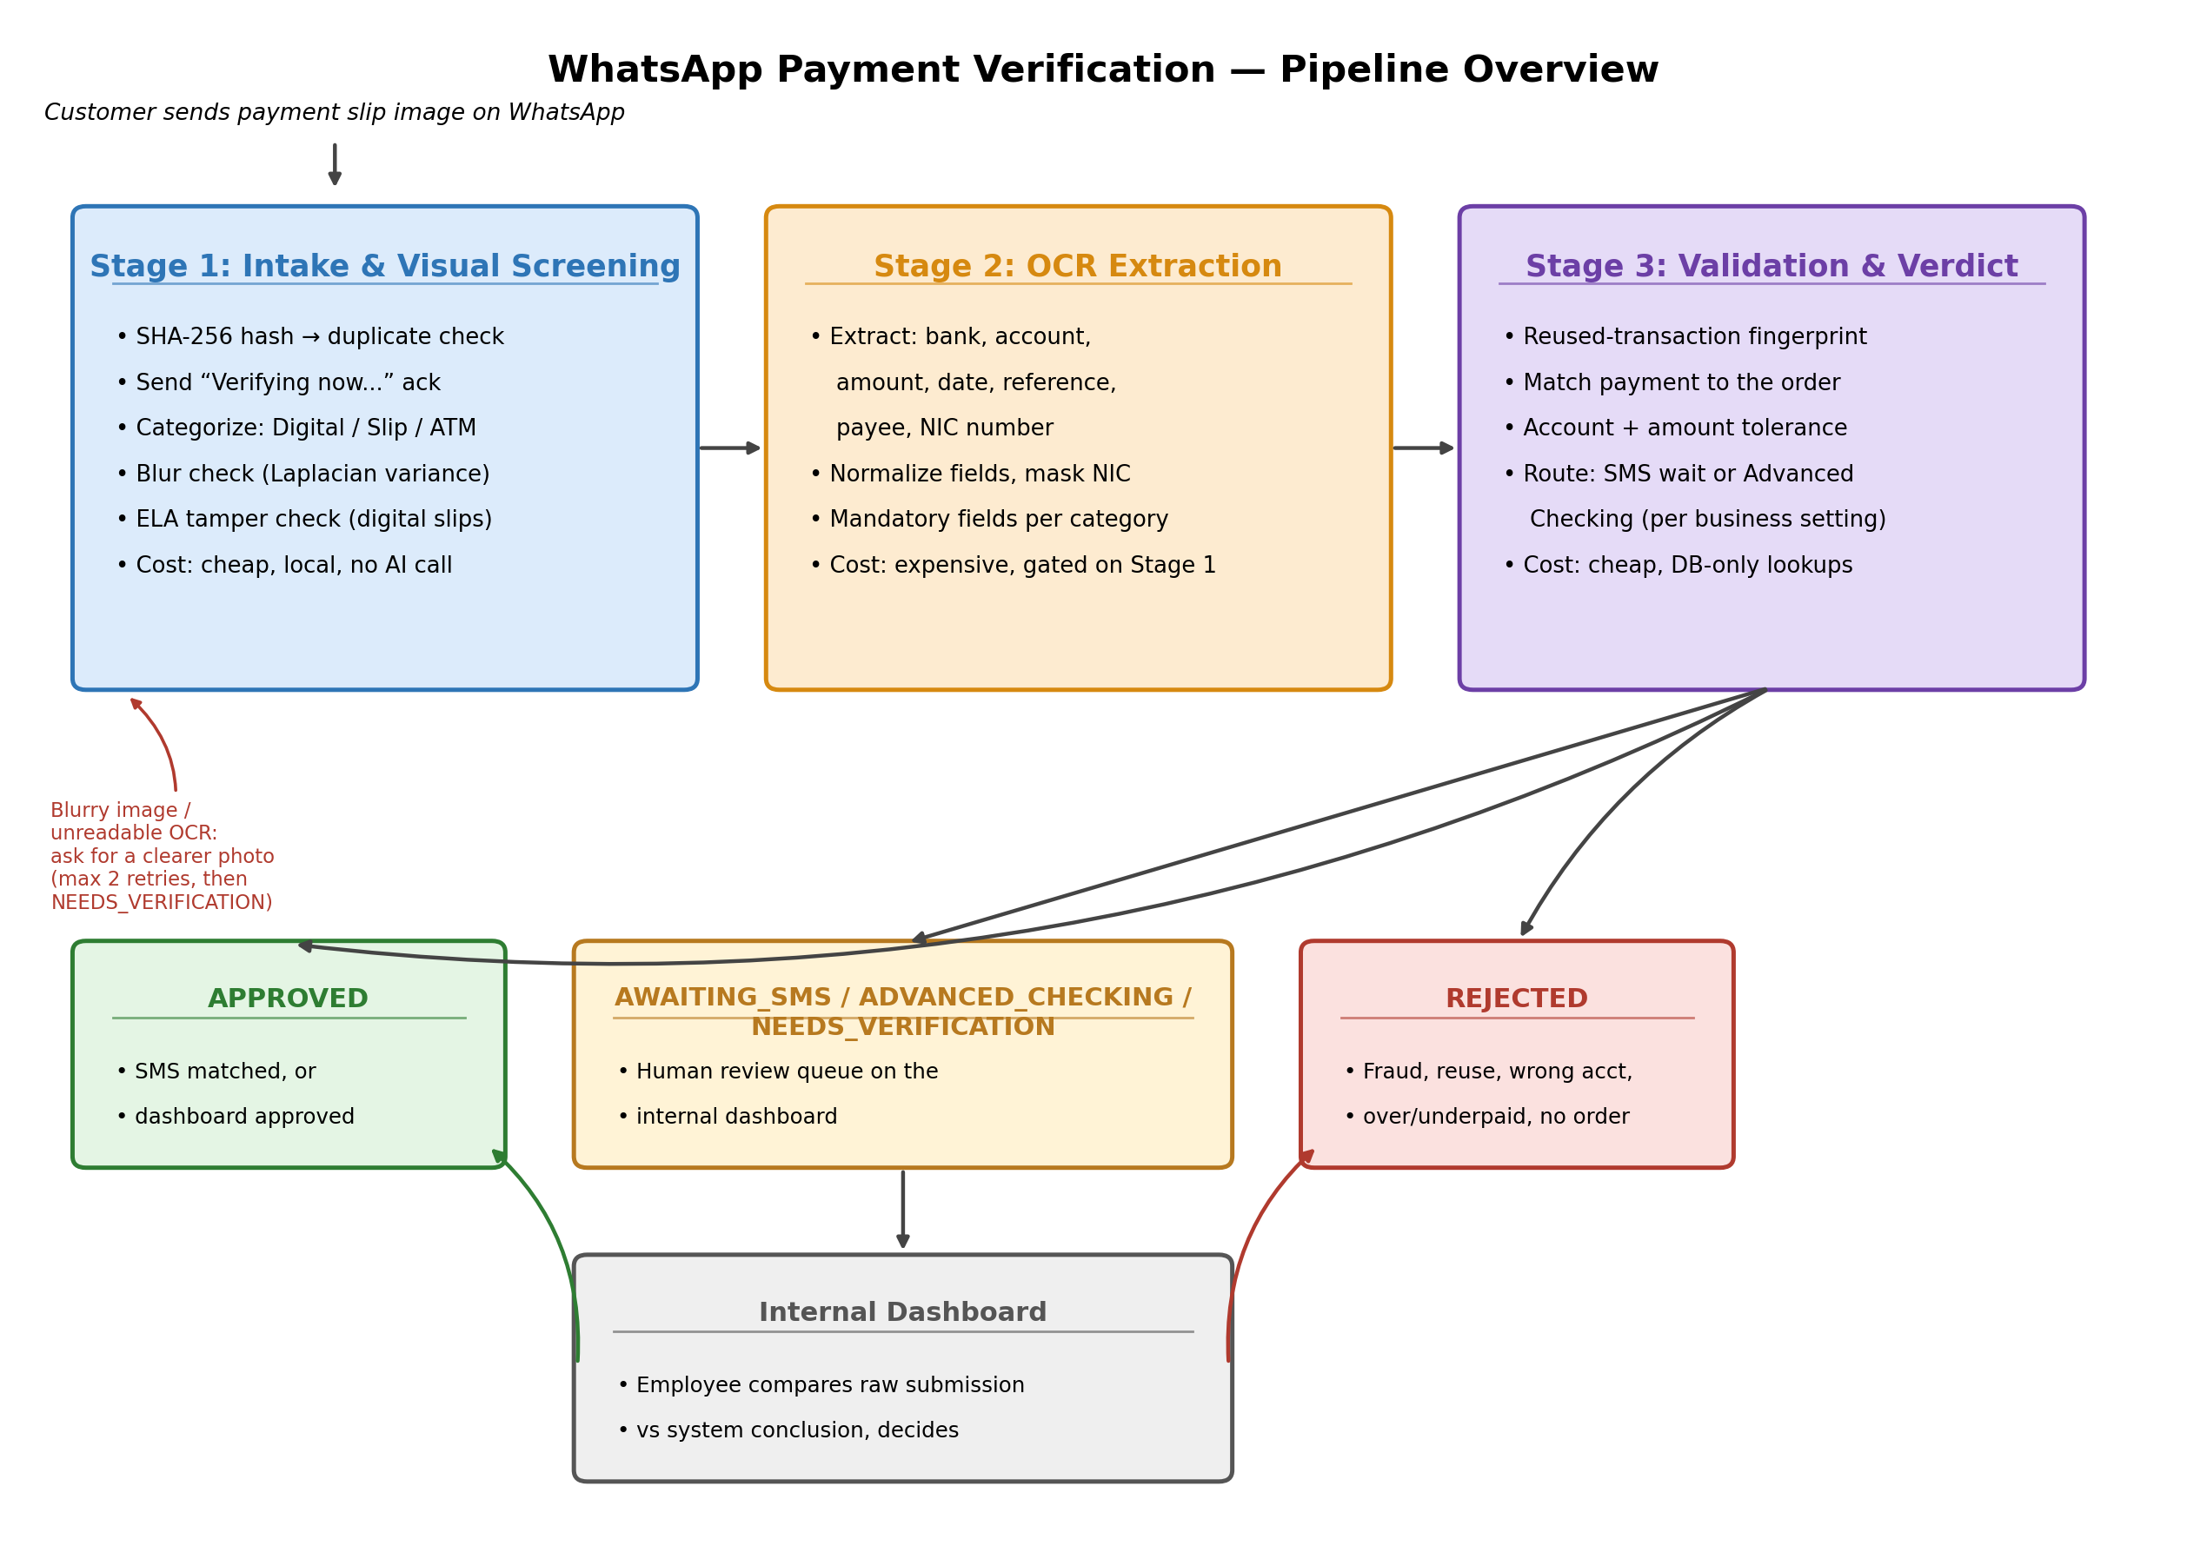
Figure 1. Three-stage verification pipeline and outcome routing.
Stage 1 (intake and visual screening) hashes the image, categorizes it as a digital screenshot, a physical bank slip, or an ATM/teller receipt, and runs cheap, local checks for blur and obvious digital tampering — all before any paid API call. Stage 2 (OCR extraction) pulls the bank name, account number, amount, date, reference number, payee name, and NIC, normalizes them into consistent formats, and masks the NIC immediately. Stage 3 (validation) cross-references the extracted data against the customer's order, checks for reused transactions, and routes the payment either to wait for a matching bank SMS or to advanced checking.

2. Verifying a Payment Belongs to an Order
Once OCR has extracted an account number and amount, the system resolves which order the payment is for. When the WhatsApp bot flow already knows the order (an order_id passed with the submission), that binding is used directly and is authoritative. Otherwise, the system looks up orders awaiting payment for that phone number: if there is exactly one, it is used; if there is more than one, the system attempts to disambiguate by matching the extracted amount to exactly one order's expected amount; if that still isn't unique, the payment is routed to NEEDS_VERIFICATION with reason ambiguous_order rather than guessing. The payment must then match the order's business account exactly, and its amount must fall within an asymmetric tolerance: zero tolerance for underpayment (which loses revenue directly), and a small fixed buffer for overpayment (which typically only requires a refund or credit).

3. Detecting Duplicate or Reused Payments
Reuse is caught at two layers. The first, cheapest layer is a SHA-256 hash of the image itself: a byte-identical resubmission is rejected immediately, before any processing. The second layer catches the harder case — the same real bank transfer, photographed or cropped differently, submitted against two different orders. For this, the system builds a transaction fingerprint from the normalized account number, amount, payment date, and reference number once OCR succeeds. Before a new payment is accepted, its fingerprint is checked against every payment currently in an active state (approved, awaiting SMS, in advanced checking, or awaiting review) — not just approved ones, since a transaction already claimed by a pending payment must still block a duplicate. Because this fingerprint depends on a reference number, reference_no is a mandatory OCR field for every slip category, including physical bank slips, which is exactly the category most prone to reuse via reprinting or resubmission of the same physical document.

4. Handling Suspicious or Manipulated Slips
Visual fraud screening happens before OCR, so a clearly manipulated slip never reaches the expensive extraction step. For digital screenshots, the system uses Error Level Analysis (ELA): the image is recompressed and compared to the original, and regions that differ far more than the rest of the image — a signature of localized editing — reduce that submission's confidence score rather than causing an outright rejection, since WhatsApp's own recompression can also introduce noise. A submission is fully rejected only on a strong signal; weaker signals accumulate as a confidence penalty that can push the payment into NEEDS_VERIFICATION for human review instead. The customer is never told which check failed or why — rejection messages are generic — so the fraud-detection logic itself is not exposed to a bad-faith submitter. Physical tamper detection (splicing, correction fluid, re-photographed edits) is designed into the pipeline but not yet implemented; it currently always passes for physical slips and ATM receipts, which is the system's most significant open gap on the fraud side.

5. Using Bank SMS Information
When a business has SMS notifications enabled, a payment that clears Stages 1–3 is placed in an AWAITING_SMS state rather than being approved outright. A separate ingestion endpoint receives inbound bank SMS notifications and matches them against pending payments by account number and exact amount. A unique match approves the payment automatically and notifies the customer. If more than one pending payment matches — the exact scenario of two customers paying an identical amount into the same account — the system deliberately does not guess; it leaves both payments waiting, since a wrong automatic match is worse than a delay, and either a later, more specific detail resolves it or the payment times out to advanced checking for a human to resolve using the reference number. Payments that receive no matching SMS at all within a configurable tolerance window are automatically escalated to ADVANCED_CHECKING, so a business is never left with a payment stuck waiting indefinitely.

6. Minimizing Cost
The pipeline is ordered specifically so that cost scales with how suspicious or unclear a submission is, not with total volume. The cheapest checks run first: hashing, database lookups, and local image analysis (blur detection, ELA) all run without any external API call. OCR, the most expensive step, only runs once a slip has passed every cheap check. As a further guard, if a phone number has no order awaiting payment at all — independent of what the image contains — and has already triggered this outcome repeatedly within an hour, the system skips OCR entirely rather than spending it on a submission that cannot possibly match anything. Extracted data is stored directly in the relational database rather than a separate cache layer, and a scheduled job purges it after twelve hours only for abandoned or retry-eligible rows, keeping storage bounded without adding infrastructure. Outbound WhatsApp messages are sent as background tasks so they never block the request path, which keeps the system responsive under concurrent load without needing a dedicated message queue at prototype scale.

7. Major Limitations
- OCR extraction is fully mocked; no real OCR engine (e.g. AWS Textract, Google Cloud Vision) is wired in yet, so field-level accuracy and confidence scoring are unverified against real slips.
- Physical-slip and ATM-receipt tamper detection is not implemented; only the digital ELA check is functional.
- There is no real WhatsApp webhook receiver or signature verification, and no signature verification on the bank SMS ingestion endpoint beyond a static shared secret.
- Dashboard authentication is a single static API key rather than per-employee accounts, so there is no audit trail of which employee made which manual decision.
- Amount and date parsing assume a single locale's formatting conventions (e.g. '.' as the decimal separator, day-first dates); a differently formatted slip would misparse silently.
- The schema assumes a single business; there is no business/tenant identifier, so the system as built cannot yet serve multiple merchants safely.
- Blur and tamper-detection thresholds are unvalidated guesses, not calibrated against a labeled set of real slips.

8. What Would Change for Production Scale
- Replace in-process background tasks with a real message queue (e.g. Celery with Redis/SQS) so OCR, WhatsApp sends, and SMS matching survive process restarts and scale across multiple workers independently of the API process.
- Integrate a production OCR engine and a trained image classifier for slip categorization and physical tamper detection, replacing the current heuristics and mocks, and calibrate every threshold against a labeled dataset of real slips.
- Move from a single static dashboard API key to per-employee authentication (OAuth/JWT) with role-based access and a full audit log of manual decisions.
- Add a business/tenant identifier throughout the schema so the system can serve multiple merchants without cross-tenant data exposure.
- Adopt Alembic (or equivalent) migrations instead of create_all, and add structured logging, metrics, and alerting (e.g. to Slack or email) for fraud flags and SMS timeouts, rather than relying on a database row a human has to notice.
- Verify WhatsApp webhook signatures and the bank SMS gateway's signature/HMAC rather than a static shared secret, and add rate limiting at the API gateway layer in addition to the existing per-phone abuse counter.
- Load-test the pipeline under realistic concurrency and tune the SMS tolerance window and retry limits against real timing data rather than initial estimates.

