Given two cells on the standard chess board, determine whether they have the same color or not.
Example
- For cell1 = "A1" and cell2 = "C3", the output should be
chessBoardCellColor(cell1, cell2) = true.
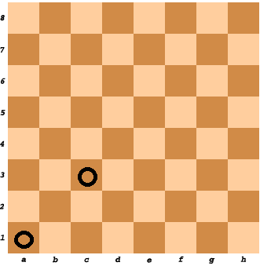
- For cell1 = "A1" and cell2 = "H3", the output should be
chessBoardCellColor(cell1, cell2) = false.
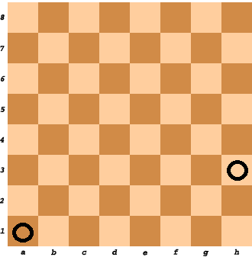
Input/Output
- [execution time limit] 0.5 seconds (cpp)
- [input] string cell1
- [input] string cell2
- [output] boolean

