Consider integer numbers from 0 to n - 1 written down along the circle in such a way that the distance between any two neighboring numbers is equal (note that 0 and n - 1 are neighboring, too).
Given n and firstNumber, find the number which is written in the radially opposite position to firstNumber.
Example
For n = 10 and firstNumber = 2, the output should be
circleOfNumbers(n, firstNumber) = 7.
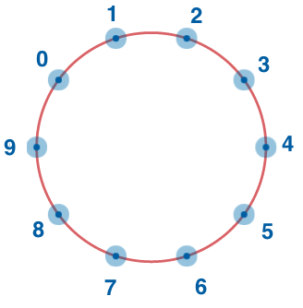
Input/Output
- [execution time limit] 0.5 seconds (cpp)
- [input] integer n
A positive even integer.
Guaranteed constraints:
4 ≤ n ≤ 20.
- [input] integer firstNumber
Guaranteed constraints:
0 ≤ firstNumber ≤ n - 1.
- [output] integer

