In the popular Minesweeper game you have a board with some mines and those cells that don't contain a mine have a number in it that indicates the total number of mines in the neighboring cells. Starting off with some arrangement of mines we want to create a Minesweeper game setup.
Example
For
matrix = [[true, false, false],
[false, true, false],
[false, false, false]]
the output should be
minesweeper(matrix) = [[1, 2, 1],
[2, 1, 1],
[1, 1, 1]]
Check out the image below for better understanding:
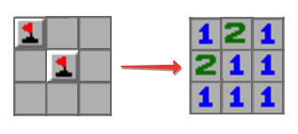
Input/Output
- [execution time limit] 0.5 seconds (cpp)
- [input] array.array.boolean matrix
A non-empty rectangular matrix consisting of boolean values - true if the corresponding cell contains a mine, false otherwise.
Guaranteed constraints:
2 ≤ matrix.length ≤ 100,
2 ≤ matrix[0].length ≤ 100.
- [output] array.array.integer

