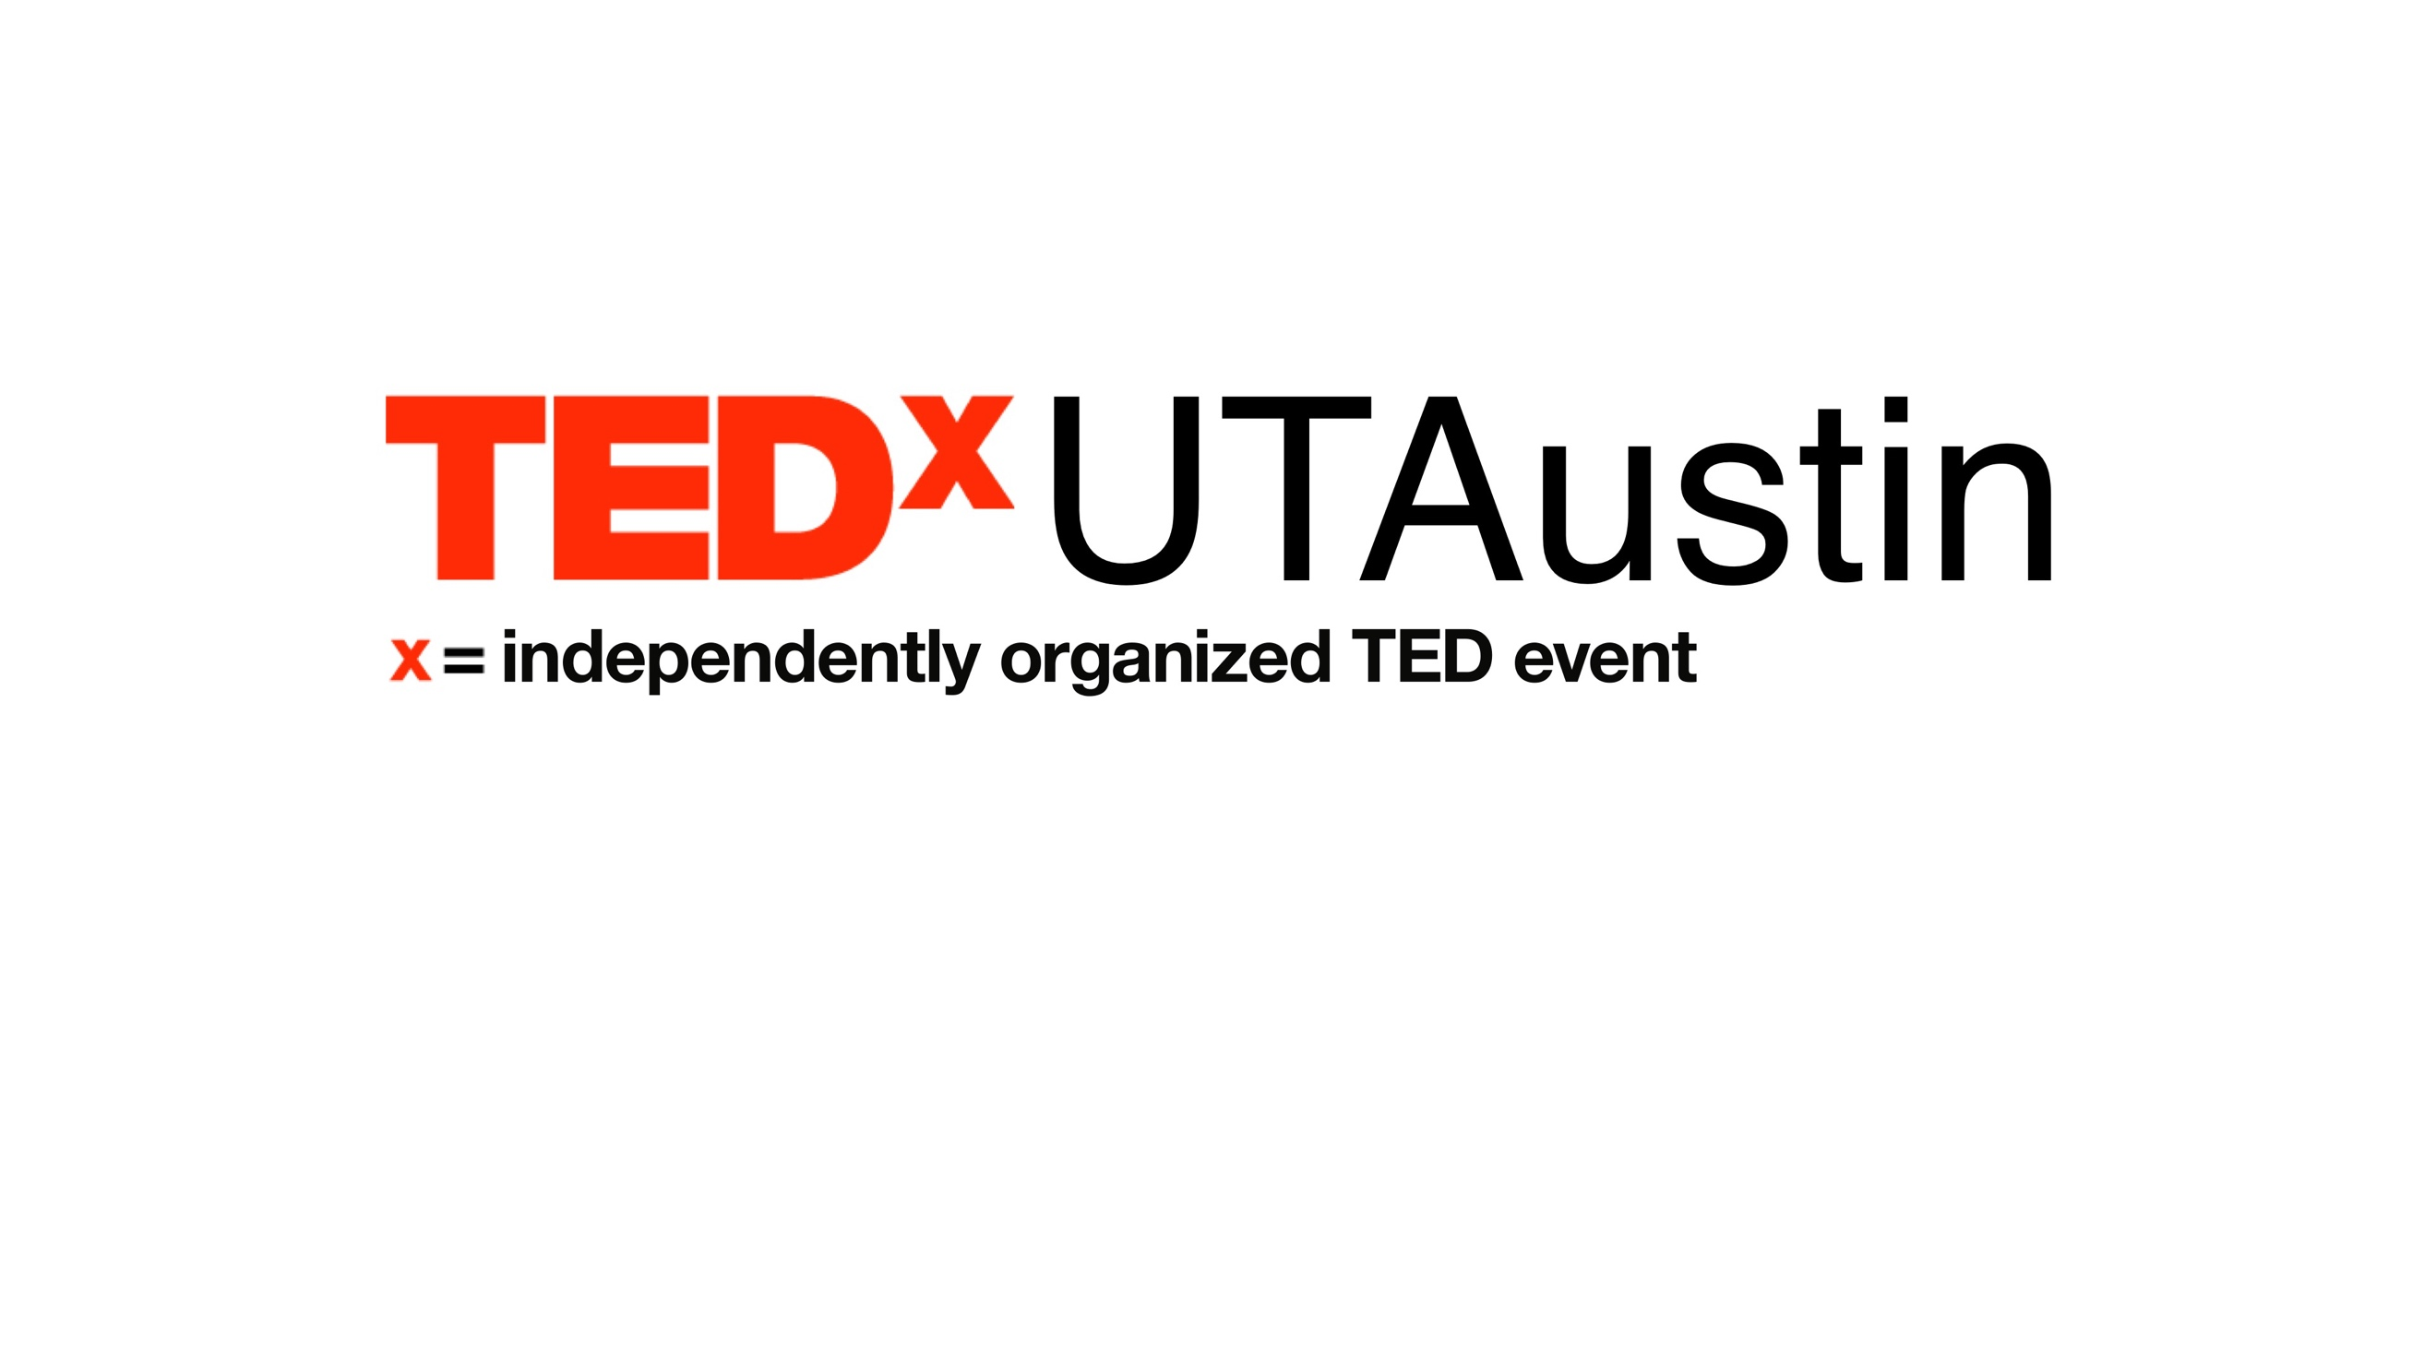

Greetings,

Thank you for choosing to apply as a student speaker for **TEDxUTAustin**.

TED is a nonprofit devoted to spreading ideas in the form of short, powerful talks.

TEDx is a self-organized program that brings people together to have a TED-like experience.

Submit this application to [this Dropbox](https://www.dropbox.com/request/DXj6TEyOPvQrhXE2yukx) by **11:59 pm CST on** **October 22, 2017**.

Our event is on **February 10, 2018**.

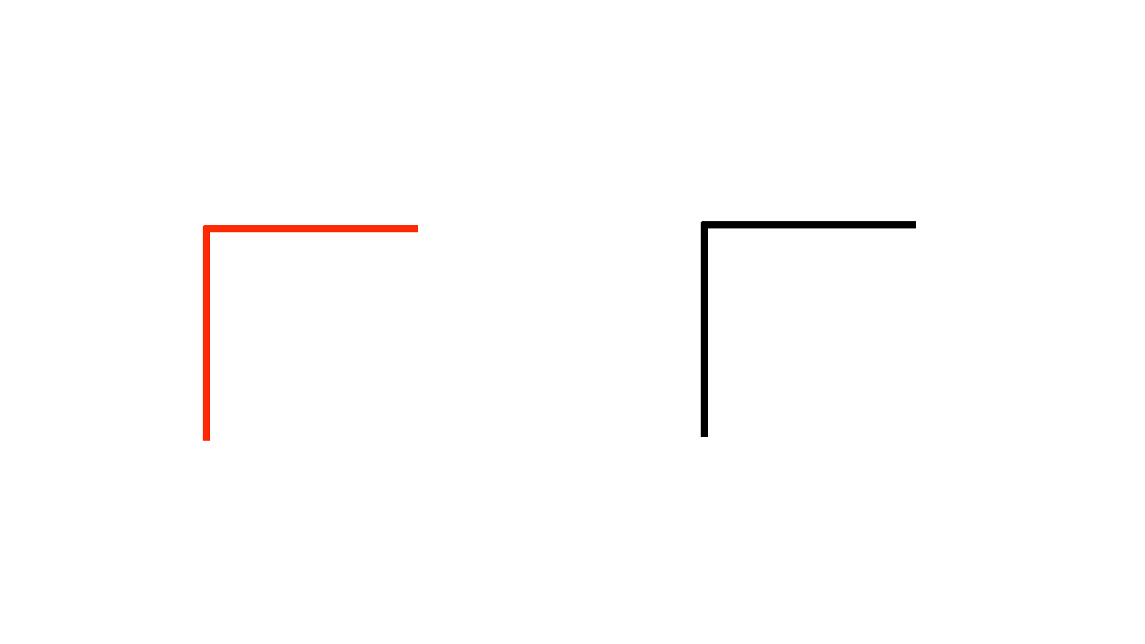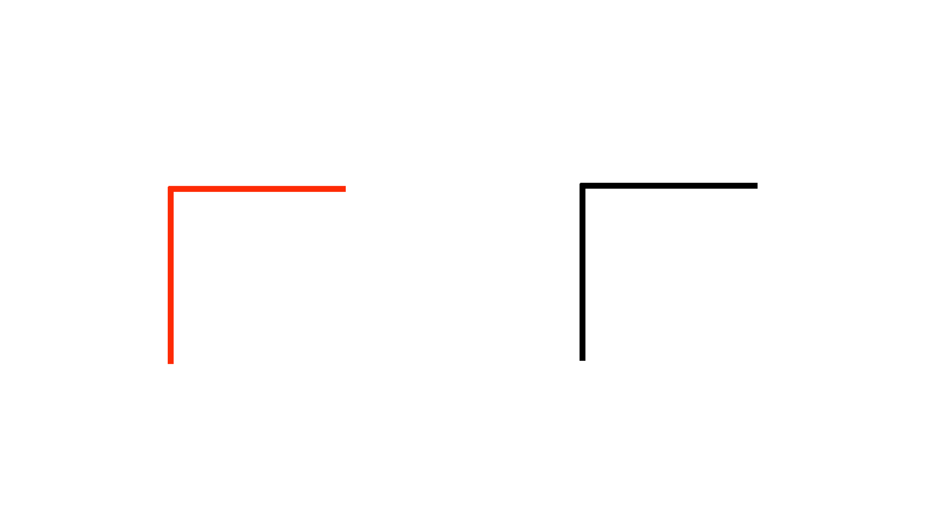

Student Speaker Application Form 2018

name | [Enter your response here]

major | [Enter your response here]

year | [Ex. Sophomore]

e-mail | [Enter your response here]

phone | [Ex. 111.222.8888]

**read** all prompts carefully

**explore** our [website](http://tedxutaustin.com/)

**unleash** your imagination

* **Tell us** the idea behind your talk. *(200 words)*

[Enter your response here]

* **Have** you spoken to large audiences before? Let us know when, why, and what you spoke about if you did. *(200 words)*

[Enter your response here]

* **What** does ***Resonance*** mean to you? *(100 words)*

[Enter your response here]

* **Who/what** inspires you? *(200 words)*

[Enter your response here]

* **How** will you spread your experience at **TEDxUTAustin** within your community? *(200 words)*

[Enter your response here]

* **If** you were anything else in this world, what would you be? Tell us why. *(∞ words)*

[Enter your response here]

* **Why** would people want to listen to your talk? *(100 words)*

[Enter your response here]

* **Give** us an outline of your talk. Feel free to use bullet points if that’s more your stride.

[Enter your response here]



Questions?

Message us on Facebook: TEDxUTAustin

Email us: apps@tedxutaustin.com