eLibrary Screenshots

Enter email: [admin@jtp.com](mailto:admin@jtp.com)

Enter password: admin123

Now login as admin.

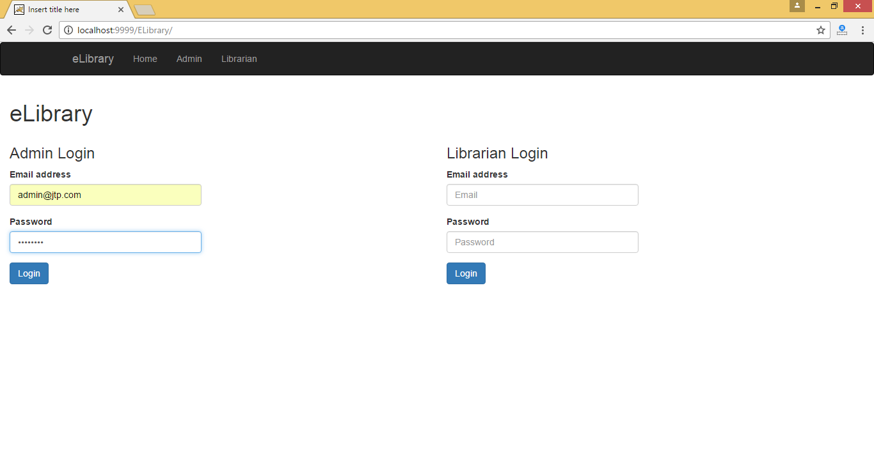

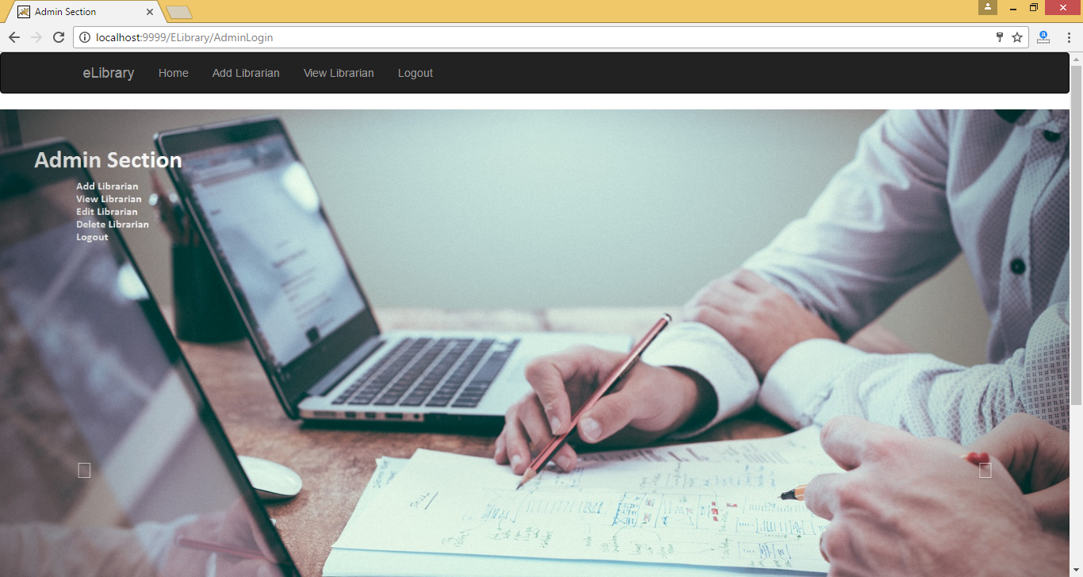

Click on Add Librarian:

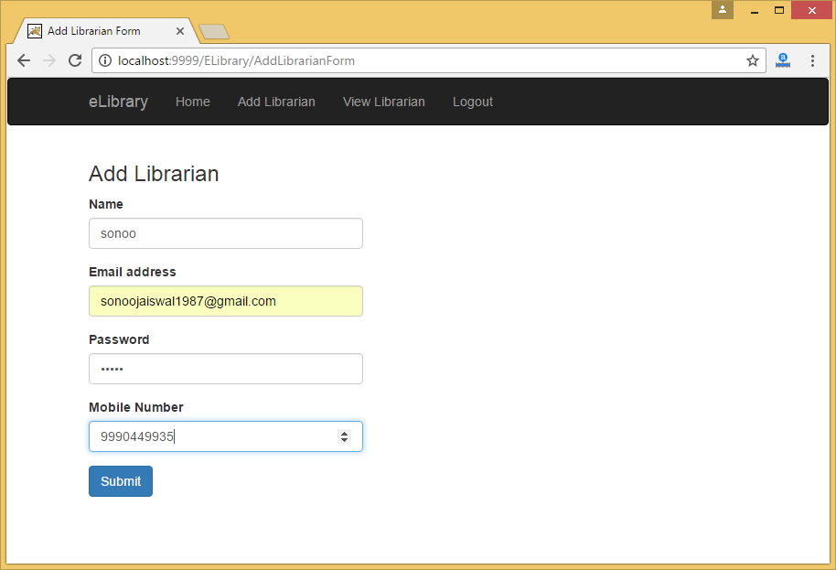

After filling form click on submit button.

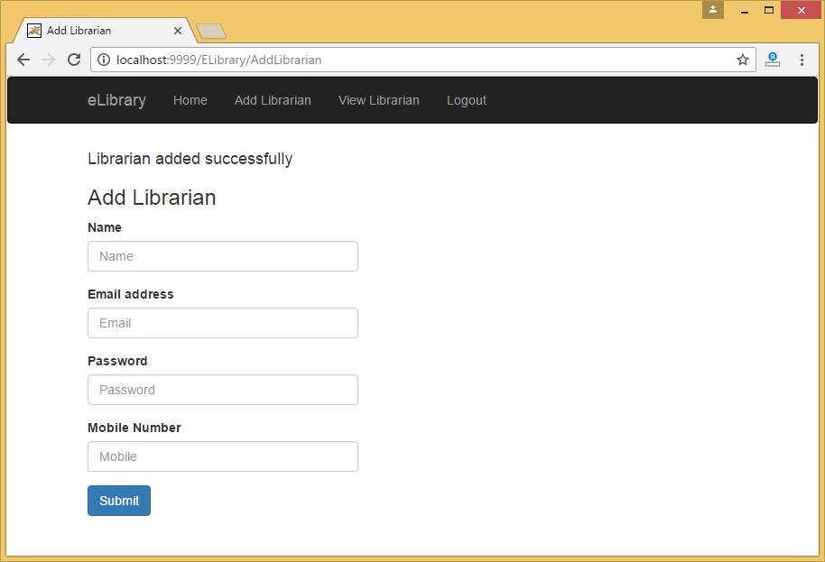

Now click on View Librarian:

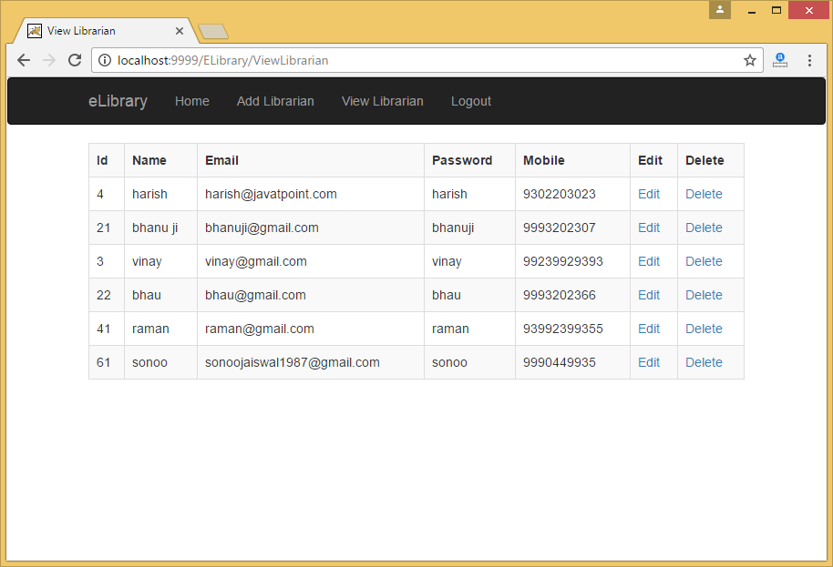

Now click on edit link:

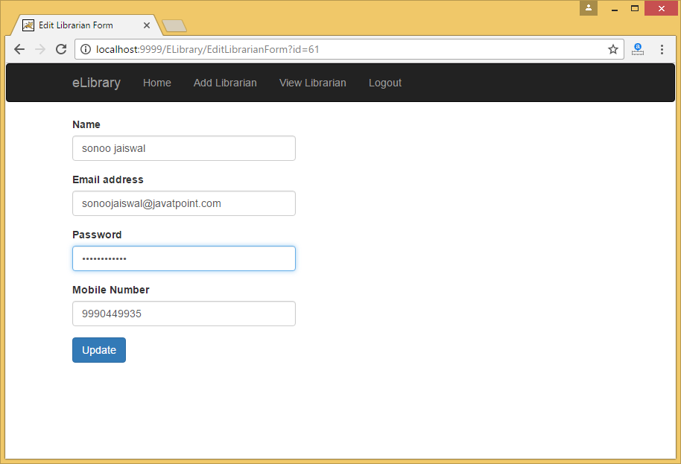

After changing the information, click on update button.

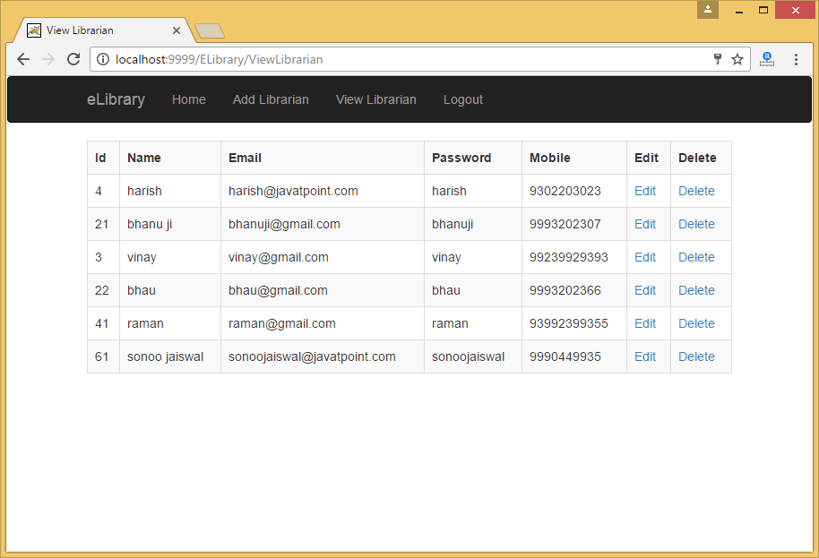

Now click on delete link:

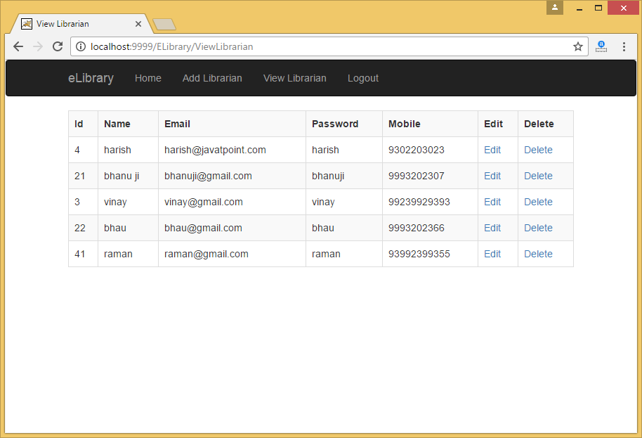

Now you can see that record is deleted.

Now click on logout button.

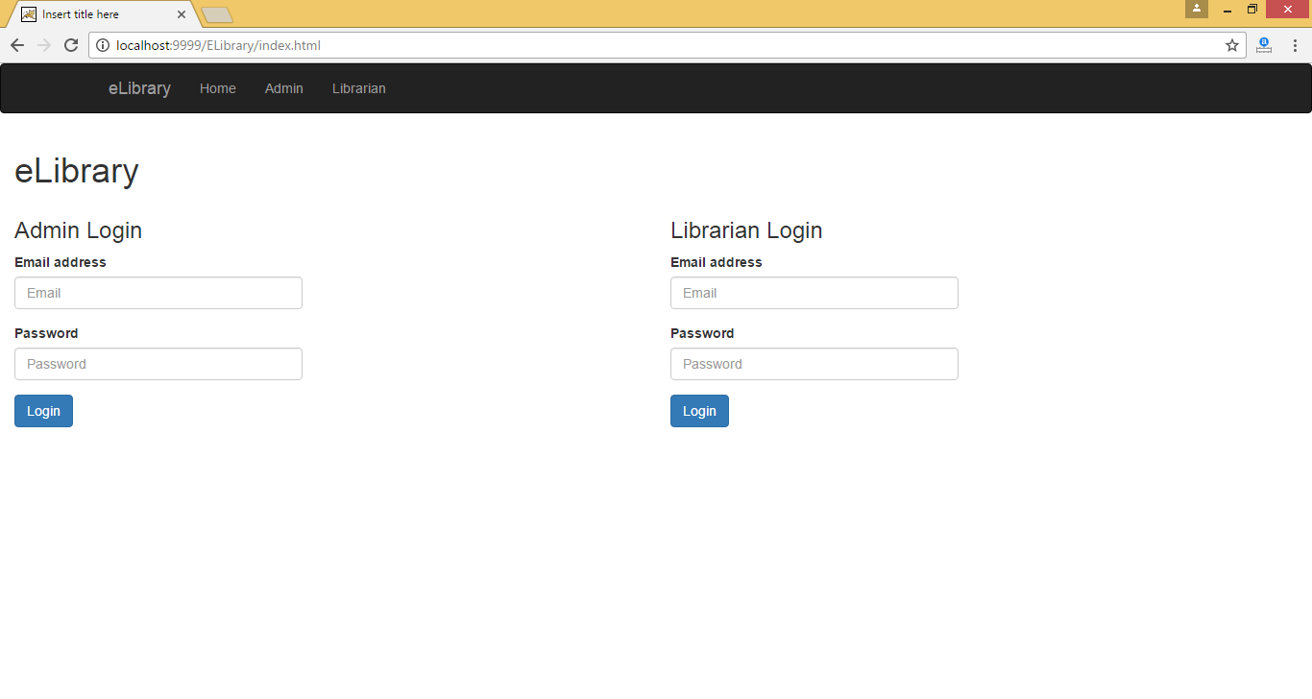

Now login through librarian section.

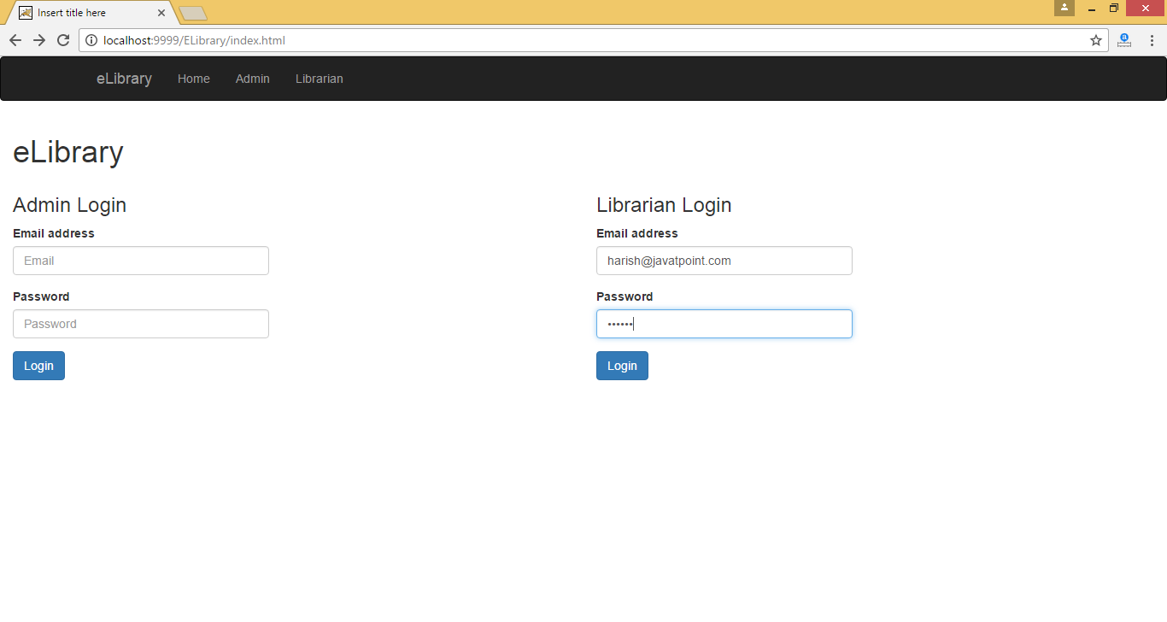

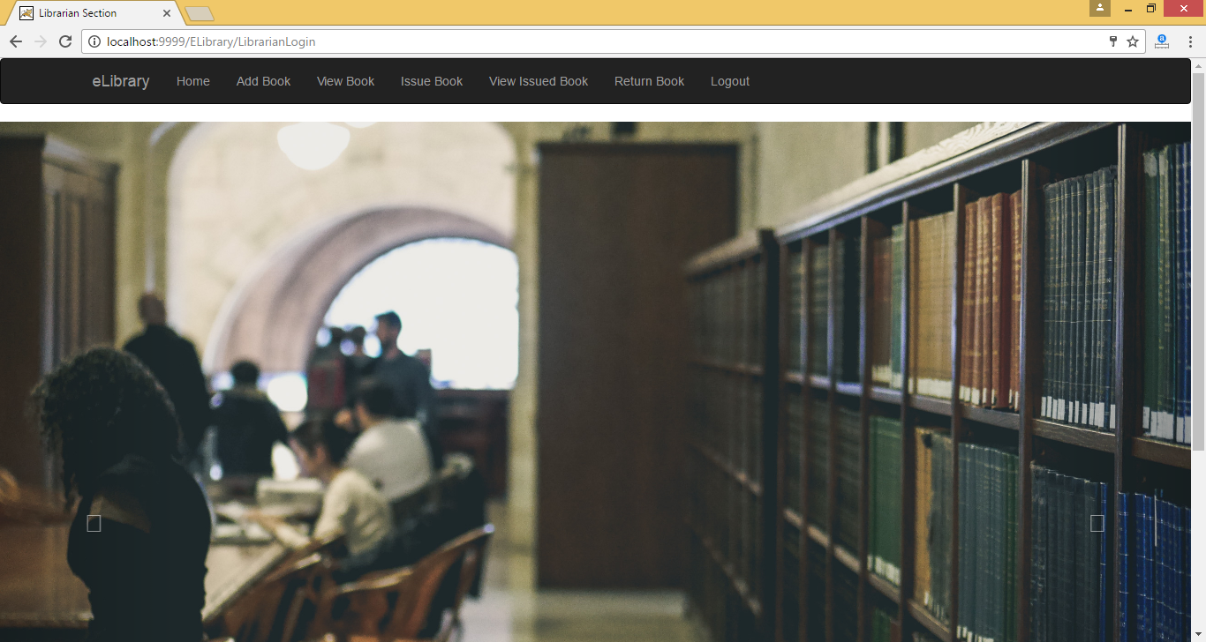

Now click on add book:

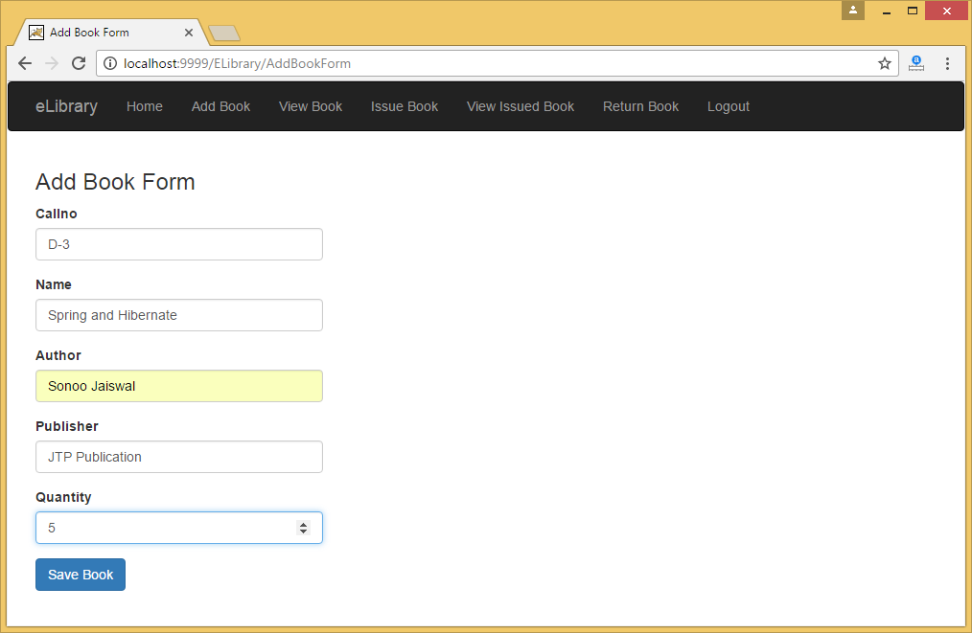

After filling the form, click on Save Book button.

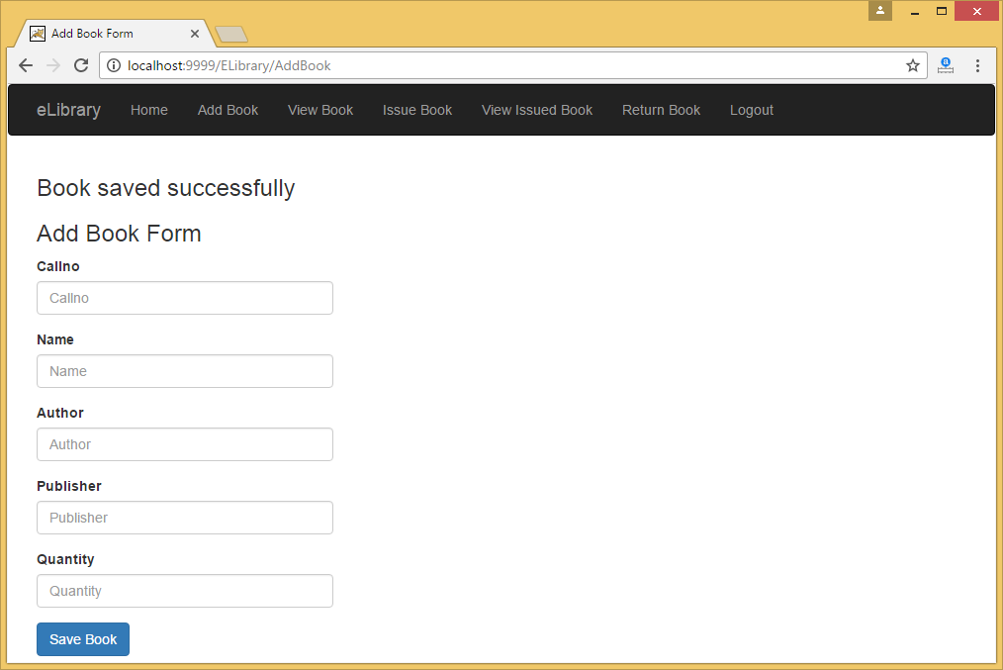

Now click on View Book link:

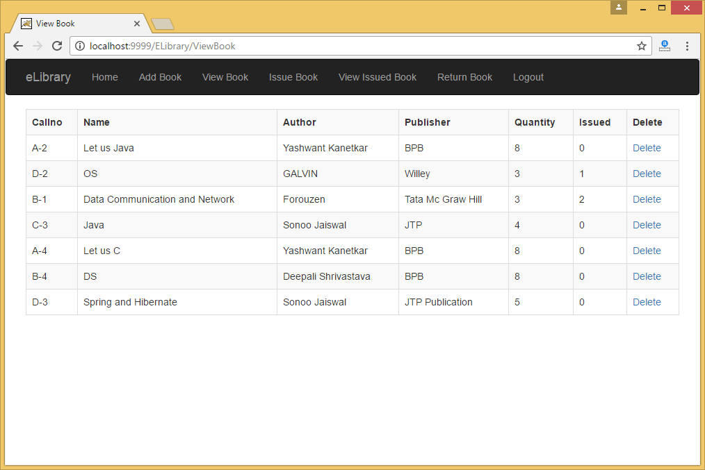

Now you can see that book is not issued to anyone, so it is set to 0.

Now click on Issue Book:

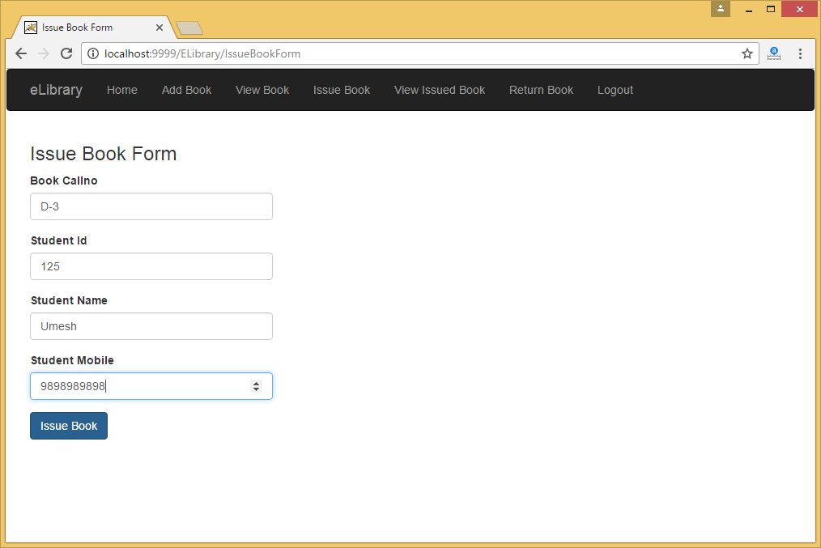

After filling the form, click on Issue Book button.

Now click on the View Issued Book link:

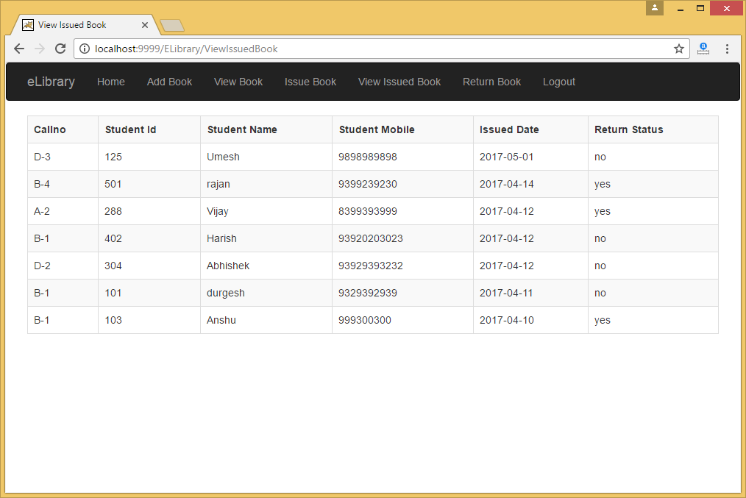

Now you can see that D-3 callno is listed in the table and its return status is no.

Again click on the View Book link:

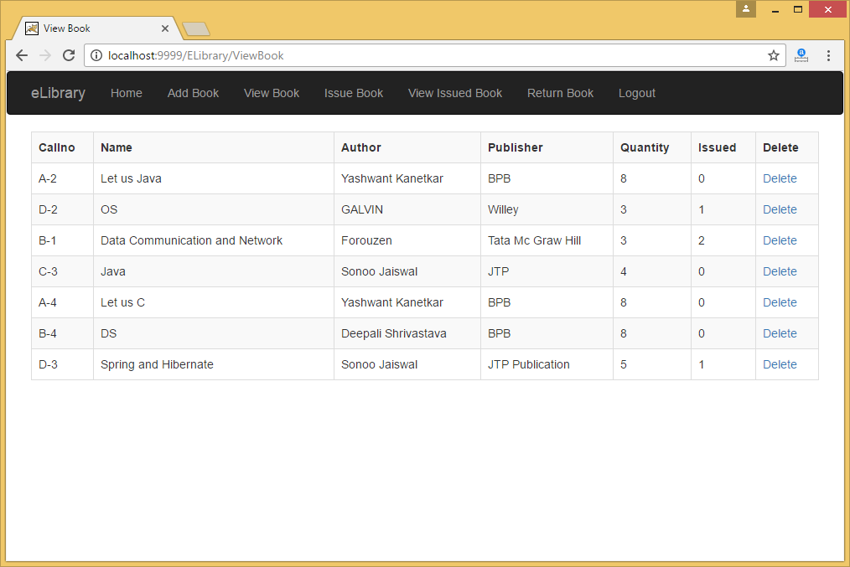

Here, you can see that issued column displays 1. If no. of issued books are equal to quantity, you will not be able to issue book.

Now click on the Return Book link:

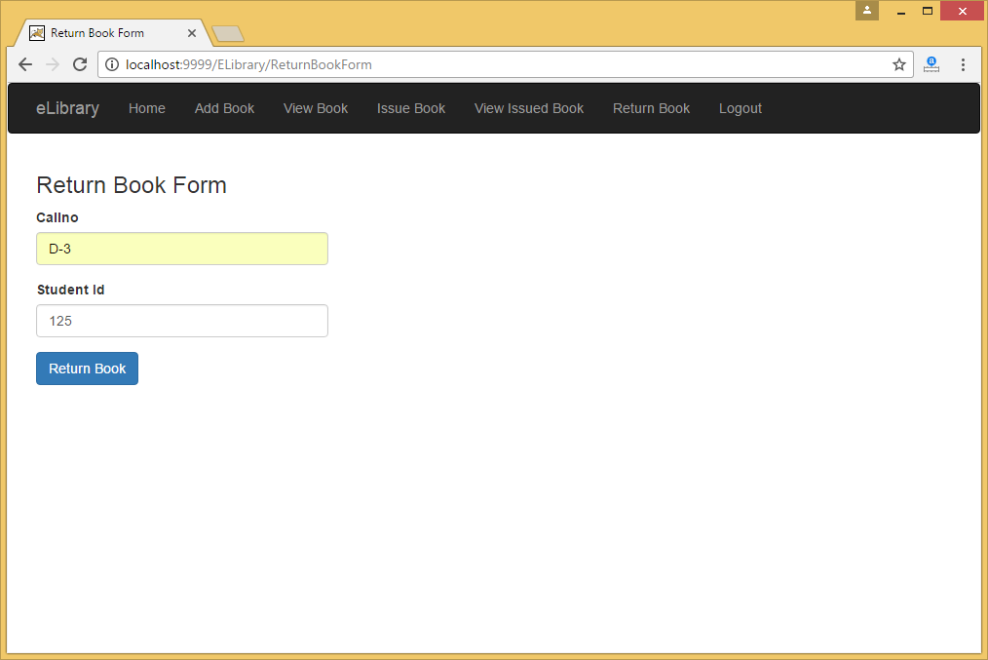

After filling correct callno and student id, click on Return Book button.

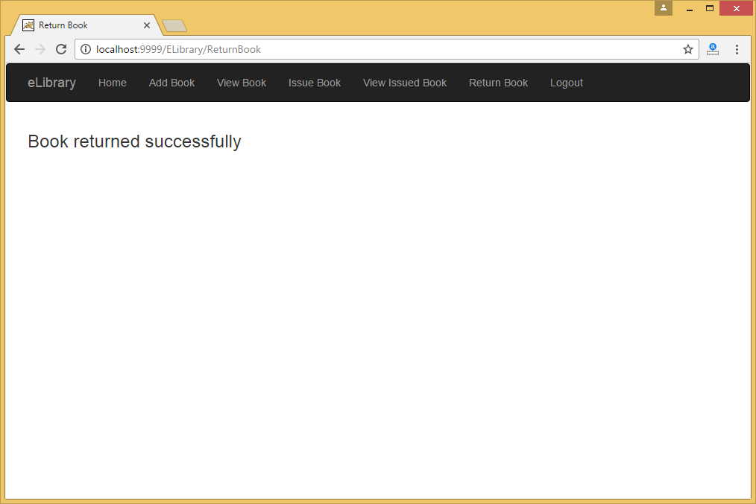

Now click on View Issued Book link again:

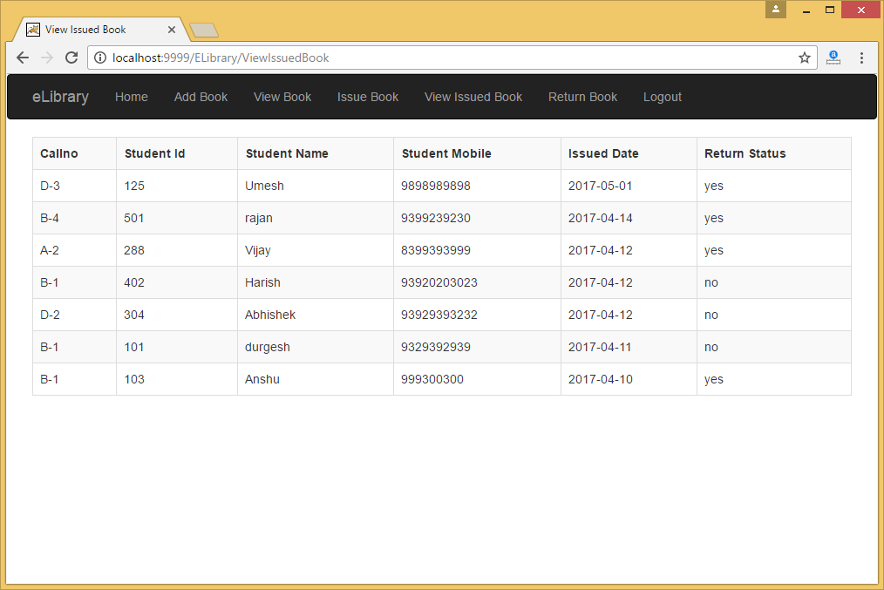

Here, you can see that return status is set to yes.

Now click on the View Book link again:



Here, you can see that issued no. is set to 0.

Now, click on logout.

This project is developed by Sonoo Jaiswal in 5 hours only in front of students while providing training on servlet. It is developed for college level students. You can improve it also.

Thanks and Regards,

**Sonoo Jaiswal**

**Founder of JavaTpoint**