**CREATING A CHATBOT**

**Introduction:**

In the world of customer service, chatbots have become invaluable tools for providing efficient and effective assistance to customers. This combination of GPT-3, ensemble methods, and deep learning techniques offers a dynamic approach to customer service, capable of natural language understanding and personalized responses. In this approach, GPT-3, pretrained on vast amounts of text data, forms the backbone of language comprehension. Here using these methods we are creating a chatbot for customer service.

**Methods used:**

**Ensemble** methods in AI involve combining multiple machine learning models to improve predictive performance by leveraging their collective wisdom. These methods typically include techniques like bagging, boosting, or stacking.

**Deep learning** is a subset of machine learning that uses neural networks with multiple hidden layers to automatically learn and represent complex patterns and features from data, making it especially suited for tasks like image and speech recognition.

**Pretrained GPT-3:** GPT-3 is a state-of-the-art language model developed by OpenAI, which has been trained on a vast amount of text data and can generate human-like text based on the input it receives.

**Algorithm:**

**Step 1: Data Collection and Preprocessing**

* Collect a diverse dataset of customer service interactions, including user queries and corresponding responses.
* Preprocess the data, which may include tokenization, cleaning, and annotation for intent recognition.

**Step 2: Pretraining and Fine-Tuning GPT-3**

* Pretrain a GPT-3 model on a large corpus of text data to establish its language understanding and generation capabilities.
* Fine-tune the GPT-3 model on your specific customer service data to make it contextually aware of your domain.

**Step 3: Ensemble Model Selection**

* Choose a set of deep learning models for the ensemble. This may include models like BERT for intent recognition, LSTM for sequence modeling, or others based on your requirements.

**Step 4: Ensemble Training**

* Train individual deep learning models on your customer service data, each with a specific focus (e.g., intent recognition, entity extraction, or response generation).
* Create an ensemble strategy for combining the outputs of these models, such as voting, weighted averaging, or a more sophisticated approach.

**Step 5: Chatbot Architecture**

* Design the chatbot’s architecture that integrates GPT-3, the ensemble models, and a user interface.
* Establish communication channels for users to interact with the chatbot (e.g., web interface, messaging platforms).

**Step 6: User Interaction**

* When a user submits a query, direct the input to the ensemble models for intent recognition and other specialized analyses.

**Step 7: Ensemble Output**

* Combine the outputs from the ensemble models to make decisions about how to handle the user query.

**Step 8: GPT-3 Response Generation**

* Based on the decisions made by the ensemble models, construct a response or action request using the fine-tuned GPT-3 model.

**Step 9: User Response Presentation**

* Present the generated response to the user through the chatbot’s interface.

**Step 10: Continuous Learning and Monitoring**

* Continuously monitor the chatbot’s performance by collecting user feedback and tracking interactions.
* Implement mechanisms for iterative improvement, such as updating ensemble models and fine-tuning the GPT-3 model as needed.

**Step 11: Error Handling and Escalation**

* Develop error handling mechanisms to manage unexpected user inputs or uncertain responses.
* Define procedures for escalating users to human agents if the chatbot is unable to assist.

**Step 12: Security and Privacy**

* Ensure that the chatbot maintains data security and respects user privacy during interactions.

**Step 13: Deployment and Scaling**

* Deploy the chatbot on a server or cloud platform to handle user interactions at scale.

**Step 14: Compliance**

* Ensure the chatbot complies with relevant regulations, including data protection laws and industry-specific standards.

**Step 15**: **User Feedback and Iteration**

* Gather user feedback and analyze chatbot performance to identify areas for improvement.
* Make iterative updates to enhance the chatbot’s capabilities and responses.

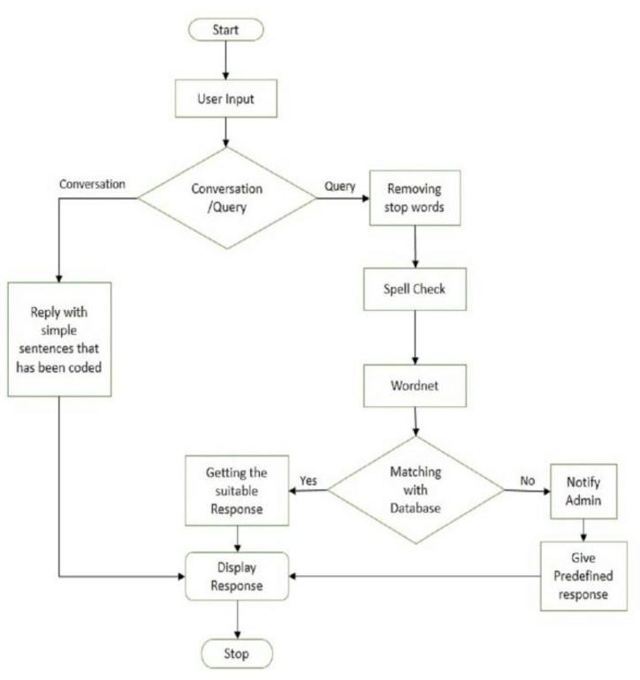**Flowchart**

**TEAM MEMBERS:**

Reshmi M J

Suvetha R

Pavithra A

Mohammed Nawfal M S

Nidhish babu T L S