OS -LAB
Suvetha.D P
CB.EN.U4CYS21078

#include <stdio.h>
// Function to find the waiting time for all processes
int waitingtime(int proc[], int n,
int burst_time[], int wait_time[]) {
// waiting time for first process is 0
wait_time[0] = 0;
// calculating waiting time
for (int i = 1; i < n ; i++ )
wait_time[i] = burst_time[i-1] + wait_time[i-1] ;
return 0;
}
// Function to calculate turn around time
int turnaroundtime( int proc[], int n,
int burst_time[], int wait_time[], int tat[]) {
// calculating turnaround time by adding
// burst_time[i] + wait_time[i]
int i;
for ( i = 0; i < n ; i++)
tat[i] = burst_time[i] + wait_time[i];
return 0;
}
//Function to calculate average time
int avgtime( int proc[], int n, int burst_time[]) {
int wait_time[n], tat[n], total_wt = 0, total_tat = 0;
int i;
//Function to find waiting time of all processes
waitingtime(proc, n, burst_time, wait_time);
//Function to find turn around time for all processes
turnaroundtime(proc, n, burst_time, wait_time, tat);
//Display processes along with all details
printf("Processes Burst Waiting Turn around:");
// Calculate total waiting time and total turn
// around time
for ( i=0; i<n; i++) {
total_wt = total_wt + wait_time[i];
total_tat = total_tat + tat[i];
printf(" %d\t %d\t\t %d \t%d", i+1, burst_time[i], wait_time[i], tat[i]);
}
printf("Average waiting time = %f", (float)total_wt / (float)n);
printf("Average turn around time = %f", (float)total_tat / (float)n);
return 0;
}
// main function
int main() {
//process id's
int proc[] = { 1, 2, 3};
int n = sizeof proc / sizeof proc[0];
//Burst time of all processes
int burst_time[] = {5, 8, 12};
avgtime(proc, n, burst_time);
return 0;
}
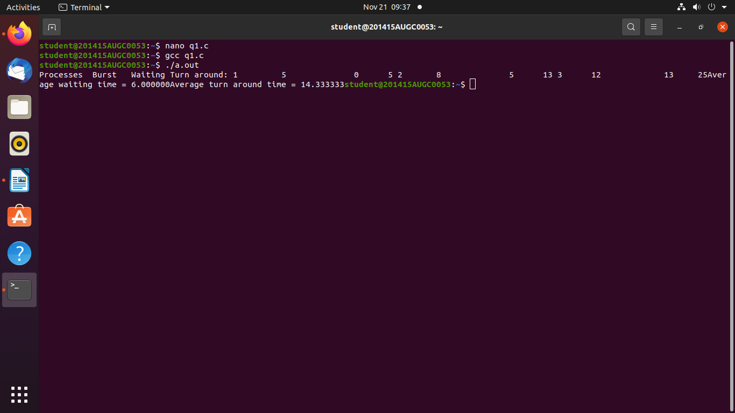
1.
#include <stdio.h>
- int main()
- {
- int pid[15];
- int bt[15];
- int n;
- printf("Enter the number of processes: ");
- scanf("%d",&n);

- printf("Enter process id of all the processes: ");
- for(int i=0;i<n;i++)
- {
- scanf("%d",&pid[i]);
- }
printf("Enter burst time of all the processes: ");
- for(int i=0;i<n;i++)
- {
- scanf("%d",&bt[i]);
- }

- int i, wt[n];
- wt[0]=0;

- //for calculating waiting time of each process
- for(i=1; i<n; i++)
- {
- wt[i]= bt[i-1]+ wt[i-1];
- }
printf("Process ID Burst Time Waiting Time TurnAround Time\n");
- float twt=0.0;
- float tat= 0.0;
- for(i=0; i<n; i++)
- {
- printf("%d\t\t", pid[i]);
- printf("%d\t\t", bt[i]);
- printf("%d\t\t", wt[i]);

- //calculating and printing turnaround time of each process
- printf("%d\t\t", bt[i]+wt[i]);
- printf("\n");

- //for calculating total waiting time
- twt += wt[i];

- //for calculating total turnaround time
- tat += (wt[i]+bt[i]);
- }
float att,awt;

- //for calculating average waiting time
- awt = twt/n;

- //for calculating average turnaround time
- att = tat/n;
- printf("Avg. waiting time= %f\n",awt);
- printf("Avg. turnaround time= %f",att);
- }
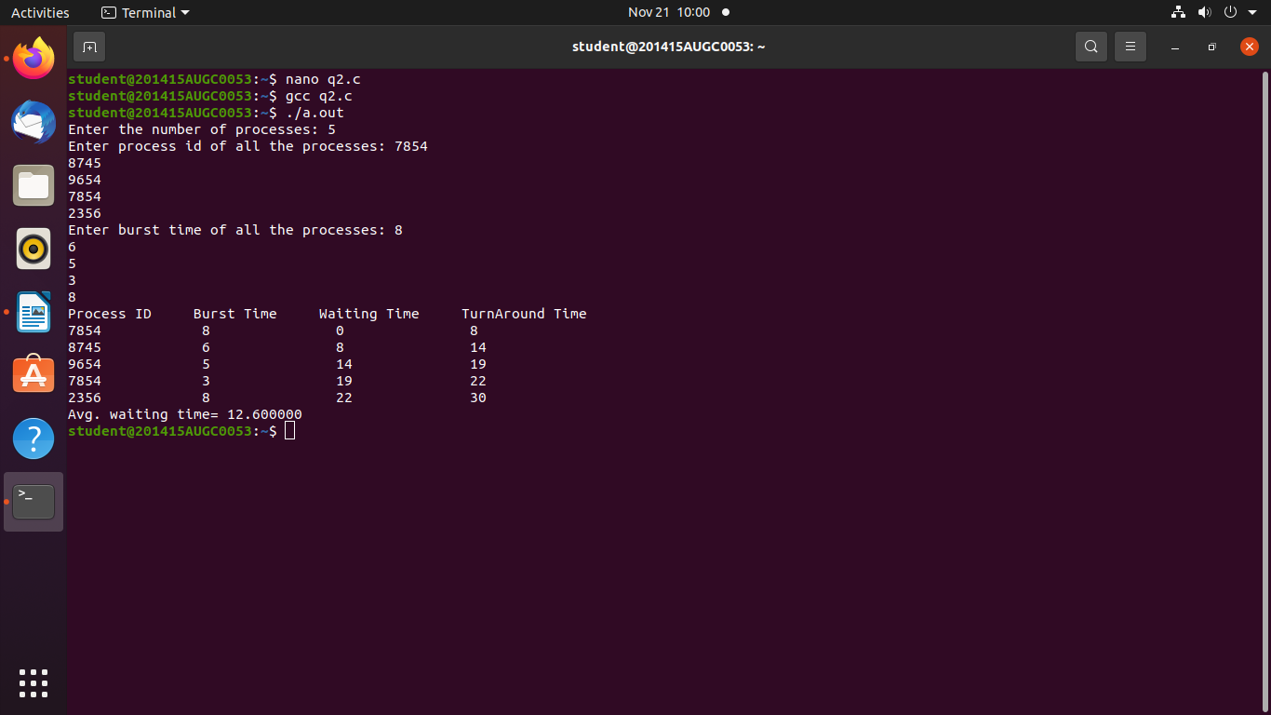
#include<stdio.h>
int main()
{
int p[10],at[10],bt[10],ct[10],tat[10],wt[10],i,j,temp=0,n;
float awt=0,atat=0;
printf("enter no of proccess you want:");
scanf("%d",&n);
printf("enter %d process:",n);
for(i=0;i<n;i++)
{
scanf("%d",&p[i]);
}
printf("enter %d arrival time:",n);
for(i=0;i<n;i++)
{
scanf("%d",&at[i]);
}
printf("enter %d burst time:",n);
for(i=0;i<n;i++)
{
scanf("%d",&bt[i]);
}
// sorting at,bt, and process according to at
for(i=0;i<n;i++)
{
for(j=0;j<(n-i);j++)
{
if(at[j]>at[j+1])
{
temp=p[j+1];
p[j+1]=p[j];
p[j]=temp;
temp=at[j+1];
at[j+1]=at[j];
at[j]=temp;
temp=bt[j+1];
bt[j+1]=bt[j];
bt[j]=temp;
}
}
}
/* calculating 1st ct */
ct[0]=at[0]+bt[0];
/* calculating 2 to n ct */
for(i=1;i<n;i++)
{
//when proess is ideal in between i and i+1
temp=0;
if(ct[i-1]<at[i])
{
temp=at[i]-ct[i-1];
}
ct[i]=ct[i-1]+bt[i]+temp;
}
/* calculating tat and wt */
printf("\np\t A.T\t B.T\t C.T\t TAT\t WT");
for(i=0;i<n;i++)
{
tat[i]=ct[i]-at[i];
wt[i]=tat[i]-bt[i];
atat+=tat[i];
awt+=wt[i];
}
atat=atat/n;
awt=awt/n;
for(i=0;i<n;i++)
{tat[i]=ct[i]-at[i];
wt[i]=tat[i]-bt[i];
atat+=tat[i];
awt+=wt[i];
}
atat=atat/n;
awt=awt/n;
for(i=0;i<n;i++)
{
printf("\nP%d\t %d\t %d\t %d \t %d \t %d",p[i],at[i],bt[i],ct[i],tat[i],wt[i]);
}
printf("\naverage turnaround time is %f",atat);

printf("\naverage wating time is %f",awt);
return 0;
}
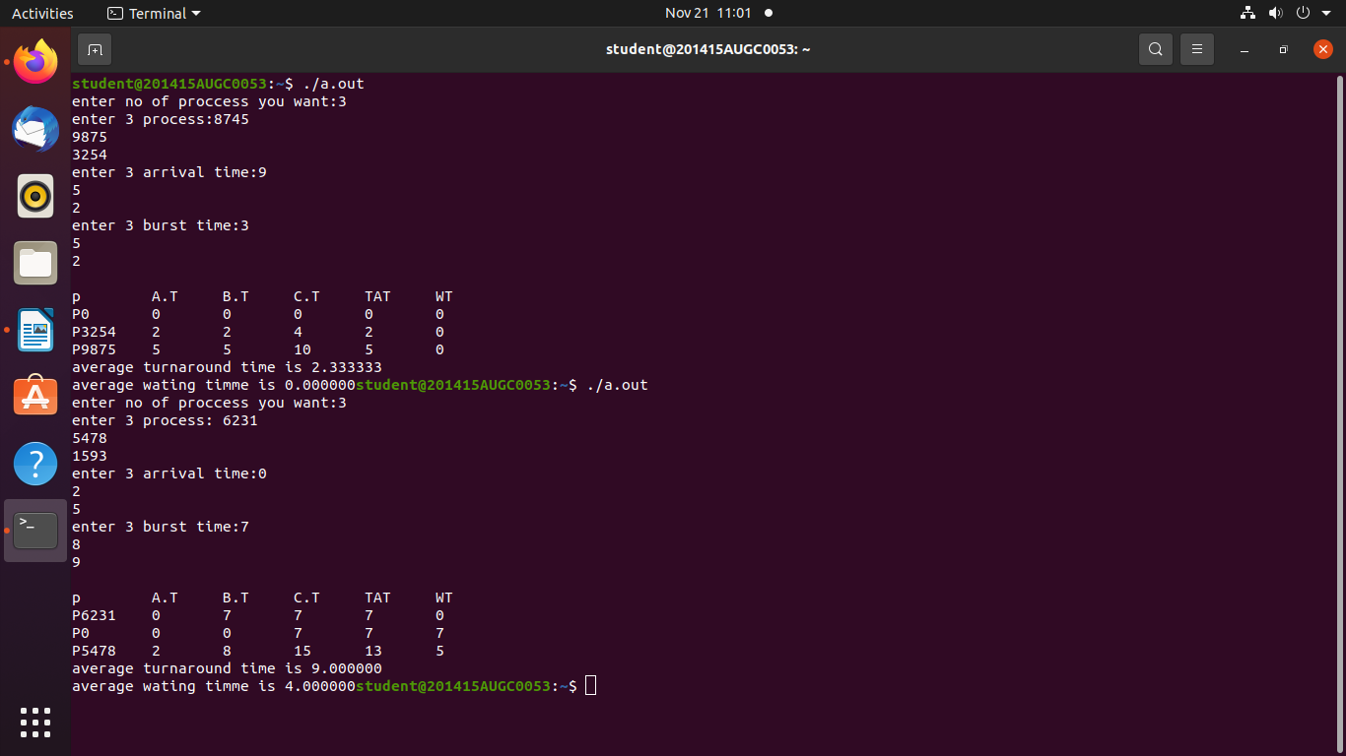
Round robin:

