SIMATS ENGINEERING (SAVEETHA SCHOOL OF ENGINEERING)
Department of Computer Science and Engineering
ASSESSMENT TOOL 1 – APPLICATION BASED QUESTIONS

Course Code: | CSA06 | Course Title: | Design and Analysis of Algorithms
CO Assessed: | CO1 – Precision (BL1, BL2, BL3) | Assessment: | Assessment Tool 1 – Application Based Questions
Weightage: | 40% of CIA | Total Marks: | 100 (2 Questions × 50 Marks)
CO1 Statement: | Determine algorithm efficiency using asymptotic notations and mathematical techniques including Master Theorem and substitution method. (BL1, BL2, BL3)
Student Name: | Suvetha C | Reg. No.: | 192421088
Section / Batch: | 2024 | Date: | 28-7-2026

Instructions to Students
- Answer BOTH questions. Each question carries 50 Marks. Total: 100 Marks.
- Clearly show all steps in derivations and complexity analysis.
- Use proper asymptotic notation (Big-O, Big-Θ, Big-Ω) wherever required.
- Justify each step in recurrence solving using appropriate methods.
- Neat presentation and logical explanation are mandatory

Question Type | Focus Area | Questions | Marks
Application-Based Questions | Apply Master Theorem and asymptotic analysis to real-world scenarios | Q1 – Q2 | Q1 –50  Q2 –50
GRAND TOTAL: |  | 100 Marks

SECTION A – APPLICATION BASED QUESTIONS

Q1. Insurance Claim Verification System An insurance system uses three nested loops to verify policy details, claim history, and supporting records. Recall how triple nested loops affect complexity, explain the rate of growth, and determine both the time complexity and space complexity for this process.

Code of Conduct
I __________________________ (Name / Reg No) certify that this submission is my original work and that I have adhered to the guidelines specified for this assessment. I understand that any violation of academic integrity rules will result in disciplinary action.
Signature of the Student: _________________________
RUBRICS FOR CALCULATION
Criteria | Wt. | Level 4 – Exemplary | Level 3 – Proficient | Level 2 – Developing | Level 1 – Beginning
Understanding of Problem Context | 20% | Clearly understands the problem and accurately identifies all requirements | Good understanding with minor gaps | Basic understanding; some requirements unclear | Poor understanding or misinterpretation of the problem
Application of Concepts | 30% | Accurately applies appropriate concepts to solve complex problems | Applies relevant concepts correctly with minor errors | Applies basic concepts with limited accuracy | Fails to apply appropriate concepts
Problem-Solving Approach | 20% | Logical, well-structured, and efficient approach | Mostly logical approach with minor gaps | Basic approach with some inconsistencies | Illogical or unclear approach
Accuracy of Solution | 20% | Completely correct solution with proper justification | Mostly correct with minor errors | Partially correct solution | Incorrect or incomplete solution
Clarity | 10% | Clear, well-organized, and properly explained solution | Understandable with minor clarity issues | Limited clarity and explanation | Poorly presented and difficult to understand
Marks Evaluation:
Question No. | Understanding of Problem Context (20%) | Application of Concepts (30%) | Problem-Solving Approach (20%) | Accuracy of Solution (20%) | Clarity (10%) | Total Marks
Q1
(50 Marks)
Q2
(50 Marks)
Overall Total (100)

Faculty In-charge | Course Coordinator | Head of Department
Signature: _______________ | Signature: _______________ | Signature: _______________
Date: ___________________ | Date: ___________________ | Date: ___________________

1. Insurance Claim Verification System using Triple Nested Loops

Introduction
In real-world insurance systems, verifying a claim is a multi-level process. Each claim must be validated against:
- The policy details (whether the policy is valid)
- The claim history (past claims and fraud checks)
- Supporting records (documents, proofs, reports)
To ensure complete verification, the system compares every policy with every claim and every record, which leads to the use of triple nested loops.

Concept of Nested Loops
A nested loop is a loop inside another loop.
- A single loop → linear complexity O(n)
- Two nested loops → quadratic complexity O(n²)
- Three nested loops → cubic complexity O(n³)
In this system:
- Outer loop → policies
- Middle loop → claims
- Inner loop → records
This ensures all possible combinations are checked.

Working of the System
The system performs the following steps:
- Select a policy
- For that policy, check all claims
- For each claim, verify all supporting records
This results in a complete and exhaustive verification process.
Algorithm
- Start
- Initialize lists for policies, claims, and records
- Loop through each policy
- For each policy, loop through each claim
- For each claim, loop through each record
- Perform verification (comparison/check)
- Repeat until all combinations are checked
- Stop

Python Code (Conclusion)
policies = [1, 2, 3]
claims = [101, 102, 103]
records = ['A', 'B', 'C']

for p in policies:
for c in claims:
for r in records:
print("Verifying Policy:", p, "Claim:", c, "Record:", r)

Mathematical Analysis of Growth
Let:
- Number of policies = n
- Number of claims = n
- Number of records = n
Total iterations:
[
n \times n \times n = n^3
]
Therefore, the algorithm grows in cubic order.
Rate of Growth (Detailed Explanation)
Input Size (n) | Number of Operations (n³)
1 | 1
2 | 8
5 | 125
10 | 1000
50 | 125000

Observation:
- Growth is very fast
- Small increase in input leads to huge increase in execution time
- Not suitable for large-scale systems

Time Complexity
O(n³)
Reason:
- Three loops run independently
- Each loop depends on input size
- Total execution = multiplication of all loops

Space Complexity
O(1) (Constant space)
Reason:
- No extra memory is used
- Only loop variables are required
- Input size does not affect memory usage

Efficiency Discussion
Although the algorithm guarantees:
✔ Complete verification
✔ No missing combinations
It suffers from:
High execution time
Poor scalability
Redundant comparisons

Real-World Implications
In real insurance systems:
- Data size is very large (millions of records)
- Using O(n³) algorithm is impractical
- Optimized methods like:
  - Hashing
  - Indexing
  - Database queries
are used instead

Advantages
- Simple and easy to understand
- Ensures thorough verification
- No additional memory required

Disadvantages
- Very slow for large datasets
- High computational cost
- Not suitable for real-time systems

Optimization Insight
Instead of triple nested loops, we can:
- Use data structures (hash tables)
- Reduce unnecessary comparisons
- Apply filtering before looping
This reduces complexity closer to O(n²) or even O(n log n).

Output:
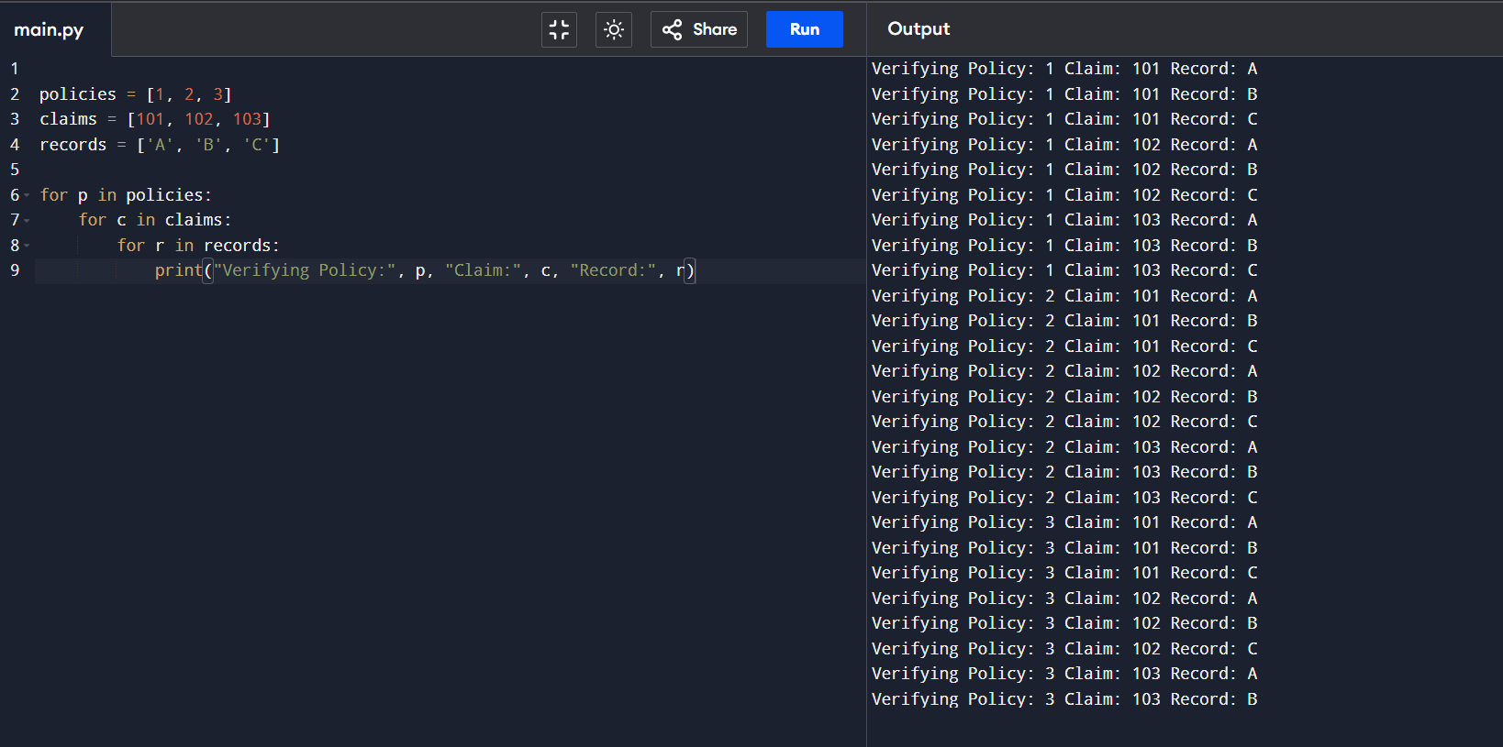

Conclusion
The insurance claim verification system using triple nested loops demonstrates cubic time complexity O(n³). This results in a rapid increase in execution time as input size grows. While the method ensures complete and accurate verification, it is inefficient for large-scale applications. The space complexity remains O(1) since no additional memory is required. This example highlights the importance of optimizing nested loops in practical systems to improve performance and scalability.

