NAME: SUVETHA C
REG NO: 192421088

Scenario-Based Requirement Analysis
Intelligent Smart Prison Monitoring and Inmate Management Platform

1. Study and Analyze the Scenario
Business Domain
The system belongs to the Correctional Facility Management / Public Safety Domain.
Stakeholders
- Prison Administrators
- Correctional Officers
- Inmates
- Visitors
- Government Authorities
- Emergency Response Teams
- IT Administrators
Existing Challenges
- Manual monitoring and paper-based records
- Lack of real-time visibility
- Delayed response to incidents
- Inefficient visitor and inmate tracking
- High workload on correctional officers
- No intelligent surveillance (only CCTV recording)
System Objectives
- Provide real-time monitoring of inmates and staff
- Detect abnormal behavior using AI
- Automate administrative tasks
- Improve security and reduce risks
- Enable predictive analysis for threats

2. Functional and Non-Functional Requirements
Functional Requirements
- Monitor inmate movement using RFID/GPS
- Detect unauthorized access and restricted-area violations
- AI-based video surveillance for abnormal behavior
- Automated inmate attendance (roll call)
- Visitor registration and tracking
- Biometric authentication system
- Alert and notification system (SMS, email, app)
- Staff tracking and duty management
- Report generation and audit logs
- Medical and rehabilitation scheduling
Non-Functional Requirements
Performance
- Real-time data processing with minimal delay
Security
- Role-based access control
- Data encryption
Reliability
- Continuous monitoring without failure
Usability
- Easy-to-use dashboard and mobile interface
Scalability
- Support multiple prison facilities
Availability
- 24/7 system uptime

Maintainability
- Easy updates and system maintenance

3. Actors and Use Cases
Actors
Primary Actors
- Admin
- Correctional Officer
Secondary Actors
- Visitor
- Inmate
- Emergency Team
Use Cases
Actor | Use Cases
Admin | Manage inmates, generate reports, monitor system
Officer | Track inmates, respond to alerts
Visitor | Register, check-in/out
System | Detect threats, send alerts
Emergency Team | Handle incidents

Use Case Diagram
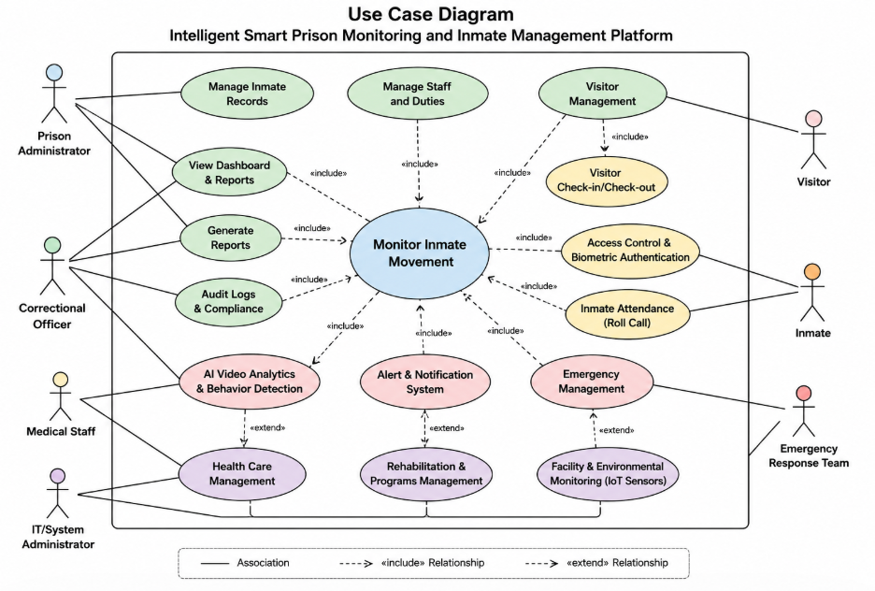
4. Software Requirement Specification (SRS)
Introduction
This system provides an intelligent solution for prison monitoring using AI, IoT, and automation.
Problem Description
Traditional prison systems lack automation and real-time intelligence, leading to security risks and inefficiency.
Scope
The system covers monitoring, tracking, alerting, and administrative automation across multiple facilities.
Functional Requirements
(Already listed above)
Non-Functional Requirements
(Already listed above)
Use Case Descriptions
Use Case 1: Monitor Inmate
- Actor: Officer
- Description: Tracks inmate location
- Result: Detects unauthorized movement
Use Case 2: Visitor Management
- Actor: Admin
- Description: Registers visitor details
- Result: Secure entry
Use Case 3: Alert System
- Actor: System
- Description: Sends alerts during incidents
- Result: Quick response
Data Requirements
- Inmate: ID, Name, Cell, Risk Level
- Staff: ID, Role, Shift
- Visitor: ID, Entry/Exit Time
- Alert: ID, Type, Status
External Interface Requirements
- User Interface: Dashboard, Mobile App
- Hardware: RFID, Cameras, Biometrics
- Software: Cloud database, AI engine
System Features
- Real-time monitoring
- AI-based predictions
- Automated alerts
- Centralized control system
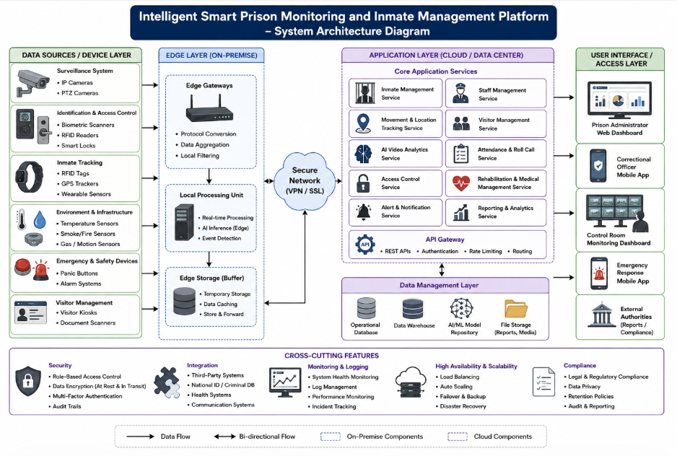

5. Assumptions and Constraints
Assumptions
- IoT devices are available
- Stable internet connectivity
- Staff are trained
Constraints
Technical
- Dependence on hardware and network
Operational
- Requires staff adaptation
Economic
- High initial cost
Legal
- Must follow data privacy laws
Time
- Limited development time

6. Validation of Requirements
Completeness
All stakeholders and system functionalities are covered.
Consistency
Requirements are logically structured and non-conflicting.
Issues Identified
- Possible dependency on network reliability
- Need for accurate AI models
Suggested Improvements
- Improve AI accuracy with training data
- Add backup systems for failure handling
- Enhance UI for better usability
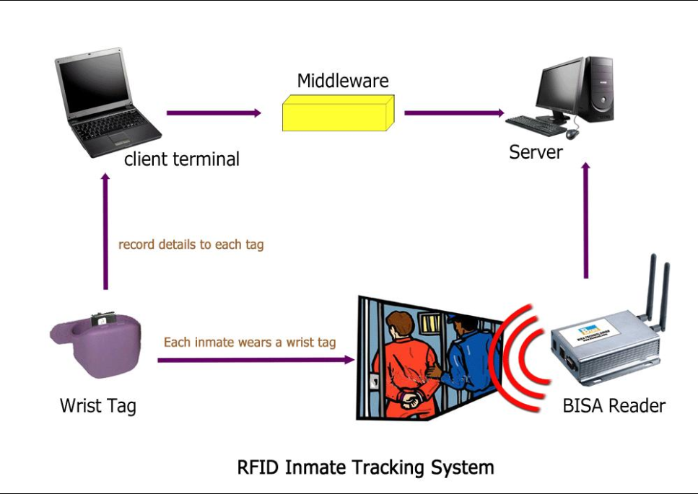
Conclusion
The proposed system provides a smart, automated, and secure solution for prison management by integrating modern technologies, improving safety, efficiency, and decision-making.

