NAME: SUVETHA C
REG NO: 192421088

Architecture Design Report
Intelligent Smart Prison Monitoring & Inmate Management Platform

1. Analyze System Requirements
The main objective of the Intelligent Smart Prison Monitoring and Inmate Management Platform is to ensure continuous real-time monitoring of inmates, staff, and visitors within a correctional facility while maintaining high security and operational efficiency. The system is designed to track inmate movement using technologies such as RFID, GPS, and wearable sensors, and to monitor activities through AI-powered video surveillance. It also aims to detect unauthorized access to restricted areas, identify abnormal behavior, and generate immediate alerts during emergency situations such as escape attempts, violence, or security violations. In addition, the system automates routine tasks including inmate attendance, visitor management, staff scheduling, and report generation, thereby reducing manual workload and improving accuracy.
From a functional perspective, the system must be capable of collecting real-time data from multiple sources such as cameras, biometric devices, RFID readers, and environmental sensors. It should process this data to detect patterns, generate alerts, and provide actionable insights to prison authorities. Non-functional requirements include high scalability to support multiple prison facilities, strong security mechanisms such as encryption and role-based access control, high availability to ensure continuous system operation, and fast performance for real-time decision-making. The system must also be reliable and maintainable to ensure long-term usability and easy updates.

2. Software Architecture Selection
For this system, a Hybrid Architecture combining Microservices Architecture and Event-Driven Architecture is selected. This approach is suitable because the system needs to handle continuous real-time data streams from multiple devices and respond instantly to critical events. Microservices architecture divides the system into smaller independent services such as inmate monitoring, visitor management, alert handling, and AI analytics, allowing each service to be developed, deployed, and scaled independently. Event-driven architecture enables real-time communication between components by using events, ensuring that the system can quickly respond to incidents like unauthorized movement or emergencies.
This combination provides flexibility, scalability, and efficiency, making it ideal for a distributed and data-intensive environment like a smart prison monitoring system.

3. Software Architecture Diagram
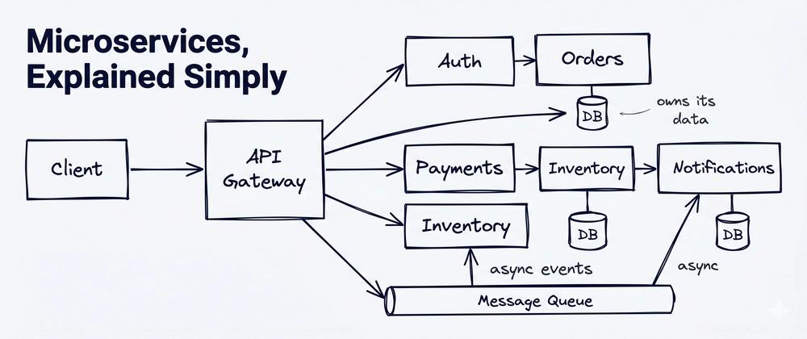
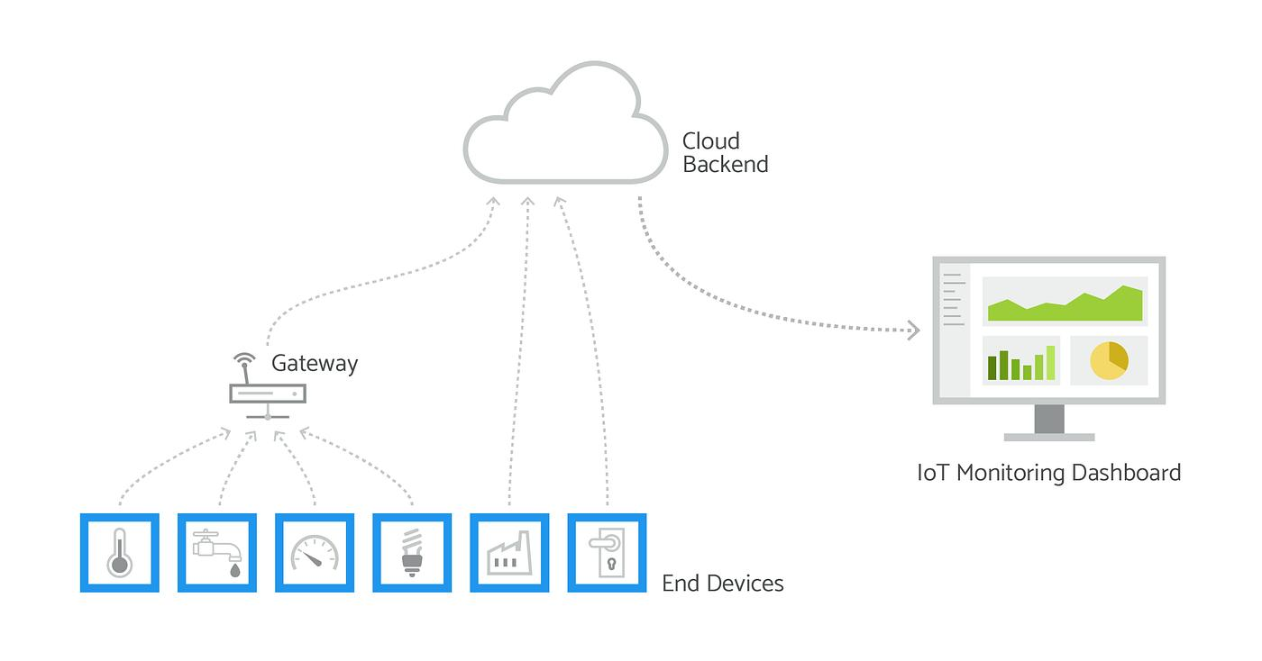
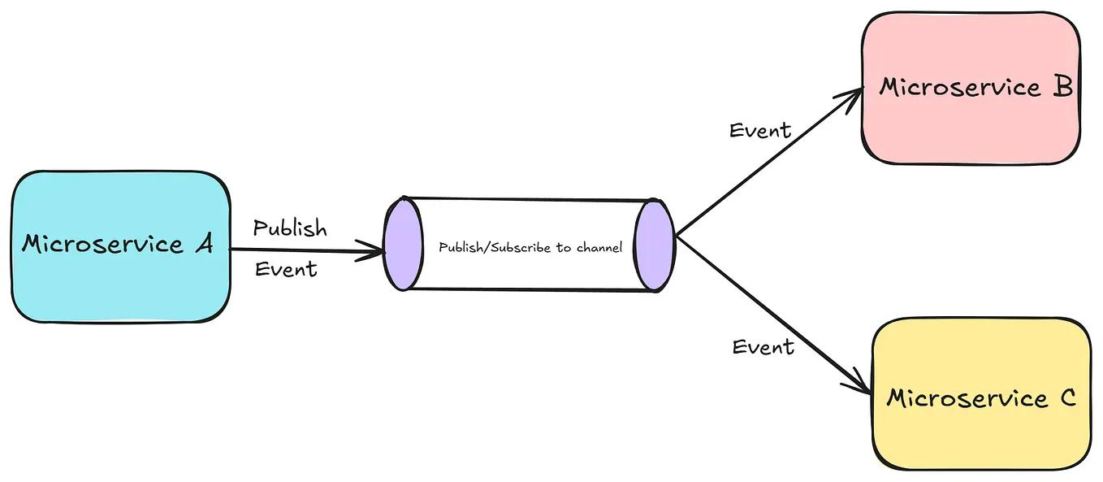
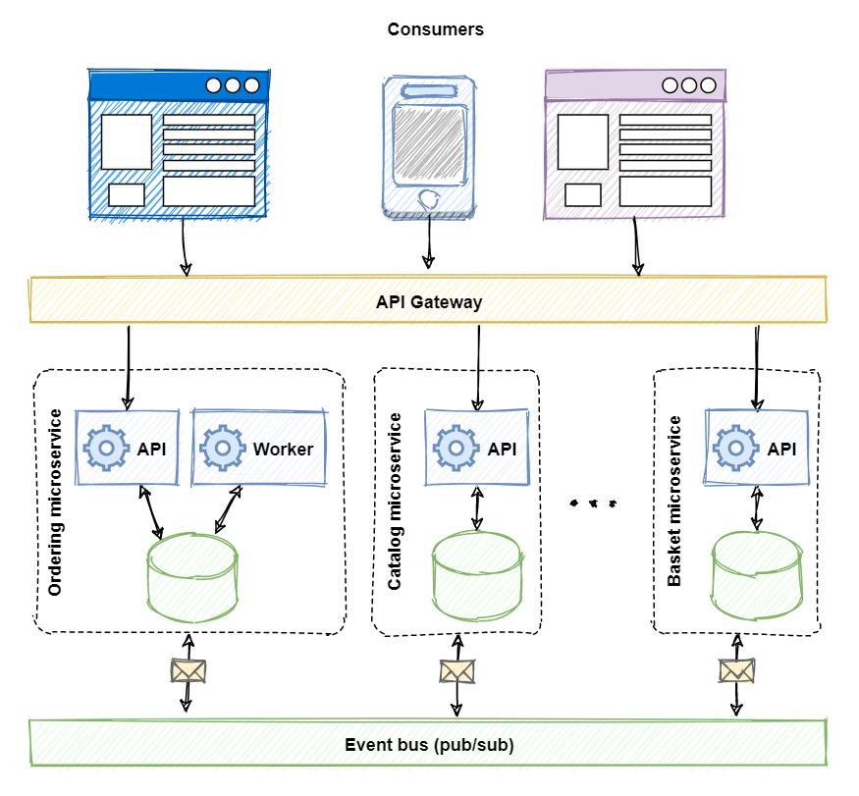
The architecture diagram represents multiple layers including the device layer, application layer, event processing layer, and data layer. The device layer consists of IoT devices such as RFID tags, cameras, biometric scanners, and sensors that continuously collect data. This data is transmitted to the application layer through secure communication networks. The application layer contains various microservices responsible for monitoring, alert generation, visitor management, and analytics. The event processing layer handles real-time data flow using message queues, ensuring that events are processed efficiently. Finally, the data layer stores all information in cloud databases and maintains logs for future analysis.

4. Components and Their Interactions
The system is composed of several key components that work together to ensure smooth operation. IoT devices such as RFID readers, cameras, and sensors continuously capture data related to inmate movement, environmental conditions, and facility activities. This data is sent to an API gateway, which acts as an entry point and routes the data to appropriate microservices. Each microservice performs a specific function, such as analyzing video data, tracking inmate location, managing visitor information, or generating alerts.
The event bus or message queue plays a crucial role in enabling communication between services by transmitting events in real time. When an abnormal activity is detected, the AI analytics service processes the data and triggers an alert. The alert service then sends notifications to prison authorities through dashboards, mobile applications, SMS, or email. All data is stored in a centralized cloud database, ensuring that records are maintained for reporting and auditing purposes. This interaction flow ensures that the system operates efficiently and responds quickly to critical situations.

5. Quality Attributes
The proposed architecture effectively satisfies important quality attributes required for the system. Scalability is achieved through microservices, allowing individual components to scale independently based on demand. Security is ensured through the use of biometric authentication, encryption, and role-based access control, protecting sensitive data and preventing unauthorized access. Performance is enhanced by the event-driven approach, which enables real-time processing and quick response to incidents.
Reliability is maintained by isolating failures within individual services, ensuring that the entire system does not crash if one component fails. Maintainability is improved due to the modular design, making it easier to update or modify specific services without affecting the whole system. Availability is ensured through cloud deployment, which provides continuous operation and minimizes downtime.

6. Justification of Architectural Decisions
The selection of a hybrid architecture combining microservices and event-driven design is justified by the system’s need for real-time monitoring, scalability, and flexibility. This architecture allows the system to efficiently handle large volumes of data generated by IoT devices while ensuring quick response times for critical events. Although this approach increases system complexity and development cost, the benefits of scalability, performance, and maintainability outweigh these challenges.
The architecture also supports future enhancements such as integration of advanced AI models, facial recognition systems, and additional IoT devices. It enables easy integration with external systems and ensures long-term sustainability. Therefore, the chosen architecture is highly suitable for building a robust and intelligent prison monitoring system.

Conclusion
In conclusion, the Intelligent Smart Prison Monitoring and Inmate Management Platform uses a modern hybrid architecture to provide a secure, scalable, and efficient solution for managing correctional facilities. By integrating IoT, AI, and cloud technologies, the system enhances security, improves operational efficiency, and enables proactive decision-making, making it an effective solution for modern prison management.

