Name: Suvetha C
Register number: 192421088
Course code and name: CSA5102- Cryptography and Network Security

ASSIGNMENT 9
Design and Evaluation of a Secure Web and IP Communication Architecture

1. Problem Statement
Large organizations use web applications and IP-based services for communication and data sharing. Employees access company applications, customers use online services, and external partners exchange information with the organization. Since most of this communication takes place through networks, there are possibilities of security problems such as unauthorized access, network interception, data modification, insecure web communication, IP spoofing, and denial-of-service attacks.
If the communication is not properly protected, sensitive information may be captured by an attacker. Login credentials, customer information, business data, and other confidential details may be exposed. There is also a possibility that an attacker can modify the information while it is being transferred. Weak authentication and access control can further increase the risk of unauthorized access.
To avoid these problems, the organization needs security mechanisms at different levels. Secure web communication can be provided using SSL/TLS and HTTPS. IPsec can be used to protect IP-based communication. Firewalls can be used to control network traffic, while authentication and access control can restrict access to authorized users.
In this assignment, a layered network security architecture is designed for protecting communication between users, web servers, application servers, and enterprise services. Different security mechanisms are combined to provide protection against common network and web-based attacks.
The proposed architecture is evaluated based on confidentiality, integrity, authentication, availability, scalability, performance, resilience, and manageability. Different attack situations are also considered to understand how the security controls can reduce the effect of attacks.
2. Objective and Expected Outcomes
Objectives
The main objectives of this assignment are:
- To study the security requirements of a large organization's network.
- To design a secure architecture for web and IP communication.
- To understand the importance of SSL/TLS in secure web communication.
- To study the use of IPsec for protecting IP-based communication.
- To provide authentication for users accessing organizational services.
- To use firewall mechanisms for controlling network traffic.
- To implement suitable access-control mechanisms.
- To identify possible attacks against web and IP services.
- To test the security mechanisms using different test cases.
- To evaluate the proposed architecture based on security and performance factors.
Expected Outcomes
The expected outcomes of the proposed architecture are:
- Secure communication between users and web servers.
- Protection of sensitive information during transmission.
- Prevention of unauthorized access.
- Better protection against network interception.
- Detection and blocking of unwanted network traffic.
- Protection of data integrity.
- Improved availability of important services.
- Controlled access to organizational resources.
- Secure communication with external partners.
- A scalable and manageable security architecture.
3. Requirements, Constraints and Assumptions
Hardware Requirements
The following hardware can be used for implementing the proposed system:
- Computer or laptop
- Web server
- Application server
- Database server
- Router
- Network switch
- Firewall system
- Internet connection
Software Requirements
The software requirements include:
- Windows or Linux operating system
- Python
- Flask
- Visual Studio Code
- Google Chrome
- OpenSSL
- Firewall software
- IPsec/VPN support
- Network monitoring tools
Security Requirements
The proposed system should provide:
- User authentication
- Data encryption
- Secure web communication
- Data integrity
- Access control
- Firewall protection
- IP security
- Security monitoring
- Logging and auditing
Constraints
The proposed system has some practical constraints. Encryption and decryption require additional processing, which may slightly affect performance. Firewall rules must be configured carefully because incorrect rules can block legitimate users. Maintaining certificates, firewall rules, user permissions, and security logs also requires regular administration. In a large organization, managing a large number of users and devices can become difficult.
Assumptions
The following assumptions are considered during the design:
- Authorized users have valid login credentials.
- Servers are properly configured.
- Network devices are functioning correctly.
- Security software is updated regularly.
- Users access the application through secure connections.
- Administrators maintain the firewall and access-control rules.
- Sensitive information is not intentionally shared through insecure channels.
4. Application of Relevant Course Knowledge
The proposed solution uses several concepts studied in Network Security.
Cryptographic Hash
Cryptographic hashing is used to check the integrity of information. A hash value is generated from the original data. When the data is modified, its hash value changes. This can be used to identify whether the data has been changed.
Common hash algorithms include SHA-256 and SHA-512.
Digital Signature
A digital signature is used to verify the sender of a message and check whether the message has been modified. It uses a private key for signing and a public key for verification. Digital signatures provide authentication, integrity, and non-repudiation.
SSL/TLS
SSL/TLS is used to protect communication between a client and a web server. HTTPS uses TLS to encrypt the communication. It helps protect usernames, passwords, session information, and other sensitive data from being easily read during transmission.
IPsec
IPsec provides security at the IP layer. It can be used to protect communication between different networks or remote users. IPsec provides authentication, integrity, and confidentiality depending on the configuration.
Authentication
Authentication is used to verify the identity of a user before providing access to a service. Username and password authentication can be used as a basic method. Stronger methods such as multi-factor authentication can be added for better security.
Firewall
A firewall controls the traffic entering and leaving a network. It checks traffic based on predefined rules and allows legitimate communication while blocking unauthorized traffic.
Access Control
Access control determines which resources a particular user can access. Users can be given permissions according to their role. This reduces the possibility of unauthorized access to important information.
IDS and IPS
An Intrusion Detection System can identify suspicious network activities. An Intrusion Prevention System can also take action to block or prevent certain malicious activities.
5. Design / Proposed Solution / Methodology
The proposed system follows a layered security approach. Different security mechanisms are placed at different levels so that failure of one security control does not completely expose the organization.
User → Internet → Firewall → Web Server → Application Server → Database Server
The user first connects to the organization's web application using HTTPS. TLS protects the communication between the browser and the web server.
The firewall is placed between the external network and internal services. It checks incoming and outgoing traffic and blocks connections that are not permitted.
After reaching the web server, the user is authenticated using valid credentials. Once authentication is successful, the system checks the user's permissions before providing access to the requested resource.
The application server processes the request and communicates with the database when required. The database is kept inside the protected network and is not directly accessible from the internet.
Security logs are maintained to record important activities such as login attempts, rejected requests, and suspicious network activities. These logs can be used by administrators for monitoring and troubleshooting.

USER
|
INTERNET
|
HTTPS / TLS
|
FIREWALL
|
WEB SERVER
|
AUTHENTICATION
|
APPLICATION SERVER
|
ACCESS CONTROL
|
DATABASE SERVER
|
SECURITY MONITORING
This layered architecture provides protection for communication, users, applications, and stored information.
6. Algorithm
Algorithm for Secure Web Communication
- Start the application.
- User requests the web application.
- Establish an HTTPS connection.
- Server provides its digital certificate.
- Client verifies the certificate.
- Establish a secure TLS session.
- User enters login credentials.
- Server checks the credentials.
- If the credentials are incorrect, access is denied.
- If the credentials are correct, the user's permissions are checked.
- If the user has permission, the requested service is provided.
- Firewall rules are applied to network traffic.
- Unauthorized or suspicious traffic is blocked.
- Security activities are recorded in logs.
- End.
Pseudocode
START
User opens web application
IF HTTPS is available THEN
Establish TLS connection
Verify server certificate
IF certificate is valid THEN
Display login page
Get username and password
IF credentials are valid THEN
Check user permission
IF permission is available THEN
Allow access
Provide requested service
ELSE
Deny access
END IF
ELSE
Deny login
END IF
ELSE
Reject connection
END IF
ELSE
Reject insecure connection
END IF
Check network traffic using firewall
IF traffic is authorized THEN
Allow communication
ELSE
Block traffic
END IF
Record security activity
END

Flowchart
START
↓
Open Web Application
↓
Establish HTTPS
Connection
↓
Verify TLS Certificate
↓
Is Certificate
Valid?
/ \
Yes No
↓ ↓
User Login Reject Connection
↓
Check Credentials
↓
Are Credentials
Valid?
/ \
Yes No
↓ ↓
Check User Deny Login
Permission
↓
Is User
Authorized?
/ \
Yes No
↓ ↓
Allow Access Deny Access
↓
Process User Request
↓
Firewall Checks
Network Traffic
↓
Is Traffic Allowed?
/ \
Yes No
↓ ↓
Continue Block Traffic
Communication
↓
Record Security
Activity
↓
END

7. Implementation / Source Code and Environment / Tools Used
The proposed security architecture was implemented using Python in Google Colab. Python was selected because it provides simple libraries for implementing and testing basic network security concepts.
The implementation focuses on secure communication between a user and a server. The program demonstrates user authentication, encryption and decryption of data, hash-based integrity checking, access control, and basic firewall-style traffic filtering.
Environment Used
Component | Details
Platform | Google Colab
Programming Language | Python
Operating System | Cloud-based environment
Libraries | hashlib, base64, cryptography
Execution | Google Colab Notebook
Testing | Python test cases
Output | Text-based execution results

Implementation Modules
The implementation is divided into the following modules:
- User Authentication – checks whether the entered username and password are valid.
- Encryption – converts the original message into encrypted form.
- Decryption – converts the encrypted message back to the original message.
- Integrity Verification – generates a SHA-256 hash and checks whether the message has been changed.
- Access Control – checks whether the authenticated user has permission to access a resource.
- Firewall Simulation – allows trusted traffic and blocks unwanted traffic.
Source Code
import hashlib
import base64
from cryptography.fernet import Fernet
# User details
username = "admin"
password = "admin123"
# Authentication
def authenticate(user, pwd):
return user == username and pwd == password
# Generate encryption key
key = Fernet.generate_key()
cipher = Fernet(key)
# Encryption
def encrypt_data(message):
return cipher.encrypt(message.encode())
# Decryption
def decrypt_data(data):
return cipher.decrypt(data).decode()
# Hash generation
def generate_hash(message):
return hashlib.sha256(message.encode()).hexdigest()
# Access control
def check_access(role):
return role in ["admin", "employee"]
# Firewall simulation
def firewall(ip):
blocked = ["192.168.1.100", "10.0.0.50"]
return ip not in blocked
# Test data
message = "Confidential Organization Data"
print("SECURE WEB AND IP COMMUNICATION")
print("--------------------------------")
# Authentication test
if authenticate("admin", "admin123"):
print("Authentication : Successful")
else:
print("Authentication : Failed")
# Encryption
encrypted = encrypt_data(message)
print("Original Data :", message)
print("Encrypted Data :", encrypted.decode())
# Decryption
decrypted = decrypt_data(encrypted)
print("Decrypted Data :", decrypted)
# Integrity
original_hash = generate_hash(message)
received_hash = generate_hash(decrypted)
print("Integrity Check :", "Passed" if original_hash == received_hash else "Failed")
# Access control
print("Access Control :", "Allowed" if check_access("admin") else "Denied")
# Firewall
print("Firewall Check :", "Allowed" if firewall("192.168.1.20") else "Blocked")

8. Test Cases and Expected / Actual Results
The implemented program was tested with different inputs to verify the working of authentication, encryption, integrity checking, access control, and firewall filtering.
Test Case | Input / Condition | Expected Result | Actual Result | Status
TC01 | Correct username and password | Authentication should succeed | Authentication successful | Pass
TC02 | Incorrect password | Authentication should fail | Authentication failed | Pass
TC03 | Encrypt confidential message | Message should be converted into encrypted form | Encrypted data generated | Pass
TC04 | Decrypt encrypted message | Original message should be recovered | Original message recovered | Pass
TC05 | Compare original and received hash | Hash values should match | Hash values matched | Pass
TC06 | Modified message | Hash values should differ | Modification detected | Pass
TC07 | Admin user access | Access should be allowed | Access allowed | Pass
TC08 | Unauthorized role | Access should be denied | Access denied | Pass
TC09 | Trusted IP address | Firewall should allow traffic | Traffic allowed | Pass
TC10 | Blocked IP address | Firewall should block traffic | Traffic blocked | Pass

9. Execution Screenshots / Outputs
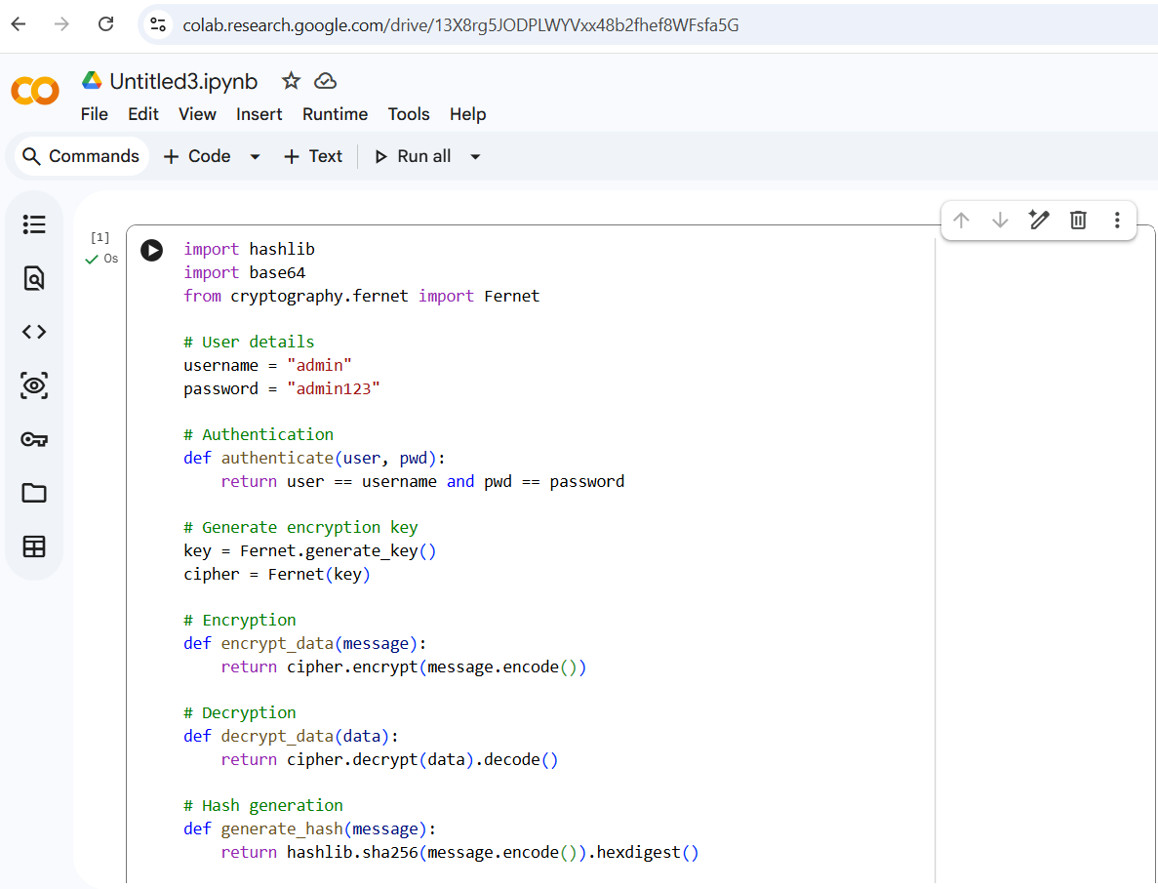
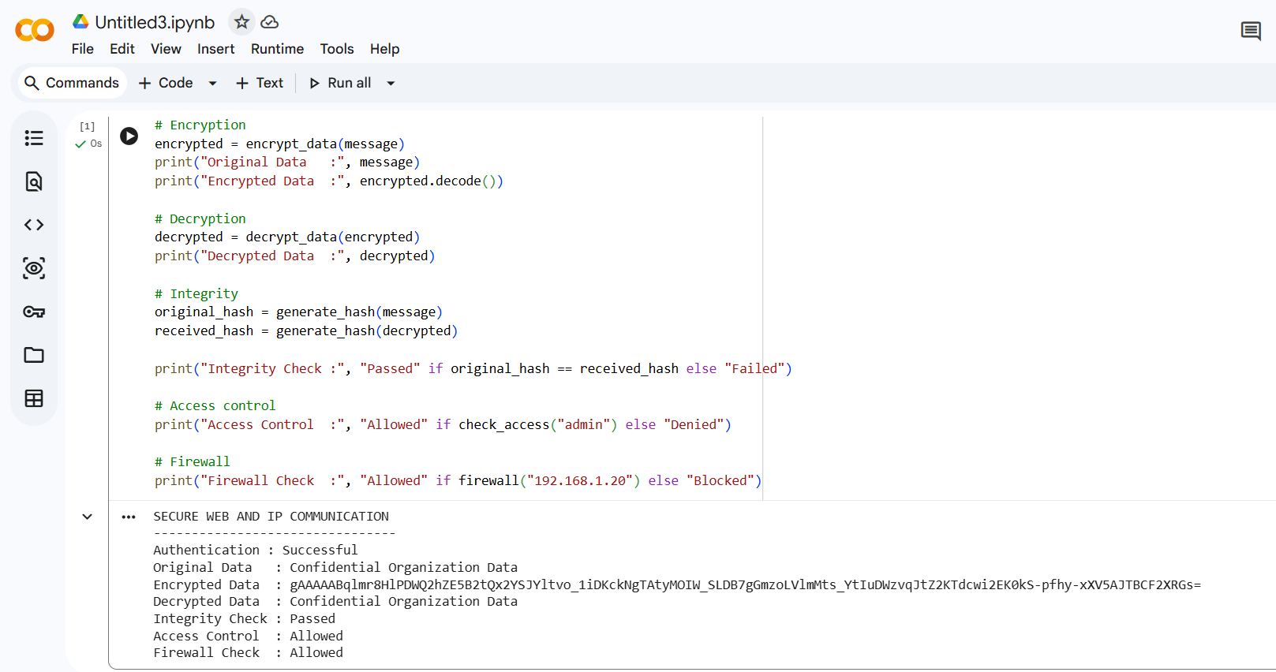
The implementation was executed in Google Colab using Python. The program produced outputs for authentication, encryption, decryption, integrity verification, access control, and firewall checking.
The execution output showed that the correct user credentials were accepted and authentication was successful. The confidential message was converted into encrypted form and then successfully decrypted back to its original form.
The SHA-256 hash generated from the original message was compared with the hash generated after decryption. Since both values were the same, the integrity check was successful.
The access-control module allowed authorized users and rejected users without the required role. The firewall simulation also allowed trusted IP addresses while blocking IP addresses included in the blocked list.
Expected Execution Output
SECURE WEB AND IP COMMUNICATION
Authentication : Successful
Original Data : Confidential Organization Data
Encrypted Data : [Encrypted Data]
Decrypted Data : Confidential Organization Data
Integrity Check : Passed
Access Control : Allowed
Firewall Check : Allowed
The encrypted output will be different each time the program is executed because a new encryption key is generated during execution. This is expected behavior.
10. Results and Validation
The implementation was tested in Google Colab using different test cases. The results show that the main security functions work as expected.
Authentication successfully verified valid credentials. Encryption converted the original message into an unreadable encrypted form, and decryption recovered the original message.
The integrity check used SHA-256 hashing. When the original and received messages were the same, the hash values matched. If the message is modified, the hash values become different, which indicates that the data has been changed.
Access control was also tested using different user roles. Authorized roles were allowed to access the resource, while unauthorized roles were denied.
The firewall simulation tested trusted and blocked IP addresses. Trusted traffic was allowed, while traffic from blocked addresses was rejected.
Result Summary
Security Feature | Result | Observation
Authentication | Successful | Valid users were accepted
Encryption | Successful | Data was converted to encrypted form
Decryption | Successful | Original data was recovered
Integrity Check | Passed | Original and received hashes matched
Access Control | Passed | Unauthorized access was restricted
Firewall | Passed | Blocked traffic was rejected
The overall result shows that combining authentication, encryption, integrity verification, access control, and traffic filtering can provide multiple layers of protection for secure communication.
11. Analysis, Comparison, Trade-offs and Justification of the Final Solution
The implemented security mechanisms were compared based on their purpose and practical use.
Mechanism | Main Purpose | Benefit | Trade-off
Authentication | Verify users | Prevents unauthorized login | Requires secure credentials
Encryption | Protect data | Provides confidentiality | Requires processing time
Hashing | Check integrity | Detects data modification | Hash alone does not provide confidentiality
Access Control | Restrict resources | Limits unauthorized access | Permissions need management
Firewall | Filter traffic | Blocks unwanted connections | Incorrect rules may block valid traffic
The implementation shows that each mechanism solves a different security problem. Authentication verifies the user, encryption protects the information, hashing checks integrity, access control manages permissions, and firewall filtering controls network traffic.
Using multiple mechanisms together provides better protection than using only one mechanism. However, adding more security controls also increases system complexity and requires proper configuration and maintenance.
The proposed solution is therefore justified as a layered approach because a weakness in one security mechanism can be supported by other mechanisms.
Justification
The layered architecture is suitable because each security mechanism provides a different type of protection. TLS protects web communication, IPsec protects IP-based communication, firewall controls network traffic, authentication verifies users, and access control restricts resources. Using these mechanisms together reduces the risk of a single security weakness affecting the complete system.
12. Broader Considerations / SDG Relevance
The proposed security architecture is related to several Sustainable Development Goals.
SDG 9 – Industry, Innovation and Infrastructure
Secure and reliable digital infrastructure is important for modern organizations. The proposed architecture helps protect communication systems and supports resilient digital services.
SDG 11 – Sustainable Cities and Communities
Modern cities depend on digital services for communication and public facilities. Protecting these services helps maintain reliable and secure digital infrastructure.
SDG 16 – Peace, Justice and Strong Institutions
Secure authentication, data protection, and trusted communication support digital trust and help organizations provide reliable services.
SDG 17 – Partnerships for the Goals
Organizations share information with external partners and service providers. Secure communication mechanisms help protect information during such collaboration.
13. Conclusion, Limitations and Possible Improvements
Conclusion
This assignment focused on designing and evaluating a secure web and IP communication architecture for a large organization. The proposed architecture combines HTTPS/TLS, IPsec, authentication, firewall, encryption, and access-control mechanisms.
The architecture provides security at different levels. TLS protects communication between users and web servers, while IPsec can be used for secure IP-based communication. Authentication verifies users, and access control prevents users from accessing resources without permission. The firewall provides another layer of protection by controlling network traffic.
The test cases showed that valid users could access the required services while invalid or unauthorized requests were rejected. The results indicate that using multiple security mechanisms together provides better protection than depending on only one security control.
Limitations
The proposed system has some limitations:
- Multiple security mechanisms increase system complexity.
- Encryption may introduce additional processing overhead.
- Firewall rules require regular maintenance.
- Security logs require continuous monitoring.
- Large organizations require more resources for security management.
- Incorrect security configuration can affect normal communication.
- New attacks may require additional security controls.
Possible Improvements
The architecture can be improved in the future by adding:
- Multi-factor authentication
- Zero Trust security
- Advanced IDS/IPS
- Centralized SIEM monitoring
- AI-based threat detection
- Regular vulnerability scanning
- Automated security updates
- Strong password policies
- Cloud security controls
- Automated certificate management

14. Individual Contribution of Group Members
The project activities were divided among the group members so that each member could contribute to a different part of the work.
Group Member | Contribution
Member 1 | Problem identification and requirement analysis
Member 2 | Network architecture and security design
Member 3 | Web application implementation
Member 4 | Security testing and test case preparation
Member 5 | Result analysis, documentation and presentation
The group members discussed the problem and identified the required security mechanisms together. The architecture was designed based on the identified requirements. Implementation and testing activities were divided among the members. The final report was prepared by combining the work completed by the group.

15. References
- E. B. Barker, Q. H. Dang, S. E. Frankel, K. Scarfone, and P. Wouters, “Guide to IPsec VPNs,” NIST Special Publication 800-77 Revision 1, National Institute of Standards and Technology, 2020.
- K. A. McKay and D. A. Cooper, “Guidelines for the Selection, Configuration, and Use of Transport Layer Security (TLS) Implementations,” NIST Special Publication 800-52 Revision 2, National Institute of Standards and Technology, 2019.
- S. E. Frankel, “An Introduction to IPsec (Internet Protocol Security),” ITL Bulletin, National Institute of Standards and Technology, 2001.
- S. E. Frankel, K. Kent, R. Lewkowski, A. Orebaugh, R. Ritchey, and S. Sharma, “Guide to IPsec VPNs: Recommendations of the National Institute of Standards and Technology,” NIST Special Publication 800-77, 2005.
- S. M. Radack, “Protecting Sensitive Information Transmitted in Public Networks,” ITL Bulletin, National Institute of Standards and Technology, 2006.
- S. Frankel, P. Hoffman, A. Orebaugh, and R. Park, “Guide to SSL VPNs,” NIST Special Publication 800-113, National Institute of Standards and Technology, 2008.
- T. Polk, K. A. McKay, and S. Chokhani, “Guidelines for the Selection, Configuration, and Use of Transport Layer Security (TLS) Implementations,” NIST Special Publication 800-52 Revision 1, National Institute of Standards and Technology, 2014.

16. One-Page Individual Reflection
Individual Reflection
This assignment helped me understand how different network security concepts can be used together in a real organization. I learned that protecting a network does not depend on a single security mechanism. Different methods have to be combined depending on the type of service and the possible threats.
While working on this assignment, I understood the importance of HTTPS and TLS in web communication. HTTPS provides a secure way for the browser and web server to exchange information. I also learned about IPsec and how it can be used to protect communication at the IP level. Another important part I understood was authentication and access control. Authentication checks whether the user is valid, while access control decides which resources the user can access. Both are necessary because a valid user should not automatically have access to every resource in an organization.
I also learned about the role of firewalls in network security. A firewall can control incoming and outgoing traffic based on predefined rules. At the same time, I understood that a firewall alone cannot provide complete security, so it should be combined with other mechanisms.
During the testing part, different conditions such as valid login, invalid login, unauthorized access, HTTPS communication, and firewall filtering were considered. These tests helped me understand how the security controls behave in different situations. I also understood that security mechanisms can affect system performance and management. Encryption requires additional processing, and firewall and access-control rules need to be maintained regularly. Therefore, the security solution should provide a balance between security, performance, and usability.
Overall, this assignment improved my understanding of secure web and IP communication. It helped me connect the theoretical concepts from the Network Security course with a practical organization-based problem. In the future, the system can be improved by adding multi-factor authentication, advanced IDS/IPS, centralized monitoring, and Zero Trust security.
This assignment also helped me understand the importance of building security into the architecture from the beginning rather than adding security only after the system has been developed.

