1 INTRODUCTION

1.1 Overview

**Project Description:**

The banking industry world-wide is being transformed. The global forces for change include technological innovation; the deregulation of financial services at the national level and opening-up to international competition; and - equally important - changes in corporate behavior, such as growing disintermediation and increased emphasis on shareholder value. In addition, recent banking crises in Asia and Latin America have accentuated these pressures. The banking industries in central Europe and Latin America have also been transformed as a result of privatizations of state-owned banks that had dominated their banking systems in the past. In this project we are trying to analysis the bank related data and able to extract some insights from the data using Business Intelligence tools. To Extract the Insights from the data and put the data in the form of visualizations, Dashboards and Story we employed Tableau tool.

1.2 Purpose

* Tableau Publiclaunched in 2010 with a mission to make data more accessible and a part of everyday conversations. It quickly enabled anyone with public data to not only see and understand it for themselves but also share those insights with others around the world.

Get started with Tableau Public, a free online visual analytics platform that allows you to learn data skills, create and explore data visualizations, discover data stories, and create your own portfolio of work to share with your network.

2 **RESULT**

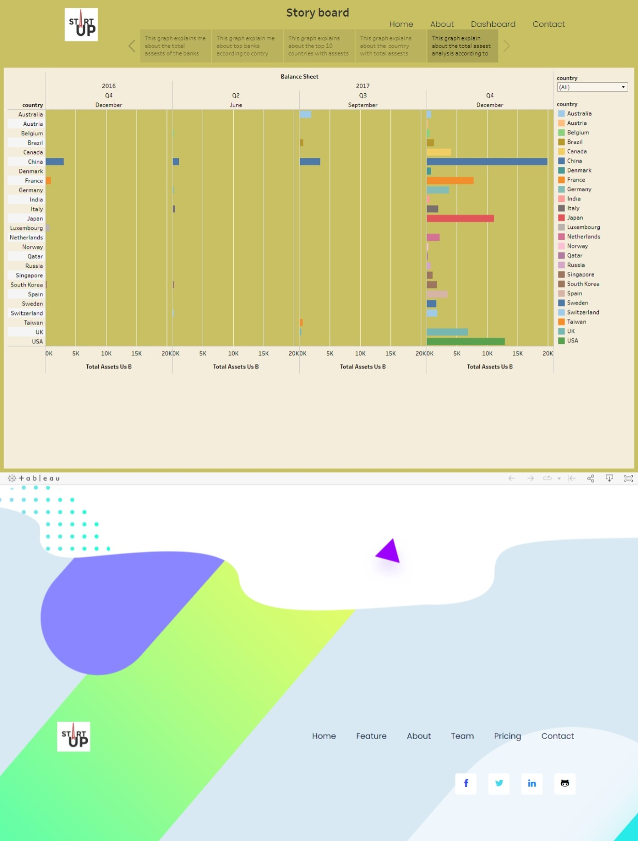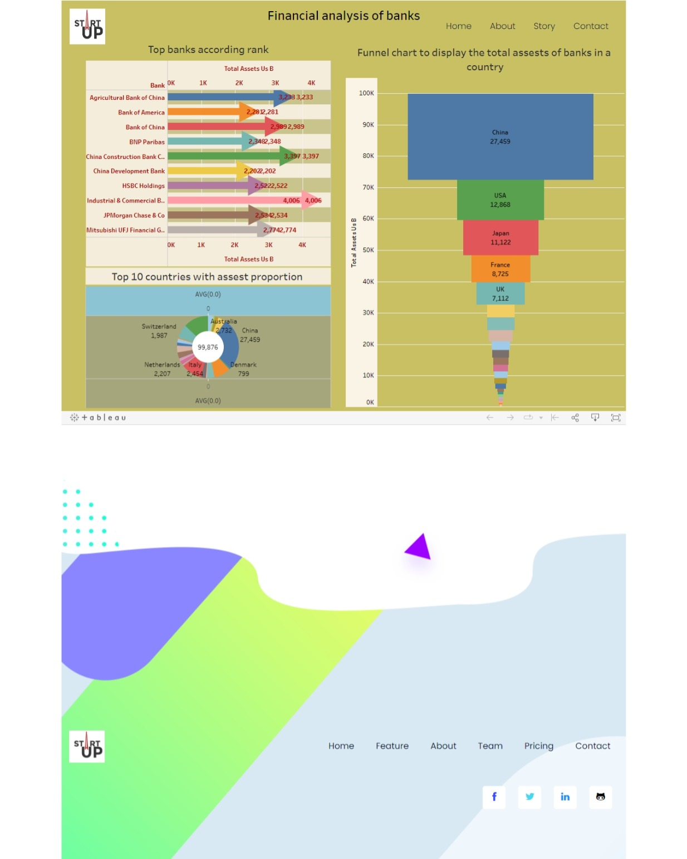

**3 ADVANTAGES & DISADVANTAGES**

**Advantages :**

* **Data Visualization:-** Tableau is a data visualization tool, and provides complex computation, data blending, and dashboarding for creating beautiful data visualizations.
* **Quickly Create Interactive Visualization:-** Users can create a very interactive visual by using drag n drop functionalities of Tableau.
* **Comfortable in Implementation:-** Many types of visualization options are available in Tableau, which enhances the user experience. Tableau is very easy to learn in comparison to Python. Who don't have any idea about coding, they also can quickly learn Tableau.
* **Tableau can Handle Large Amounts of Data:-** Tableau can easily handle millions of rows of data. A large amount of data can create different types of visualization without disturbing the performance of the dashboards. As well as, there is an option in Tableau where the user can make '**live**' to connect different data sources like SQL, etc.

**Disadvantages :**

* **Scheduling of Reports:-** Tableau does not provide the automatic schedule of reports. That's why there is always some manual effort required when the user needs to update the data in the back end.
* **No Custom Visual Imports:-** Other tools like Power BI, a developer can create custom visual that can be easily imported in Tableau, so any new visuals can recreate before imported, but Tableau is not a complete open tool.
* **Custom Formatting in Tableau:-** Tableau's conditional formatting, and limited 16 column table that is very inconvenient for users. Also, to implement the same format in multiple fields, there is no way for the user that they can do it for all fields directly. Users have to do that manually for each, so it is a very time-consuming.
* **Static and Single Value Parameter:-** Tableau parameters are static, and it always select a single value as a parameter. Whenever the data gets changed, these parameters also have to be updated manually every time. There is no other option for users that can automate the updating of parameters.

**4 APPLICATION**

**Introduction to Uses of Tableau**

Tableau is a powerful Data Visualization Tool which is often called as Data Analytics or Business intelligence (BI) Tool. Uses of Tableau contains a different set of processes such as visualization, exploration, and analysis of data and has different uses. Please find the below sections, where Tableau has been used widely and effectively.

**Tableau**

* Tableau is a Business Intelligence and [**Analytics Software**](https://www.educba.com/analytics-software/) which gives interactive data visualization views from the product. It was developed by a Software Development Company named Tableau where its’ headquarters is based in Seattle, Washington, United States. It was founded by Pat Hanrahan, Christian Chabot, Chris Stolte. It was founded in the year 2003.
* It is mainly focused on the purpose of Business Intelligence applications. Interactive dashboards can be created by users as per the required customized preference. Different kinds of data sources can be configured to this tool and can be connected. Real-time data can easily be analyzed using this tool. It has been in a top position in the area of [**Business Intelligence and Data Analytics**](https://www.educba.com/business-intelligence-vs-data-analytics/) stream.

**Top Uses of Tableau**

Below is the list of top uses of Tableau:

**1. It provides and fulfills different requirements of the organizational needs**

The different types of needs and requirements of the organizations can be fulfilled by Tableau by getting its data analyzed in very depth. The requirement of an organization can be based on the requirement of the client and applications of the product or program or an application.

**2. Data can be understood and analyzed well meaningfully**

The data from different data sources can easily be analyzed and report can be generated which can be easily understood at first sight. The data will be analyzed in different ways by extracting, loading and transforming. There are multiple methods, steps, and processes where the data can be processed and analyzed.

**3. Tableau gives greater visual dashboards easily**

The is another kind of process in which uses of Tableau performs the process of data analysis by reducing or summarizing the content or main and key important characteristics of the data sets into a non-redundant information. The visual dashboards in Tableau can give different kinds of representations such as Pictorial representations, Pie Charts, Bar Graphs, tabular or Graphical representations.

**4. Supports many Data Sources**

There are different kinds of data sources such as different types of data like Structured, Unstructured and Semi-Structured Data. The different data sources can be from multiple types of databases like Oracle, MySQL, IBM DB2, MS SQL, MongoDB, Cassandra, Virtual databases etc.,

**5. Supports multiple Database features**

Uses of Tableau supports multiple types of database features such as RDBMS, No SQL Databases, Object-oriented Databases, etc., where the data in Relational [**Database Management System**](https://www.educba.com/database-management-system/) has structured data and No SQL and object-oriented databases are having semi-structured and unstructured data such as JSON, text or document files, etc.,

**5 CONCLUSION**

Conclusion Tableau Public is an easy-to-use and free-to-access business intelligence tool. We have learned how to create a simple Tableau dashboard from scratch. However, it doesn’t stop here. Use your creative side to create visually appealing worksheets and dashboards.

6