**VRV Security’s Backend Developer**

**Intern Assignment**

* **First should be define roles in Role table .**

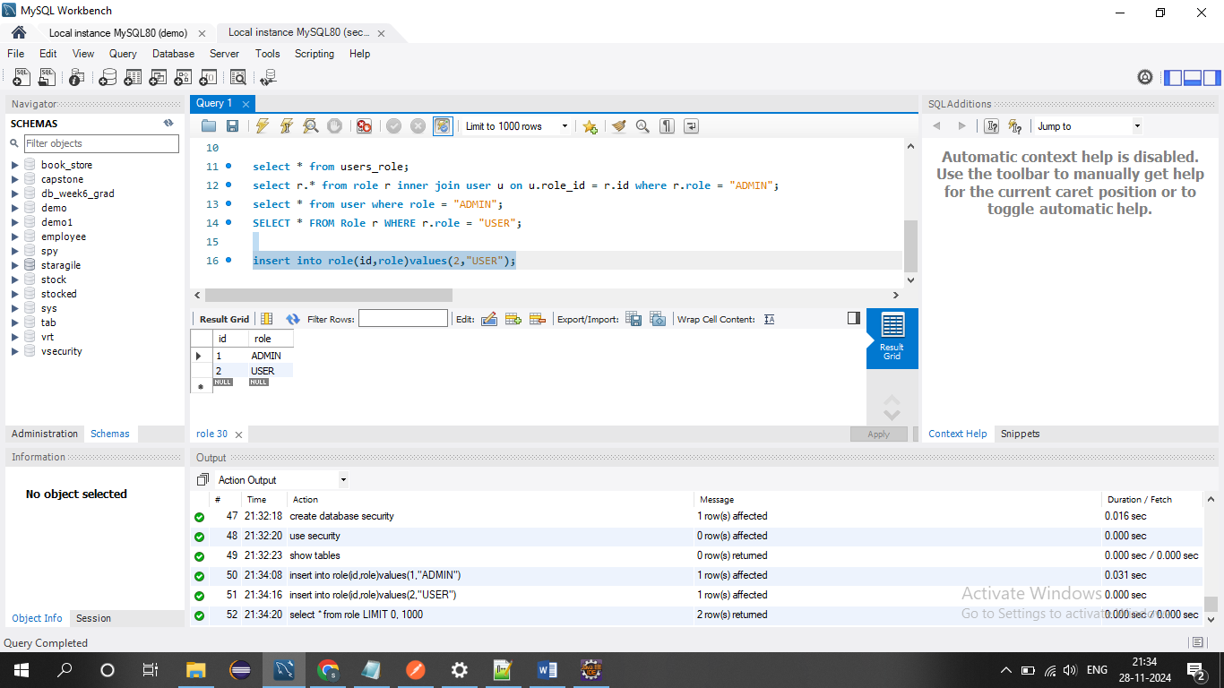

* **For registration: http://localhost:8089/registration**

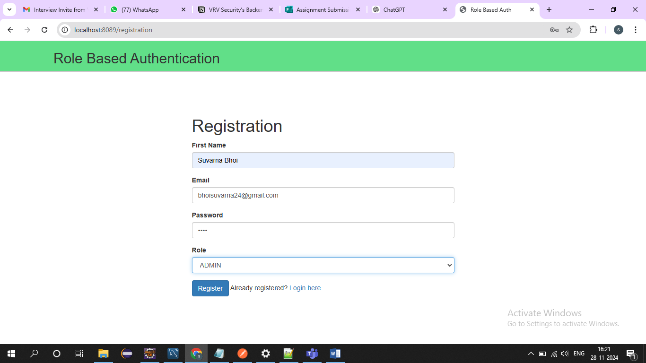

* **After successfully registration redirect on login page.**
* **http://localhost:8089/login**

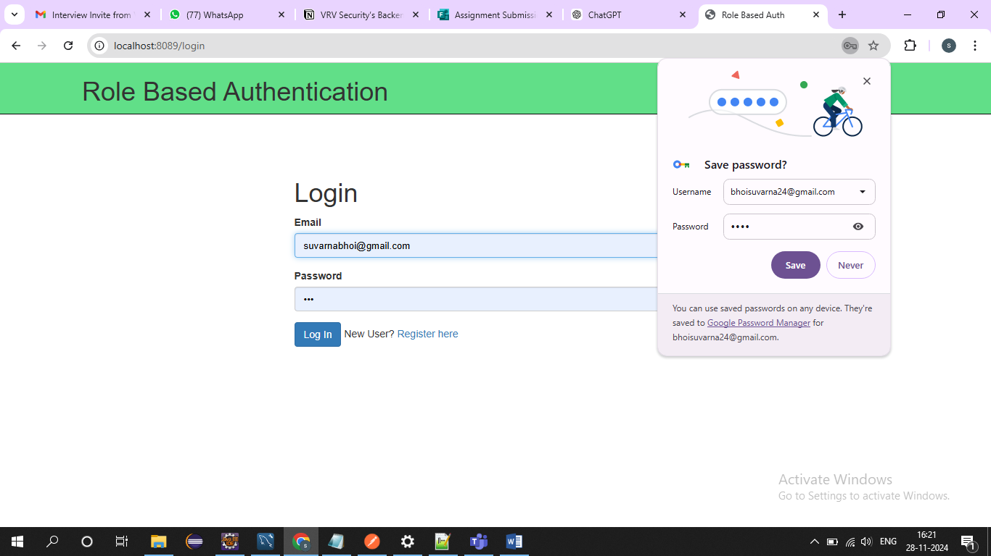

* **Data is stored in database after registration successfully.**
* 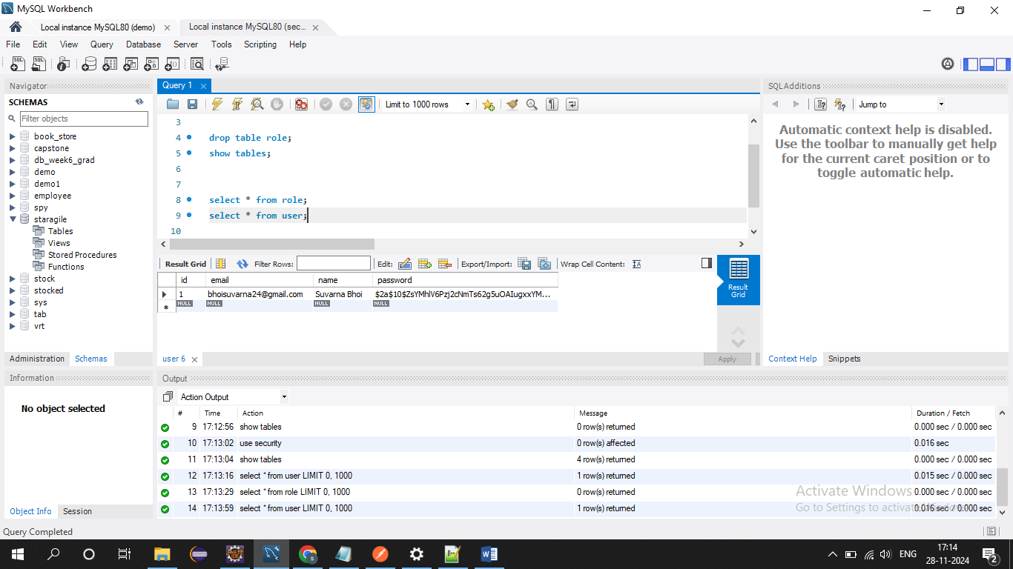
* **If login with incorrect id and password it’s throw the error.**

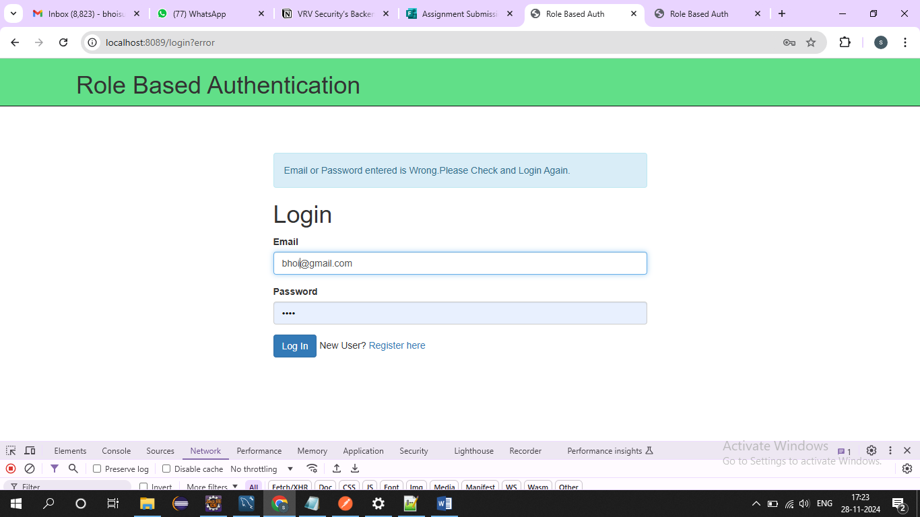

* **Login with correct Email Id and Password**
* **http://localhost:8089/login**

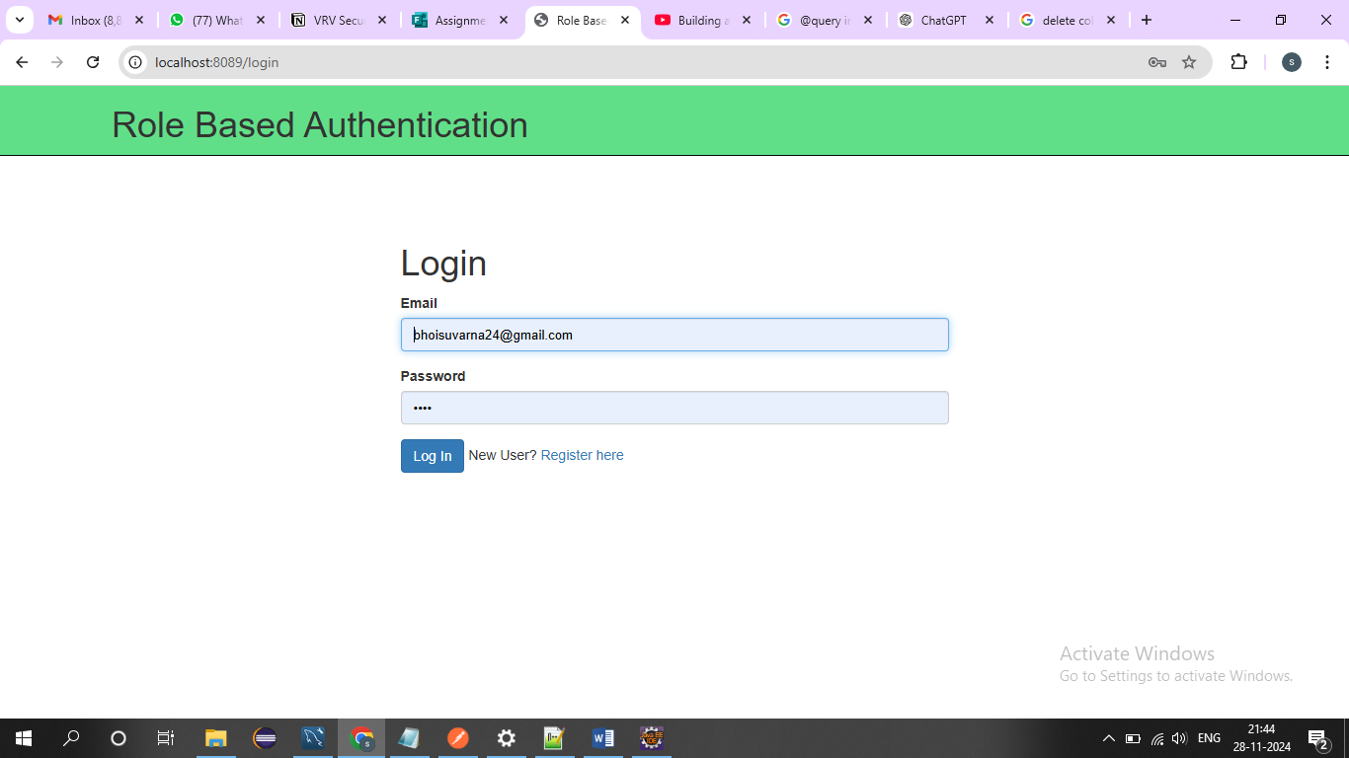

* **If login as a Admin, it’s redirect on adminScreen(<http://localhost:8089/adminScreen>) after login successfully.**

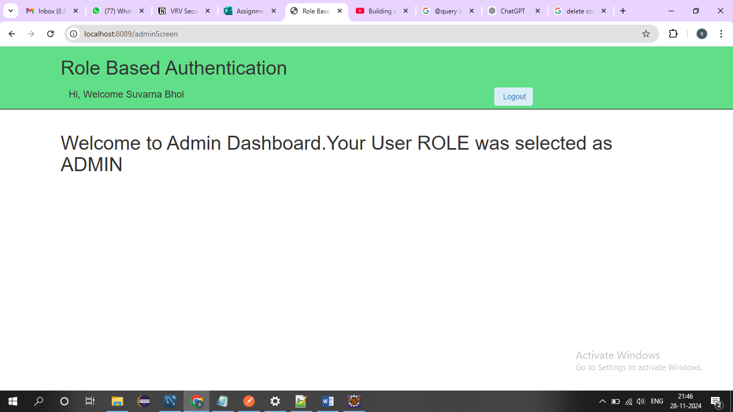

* **If login as a User, it’s redirect on dashboard(**[**http://localhost:8089/dashboard**](http://localhost:8089/dashboard) **) after login successfully.**
* 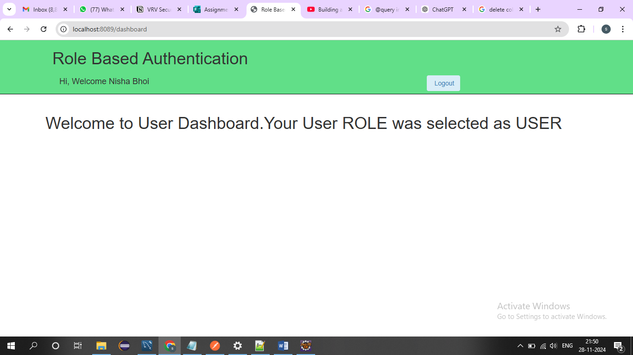
* **After logout successfully it’s redirect on login screen.**

