* Introduction: I’m Susana Villegas De La Hoz. I study at Marymount school medellin. My favorite color is green. But there’s a secret... I study at day and I’m the Batman at night.
* 
* Hobbies: I play the bass, guitar and enjoy music overall. I also like art and its history. I draw and sometimes paint. Right now, I’m working on Klimt’s “The Kiss” painting.

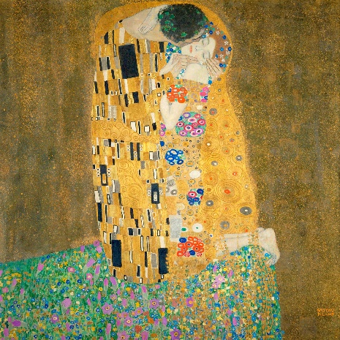

* Dreams – Aspirations: I aspire to become a sociologist or maybe a musician. I dream to open a record store or have a lot of records.
* 
* Pets: I have a Shih Tzu who is 5 years old. Her name is Luli. 
* Family (Webpage) My family is formed by my dad ( Carlos Villegas Arenas) and my mom (Yamile De La Hoz García)
* Reccomendations: Places to Visit, Restaurants, Books, TV shows, Movies... (Webpage): I recommend visiting a neighborhood in Bogotá called “San Felipe”. It is very artistic and cultural. I also would like to recommend a book for mystery and true crime lovers. “Satanás” By Mario Mendoza.
* 
* Favorite: Songs, Artist, place, writer, subject, team (Choose at least two): I love David Bowie with all my heart. My favorite song of all time is The Trooper by Iron Maiden.
* 
* Celebrity crush if not funny real story: "Story Time"

My celebrity crush is Cate Blanchett

