**NAME - SUVIDHI V. PAREEK**

**SE(COMPS) / DIV - 3 / ROLL NO. 10**

**Experiment No. 9: Depth First Search and Breath First Search**

**Aim** : Implementation of DFS and BFS traversal of graph.

**Objective:**

1. Understand the Graph data structure and its basic operations.
2. Understand the method of representing a graph.
3. Understand the method of constructing the Graph ADT and defining its operations

**Theory:**

A graph is a collection of nodes or vertex, connected in pairs by lines referred as edges. A graph can be directed or undirected graph.

One method of traversing through nodes is depth first search. Here we traverse from starting node and proceeds from top to bottom. At a moment we reach a dead end from where the further movement is not possible and we backtrack and then proceed according to left right order. A stack is used to keep track of a visited node which helps in backtracking.

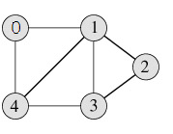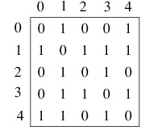

DFS Traversal –0 1 2 3 4

**Algorithm**

Algorithm: DFS_LL(V)

Input: V is a starting vertex

Output : A list VISIT giving order of visited vertices during traversal.

Description: linked structure of graph with gptr as pointer

1. if gptr = NULL then

print “Graph is empty” exit

1. u=v
2. OPEN.PUSH(u)
3. while OPEN.TOP !=NULL do

u=OPEN.POP()

if search(VISIT,u) = FALSE then

INSERT_END(VISIT,u)

Ptr = gptr(u)

While ptr.LINK != NULL do

Vptr = ptr.LINK

OPEN.PUSH(vptr.LABEL)

End while

End if

End while

1. Return VISIT
2. Stop

BFS Traversal

 

BFS Traversal – 0 1 4 2 3

**Algorithm**

Algorithm: DFS()

i=0

count=1

visited[i]=1

print("Visited vertex i")

repeat this till queue is empty or all nodes visited

repeat this for all nodes from first till last

if(g[i][j]!=0&&visited[j]!=1)

{

push(j)

}

i=pop()

print("Visited vertex i")

visited[i]=1

count++

Algorithm: BFS()

i=0

count=1

visited[i]=1

print("Visited vertex i")

repeat this till queue is empty or all nodes visited

repeat this for all nodes from first till last

if(g[i][j]!=0&&visited[j]!=1)

{

enqueue(j)

}

i=dequeue()

print("Visited vertex i")

visited[i]=1

count++

**Code:**

#include <stdio.h>

#include <stdlib.h>

// Define the maximum number of vertices in the graph

#define MAX_VERTICES 100

// Define a stack for DFS and a queue for BFS

int stack[MAX_VERTICES];

int top = -1;

int queue[MAX_VERTICES];

int front = -1, rear = -1;

int visited[MAX_VERTICES];

// Define the adjacency matrix for the graph

int graph[MAX_VERTICES][MAX_VERTICES];

int numVertices;

int i;

void push(int vertex) {

stack[++top] = vertex;

}

int pop() {

return stack[top--];

}

void enqueue(int vertex) {

if (rear == MAX_VERTICES - 1)

printf("Queue is full.\n");

else

queue[++rear] = vertex;

}

int dequeue() {

if (front == rear)

return -1; // Empty queue

return queue[++front];

}

void initGraph(int vertices) {

numVertices = vertices;

for (int i = 0; i < numVertices; i++) {

visited[i] = 0;

for (int j = 0; j < numVertices; j++) {

graph[i][j] = 0;

}

}

}

void addEdge(int start, int end) {

graph[start][end] = 1;

}

void DFS(int vertex) {

int u, v;

push(vertex);

while (top != -1) {

u = pop();

if (visited[u] == 0) {

printf("Visited vertex %d\n", u);

visited[u] = 1;

for (v = 0; v < numVertices; v++) {

if (graph[u][v] && !visited[v]) {

push(v);

}

}

}

}

}

void BFS(int vertex) {

int u, v;

enqueue(vertex);

while (front != rear) {

u = dequeue();

if (visited[u] == 0) {

printf("Visited vertex %d\n", u);

visited[u] = 1;

for (v = 0; v < numVertices; v++) {

if (graph[u][v] && !visited[v]) {

enqueue(v);

}

}

}

}

}

int main() {

int vertices, edges, startVertex;

printf("Enter the number of vertices and edges: ");

scanf("%d %d", &vertices, &edges);

initGraph(vertices);

printf("Enter the edges (format: start end):\n");

for (int i = 0; i < edges; i++) {

int start, end;

scanf("%d %d", &start, &end);

addEdge(start, end);

}

printf("Enter the starting vertex for traversal: ");

scanf("%d", &startVertex);

printf("DFS Traversal:\n");

DFS(startVertex);

// Reset visited array

for (i = 0; i < vertices; i++) {

visited[i] = 0;

}

printf("\nBFS Traversal:\n");

BFS(startVertex);

return 0;

}

**Output:**

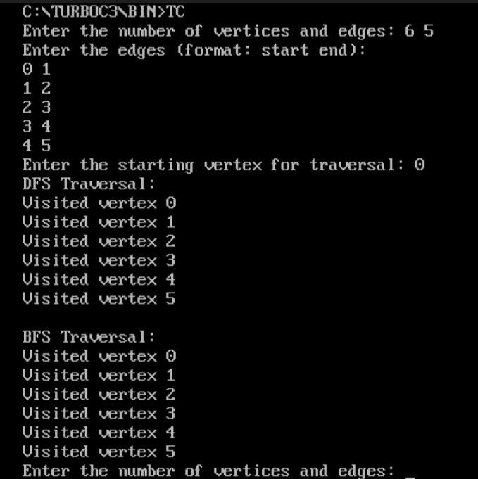

**Conclusion:**

BFS, Breadth-First Search, is a vertex-based technique for finding the shortest path in the graph. It uses a Queue data structure that follows first in first out. In BFS, one vertex is selected at a time when it is visited and marked then its adjacent are visited and stored in the queue. It is slower than DFS.

DFS, Depth-First Search, is an edge-based technique. It uses the Stack data structure and performs two stages, first visited vertices are pushed into the stack, and second if there are no vertices then visited vertices are popped.