Name : Suvidhi V. Pareek

Class / Div : TE / 03

Roll No : 09

| Experiment No.2 |
| --- |
| Apply OLAP operations |
| Date of Performance: 15-07-2024 |
| Date of Submission: 22-07-2024 |

**Aim:** To implement Perform OLAP Operations

**Objective:** Develop a program to implement OLAP operations

**Theory:**

**Online analytical processing**, or **OLAP** is an approach to answering [multi-dimensional analytical](https://en.wikipedia.org/wiki/Multi-dimensional_analytical) (MDA) queries swiftly in [computing](https://en.wikipedia.org/wiki/Computing) OLAP is part of the broader category of [business intelligence](https://en.wikipedia.org/wiki/Business_intelligence), which also encompasses [relational](https://en.wikipedia.org/wiki/Relational_database) [database,](https://en.wikipedia.org/wiki/Relational_database) report writing and [data mining](https://en.wikipedia.org/wiki/Data_mining). Typical applications of OLAP include [business reporting](https://en.wikipedia.org/wiki/Business_reporting) for sales, [marketing](https://en.wikipedia.org/wiki/Marketing), management reporting, [business process management](https://en.wikipedia.org/wiki/Business_process_management) (BPM), [budgeting](https://en.wikipedia.org/wiki/Budget) and [forecasting](https://en.wikipedia.org/wiki/Forecasting), [financial](https://en.wikipedia.org/wiki/Financial_reporting) [reporting](https://en.wikipedia.org/wiki/Financial_reporting) and similar areas, with new applications coming up, such as [agriculture.](https://en.wikipedia.org/wiki/Agriculture) The term OLAP was created as a slight modification of the traditional database term [online transaction processing](https://en.wikipedia.org/wiki/Online_transaction_processing) (OLTP).

OLAP tools enable users to analyze multidimensional data interactively from multiple perspectives. OLAP consists of three basic analytical operations: consolidation (roll-up), drill-down, and slicing and dicing. Consolidation involves the aggregation of data that can be accumulated and computed in one or more dimensions. For example, all sales offices are rolled up to the sales department or sales division to anticipate sales trends. By contrast, the drill-down is a technique that allows users to navigate through the details. For instance, users can view the sales by individual products that make up a region's sales. Slicing and dicing is a feature whereby users can take out (slicing) a specific set of data of the [OLAP cube](https://en.wikipedia.org/wiki/OLAP_cube) and view (dicing) the slices from different viewpoints. These viewpoints are sometimes called dimensions (such as looking at the same sales by salesperson or by date or by customer or by product or by region, etc.)

The following are different types of OLAP models:

1. MOLAP (Multidimensional OLAP)
2. ROLAP (Relational OLAP)
3. HOLAP (Hybrid OLAP)
4. DOLAP (Desktop OLAP)

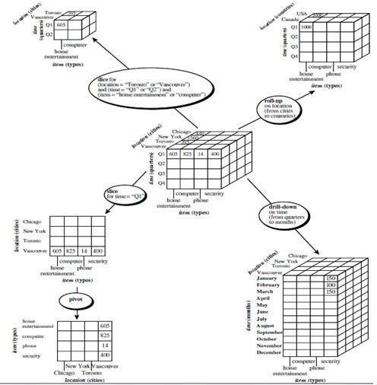

Figure 1: OLAP Operations

Roll-up: The roll-up operation (also called the drill-up operation by some vendors) performs aggregation on a data cube, either by climbing up a concept hierarchy for a dimension or by dimension reduction. Figure 1 shows the result of a roll-up operation performed on the central cube by climbing up the concept hierarchy for location given in Figure 1. This hierarchy was defined as the total order “street < city < province or state < country.” The roll-up operation shown aggregates the data by ascending the location hierarchy from the level of city to the level of country. In other words, rather than grouping the data by city, the resulting cube groups the data by country. When roll-up is performed by dimension reduction, one or more dimensions are removed from the given cube. For example, consider a sales data cube containing only the two dimensions location and time. Roll-up may be performed by removing, say, the time dimension, resulting in an aggregation of the total sales by location, rather than by location and by time.

Drill-down: Drill-down is the reverse of roll-up. It navigates from less detailed data to more detailed data. Drill-down can be realized by either stepping down a concept hierarchy for a dimension or introducing additional dimensions. Figure 1 shows the result of a drill-down operation performed on the central cube by stepping down a concept hierarchy for time defined as “day < month < quarter < year.” Drill-down occurs by descending the time hierarchy from the level of quarter to the more detailed level of month. The resulting data cube details the total sales per month rather than summarizing them by quarter. Because a drill-down adds more detail to the given data, it can also be performed by adding new dimensions to a cube. For example, a drill-down on the central cube of Figure 1 can occur by introducing an additional dimension, such as customer group.

Slice and dice: The slice operation performs a selection on one dimension of the given cube, resulting in a subcube. Figure 1 shows a slice operation where the sales data are selected from the central cube for the dimension time using the criterion time = “Q1”. The dice operation defines a subcube by performing a selection on two or more dimensions. Figure 1 shows a dice operation on the central cube based on the following selection criteria that involve three dimensions: (location = “Toronto” or “Vancouver”) and (time = “Q1” or “Q2”) and (item = “home entertainment” or “computer”).

Pivot (rotate): Pivot (also called rotate) is a visualization operation that rotates the data axes in view in order to provide an alternative presentation of the data. Figure 1 shows a pivot operation where the item and location axes in a 2-D slice are rotated.

**Code and output**:

CREATE table Time_dw5

(time_id int PRIMARY KEY,day DATE NOT NULL,

month varchar(255) NOT NULL,

qt varchar(255) NOT NULL,

yr varchar(255) NOT NULL);

INSERT INTO Time_dw5(time_id,day,month,qt,yr)

VALUES (101,'2021-01-17','january','Q1','2021');

INSERT INTO Time_dw5(time_id,day,month,qt,yr)

VALUES (102,'2021-02-14','february','Q1','2021');

INSERT INTO Time_dw5(time_id,day,month,qt,yr)

VALUES (103,'2021-05-21','may','Q2','2021');

INSERT INTO Time_dw5(time_id,day,month,qt,yr)

VALUES (104,'2021-06-26','june','Q2','2021');

select*from Time_dw5;

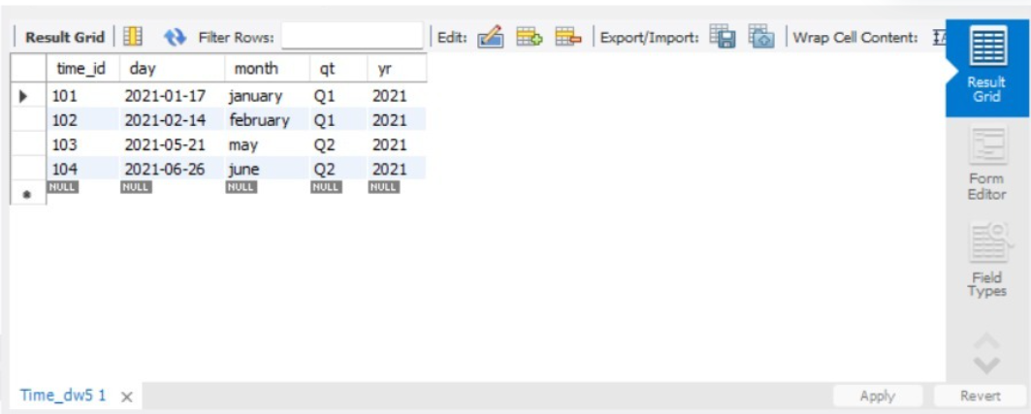

-- Creating the table Product_dw

CREATE TABLE Product_dw (

prod_id INT PRIMARY KEY,

prod_name VARCHAR(60) NOT NULL,

prod_category VARCHAR(255) NOT NULL,

brand_name VARCHAR(255) NOT NULL,

suppl_name VARCHAR(255) NOT NULL,

prod_price INT

);

-- Inserting data into Product_dw

INSERT INTO Product_dw (prod_id, prod_name, prod_category, brand_name, suppl_name, prod_price) VALUES (1, 'Rice', 'Grocery', 'Dawat', 'Ramesh', 140);

INSERT INTO Product_dw (prod_id, prod_name, prod_category, brand_name, suppl_name, prod_price) VALUES (2, 'Sugar', 'Grocery', 'Dawat', 'Ramesh', 50);

INSERT INTO Product_dw (prod_id, prod_name, prod_category, brand_name, suppl_name, prod_price) VALUES (3, 'Kurta', 'Cloth', 'Max', 'Lila', 500);

INSERT INTO Product_dw (prod_id, prod_name, prod_category, brand_name, suppl_name, prod_price) VALUES (4, 'Jacket', 'Cloth', 'Max', 'Lila', 700);

-- Selecting all records from Product_dw

SELECT * FROM Product_dw;

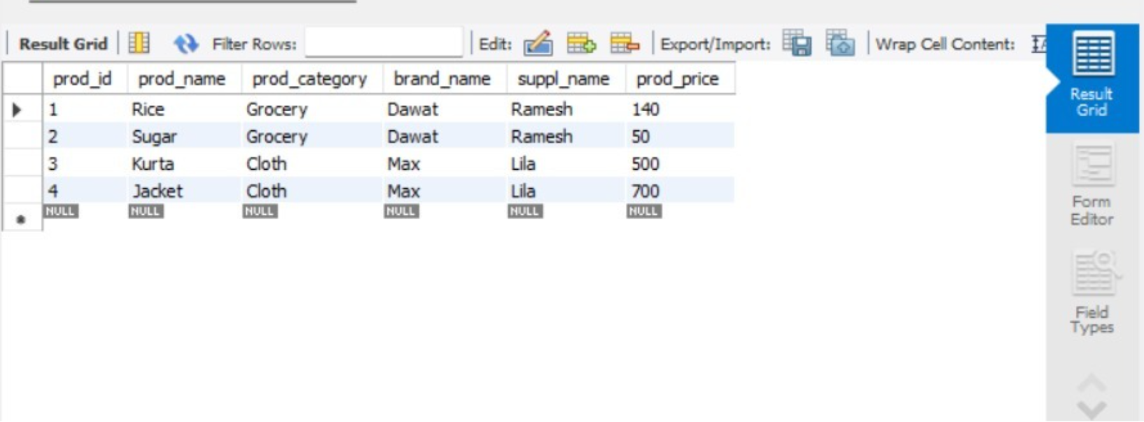

-- Creating the table Location_dw

CREATE TABLE Location_dw (

loc_id INT PRIMARY KEY,

street VARCHAR(60) NOT NULL,

city VARCHAR(255) NOT NULL,

state VARCHAR(255) NOT NULL,

country VARCHAR(255) NOT NULL

);

-- Inserting data into Location_dw

INSERT INTO Location_dw (loc_id, street, city, state, country)

VALUES (201, 'MLROAD', 'MUMBAI', 'MAHARASHTRA', 'INDIA');

INSERT INTO Location_dw (loc_id, street, city, state, country)

VALUES (202, 'AIROAD', 'MUMBAI', 'MAHARASHTRA', 'INDIA');

INSERT INTO Location_dw (loc_id, street, city, state, country)

VALUES (203, 'BIROAD', 'KOLKATA', 'WESTBENGAL', 'INDIA');

INSERT INTO Location_dw (loc_id, street, city, state, country)

VALUES (204, 'DBROAD', 'KOLKATA', 'WESTBENGAL', 'INDIA');

-- Selecting all records from Location_dw

SELECT * FROM Location_dw;

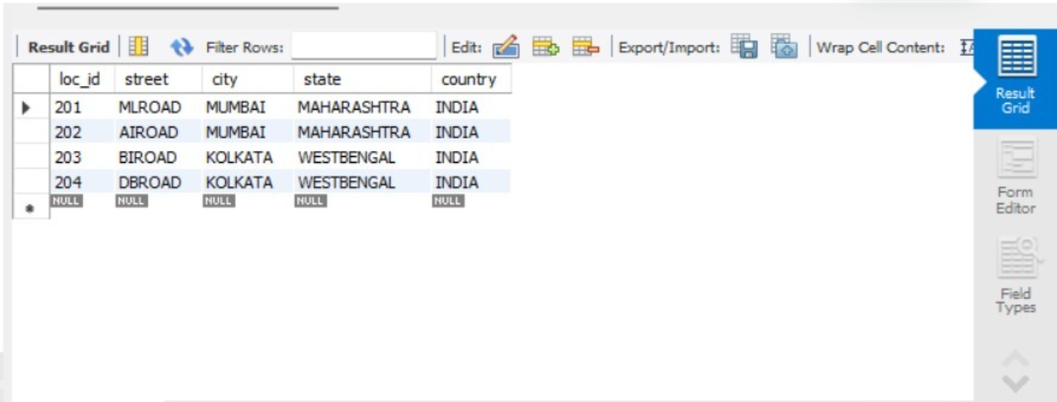

-- Creating the Fact_sales table

CREATE TABLE Fact_sales (

prod_id INT REFERENCES Product_dw(prod_id),

time_id INT REFERENCES Time_dw5(time_id),

loc_id INT REFERENCES Location_dw(loc_id),

Number_of_unit_sold INT NOT NULL,

Total_sales INT NOT NULL

);

-- Inserting data into Fact_sales

INSERT INTO Fact_sales (prod_id, time_id, loc_id, Number_of_unit_sold, Total_sales) VALUES (1, 101, 201, 400, 90000);

INSERT INTO Fact_sales (prod_id, time_id, loc_id, Number_of_unit_sold, Total_sales) VALUES (1, 102, 201, 400, 80000);

INSERT INTO Fact_sales (prod_id, time_id, loc_id, Number_of_unit_sold, Total_sales) VALUES (1, 103, 201, 400, 70000);

INSERT INTO Fact_sales (prod_id, time_id, loc_id, Number_of_unit_sold, Total_sales) VALUES (1, 104, 201, 400, 50000);

-- Selecting all records from Fact_sales

SELECT * FROM Fact_sales;

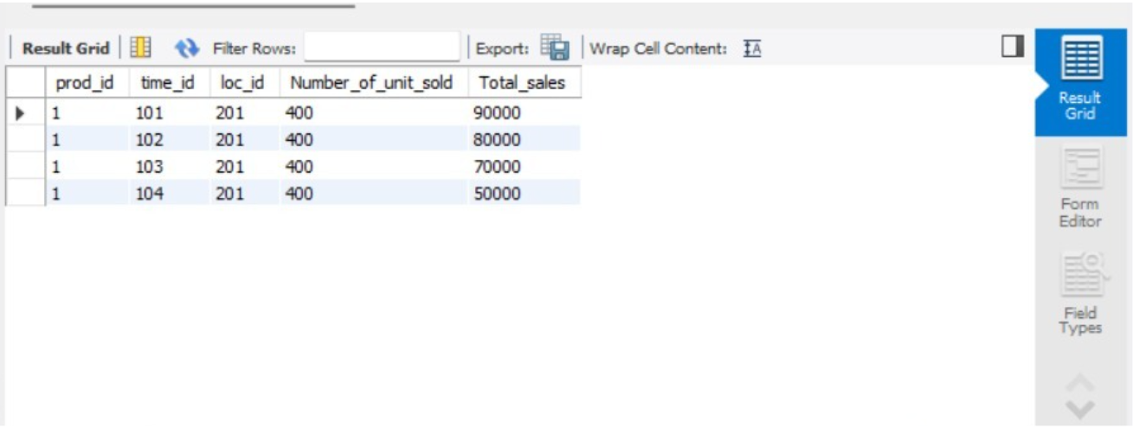

-- Query to group by year and sum total sales

SELECT Time_dw5.yr, SUM(Total_sales)

FROM Fact_sales

JOIN Product_dw ON Fact_sales.prod_id = Product_dw.prod_id

JOIN Time_dw5 ON Fact_sales.time_id = Time_dw5.time_id

GROUP BY Time_dw5.yr;

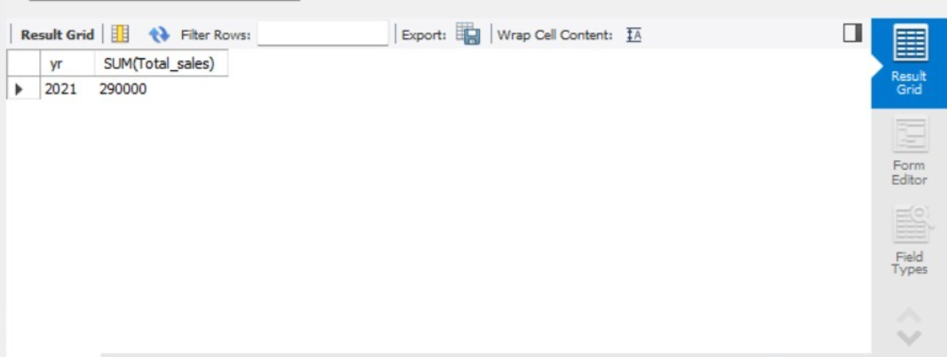

-- Query to group by year and sum total sales

SELECT Time_dw5.yr, SUM(Total_sales)

FROM Fact_sales

JOIN Product_dw ON Fact_sales.prod_id = Product_dw.prod_id

JOIN Time_dw5 ON Fact_sales.time_id = Time_dw5.time_id

GROUP BY Time_dw5.yr;

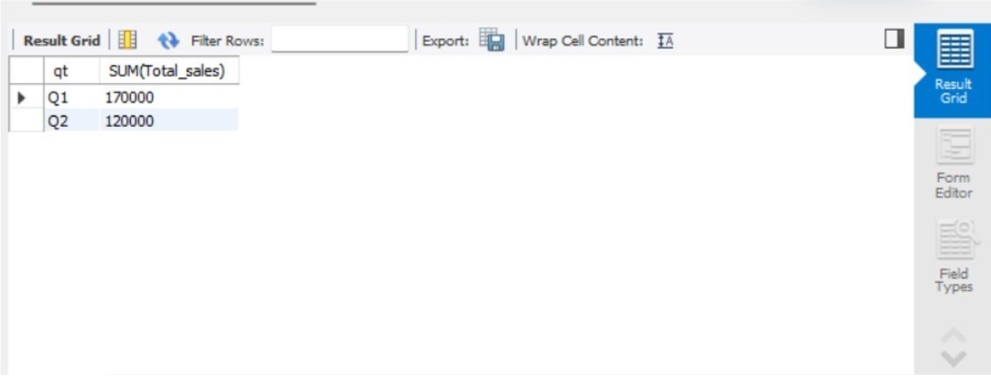

-- Slice operation

SELECT prod_name, Total_sales

FROM Fact_sales

INNER JOIN Product_dw ON Fact_sales.prod_id = Product_dw.prod_id;

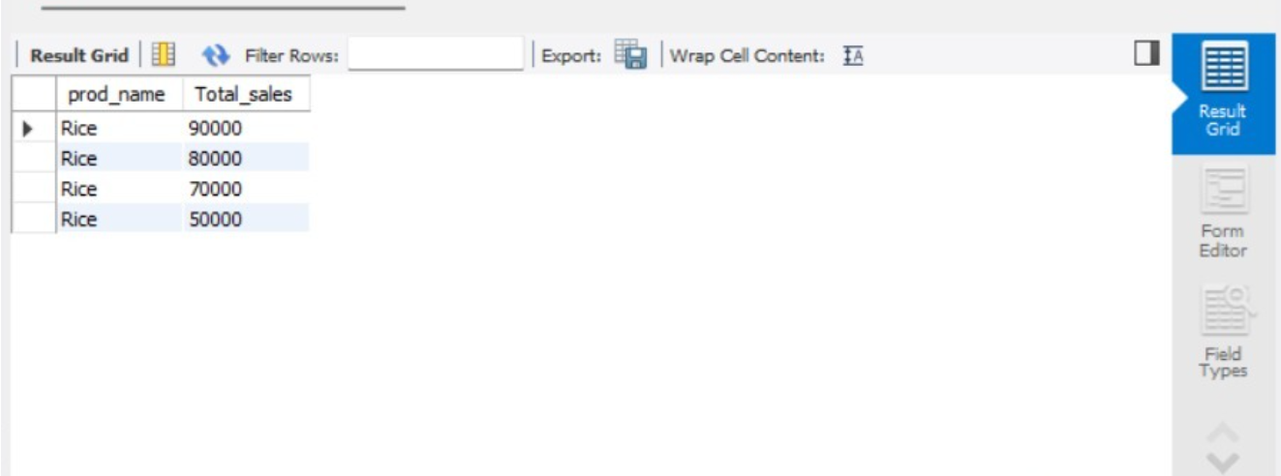

-- Dice operation

SELECT prod_name, Total_sales, day

FROM (Fact_sales

INNER JOIN Product_dw ON Fact_sales.prod_id = Product_dw.prod_id)

JOIN Time_dw5 ON Fact_sales.time_id = Time_dw5.time_id;

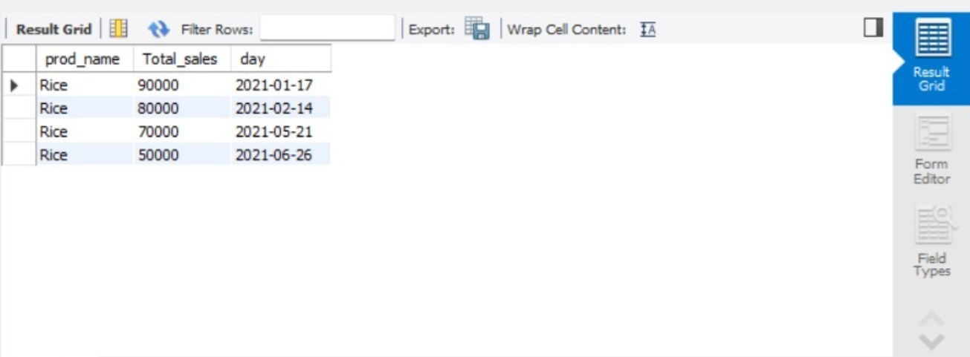

**Conclusion:** Comment on the usefulness of the OLAP queries on your application. OLAP queries enhance application performance by enabling fast, multidimensional analysis of large datasets, facilitating insightful data exploration and decision-making.