Name : Suvidhi V. Pareek

Class / Div : TE / 03

Roll No : 09

| Experiment No. 6 |
| --- |
| Implement clustering algorithm(K-means) |
| Date of Performance: 12/08/24 |
| Date of Submission: 02/09/24 |

**AIM:** To Study and Implement K‐Means algorithm

**Objective:** Develop a program to implement K-Means Algorithm

**THEORY:**

In statistics and machine learning, k‐means clustering is a method of cluster analysis which aims to partition n observations into k clusters in which each observation belongs to the cluster with the nearest mean.

Input

K:-number of clusters

D:- data set containing n objects

Output

A set of k clusters

Given *k* , the *k-means* algorithm is implemented in 5 steps:

**Step 1:** Arbitrarily choose k objects from D as the initial cluster centers.

**Step 2:** Find the distance from each and every object in the dataset with respect to cluster centres

**Step 3:** Assign each object to the cluster with the nearest seed point based on the mean value of the objects in the cluster.

**Step 4:**Update the cluster means i,e calculate the mean value of the objects for each cluster.

**Step 5:**Repeat the procedure **,** until there is no change in mean.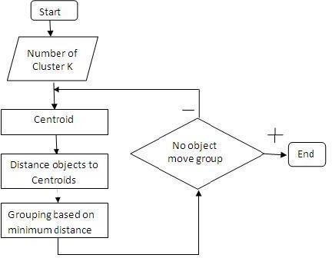

Figure. 1 Flow Chart

**Example:**  d= {2,4,10,12,3,20,30,11,25} k =2

1. Randomly assign mean m1=3 and m2 = 4

Therefore, k1 = {2,3} Therefore, k1 = {4,10,12,20,30,11,25}

1. Randomly assign mean m1=2.5 and m2 = 16 Therefore, k1 = {2,3,4} Therefore, k1 = {4,10,12,20,30,11,25}
2. Randomly assign mean m1=3 and m2 = 18

Therefore, k1 = {2,3,4,10} Therefore, k1 = {12,20,30,11,25}

1. Randomly assign mean m1=7 and m2 = 25 Therefore, k1 = {2,3,4,10,11,12} Therefore, k1 = {20,30,25}
2. Randomly assign mean m1=7 and m2 = 25 Therefore, we stop as we are getting same mean values.
3. Therefore, Final clusters are : k1 = {2,3,4,10,11,12} Therefore, k1 = {20,30,25}

**Code and output**:

import numpy as np

import matplotlib.pyplot as plt

import pandas as pd

dataset = pd.read_csv('Mall_Customers.csv')

X = dataset.iloc[:, [3, 4]].values

from sklearn.cluster import KMeans

wcss = []

for i in range(1, 11):

    kmeans = KMeans(n_clusters = i, init = 'k-means++', random_state = 42)

    kmeans.fit(X)

    wcss.append(kmeans.inertia_)

plt.plot(range(1, 11), wcss)

plt.title('The Elbow Method')

plt.xlabel('Number of clusters')

plt.ylabel('WCSS')

plt.show()

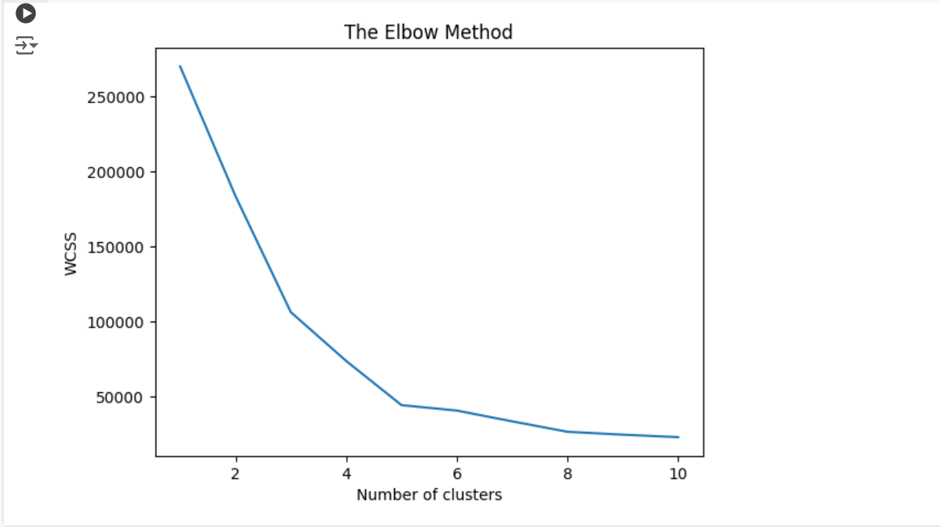

kmeans = KMeans(n_clusters = 5, init = 'k-means++', random_state = 42)

y_kmeans = kmeans.fit_predict(X)

plt.scatter(X[y_kmeans == 0, 0], X[y_kmeans == 0, 1], s = 100, c = 'red', label = 'Cluster 1')

plt.scatter(X[y_kmeans == 1, 0], X[y_kmeans == 1, 1], s = 100, c = 'blue', label = 'Cluster 2')

plt.scatter(X[y_kmeans == 2, 0], X[y_kmeans == 2, 1], s = 100, c = 'green', label = 'Cluster 3')

plt.scatter(X[y_kmeans == 3, 0], X[y_kmeans == 3, 1], s = 100, c = 'cyan', label = 'Cluster 4')

plt.scatter(X[y_kmeans == 4, 0], X[y_kmeans == 4, 1], s = 100, c = 'magenta', label = 'Cluster 5')

plt.scatter(kmeans.cluster_centers_[:, 0], kmeans.cluster_centers_[:, 1], s = 300, c = 'yellow', label = 'Centroids')

plt.title('Clusters of customers')

plt.xlabel('Annual Income (k$)')

plt.ylabel('Spending Score (1-100)')

plt.legend()

plt.show()

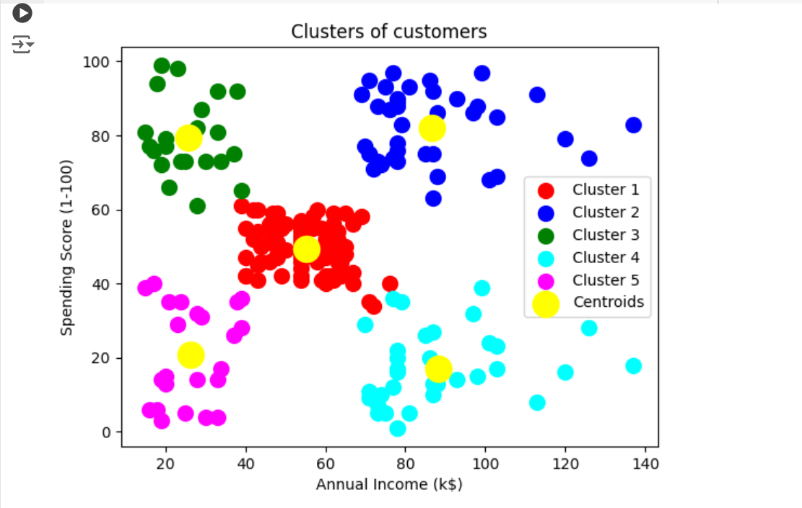

**Conclusion**: Comment on the clusters that are formed after performing the clustering algorithms. The clusters formed by clustering algorithms group similar data points, helping to reveal patterns, relationships, or natural groupings within the dataset.