Name : Suvidhi V. Pareek

Class / Div : TE / 03

Roll No : 09

| Experiment No. 7 |
| --- |
| Implement frequent pattern mining algorithm(Apriori) |
| Date of Performance: 02/09/24 |
| Date of Submission: 24/09/24 |

**AIM:** To implement Apriori algorithm

**Objective:** Develop a program to implement Apriori Algorithm on the given dataset

**THEORY:**

Apriori is an algorithm for frequent item set mining and [association rule learning](https://en.wikipedia.org/wiki/Association_rule_learning) over transactional [databases](https://en.wikipedia.org/wiki/Databases). It proceeds by identifying the frequent individual items in the database and extending them to larger and larger item sets as long as those item sets appear sufficiently often in the database. The frequent item sets determined by Apriori can be used to determine [association rules](https://en.wikipedia.org/wiki/Association_rules) which highlight general trends in the [database](https://en.wikipedia.org/wiki/Database): this has applications in domains such as [market basket analysis](https://en.wikipedia.org/wiki/Market_basket_analysis).

**Procedure or algorithm description:**

Level-wise algorithm:

a. Let k = 1

b. Generate frequent itemsets of length 1

c. Repeat until no new frequent itemsets are identified

1. Generate length (k+1) candidate itemsets from length k frequent itemsets

2. Prune candidate itemsets containing subsets of length k that are infrequent

3. Count the support of each candidate by scanning the DB

4. Eliminate candidates that are infrequent, leaving only those that are frequent

**Apriori Algorithm:**

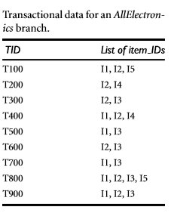

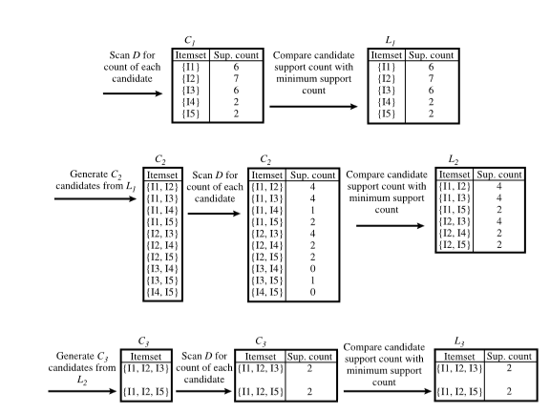

**Code and output**:

import numpy as np

import matplotlib.pyplot as plt

import pandas as pd

dataset = pd.read_csv('Market_Basket_Optimisation.csv', header = None)

transactions = []

for i in range(0, 7501):

transactions.append([str(dataset.values[i,j]) for j in range(0, 20)])

dataset

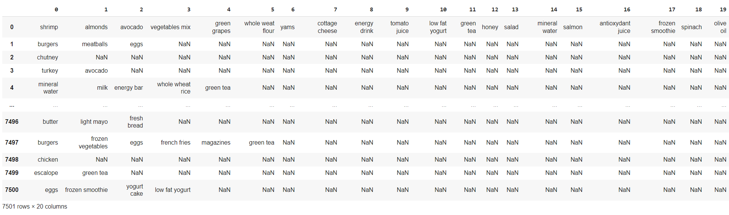

transactions

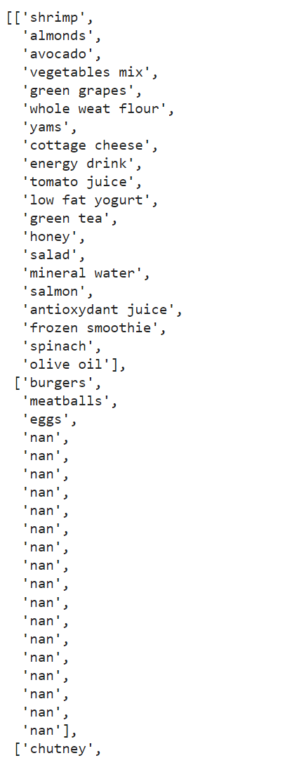

!pip install apyori

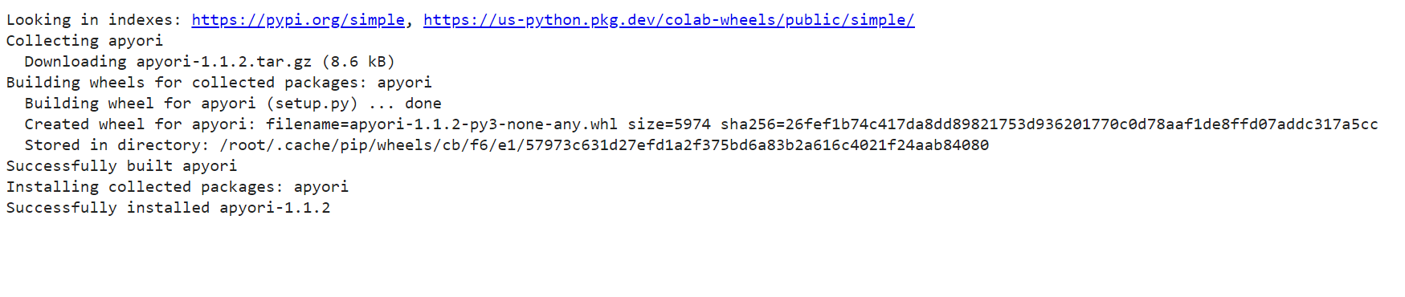

from apyori import apriori

rules = apriori(transactions = transactions, min_support = 0.003, min_confidence = 0.2)

results = list(rules)

results

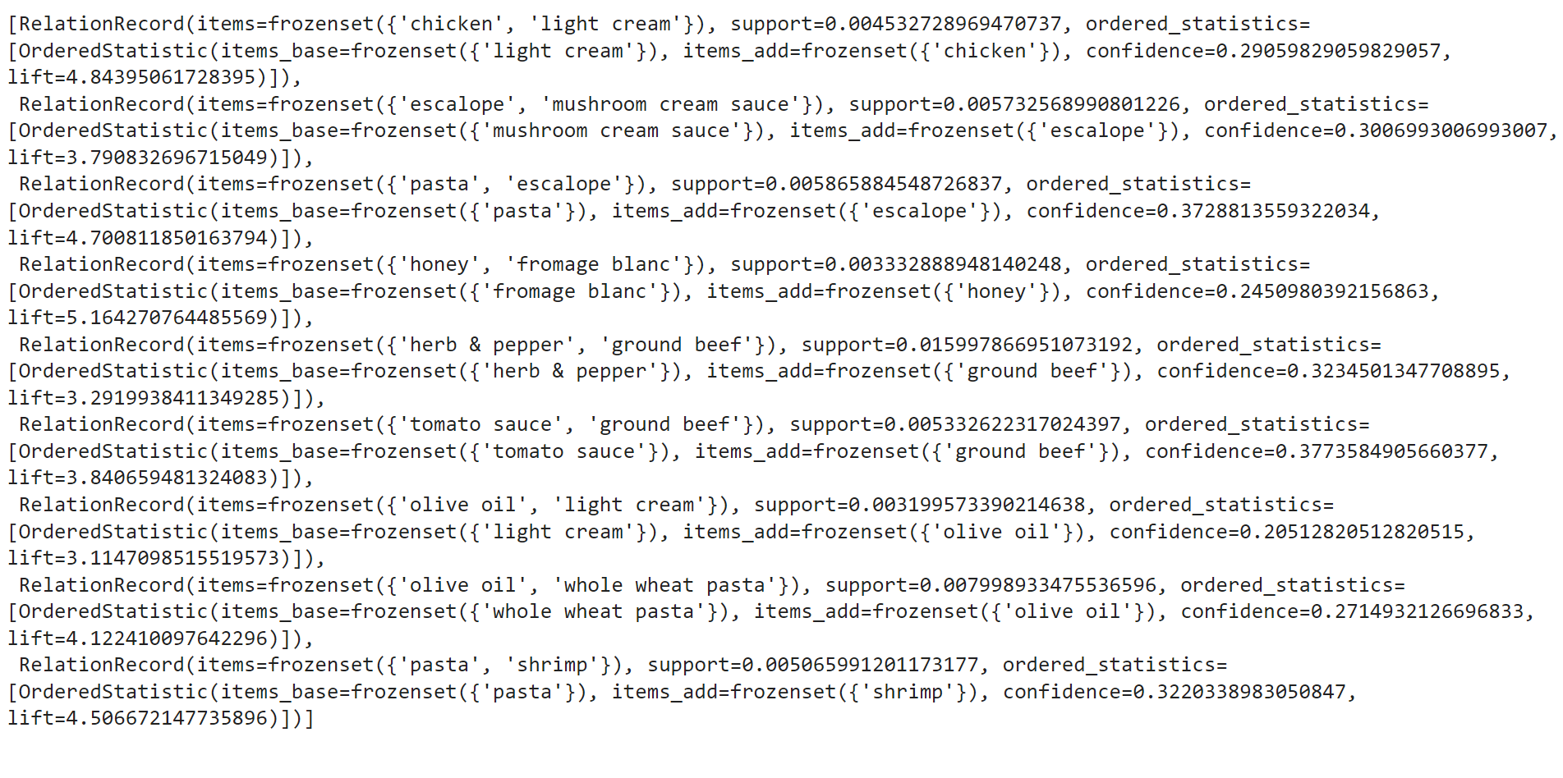

**Conclusion**: Comment on the rules generated by the algorithm. The Apriori algorithm effectively uncovers associations in transactional data, helping businesses optimize strategies based on customer purchasing patterns.