# Experiment 1.3

**Student Name: Aaryan Aneja UID:21BCS9186**

**Branch: BE-CSE Section/Group: CC-646-B**

**Date of Performance:06-02-2024 Subject Code: 21CSP-378**

**Subject Name: Cloud Computing & Semester: 6 Distributed Systems**

# Aim:

Installation of Cloud Sim tool and IDE.

# Objective:

To install Cloud Sim 3.03 and common math 4.0 library along with the Eclipse IDE to run the examples.

# Steps to Install:

Step 1: Open the browser and search cloud sim 3.03 go to the GitHub link and download the [cloudsim-3.0.3.zip](https://github.com/Cloudslab/cloudsim/releases/download/cloudsim-3.0.3/cloudsim-3.0.3.zip)

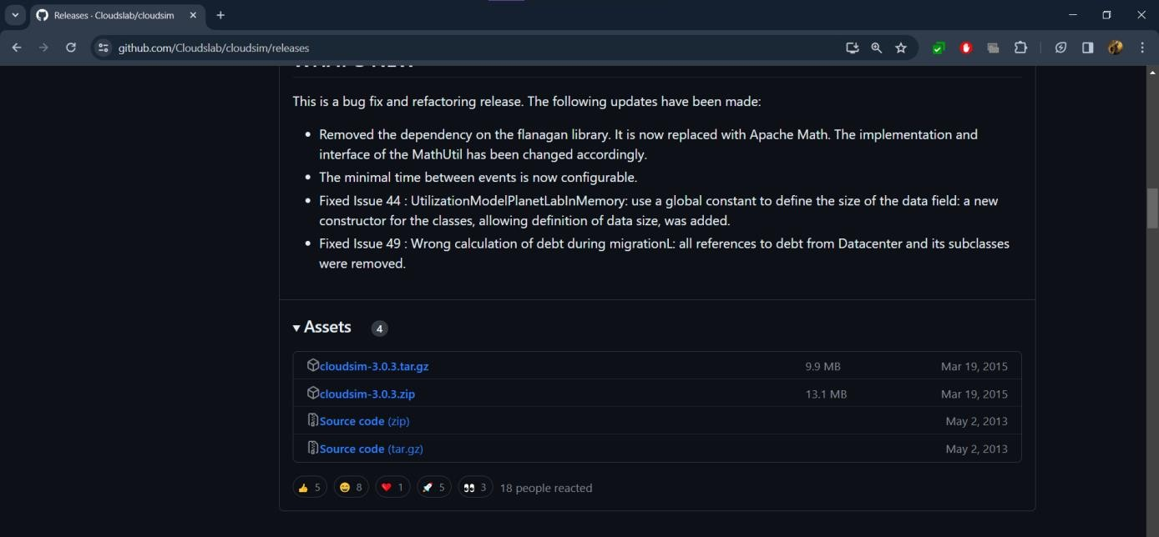

Step 2: Now download the Common Math library from the Apache Commons website i.e. [commons-](https://dlcdn.apache.org/commons/math/binaries/commons-math4-4.0-beta1-bin.zip) [math4-4.0-beta1-bin.zip](https://dlcdn.apache.org/commons/math/binaries/commons-math4-4.0-beta1-bin.zip)

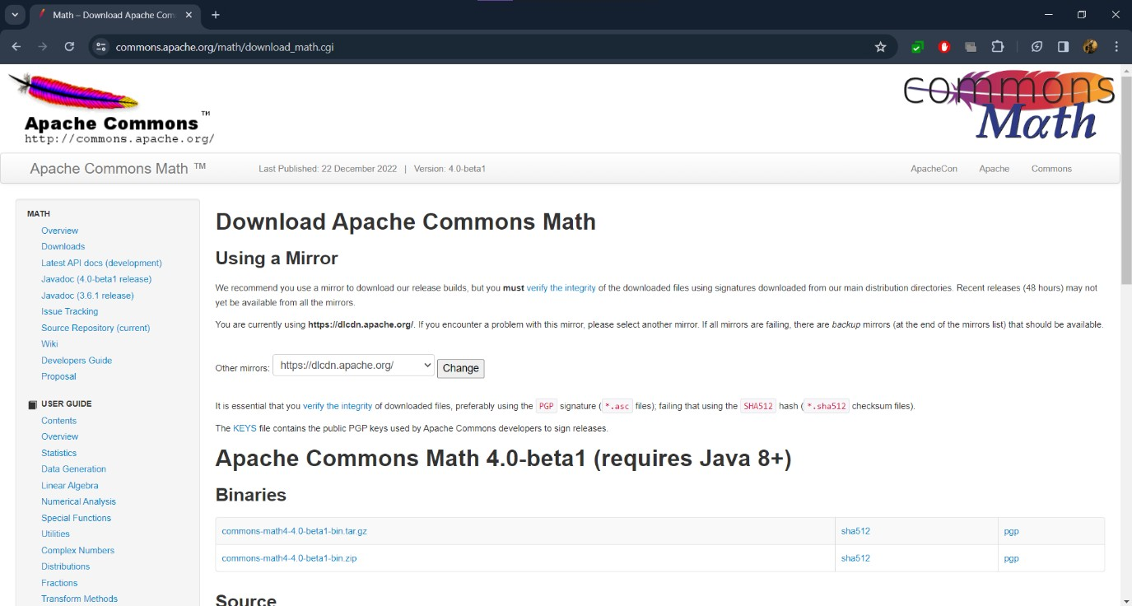

Step 3: Install the Eclipse IDE for the Java from the official website after that extract all the files.

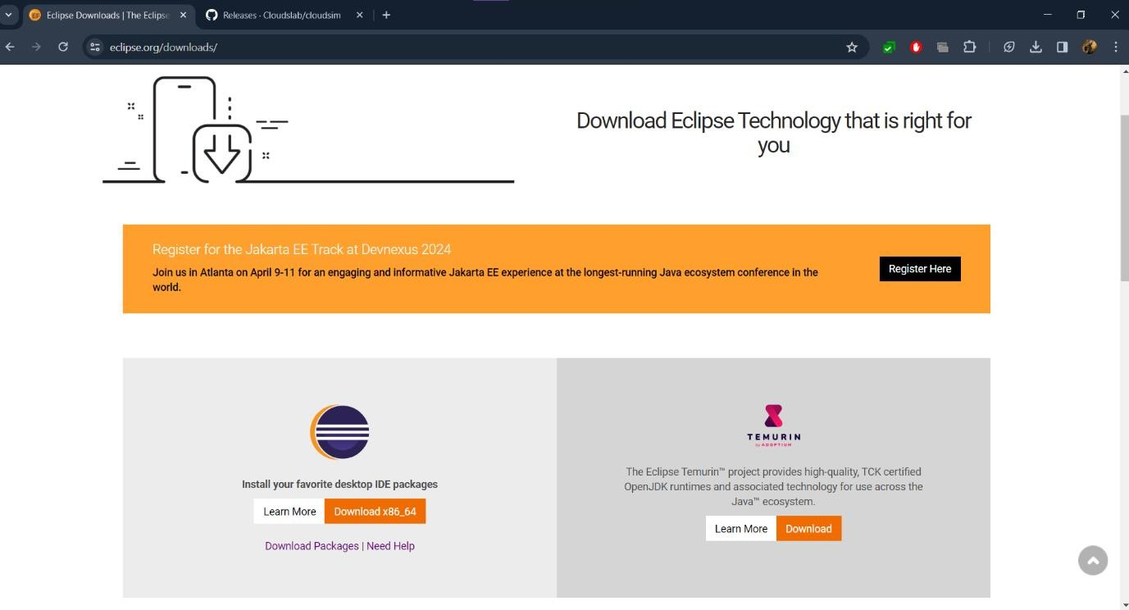

Step 4: Enter the project name and uncheck the default location and go the extract cloudsim location and select that after that click on the next.

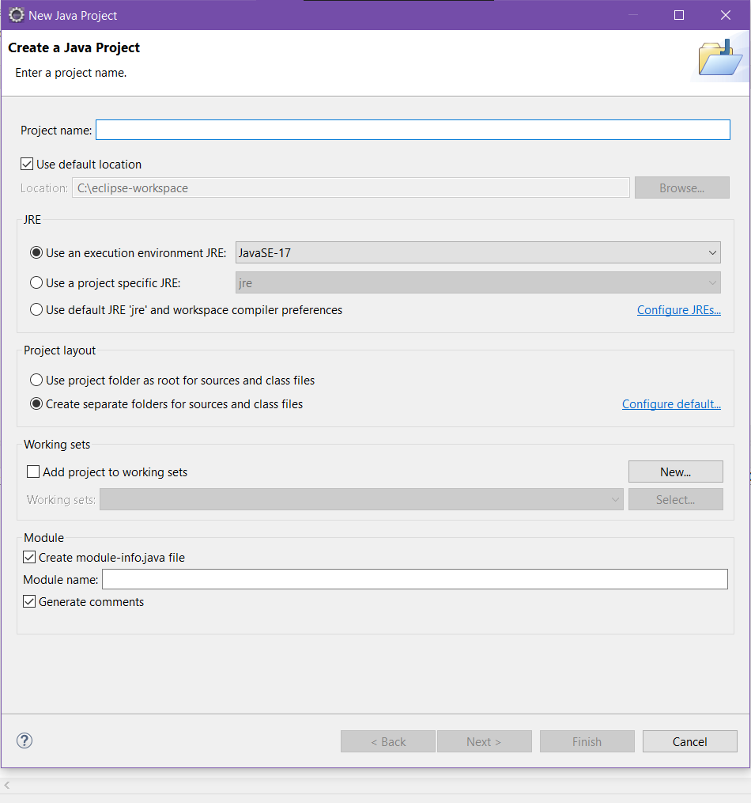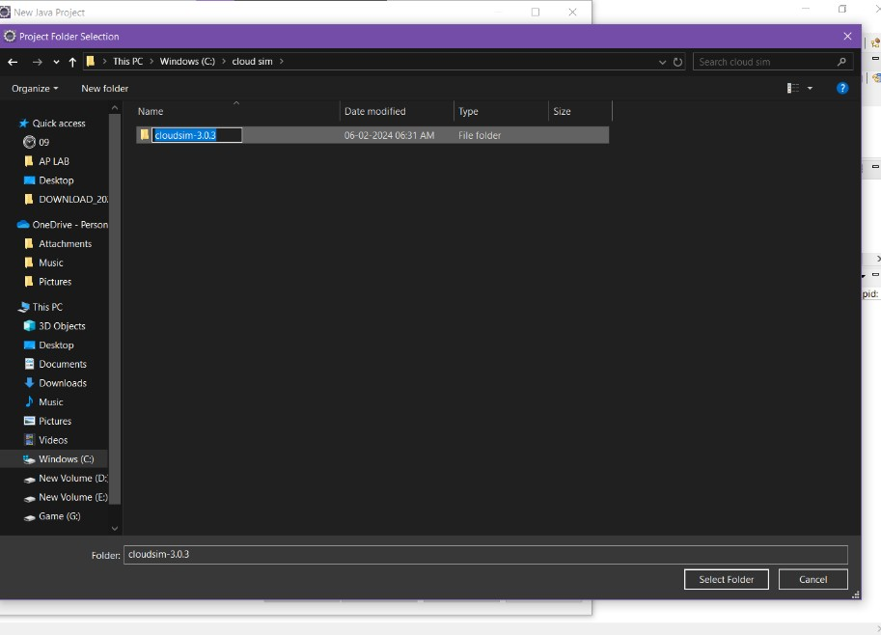

Step 5: Once Go to the libraries and then Add External JARs and select the first jar file from the common math extracted folder

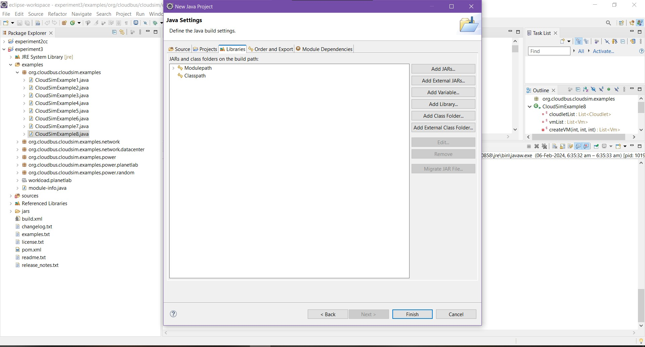

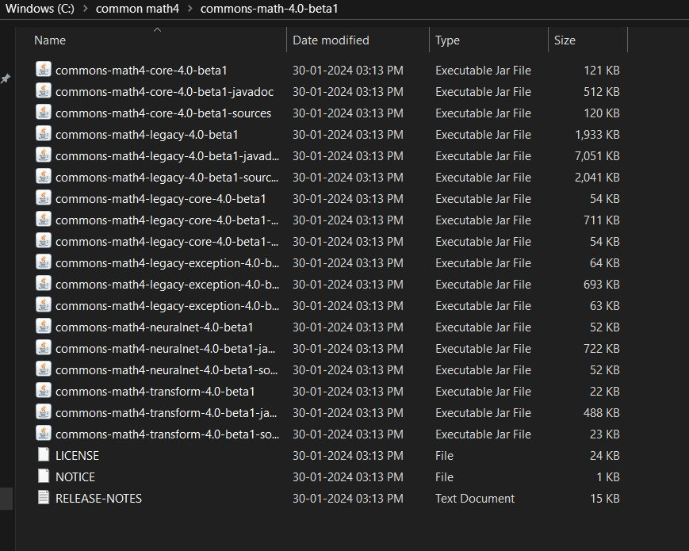

Step 6: Click on finish and go to examples folder then run the CloudSimExample9.java file.

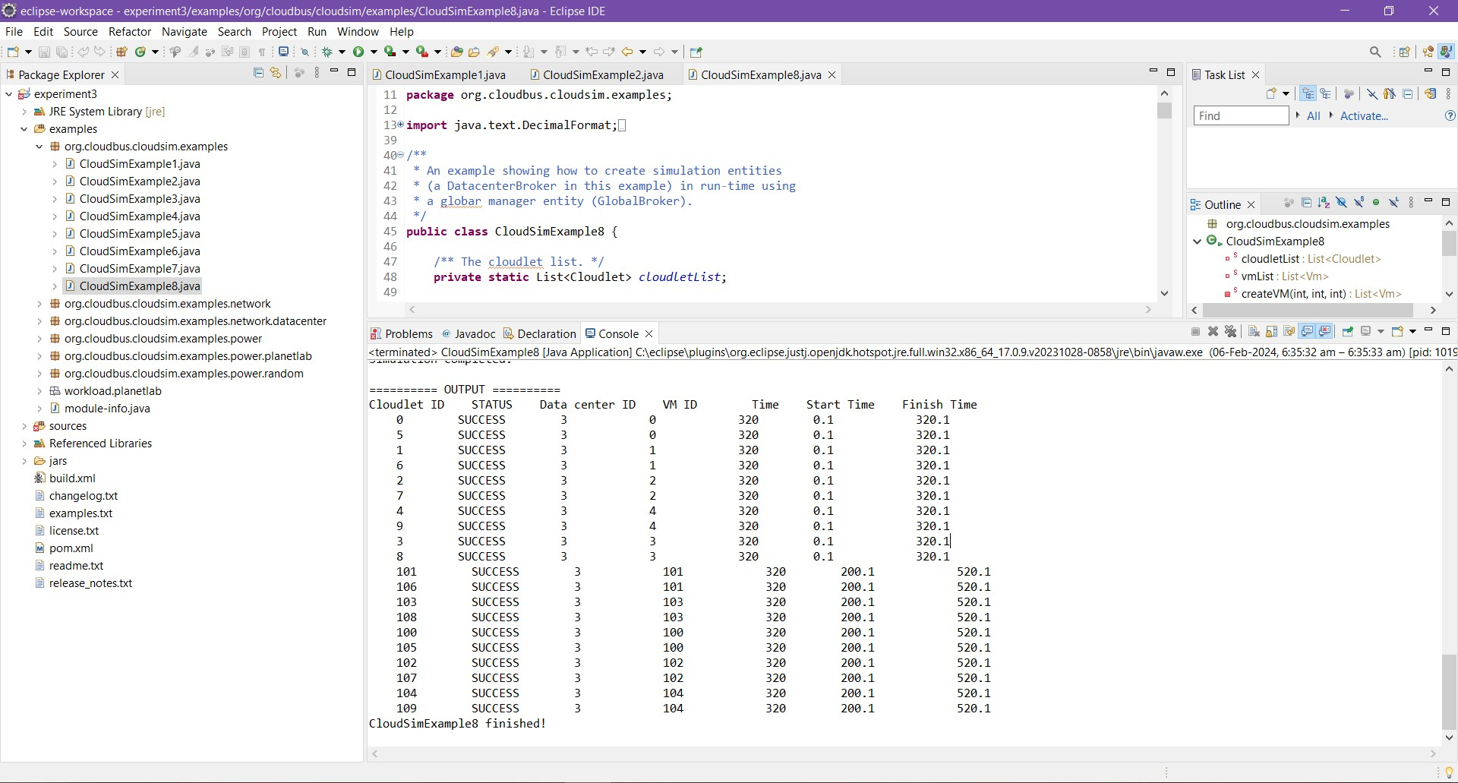

# Learning Outcome:

* Learn how to Install cloud sim and common math libraries
* Understand how to install Eclipse IDE.
* Understand how to new java project, add path and external libraries.
* Learned how to run java program related to cloud Sim and analyze the output.