# Experiment 1.4

**Student Name: Aaryan Aneja UID:21BCS9186**

**Branch: BE-CSE Section/Group: CC-646-B**

**Date of Performance:20-02-2024 Subject Code: 21CSP-378**

**Subject Name: Cloud Computing & Semester: 6 Distributed Systems**

# Aim:

Use of GAE launcher to launch the web applications.

# Objective:

With the help of Google App Engine Launcher connecting to the GitHub Repository through the Cloud Shell console and fetching the files through HTTPS connection.

# Steps to Install:

Step 1: Open the browser and search google app engine and open the cloud.google.com

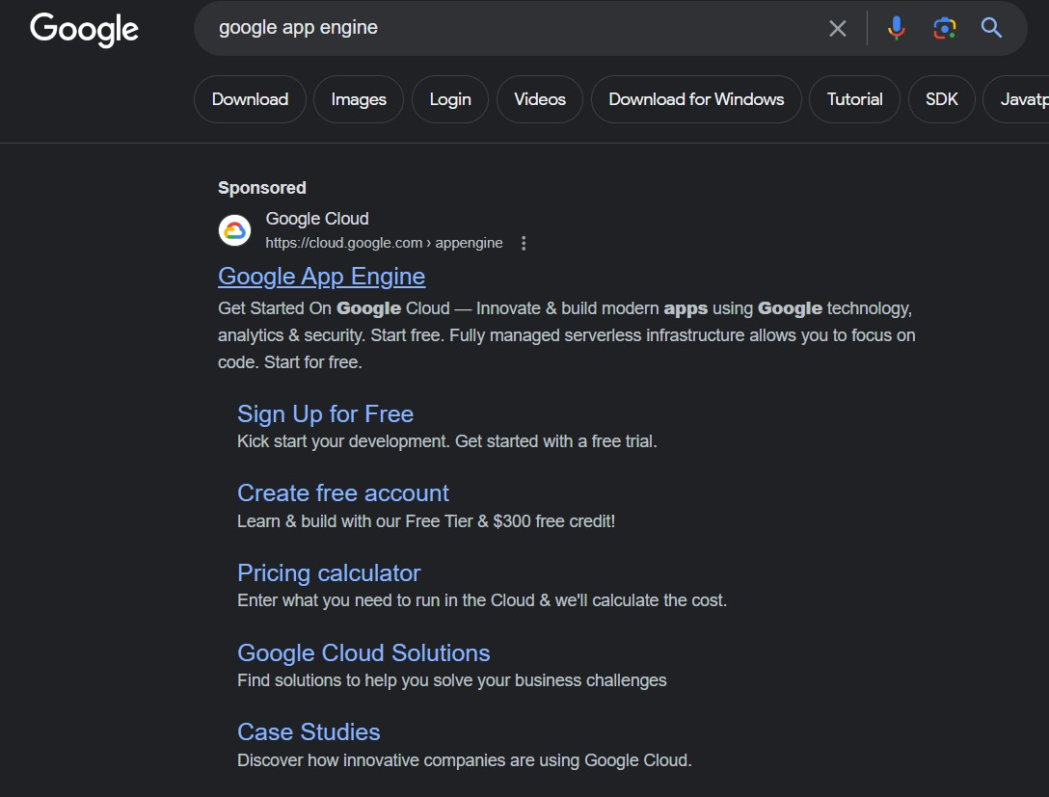

Step 2: Now click on the Go to console button and wait for the new window to open.

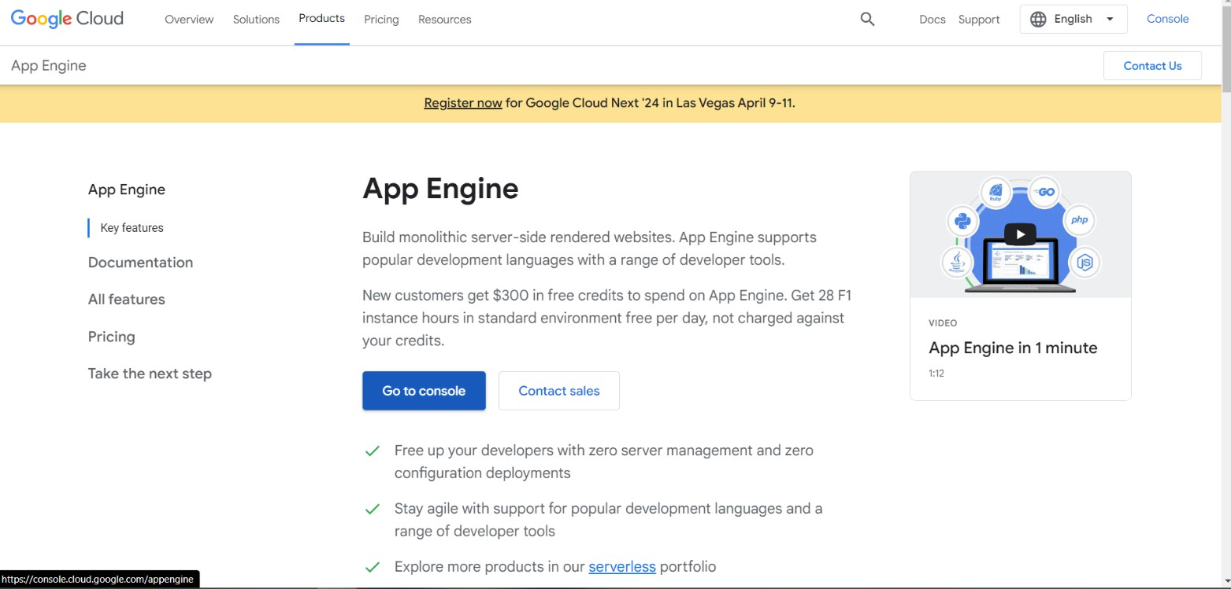

Step 3: The dashboard will open and go the Active Cloud Shell and open it.

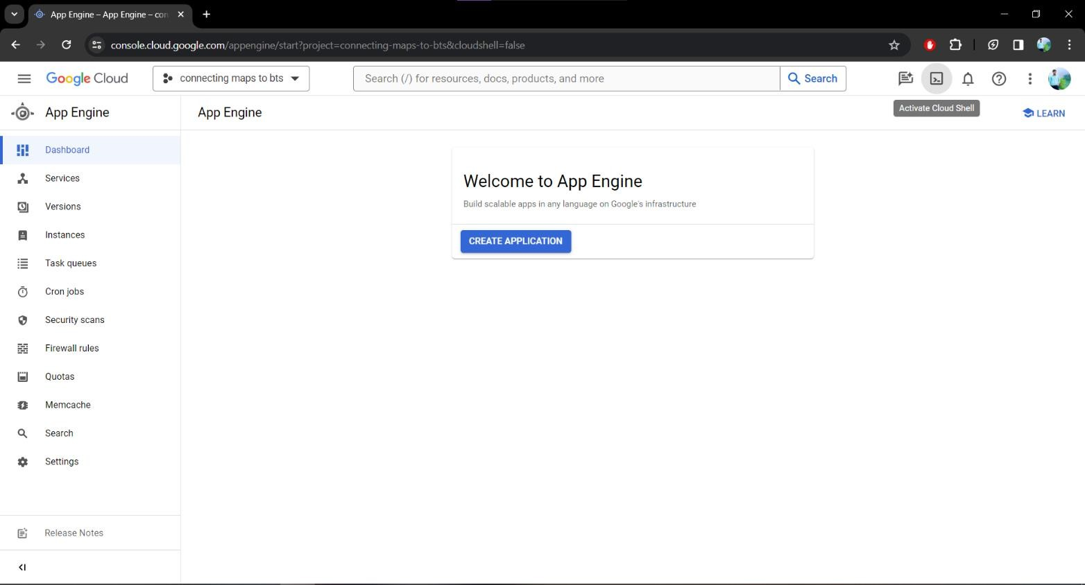

Step 4: Now open the GitHub account and select any repo and its HTTPS web URL .

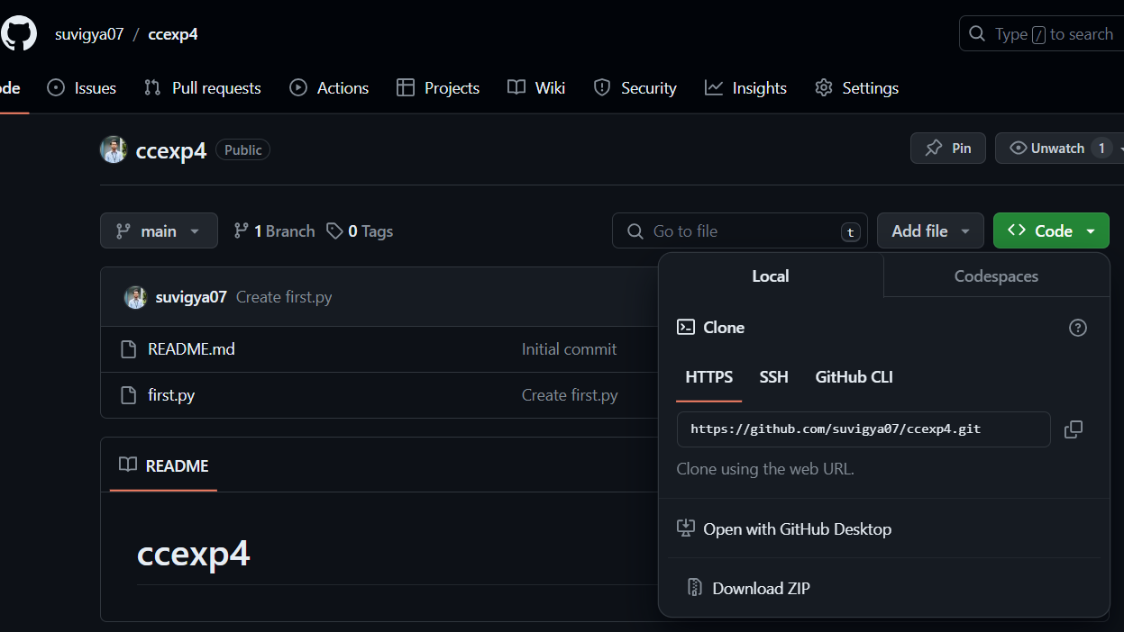

Step 5: Once its connected type ls command to check the present files. Now enter the “git clone (copied url)” command to clone the files from the GitHub.

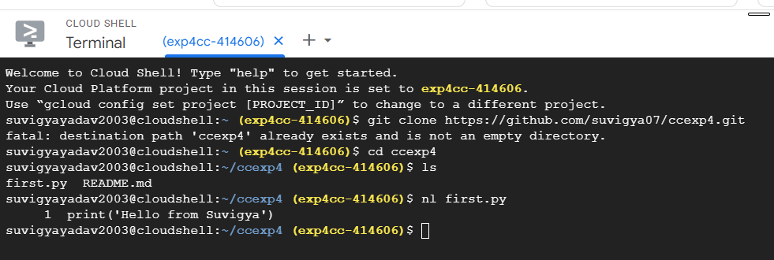

Step 6: Now open the README.md file through nl command. Similar way we can launch web applications.



# Learning Outcome:­­­­­

* Learn about the Google App Engine
* Understand how to use Cloud Shell and clone repositories.
* Understand how to connect the web application through https connection via command line.
* Learned how to run web application through google app engine.