**Experiment-2.2**

**Student Name: Aaryan Aneja UID: 21BCS9186**

**Branch: CSE Section/Group: CC-646-B**

**Semester: 6th Date of Performance: 05/03/24 Subject Name: Cloud Computing and Subject Code: 21CSP-378**

**Distributed Systems**

**Aim:** To Find a procedure to transfer the files from one virtual machine to another virtual machine.

**Objective:** To share files between two virtual machines over a local network via Ip address

# Procedure:

**Step 1:** Open the file manager and right-click on the folder you want to share or create a new folder. Click on the option “Local Network Share” in the context menu.

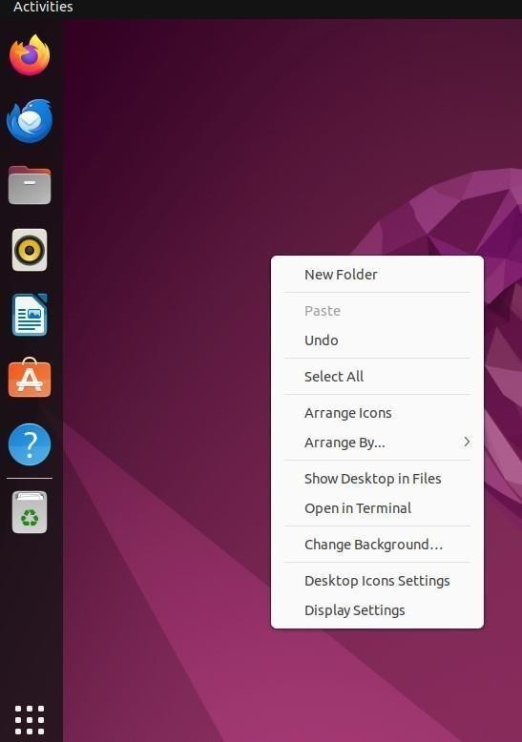

**Step 2:** Click on the Share this folder checkbox in the Folder Sharing dialog.

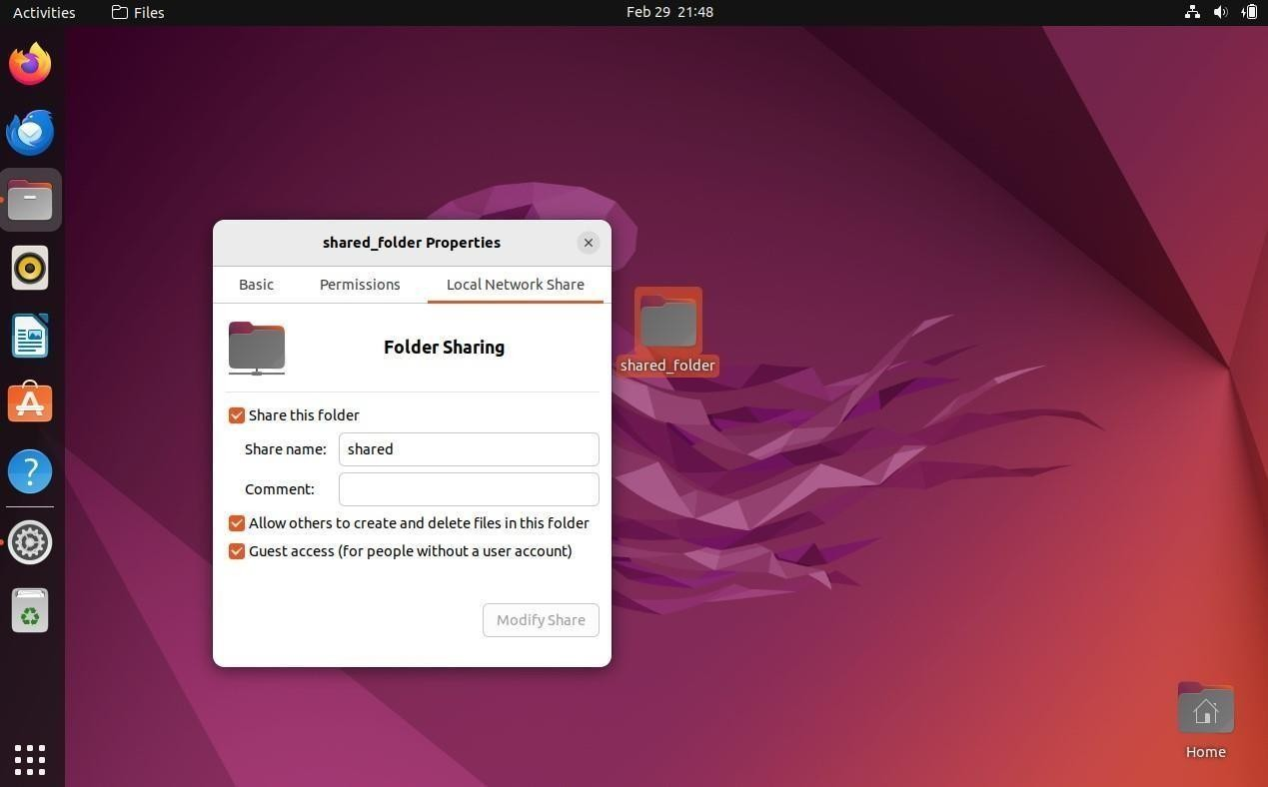

**Step 3: Install** [**Samba**](https://en.wikipedia.org/wiki/Samba_(software)) **packages** in your system. Samba is used to share files and printers over the network between Windows and Unix systems.

After samba installation, do the following to share a folder or directory.

* Select the checkbox Share this folder.
* Input a share name. This would be the name you would be seeing from another system, e.g. Windows. Try not to use any name with spaces.
* (Optional) You can control the write permission to the shared folder and allow guest access by checking the corresponding option.
* If you allow guest access, people without credentials can access the shared folder. So be cautious.

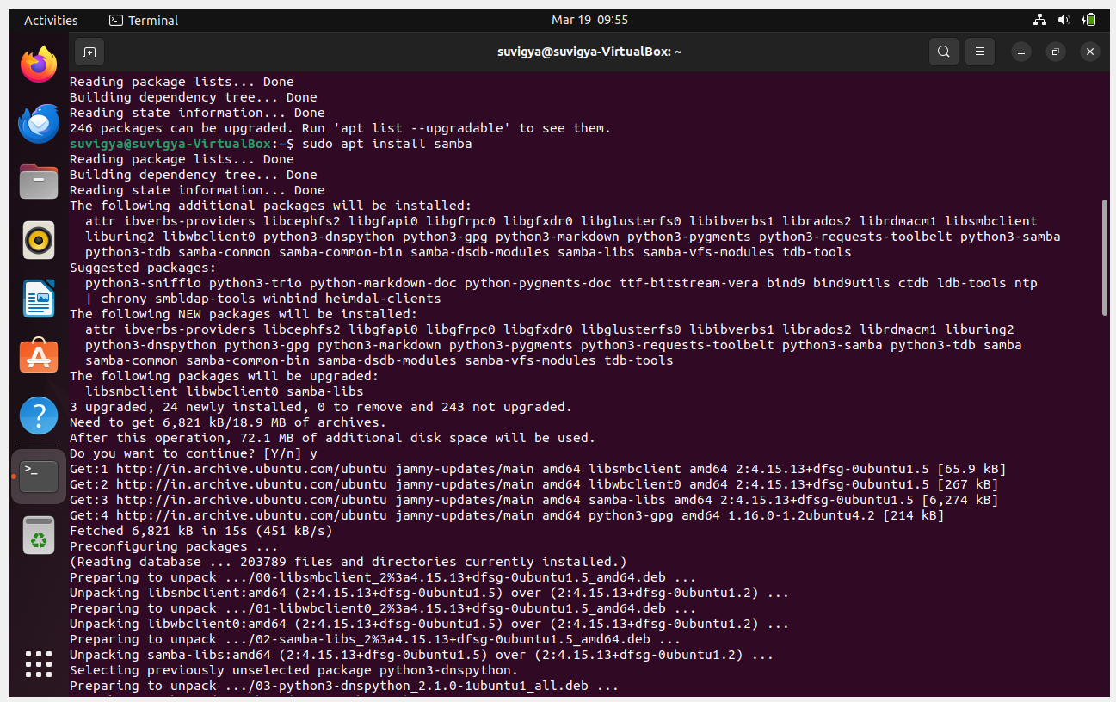

**Step 4:** To access the shared folder from Ubuntu/Linux system, you need your system’s

IP address/hostname. To do that, open System Settings -> Wifi -> **Get the IP address.**

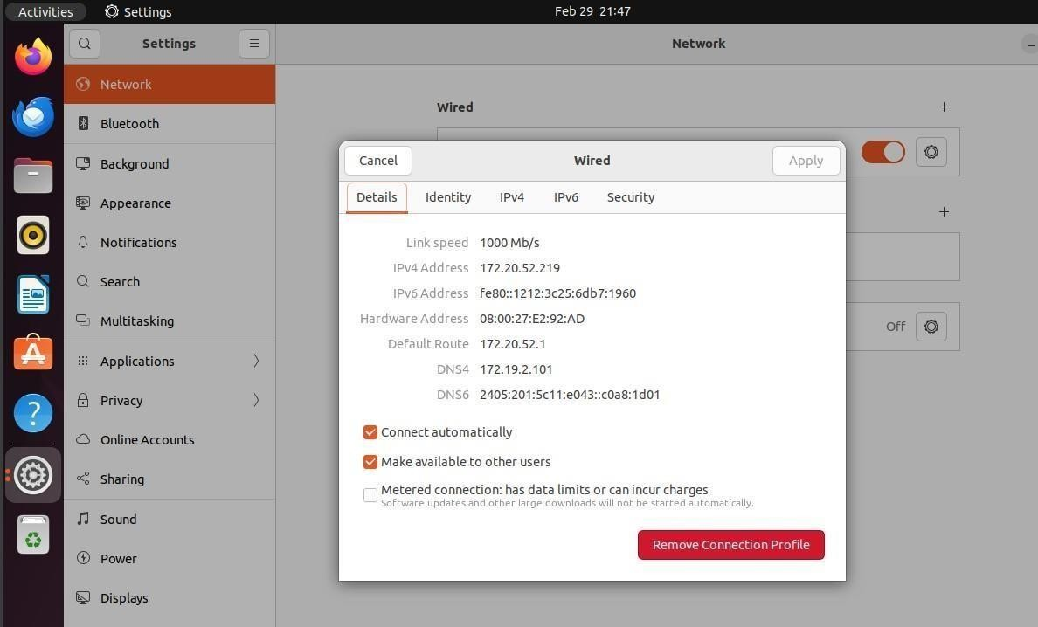

**Step 5**: To access the shared folder from the **Windows system or** any other VM, Open Run (Windows Key+R) or open Explorer and enter the address below. You should change the IP address and Folder name based on your system

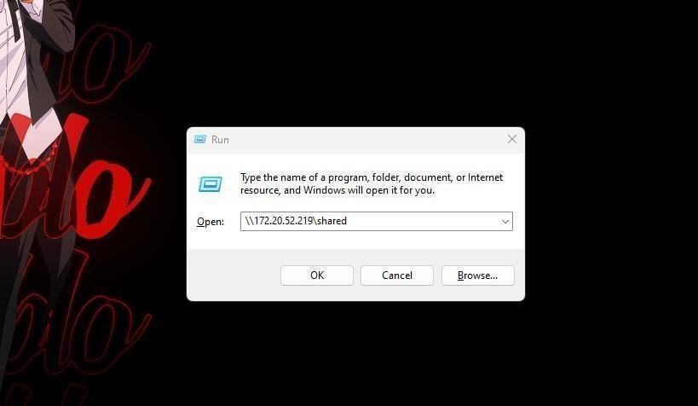

The system will also ask you to enter the username and password of the user on the PC.

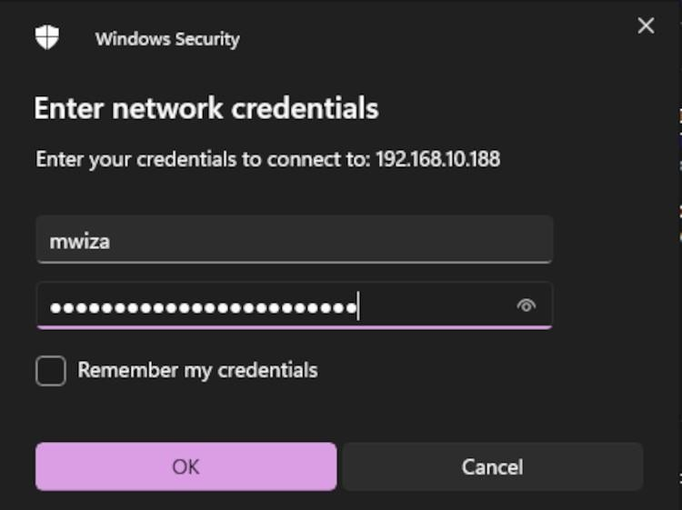

**Step 6:** THE CONTENTS OF THE SHARED FOLDER ARE NOW VISIBLE IN THE OTHER OPERATING SYSTEM

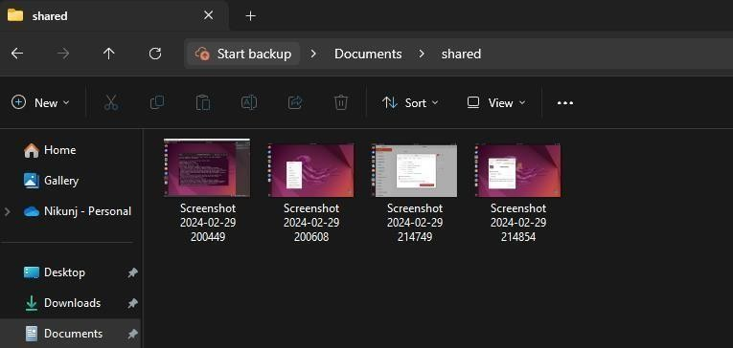

# Learning outcomes

* Learning the usage of samba library
* File transfer between two VMs
* Creating local server between guest VM and OS