Software Requirements Specification



for

Automated Financial Management System

Version <1.0>

|  |  |  |  |  |
| --- | --- | --- | --- | --- |
| Suvigya Agrawal | | 150953130 | | [suvigya1st@gmail.com](mailto:suvigya1st@gmail.com) |
| Y Aditya Sai | | 150953128 | | [adityasai24@gmail.com](mailto:adityasai24@gmail.com) |
| Nidhesh Perumal | | 150953042 | | [nidheshperumal@gmail.com](mailto:nidheshperumal@gmail.com) |
| Instructor: | | K. Rajesh Rao | |
| Course: | | Rational Unified Process Lab Project | |
| Lab Section: | | *CCE-B1* | |
| Date: | | 25/09/2017 | |
|  | |  | |

Prepared by:

Contents

Revisions 33

1 Introduction 4

1.1 Document Purpose 4

1.2 Product Scope 4

1.3 Intended Audience and Document Overview 4

1.4 Definitions, Acronyms and Abbreviations 5

1.5 Document Conventions 5

1.6 References and Acknowledgments 5

2 Overall Description 6

2.1 Product Perspective 6

2.2 Product Functionality 6

2.3 Users and Characteristics 6

2.4 Operating Environment 7

2.5 Design and Implementation Constraints 7

2.6 User Documentation 7

2.7 Assumptions and Dependencies 7

3 Specific Requirements 8

3.1 External Interface Requirements 8

3.2 Functional Requirements 9

3.3 Behaviour Requirements 11

4 Other Non-functional Requirements 12

4.1 Performance Requirements 12

4.2 Safety and Security Requirements 12

4.3 Software Quality Attributes 12

Revisions

| Version | Primary Author(s) | Description of Version | Date Completed |
| --- | --- | --- | --- |
| 1.0 | Suvigya Agrawal  Y Aditya Sai  Nidhesh Perumal | Information about the Automated Financial Management System that can be used at every store for sale of goods and products. Also it helps in the management and the detailed report too. | 25/09/17 |

# 

# Introduction

## Document Purpose

The purpose of this document is to present a detailed description of the Automated Financial Management System. The product description in this document is of AFMS V 1.0.0.

The document will explain the purpose and features of the system, the interfaces of the system, what the system will do, the constraints under which it must operate and how the system will react to external stimuli. This document is intended for both the stakeholders and the developers of the system. The SRS describes the entirety of the AFMS V 1.0.0.

## Product Scope

AFMS is a desktop application which at its core tracks all logistical and financial data of a the particular client. This system is designed to maximize the productivity of the portfolio managers and accountants by providing tools to assist in automating the logistics and invoices review, which would otherwise have to be performed manually.

The databases keeps an inventory of all products. The products are categorized by type, name, price, tax bracket, unique code, vendor. This helps the portfolio managers access required information during sales review, profit and risk analysis. All transactions of the products and their invoices are updated onto the database automatically. This helps tax calculation at the end of the financial year. The sales information obtained helps risk assessment for the vendor credit which is reviewed every quarter. The system also provides recommendations to assess product purchases from vendors based upon the transactional history of the vendors.

## Intended Audience and Document Overview

The intended audience of the document are the software developers, testers, portfolio managers and accountants. It is recommended that people with no knowledge  of the product read the document in sequence starting from the overview, all the way to the end. Developers and all other stakeholders, with relevant knowledge of the product may skip through the sections to read only the relevant parts of this document. Appendices may be referred to navigate the document.

Relevance of use for each actor:

Developer - To help in update and upgradation of software.

Tester - To help in figuring out the working of each module and its limitations.

Portfolio Managers and Accountants- To know the accuracy and flexibility of software so they can make reliable decisions when making critical decisions.

## Definitions, Acronyms and Abbreviations

* AFMS: Automated Financial Management System
* SRS: System Requirement Specification

## Document Conventions

This document uses standard typographical conventions with font Arial (size 12, bold) used headings, and Arial (size 11) for normal text. The numbering convention used is an ordered list for every section of the document and the same is followed for subsection. Bold font is used in text to highlight important text wherever necessary. Subheadings under subheadings are in italics. All links used are underlined for better readability. For solely the purposes of ease of writing, the gender used throughout the documentation is male.

## References and Acknowledgments

Books: An Integrated Approach Software Engineering 3rd Edition by

Pankaj Jalote.

Website: <http://www.W3shools.com>

# Overall Description

## Product Perspective

Product perspective is essentially the relationship of the product to the other products, defining if the product is independent or is part of a larger product (dependent), and what the principal interfaces of the product are.

This software is totally independent system that manages activities of the seller as by taking into account the basic functionalities used. It starts from the maintain the inventory of the goods or the products to the selling those goods and generating a user-modified bill. The details are being saved and calculated and smart reports are generated for the sales team to get into the minor details to increase the profit. Also any article can be searched and can within seconds using different criteria to filter them out.

Database

**retrieves data**

Customer

**generates**

**searches order**

**selects order**

System

Salesman

Bill

High-level Diagram

## Product Functionality

* Store a detailed inventory list about the goods available.
* Search the particular item or items according to the criteria needed.
* Easily modify the taxation and the discount.
* Generate easy to go bills.
* Store information about the customers for further study.
* Make smart reports on the articles sold or which type of article to be focused more on for better profits.

## Users and Characteristics

The users in the management system are Customer, Receptionist, Salesman, Sales Manager, Owner, Admin. They play different roles and are mostly in different types of shops.

* **Customer** : The user whose details are stored in the system. He buys the products from the list of available inventories.
* **Receptionist** : The one that adds the list of articles in the billing desk as that are bought by the Customer. It can also check a particular product. It maintains the backup of the data too.
* **Salesman** : It is same as the Receptionist, but it can also check the detailed list of articles that are in the available inventory list.
* **Sales Manager** : It can view the list of the sold articles and imply results from the reports made by the data collected on the sold articles.
* **Owner** : It has the overall control to view each and every detail.
* **Admin** : It can change any changes in the criteria that might be required.

## Operating Environment

This proposed software will be used in Windows platform in the version of Windows 7.

MySQL will be used for the database to hold the customers, inventory and billing details.

## Design and Implementation Constraints

* Operating system: Windows platform, Linux, Mac OS
* Processor: Pentium 4
* Processor speed: 2.5 GHz
* RAM: 512MB
* Hard disk drive: 40GB

## User Documentation

The system shall be a web based application system running in a windows environment. The system shall be developed using PHP and MySQL server.

A person who has no knowledge of computers will find it difficult to understand the system. But with a little knowledge it will be very easy to handle the project. Standard compliances. This document follows IEEE standard for software requirement specification.

## Assumptions and Dependencies

The code should be free with compilation errors/syntax errors. The product must have an interface which is simple enough to understand.

# Specific Requirements

## External Interface Requirements

### User Interfaces

* The system follows a menu-based user interface. This approach allows different users to be presented with different menus and thereby gain user specific access to the database.
* There will be login for different types of users (Salesman, Sales Manager, Admin). These all have different roles in the system and the facilities of each of them can be accessed by a particular login.
* The Admin can access all the details, and can be allowed to alter any changes needed accordingly.
* The Sales Manager can view reports and analysis on them. It can view the daily, weekly, monthly reports on the sales. It can also access the articles sold more to increase the sales.
* The Salesman can view the inventory, add products to the inventory, and generate bill.
* The software shall work in off-line mode and will prompt user for confirming all the main operations like termination, sending email, etc.
* It shall also follow the basic GUI and error message display standards set by Microsoft.

1. Main/Navigation window: Opens when the system starts, shows the Menu, and is used for navigating between different users.
2. Task window (multiple): Opens on the user’s request by clicking. Supports a given task, for example to edit a list, or view or edit details of an entity.
3. Dialog window (one at a time): Opens when the system informs or warns the user, or when the system requires input before continuing an operation.

* Option for off-line help should appear at all times.

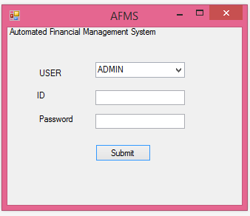

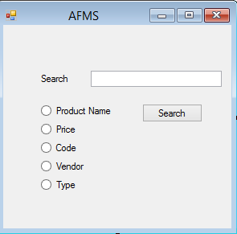

### Hardware Interfaces

* Because the language used to build this software is **Java**, this software creates an executable file that can be used on any platform in the world.
* The software requires a storage media for storing the information related to products or goods. (40GB or above)
* A barcode scanner can be used to scan the barcode for easy entering of the products into the billing system.
* The system should have these hardware requirements:
  1. Processor: Intel Pentium4 3.2GHz or above
  2. Memory: 512MB or above

### Software Interfaces

* This software uses Java as the development language along with NetBeans IDE 8.0.
* Microsoft Excel or SQL Server for database.
* An operating system that supports Java (Linux, Windows XP, 7, 8, 10 etc.)

### Communications Interfaces

* The function allows the communication between Salesman and the Customers via phone and email whose function is provided in the system.
* E-mail:
  + Java-Mail API for sending and composing electronic messages.
  + As soon as the software is told to send an email, it will ask for the email address and will automatically generate the desired message and will send it.
* Download and backup database on Google Drive. User is required to provide login information to access the database.
* For the Sold Inventory List and the details of the bill, since it gets to increase day by day, a better way of it store is automatically transfer the details into a copy database year wise and convert into csv to store the data. This will help the main tables being frequently used have all the values.

## Functional Requirements

The functional requirements of the Automated Financial System are to fulfill the various steps in selling of goods in a systematic manner to have proper management. It controls the functions and on those transactions, the detailed survey reports are being made which allows us to increase profits by focusing on the little details and survey on them.

The software includes functionalities:

1. Adding goods to the inventory list:
   * A good can in two types of inventory list. The two types of the inventory list are Available List and Sold List.
   * The Available inventory list contains all the details about a good (articleNo, articleName, articleCategory, sellingPrice, size, brand, color, barcodeNo, manufactureDate, gender, costPrice, isSold). Various goods are added to the available inventory list that are available for sale. This helps the shopkeeper keep a track on all the list of goods that are available.
   * The Sold inventory list contains the details about a good (articleNo, articleName, articleCategory, sellingPrice, size, brand, color, barcodeNo, manufactureDate, gender, costPrice, priceSold, customerId, billNo). This list adds some details from the available inventory list that are sold. The articles/goods sold details are copied from the available inventory list to the sold inventory list with adding some information about the sale too.
   * This function helps the Sales Manager to keep track on each and every product.
2. Searching product detail:
   * This function allows searching of products and gain knowledge about its deatails.
   * That product can be sold or can be available. For any type of information to be known, we should be able to retrieve a product or a list of products from the inventory lists.
   * Now to search a product, has many options. It can be searched based on:
     + Article Number
     + Barcode Number
     + Article Category
     + Article Name
     + Brand
   * Using any of the above searching criteria, we create a filter and search a product or a list of products both from the available list and the sold list.
3. Generate Bill:
   * The software can be used to generate a bill for the customer. It can be by scanning the barcode or entering the barcode or the article number. The details gets added in the billing desk. The customer details can be added too.
   * It adds the taxes and can be given a special discount on it. The final payment can be done the bill is generated. As soon as the bill is generated the products are added to the Sold inventory list. The bill details are also stored in the separately.
4. Detailed report on sales:
   * The sales are being recorded along with the items being tracked. So the software can give a detailed report on which type of products are being sold more.
   * The software can also track customer-wise too. It shows when a customer is buying a particular product and how often it shops. It gives insight to the Sales Manager about it and helps in showing a way to focus on a particular sector to increase profits.

## Behaviour Requirements

### Use Case View

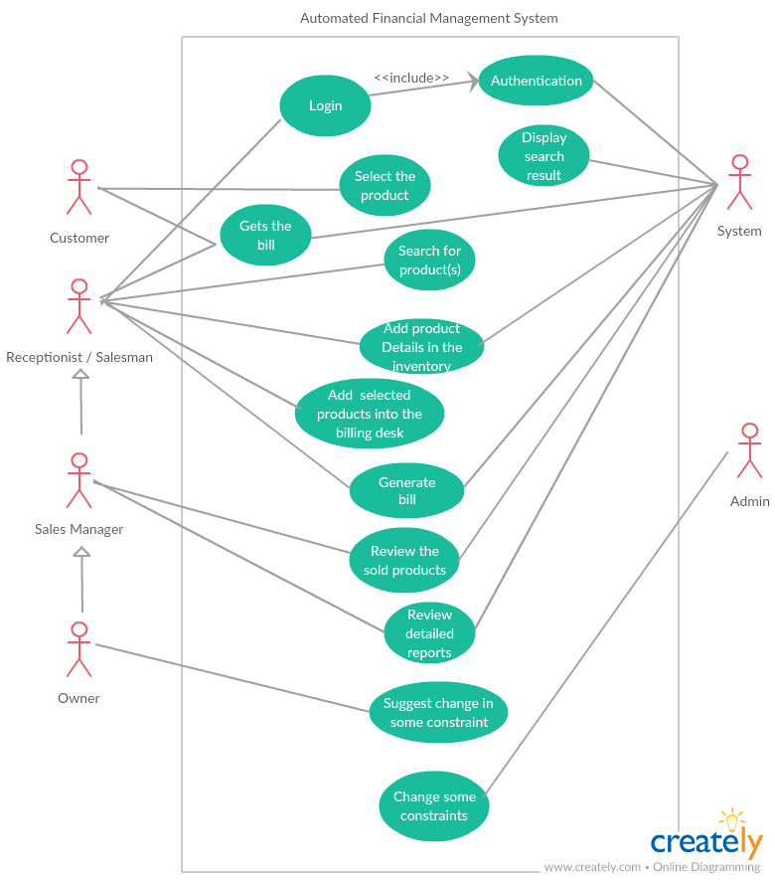

# Other Non-functional Requirements

## Performance Requirements

* Automated Financial Management System manages facilities required by a salesman quickly and easily. It offers to keep track of the inventory and search any article(s) related to requirement (query) immediately within seconds.
* The billing is done within seconds and the details of the bill are automatically added on in the Sold Inventory List, which can be used to monitor the data in seconds.

## Safety and Security Requirements

This system is provided with authentication without which no user can pass. So only the legitimate

users are allowed to use the application. If the legitimate user’s share the authentication

information then the system is open to outsiders.

* In case the user forgets or loses Password, the repair functionality helps by choosing “forgot password” option in the main login window.
* To avoid this kind of situations, backups can be done regularly.
* While typing the password, if the caps lock is on it must be notified.
* If the system is kept idle for 10 min the session will expire.

## Software Quality Attributes

* **Reliability**: Good validations of user inputs will be done to avoid incorrect storage of records.
* **Maintainability**: During the maintenance stage, SRS document can be referred for any validations.
* **Portability**: This system can be installed in any personal computers supporting windows operating system platform.
* **Flexibility**: The system keeps on updating the data according to the transactions that takes place.
* **Timeless**: The system carries out all the operations with consumption of very less time.
* **Security**: Security of the system is maintained d by giving access to only authenticated user id and password.