Adding a doctor-patient chat feature

1. The Problem with Normal HTTP (Before WebSockets)

How normal HTTP works
- The HTTP protocol is the standard way browsers and servers communicate.
- It uses a request-response model:
  - The client (browser) sends a request (like “Give me this web page”).
  - The server sends back a response (like “Here’s the HTML page”).

Limitation
HTTP is one-way:
- The server cannot send data to the browser unless the browser asks for it first.
- So if you want to get new data frequently (like messages, stock prices, live updates):
  - You would have to keep asking the server again and again.
  - This technique is called polling — it’s inefficient, creates delay, and wastes bandwidth.

2. What Are WebSockets?

- WebSockets are a special type of network connection that allows two-way (bidirectional), real-time communication between a client (browser) and a server over a single long-lived connection.

How WebSockets work
- When a webpage first loads, it starts a normal HTTP connection.
- Then, it sends a WebSocket handshake request to the server to “upgrade” the connection.
- Once upgraded, the connection stays open — both sides can send messages anytime.
So:
- Client → Server: send messages instantly
- Server → Client: push updates instantly
This is called full-duplex communication (both can talk at the same time).
- We can use this to make
- Chat applications
- Online games
- Real –time dashboards

3. What Is Socket.IO?

Definition
Socket.IO is a JavaScript library built on top of WebSockets that makes real-time communication easy, reliable, and cross-platform.
It provides both:
- A server library for Node.js
- A client library for browsers (or mobile)

Why not just use raw WebSockets?
Raw WebSockets are powerful, but they can be hard to manage:
- You have to handle reconnections manually if the network drops.
- Some old browsers or networks don’t support WebSockets.
- You must manually define event structures for communication.

Socket.IO solves all that
Socket.IO automatically:
- Reconnects clients if the network fails
- Falls back to other techniques (like long-polling) if WebSockets aren’t supported
- Organizes communication using events (like message, connect, disconnect)
- Supports rooms and namespaces (to group clients or events)
- Works across browsers easily

How Socket.IO works internally
- Client connects to server via WebSocket (or fallback if not possible).
- They establish a persistent connection.
- Both can emit and listen to custom events (e.g., send_message, user_typing).
- Either side can send data anytime, instantly.

What I did in the procedure to make a chat system
- Made the messageModel.js in the backend.
- Modify backend/server.js to integrate Socket.IO with my existing Express serve
- 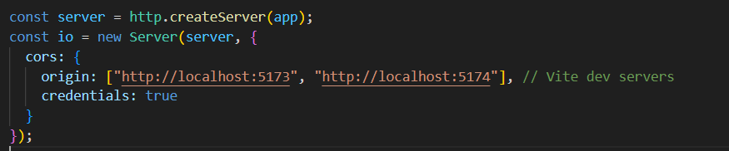

1. http.createServer(app)
- This line creates a raw HTTP server using Node.js’s built-in http module.
- The app argument is your Express application (const app = express();).
- So this server will handle all HTTP routes defined in your Express app (like /api/...).
Essentially, this wraps your Express app into a server instance so you can:
- Use it with Socket.IO (which needs direct access to the HTTP server).
- Start listening with server.listen(port).

2. new Server(server, { ... })
- This creates a Socket.IO server instance attached to the same HTTP server.
- That means HTTP requests and WebSocket (real-time) connections share the same server and port.
io now handles real-time communication — like live chat, notifications, etc.
3. cors configuration
This defines CORS (Cross-Origin Resource Sharing) settings for the Socket.IO server.
- origin: allows connections only from frontend apps served on these URLs — likely your React/Vite frontends running locally on ports 5173 and 5174.
- credentials: true: allows cookies, authorization headers, or socket authentication tokens to be sent along with the connection.

So what happens when you run it
- Your Express backend (app) serves APIs (like /api/doctors).
- Your Socket.IO server (io) handles real-time communication (like chat messages or live updates).
- Both run on the same HTTP server — for example, http://localhost:8000.
- Only clients from localhost:5173 and localhost:5174 can connect to the WebSocket server (for security).
- 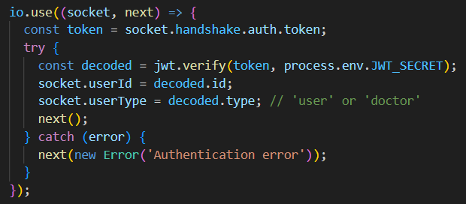
It authenticates every new socket connection using a JWT (JSON Web Token).
If the token is valid → connection proceeds.
If the token is invalid → connection is denied.
1. io.use((socket, next) => {
- This registers a middleware function for all incoming socket connections.
- Every time a client tries to connect, this function runs first.
- It has access to:
- socket: the connection object (contains request data)
- next: a function that must be called to continue (or to reject the connection if there’s an error).
2. const token = socket.handshake.auth.token;
- When the client connects to the server, it sends authentication data in the handshake (initial connection).
- This line extracts the token that the client provided (e.g., in your React code, io('http://localhost:8000', { auth: { token } })).
3. try { const decoded = jwt.verify(token, process.env.JWT_SECRET);
- The middleware tries to verify the token using your secret key (process.env.JWT_SECRET).
- If the token is valid, jwt.verify() returns the decoded payload (for example, { id: "user123", type: "doctor" }).
- If the token is invalid or expired, an error is thrown.
4. socket.userId = decoded.id; socket.userType = decoded.type
- The decoded user info is attached to the socket object.
- This means anywhere else in your server code, you can access:
socket.userId // to identify who sent a message
socket.userType // to know if it’s a doctor or a user
5.next();
if verification succeeded, next() allows the connection to continue — the user is now authenticated.

- 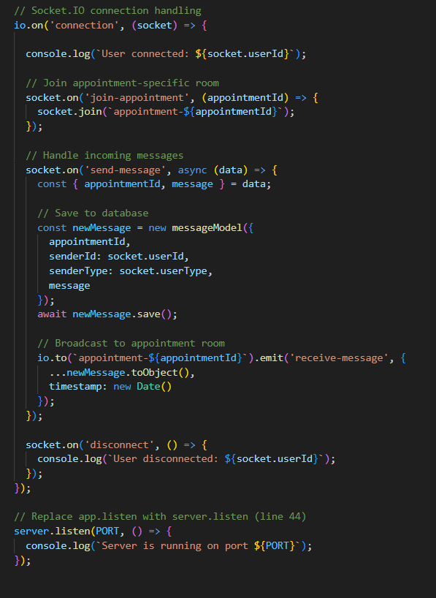
io.on('connection', (socket) => {
- io is the Socket.IO server instance.
- .on('connection', ...) registers an event handler that runs every time a new client connects (after any authentication middleware).
- The callback receives a socket object that represents this particular client’s connection. You use socket to listen for messages from that client, emit messages to that client, and manage which "rooms" the client is in.
- This code handles real-time communication between connected clients using Socket.IO. When a user connects, the server logs their ID and allows them to join a specific “appointment room” based on the appointment ID. When a message is sent, the server saves it to the database with the sender’s details and then broadcasts it to everyone in that appointment room so both the doctor and patient see it instantly. It also logs when users disconnect, and finally, the server starts listening for incoming connections on the specified port.

Here is a full description of how your chat system works, based on the file structure.

Overall Concept
Your chat system is designed for private, one-on-one conversations between a user and a doctor within the context of a specific appointment. It uses a combination of standard HTTP requests to fetch chat history and WebSockets for real-time, two-way communication.
The entire process can be broken down into three main parts:
- Authentication: Verifying who the user is.
- Fetching Chat History: Loading past messages when the chat is opened.
- Real-Time Messaging: Sending and receiving new messages instantly.

How It Works: A Step-by-Step Flow

1. Authentication: The Entry Ticket to the Chat
Before anything else, the system needs to know who is trying to chat.
- Login: When a user or a doctor logs in (userController.js or doctorController.js), the server generates a JSON Web Token (JWT). This token is a secure digital key containing the user's ID and their type ('user' or 'doctor').
- Token Storage: The frontend application receives this token and stores it, usually in the browser's local storage.
- Socket.IO Authentication (server.js): When the user navigates to a chat page, the frontend tries to open a WebSocket connection with the server. It sends the stored JWT as part of this initial connection request.
  - A special middleware on your server.js intercepts this request. It verifies the token. If the token is valid, it extracts the user's ID and type and attaches them to the socket connection.
  - If the token is invalid, the connection is rejected. This is a crucial security step that ensures only logged-in users can connect to the chat server.

2. Fetching Chat History: Loading Past Conversations
When a user opens a chat window for a specific appointment, they expect to see the previous messages. This is handled via a standard API call, not WebSockets.
- Frontend Request: The chat page (UserChatPage.jsx or DoctorChatPage.jsx) makes a GET request to an API endpoint like /api/user/messages/:appointmentId.
- Backend Handling (messageController.js):
  - The getMessages function in the controller receives this request.
  - It first checks if the logged-in user (whose ID it knows from the authentication token) is actually a participant in that appointment. This prevents a user from snooping on someone else's chat.
  - If authorized, it queries the messageModel in the database for all messages matching the appointmentId, sorts them by time, and returns them to the frontend.
- Displaying Messages: The frontend receives this list of historical messages and displays them in the chat window.

3. Real-Time Messaging: The Live Conversation
This is where WebSockets and Socket.IO come into play, enabling instant communication without needing to refresh the page.
- Joining a Room (server.js): After the WebSocket connection is authenticated, the frontend client immediately sends a join-appointment event to the server, specifying the appointmentId. The server then places this user's socket into a private "room" named after the appointment (e.g., appointment-6907c07b6ace5be0d457a075). This is like putting the user and the doctor into a private virtual chat room.
- Sending a Message:
  - A user types a message in ChatBox.jsx and hits send.
  - The frontend emits a send-message event to the server via WebSockets. This event includes the appointmentId and the message text.
- Server Processing (server.js):
  - The server listens for the send-message event. When it receives one, it knows the sender's ID and type from the authenticated socket connection.
  - It creates a new message object with all the necessary details (appointmentId, senderId, senderType, message).
  - It saves this new message to the MongoDB database using messageModel. This ensures the message is permanently stored.
  - Crucially, the server then broadcasts a receive-message event containing the new message data only to the specific appointment room.
- Receiving a Message:
  - Both the sender and the other participant are in the same room, so they both receive the receive-message event from the server.
  - The frontend listens for this event. When it catches it, it takes the new message data and adds it to the chat window in real-time.
This architecture ensures that the chat is both secure and efficient. HTTP is used for the one-time task of loading history, while the more lightweight WebSockets are used for the continuous flow of live messages.

Process of showing new messages badge on the message icon

1) High-level idea (plain language)
- Every message saved in the DB has a flag isRead (you already have this).
- When a new message is posted, the server:
  - saves the message,
  - computes how many unread messages the other participant has (messages they didn’t send and isRead=false),
  - emits a real-time event to that other participant (or to any UI listening) with the updated unread count.
- On the client (doctor or user), you:
  - open a socket connection and listen for unread-count updates,
  - show the unread count in a small badge on the message icon,
  - when the chat is opened, call an API to mark the relevant messages as read; the server updates DB and broadcasts the new unread count.
That’s the mental model: messages → DB flags → server calculates count → server pushes count

Here is a complete, step-by-step explanation of the entire backend functionality for getting and showing unread messages.
The whole process can be broken down into two main parts:
- Counting the Unread Messages: This is for displaying the notification badge (e.g., "You have 5 new messages").
- Marking Messages as Read: This happens when the user actually opens a chat to read the new messages.

Part 1: Counting Unread Messages
This is what happens when the frontend needs to know how many new messages a user or doctor has.
- The Request: The frontend sends a GET request to a special endpoint.
  - For a user: GET /api/user/unread-messages
  - For a doctor: GET /api/doctor/unread-messages
- Authentication (Middleware):
  - The authUser or authDoctor middleware intercepts the request.
  - It verifies the JWT token from the request headers to confirm the user is logged in.
  - Crucially, it decodes the token to get the user's ID (req.userId or req.docId) and their role (req.userType, which is either 'user' or 'doctor'). It attaches this information to the req object for the next step.
- The Controller (getUnreadMessagesCount):
  - The request is passed to the getUnreadMessagesCount function in either userController.js or doctorController.js.
  - Step A: Find All Appointments: The function first queries the appointmentModel to find every single appointment associated with the logged-in user's ID.
  - Step B: Identify Messages to Check: It knows that unread messages for a user must have been sent by a doctor, and vice-versa.
  - Step C: Count the Messages: It performs a countDocuments query on the messageModel with three strict conditions:
    - The appointmentId must be one of the appointments found in Step A.
    - The senderType must be the opposite of the current user's role (e.g., if req.userType is 'user', it looks for senderType: 'doctor').
    - The isRead field must be false.
  - This query efficiently returns only the number of messages that are unread for the current user.
- The Response: The controller sends a JSON response back to the frontend, containing the final count, like this:
Part 2: Marking Messages as Read
This is what happens when a user clicks on a chat and the message history is displayed.
- The Request: The frontend sends a GET request to fetch the contents of a specific chat.
  - Example: GET /api/user/messages/60d21b4667d0d8992e610c85 (where the last part is the appointmentId).
- Authentication (Middleware):
  - This works exactly the same as before. The authUser or authDoctor middleware verifies the user and adds their ID and role (userType) to the req object.
- The Controller (getMessages in messageController.js):
  - The request is passed to the getMessages function.
  - Step A: Authorization: It first checks if the logged-in user is actually a participant in the requested appointment. This prevents users from snooping on other people's conversations.
  - Step B: Mark as Read (The Core Logic): Before fetching the messages, it performs an updateMany query on the messageModel. This query finds all messages that meet the following conditions:
    - They belong to the specific appointmentId from the request URL.
    - Their senderType is the opposite of the current user's role.
    - Their isRead status is false.
  - For all messages that match, it sets { isRead: true }. This is done in a single, efficient database operation.
  - Step C: Fetch All Messages: After the update is complete, the function proceeds with its main job: it fetches all messages for the appointmentId (both read and unread, from both sender and receiver) and sorts them by timestamp.
- The Response: The controller sends a JSON response back to the frontend with the full chat history.
→ client updates UI.

