**Andarilha**

Third Person - Single Player

Unreal Engine 5  
Genre: Adventure 3D, Horror

## Progression type

Non-Linear

Open HUB

Metroidvania-like

Hallway-like

Elevator-like

## Theme

Surrealism-like / Nightmare-like

Dream-like / Dreamcore / Liminal space*

Cyber Punk (dark + neon)  
Art Deco

Retro Futurism

Dark city/ low light caused by high buildings blocking sunlight to reach the ground floor

Player access <= 1% of the environment

Narrative through the environment art and level design, having the architecture as a key element for the game.

Player can’t fight back

* Places that feel familiar and strange at the same time. Narrative created by our own minds.

## Art Direction

3D Low Poly

Semi realistic

## Story summary

In a futuristic dystopian city, cybersecurity has become a problem. Companies are being threatened and having their sensitive data about their business decisions leaked.

Data is the new oil. Storing and trafficking them within Clouds is getting even more dangerous, to a level that some data/information/messages need to be shared in analogical/offline/physical way, such as pendrives and letters.

The issue created a demand in the market for special couriers/messengers that can deliver this data/information/messages safely from point A to point B. It's a high-risk job once the courier/messenger is bearing information that others (interceptors/data pirates) want to steal and sell to other companies and/or the illegal market.

Andarilha is the game's protagonist and has been working as one of these couriers/messengers. In one of her jobs, she unintentionally read valuable information about how companies are planning the city's future. This event makes her wonder about how her job might influence the future, and that data pirates might not be that much wrong by stealing data/information/messages.

She decides to live a double life as a special courier. Delivering messages for companies and escaping from interceptors/data pirates, as well as a data pirate, invading places to steal the most important data these companies might have and running away from security guards that protect the companies' properties.

Andarilha needs to deliver, steal and escape.

## Mechanics

* Movements
  + Walk
  + Run
  + Sprint
  + Jump
  + Jump Climb
  + Climb up / down
* Interactions
  + Triggerable actors: door lock, …
  + Collectables: key, card access, …
* Inventory / UI
  + Move up
  + Move down
  + Use
  + Drop
* Save / Load game

## Controls

- Gameplay

|  |  |  |
| --- | --- | --- |
| **Action** | **Controller** | **Keyboard + Mouse** |
| Locomotion (Walk, Run, Sprint) | Left thumbstick | WASD |
| Look camera | Right thumbstick | Mouse |
| Activate sprint | A (face button right) | Left shift |
| Jump | B (face button bottom) | Space |
| Sprint Jump |  |  |
| Interact | X (face button top) | E |

- UI Inventory

|  |  |  |
| --- | --- | --- |
| **Action** | **Controller** | **Keyboard** |
| UI Use | Right | Arrow Right |
| UI Drop | Left | Arrow Left |
| UI Up | Up | Arrow Up |
| UI Down | Down | Arrow Down |

## Description of Play Experience

Level 1

- Section 1 - Train

-- Andarilha is getting a train from Bleucollar Station to City Hall Station (Nova's Downtown). Enters the train a activate trigger to the next station.

-- There is a propaganda glued on the train's wall, it's communicating to people to land a job at Nova Express (some delivery office, kindof uber).

-- On both train stations, we can see/identify their names. (Bleucollar Station ; City Hall Station)

-- Train arrives at City Hall Station, and its doors open by sliding out, opening.

-- Andarilha walks through the station in direction of City Hall.

-- Block passage to Museum, Office and any other place that it's not meant to be accessed at this moment. (Create HUB instead of blocking access too much)

-- Level Streaming from Section 1 to Section 2.

- Section 2 - City Hall

-- Enters the building and gets delighted by the City Hall's interior.

--- Sees City Hall's Logo in art deco style.

--- Realizes that there's a painting from Tarsila do Amaral on the building's mezzanine, Trabalhadores - Workers (1933), right above the elevator's entrance.

-- Andarilha can wander around the floor and visit the theatre, coffee shop, bookshelves or go upstairs.

-- Talks with receptionist to figure out where to go next. She indicates that you go upstairs.

-- Andarilha go upstairs and talks with another city hall employee, who indicates that you should get the elevator to Mayor's Office.

-- Andarilha gets elevator.

-- Level Streaming from Section 2 to Section 3.

- Section 3 - Mayor's Office

-- Exits elevator and finds the Mayor's Office.

-- Talks with Mayor, getting your first job to deliver a mysterious package to Toscos Office.

-- Mayor indicates the path to the nearest footbridge to the next building.

-- Andarilha goes to a door in the same (nearest?) floor that gives access to the footbridge that takes her to Toscos Office Building.

-- Level Streaming from Section 3 to Section 4.

- Section 4 - Toscos Office

-- Exits footbridge.

...

-- End... So far.

## Characters

**Andarilha**

* Main character
* Velocity:
  + Walk: 0 – 150
  + Run: 151 – 300
  + Sprint: 301 – 600*
* Interact radius: 1.50m
* Account balance: 0
* Player jump distance:
  + Running: ~3m
  + Sprinting: ~5m
* Die falling distance: ~6.1m
* Stats:
  + Health: 100
  + Stamina: 100
  + Stamina loose rate when sprint(temporary): 15 / second
  + Stamina recovery rate: 10 / second
* Sprint consumes Stamina

**Eye – TBD – Not implemented**

* Andarilha’s companion inventory
* Inventory Component
* Floating eye
* Follows the player
* Collect items within player’s radius distance: 3m
* If interacted within 3m from player’s radius, it moves towards the item to collect them
* Works as a chest/inventory.
  + Capacity: 5 slots
  + Not stackable
  + Actions:
    - Interact/Get (!)
    - Use
    - Drop
    - Navigate: Move Up, Move Down

**References for design:**

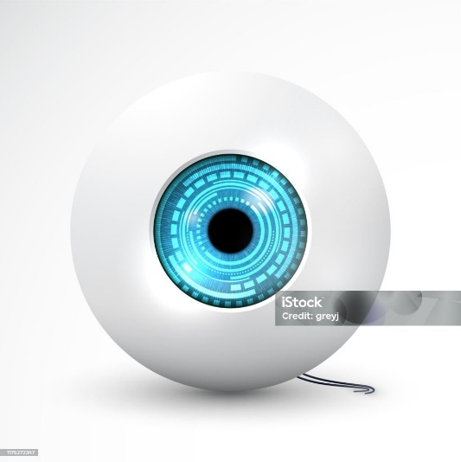 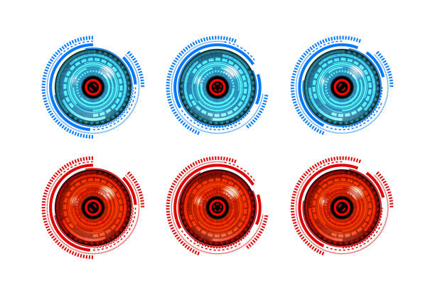



**Game References:**

Don’t starve – Chester Followers



Moonlighter - Familiars



## Guardbot

## Mayor

* TBD

## Receptionist

* TBD

## Trigger items

* Trigger base
* Pin Pad
* Wall button
* Floor button
* Key lock
* Card lock/receptor
* PC / laptop

## Movable objects

* Elevators
* Trains
* Doors
* Safers

## Collectable Items

* Keys
* Access card
* Flashdrive / pendrive
* Packages/ Parcels
* Letters / Mails
* Edibles (Apple, water, ...)

Collectable Edibles**\* \*\*** – Not implemented

|  |  |  |  |  |
| --- | --- | --- | --- | --- |
|  | **Stamina** | **Velocity** | **Price** | **Rarity** |
| **Coffee cup** | +5 | +50 | 110 | Medium |
| **Water** | +5 | +25 | 100 | Rare |
| **Apple** | +5 | +10 | 66 | Rare |
| **Cola** | -5 | +10 | 30 | Common |
|  |  |  |  |  |

*Increase/Decrease vs Recover/Remove

**Absolute vs Percentage

## Nova city places – Open Hub – Not Implemented yet

**Inside Colosseum Downtown**

* City Hall (Banespa SP / Crysler NYC)
* Office 1 (Cenesp)
* Office 2
* Office 3
* Museum (masp SP) -
* Hospital
* Temple ()
* Stadium (Cowboy hat)

**Outside Colosseum Downtown**

* Factory: Oil drum (Sesc Pompeia SP)
* Refinery: Oil and Gas
* Airport
* Landfill
* Mine
* Log industry
* Water treatment
* Residences:
  + Favela
  + Ranch
  + Modern - Alphaville
  + Greek revival
  + Futurism - Dome

## Brands

* Tosco – Supermarket
* Bill Mortons – Coffee Shop
* Edaí – Bank
* Last drop – Water, Cola and Refinery

## Asset List

**Edible Collectables**

* Coffee cup (Last drop refinery symbol)
* Water (Last drop refinery symbol)
* Apple
* Cola (Last drop refinery symbol)

**World elements**

* Wall banner / propaganda
* Billboard
* Screens: monitor, tv, laptop, …
  + AD
  + Security camera footage
  + Other images/ videos
* Safer: pin, key, card access
* Doors: pin, key, card access
* Elevator: pin, card access
* Train: (?)
* Key
* Card access
* Floor button
* Wall button
* Movable platform
* Conveyor belt
* Security camera: fixed or following the player
* Walls closing towards the player
* Teleport
* Portal that changes world elements (level streaming?)
* Level Streaming
* Lights kill player
* Spikes kill player
* Floors fall off

## UI

**Inventory**

**\* Remove it from HUD and add it as “sibling” within “pause menu” / Sable Ref**

**Slot**

* Default state: neutral border (add image)
* Hover state: border changes color (add image)

**Quest**

* Addresser: name, short description, address
* Recipient: name, short description, address
* Earns / Payment *
* Fee lost package / not delivered **
* Can have health percentage requirement

*How much she will receive for delivering

**Game gets more intense

**Letter**

* PNG file on screen

**Main Menu**

**Pause Menu**

**Credits Menu**

**Game Over**

**Save System (Load, Save)**

**PIN Widget**

## References

* Games

|  |  |
| --- | --- |
| Elevator Action | * Progress through architecture: elevators and stairs * Infiltrate secret agent, access 30-story building from the roof. Descend to the ground level via elevators and stairways. * Collect secret packages/ documents   Idea for Andarilha: Elevator signals display the elevator is approaching. Elevator reaches current floor and doors open. There are Guardbots inside who starts to chase Andarilha. |
| Tomb Raider 1-3 Remastered | * Hallway-like game * Grandiose architecture * Corridor/Hallway progression * Loop created by the architecture * Level Design * Adventure Exploration * Mechanics (Climbing) |
| Sable | * Usage of mask * Open HUB |
| Super Metroid | * Nonlinear progression |
| Lost in Random | * Quest progression * World design – different ambient, biomes and styles * Level design |
| Inside | * Narrative * Art, Render and Shader Style * Level of architecture details |
| Little Kitty, Big City | * Open hub * Render and Shader Style * Adventure Exploration * Environment art |
| Wylde Flowers | * Open hub * Quests |
| Hogwarts | * Puzzle with portals which changes environment depending on switch on/off of the portal, modifying stairs, blocks, etc. |

* TV Show/Movie

|  |  |
| --- | --- |
| Severance | Labyrinth office architecture. |
| Metropolis | Grandiose architecture.  Labyrinth architecture. |

* Video Analyses

|  |  |
| --- | --- |
| https://www.youtube.com/watch?v=HLeU4BF2s4o | An architect view of the TV show Severance explaining how architecture shape our feelings and emotions |

## Old idea – Backlog

**Decision-Making**

The player needs to decide which quest they are going to get from the City Hall mural (computer space/lan house).

In a advanced stage of the game, I would like to allow the player to decide whether they are going to delivery the package from the quest (and have a possible outcome in the world), or open the package and found out that these important data on the packages are meant to cause changes in the game world and is up to the player to decide if they are going to delivery or not, making the player an important piece in this world.

If the player decides (decision-making), earn money/points but it create bad outcomes to the city by delivering whatever info or content was within that package.

If the player decides (decision-making) to open the package, it immediately shows what is in the package and create a sense of urgency to escape of security guards and/or interceptors/data pirates.

If caught (Game Over)  
If not caught and escaped with success from the building/environment (decision-making), the “bad outcome” won’t happen as would be in the case if you had delivered the package. (This is a “good outcome” (for the game’s history). AND eventually you can find someone else who you can deliver this item and earn money/points with this.

**Rules**

Choices, causes and effects.

~~Effects:  
Pollute river – Refinery / Landfill  
Pollute air – Factory  
Deforestation – Logging company~~

**Environment List / Asset List**

- Downtown

Office buildings A, B, C

Mixed building: office + residential

Residential building – Penthouse example

City Hall

Museum

Hospital

Temple

Supermarket – Tosco

Cafeterie – Bill Mortons

Stadium / Colosseum

- Factory - Oil Drum

- Refinery

- Airport

- Mine

- Landfill

- Logging industry

- Water treatment

- Village1 - Ranch

Ranch / Cottage / Katrina Cottage / Craftsman / Bungalow

Cul de sac

- Village2 - Favela

Amianto roof

- Village3 – Alphaville

Farmhouse / Modern / Contemporary

- Village4 – Dome

Futurism / Dome

- Village5 –

Greek revival / Neoclassic / Beaux Arts