**City Hall - Level Design Document**

**1. Level Name:**

* Level 1 – City Hall

**2. Game/Project:**

* Andarilha

**3. Designer(s):**

* Suellen

**4. Version:**

* V 0.5

**5. Date:**

* 2025 / June / 18

**6. Level Overview**

* **Level Goal:**
  + Learn the basic movements, interact with train and elevator. Get used with the environment and dialogue system.
* **Target Audience:**
  + Beginners that enjoy dystopian and horror games.
* **Level Theme/Setting:**
  + Dystopian
  + Art Deco
  + Futurism
  + …
* **Level Flow:**
  + The player starts on a train; they should interact with the train by pressing “E” when seeing an “!” signal.
  + After that, they arrive in front of the City Hall, there is a path that leads to the entrance of the City Hall.
  + The player will encounter a receptionist who will guide the player upstairs to get a task with a person standing there.

**7. Gameplay Mechanics**

* **Core Mechanics:**
  + Walk
  + Run
  + Sprint
  + Jump
  + Interact with train and elevator
* **Challenges:**
  + Wip
* **Enemy Encounters:**
  + n/a
* **Puzzles/Obstacles:**
  + n/a

**8. Level Layout and Design**

* **Map/Sketch:**

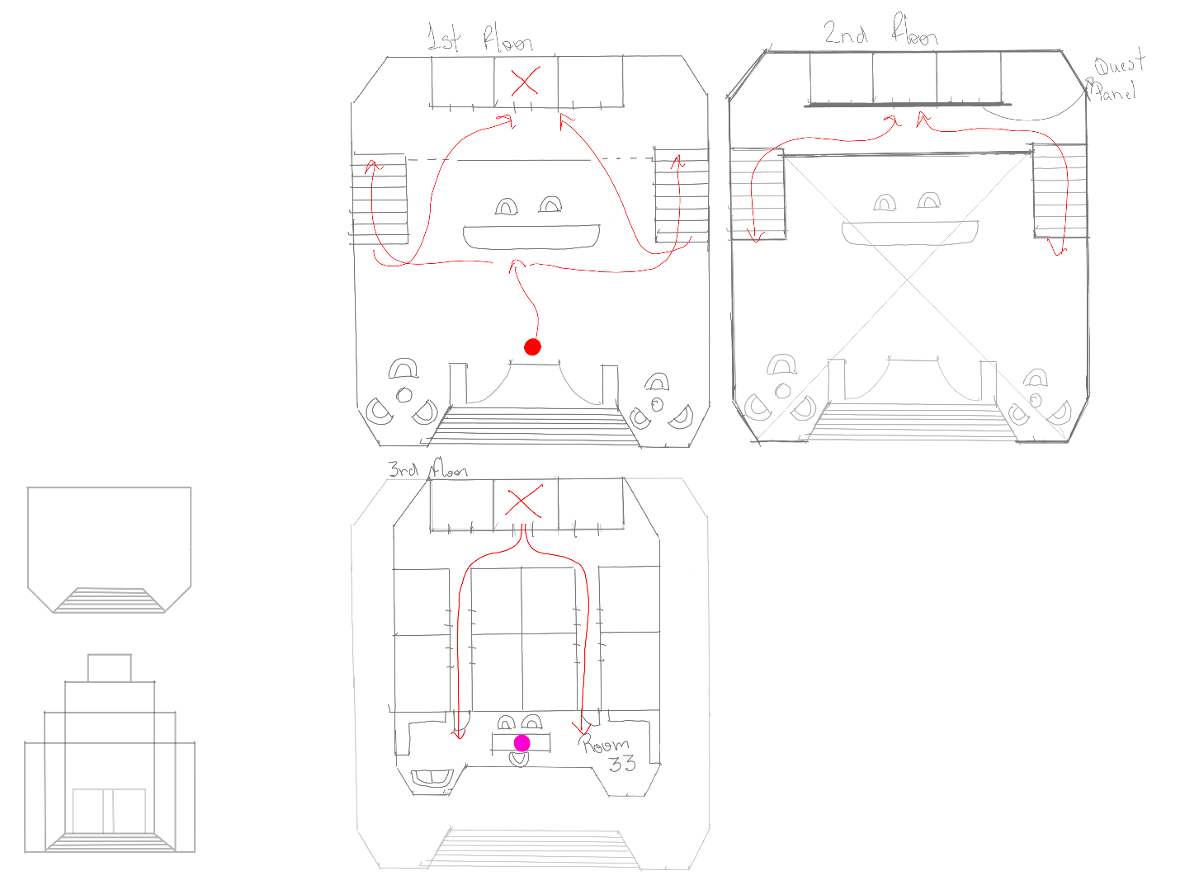

* **Areas/Zones:**
  + (Divide the level into distinct areas or zones and describe their purpose and characteristics.)
* **Points of Interest:**
  + (Highlight specific locations within the level that are important for gameplay, narrative, or visual impact.)
* **Verticality:**
  + (Describe how vertical space is used in the level. Are there multiple levels, climbing sections, or vantage points?)
* **Visual Design:**
  + (Explain the visual elements that contribute to the level's atmosphere and theme. Consider color palette, lighting, and environmental details.)

**9. Narrative and Story Integration**

* **Story Context:**
  + (How does this level fit into the overall game narrative? What story elements are conveyed?)
* **Environmental Storytelling:**
  + (Describe how the level design itself tells a story or reveals information about the game world.)
* **Character Interactions:**
  + (If applicable, outline any interactions the player might have with NPCs or other characters in the level.)

**10. Technical Considerations**

* **Performance:**
  + (Are there any potential performance bottlenecks in the level? How will they be addressed?)
* **Optimization:**
  + (Describe any optimization techniques used to ensure smooth gameplay.)
* **Scripting/Triggers:**
  + (Outline any special scripting or trigger events that occur within the level.)

**11. Playtesting and Feedback**

* **Playtesting Plan:**
  + (How will the level be playtested? Who will be the target playtesters?)
* **Feedback Integration:**
  + (How will playtest feedback be collected and incorporated into the level design?)

**12. References/Inspiration**

* **Reference Images:**
  + (Include images that serve as visual inspiration for the level's design, mood, or specific elements.)
* **Level Design Examples:**

restriction - things you have to do / introduce and teach mechanics

goals - things you want to do / level theme / challenges / fear

context - things you need to consider - how will be unique

-where does the level take place?

City hall

-When does the level take place?

Beginning of the game

-What are the mechanics of the game?

basic movements (walk, run, jump, crounch, grab)

object interaction

-Why will players remember your level?

City hall is the mains hobby for getting missions, it is the first level, and the player should come back often. Also, the architecture is unique and grandiose.

-Does the location fit the gameplay?

-What is the story of the location?

-What will I need to communicate to my team?

-Is your level possible?

Critical path vs Golden path

The first level takes place in the City Hall building. The player spawns in the lobby area, which features some armchairs and side tables made of wood and light fabric on both sides. There is also a reception in front of the player and an elevator behind the reception.

The player can also see the second level/mezzanine, and two side stairs to go up. Something catches the player's attention in the 2nd level/mezzanine floor, a bright panel, where the player can get quests/orders.

After talking with the receptionist, the player should go upstairs and get a quest/order. The quest/order starts on the mayor’s floor room (?), the mayor's room, where the player should get a parcel, which is a letter, to deliver to the office 1(level 2)