**Nova - Level Design Document**

* **Level Goal:**
  + Learn the basic movements.
  + interact with train, elevator, collectables.
  + Get used with the environment and dialogue system.
  + Deliver the first package.
* **Target Audience:**
  + Beginners that enjoy dystopian and horror games.
* **Level Theme/Setting:**
  + Dystopian
  + Art Deco
  + Retro Futurism
  + Cyber Punk
* **Level Flow:**

**- Section 1 - Train**

-- Andarilha is getting a train from Bleucollar Station to City Hall Station (Nova's Downtown). Enters the train a activate trigger to the next station.

-- There is a propaganda glued on the train's wall, it's communicating to people to land a job at Nova Express (some delivery office, kindof uber).

-- On both train stations, we can see/identify their names. (Bleucollar Station ; City Hall Station)

-- Train arrives at City Hall Station, and its doors open by sliding out, opening.

-- Andarilha walks through the station in direction of City Hall.

-- Block passage to Museum, Office and any other place that it's not meant to be accessed at this moment.

-- Level Streaming from Section 1 to Section 2.

**- Section 2 - City Hall**

-- Enters the building and gets delighted by the City Hall's interior.

--- Sees City Hall's Logo in art deco style.

--- Realizes that there's a painting from Tarsila do Amaral on the building's mezzanine, Trabalhadores - Workers (1933), right above the elevator's entrance.

-- Andarilha can wander around the floor and visit the theatre, coffee shop, bookshelves or go upstairs.

-- Talks with receptionist to figure out where to go next. She indicates that you go upstairs.

-- Andarilha go upstairs and talks with another city hall employee, who indicates that you should get the elevator to Mayor's Office.

-- Andarilha gets elevator.

-- Level Streaming from Section 2 to Section 3.

Materials: Black Marble, Bege Marble, Wood,

**- Section 3 - Mayor's Office**

-- Exits elevator and finds the Mayor's Office.

-- Talks with Mayor, getting your first job to deliver a mysterious package to Toscos Office.

-- Mayor indicates the path to the nearest footbridge to the next building.

-- Andarilha goes to a door in the same (nearest?) floor that gives access to the footbridge that takes her to Toscos Office Building.

-- Level Streaming from Section 3 to Section 4.

Materials: Black Marble, Bege Marble, Wood

**- Section 4 - Toscos Office**

-- Exits footbridge.

-- End... So far.

**7. Gameplay Mechanics**

* **Core Mechanics:**
  + Walk
  + Run
  + Sprint
  + Jump
  + Interact with train, elevator, collectable
  + Climb

**8. Level Layout and Design**

* **Map/Sketch:**

City Hall Interior – Design 1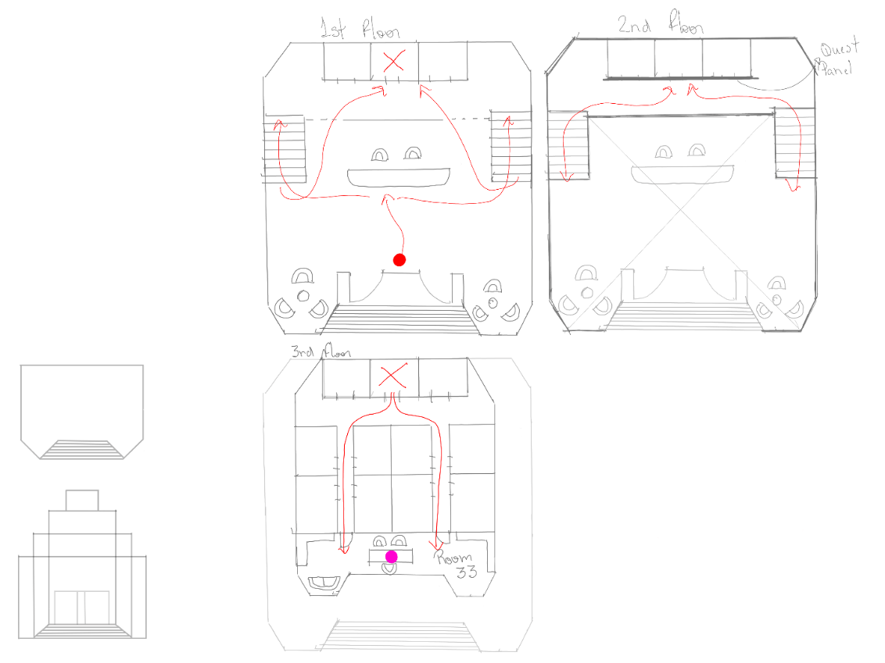

City Hall Interior – Design 2 review

Mayor – Design – To Be Implemented

