* C1-C14:
  + C1-C14: counting, such as how many addresses are found to be associated with the payment card, etc. The actual meaning is masked.
  + Average # of addresses are higher in fraud cases compared to non-fraud cases
  + 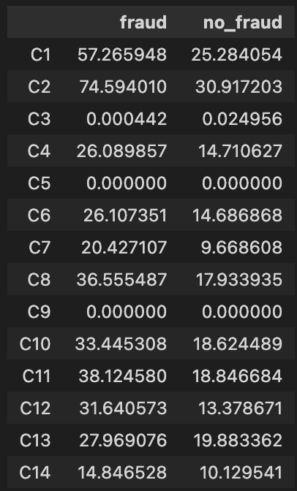
* Device Type:
  + Both desktop & mobile are almost equally high in case of fraud transactions
  + Desktop cases are way higher in non-fraudulent transactions
* Device Info:
  + There are some different OS in top 10 device info when comparing fraud and non-fraud cases.
  + Left: Fraud, Right: Non-fraud

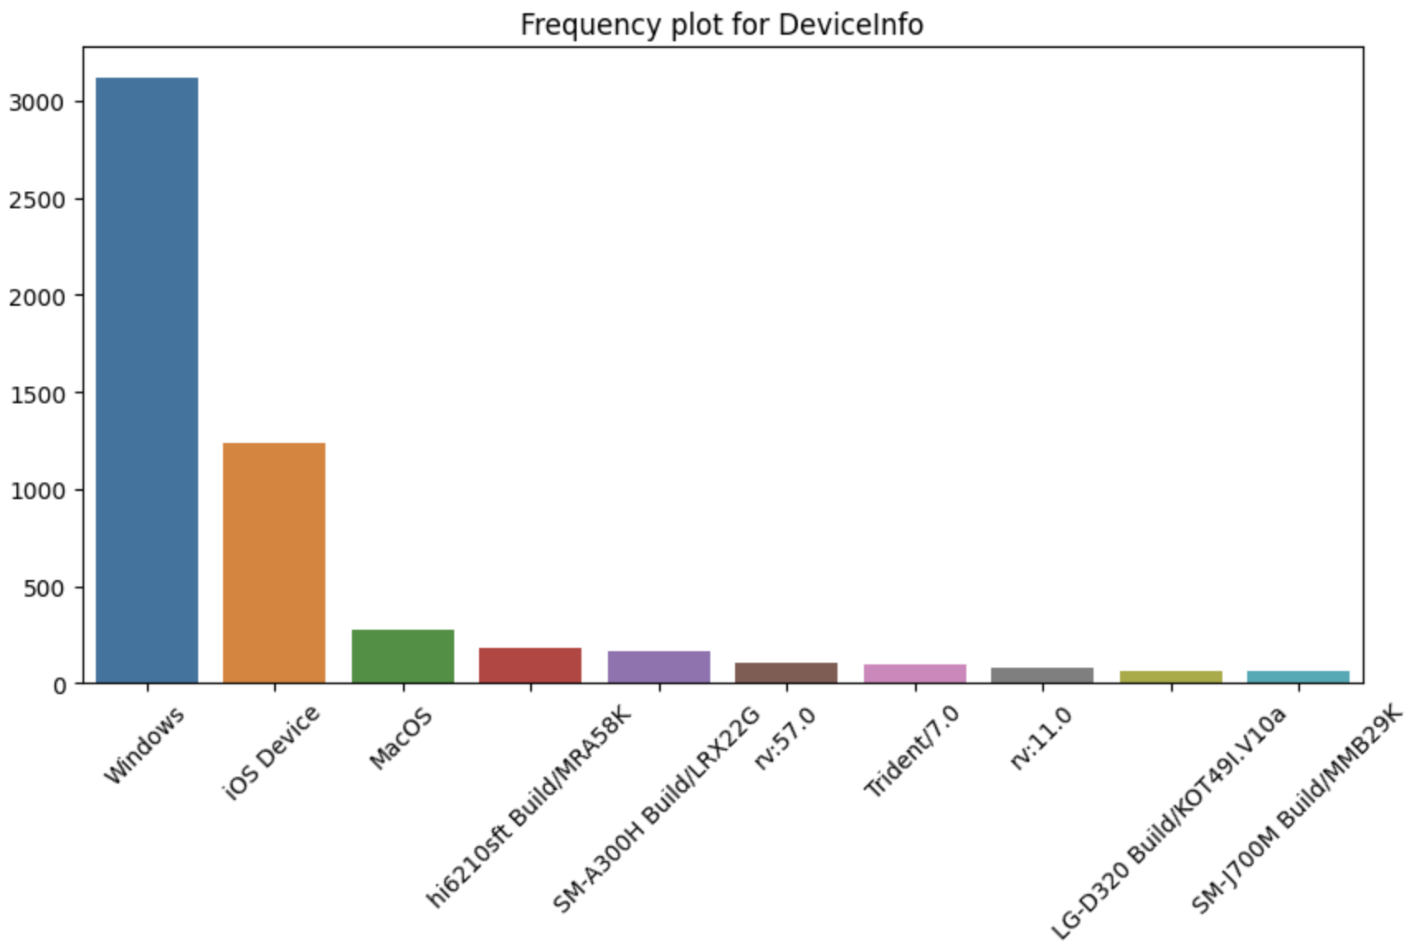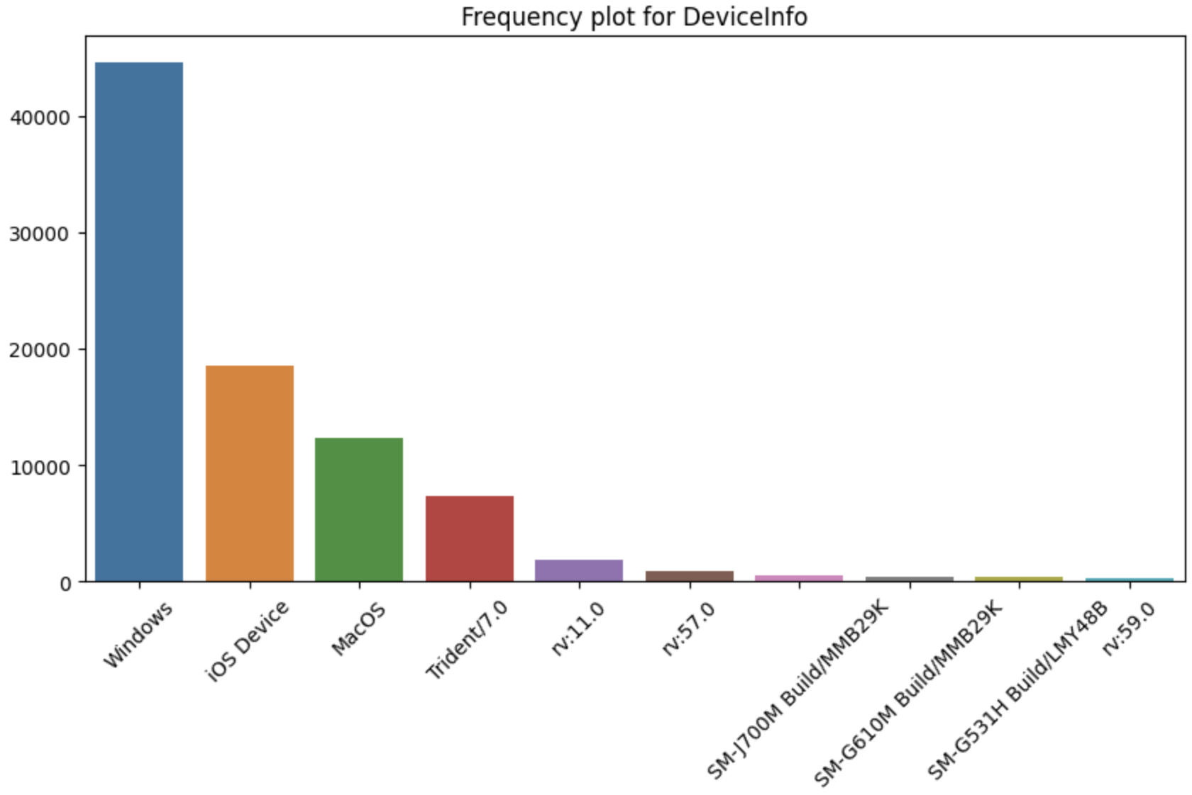

* Credit6:
  + Credit cards are significantly more used in Fraudulent transactions than debit cards