Once you have Node.js setup, the next step is to install TypeScript. Make sure you install at least
version 1.7 or greater. To install it, run the following npm command:
1 $ npm install -g 'typescript@1.9.0-dev.20160409'

Windows Users: We’ll be using Linux/Mac-style commands on the commandline throughout
this book. We’d highly recommend you install Cygwin⁸ as it will let you run commands
just as we have them written out in this book.

To run Angular 2, we depend on these four libraries:
• es6-shim
• zone.js
• reflect-metadata
• SystemJS
To include them, add the following inside your <head>
1 <script src="node_modules/es6-shim/es6-shim.js"></script>
2 <script src="node_modules/zone.js/dist/zone.js"></script>
3 <script src="node_modules/reflect-metadata/Reflect.js"></script>
4 <script src="node_modules/systemjs/dist/system.src.js"></script>

ES6 Shim
ES6 provides shims so that legacy JavaScript engines behave as closely as possible to ECMAScript 6.
This shim isn’t strictly needed for newer versions of Safari, Chrome, etc. but it is required for older
versions of IE.

Zones
Zone.js¹² is an advanced topic that we don’t need to worry about much here. For know, just know
that it is a library used by Angular, primarily for detecting changes to data.

Reflect Metadata
Angular itself was written in Typescript, and Typescript provides annotations for adding metadata
to code. Roughly speaking, the reflect-metadata package is a polyfill that lets us use this metadata.

SystemJS
SystemJS is a module loader. That is, it helps us create modules and resolve dependencies.

Adding CSS
We also want to add some CSS styling so that our app isn’t completely unstyled. Let’s include two
stylesheets as well:
<head>
4 <title>Angular 2 - Simple Reddit</title>
5 <!-- Libraries -->
6 <script src="node_modules/es6-shim/es6-shim.js"></script>
7 <script src="node_modules/zone.js/dist/zone.js"></script>
8 <script src="node_modules/reflect-metadata/Reflect.js"></script>
9 <script src="node_modules/systemjs/dist/system.src.js"></script>
10
11 <!-- Stylesheet -->
12 <link rel="stylesheet" type="text/css"
13 href="resources/vendor/semantic.min.css">
14 <link rel="stylesheet" type="text/css" href="styles.css">
15 </head>

Our First TypeScript
Create a new file called app.ts in the same folder and add
the following code:
code/first_app/angular2-reddit-base/app.ts
1 import { bootstrap } from "@angular/platform-browser-dynamic";
2 import { Component } from "@angular/core";
3
4 @Component({
5 selector: 'hello-world',
6 template: `
7 <div>
8 Hello world
9 </div>
10 `
11 })
12 class HelloWorld {
13 }
14
15 bootstrap(HelloWorld);
TypeScript is a form of typed Javascript. In order to use Angular in our browser, we need to tell the
TypeScript compiler where to find some typing files. The reference statements specify the path to
some typing files (ending in .d.ts).

The import statement defines the modules we want to use to write our code. Here we’re importing
two things: Component, and bootstrap.

Making a Component
One of the big ideas behind Angular 2 is the idea of components.
What if we wanted to have a <weather> tag that shows the weather? Or what if we wanted to have
a <login> tag that creates a login panel?
That is the idea behind components: we teach the browser new tags that have new functionality.
If you have a background in Angular 1, Components are the new version of directives.

<hello-world></hello-world>
So how do we actually define a new Component? A basic Component has two parts:
1. A Component annotation
2. A component definition class
When we use @Component on the HelloWorld
class, we are “decorating” the HelloWorld as a Component.
We want to be able to use this component in our markup by using a <hello-world> tag. To do that
we configure the @Component and specify the selector as hello-world.
1 @Component({
2 selector: 'hello-world'
3 })

The selector property here indicates which DOM element this component is going to use.

Adding a template
We can add a template to our @Component by passing the template option:
1 @Component({
2 selector: 'hello-world',
3 template: `
4 <div>
5 Hello world
6 </div>
7 `
8 })
Notice that we’re defining our template string between backticks (` … `). This is a new (and
fantastic) feature of ES6 that allows us to do multiline strings.
Should I really be putting templates in my code files? The answer is: it depends. For
a long time the commonly held belief was that you should keep your code and templates
separate. While this might be easier for some teams, for some projects it adds overhead
because you have switch between a lot of files.

Booting Our Application
The last line of our file bootstrap(HelloWorld); will start the application. The first argument
indicates that the “main” component of our application is our HelloWorld component.
Once the application is bootstrapped, the HelloWorld component will be rendered where the <helloworld></
hello-world> snippet is on the index.html file. Let’s try it out!

Loading our Application
To run our application, we need to do two things:
1. we need to tell our HTML document to import our app file
2. we need to use our <hello-world> component

<!doctype html>
2 <html>
3 <head>
4 <title>First App - Hello world</title>
5 <!-- Libraries -->
6 <script src="node_modules/es6-shim/es6-shim.js"></script>
7 <script src="node_modules/zone.js/dist/zone.js"></script>
8 <script src="node_modules/reflect-metadata/Reflect.js"></script>
9 <script src="node_modules/systemjs/dist/system.src.js"></script>
10
11 <!-- Stylesheet -->
12 <link rel="stylesheet" type="text/css" href="resources/vendor/semantic.min.c\
13 ss">
14 <link rel="stylesheet" type="text/css" href="styles.css">
15 </head>
16 <body>
17 <script src="resources/systemjs.config.js"></script>
18 <script>
19 System.import('app.js')
20 .then(null, console.error.bind(console));
21 </script>
22
23 <hello-world></hello-world>
24
25 </body>
26 </html>
We’ve added two script tags here that configure our module loader, System.js:
1. We load resources/systemjs.config.js - this file tells System.js how to load libraries and
files. The details aren’t important now.
2. We import our app.js file.
The important line to understand here is:
1 System.import('app.js')
This tells System.js that we want to load app.js as our main entry point. There’s one problem
though: we don’t have an app.js file yet! (Our file is app.ts, a TypeScript file.)

Running The App
Compiling the TypeScript Code to .js
Since our application is written in TypeScript, we used a file called app.ts. The next step is to
compile it to JavaScript, so that the browser can understand it.
In order to do that, let’s run the TypeScript compiler command line utility, called tsc:
1 tsc
If you get a prompt back with no error messages, it means that the compilation worked and we
should now have the app.js file sitting in the same directory.
1 ls app.js
2 # app.js should exist

Using npm
If your tsc command worked above, you can also use npm to compile the files. In the package.json
included in the sample code we’ve defined a few shortcuts you can use to help compile.
Try running:
1 npm run tsc // compiles TypeScript code once and exits
2 npm run tsc:w // watches for changes and compiles on change

Serving The App
We have one more step to test our application: we need to run a local webserver to serve our app.
If you did an npm install earlier, you’ve already got a local webserver installed. To run it, just run
the following command:
1 npm run serve
Then open up your browser to http://localhost:8080¹⁴.
Why do I need a webserver? If you’ve developed javascript applications before you
probably know that sometimes you can simply open up the index.html file by double
clicking on it and view it in your browser. This won’t work for us because we’re using
SystemJS.
When you open the index.html file directly, your browser is going to use a file:/// URL.
Because of security restrictions, your browser will not allow AJAX requests to happen
when using the file:/// protocol (this is a good thing because otherwise javascript could
read any file on your system and do something malicious with it).
So instead we run a local webserver that simply serve whatever is on the filesystem. This is
really convenient for testing, but not how you would deploy your production application.

If you have trouble with the hostname (localhost) or the port (8080) then simply adjust the
configuration flags in the package.json file. For instance, if you’re having trouble reaching
localhost, try changing your hostname to 127.0.0.1.

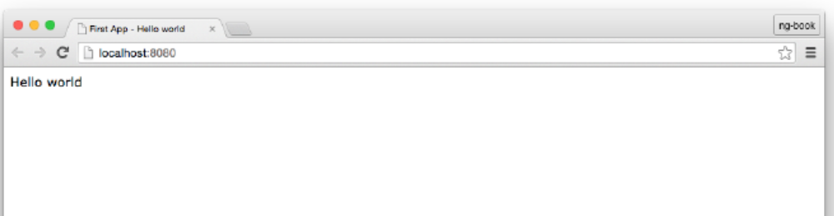

Compiling on every change
The --watch option will tell tsc
to stay running and watch for any changes to our TypeScript files and automatically recompile to
JavaScript on every change:
1 tsc --watch
2 message TS6042: Compilation complete. Watching for file changes.
In fact, this is so common that we’ve created a shortcut that will both
1. recompile on file changes and
2. reload your dev server
1 npm run go

Adding Data to the Component

Let’s introduce name as a new property of our component. This way we can reuse the same
component for different inputs.
Make the following changes:
1 @Component({
2 selector: 'hello-world',
3 template: `<div>Hello {{ name }}</div>`
4 })
5 class HelloWorld {
6 name: string;
7
8 constructor() {
9 this.name = 'Felipe';
10 }
11 }
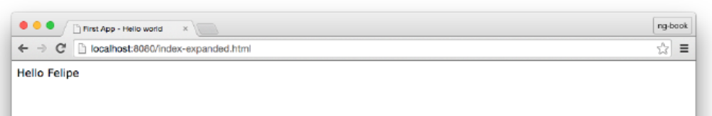

Working with arrays
Now we are able to say “Hello” to a single name, but what if we want to say “Hello” to a collection
of names?
If you’ve worked with Angular 1 before, you probably used ng-repeat directive. In Angular 2, the
analogous directive is called NgFor

1 import { bootstrap } from "@angular/platform-browser-dynamic";
2 import { Component } from "@angular/core";
3
4 @Component({
5 selector: 'hello-world',
6 template: `
7 <ul>
8 <li *ngFor="let name of names">Hello {{ name }}</li>
9 </ul>
10 `
11 })
12 class HelloWorld {
13 names: string[];
14
15 constructor() {
16 this.names = ['Ari', 'Carlos', 'Felipe', 'Nate'];
17 }
18 }
19
20 bootstrap(HelloWorld);

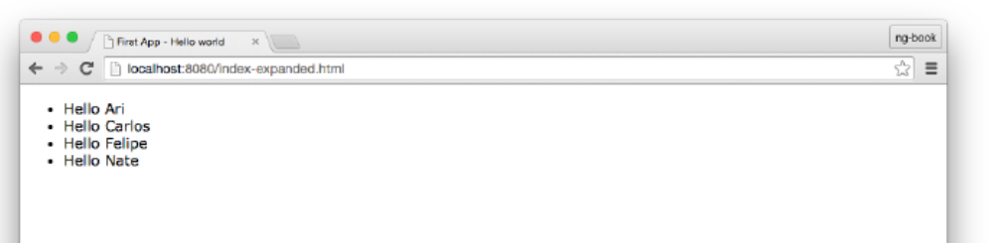

Expanding our Application
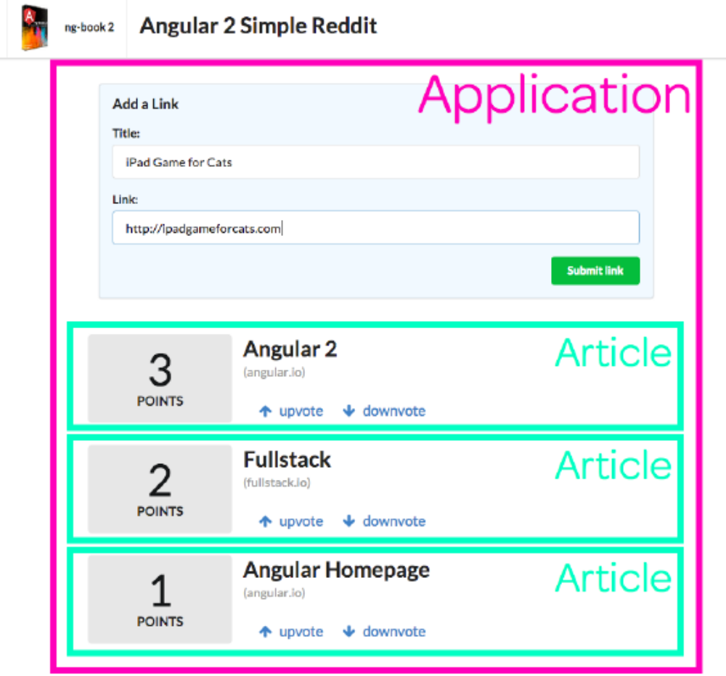
We’re going to make two components in this app:
1. The overall application, which contains form used to submit new articles (marked in magenta
in the picture).
2. Each article (marked in mint green).

The Application Component
import { bootstrap } from '@angular/platform-browser-dynamic';
2 import { Component } from '@angular/core';
3
4 @Component({
5 selector: 'reddit',
6 template: `
7 <form class="ui large form segment">
8 <h3 class="ui header">Add a Link</h3>
9
10 <div class="field">
11 <label for="title">Title:</label>
12 <input name="title">
13 </div>
14 <div class="field">
15 <label for="link">Link:</label>
16 <input name="link">
17 </div>
18 </form>
19 `
20 })
21 class RedditApp {
22 constructor() {
23 }
24 }
25
26 bootstrap(RedditApp);

We can use our new RedditApp component by opening up the index.html and replacing the <helloworld></
hello-world> tag with <reddit></reddit>.
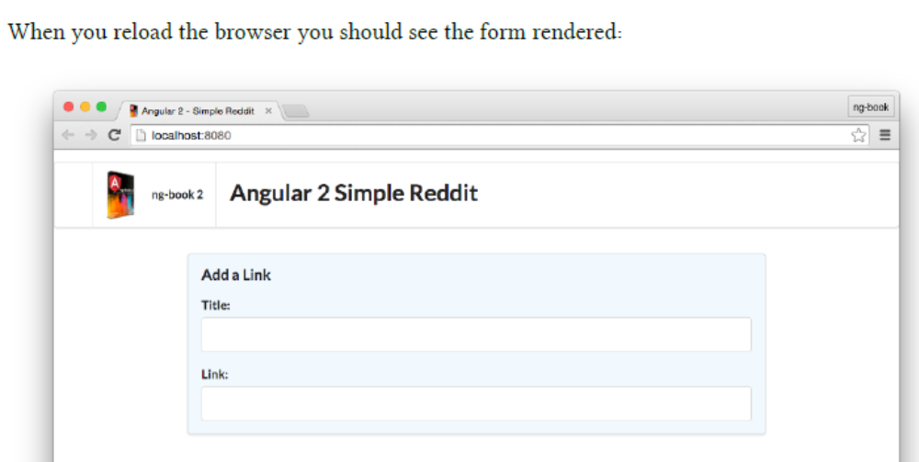

Adding Interaction
@Component({
2 selector: 'reddit',
3 template: `
4 <form class="ui large form segment">
5 <h3 class="ui header">Add a Link</h3>
6
7 <div class="field">
8 <label for="title">Title:</label>
9 <input name="title" #newtitle>
10 </div>
11 <div class="field">
12 <label for="link">Link:</label>
13 <input name="link" #newlink>
14 </div>
15
16 <button (click)="addArticle(newtitle, newlink)"
17 class="ui positive right floated button">
18 Submit link
19 </button>
20 </form>
21 `
22 })
23 class RedditApp {
24 constructor() {
25 }
26
27 addArticle(title: HTMLInputElement, link: HTMLInputElement): void {
28 console.log(`Adding article title: ${title.value} and link: ${link.value}`);
29 }
30 }

Binding inputs to values
<input name="title" #newtitle>

This syntax is new. This markup tells Angular to bind this <input> to the variable newtitle. The #newtitle syntax is called a resolve. The effect is that this makes the variable newtitle available to the expressions within this view.
newtitle is now an object that represents this input DOM element.

Binding actions to events
On our button tag we add the attribute (click) to define what should happen when the button is
clicked on.

Defining the Action Logic
On our class RedditApp we define a new function called addArticle. It takes two arguments:
title and link. Again, it’s important to realize that title and link are both objects of type
HTMLInputElement and not the input values directly.
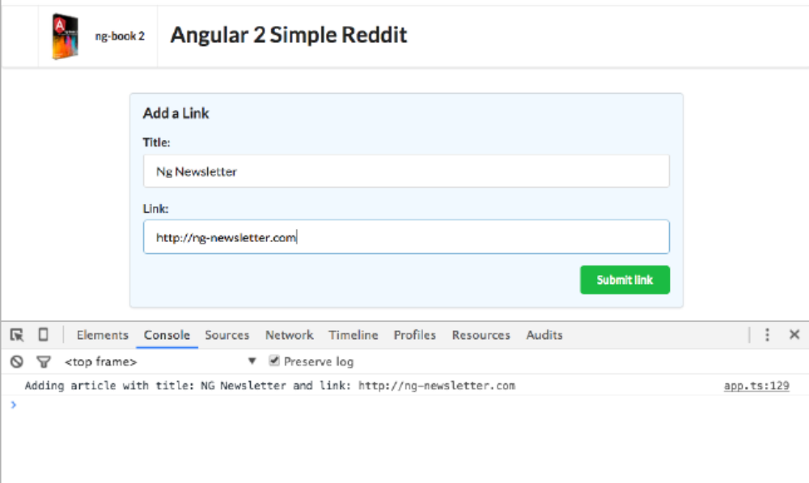

Adding the Article Component
Now we have a form to submit new articles, but we aren’t showing the new articles anywhere.
Because every article submitted is going to be displayed as a list on the page, this is the perfect
candidate for a new component.
@Component({
5 selector: 'reddit-article',
6 host: {
7 class: 'row'
8 },
9 template: `
10 <div class="four wide column center aligned votes">
11 <div class="ui statistic">
12 <div class="value">
13 {{ votes }}
14 </div>
15 <div class="label">
16 Points
17 </div>
18 </div>
19 </div>
20 <div class="twelve wide column">
21 <a class="ui large header" href="{{ link }}">
22 {{ title }}
23 </a>
24 <ul class="ui big horizontal list voters">
25 <li class="item">
26 <a href (click)="voteUp()">
27 <i class="arrow up icon"></i>
28 upvote
29 </a>
30 </li>
31 <li class="item">
32 <a href (click)="voteDown()">
33 <i class="arrow down icon"></i>
34 downvote
35 </a>
36 </li>
37 </ul>
38 </div>
39 `
40 })
41 class ArticleComponent {
42 votes: number;
43 title: string;
44 link: string;
45
46 constructor() {
47 this.title = 'Angular 2';
48 this.link = 'http://angular.io';
49 this.votes = 10;
50 }
51
52 voteUp() {
53 this.votes += 1;
54 }
55
56 voteDown() {
57 this.votes -= 1;
58 }
59 }

We want each reddit-article to be on its own row. We’re using Semantic UI, and Semantic
provides a CSS class for rows¹⁸ called row.
In Angular 2, a component host is the element this component is attached to. You’ll notice on our
@Component we’re passing the option: host: { class: 'row' }. This tells Angular that on the host
element (the reddit-article tag) we want to set the class attribute to have “row”.

Using the reddit-article Component

<button (click)="addArticle(newtitle, newlink)"
2 class="ui positive right floated button">
3 Submit link
4 </button>
5 </form>
6
7 <div class="ui grid posts">
8 <reddit-article>
9 </reddit-article>
10 </div>
11 `

In order to tell our RedditApp about our new ArticleComponent component, we need to add the
directives property on our RedditApp:

// for RedditApp
2 @Component({
3 selector: 'reddit',
4 directives: [ArticleComponent],
5 template: `
6 // ..

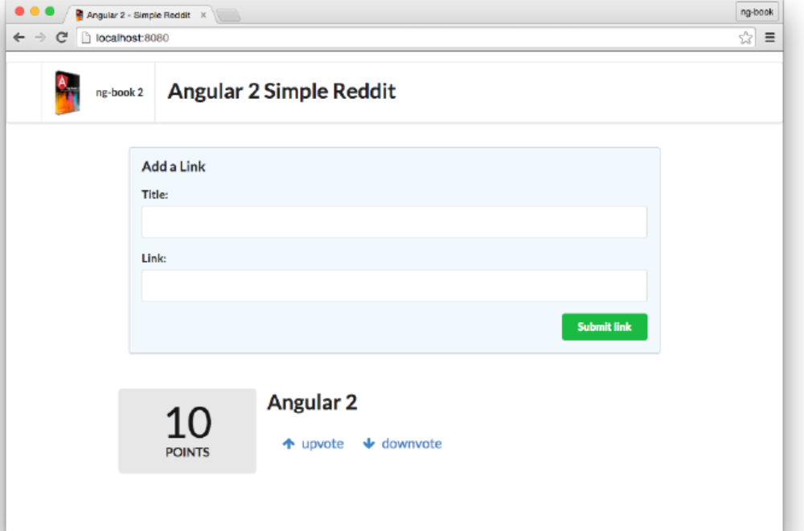

Rendering Multiple Rows
Right now we only have one article on the page and there’s no way to render more, unless we paste
another <reddit-article> tag. And even if we did that all the articles would have the same content,
so it wouldn’t be very interesting.

Creating an Article class
class Article {
2 title: string;
3 link: string;
4 votes: number;
5
6 constructor(title: string, link: string, votes?: number) {
7 this.title = title;
8 this.link = link;
9 this.votes = votes || 0;
10 }
11 }
Here we are creating a new class that represents an Article. Note that this is a plain class and not
a component. In the Model-View-Controller pattern this would be the Model.

The votes parameter is optional and defaults to zero.

Now let’s change the ArticleComponent code to use our new Article class.
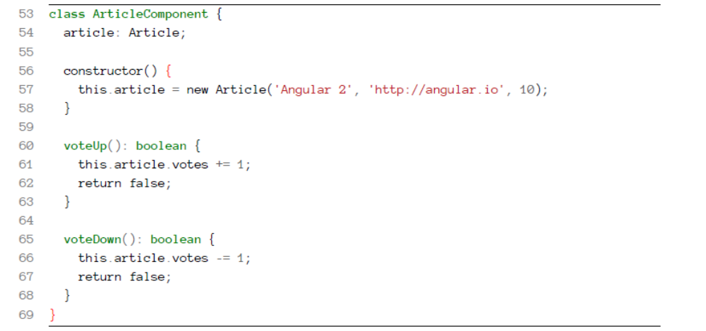
However this refactoring introduces another change: we need to update our view to get the template
variables from the right location.
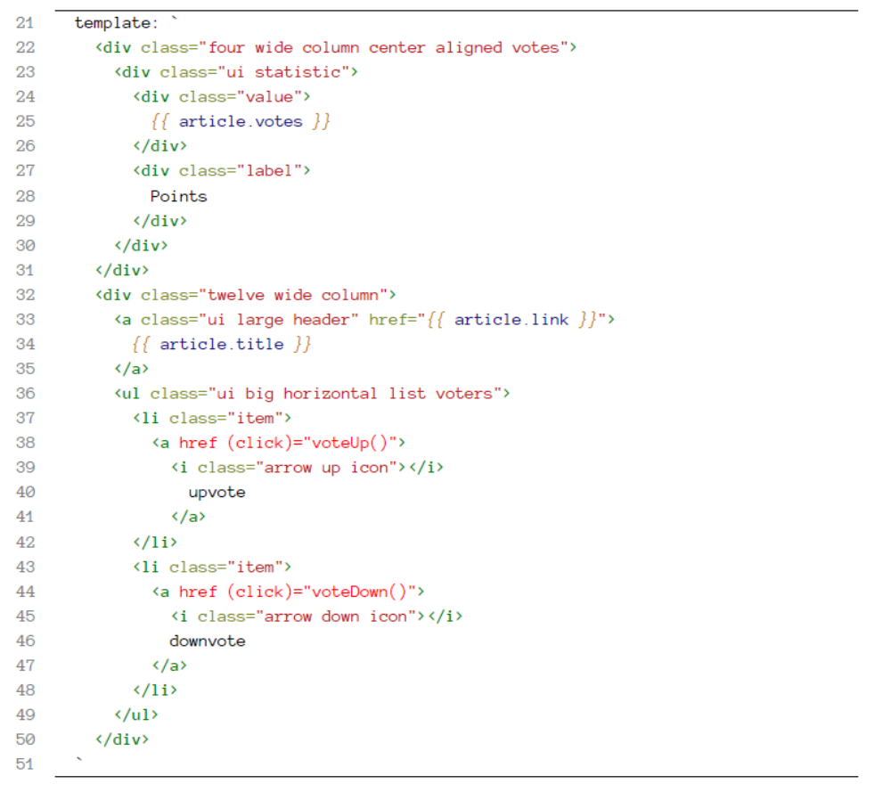
Reload the browser and everything should still work.
That’s good, but something in our code is still off: our voteUp and voteDown methods break the
encapsulation of the Article class by changing the article’s internal properties directly.
voteUp and voteDown current break the Law of Demeter¹⁹ which says that a given object
should assume as little as possible about the structure or properties any other objects.
One way to detect this is to be suspicious when you see long method/property chains like foo.bar.baz.bam. This pattern of long-method chaining is also affectionately referred to as a “train-wreck”.

The problem is that our ArticleComponent component knows too much about the Article class internals. To fix that, let’s add voteUp and voteDown methods on the Article class.

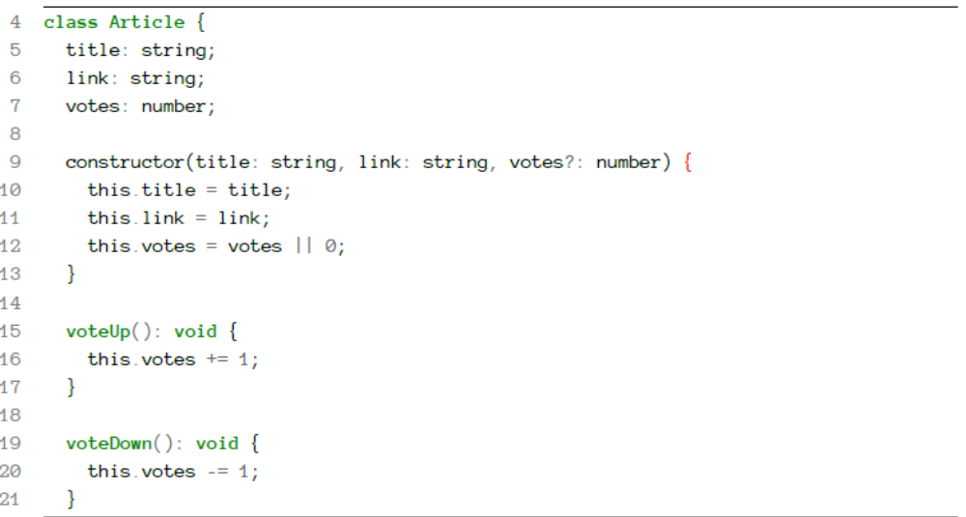

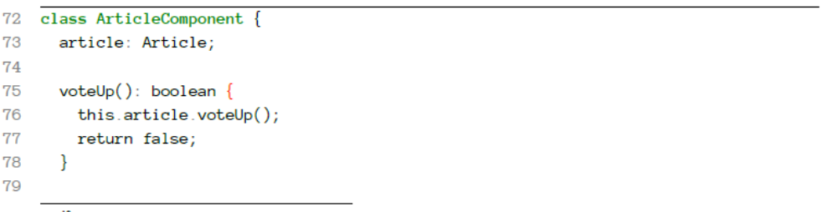

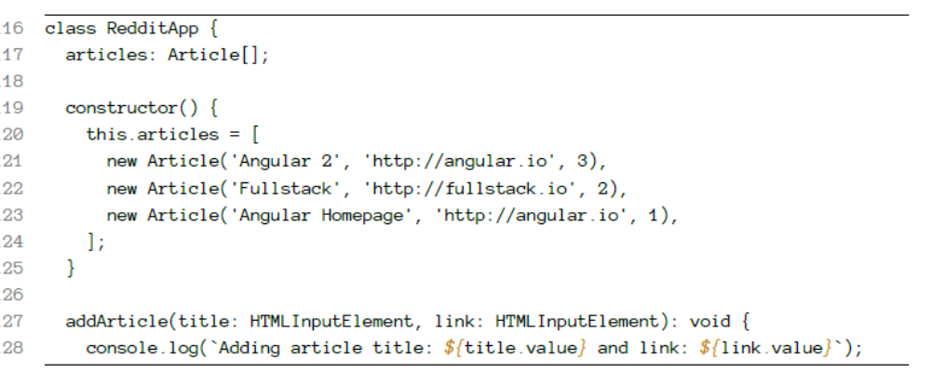

The Article[] might look a little unfamiliar. We’re saying here that articles is an Array of
Articles. Another way this could be written is Array<Article>. The word for this pattern is
generics.

Configuring the ArticleComponent with inputs

What we would really like to do is to configure the Article we want to display. If, for instance,
we had two articles, article1 and article2, we would like to be able to reuse the reddit-article
component by passing an Article as a “parameter” to the component like this:
Writing your First Angular 2 Web Application 44
1 <reddit-article [article]="article1"></reddit-article>
2 <reddit-article [article]="article2"></reddit-article>

Angular allows us to do this by using the inputs option of Component:
1 @Component({
2 selector: 'reddit-article',
3 inputs: ['article'],
4 // ... same
5 })
6 class ArticleComponent {
7 article: Article;
8 // ...

Now if we have an Article in a variable myArticle we could pass it to our ArticleComponent in
our view like this:
1 <reddit-article [article]="myArticle"></reddit-article>

You can think of it like myArticle is being passed as a parameter (i.e. input) to your
component (via inputs).

Notice that inputs is an Array. This is because you can specify that a component has many inputs.

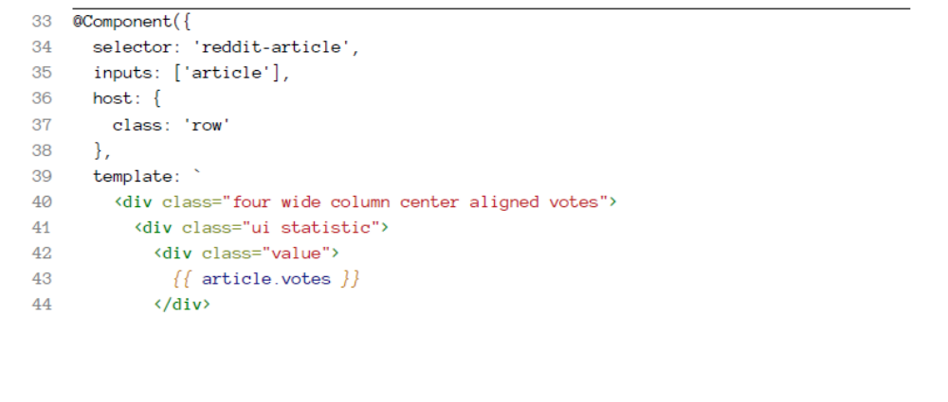
Rendering a List of Articles
<reddit-article
2 *ngFor="let foobar of articles"
3 [article]="foobar">
4 </reddit-article>
So here we have three variables:
1. articles which is an Array of Articles, defined on the RedditApp component
2. foobar which is a single element of articles (an Article), defined by NgFor
3. article which is the name of the field defined on inputs of the ArticleComponent
Basically, NgFor generates a temporary variable foobar and then we’re passing it in to
reddit-article

Adding New Articles
Now we need to change addArticle to actually add new articles when the button is pressed. Change
the addArticle method to match the following:

127 addArticle(title: HTMLInputElement, link: HTMLInputElement): void {
128 console.log(`Adding article title: ${title.value} and link: ${link.value}`);
129 this.articles.push(new Article(title.value, link.value, 0));
130 title.value = '';
131 link.value = '';
132 }
Finishing Touches
Displaying the Article Domain
As a nice touch, let’s add a hint next to the link that shows the domain where the user will be
redirected to when the link is clicked.
Add this domain method to the Article class:
code/first_app/angular2-reddit-completed/intermediates/app-04.ts
23 domain(): string {
24 try {
25 const link: string = this.link.split('//')[1];
26 return link.split('/')[0];
27 } catch (err) {
28 return null;
29 }
30 }
<div class="twelve wide column">
2 <a class="ui large header" href="{{ article.link }}">
3 {{ article.title }}
4 </a>
5 <!-- right here -->
6 <div class="meta">({{ article.domain() }})</div>
7 <ul class="ui big horizontal list voters">
8 <li class="item">
9 <a href (click)="voteUp()">

Re-sorting Based on Score
If you click and vote you’ll notice something doesn’t feel quite right: our articles don’t sort based
on score! We definitely want to see the highest-rated items on top.
We’re storing the articles in an Array in our RedditApp class, but that Array is unsorted. An easy
way to handle this is to create a new method sortedArticles on RedditApp:
code/first_app/angular2-reddit-completed/app.ts
134 sortedArticles(): Article[] {
135 return this.articles.sort((a: Article, b: Article) => b.votes - a.votes);
136 }
Now in our ngFor we can iterate over sortedArticles() (instead of articles directly):
code/first_app/angular2-reddit-completed/app.ts
108 <div class="ui grid posts">
109 <reddit-article
110 *ngFor="let article of sortedArticles()"
111 [article]="article">
112 </reddit-article>
113 <

import { bootstrap } from '@angular/platform-browser-dynamic';
2 import { Component } from '@angular/core';
3
4 class Article {
5 title: string;
6 link: string;
7 votes: number;
8
9 constructor(title: string, link: string, votes?: number) {
10 this.title = title;
11 this.link = link;
12 this.votes = votes || 0;
13 }
14
15 domain(): string {
16 try {
17 const link: string = this.link.split('//')[1];
18 return link.split('/')[0];
19 } catch (err) {
20 return null;
21 }
22 }
23
24 voteUp(): void {
25 this.votes += 1;
26 }
27
28 voteDown(): void {
29 this.votes -= 1;
30 }
31 }
32
33 @Component({
34 selector: 'reddit-article',
35 inputs: ['article'],
36 host: {
37 class: 'row'
38 },
39 template: `
40 <div class="four wide column center aligned votes">
41 <div class="ui statistic">
42 <div class="value">
43 {{ article.votes }}
44 </div>
45 <div class="label">
46 Points
47 </div>
48 </div>
49 </div>
50 <div class="twelve wide column">
51 <a class="ui large header" href="{{ article.link }}">
52 {{ article.title }}
53 </a>
54 <div class="meta">({{ article.domain() }})</div>
55 <ul class="ui big horizontal list voters">
56 <li class="item">
57 <a href (click)="voteUp()">
58 <i class="arrow up icon"></i>
59 upvote
60 </a>
61 </li>
62 <li class="item">
63 <a href (click)="voteDown()">
64 <i class="arrow down icon"></i>
65 downvote
66 </a>
67 </li>
68 </ul>
69 </div>
70 `
71 })
72 class ArticleComponent {
73 article: Article;
74
75 voteUp(): boolean {
76 this.article.voteUp();
77 return false;
78 }
79
80 voteDown(): boolean {
81 this.article.voteDown();
82 return false;
83 }
WOW! eBook
www.wowebook.org
Writing your First Angular 2 Web Application 53
84 }
85
86 @Component({
87 selector: 'reddit',
88 directives: [ArticleComponent],
89 template: `
90 <form class="ui large form segment">
91 <h3 class="ui header">Add a Link</h3>
92
93 <div class="field">
94 <label for="title">Title:</label>
95 <input name="title" #newtitle>
96 </div>
97 <div class="field">
98 <label for="link">Link:</label>
99 <input name="link" #newlink>
100 </div>
101
102 <button (click)="addArticle(newtitle, newlink)"
103 class="ui positive right floated button">
104 Submit link
105 </button>
106 </form>
107
108 <div class="ui grid posts">
109 <reddit-article
110 *ngFor="let article of sortedArticles()"
111 [article]="article">
112 </reddit-article>
113 </div>
114 `
115 })
116 class RedditApp {
117 articles: Article[];
118
119 constructor() {
120 this.articles = [
121 new Article('Angular 2', 'http://angular.io', 3),
122 new Article('Fullstack', 'http://fullstack.io', 2),
123 new Article('Angular Homepage', 'http://angular.io', 1),
124 ];
125 }
WOW! eBook
www.wowebook.org
Writing your First Angular 2 Web Application 54
126
127 addArticle(title: HTMLInputElement, link: HTMLInputElement): void {
128 console.log(`Adding article title: ${title.value} and link: ${link.value}`);
129 this.articles.push(new Article(title.value, link.value, 0));
130 title.value = '';
131 link.value = '';
132 }
133
134 sortedArticles(): Article[] {
135 return this.articles.sort((a: Article, b: Article) => b.votes - a.votes);
136 }
137
138 }
139
140 bootstrap(RedditApp);

TypeScript
Angular 2 is built in TypeScript
TypeScript isn’t a completely new language, it’s a superset of ES6. If we write ES6 code, it’s perfectly
valid and compilable TypeScript code. Here’s a diagram that shows the relationship between the
languages:

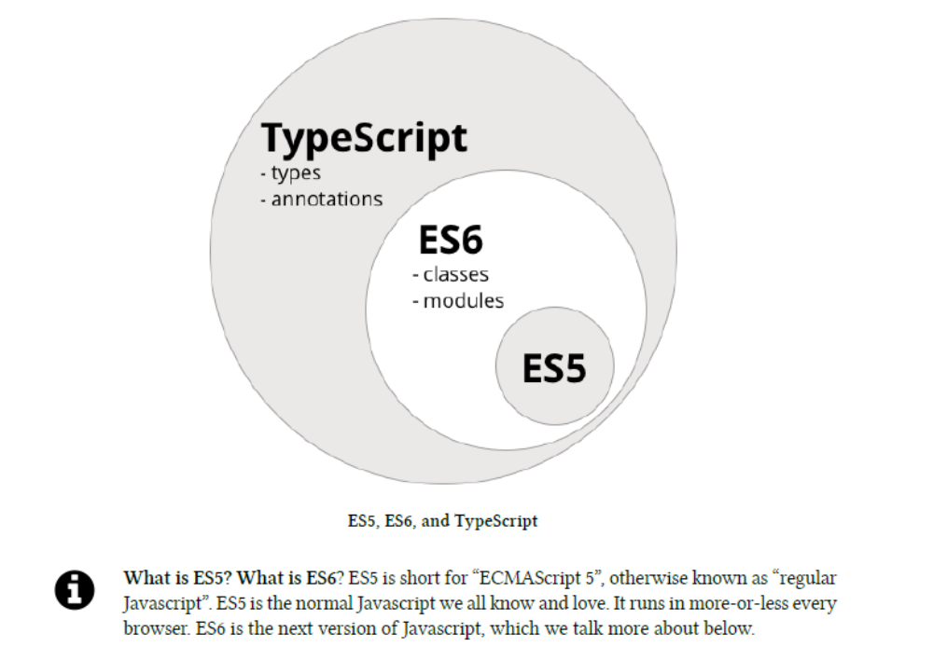

we have transpilers (or sometimes called transcompiler). The TypeScript transpiler takes our TypeScript code as input and outputs ES5 code that nearly all browsers understand.

TypeScript is an official collaboration between Microsoft and Google

What do we get with TypeScript?
There are five big improvements that TypeScript bring over ES5:
• types
• classes
• annotations
• imports
• language utilities (e.g. destructuring)

Types
One of the great things about type checking is that
1. it helps when writing code because it can prevent bugs at compile time and
2. it helps when reading code because it clarifies your intentions

The new TypeScript syntax is a natural evolution from ES5, we still use var but now we can
optionally provide the variable type along with its name:
1 var name: string;
When declaring functions we can use types for arguments and return values:
1 function greetText(name: string): string {
2 return "Hello " + name;
3 }

function hello(name: string): string {
2 return 12;
3 }
If we try to compile it, we’ll see the following error:
1 $ tsc compile-error.ts
2 compile-error.ts(2,12): error TS2322: Type 'number' is not assignable to type 's\
3 tring'.

Trying it out with a REPL
To play with the examples on this chapter, let’s install a nice little utility called TSUN²⁶ (TypeScript
Upgraded Node):
1 $ npm install -g tsun
Now start tsun:
²
$ tsun
2 TSUN : TypeScript Upgraded Node
3 type in TypeScript expression to evaluate
4 type :help for commands in repl
5
6 >
That little > is the prompt indicating that TSUN is ready to take in commands.
Built-in types
String
Number
Boolean
Array
var jobs: Array<string> = ['IBM', 'Microsoft', 'Google'];
var jobs: string[] = ['Apple', 'Dell', 'HP'];
Or similarly with a number:
1 var jobs: Array<number> = [1, 2, 3];
2 var jobs: number[] = [4, 5, 6];

Enums
enum Role {Employee, Manager, Admin};
var role: Role = Role.Employee

The default initial value for an enum is 0. You can tweak either the start of the range:
1 enum Role {Employee = 3, Manager, Admin};
2 var role: Role = Role.Employee;
In the code above, instead of Employee being 0, Employee is 3. The value of the enum increments
from there, which means Manager is 4 and Admin is 5, and we can even set individual values:
1 enum Role {Employee = 3, Manager = 5, Admin = 7};
2 var role: Role = Role.Employee;
You can also look up the name of a given enum, but using its value:
1 enum Role {Employee, Manager, Admin};
2 console.log('Roles: ', Role[0], ',', Role[1], 'and', Role[2]);

Any
any is the default type if we omit typing for a given variable. Having a variable of type any allows
it to receive any kind of value:
var something: any = 'as string';
something = 1;
something = [1, 2, 3];
Void
Using void means there’s no type expected. This is usually in functions with no return value:
1 function setName(name: string): void {
2 this.name = name;
3 }

Classes
In Javascript ES5 object oriented programming was accomplished by using prototype-based objects.
This model doesn’t use classes, but instead relies on prototypes.

To define a class we use the new class keyword and give our class a name and a body:
1 class Vehicle {
2 }
Classes may have properties, methods, and constructors.

Properties
class Person {
2 first_name: string;
3 last_name: string;
4 age: number;
5 }
Methods
1 class Person {
2 first_name: string;
3 last_name: string;
4 age: number;
5
6 greet() {
7 console.log("Hello", this.first_name);
8 }
9 }

In order to invoke the greet method, you would need to first have an instance of the Person class.
Here’s how we do that:

1 // declare a variable of type Person
2 var p: Person;
3
4 // instantiate a new Person instance
5 p = new Person();
6
7 // give it a first_name
8 p.first_name = 'Felipe';
9
10 // call the greet method
11 p.greet();

You can declare a variable and instantiate a class on the same line if you want:
1 var p: Person = new Person();

1 class Person {
2 first_name: string;
3 last_name: string;
4 age: number;
5
6 greet() {
7 console.log("Hello", this.first_name);
8 }
9
10 ageInYears(years: number): number {
11 return this.age + years;
12 }
13 }

Constructors
A constructor is a special method that is executed when a new instance of the class is being created.
class Person {
2 first_name: string;
3 last_name: string;
4 age: number;
5
6 constructor(first_name: string, last_name: string, age: number) {
7 this.first_name = first_name;
8 this.last_name = last_name;
9 this.age = age;
10 }
11
12 greet() {
13 console.log("Hello", this.first_name);
14 }
15
16 ageInYears(years: number): number {
17 return this.age + years;
18 }
19 }
It makes our previous example a little easier to write:
1 var p: Person = new Person('Felipe', 'Coury', 36);
2 p.greet();

Inheritance
Another important aspect of object oriented programming is inheritance. Inheritance is a way to
indicate that a class receives behavior from a parent class. Then we can override, modify or augment
those behaviors on the new class.

class Report {
2 data: Array<string>;
3
4 constructor(data: Array<string>) {
5 this.data = data;
6 }
7
8 run() {
9 this.data.forEach(function(line) { console.log(line); });
10 }
11 }

1 var r: Report = new Report(['First line', 'Second line']);
2 r.run();
Running this should show:
1 First line
2 Second line

1 class TabbedReport extends Report {
2 headers: Array<string>;
3
4 constructor(headers: string[], values: string[]) {
5 this.headers = headers;
6 super(values)
7 }
8
9 run() {
10 console.log(headers);
11 super.run();
12 }
13 }
1 var headers: string[] = ['Name'];
2 var data: string[] = ['Alice Green', 'Paul Pfifer', 'Louis Blakenship'];
3 var r: TabbedReport = new TabbedReport(headers, data)
4 r.run();

Utilities
ES6, and by extension TypeScript provides a number of syntax features that make programming
really enjoyable. Two important ones are:
• fat arrow function syntax
• template strings

Fat Arrow Functions
Fat arrow => functions are a shorthand notation for writing functions.
In ES5, whenever we want to use a function as an argument we have to use the function keyword
along with {} braces like so:
1 // ES5-like example
2 var data = ['Alice Green', 'Paul Pfifer', 'Louis Blakenship'];
3 data.forEach(function(line) { console.log(line); });
However with the => syntax we can instead rewrite it like so:

// Typescript example
2 var data: string[] = ['Alice Green', 'Paul Pfifer', 'Louis Blakenship'];
3 data.forEach( (line) => console.log(line) );
The => syntax can be used both as an expression:
1 var evens = [2,4,6,8];
2 var odds = evens.map(v => v + 1);
Or as a statement:
1 data.forEach( line => {
2 console.log(line.toUpperCase())
3 });

One important feature of the => syntax is that it shares the same this as the surrounding code. This
is important and different than what happens when you normally create a function in Javascript.
Generally when you write a function in Javascript that function is given its own this. Sometimes
in Javascript we see code like this:
1 var nate = {
2 name: "Nate",
3 guitars: ["Gibson", "Martin", "Taylor"],
4 printGuitars: function() {
5 var self = this;
6 this.guitars.forEach(function(g) {
7 // this.name is undefined so we have to use self.name
8 console.log(self.name + " plays a " + g);
9 });
10 }
11 };

Because the fat arrow shares this with its surrounding code, we can instead write this:
var nate = {
2 name: "Nate",
3 guitars: ["Gibson", "Martin", "Taylor"],
4 printGuitars: function() {
5 this.guitars.forEach( (g) => {
6 console.log(this.name + " plays a " + g);
7 });
8 }
9 };

Template Strings
In ES6 new template strings were introduced. The two great features of template strings are
1. Variables within strings (without being forced to concatenate with +) and
2. Multi-line strings

Variables in strings
This feature is also called “string interpolation.” The idea is that you can put variables right in your
strings. Here’s how:
1 var firstName = "Nate";
2 var lastName = "Murray";
3
4 // interpolate a string
5 var greeting = `Hello ${firstName} ${lastName}`;
6
7 console.log(greeting);

Multiline strings
Another great feature of backtick strings is multi-line strings:

1 var template = `
2 <div>
3 <h1>Hello</h1>
4 <p>This is a great website</p>
5 </div>
6 `
7
8 // do something with `template`

How Angular Works
Application
An Angular 2 Application is nothing more than a tree of Components.
At the root of that tree, the top level Component is the application itself. And that’s what the browser will render when “booting” (a.k.a bootstrapping) the app.
One of the great things about Components is that they’re composable. This means that we can build up larger Components from smaller ones. The Application is simply a Component that renders other
Components.
Because Components are structured in a parent/child tree, when each Component renders, it recursively renders its children Components.

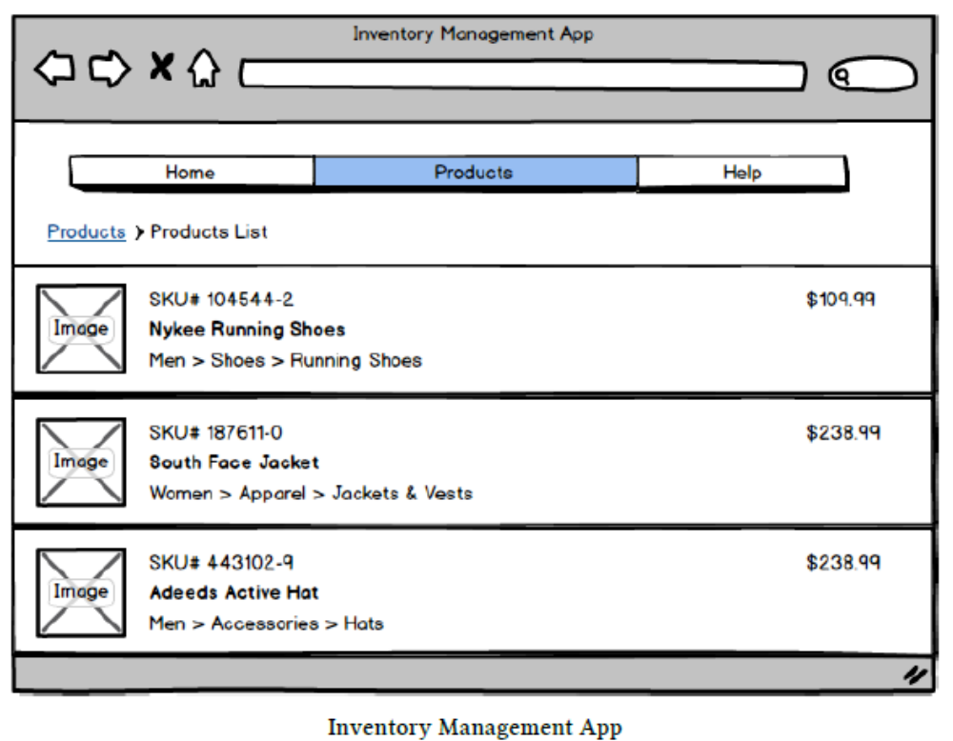

Given this mockup, to write this application the first thing we want to do is split it into components.
In this example, we could group the page into three high level components
1. The Navigation Component
2. The Breadcrumbs Component
3. The Product Info Component

Breaking this component down into the next level of smaller components, we could say that the Product List is composed of multiple Product Rows.

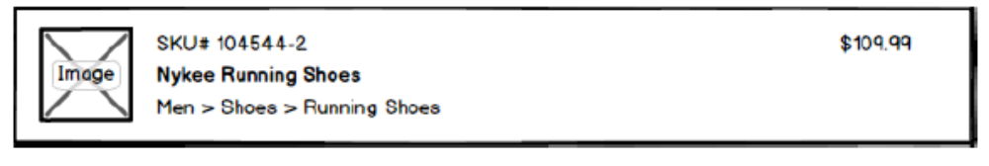

And of course, we could continue one step further, breaking each Product Row into smaller pieces:
• the Product Image component would be responsible for rendering a product image, given its
image name
• the Product Department component would render the department tree, like Men > Shoes >
Running Shoes
• the Price Display component would render the price. Imagine that our implementation
customizes the pricing if the user is logged in to include system-wide tier discounts or include
shipping for instance. We could implement all this behavior into this component.

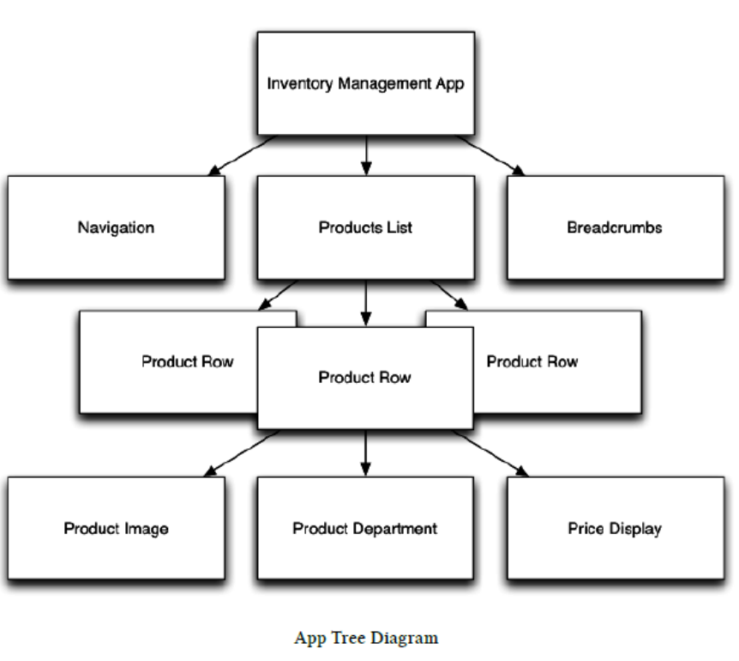

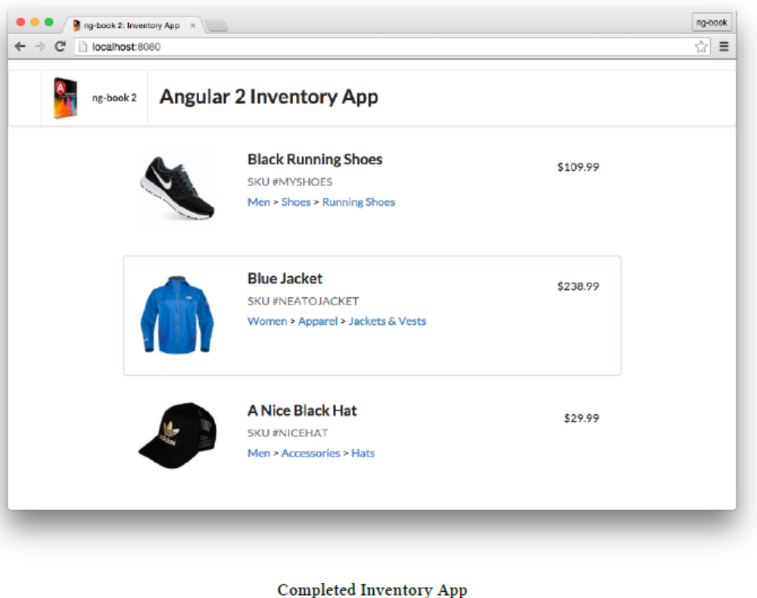

Product Model
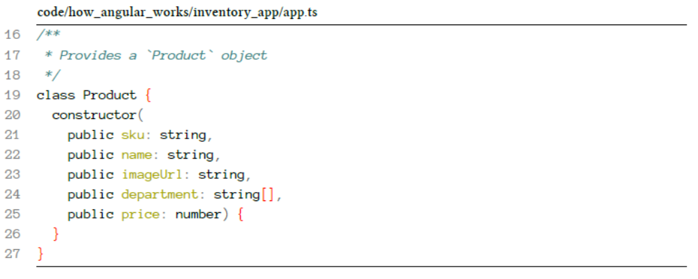

We’re creating a new Product class and the constructor takes 5 arguments. When we write public
sku: string, we’re saying two things:
• there is a public variable on instances of this class called sku
• sku is of type string.

Components
The “application” itself is just the top-level Component. Then we break our application into smaller
child Components.
Each components is composed of three parts:
• Component Decorator
• A View
• A Controller

@Component({
2 selector: 'inventory-app',
3 template: `
4 <div class="inventory-app">
5 (Products will go here soon)
6 </div>
7 `
8 })
9 class InventoryApp {
10 }
11
12 bootstrap(InventoryApp);

The @Component is called a decorator. It adds metadata to the class that follows it (InventoryApp).
The @Component annotation specifies:
• a selector, which tells Angular what element to match
• a template, which defines the view

Component selector
1 <inventory-app></inventory-app>
Alternatively, with this selector, we can also use a regular div and specify the component as an
attribute:
1 <div inventory-app></div>

Adding A Product

1 class InventoryApp {
2 product: Product;
3
4 constructor() {
5 this.product = new Product(
6 'NICEHAT', 'A Nice Black Hat',
7 '/resources/images/products/black-hat.jpg',
8 ['Men', 'Accessories', 'Hats'],
9 29.99);
10 }
11 }

Viewing the Product with Template Binding
1 @Component({
2 selector: 'inventory-app',
3 template: `
4 <div class="inventory-app">
5 <h1>{{ product.name }}</h1>
6 <span>{{ product.sku }}</span>
7 </div>
8 `
9 })

What’s neat about template binding is that the code inside the brackets is an expression. That means
you can do things like this:
• {{ count + 1 }}
• {{ myFunction(myArguments) }}

Adding More Products
176 class InventoryApp {
177 products: Product[];
178
179 constructor() {
180 this.products = [
181 new Product(
182 'MYSHOES', 'Black Running Shoes',
183 '/resources/images/products/black-shoes.jpg',
184 ['Men', 'Shoes', 'Running Shoes'],
185 109.99),
186 new Product(
187 'NEATOJACKET', 'Blue Jacket',
188 '/resources/images/products/blue-jacket.jpg',
189 ['Women', 'Apparel', 'Jackets & Vests'],
190 238.99),
191 new Product(
192 'NICEHAT', 'A Nice Black Hat',
193 '/resources/images/products/black-hat.jpg',
194 ['Men', 'Accessories', 'Hats'],
195 29.99)
196 ];
197 }
Selecting a Product
Let’s add some functionality here in our InventoryApp to handle what happens when a new Product
is selected. To do that, let’s define a new function, productWasSelected:
code/how_angular_works/inventory_app/app.ts
199 productWasSelected(product: Product): void {
200 console.log('Product clicked: ', product);
201 }

Listing products using <products-list>
code/how_angular_works/inventory_app/app.ts
164 @Component({
165 selector: 'inventory-app',
166 directives: [ProductsList],
167 template: `
168 <div class="inventory-app">
169 <products-list
170 [productList]="products"
171 (onProductSelected)="productWasSelected($event)">
172 </products-list>
173 </div>
174 `
175 })

Inputs and Outputs
When we use products-list we’re using a key feature of Angular components: inputs and outputs:
1 <products-list
2 [productList]="products" <!-- input -->
3 (onProductSelected)="productWasSelected($event)"> <!-- output -->
4 </products-list>

Data flows in to your component via input bindings and events flow out of your component through
output bindings.

(parens) handle outputs
1 <products-list
2 ...
3 (onProductSelected)="productWasSelected($event)">

That is:
• (onProductSelected), the left-hand side is the name of the output we want to “listen” on
• "productWasSelected", the right-hand side is the function we want to call when something
new is on this output
• $event is a special variable here that represents the thing emitted on the output.

161 /**
162 * @InventoryApp: the top-level component for our application
163 */
164 @Component({
165 selector: 'inventory-app',
166 directives: [ProductsList],
167 template: `
168 <div class="inventory-app">
169 <products-list
170 [productList]="products"
171 (onProductSelected)="productWasSelected($event)">
172 </products-list>
173 </div>
174 `
175 })
176 class InventoryApp {
177 products: Product[];
178
179 constructor() {
180 this.products = [
181 new Product(
182 'MYSHOES', 'Black Running Shoes',
183 '/resources/images/products/black-shoes.jpg',
184 ['Men', 'Shoes', 'Running Shoes'],
185 109.99),
186 new Product(
187 'NEATOJACKET', 'Blue Jacket',
188 '/resources/images/products/blue-jacket.jpg',
189 ['Women', 'Apparel', 'Jackets & Vests'],
190 238.99),
191 new Product(
192 'NICEHAT', 'A Nice Black Hat',
193 '/resources/images/products/black-hat.jpg',
194 ['Men', 'Accessories', 'Hats'],
195 29.99)
196 ];
197 }
198
199 productWasSelected(product: Product): void {
200 console.log('Product clicked: ', product);
201 }
202 }
203
204 bootstrap(InventoryApp);

The ProductsList Component
105 /**
106 * @ProductsList: A component for rendering all ProductRows and
107 * storing the currently selected Product
108 */
109 @Component({
110 selector: 'products-list',
111 directives: [ProductRow],
112 inputs: ['productList'],
113 outputs: ['onProductSelected'],

Component inputs
With the inputs option, we’re specifying the parameters we expect our component to receive. Inputs takes an array of strings which specify the input keys.
When we specify that a Component takes an input, it is expected that the definition class will have an instance variable that will receive the value. For example, say we have the following code:

1 @Component({
2 selector: 'my-component',
3 inputs: ['name', 'age']
4 })
5 class MyComponent {
6 name: string;
7 age: number;
8 }

The name and age inputs map to the name and age properties on instances of the MyComponent class.If we want to use MyComponent from another template, we write something like: <my-component [name]="myName" [age]="myAge"></my-component>.

We wanted our attribute key and instance property to differ. That is, we want to
use our component like this:
1 <my-component [shortName]="myName" [oldAge]="myAge"></my-component>
To do this, we would change the format of the string in the inputs option:
1 @Component({
2 selector: 'my-component',
3 inputs: ['name: shortName', 'age: oldAge']
4 })
5 class MyComponent {
6 name: string;
7 age: number;
8 }

Passing products through via the inputs
161 /**
162 * @InventoryApp: the top-level component for our application
163 */
164 @Component({
165 selector: 'inventory-app',
166 directives: [ProductsList],
167 template: `
168 <div class="inventory-app">
169 <products-list
170 [productList]="products"
171 (onProductSelected)="productWasSelected($event)">
172 </products-list>
173 </div>
174 `
175 })
176 class InventoryApp {
177 products: Product[];
178
179 constructor() {
180 this.products = [
181 new Product(

Component outputs
When you want to send data from your component to the outside world, you use output bindings.
Let’s say a component we’re writing has a button and we need to do something when that button
is clicked.
The way to do this is by binding the click output of the button to a method declared on our
component’s controller. You do that using the (output)="action" notation.

is pressed:
1 @Component({
2 selector: 'counter',
3 template: `
4 {{ value }}
5 <button (click)="increase()">Increase</button>
6 <button (click)="decrease()">Decrease</button>
7 `
8 })
9 class Counter {
10 value: number;
11
12 constructor() {
13 this.value = 1;
14 }
15
16 increase() {
17 this.value = this.value + 1;
18 }
19
20 decrease() {
21 this.value = this.value - 1;
22 }
23 }

Emitting Custom Events
Let’s say we want to create a component that emits a custom event, like click or mousedown above.
To create a custom output event we do three things:
1. Specify outputs in the @Component configuration
2. Attach an EventEmitter to the output property
3. Emit an event from the EventEmitter, at the right time

An EventEmitter is simply an object that helps you implement the Observer Pattern³¹.
That is, it’s an object that can maintain a list of subscribers and publish events to them.
That’s it.
Here’s a short and sweet example of how you can use EventEmitter
1 let ee = new EventEmitter();
2 ee.subscribe((name: string) => console.log(`Hello ${name}`));
3 ee.emit("Nate");
4
5 // -> "Hello Nate"
When we assign an EventEmitter to an output Angular automatically subscribes for us.
You don’t need to do the subscription yourself

1 @Component({
2 selector: 'single-component',
3 outputs: ['putRingOnIt'],
4 template: `
5 <button (click)="liked()">Like it?</button>
6 `
7 })
8 class SingleComponent {
9 putRingOnIt: EventEmitter<string>;
10
11 constructor() {
12 this.putRingOnIt = new EventEmitter();
13 }
14
15 liked(): void {
16 this.putRingOnIt.emit("oh oh oh");
17 }
18 }
Notice that we did all three steps: 1. specified outputs, 2. created an EventEmitter that we attached
to the output property putRingOnIt and 3. Emitted an event when liked is called.

If we wanted to use this output in a parent component we could do something like this:
1 @Component({
2 selector: 'club',
3 template: `
4 <div>
5 <single-component
6 (putRingOnIt)="ringWasPlaced($event)"
7 ></single-component>
8 </div>
9 `
10 })
11 class ClubComponent {
12 ringWasPlaced(message: string) {
13 console.log(`Put your hands up: ${message}`);
14 }
15 }
16
17 // logged -> "Put your hands up: oh oh oh"

Writing the ProductsList Controller Class
125 class ProductsList {
126 /**
127 * @input productList - the Product[] passed to us
128 */
129 productList: Product[];
130
131 /**
132 * @ouput onProductSelected - outputs the current
133 * Product whenever a new Product is selected
134 */
135 onProductSelected: EventEmitter<Product>;
136
137 /**
138 * @property currentProduct - local state containing
139 * the currently selected `Product`
140 */
141 currentProduct: Product;
142
143 constructor() {
144 this.onProductSelected = new EventEmitter();
145 }

Writing the ProductsList View Template

114 template: `
115 <div class="ui items">
116 <product-row
117 *ngFor="let myProduct of productList"
118 [product]="myProduct"
119 (click)='clicked(myProduct)'
120 [class.selected]="isSelected(myProduct)">
121 </product-row>
122 </div>
123 `
124 })

The line that reads [product]="myProduct" says that we want to pass myProduct (the local variable)to the input product of the product-row. (We’ll define this input when we define the ProductRow component below.)
The (click)='clicked(myProduct)' line describes what we want to do when this element is clicked.

The line [class.selected]="isSelected(myProduct)" is a fun one: Angular allows us to set
classes conditionally on an element using this syntax. This syntax says “add the CSS class selected

147 clicked(product: Product): void {
148 this.currentProduct = product;
149 this.onProductSelected.emit(product);
150 }

152 isSelected(product: Product): boolean {
153 if (!product || !this.currentProduct) {
154 return false;
155 }
156 return product.sku === this.currentProduct.sku;
157 }

The Full ProductsList Component
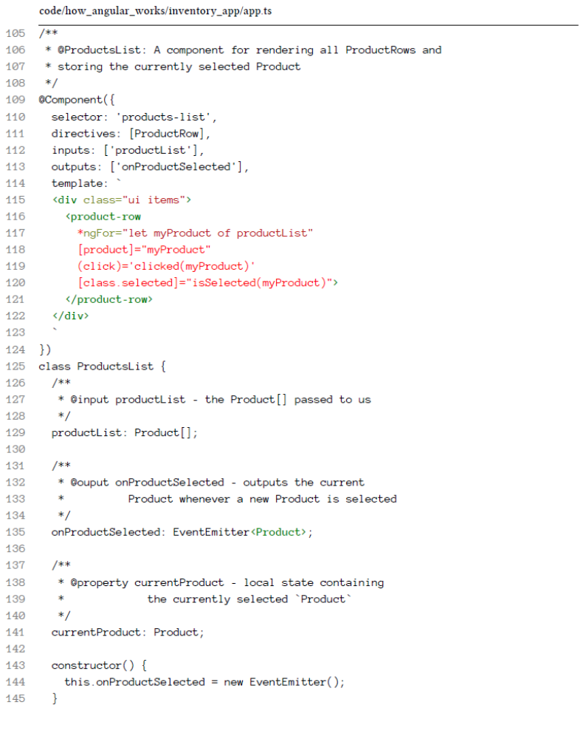

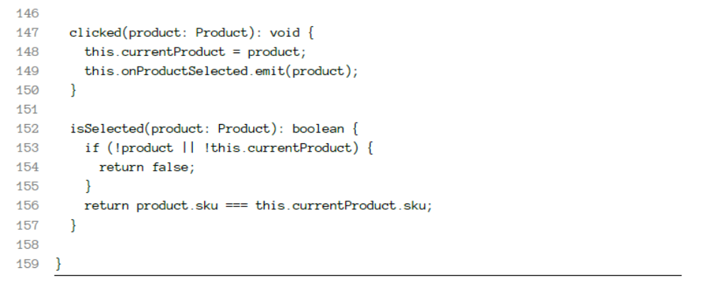

The ProductRow Component

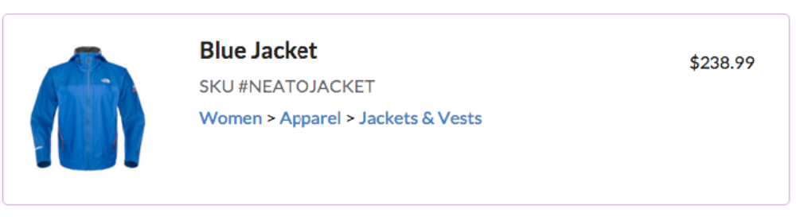

ProductRow will have its own template, but will also be split
up into three smaller Components:
• ProductImage - for the image
• ProductDepartment - for the department “breadcrumbs”
• PriceDisplay - for showing the product’s price

79 /**
80 * @ProductRow: A component for the view of single Product
81 */
82 @Component({
83 selector: 'product-row',
84 inputs: ['product'],
85 host: {'class': 'item'},
86 directives: [ProductImage, ProductDepartment, PriceDisplay],

ProductRow Component Definition Class
101 class ProductRow {
102 product: Product;
103 }

ProductRow template

87 template: `
88 <product-image [product]="product"></product-image>
89 <div class="content">
90 <div class="header">{{ product.name }}</div>
91 <div class="meta">
92 <div class="product-sku">SKU #{{ product.sku }}</div>
93 </div>
94 <div class="description">
95 <product-department [product]="product"></product-department>
96 </div>
97 </div>
98 <price-display [price]="product.price"></price-display>
99

The ProductImage Component
29 /**
30 * @ProductImage: A component to show a single Product's image
31 */
32 @Component({
33 selector: 'product-image',
34 host: {class: 'ui small image'},
35 inputs: ['product'],
36 template: `
37 <img class="product-image" [src]="product.imageUrl">
38 `
39 })
40 class ProductImage {
41 product: Product;
42 }

The PriceDisplay Component
64 /**
65 * @PriceDisplay: A component to show the price of a
66 * Product
67 */
68 @Component({
69 selector: 'price-display',
70 inputs: ['price'],
71 template: `
72 <div class="price-display">\${{ price }}</div>
73 `
74 })
75 class PriceDisplay {
76 price: number;
77 }

The ProductDepartment Component
44 /**
45 * @ProductDepartment: A component to show the breadcrumbs to a
46 * Product's department
47 */
48 @Component({
49 selector: 'product-department',
50 inputs: ['product'],
51 template: `
52 <div class="product-department">
53 <span *ngFor="let name of product.department; let i=index">
54 <a href="#">{{ name }}</a>
55 <span>{{i < (product.department.length-1) ? '>' : ''}}</span>
56 </span>
57 </div>
58 `
59 })
60 class ProductDepartment {.
61 product: Product;
62 }

The idea is that given a department, we want to show the department string like:
1 Women > Apparel > Jackets & Vests
The expression {{i < (product.department.length-1) ? '>' : ''}} says that we only want to
use the '>' character if we’re not the last department. On the last department just show an empty
string ''.

A Word on Data Architecture
In Angular 1, the default option was two-way data binding. Two-way data binding is super easy to get started: your controllers have data, your forms manipulate that data directly, and your views
show the data.
The problem with two-way data binding is that it often causes cascading effects throughout your
application and makes it really difficult to trace data flow as your project grows.
Another problem with two-way data binding is that because you’re passing data down through
components it often forces your “data layout tree” to match your “dom view tree”. In practice, these
two things should really be separate.

The recommended way in Angular 2, and in many modern web frameworks (such as React) is to
adopt a pattern of one-way data binding. That is, your data flows only down through components.
If you need to make changes, you emit events that cause changes to happen “at the top” which then
trickle down.
One-way data binding can seem like it adds some overhead in the beginning but it saves a lot of
complication around change detection and it makes your systems easier to reason about.
Thankfully there are two major contenders for managing your data architecture:
1. Use an Observables-based architecture like RxJS
2. Use a Flux-based architecture

Built-in Components

NgIf
The ngIf directive is used when you want to display or hide an element based on a condition. The
condition is determined by the result of the expression that you pass in to the directive.

1 <div *ngIf="false"></div> <!-- never displayed -->
2 <div *ngIf="a > b"></div> <!-- displayed if a is more than b -->
3 <div *ngIf="str == 'yes'"></div> <!-- displayed if str holds the string "yes" -\
4 ->
5 <div *ngIf="myFunc()"></div> <!-- displayed if myFunc returns a true value \
6 -->

NgSwitch
Sometimes you need to render different elements depending on a given condition.
When you run into this situation, you could use ngIf several times like this

1 <div class="container">
2 <div *ngIf="myVar == 'A'">Var is A</div>
3 <div *ngIf="myVar == 'B'">Var is B</div>
4 <div *ngIf="myVar != 'A' && myVar != 'B'">Var is something else</div>
5 </div>
But as you can see, the scenario where myVar is neither A nor B is pretty verbose

1 <div class="container" [ngSwitch]="myVar">
2 <div *ngSwitchWhen="'A'">Var is A</div>
3 <div *ngSwitchWhen="'B'">Var is B</div>
4 <div *ngSwitchDefault>Var is something else</div>
5 </div>

1 <div class="container" [ngSwitch]="myVar">
2 <div *ngSwitchWhen="'A'">Var is A</div>
3 <div *ngSwitchWhen="'B'">Var is B</div>
4 <div *ngSwitchWhen="'C'">Var is C</div>
5 <div *ngSwitchDefault>Var is something else</div>
6 </div>

NgStyle

The simplest way to use this directive is by doing [style.<cssproperty>]="value". For example:
11 <div [style.background-color]="'yellow'">
12 Uses fixed yellow background
13 </div>

Another way to set fixed values is by using the NgStyle attribute and using key value pairs for each
property you want to set, like this:

19 <div [ngStyle]="{color: 'white', 'background-color': 'blue'}">
20 Uses fixed white text on blue background
21 </div>

62 <div class="ui input">
63 <input type="text" name="color" value="{{color}}" #colorinput>
64 </div>
65
66 <div class="ui input">
67 <input type="text" name="fontSize" value="{{fontSize}}" #fontinput>
68 </div>

27 <div>
28 <span [ngStyle]="{color: 'red'}" [style.font-size.px]="fontSize">
29 red text
30 </span>
31 </div>

The .px suffix indicates that we’re setting the font-size property value in pixels. You could easily
replace that by [style.fontSize.em]

97 apply(color, fontSize) {
98 this.color = color;
99 this.fontSize = fontSize;
100 }
And with that, both the color and the font size will be applied to the elements using the NgStyle
directive.

NgClass
The NgClass directive, represented by a ngClass attribute in your HTML template, allows you to
dynamically set and change the CSS classes for a given DOM element.

14 .bordered {
15 border: 1px dashed black;
16 background-color: #eee;
17 }

7 <div [ngClass]="{bordered: false}">This is never bordered</div>
8 <div [ngClass]="{bordered: true}">This is always bordered</div>

10 <div [ngClass]="{bordered: isBordered}">
11 Using object literal. Border {{ isBordered ? "ON" : "OFF" }}
12 </div>

58 toggleBorder() {
59 this.isBordered = !this.isBordered;
60 this.classesObj = {
61 bordered: this.isBordered
62 };
63 }

14 <div [ngClass]="classesObj">
15 Using object var. Border {{ classesObj.bordered ? "ON" : "OFF" }}
16 </div>

1 this.classList = ['blue', 'round'];

41 <div class="base" [ngClass]="classList">
42 This is {{ classList.indexOf('blue') > -1 ? "" : "NOT" }} blue
43 and {{ classList.indexOf('round') > -1 ? "" : "NOT" }} round
44 </div>

NgFor

1 this.cities = ['Miami', 'Sao Paulo', 'New York'];

7 <h4 class="ui horizontal divider header">
8 Simple list of strings
9 </h4>
10
11 <div class="ui list" *ngFor="let c of cities">
12 <div class="item">{{ c }}</div>
13 </div>

76 this.peopleByCity = [
77 {
78 city: 'Miami',
79 people: [
80 { name: 'John', age: 12 },
81 { name: 'Angel', age: 22 }
82 ]
83 },
84 {
85 city: 'Sao Paulo',
86 people: [
87 { name: 'Anderson', age: 35 },
88 { name: 'Felipe', age: 36 }
89 ]
90 }
91 ];
92 };

34 <h4 class="ui horizontal divider header">
35 Nested data
36 </h4>
37
38 <div *ngFor="let item of peopleByCity">
39 <h2 class="ui header">{{ item.city }}</h2>
40
41 <table class="ui celled table">
42 <thead>
43 <tr>
44 <th>Name</th>
45 <th>Age</th>
46 </tr>
47 </thead>
48 <tr *ngFor="let p of item.people">
49 <td>{{ p.name }}</td>
50 <td>{{ p.age }}</td>
51 </tr>
52 </table>
53 </div>

59 <div class="ui list" *ngFor="let c of cities; let num = index">
60 <div class="item">{{ num+1 }} - {{ c }}</div>
61 </div>

NgNonBindable

We use ngNonBindable when we want tell Angular not to compile or bind a particular section of our page.
Let’s say we want to render the literal text {{ content }} in our template. Normally that text will
be bound to the value of the content variable because we’re using the {{ }} template syntax.
So how can we render the exact text {{ content }}? We use the ngNonBindable directive.

7 <div>
8 <span class="bordered">{{ content }}</span>
9 <span class="pre" ngNonBindable>
10 &larr; This is what {{ content }} rendered
11 </span>
12 </div>

Forms in Angular 2

Control

A Control represents a single input field - it is the smallest unit of an Angular form.
Controls encapsulate the field’s value, and states such as if it is valid, dirty (changed), or has errors.

1 // create a new Control with the value "Nate"
2 let nameControl = new Control("Nate");
3
4 let name = nameControl.value; // -> Nate
5
6 // now we can query this control for certain values:
7 nameControl.errors // -> StringMap<string, any> of errors
8 nameControl.dirty // -> false
9 nameControl.valid // -> true
10 // etc

Like many things in Angular, we have a class (Control, in this case) that we attach to the DOM with
an attribute (ngControl, in this case). For instance, we might have the following in our form:
1 <!-- part of some bigger form -->
2 <input type="text" ngControl="name" />

ControlGroup
Most forms have more than one field, so we need a way to manage multiple Controls. If we wanted
to check the validity of our form, it’s cumbersome to iterate over an array of Controls and check
each Control for validity. ControlGroups solve this issue by providing a wrapper interface around
a collection of Controls.
Here’s how you create a ControlGroup:
1 let personInfo = new ControlGroup({
2 firstName: new Control("Nate"),
3 lastName: new Control("Murray"),
4 zip: new Control("90210")
5 })

Our First Form

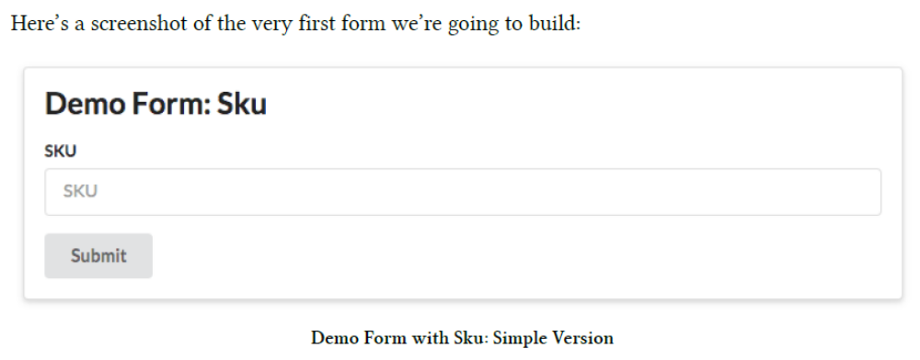

Let’s turn this form into a Component. If you recall, there are three parts to defining a component:
• Configure the @Component() annotation
• Create the template
• Implement custom functionality in the component definition class

Simple SKU Form: @Component Annotation
code/forms/app/forms/demo_form_sku.ts
1 import { Component } from '@angular/core';
2 import { FORM_DIRECTIVES } from '@angular/common';
3
4 @Component({
5 selector: 'demo-form-sku',
6 directives: [FORM_DIRECTIVES],

1 <demo-form-sku></demo-form-sku>

FORM_DIRECTIVES includes:
• ngControl
• ngControlGroup
• ngForm
• ngModel

Simple SKU Form: template

4 @Component({
5 selector: 'demo-form-sku',
6 directives: [FORM_DIRECTIVES],
7 template: `
8 <div class="ui raised segment">
9 <h2 class="ui header">Demo Form: Sku</h2>
10 <form #f="ngForm"
11 (ngSubmit)="onSubmit(f.value)"
12 class="ui form">
13
14 <div class="field">
15 <label for="skuInput">SKU</label>
16 <input type="text"
17 id="skuInput"
18 placeholder="SKU"
19 ngControl="sku">
20 </div>
21
22 <button type="submit" class="ui button">Submit</button>
23 </form>
24 </div>
25 `
26 })

form & NgForm

10 <form #f="ngForm"
11 (ngSubmit)="onSubmit(f.value)"

First we have #f="ngForm". The #v=thing syntax says that we want to create a local variable for
this view.
Here we’re creating an alias to ngForm, for this view, bound to the variable #f. Where did ngForm
come from in the first place? It came from the NgForm directive.
And what type of object is ngForm? It is a ControlGroup. That means we can use f as a ControlGroup
in our view. And that’s exactly what we do in the (ngSubmit) output.

We bind to the ngSubmit action of our form by using the syntax: (ngSubmit)="onSubmit(f.value)".
• (ngSubmit) - comes from NgForm
• onSubmit() - will be implemented in our component definition class (below)
• f.value - f is the ControlGroup that we specified above. And .value will return the key/value
pairs of this ControlGroup

input & NgControl

10 <form #f="ngForm"
11 (ngSubmit)="onSubmit(f.value)"
12 class="ui form">
13
14 <div class="field">
15 <label for="skuInput">SKU</label>
16 <input type="text"
17 id="skuInput"
18 placeholder="SKU"
19 ngControl="sku">
20 </div>

• class="ui form" and class="field" - these two classes are totally optional. They come from
the CSS framework Semantic UI³⁵. I’ve added them in some of our examples just to give them
a nice coat of CSS but they’re not part of Angular.
• The label “for” attribute and the input “id” attribute are to match, as per W3C standard³⁶
• We set a placeholder of “SKU”, which is just a hint to the user for what this input should
say when it is blank
The NgControl directive specifies a selector of ngControl³⁷. This means we can attach it to
our input tag by adding this sort of attribute: ngControl="whatever". In this case, we say:
ngControl="sku".
NgControl vs. ngControl:
The lower case (CamelCase), as in ngControl, comes from the selector of the directive
and it’s only used in the DOM / template.

Simple SKU Form: Component Definition Class

27 export class DemoFormSku {
28 onSubmit(form: any): void {
29 console.log('you submitted value:', form);
30 }
31 }

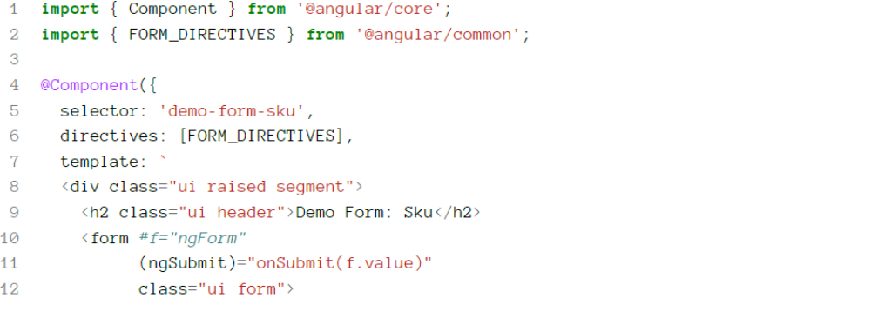
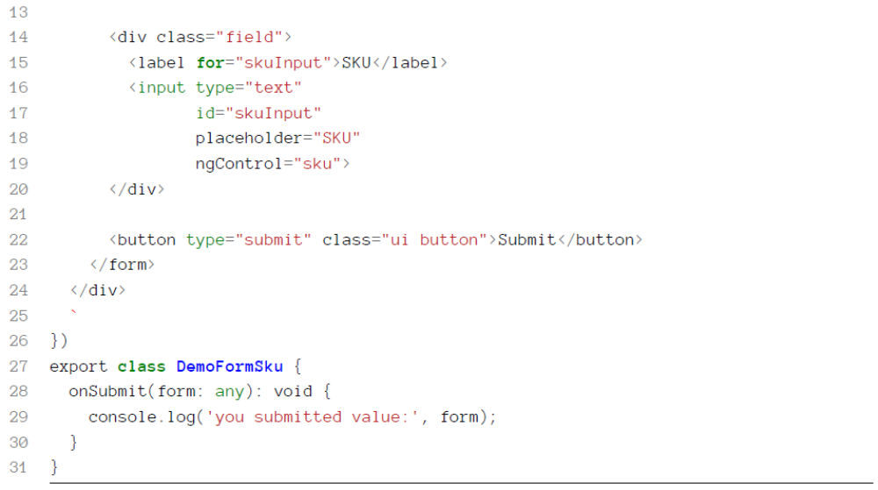

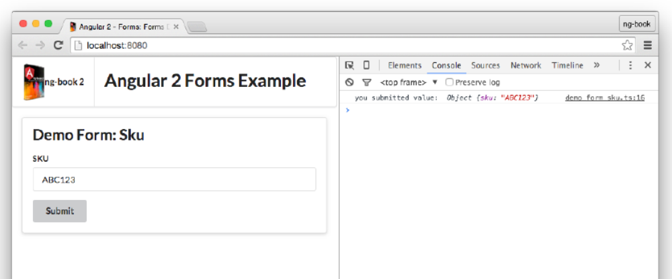

Using FormBuilder
Building our Controls and ControlGroups implicitly using ngForm and ngControl is convenient, but
doesn’t give us a lot of customization options. A more flexible and common way to configure forms
is to use a FormBuilder.

Using FormBuilder
We inject FormBuilder by creating an argument in the constructor of our component class:

31 export class DemoFormSkuBuilder {
32 myForm: ControlGroup;
33
34 constructor(fb: FormBuilder) {
35 this.myForm = fb.group({
36 'sku': ['ABC123']
37 });
38 }
39
40 onSubmit(value: string): void {
41 console.log('you submitted value: ', value);
42 }
43 }

myForm is typed to be a ControlGroup. We create a ControlGroup by calling fb.group(). .group
takes an object of key-value pairs that specify the Controls in this group.
In this case, we’re setting up one control sku, and the value is ["ABC123"] - this says that the default
value of this control is "ABC123".

Using myForm in the view

We want to change our <form> to use myForm. If you recall, in the last section we said that ngForm
is applied for us automatically when we used FORM_DIRECTIVES. We also mentioned that ngForm
creates its own ControlGroup. Well, in this case, we don’t want to use an outside ControlGroup.
Instead we want to use our instance variable myForm, which we created with our FormBuilder. How
can we do that?
Angular provides another directive that we use when we have an existing ControlGroup: it’s called
NgFormModel and we use it like this:

14 <form [ngFormModel]="myForm"
15 (ngSubmit)="onSubmit(myForm.value)"

Here we’re telling Angular that we want to use myForm as the ControlGroup for this form.

1 form:not([ngNoForm]):not([ngFormModel]),ngForm,[ngForm]
This means you could have a form that doesn’t get NgForm applied by using the ngNoForm
attribute.

We also need to change onSubmit to use myForm instead of f, because now it is myForm that has our configuration and values.
There’s one last thing we need to do to make this work: bind our Control to the input tag. Remember that ngControl creates a new Control object, and attaches it to the parent ControlGroup. But in this case, we used FormBuilder to create our own Controls.When we want to bind an existing Control to an input we use NgFormControl:

20 <input type="text"
21 id="skuInput"
22 placeholder="SKU"
23 [ngFormControl]="myForm.controls['sku']">

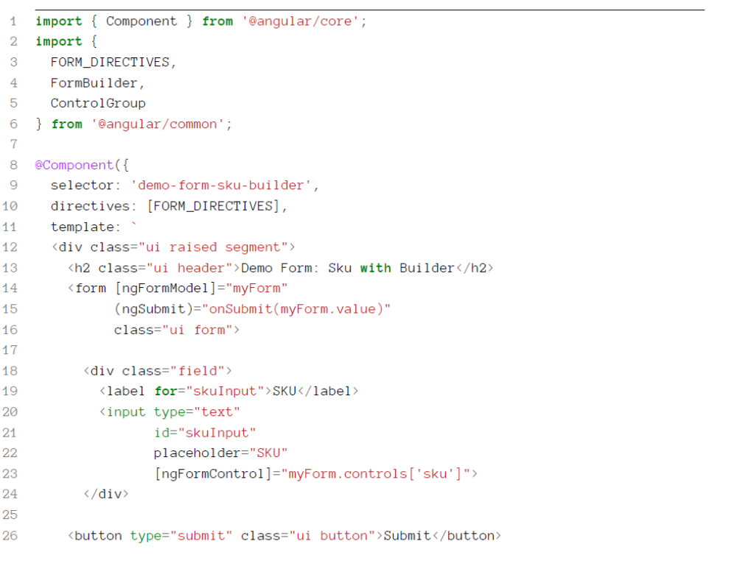
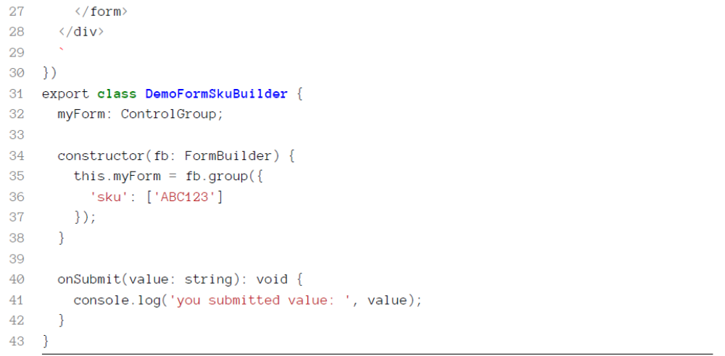

Adding Validations
To use validators we need to do two things:
1. Assign a validator to the Control object
2. Check the status of the validator in the view and take action accordingly

1 let control = new Control('sku', Validators.required);
Or in our case, because we’re using FormBuilder we will use the following syntax:
47 constructor(fb: FormBuilder) {
48 this.myForm = fb.group({
49 'sku': ['', Validators.required]

Explicitly setting the sku Control as an instance variable
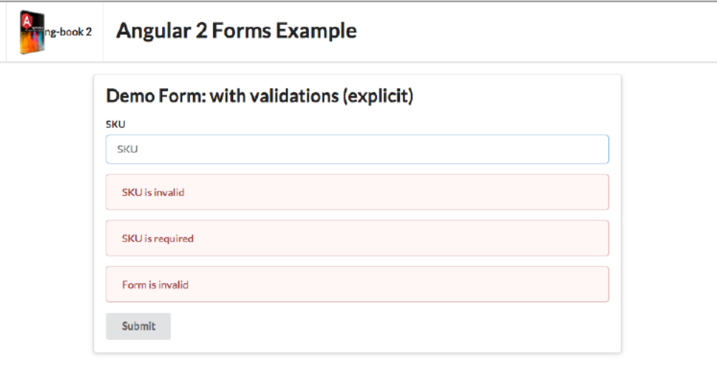

42 })
43 export class DemoFormWithValidationsExplicit {
44 myForm: ControlGroup;
45 sku: AbstractControl;
46
47 constructor(fb: FormBuilder) {
48 this.myForm = fb.group({
49 'sku': ['', Validators.required]
50 });
51
52 this.sku = this.myForm.controls['sku'];
53 }
54

This is great because it means we can reference sku anywhere in our component view. The downside
is that by doing it this way, we’d have to setup an instance variable for every field in our form.
Now that we have our sku being validated, I want to look at four different ways we can use it in
our view:
1. Checking the validity of our whole form and displaying a message
2. Checking the validity of our individual field and displaying a message
3. Checking the validity of our individual field and coloring the field red if it’s invalid
4. Checking the validity of our individual field on a particular requirement and displaying a
Message

Form message
We can check the validity of our whole form by looking at myForm.valid:
code/forms/app/ts/forms/demo_form_with_validations_explicit.ts
34 <div *ngIf="!myForm.valid"

Field message
28 [ngFormControl]="sku">
29 <div *ngIf="!sku.valid"

Field coloring
21 <div class="field"
22 [class.error]="!sku.valid && sku.touched">

Specific validation
30 class="ui error message">SKU is invalid</div>
31 <div *ngIf="sku.hasError('required')"

1 <div *ngIf="myForm.hasError('required', 'sku')"
2 class="error">SKU is required</div>

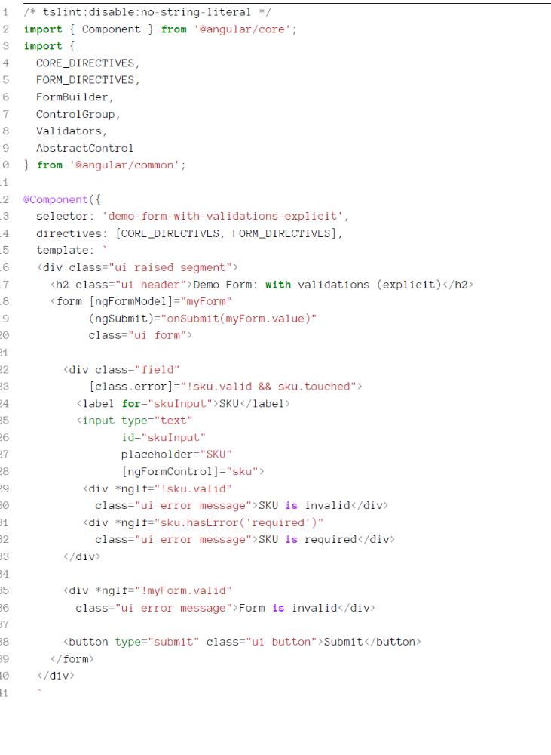
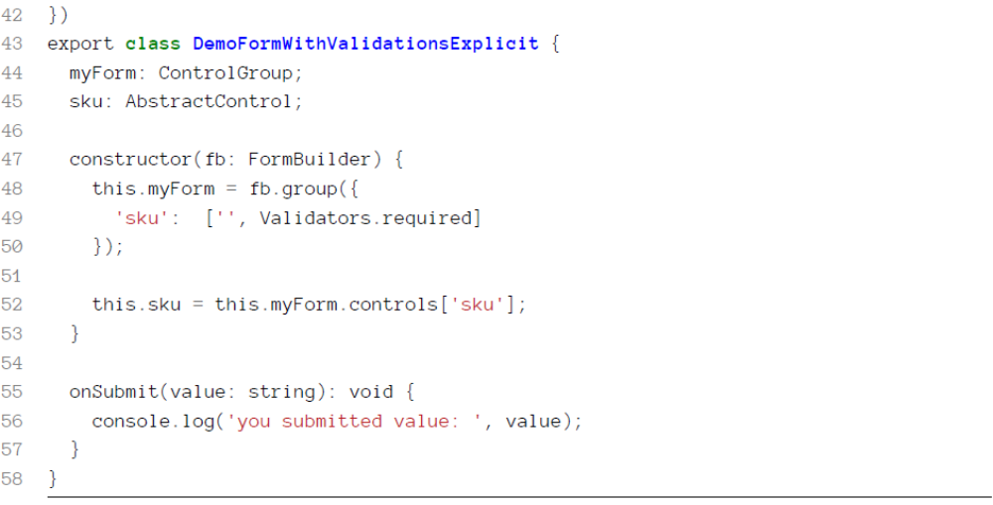

Explicitly setting the sku Control as an instance variable
42 export class DemoFormWithValidationsShorthand {
43 myForm: ControlGroup;
44
45 constructor(fb: FormBuilder) {
46 this.myForm = fb.group({
47 'sku': ['', Validators.required]
48 });
49 }
50
51 onSubmit(value: any): void {
52 console.log('you submitted value:', value.sku);
53 }
54 }

Declaring a local sku reference
Because we didn’t expose the sku Control as an instance variable, we now need a way to get a
reference to it. There are two ways we can get at it:
1. via myForm.find
2. via the ngFormControl directive

Field coloring via myForm.find
20 <div class="field"
21 [class.error]="!myForm.find('sku').valid && myForm.find('sku').touched">

The form export from NgFormControl
Components can export a reference themselves so that you can use them in the view.

23 <input type="text"
24 id="skuInput"
25 placeholder="SKU"
26 #sku="ngForm"
27 [ngFormControl]="myForm.controls['sku']">

Now that we have sku available to us, we can check the validity and errors like so:
28 <div *ngIf="!sku.control.valid"
29 class="ui error message">SKU is invalid</div>
30 <div *ngIf="sku.control.hasError('required')"
31 class="ui error message">SKU is required</div>

Local reference to sku scope
When we create a local reference using the #reference syntax, it is only available to sibling and
children elements, not parents.
For instance, we can’t do this
1 // this won't work
2 <div class="field"
3 [class.error]="!sku.control.valid && sku.control.touched">

Custom Validations
1 export class Validators {
2 static required(c: Control): StringMap<string, boolean> {
3 return isBlank(c.value) || c.value == "" ? {"required": true} : null;
4 }
A validator: - Takes a Control as its input and - Returns a StringMap<string, boolean> where the
key is “error code” and the value is true if it fails

Writing the Validator

21 function skuValidator(control: Control): { [s: string]: boolean } {
22 if (!control.value.match(/^123/)) {
23 return {invalidSku: true};
24 }
25 }
This validator will return an error code invalidSku if the input (the control.value) does not begin
with 123.
Assigning the Validator to the Control
How can we add multiple validators to a single field?
For that, we use Validators.compose:
64 this.myForm = fb.group({
65 'sku': ['', Validators.compose([
66 Validators.required, skuValidator])]
67 });

48 <div *ngIf="sku.hasError('invalidSku')"
49 class="ui error message">SKU must begin with <tt>123</tt></div>

Watching For Changes
So far we’ve only extracted the value from our form by calling onSubmit when the form is submitted.
But often we want to watch for any value changes on a control.
Both ControlGroup and Control have an EventEmitter that we can use to observe changes.

To watch for changes on a control we:
1. get access to the EventEmitter by calling control.valueChanges. Then we
2. add an observer using the .observer method

48 constructor(fb: FormBuilder) {
49 this.myForm = fb.group({
50 'sku': ['', Validators.required]
51 });
52
53 this.sku = this.myForm.controls['sku'];
54
55 this.sku.valueChanges.subscribe(
56 (value: string) => {
57 console.log('sku changed to:', value);
58 }
59 );
60
61 this.myForm.valueChanges.subscribe(
62 (form: any) => {
63 console.log('form changed to:', form);
64 }

Here we’re observing two separate events: changes on the sku field and changes on the form as a
whole.

ngModel
NgModel is a special directive: it binds a model to a form. ngModel is special in that it implements two-way data binding. Two-way data binding is almost always more complicated and difficult to
reason about vs. one-way data binding. Angular 2 is built to generally have data flow one-way: topdown.However, when it comes to forms, there are times where it is easier to opt-in to a two-way bind.

42 export class DemoFormNgModel {
43 myForm: ControlGroup;
44 productName: string;
45
46 constructor(fb: FormBuilder) {
47 this.myForm = fb.group({
48 'productName': ['', Validators.required]
49 });
50 }
51
52 onSubmit(value: string): void {
53 console.log('you submitted value: ', value);
54 }
55 }

27 <input type="text"
28 id="productNameInput"
29 placeholder="Product Name"
30 [ngFormControl]="myForm.find('productName')"
31 [(ngModel)]="productName">

Now notice something - the syntax for ngModel is funny: we are using both brackets and parenthesis
around the ngModel attribute! The idea this is intended to invoke is that we’re using both the input
[] brackets and the output () parenthesis. It’s an indication of the two-way bind.

17 <div class="ui info message">
18 The product name is: {{productName}}
19 </div>
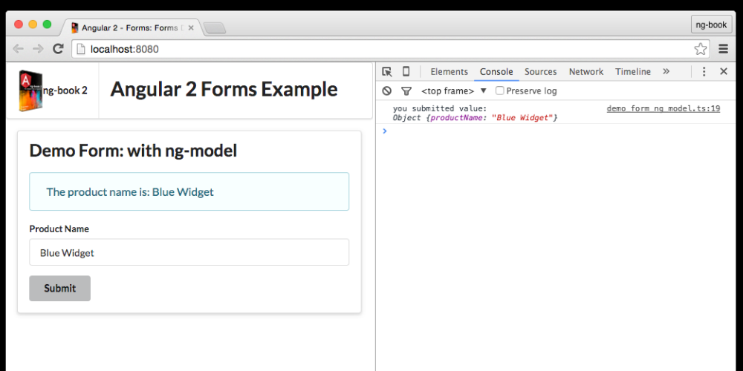

Data Architecture in Angular 2
There are tons of
ways to get data into your application:
• AJAX HTTP Requests
• Websockets
• Indexdb
• LocalStorage
• Service Workers
• etc.
The problem of data architecture addresses questions like:
• How can we aggregate all of these different sources into a coherent system?
• How can we avoid bugs caused by unintended side-effects?
• How can we structure the code sensibly so that it’s easier to maintain and on-board new team
members?
• How can we make the app run as fast as possible when data changes?

MVW / Two-way data binding: Model-View-Whatever is a term used⁴⁰ to describe Angular
1’s default architecture. The $scope provides a two-way data-binding - the whole application
shares the same data structures and a change in one area propagates to the rest of the app.
• Flux⁴¹: uses a unidirectional data flow. In Flux, Stores hold data, Views render what’s in the
Store, and Actions change the data in the Store. There is a bit more ceremony to setup Flux,
but the idea is that because data only flows in one direction, it’s easier to reason about.
• Observables: Observables give us streams of data. We subscribe to the streams and then
perform operations to react to changes. RxJs⁴² is the most popular reactive streams library

Data Architecture in Angular 2
A data strategy that works
for one project doesn’t necessarily work for another. So Angular doesn’t prescribe a particular stack,
but instead tries to make it easy to use whatever architecture we choose

Observables and RxJS
In Angular, we can structure our application to use Observables as the backbone of our data architecture. Using Observables to structure our data is called Reactive Programming.
Reactive Programming is a way to work with asynchronous streams of data. Observables are the main data structure we use to implement Reactive Programming.

Learning Reactive Programming and RxJS

1. Promises emit a single value whereas streams emit many values. - Streams fulfill the same
role in your application as promises. If you’ve made the jump from callbacks to promises, you
know that promises are a big improvement in readability and data maintenance vs. callbacks.
In the same way, streams improve upon the promise pattern in that we can continuously
respond to data changes on a stream
2. Imperative code “pulls” data whereas reactive streams “push” data - In Reactive Programming
our code subscribes to be notified of changes and the streams “push” data to these
subscribers
3. RxJS is functional - If you’re a fan of functional operators like map, reduce, and filter
then you’ll feel right at home with RxJS because streams are, in some sense, lists and so the
powerful functional operators all apply
4. Streams are composable - Think of streams like a pipeline of operations over your data. You
can subscribe to any part of your stream and even combine them to create new streams

Chat App Overview
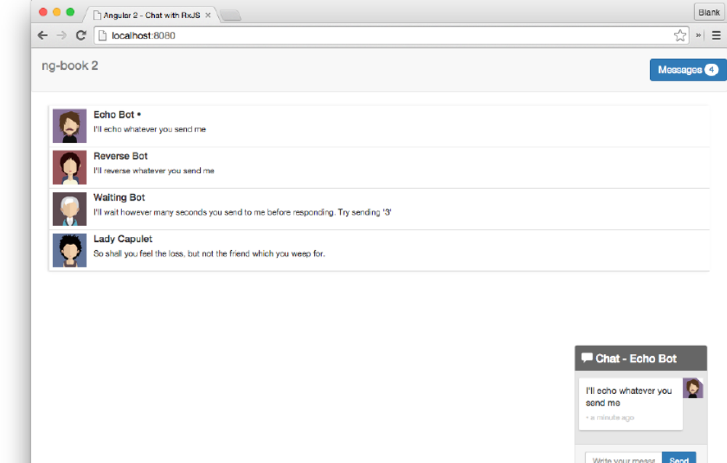

In this application we’ve provided a few bots you can chat with. Open up the code and try it out:
1 cd code/rxjs/chat
2 npm install
3 npm run go

Notice a few things about this application:
• You can click on the threads to chat with another person
• The bots will send you messages back, depending on their personality
• The unread message count in the top corner stays in sync with the number of unread messages
Let’s look at an overview of how this app is constructed. We have
• 3 top-level Angular Components
• 3 models
• and 3 services

Components
The page is broken down into three top-level components:

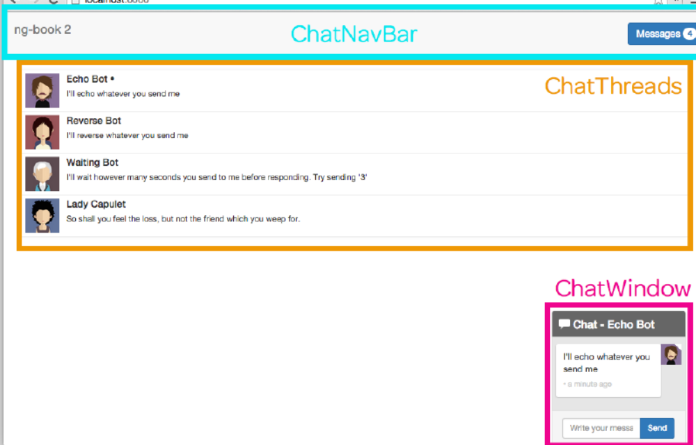

• ChatNavBar - contains the unread messages count
• ChatThreads - shows a clickable list of threads, along with the most recent message and the
conversation avatar
• ChatWindow - shows the messages in the current thread with an input box to send new
Messages

Models
This application also has three models:
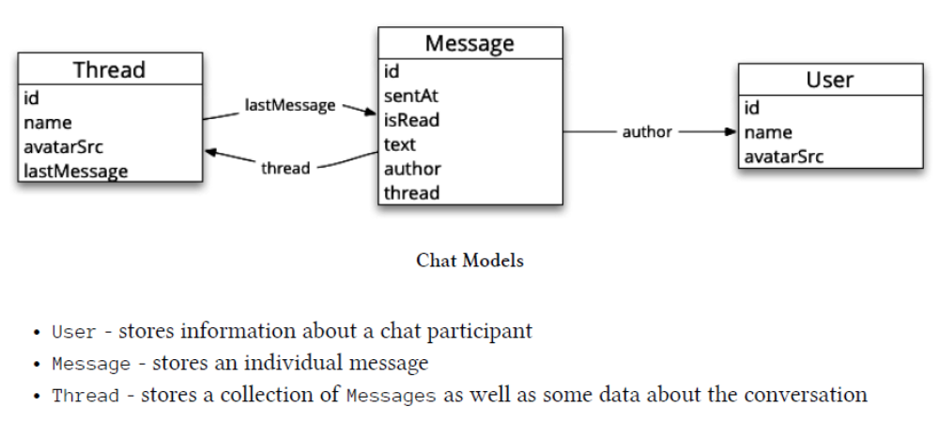

Services
In this app, each of our models has a corresponding service. The services are singleton objects that
play two roles:
1. Provide streams of data that our application can subscribe to
2. Provide operations to add or modify data
For instance, the UserService:
• publishes a stream that emits the current user and
• offers a setCurrentUser function which will set the current user (that is, emit the current user
from the currentUser stream)

Summary
At a high level, the application data architecture is straightforward:
• The services maintain streams which emit models (e.g. Messages)
• The components subscribe to those streams and render according to the most recent values
For instance, the ChatThreads component listens for the most recent list of threads from the
ThreadService and the ChatWindow subscribes for the most recent list of messages.

Implementing the Models
User
Our User class is straightforward. We have an id, name, and avatarSrc.
code/rxjs/chat/app/ts/models.ts
3 export class User {
4 id: string;
5
6 constructor(public name: string,
7 public avatarSrc: string) {
8 this.id = uuid();
9 }
10 }

Thread
Similarly, Thread is also a straightforward TypeScript class:
code/rxjs/chat/app/ts/models.ts
12 export class Thread {
13 id: string;
14 lastMessage: Message;
15 name: string;
16 avatarSrc: string;
17
18 constructor(id?: string,
19 name?: string,
20 avatarSrc?: string) {
21 this.id = id || uuid();
22 this.name = name;
23 this.avatarSrc = avatarSrc;
24 }
25 }

Message
27 export class Message {
28 id: string;
29 sentAt: Date;
30 isRead: boolean;
31 author: User;
32 text: string;
33 thread: Thread;
34
35 constructor(obj?: any) {
36 this.id = obj && obj.id || uuid();
37 this.isRead = obj && obj.isRead || false;
38 this.sentAt = obj && obj.sentAt || new Date();
39 this.author = obj && obj.author || null;
40 this.text = obj && obj.text || null;
41 this.thread = obj && obj.thread || null;
42 }
43 }

The pattern you see here in the constructor allows us to simulate using keyword arguments in the
constructor. Using this pattern, we can create a new Message using whatever data we have available
and we don’t have to worry about the order of the arguments. For instance we could do this:

1 let msg1 = new Message();
2
3 # or this
4
5 let msg2 = new Message({
6 text: "Hello Nate Murray!"
7 })

Implementing UserService
The point of the UserService is to provide a place where our application can learn about the current
user and also notify the rest of the application if the current user changes.
The first thing we need to do is create a TypeScript class and make it injectable by using the
@Injectable annotation.

9 @Injectable()
10 export class UserService {

When we make something injectable that means we will be able to use it as a dependency
to other components in our application. Briefly, two benefits of dependency-injection are:
1. we let Angular handle the lifecycle of the object and
2. it’s easier to test injected components.
We talk more about @Injectable in the chapter

currentUser stream
Next we setup a stream which we will use to manage our current user:

12 currentUser: Subject<User> = new BehaviorSubject<User>(null);

There’s a lot going on here, so let’s break it down:
• We’re defining an instance variable currentUser which is a Subject stream.
• Concretely, currentUser is a BehaviorSubject which will contain User.
• However, the first value of this stream is null (the constructor argument).

If you haven’t worked with RxJS much, then you may not know what Subject or BehaviorSubject are. You can think of a Subject as a “read/write” stream.
BehaviourSubject⁵⁴ has a special property in that it stores the last value. Meaning that any
subscriber to the stream will receive the latest value.

Setting a new user

- Add new users to the stream directly:

1 userService.subscribe((newUser) => {
2 console.log('New User is: ', newUser.name);
3 })
4
5 // => New User is: originalUserName
6
7 let u = new User('Nate', 'anImgSrc');
8 userService.currentUser.next(u);
9
10 // => New User is: Nate

- Create a setCurrentUser(newUser: User) method

14 public setCurrentUser(newUser: User): void {
15 this.currentUser.next(newUser);
16 }

By wrapping the next in the setCurrentUser call we give ourselves room to change
the implementation of the UserService without breaking our clients.

UserService.ts

1 import {Injectable, bind} from '@angular/core';
2 import {Subject, BehaviorSubject} from 'rxjs';
3 import {User} from '../models';
4
5
6 /**
7 * UserService manages our current user
8 */
9 @Injectable()
10 export class UserService {
11 // `currentUser` contains the current user
12 currentUser: Subject<User> = new BehaviorSubject<User>(null);
13
14 public setCurrentUser(newUser: User): void {
15 this.currentUser.next(newUser);
16 }
17 }
18
19 export var userServiceInjectables: Array<any> = [
20 bind(UserService).toClass(UserService)
21 ];

The MessagesService

There are five streams that make up our MessagesService: 3 “data management” streams and 2 “action”
streams.
The three data management streams are:
• newMessages - emits each new Message only once
• messages - emits an array of the current Messages
• updates - performs operations on messages

the newMessages stream
newMessages is a Subject that will publish each new Message only once.

11 @Injectable()
12 export class MessagesService {
13 // a stream that publishes new messages only once
14 newMessages: Subject<Message> = new Subject<Message>();

If we want, we can define a helper method to add Messages to this stream:
code/rxjs/chat/app/ts/services/MessagesService.ts
88 addMessage(message: Message): void {
89 this.newMessages.next(message);
90 }

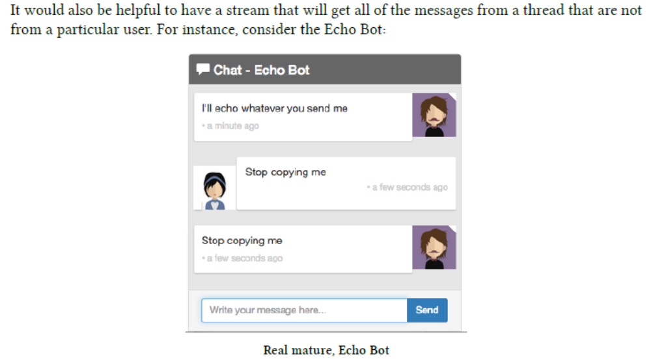

When we are implementing the Echo Bot, we don’t want to enter an infinite loop and repeat back
the bot’s messages to itself.
To implement this we can subscribe to the newMessages stream and filter out all messages that are
1. part of this thread and
2. not written by the bot.
You can think of this as saying, for a given Thread I want a stream of the messages that are “for”
this User.

92 messagesForThreadUser(thread: Thread, user: User): Observable<Message> {
93 return this.newMessages
94 .filter((message: Message) => {
95 // belongs to this thread
96 return (message.thread.id === thread.id) &&
97 // and isn't authored by this user
98 (message.author.id !== user.id);
99 });
100 }

messagesForThreadUser takes a Thread and a User and returns a new stream of Messages that are
filtered on that Thread and not authored by the User. That is, it is a stream of “everyone else’s”
messages in this Thread.

the messages stream
Whereas newMessages emits individual Messages, the messages stream emits an Array of the most
recent Messages.

16 // `messages` is a stream that emits an array of the most up to date messages
17 messages: Observable<Message[]>;

The type Message[] is the same as Array<Message>. Another way of writing the same
thing would be: Observable<Array<Message>>. When we define the type of messages to
be Observable<Message[]> we mean that this stream emits an Array (of Messages), not
individual Messages.

So how does messages get populated? For that we need to talk about the updates stream and a new
pattern: the Operation stream.
The Operation Stream Pattern

Here’s the idea:
• We’ll maintain state in messages which will hold an Array of the most current Messages
• We use an updates stream which is a stream of functions to apply to messages
You can think of it this way: any function that is put on the updates stream will change the list of
the current messages. A function that is put on the updates stream should accept a list of Messages
and then return a list of Messages.

7 interface IMessagesOperation extends Function {
8 (messages: Message[]): Message[];
9 }

Let’s define our updates stream:

19 // `updates` receives _operations_ to be applied to our `messages`
20 // it's a way we can perform changes on *all* messages (that are currently
21 // stored in `messages`)
22 updates: Subject<any> = new Subject<any>();

Remember, updates receives operations that will be applied to our list of messages. But how do we
make that connection? We do (in the constructor of our MessagesService) like this:

28 constructor() {
29 this.messages = this.updates
30 // watch the updates and accumulate operations on the messages
31 .scan((messages: Message[],
32 operation: IMessagesOperation) => {
33 return operation(messages);
34 },
35 initialMessages)

This code introduces a new stream function: scan⁵⁵. If you’re familiar with functional programming,
scan is a lot like reduce: it runs the function for each element in the incoming stream and
accumulates a value. What’s special about scan is that it will emit a value for each intermediate
result. That is, it doesn’t wait for the stream to complete before emitting a result, which is exactly
what we want.
When we call this.updates.scan, we are creating a new stream that is subscribed to the updates
stream. On each pass, we’re given:
1. the messages we’re accumulating and
2. the new operation to apply.
and then we return the new Message[].

