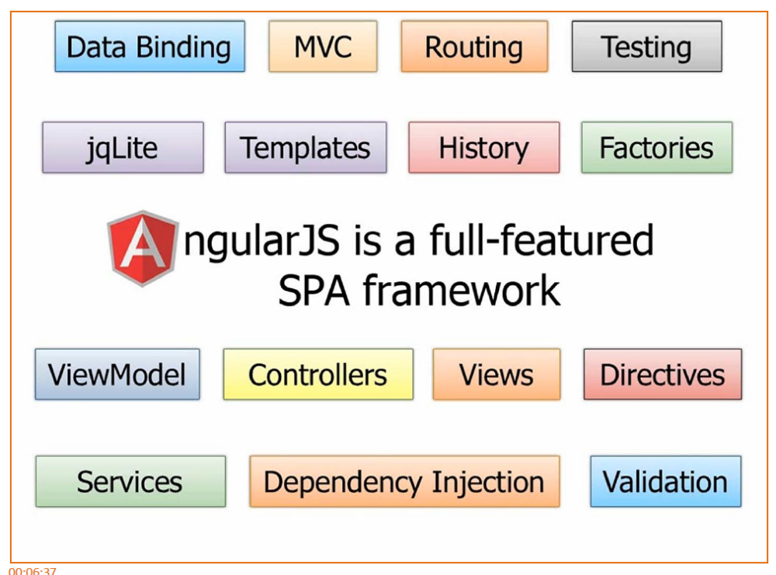

We have two-way data binding. We have the Model-View-Controller concept. Routing of the Views I mentioned into the shell pages is done through built-in routing support.

For DOM manipulation jQLite is built-in which is kind of like the Mini-Me of jQuery. If you want to use more advanced stuff you can even use jQuery and they play really nice together: Angular and jQuery.

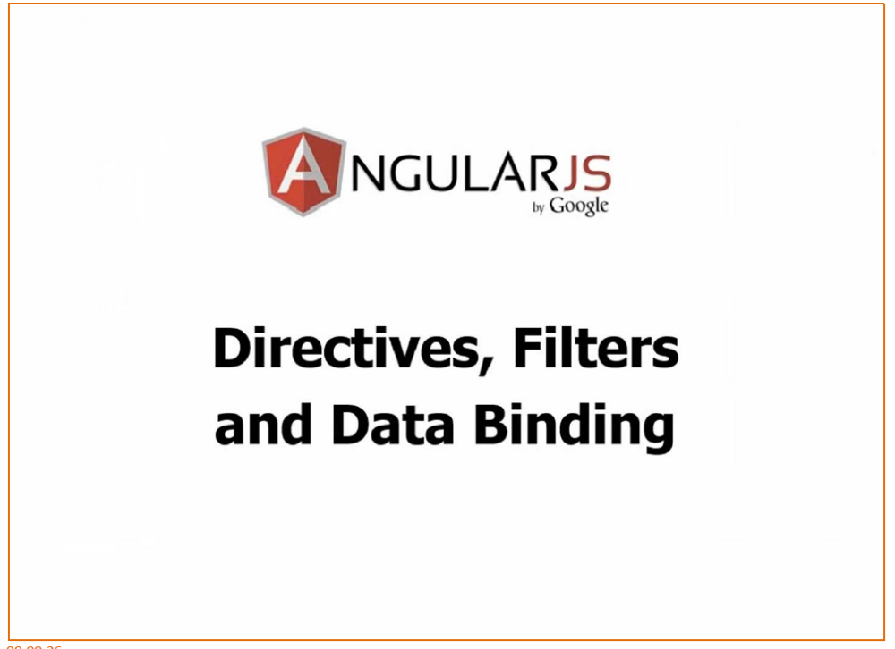

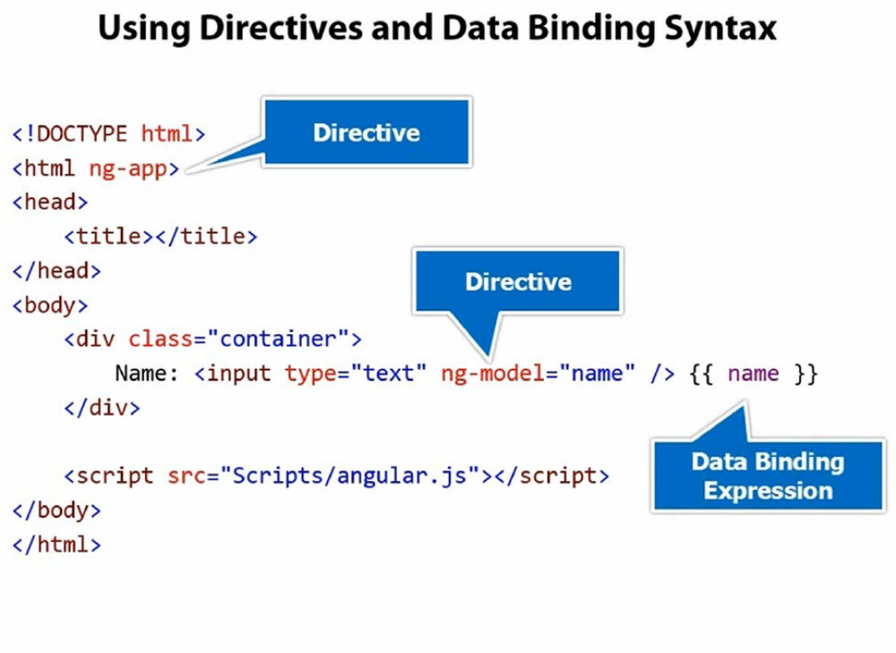
Notice at the top we have ng-app. Any time you see ng- that is an Angular directive. It’s a built-on directive. You can also write custom ones. You can get third party ones and things like that.
This particular directive is very important because the script that’s now loaded [at the bottom] is going to kick off and this will initialise the Angular app. Right now we don’t have any particular module associated or any other code but we can still do stuff just by adding ng-app.
So for example, this is an example of another directive called ng-model.
What ng-model does is behind the scenes it’s going to add a property up in the memory called “name” into what’s called “the scope”.
I’m going to come down a little bit and say ng-model=”name”.
This is the name of the property. I could have said “foo” or I could have said “fo”, “fum” or whatever I wanted but we’re going to do “name” here, and again I’m going to add data- just because it makes me feel all warm and fuzzy.

Next what I’m going to do is as they type I would like to bind to the value that they type. Because we now, behind the scenes, made a property up in memory called “name” I can now bind to that, and we do that using the double brackets “{{“. We’re using the kind of handlebars or moustache –type style of data-binding if you’ve used those script libraries before.

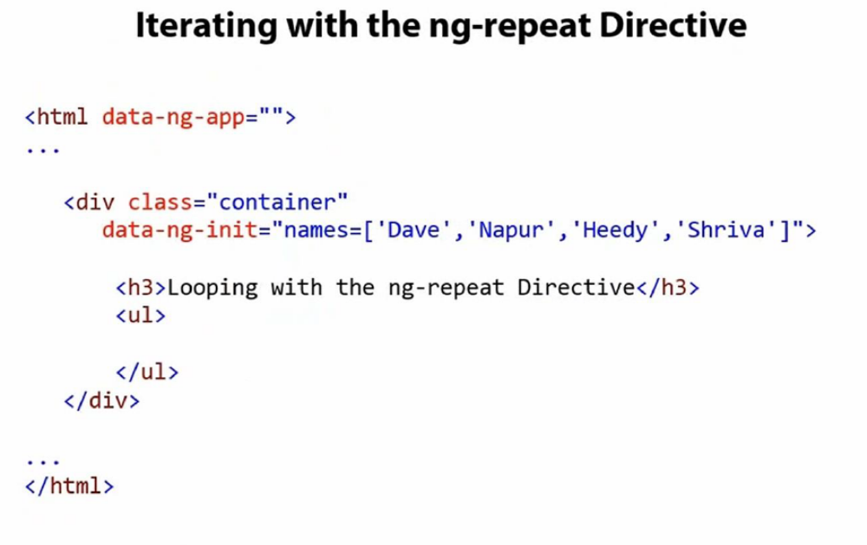

So I have another directive here called ng-init and this isn’t one I use a lot in real life apps because we’re going to get into controllers and things like that later in the video, but this is going to give me some initialisation data that I want to actually bind to and display so we can come in and use another directive in Angular called ng-repeat.

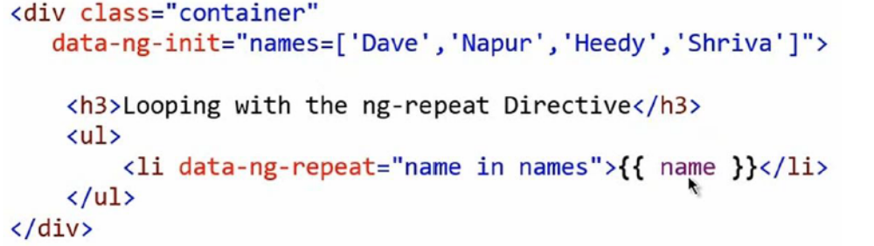

We’ve now initialised our data with the ng-init.
• We’re going to iterate through our data with the ng-repeat
• We simply give it the name and it’s going to put that name into the variable when we bind to it

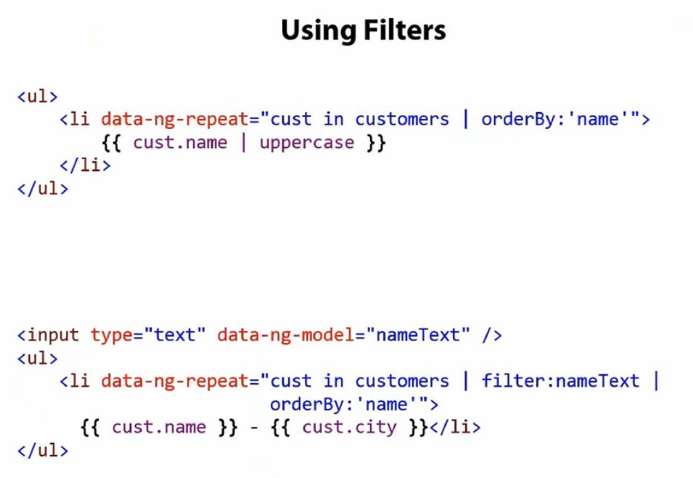

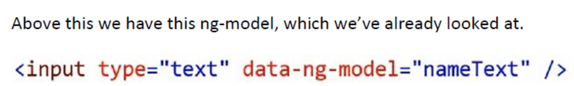

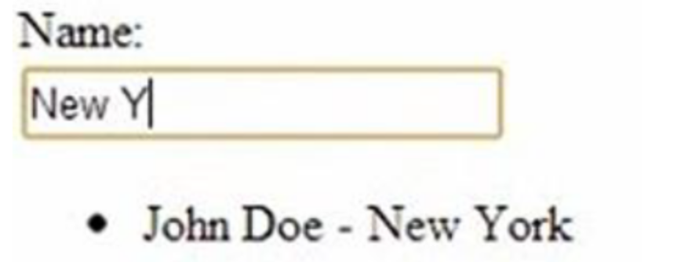

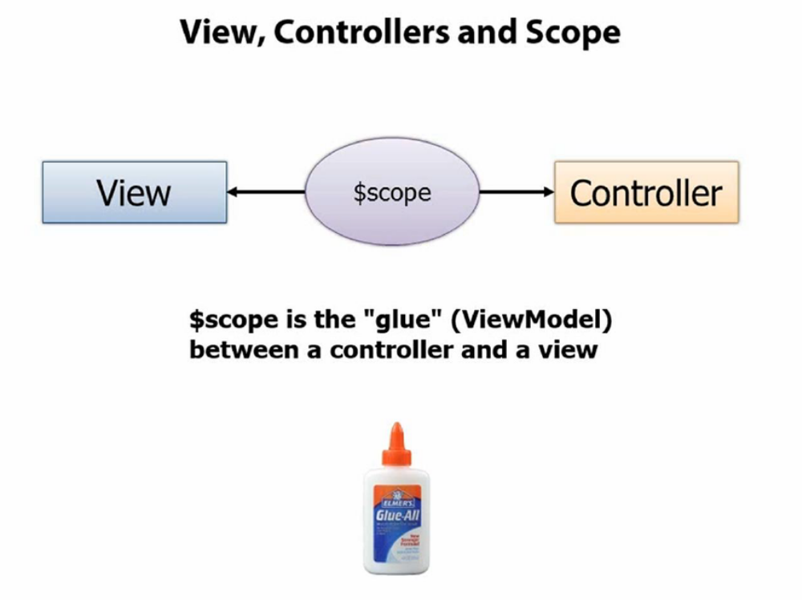

But we don’t want to put all of our logic into the View because it’s not very maintainable or testable or all those types of things.

Instead we’re going to have a special little JavaScript object – a container - called a Controller. The Controller will drive things. It’s going to control ultimately what data gets bound into the View. If the View passes up data to the controller it will handle passing off maybe to a service which then updates a back-end data store.

The glue between the View and the Controller is something called the Scope, and in Angular you’re going to see a lot of objects or variables that start with $. $scope represents the scope object.

