Wat is ORM?

In a nutshell, object/relational mapping is the automated (and transparent) per-
sistence of objects in a Java application to the tables in a relational database, using
metadata that describes the mapping between the objects and the database.

An ORM solution consists of the following four pieces:

- An API for performing basic CRUD operations on objects of persistent classes

- A language or API for specifying queries that refer to classes and properties of classes

- A facility for specifying mapping metadata

- A technique for the ORM implementation to interact with transactional objects to perform dirty checking, lazy association fetching, and other optimization functions

Advantages

Productivity
Persistence-related code can be perhaps the most tedious code in a Java applica-
tion. Hibernate eliminates much of the grunt work (more than you’d expect) and
lets you concentrate on the business problem.

Maintainability
Fewer lines of code (LOC) make the system more understandable, because it
emphasizes business logic rather than plumbing. Most important, a system with
less code is easier to refactor.

Vendor independence
An ORM abstracts your application away from the underlying database and
SQL dialect.

Hibernate Core
It’s the base service for persistence, with its native API and its mapping metadata stored in XML. It has a query language called HQL as well as programmatic query interfaces for Criteria and Example queries.

Hibernate Annotations
A new way to define application metadata. Annotations embedded directly in the Java source code.

Hibernate EntityManager
JPA specification also defines programming interfaces, lifecycle rules for per-
sistent objects, and query features. The Hibernate implementation for this part of
is available as Hibernate EntityManager, another optional module you can
stack on top of Hibernate Core.

Different Development scenarios

Top down —In top-down development, you start with an existing domain
model, its implementation in Java, and (ideally) complete freedom with
respect to the database schema. You must create mapping metadata—
either with files or by annotating the Java source—and then optionally
XML let Hibernate’s tool (hbm2ddl) generate the database schema.

Bottom up —Conversely, bottom-up development begins with an existing data-
base schema and data model. In this case, the easiest way to proceed is to
use the reverse-engineering tools to extract metadata from the database.
This metadata can be used to generate mapping files, with
XML hbm2hbmxml for example. With, the Hibernate mapping metadata is used to
hbm2java generate Java persistent classes, and even data access objects—in other
words, a skeleton for a Java persistence layer.

Middle out - Some architects and XML developers prefer middle-out development, where they begin with handwritten Hibernate mapping files, and then generate the database schema using hbm2ddl and Java classes using hbm2java.

Creating the domain mode

Hibernate applications define persistent classes that are mapped to database tables.
You define these classes based on your analysis of the business domain; hence,
they’re a model of the domain. The “Hello World” example consists of one class
and its mapping.

Message.java

a simple persistent class

package hello;

public class Message {
//ID attribute
private Long id;

//Message text
private String text;

//Reference to another
private Message nextMessage;

Message() {}

public Message(String text) {
this.text = text;
}
public Long getId() {
return id;
}
private void setId(Long id) {
this.id = id;
}
public String getText() {
return text;
}
public void setText(String text) {
this.text = text;
}
public Message getNextMessage() {
return nextMessage;
}
public void setNextMessage(Message nextMessage) {
this.nextMessage = nextMessage;
}
}

Mapping the class to a database schema
<?xml version="1.0"?>
<!DOCTYPE hibernate-mapping PUBLIC
"-//Hibernate/Hibernate Mapping DTD//EN"
"http://hibernate.sourceforge.net/hibernate-mapping-3.0.dtd">

<hibernate-mapping>
<class name="hello.Message" table="MESSAGES">
<id name="id" column="MESSAGE_ID">
<generator class="increment"/>
</id>

<property name="text" column="MESSAGE_TEXT"/>

<many-to-one name="nextMessage"
cascade="all" column="NEXT_MESSAGE_ID"
foreign-ey="FK_NEXT_MESSAGE"/>
</class>
</hibernate-mapping>

Storing and loading objects

package hello;
import java.util.*;
import org.hibernate.*;
import persistence.*;

public class HelloWorld {
public static void main(String[] args) {
// First unit of work
Session session = HibernateUtil.getSessionFactory().openSession();
Transaction tx = session.beginTransaction();
Message message = new Message("Hello World");
Long msgId = (Long) session.save(message);
tx.commit();
session.close();

// Second unit of work
Session newSession = HibernateUtil.getSessionFactory().openSession();
Transaction newTransaction = newSession.beginTransaction();
List messages = newSession.createQuery("from Message m order by m.text asc").list();

System.out.println( messages.size() +" message(s) found:" );
for ( Iterator iter = messages.iterator(); iter.hasNext(); ) {
Message loadedMsg = (Message) iter.next();
System.out.println( loadedMsg.getText() );
}
newTransaction.commit();
newSession.close();

// Third unit of work
Session thirdSession = HibernateUtil.getSessionFactory().openSession();

Transaction thirdTransaction = thirdSession.beginTransaction();
// msgId holds the identifier value of the first message
message = (Message) thirdSession.get( Message.class, msgId );
message.setText( "Greetings Earthling" );
message.setNextMessage(new Message( "Take me to your leader (please)" )
);
thirdTransaction.commit();
thirdSession.close();

// Shutting down the application
HibernateUtil.shutdown();
}
}

SessionFactory

SessionFactory should be instantiated once during application initialization. The single instance should then be used by all code in a particular process. This is thread-safe and can be shared across application.

Session
Session is a single-threaded nonshared object that represents a particular unit of work with the database. It has the persistence manager API you call to load and store objects.

Transaction
This can be used to set transaction boundaries programmatically.
Other choices are JDBC, JTA or container-managed transactions with EJB.

Query
A database query can be written in Hibernate’s own object-oriented Query language (HQL) or plain SQL.

This third unit code calls three statements inside the same database transaction:

SQL
select m.MESSAGE_ID, m.MESSAGE_TEXT, m.NEXT_MESSAGE_ID from MESSAGES m where m.MESSAGE_ID = 1

insert into MESSAGES (MESSAGE_ID, MESSAGE_TEXT, NEXT_MESSAGE_ID)
values (2, 'Take me to your leader (please)', null)

update MESSAGES
set MESSAGE_TEXT = 'Greetings Earthling', NEXT_MESSAGE_ID = 2
where MESSAGE_ID = 1

Dirty Checking

Notice how Hibernate detected the modification to the and text nextMessage properties of the first message and automatically updated the database. Hibernate did automatic dirty checking.

Cascading save

Similarly, the new message was made persistent when a reference was created from the first message. This feature is called cascading save.

Transactional write-behind

Also notice that the ordering of the statements isn’t the same as the order SQL
in which you set property values. Hibernate uses a sophisticated algorithm to determine an efficient ordering that avoids database foreign key constraint violations but is still sufficiently predictable to the user. This feature is called transactional write-behind.

Building a SessionFactory

package persistence;
import org.hibernate.*;
import org.hibernate.cfg.*;
public class HibernateUtil {

private static SessionFactory sessionFactory;
static {
try {
sessionFactory=new Configuration().configure().buildSessionFactory();
} catch (Throwable ex) {
throw new ExceptionInInitializerError(ex);
}
}

public static SessionFactory getSessionFactory() {
// Alternatively, you could look up in JNDI here
return sessionFactory;
}
public static void shutdown() {
// Close caches and connection pools
getSessionFactory().close();
}
}

When new Configuration() is called, Hibernate searches for a file named hibernate.properties in the root of the classpath. If it’s found, all hibernate.*
properties are loaded and added to the object.

When configure() is called Hibernate searches for a file named
hibernate.cfg.xml in the root of the classpath, and an exception is thrown if it can’t
be found.

hibernate.cfg.xml

<!DOCTYPE hibernate-configuration SYSTEM "http://hibernate.sourceforge.net/hibernate-configuration-3.0.dtd">

<hibernate-configuration>

<session-factory>
<property name="hibernate.connection.driver_class">
org.hsqldb.jdbcDriver
</property>
<property name="hibernate.connection.url">
jdbc:hsqldb:hsql://localhost
</property>
<property name="hibernate.connection.username">
sa
</property>

<property name="hibernate.dialect">
org.hibernate.dialect.HSQLDialect
</property>

<!-- Use the C3P0 connection pool provider -->
<property name="hibernate.c3p0.min_size">5</property>
<property name="hibernate.c3p0.max_size">20</property>
<property name="hibernate.c3p0.timeout">300</property>
<property name="hibernate.c3p0.max_statements">50</property>
<property name="hibernate.c3p0.idle_test_period">3000</property>

<!-- Show and print nice SQL on stdout -->
<property name="show_sql">true</property>
<property name="format_sql">true</property>

<!-- List of XML mapping files -->
<mapping resource="hello/Message.hbm.xml"/>
</session-factory>
</hibernate-configuration>

Enabling logging and statistic

hibernate.show_sql :– Shows the SQL.

hibernate.format_sql :- The output is more readable.

hibernate.use_sql_comments :- It causes Hibernate to put comments inside all generated statements to hint at their origin. For example, you can then easily see if a particular-SQL statement was generated from an explicit query or an on-demand collection initialization.

You can also monitor Hibernate by enabling live statistics.

SessionFactory Statistics stats = HibernateUtil.getSessionFactory().getStatistics();
stats.setStatisticsEnabled(true);
...
stats.getSessionOpenCount();
stats.logSummary();
EntityStatistics itemStats = stats.getEntityStatistics("auction.model.Item");
itemStats.getFetchCount();

Hibernate Annotations

package hello;
import javax.persistence.*;
@Entity
@Table(name = "MESSAGES")
public class Message {

@Id @GeneratedValue
@Column(name = "MESSAGE_ID")
private Long id;

@Column(name = "MESSAGE_TEXT")
private String text;

@ManyToOne(cascade = CascadeType.ALL)
@JoinColumn(name = "NEXT_MESSAGE_ID")

private Message nextMessage;
private Message() {}
public Message(String text) {
this.text = text;
}
public Long getId() {
return id;
}

private void setId(Long id) {
this.id = id;
}

public String getText() {
return text;
}
public void setText(String text) {
this.text = text;
}

public Message getNextMessage() {
return nextMessage;
}
public void setNextMessage(Message nextMessage) {
this.nextMessage = nextMessage;
}
}

Hibernate.cfg.xml:

<!DOCTYPE hibernate-configuration SYSTEM
"http://hibernate.sourceforge.net/hibernate-configuration-3.0.dtd">
<hibernate-configuration>
<session-factory>
<!-- ... Many property settings ... -->
<!-- List of annotated classes-->
<mapping class="hello.Message"/>

Creation of Session Factory

// Load settings from hibernate.properties
AnnotationConfiguration cfg = new AnnotationConfiguration();
// ... set other configuration options programmatically
cfg.addAnnotatedClass(hello.Message.class);
SessionFactory sessionFactory = cfg.buildSessionFactory();

Using Hibernate EntityManager/Basic JPA configuration

Hibernate EntityManager is a wrapper around Hibernate Core that provides the
JPA programming interfaces. JPA uses persistence.xml available in meta-inf folder to get the configuration details.

<persistence xmlns="http://java.sun.com/xml/ns/persistence"
xmlns:xsi="http://www.w3.org/2001/XMLSchema-instance"
xsi:schemaLocation="http://java.sun.com/xml/ns/persistence
http://java.sun.com/xml/ns/persistence/persistence_1_0.xsd"
version="1.0">
<persistence-unit name="helloworld">
<properties>
<property name="hibernate.ejb.cfgfile"
value="/hibernate.cfg.xml"/>
</properties>
</persistence-unit>
</persistence>

javax.persistence.EntityManagerFactory : This is equivalent to SessionFactory. It’s thread-safe, is usually handled as a singleton, and provides methods for the creation of EntityManager.

javax.persistence.EntityManager :- This is equivalent to Session object. This single-threaded, nonshared object represents a
particular unit of work for data access.

javax.persistence.Query :- This is equivalanet to Query. An object is a particular JPA query language or native
query representation.

javax.persistence.EntityTransaction :- It is used in Java SE environments for the demarcation Transaction.

package hello;
import java.util.*;
import javax.persistence.*;

public class HelloWorld {
public static void main(String[] args) {
// Start EntityManagerFactory
EntityManagerFactory emf = Persistence.createEntityManagerFactory("helloworld");

// First unit of work
EntityManager em = emf.createEntityManager();
EntityTransaction tx = em.getTransaction();
tx.begin();
Message message = new Message("Hello World");
em.persist(message);
tx.commit();
em.close();
....

Understanding Mapping persistent classes

Entity

Entity object has its own idenity, its instance has references from many other instances (shared references), and they have independent lifecycles.

Selecting a key generator
native AUTO | The identity generator picks other identity generators like  sequence, hilo, etc depending on the capabilities of the underlying database.
sequence SEQUENCE | This generator creates and uses a sequence.
Increment | This generator reads the maximum (numeric) primary key column value of the table and increments the value to +1.
IDENTITY
hilo

<id column="MY_ID">
<generator class="sequence">
<parameter name="sequence">MY_SEQUENCE</parameter>
<parameter name="parameters">
INCREMENT BY 1 START WITH 1
</parameter>
</generator>
</id>

Dynamic SQ L generation

By default, Hibernate creates statements for each persistent class on startup.
These statements are simple create, read, update, and delete operations for reading a single row, deleting a row, and so on.

How can Hibernate create an statement on startup? After all, the columns to be updated aren’t known at this time.
The answer is that the generated statement updates all columns, and if the value of a particular column isn’t modified, the statement sets it to its old value.

Two attributes for disabling CRUD SQL generation on startup are available on
the mapping element:
<class>
<class name="Item"
dynamic-insert="true"
dynamic-update="true">
...
</class>

@Entity
@org.hibernate.annotations.Entity(
dynamicInsert = true, dynamicUpdate = true
)
public class Item { ...

Making an entity immutable

Instances of a particular class may be immutable. For example, a Bid made for an item is immutable. Hence, no update statement ever needs to be executed on the Bid
table.

<hibernate-mapping default-access="field">
<class name="Bid" mutable="false">
...
</class>
</hibernate-mapping>

@Entity
@org.hibernate.annotations.Entity(mutable = false)
@org.hibernate.annotations.AccessType("field")
public class Bid { ..

Implementing naming conventions

We often encounter organizations with strict conventions for database table and
column names. Hibernate provides a feature that allows you to enforce naming
standards automatically using NamingStrategy interface.

Customizing property access

Properties of a class are accessed by the persistence engine either directly
(through fields) or indirectly (through getter and setter property accessor meth-
ods).

Using derived properties

The value of a derived property is calculated at runtime by evaluating an expres-
sion that you define using the formula attribute. For example, you may map totalIncludingTax a property to an expression:

<property name="totalIncludingTax"
formula="TOTAL + TAX_RATE * TOTAL"
type="big_decimal"/>

@org.hibernate.annotations.Formula("TOTAL + TAX_RATE * TOTAL")
public BigDecimal getTotalIncludingTax() {

<property
name="averageBidAmount"
type="big_decimal"
formula=
"( select AVG(b.AMOUNT) from
BID b where b.ITEM_ID = ITEM_ID )"/>

Generated and default property values

Imagine a particular property of a class has its value generated by the database,
usually when the entity row is inserted for the first time. Typical database-gener-
ated values are timestamp of creation, a default price for an item, and a trigger
that runs for every modification.

Typically, Hibernate applications need to refresh objects that contain any
properties for which the database generates values. After insert or update, it automatically generated a select to get the updated values.

<property name="lastModified"
column="LAST_MODIFIED"
update="false"
insert="false"
generated="always"/>

@Column(updatable = false, insertable = false)
@org.hibernate.annotations.Generated(
org.hibernate.annotations.GenerationTime.ALWAYS
)
private Date lastModified;

Mapping components

A User entity class has 6 address fields at db level for home and billing address. Breaking the 6 fields into class level provides a better design.

public class Address {
private String street;
private String zipcode;

private String city;

public Address() {}
public String getStreet() { return street; }
public void setStreet(String street) { this.street = street; }
public String getZipcode() { return zipcode; }
public void setZipcode(String zipcode) {
this.zipcode = zipcode; }
public String getCity() { return city; }
public void setCity(String city) { this.city = city; }
}

<class name="User" table="USER">
<id name="id" column="USER_ID" type="long">
<generator class="native"/>
</id>

<property name="loginName" column="LOGIN" type="string"/>
<component name="homeAddress" class="Address">

<property name="street" type="string"
column="HOME_STREET" not-null="true"/>
<property name="city" type="string"
column="HOME_CITY" not-null="true"/>
<property name="zipcode" type="string"
column="HOME_ZIPCODE" not-null="true"/>
</component>

<component name="billingAddress" class="Address">
<property name="street" type="string"
column="BILLING_STREET" not-null="true"/>

<property name="city" type="string"
column="BILLING_CITY" not-null="true"/>

<property name="zipcode" type="string"
column="BILLING_ZIPCODE" not-null="true"/>
</component>

In the above case, you can’t navigate from Address to User.
Hibernate supports both unidirectional and bidirectional

<component name="homeAddress" class="Address">
<parent name="user"/>
<property name="street" type="string"
column="HOME_STREET" not-null="true"/>
<property name="city" type="string"
column="HOME_CITY" not-null="true"/>
<property name="zipcode" type="stringshort"
column="HOME_ZIPCODE" not-null="true"/>
</component>

The <parent> element maps a property of type User
to the owning entity, which in this example is the property named
user. You can then call to navigate in the other direction.
This is really a simple Address.getUser() back-pointer.

Annotations

@Embeddable

public class Address {
@Column(name = "ADDRESS_STREET", nullable = false)
private String street;
@Column(name = "ADDRESS_ZIPCODE", nullable = false)
private String zipcode;
@Column(name = "ADDRESS_CITY", nullable = false)
private String city;
...
}

@Entity
@Table(name = "USERS")
public class User {
...
@Embedded
@AttributeOverrides( {
@AttributeOverride(name = "street",
column = @Column(name="HOME_STREET") ),
@AttributeOverride(name = "zipcode",
column = @Column(name="HOME_ZIPCODE") ),
@AttributeOverride(name = "city",
column = @Column(name="HOME_CITY") )
})
private Address homeAddress;
...
}

Java primitive mapping types

Mapping type | Java type | Standard SQL built-in type
integer | int or java.lang.Integer | INTEGER
big_decimal | java.math.BigDecimal | NUMERIC
character | java.lang.String | CHAR/ VARCHAR
yes_no | boolean or java.lang.Boolean | CHAR(1) ('Y' or 'N')

Date and time mapping types
Mapping type | Java type | Standard SQL built-in type
date | java.util.Date or java.sql.Date | DATE
time | java.util.Date or java.sql.Time | TIME
timestamp | java.util.Date or java.sql.Timestamp | TIMESTAMP

Binary and large value mapping types
Mapping type | Java type | Standard SQL built-in type
binary | byte[] | VARBINARY
clob | java.sql.Clob | CLOB
blob | java.sql.Blob | BLOB
text | java.lang.String | CLOB

Mapping class inheritance

There are four different approaches to representing an inheritance hierarchy:
■ Table per concrete class with implicit polymorphism—Use no explicit
inheritance mapping, and default runtime polymorphic behavior.
■ Table per concrete class—Discard polymorphism and inheritance relationships
completely from the SQL schema.
■ Table per class hierarchy—Enable polymorphism by denormalizing the SQL
schema, and utilize a type discriminator column that holds type information.
■ Table per subclass—Represent is a (inheritance) relationships as has a (foreign
key) relationships.

Table per concrete class with implicit polymorphism

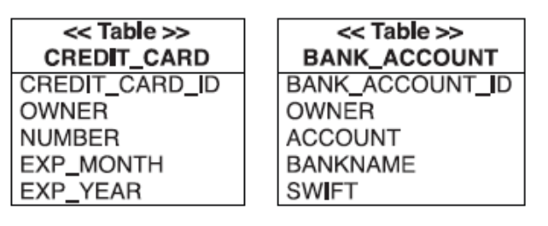

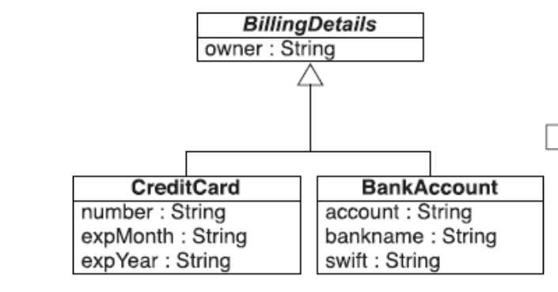

You don’t have to do anything special in Hibernate to enable polymorphic behavior.
The mapping for CreditCard and BankAccount is straightforward, each in its
own entity <class> element, as we have done already for classes without a superclass
(or persistent interfaces). Hibernate still knows about the superclass (or any
interface) because it scans the persistent classes on startup.

BillingDetails
is associated with User; both subclass tables would need a foreign
key reference to the USERS table. Or, if User had a many-to-one relationship with
BillingDetails, the USERS table would need a single foreign key column,
which would have to refer both concrete subclass tables. This isn’t possible with
regular foreign key constraints.

Polymorphic queries (queries that return objects of all classes that match the
interface of the queried class)

For a
query against the BillingDetails class Hibernate uses the following SQL:
select CREDIT_CARD_ID, OWNER, NUMBER, EXP_MONTH, EXP_YEAR ...
from CREDIT_CARD
select BANK_ACCOUNT_ID, OWNER, ACCOUNT, BANKNAME, ...
from BANK_ACCOUNT

Single Table Inheritance[edit]
Single table inheritance is the simplest and typically the best performing and best solution. In single table inheritance a single table is used to store all of the instances of the entire inheritance hierarchy. The table will have a column for every attribute of every class in the hierarchy. A discriminator column is used to determine which class the particular row belongs to, each class in the hierarchy defines its own unique discriminator value.
PROJECT (table)
ID | PROJ_TYPE | NAME | BUDGET
1 | L | Accounting | 50000
2 | S | Legal | null

@Entity
@Inheritance
@DiscriminatorColumn(name="PROJ_TYPE")
@Table(name="PROJECT")
public abstract class Project {
@Id
private long id;
...
}

@Entity
@DiscriminatorValue("L")
public class LargeProject extends Project {
private BigDecimal budget;
}

@Entity
@DiscriminatorValue("S")
public class SmallProject extends Project {
}

Joined, Multiple Table Inheritance
Joined inheritance is the most logical inheritance solution because it mirrors the object model in the data model. In joined inheritance a table is defined for each class in the inheritance hierarchy to store only the local attributes of that class. Each table in the hierarchy must also store the object's id (primary key), which is only defined in the root class. All classes in the hierarchy must share the same id attribute. A discriminator column is used to determine which class the particular row belongs to, each class in the hierarchy defines its own unique discriminator value.

PROJECT (table)
ID | PROJ_TYPE | NAME
1 | L | Accounting
2 | S | Legal
SMALLPROJECT (table)
ID
2
LARGEPROJECT (table)
ID | BUDGET
1 | 50000
@Entity
@Inheritance(strategy=InheritanceType.JOINED)
@DiscriminatorColumn(name="PROJ_TYPE")
@Table(name="PROJECT")
public abstract class Project {
@Id
private long id;
...
}

@Entity
@DiscriminatorValue("L")
@Table(name="LARGEPROJECT")
public class LargeProject extends Project {
private BigDecimal budget;
}

@Entity
@DiscriminatorValue("S")
@Table(name="SMALLPROJECT")
public class SmallProject extends Project {
}

http://en.wikibooks.org/wiki/Java_Persistence/Inheritance

Single Table Inheritance

PROJECT (table)
ID | PROJ_TYPE | NAME | BUDGET
1 | L | Accounting | 50000
2 | S | Legal | null

@Entity
@Inheritance
@DiscriminatorColumn(name="PROJ_TYPE")
@Table(name="PROJECT")
public abstract class Project {
@Id
private long id;
...
}
@Entity
@DiscriminatorValue("L")
public class LargeProject extends Project {
private BigDecimal budget;
}
@Entity
@DiscriminatorValue("S")
public class SmallProject extends Project {
}

Joined, Multiple Table Inheritance
Joined inheritance is the most logical inheritance solution because it mirrors the object model in the data model. In joined inheritance a table is defined for each class in the inheritance hierarchy to store only the local attributes of that class. Each table in the hierarchy must also store the object's id (primary key), which is only defined in the root class. All classes in the hierarchy must share the same id attribute. A discriminator column is used to determine which class the particular row belongs to, each class in the hierarchy defines its own unique discriminator value.

Example joined inheritance tables in database[edit]
PROJECT (table)
ID | PROJ_TYPE | NAME
1 | L | Accounting
2 | S | Legal
SMALLPROJECT (table)
ID
2
LARGEPROJECT (table)
ID | BUDGET
1 | 50000
@Entity
@Inheritance(strategy=InheritanceType.JOINED)
@DiscriminatorColumn(name="PROJ_TYPE")
@Table(name="PROJECT")
public abstract class Project {
@Id
private long id;
...
}
@Entity
@DiscriminatorValue("L")
@Table(name="LARGEPROJECT")
public class LargeProject extends Project {
private BigDecimal budget;
}
@Entity
@DiscriminatorValue("S")
@Table(name="SMALLPROJECT")
public class SmallProject extends Project {
}

Common Problems[edit]

Poor query performance

Do not have/want a table for every subclass[edit]
Most inheritance hierarchies do not fit with either the joined or the single table inheritance strategy. Typically the desired strategy is somewhere in between, having joined tables in some subclasses and not in others. Unfortunately JPA does not directly support this. One workaround is to map your inheritance hierarchy as single table, but them add the additional tables in the subclasses, either through defining a Table or SecondaryTable in each subclass as required.

Table Per Class Inheritance
Table per class inheritance allows inheritance to be used in the object model, when it does not exist in the data model. In table per class inheritance a table is defined for eachconcrete class in the inheritance hierarchy to store all the attributes of that class and all of its superclasses.

Example table per class inheritance tables in database[edit]
SMALLPROJECT (table)
ID | NAME
2 | Legal
LARGEPROJECT (table)
ID | NAME | BUDGET
1 | Accounting | 50000

Example table per class inheritance annotations[edit]
@Entity
@Inheritance(strategy=InheritanceType.TABLE_PER_CLASS)
public abstract class Project {
@Id
private long id;
...
}
@Entity
@Table(name="LARGEPROJECT")
public class LargeProject extends Project {
private BigDecimal budget;
}
@Entity
@Table(name="SMALLPROJECT")
public class SmallProject extends Project {
}

Poor query performance

Issues with ordering and joins[edit]
Because table per class inheritance requires multiple queries, or unions, you cannot join to, fetch join, or traverse them in queries.

Mapped Superclasses[edit]
Mapped superclass inheritance allows inheritance to be used in the object model, when it does not exist in the data model. It is similar to table per class inheritance, but does not allow querying, persisting, or relationships to the superclass. Its main purpose is to allow mappings information to be inherited by its subclasses. The subclasses are responsible for defining the table, id and other information, and can modify any of the inherited mappings.

Example mapped superclass tables in database[edit]
SMALLPROJECT (table)
ID | NAME
2 | Legal
LARGEPROJECT (table)
ID | PROJECT_NAME | BUDGET
1 | Accounting | 50000

Example mapped superclass annotations[edit]
@MappedSuperclass
public abstract class Project {
@Id
private long id;
@Column(name="NAME")
private String name;
...
}
@Entity
@Table(name="LARGEPROJECT")
@AttributeOverride(name="name", column=@Column(name="PROJECT_NAME"))
public class LargeProject extends Project {
private BigDecimal budget;
}
@Entity
@Table("SMALLPROJECT")
public class SmallProject extends Project {
}

Cannot query, persist, or have relationships[edit]
The main disadvantage of mapped superclasses is that they cannot be queried or persisted. You also cannot have a relationship to a mapped superclass.

Table per concrete class with implicit polymorphism

You can use exactly one
table for each (nonabstract) class. All properties of a class, including inherited
properties, can be mapped to columns of this table

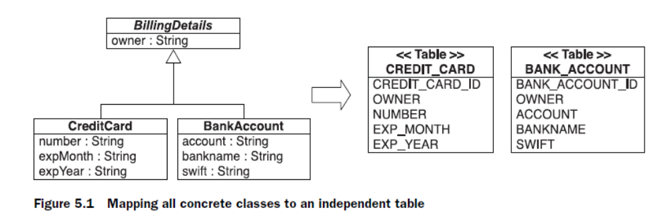

You don’t have to do anything special in Hibernate to enable polymorphic behavior.
The mapping for CreditCard and BankAccount is straightforward, each in its
own entity <class> element, as we have done already for classes without a superclass
(or persistent interfaces). Hibernate still knows about the superclass (or any
interface) because it scans the persistent classes on startup.

it doesn’t support polymorphic
associations very well. In the database, associations are usually represented as
foreign key relationships.

if the subclasses are all mapped to different
tables, a polymorphic association to their superclass (abstract BillingDetails
in this example) can’t be represented as a simple foreign key
relationship. This would be problematic in our domain model, because BillingDetails
is associated with User; both subclass tables would need a foreign
key reference to the USERS table. Or, if User had a many-to-one relationship with
BillingDetails, the USERS table would need a single foreign key column,
which would have to refer both concrete subclass tables. This isn’t possible with
regular foreign key constraints.

Polymorphic queries (queries that return objects of all classes that match the
interface of the queried class) are also problematic. A query against the superclass
must be executed as several SQL SELECTs, one for each concrete subclass. For a
query against the BillingDetails class Hibernate uses the following SQL:
select CREDIT_CARD_ID, OWNER, NUMBER, EXP_MONTH, EXP_YEAR ...
from CREDIT_CARD
select BANK_ACCOUNT_ID, OWNER, ACCOUNT, BANKNAME, ...
from BANK_ACCOUNT

A further conceptual problem with this mapping strategy is that several different
columns, of different tables, share exactly the same semantics. This makes
schema evolution more complex. For example, a change to a superclass property
results in changes to multiple columns. It also makes it much more difficult to
implement database integrity constraints that apply to all subclasses.
We recommend this approach (only) for the top level of your class hierarchy,
where polymorphism isn’t usually required, and when modification of the superclass
in the future is unlikely.

@MappedSuperclass
public abstract class BillingDetails {
@Column(name = "OWNER", nullable = false)
private String owner;
...
}

@Entity
@AttributeOverride(name = "owner", column =
@Column(name = "CC_OWNER", nullable = false)
)
public class CreditCard extends BillingDetails {
@Id @GeneratedValue
@Column(name = "CREDIT_CARD_ID")
private Long id = null;
@Column(name = "NUMBER", nullable = false)
private String number;
...
}

Table per concrete class with unions

First, let’s consider a union subclass mapping with BillingDetails as an abstract class (or interface), as in the previous section. In this situation, we again have two
tables and duplicate superclass columns in both: CREDIT_CARD and BANK_ACCOUNT.

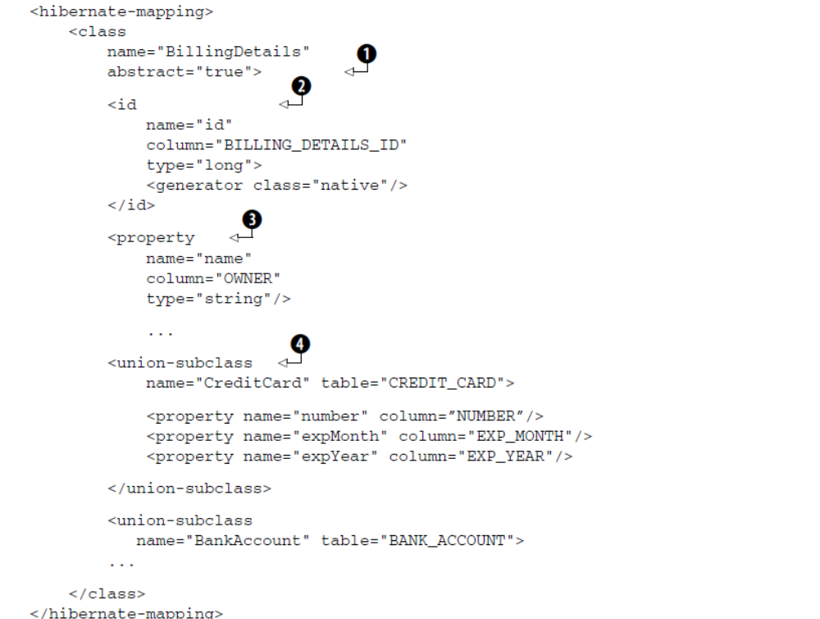

The database identifier mapping is shared for all concrete classes in the hierarchy.
The CREDIT_CARD and the BANK_ACCOUNT tables both have a BILLING_DETAILS_ID
primary key column.

A concrete subclass is mapped to a table; the table inherits the superclass (or
interface) identifier and other property mappings.

@Entity
@Inheritance(strategy = InheritanceType.TABLE_PER_CLASS)
public abstract class BillingDetails {
@Id @GeneratedValue
@Column(name = "BILLING_DETAILS_ID")
private Long id = null;
@Column(name = "OWNER", nullable = false)
private String owner;
...
}

@Entity
@Table(name = "CREDIT_CARD")
public class CreditCard extends BillingDetails {
@Column(name = "NUMBER", nullable = false)
private String number;
...
}

If your superclass is concrete, then an additional table is needed to hold
instances of that class. We have to emphasize again that there is still no relationship
between the database tables, except for the fact that they share some similar
columns. The advantages of this mapping strategy are clearer if we examine polymorphic
queries. For example, a query for BillingDetails executes the following
SQL statement:
select
BILLING_DETAILS_ID, OWNER,
NUMBER, EXP_MONTH, EXP_YEAR,
ACCOUNT, BANKNAME, SWIFT
CLAZZ_
from
( select
BILLING_DETAILS_ID, OWNER,
NUMBER, EXP_MONTH, EXP_YEAR,
null as ACCOUNT, null as BANKNAME, null as SWIFT,
1 as CLAZZ_
from
CREDIT_CARD
union
select
BILLING_DETAILS_ID, OWNER,
null as NUMBER, null as EXP_MONTH, null as EXP_YEAR, ...
ACCOUNT, BANKNAME, SWIFT,
2 as CLAZZ_
from
BANK_ACCOUNT
)

Hibernate reads this to instantiate the correct class given the data from a particular
row. A union requires that the queries that are combined project over the
same columns; hence, we have to pad and fill up nonexistent columns with NULL.

Another much more important advantage is the ability to handle polymorphic
associations; for example, an association mapping from User to BillingDetails
would now be possible. Hibernate can use a UNION query to simulate a single table
as the target of the association mapping.

Table per class hierarchy
An entire class hierarchy can be mapped to a single table. This table includes columns
for all properties of all classes in the hierarchy. The concrete subclass represented
by a particular row is identified by the value of a type discriminator
column.

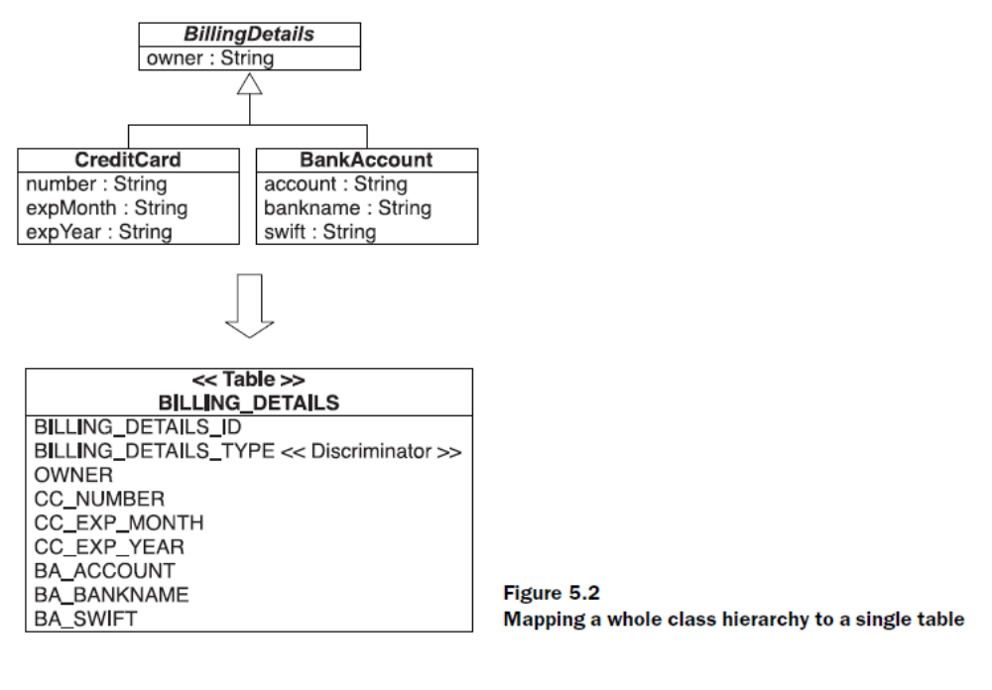

There is one major problem: Columns for properties declared by subclasses
must be declared to be nullable.

Another important issue is normalization.

Hibernate generates the following SQL when querying the BillingDetails
class:
select
BILLING_DETAILS_ID, BILLING_DETAILS_TYPE, OWNER,
CC_NUMBER, CC_EXP_MONTH, ..., BA_ACCOUNT, BA_BANKNAME, ...
from BILLING_DETAILS
To query the CreditCard subclass, Hibernate adds a restriction on the discriminator
column:
select BILLING_DETAILS_ID, OWNER, CC_NUMBER, CC_EXP_MONTH, ...
from BILLING_DETAILS
where BILLING_DETAILS_TYPE='CC'

Sometimes, especially in legacy schemas, you don’t have the freedom to include
an extra discriminator column in your entity tables. In this case, you can apply a
formula to calculate a discriminator value for each row:

<discriminator
formula="case when CC_NUMBER is not null then 'CC' else 'BA' end"
type="string"/>

Table per subclass
The fourth option is to represent inheritance relationships as relational foreign
key associations. Every class/subclass that declares persistent properties—including
abstract classes and even interfaces—has its own table.

Unlike the table per concrete class strategy we mapped first, the table here
contains columns only for each noninherited property (each property declared
by the subclass itself) along with a primary key that is also a foreign key of the
superclass table.

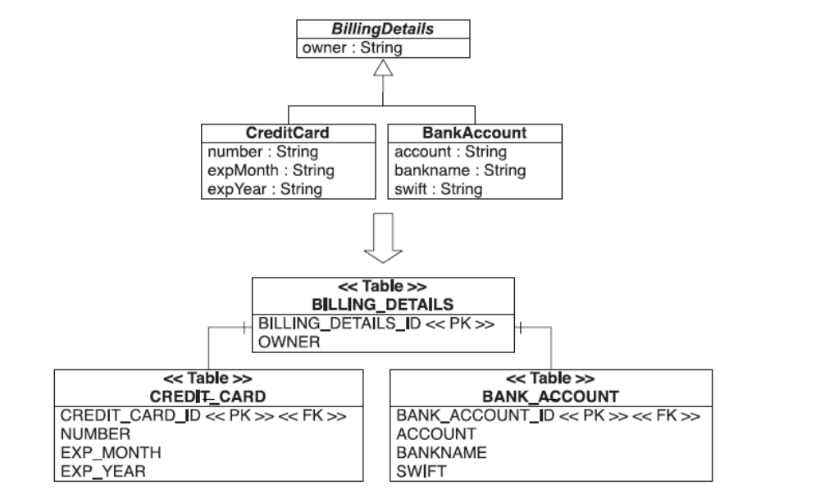

The primary advantage of this strategy is that the SQL schema is normalized.
Schema evolution and integrity constraint definition are straightforward. A polymorphic
association to a particular subclass may be represented as a foreign key
referencing the table of that particular subclass.

Hibernate relies on an outer join when querying the BillingDetails class:
select BD.BILLING_DETAILS_ID, BD.OWNER,
CC.NUMBER, CC.EXP_MONTH, ..., BA.ACCOUNT, BA.BANKNAME, ...
case
when CC.CREDIT_CARD_ID is not null then 1
when BA.BANK_ACCOUNT_ID is not null then 2
when BD.BILLING_DETAILS_ID is not null then 0
end as CLAZZ_
from BILLING_DETAILS BD
left join CREDIT_CARD CC
on BD.BILLING_DETAILS_ID = CC.CREDIT_CARD_ID
left join BANK_ACCOUNT BA
on BD.BILLING_DETAILS_ID = BA.BANK_ACCOUNT_ID

To narrow the query to the subclass, Hibernate uses an inner join:
select BD.BILLING_DETAILS_ID, BD.OWNER, CC.NUMBER, ...
from CREDIT_CARD CC
inner join BILLING_DETAILS BD
on BD.BILLING_DETAILS_ID = CC.CREDIT_CARD_ID

Furthermore, even though this mapping strategy is deceptively simple, our
experience is that performance can be unacceptable for complex class hierarchies.
Queries always require either a join across many tables or many sequential reads.

Let’s map the hierarchy with the same strategy and annotations, here called
the JOINED strategy:
@Entity
@Inheritance(strategy = InheritanceType.JOINED)
public abstract class BillingDetails {
@Id @GeneratedValue
@Column(name = "BILLING_DETAILS_ID")
private Long id = null;
...
}

In subclasses, you don’t need to specify the join column if the primary key column
of the subclass table has (or is supposed to have) the same name as the primary
key column of the superclass table:
@Entity
public class BankAccount {
...
}

This entity has no identifier property; it automatically inherits the BILLING_
DETAILS_ID property and column from the superclass, and Hibernate knows how

to join the tables together if you want to retrieve instances of BankAccount. Of
course, you can specify the column name explicitly:
@Entity
@PrimaryKeyJoinColumn(name = "CREDIT_CARD_ID")
public class CreditCard {
...
}

Mixing inheritance strategies

With some Hibernate tricks, you can
switch the mapping strategy for a particular subclass. For example, you can map a
class hierarchy to a single table, but for a particular subclass, switch to a separate
table with a foreign key mapping strategy, just as with table per subclass. This is
possible with the <join> mapping element:

<hibernate-mapping>
<class name="BillingDetails"
table="BILLING_DETAILS">
<id>...</id>
<discriminator
column="BILLING_DETAILS_TYPE"
type="string"/>

<subclass
name="CreditCard"
discriminator-value="CC">
<join table="CREDIT_CARD">
<key column="CREDIT_CARD_ID"/>
<property name="number" column="CC_NUMBER"/>
<property name="expMonth" column="CC_EXP_MONTH"/>
<property name="expYear" column="CC_EXP_YEAR"/>
...
</join>
</subclass>
<subclass
name="BankAccount"
discriminator-value="BA">
<property name=account" column="BA_ACCOUNT"/>
...
</subclass>

The <join> element groups some properties and tells Hibernate to get them from
a secondary table. This mapping element has many uses

In this example, it separates the CreditCard properties from the
table per hierarchy into the CREDIT_CARD table. The CREDIT_CARD_ID column of
this table is at the same time the primary key, and it has a foreign key constraint
referencing the BILLING_DETAILS_ID of the hierarchy table.

At runtime, Hibernate executes an outer join to fetch BillingDetails and all
subclass instances polymorphically:
select
BILLING_DETAILS_ID, BILLING_DETAILS_TYPE, OWNER,
CC.CC_NUMBER, CC.CC_EXP_MONTH, CC.CC_EXP_YEAR,
BA_ACCOUNT, BA_BANKNAME, BA_SWIFT
from
BILLING_DETAILS
left outer join
CREDIT_CARD CC
on BILLING_DETAILS_ID = CC.CREDIT_CARD_ID

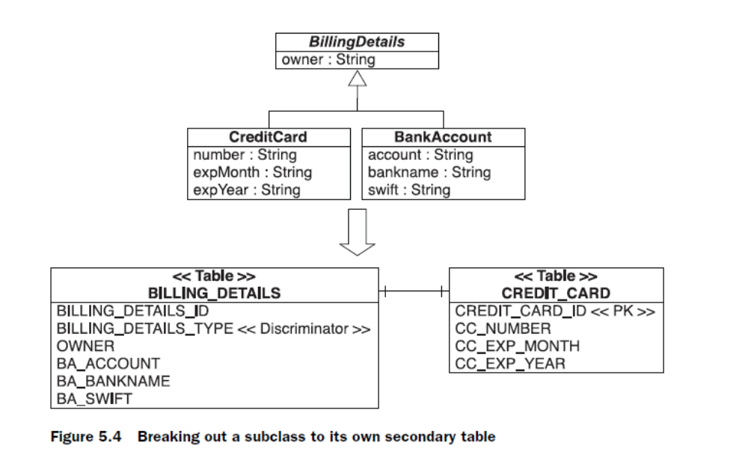

However,
if you have an exceptionally wide class hierarchy, the outer join can become
a problem. Some database systems (Oracle, for example) limit the number of
tables in an outer join operation. For a wide hierarchy, you may want to switch to a
different fetching strategy that executes an immediate second select instead of an
outer join:
<subclass
name="CreditCard"
discriminator-value="CC">
<join table="CREDIT_CARD" fetch="select">
<key column="CREDIT_CARD_ID"/>
...
</join>
</subclass>

Java Persistence also supports this mixed inheritance mapping strategy with annotations.
Map the superclass BillingDetails with InheritanceType.SINGLE_
TABLE, as you did before. Now map the subclass you want to break out of the single
table to a secondary table.
@Entity
@DiscriminatorValue("CC")
@SecondaryTable(
name = "CREDIT_CARD",
pkJoinColumns = @PrimaryKeyJoinColumn(name = "CREDIT_CARD_ID")
)
public class CreditCard extends BillingDetails {
@Column(table = "CREDIT_CARD",
name = "CC_NUMBER",
nullable = false)
private String number;
...
}

If you don’t specify a primary key join column for the secondary table, the name
of the primary key of the single inheritance table is used—in this case,
BILLING_DETAILS_ID.

Choosing a strategy

Here are some rules of thumb:
■ If you don’t require polymorphic associations or queries, lean toward tableper-
concrete-class—in other words, if you never or rarely query for BillingDetails
and you have no class that has an association to BillingDetails
(our model has).

If you do require polymorphic associations (an association to a superclass,
hence to all classes in the hierarchy with dynamic resolution of the concrete class at runtime) or queries, and subclasses declare relatively few properties
(particularly if the main difference between subclasses is in their behavior),
lean toward table-per-class-hierarchy.

If you do require polymorphic associations or queries, and subclasses
declare many properties (subclasses differ mainly by the data they hold),
lean toward table-per-subclass.

By default, choose table-per-class-hierarchy only for simple problems. For more
complex cases (or when you’re overruled by a data modeler insisting on the
importance of nullability constraints and normalization), you should consider the
table-per-subclass strategy.

So to summarize you could say the following rules apply when choosing from JPA's standard inheritance mapping options:
- Small inheritance hierarchy -> SINGLE_TABLE.
- Wide inheritance hierarchy -> TABLE_PER_CLASS.
- Deep inheritance hierarchy -> JOINED.

When you start thinking about mixing inheritance strategies, remember that
implicit polymorphism in Hibernate is smart enough to handle more exotic cases.
For example, consider an additional interface in our application, Electronic-
PaymentOption. This is a business interface that doesn’t have a persistence
aspect—except that in our application, a persistent class such as CreditCard will
likely implement this interface. No matter how you map the BillingDetails
hierarchy, Hibernate can answer a query from ElectronicPaymentOption correctly.

This even works if other classes, which aren’t part of the BillingDetails
hierarchy, are mapped persistent and implement this interface. Hibernate always
know what tables to query, which instances to construct, and how to return a polymorphic
result.

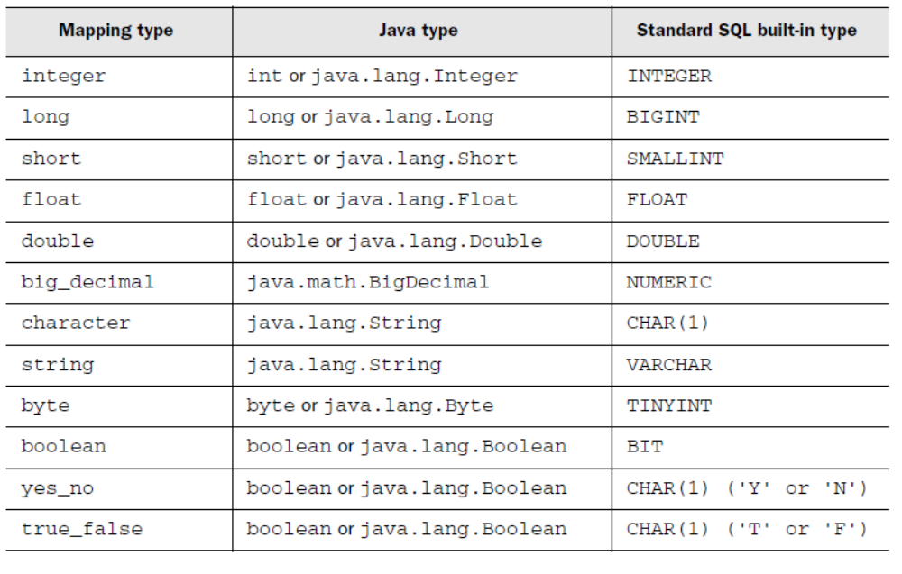

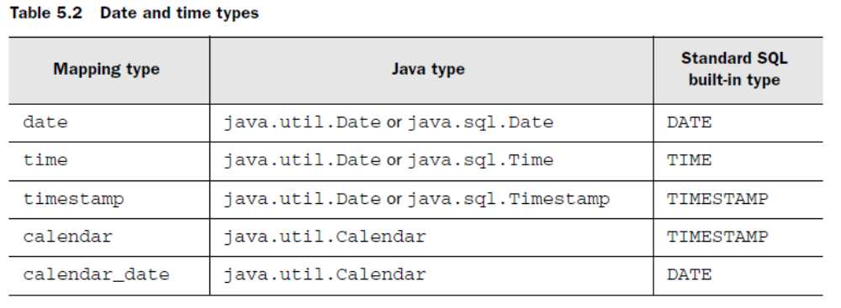
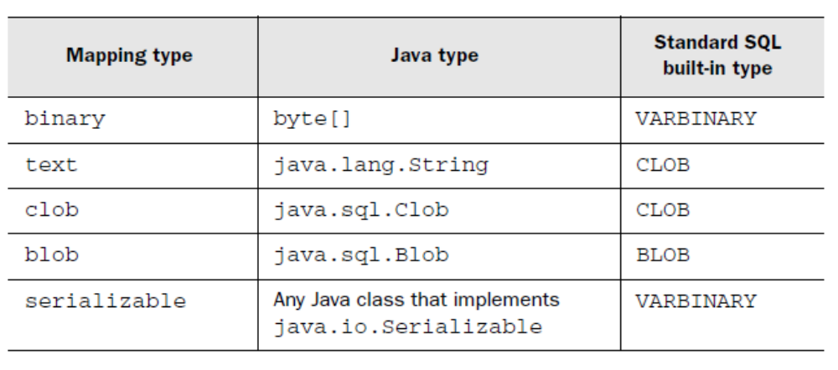

Creating custom mapping types

Hibernate provides several interfaces that applications may use when defining
custom mapping types.

The extension points are as follows:
■ org.hibernate.usertype.UserType

Sets, bags, lists, and maps of value types

Mapping a set
The simplest implementation is a Set of String image filenames. First, add a collection
property to the Item class:

private Set images = new HashSet();
...
public Set getImages() {
return this.images;
}
public void setImages(Set images) {
this.images = images;
}

<set name="images" table="ITEM_IMAGE">
<key column="ITEM_ID"/>
<element type="string" column="FILENAME" not-null="true"/>
</set>

A set can’t contain duplicate elements, so the primary key of the ITEM_IMAGE
collection table is a composite of both columns in the <set> declaration: ITEM_ID
and FILENAME. You can see the schema in figure 6.1.

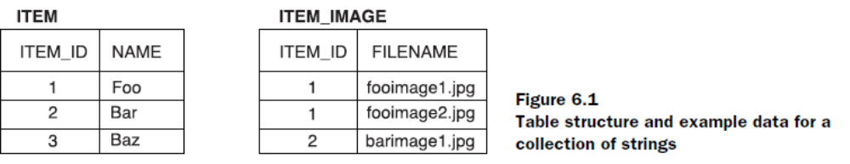

Mapping an identifier bag
An unordered collection that permits duplicate elements is called a bag. Curiously,
the Java Collections framework doesn’t include a bag implementation.
However, the java.util.Collection interface has bag semantics, so you only
need a matching implementation. You have two choices:

Write the collection property with the java.util.Collection interface,
and, on declaration, initialize it with an ArrayList of the JDK.

private Collection images = new ArrayList();
...
public Collection getImages() {
return this.images;
}
public void setImages(Collection images) {
this.images = images;
}

<idbag name="images" table="ITEM_IMAGE">
<collection-id type="long" column="ITEM_IMAGE_ID">
<generator class="sequence"/>
</collection-id>
<key column="ITEM_ID"/>
<element type="string" column="FILENAME" not-null="true"/>
</idbag>

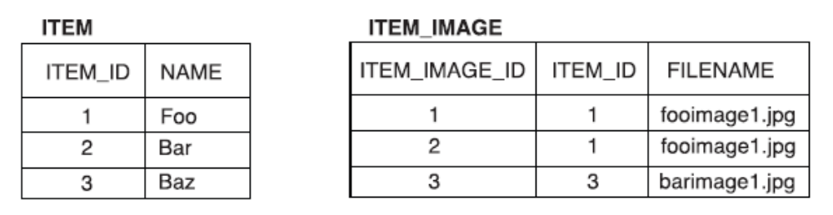

Mapping a list
First, let’s update the Item class:
private List images = new ArrayList();
...
public List getImages() {
return this.images;
}
public void setImages(List images) {
this.images = images;
}

<list name="images" table="ITEM_IMAGE">
<key column="ITEM_ID"/>
<list-index column="POSITION"/>
<element type="string" column="FILENAME" not-null="true"/>
</list>

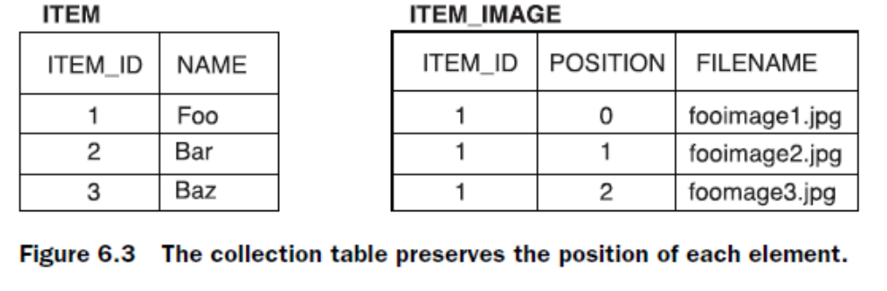

Mapping a map

private Map images = new HashMap();
...
public Map getImages() {
return this.images;
}
public void setImages(Map images) {
this.images = images;
}

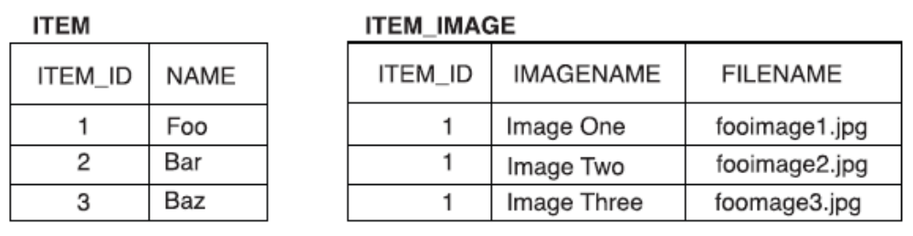

<map name="images" table="ITEM_IMAGE">
<key column="ITEM_ID"/>
<map-key column="IMAGENAME" type="string"/>
<element type="string" column="FILENAME" not-null="true"/>
</map>

Sorted and ordered collections

A sorted collection is
sorted in memory using a Java comparator. An ordered collection is ordered at the
database level using an SQL query with an order by clause.

private SortedMap images = new TreeMap();
...
public SortedMap getImages() {
return this.images;
}
public void setImages(SortedMap images) {
this.images = images;
}

Hibernate handles this collection accordingly, if you map it as sorted:

<map name="images"
table="ITEM_IMAGE"
sort="natural">
<key column="ITEM_ID"/>
<map-key column="IMAGENAME" type="string"/>
<element type="string" column="FILENAME" not-null="true"/>
</map>

If
you need some other sort algorithm

<map name="images"
table="ITEM_IMAGE"
sort="auction.util.comparator.ReverseStringComparator">

Alternatively, instead of switching to the Sorted* interfaces and the (Tree*
implementations), you may want to work with a linked map and to sort elements
on the database side, not in memory.

<map name="images"
table="ITEM_IMAGE"
order-by="IMAGENAME asc">

Collections of components

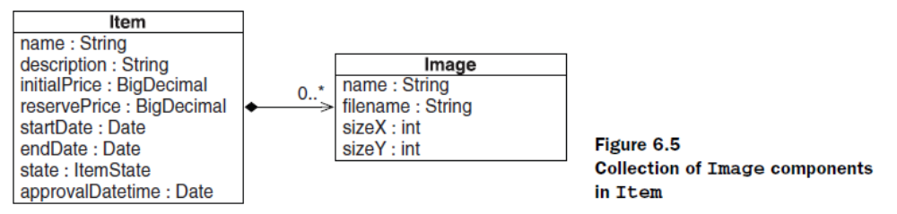

Writing the component class
First, implement the Image class as a regular POJO. As you know from chapter 4,
component classes don’t have an identifier property. You must implement
equals() (and hashCode()) and compare the name, filename, sizeX, and sizeY
properties. Hibernate relies on this equality routine to check instances for
modifications.

<set name="images"
table="ITEM_IMAGE"
order-by="IMAGENAME asc">
<key column="ITEM_ID"/>
<composite-element class="Image">
<property name="name" column="IMAGENAME" not-null="true"/>
<property name="filename" column="FILENAME" not-null="true"/>
<property name="sizeX" column="SIZEX" not-null="true"/>
<property name="sizeY" column="SIZEY" not-null="true"/>
</composite-element>
</set>

Enabling bidirectional navigation

The association from Item to Image is unidirectional. You can navigate to the
images by accessing the collection through an Item instance and iterating:
anItem.getImages().iterator().

However, it may be convenient to access a back pointer like anImage.
getItem() in some cases. Hibernate can fill in this property for you if you
add a <parent> element to the mapping:
<set name="images"
table="ITEM_IMAGE"
order-by="IMAGE_NAME asc">
<key column="ITEM_ID"/>
<composite-element class="Image">
<parent name="item"/>
<property name="name" column="IMAGENAME" not-null="true"/>
<property name="filename" column="FILENAME" not-null="true"/>
<property name="sizeX" column="SIZEX" not-null="true"/>
<property name="sizeY" column="SIZEY" not-null="true"/>
</composite-element>
</set>
Mapping collections with annotations

@org.hibernate.annotations.CollectionOfElements(
targetElement = java.lang.String.class
)
@JoinTable(
name = "ITEM_IMAGE",
joinColumns = @JoinColumn(name = "ITEM_ID")
)
@Column(name = "FILENAME", nullable = false)
private Set<String> images = new HashSet<String>();

@org.hibernate.annotations.CollectionOfElements
@JoinTable(
name = "ITEM_IMAGE",
joinColumns = @JoinColumn(name = "ITEM_ID")
)
@org.hibernate.annotations.IndexColumn(
name="POSITION", base = 1
)
@Column(name = "FILENAME")
private List<String> images = new ArrayList<String>();

Mapping a parent/children relationship

Now you want to map one- and many-valued relationships between entity
classes.

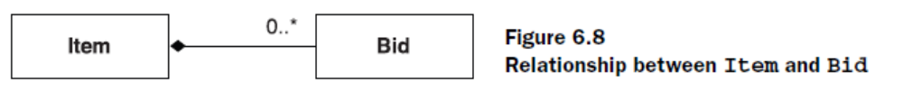

Multiplicity
In describing and classifying associations, we’ll almost always use the term multiplicity.
In our example, the multiplicity is just two bits of information:
■ Can there be more than one Bid for a particular Item?
■ Can there be more than one Item for a particular Bid?

After glancing at the domain model (see figure 6.8), you can conclude that the
association from Bid to Item is a many-to-one association. Recalling that associations
are directional, you classify the inverse association from Item to Bid as a oneto-
many association.

There are only two more possibilities: many-to-many and one-to-one.

The simplest possible association
The association from Bid to Item (and vice versa) is an example of the simplest
possible kind of entity association. You have two properties in two classes. One is a
collection of references, and the other a single reference.

public class Bid {
...
private Item item;
public void setItem(Item item) {
this.item = item;
}
public Item getItem() {
return item;
}
...
}

<class
name="Bid"
table="BID">
...
<many-to-one
name="item"
column="ITEM_ID"
class="Item"
not-null="true"/>
</class>

This mapping is called a unidirectional many-to-one association.

The column
ITEM_ID in the BID table is a foreign key to the primary key of the ITEM table.

You added the not-null attribute because you can’t have a bid without an
item

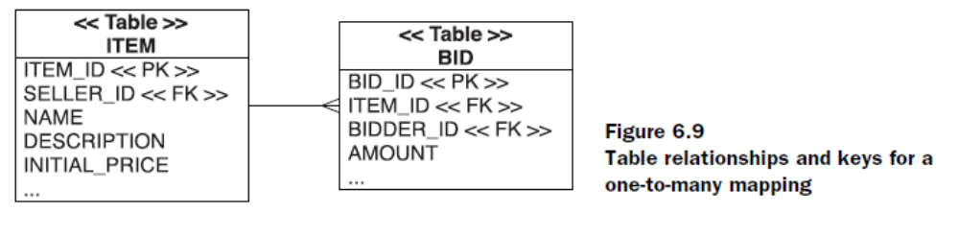

public class Bid {
...
@ManyToOne( targetEntity = auction.model.Item.class )
@JoinColumn(name = "ITEM_ID", nullable = false)
private Item item;
...
}

Making the association bidirectional

You want to be able to easily fetch all the bids for a particular item without an
explicit query, by navigating and iterating through the network of persistent
objects.

public class Item {
...
private Set bids = new HashSet();
public void setBids(Set bids) {
this.bids = bids;
}
public Set getBids() {
return bids;
}
public void addBid(Bid bid) {
bid.setItem(this);
bids.add(bid);
}
...
}

<class
name="Item"
table="ITEM">
...
<set name="bids">
<key column="ITEM_ID"/>
<one-to-many class="Bid"/>
</set>
</class>

At runtime, there are two different in-memory representations of the same foreign
key value

Hibernate doesn’t transparently detect the fact that the two changes refer to
the same database column, because at this point you’ve done nothing to indicate
that this is a bidirectional association. In other words, you’ve mapped the same
column twice (it doesn’t matter that you did this in two mapping files), and Hibernate
always needs to know about this because it can’t detect this duplicate automatically
(there is no reasonable default way it could be handled).

The inverse attribute tells Hibernate that the collection
is a mirror image of the <many-to-one> association on the other side:
<class
name="Item"
table="ITEM">
...
<set name="bids"
inverse="true">
<key column="ITEM_ID"/>
<one-to-many class="Bid"/>
</set>
</class>

If you only call anItem.getBids().add(bid), no changes are made persistent!
You get what you want only if the other side, aBid.setItem(anItem), is set correctly.

If an association
is bidirectional, you have to create the link with pointers on two sides, not just
one.

Let’s map this inverse collection side again, with JPA annotations:
public class Item {
...
@OneToMany(mappedBy = "item")
private Set<Bid> bids = new HashSet<Bid>();
...
}

Cascading object state

The following code creates a new Item (which we consider the parent) and a
new Bid instance (the child):
Item newItem = new Item();
Bid newBid = new Bid();
newItem.addBid(newBid); // Set both sides of the association
session.save(newItem);
session.save(newBid);
The second call to session.save() seems redundant, if we’re talking about a true
parent/children relationship.

Transitive persistence
When you instantiate a new Bid and add it to an Item, the bid should become persistent
automatically. You’d like to avoid making the Bid persistent explicitly with
an extra save() operation.

<class
name="Item"
table="ITEM">
...
<set name="bids"
inverse="true"
cascade="save-update">
<key column="ITEM_ID"/>
<one-to-many class="Bid"/>
</set>
</class>

The cascade attribute is directional: It applies to only one end of the association.
You could also add cascade="save-update" to the <many-to-one> association
in the mapping of Bid, but because bids are created after items, doing so
doesn’t make sense.

public class Item {
...
@OneToMany(cascade = { CascadeType.PERSIST, CascadeType.MERGE },
mappedBy = "item")
private Set<Bid> bids = new HashSet<Bid>();
...
}

You can now simplify the code that links and saves an Item and a Bid, in native
Hibernate:
Item newItem = new Item();
Bid newBid = new Bid();
newItem.addBid(newBid); // Set both sides of the association
session.save(newItem);

Cascading deletion

Item anItem = // Load an item
// Delete all the referenced bids
for ( Iterator<Bid> it = anItem.getBids().iterator();
it.hasNext(); ) {
Bid bid = it.next();
it.remove(); // Remove reference from collection
session.delete(bid); // Delete it from the database
}
session.delete(anItem); // Finally, delete the item

Hibernate (and JPA) offer a cascading option for this purpose. You can enable
cascading for the delete operation:
<set name="bids"
inverse="true"
cascade="save-update, delete">

public class Item {
...
@OneToMany(cascade = { CascadeType.PERSIST,
CascadeType.MERGE,
CascadeType.REMOVE },
mappedBy = "item")
private Set<Bid> bids = new HashSet<Bid>();
...
}

Item anItem = // Load an item
session.delete(anItem);
entityManager.remove(anItem);
The delete operation is now cascaded to all entities referenced in the collection.
You no longer have to worry about removal from the collection and manually
deleting those entities one by one.

Enabling orphan deletion

<set name="bids"
inverse="true"
cascade="save-update, delete, delete-orphan">

mappedBy = "...", where the value is the name of the field on the parent class.

ContactInfo.java
import Employee;
// ...
@Persistent(mappedBy = "contactInfo")
private Employee employee;

Employee.java
import ContactInfo;
// ...
@Persistent(defaultFetchGroup = "true")
private ContactInfo contactInfo;
Single-valued entity associations

User and Address classes have a true one-to-one association.

another entity class (let’s say Shipment) can also have a reference to a
particular Address instance. If a User has a reference to this instance, as their
shippingAddress, the Address instance has to support shared references and
needs its own identity.

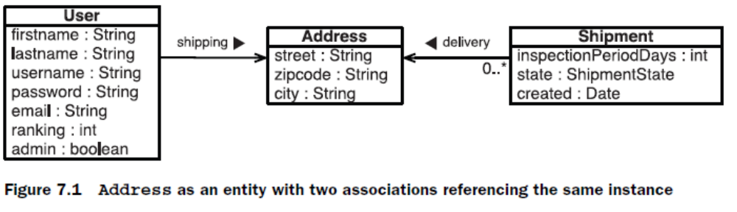

Shared primary key associations

Rows in two tables related by a primary key association share the same primary key
values

public class User {
...
private Address shippingAddress;
// Getters and setters
}
Next, map the association in User.hbm.xml:
<one-to-one name="shippingAddress"
class="Address"
cascade="save-update"/>

User newUser = new User();
Address shippingAddress = new Address();
newUser.setShippingAddress(shippingAddress);
session.save(newUser);
Hibernate inserts a row into the USERS table and a row into the ADDRESS table. But
wait, this doesn’t work! How can Hibernate possibly know that the record in the
ADDRESS table needs to get the same primary key value as the USERS row?

The foreign identifier generator

The first step to create this identifier binding between Address and User is a
bidirectional association. Add a new user property to the Address entity:
public class Address {
...
private User user;
// Getters and setters
}
Map the new user property of an Address in Address.hbm.xml:
<one-to-one name="user"
class="User"
constrained="true"/>

with constrained="
true", adds a foreign key constraint linking the primary key of the
ADDRESS table to the primary key of the USERS table. In other words, the database
guarantees that an ADDRESS row’s primary key references a valid USERS primary
key. (

You can now use the special foreign identifier generator for Address objects
<class name="Address" table="ADDRESS">
<id name="id" column="ADDRESS_ID">
<generator class="foreign">
<param name="property">user</param>
</generator>
</id>
...
<one-to-one name="user"
class="User"
constrained="true"/>
</class>

Shared primary key with annotations
JPA supports one-to-one entity associations with the @OneToOne annotation. To
map the association of shippingAddress in the User class as a shared primary key
association, you also need the @PrimaryKeyJoinColumn annotation:
@OneToOne
@PrimaryKeyJoinColumn
private Address shippingAddress;

The JPA specification doesn’t include a standardized method to deal with the
problem of shared primary key generation, which means you’re responsible for
setting the identifier value of an Address instance correctly before you save it

@Entity
@Table(name = "ADDRESS")
public class Address {
@Id @GeneratedValue(generator = "myForeignGenerator")
@org.hibernate.annotations.GenericGenerator(
name = "myForeignGenerator",
strategy = "foreign",
parameters = @Parameter(name = "property", value = "user")
)
@Column(name = "ADDRESS_ID")
private Long id;
...
private User user;
}

One-to-one foreign key associations
Instead of sharing a primary key, two rows can have a foreign key relationship.
One table has a foreign key column that references the primary key of the
associated table.

(The source and target of this foreign key constraint can even be
the same table: This is called a self-referencing relationship.)

Let’s change the mapping from a User to an Address. Instead of the shared
primary key, you now add a SHIPPING_ADDRESS_ID column in the USERS table:
<class name="User" table="USERS">
<many-to-one name="shippingAddress"
class="Address"
column="SHIPPING_ADDRESS_ID"
cascade="save-update"
unique="true"/>
</class>

The mapping element in XML for this association is <many-to-one>—not <oneto-
one>, as you might have expected. The reason is simple: You don’t care what’s
on the target side of the association, so you can treat it like a to-one association
without the many part. All you want is to express “This entity has a property that is
a reference to an instance of another entity” and use a foreign key field to represent
that relationship.

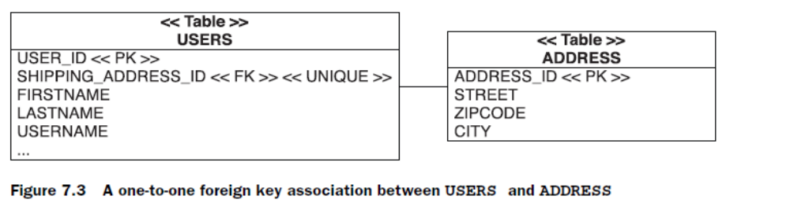

An additional constraint enforces this relationship as a real one to one. By making
the SHIPPING_ADDRESS_ID column unique, you declare that a particular address
can be referenced by at most one user, as a shipping address.

Inverse property reference

access from Address to User is possible in the Java domain model

In XML, you create a <one-to-one> mapping with a property reference
attribute:
<one-to-one name="user"
class="User"
property-ref="shippingAddress"/>

You tell Hibernate that the user property of the Address class is the inverse of a
property on the other side of the association.

Mapping a foreign key with annotations

public class User {
...
@OneToOne
@JoinColumn(name="SHIPPING_ADDRESS_ID")
private Address shippingAddress;
...
}

public class Address {
...
@OneToOne(mappedBy = "shippingAddress")
private User user;
...
}

Mapping with a join table

Shipment entity with an optional one-to-one association
to an Item.

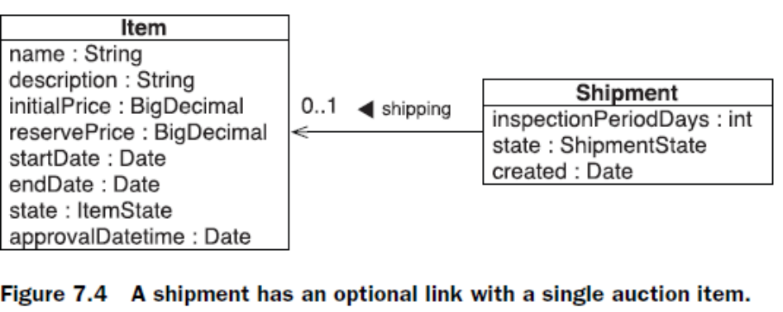

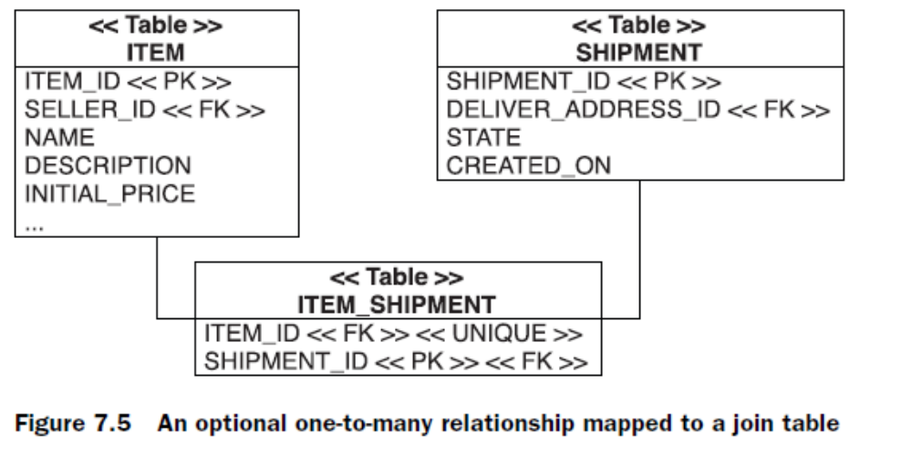

In the database schema, you add an intermediate link table called ITEM_SHIPMENT.
A row in this table represents a Shipment made in the context of an auction. The
tables are shown in figure 7.5.

<class name="Shipment" table="SHIPMENT">
<id name="id" column="SHIPMENT_ID">...</id>
...
<join table="ITEM_SHIPMENT" optional="true">
<key column="SHIPMENT_ID"/>
<many-to-one name="auction"
column="ITEM_ID"
not-null="true"
unique="true"/>
</join>
</class>

public class Shipment {
@OneToOne
@JoinTable(
name="ITEM_SHIPMENT",
joinColumns = @JoinColumn(name = "SHIPMENT_ID"),
inverseJoinColumns = @JoinColumn(name = "ITEM_ID")
)
private Item auction;
...
// Getter/setter methods
}

Alternatively, you can map properties of a JPA entity to more than one table,
as demonstrated in “Moving properties into a secondary table” in chapter 8,
section 8.1.3. First, you need to declare the secondary table for the entity:
@Entity
@Table(name = "SHIPMENT")
@SecondaryTable(name = "ITEM_SHIPMENT")
public class Shipment {
@Id @GeneratedValue
@Column(name = "SHIPMENT_ID")
private Long id;
...
}

The auction property mapping is a @OneToOne; and as before, the foreign key
column referencing the ITEM table is moved to the intermediate secondary table:
...
public class Shipment {
...
@OneToOne
@JoinColumn(table = "ITEM_SHIPMENT", name = "ITEM_ID")
private Item auction;
}

Declaring a secondary
table for an entity is useful if not only one property (the many-to-one in this case)
but several properties must be moved into the secondary table. We don’t have a
great example with Shipment and Item, but if your ITEM_SHIPMENT table would
have additional columns, mapping these columns to properties of the Shipment
entity might be useful.

Many-valued entity associations

One-to-many associations

The parent/children relationship you mapped earlier was a bidirectional association,
with a <one-to-many> and a <many-to-one> mapping.

Considering bags
Bags have the most efficient performance characteristics of all the collections
you can use for a bidirectional one-to-many entity association (in other words, if
the collection side is inverse="true")

You can’t make an indexed collection inverse="true".
The collection becomes
responsible for state synchronization, and the one side, the Bid, has to be made
inverse.

Remember that Hibernate ignores the state of
an inverse collection!

public class Item {
...
@OneToMany
@JoinColumn(name = "ITEM_ID", nullable = false)
@org.hibernate.annotations.IndexColumn(name = "BID_POSITION")
private List<Bid> bids = new ArrayList<Bid>();
...
}

public class Bid {
...
@ManyToOne
@JoinColumn(name = "ITEM_ID", nullable = false,
updatable = false, insertable = false)
private Item item;
...
}

Optional one-to-many association with a join table

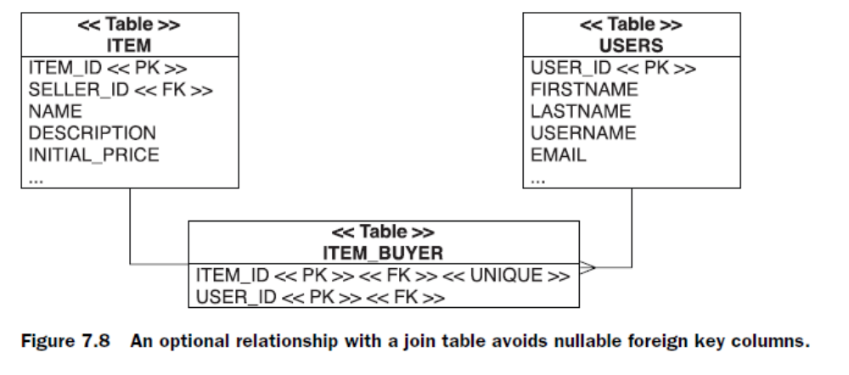

@Entity
public class Item {
@ManyToOne
@JoinTable(
name = "ITEM_BUYER",
joinColumns = {@JoinColumn(name = "ITEM_ID")},
inverseJoinColumns = {@JoinColumn(name = "USER_ID")}
)
private User buyer;
...
}

To make this mapping bidirectional, add a collection on the User class and
make it inverse with mappedBy:
@OneToMany(mappedBy = "buyer")
private Set<Item> boughtItems = new HashSet<Item>();

Many-to-many associations
The association between Category and Item is a many-to-many association

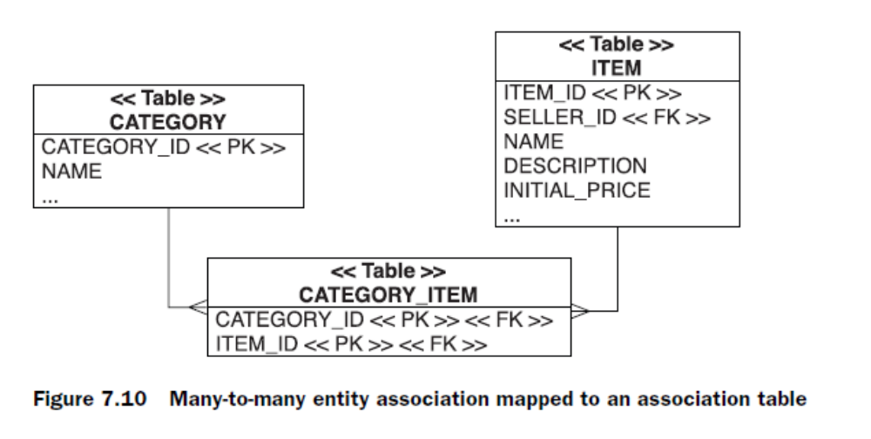

As usual with an <idbag> mapping, the primary key is a surrogate key column,
CATEGORY_ITEM_ID. Duplicate links are therefore allowed; the same Item can be
added twice to a Category. (This doesn’t seem to be a useful feature.) With annotations,
you can switch to an identifier bag with the Hibernate @CollectionId:
@ManyToMany
@CollectionId(
columns = @Column(name = "CATEGORY_ITEM_ID"),
type = @org.hibernate.annotations.Type(type = "long"),
generator = "sequence"
)
@JoinTable(
name = "CATEGORY_ITEM",
joinColumns = {@JoinColumn(name = "CATEGORY_ID")},
inverseJoinColumns = {@JoinColumn(name = "ITEM_ID")}
)
private Collection<Item> items = new ArrayList<Item>();

The join table (or link table, as some developers call it) has two columns: the foreign
keys of the CATEGORY and ITEM tables. The primary key is a composite of both
columns. The full table structure is shown in figure 7.10.

You may even switch to an indexed collection (a map or list) in a many-to-many
association

@ManyToMany
@JoinTable(
name = "CATEGORY_ITEM",
joinColumns = {@JoinColumn(name = "CATEGORY_ID")},
inverseJoinColumns = {@JoinColumn(name = "ITEM_ID")}
)
@org.hibernate.annotations.IndexColumn(name = "DISPLAY_POSITION")
private List<Item> items = new ArrayList<Item>();

A bidirectional many-to-many association

When you map a bidirectional many-to-many association, you must declare
one end of the association using inverse="true" to define which side’s state is
used to update the join table. You can choose which side should be inverse.

<class name="Item" table="ITEM">
...
<set name="categories"
table="CATEGORY_ITEM”
inverse="true"
cascade="save-update">
<key column="ITEM_ID"/>
<many-to-many class="Category" column="CATEGORY_ID"/>
</set>
</class>
Note the inverse="true". Again, this setting tells Hibernate to ignore changes
made to the categories collection and that the other end of the association, the
items collection, is the representation that should be synchronized with the database
if you link instances in Java code.

No other mappings can be used for the inverse end of a many-to-many association.
Indexed collections (lists and maps) don’t work, because Hibernate won’t initialize
or maintain the index column if the collection is inverse. In other words, a
many-to-many association can’t be mapped with indexed collections on both sides.

Adding columns to join tables

What do I do if my join table has additional columns, not only two foreign key columns?
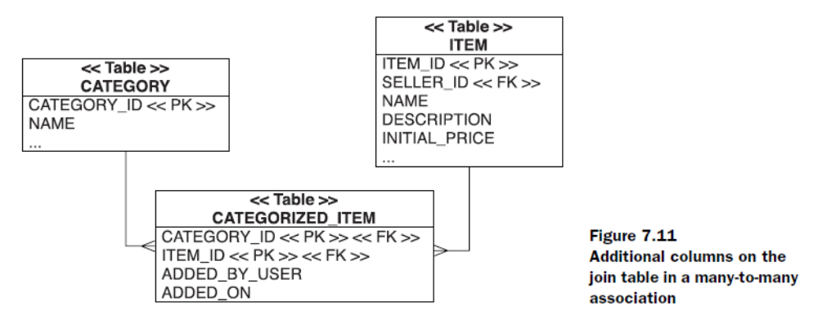

You can use two common strategies to map such a structure to Java classes. The
first strategy requires an intermediate entity class for the join table and is mapped
with one-to-many associations. The second strategy utilizes a collection of components,
with a value-type class for the join table.
Mapping the join table to an intermediate entity

The first option we discuss now resolves the many-to-many relationship between
Category and Item with an intermediate entity class, CategorizedItem.

@Entity
@Table(name = "CATEGORIZED_ITEM")
public class CategorizedItem {
@Embeddable
public static class Id implements Serializable {
@Column(name = "CATEGORY_ID")
private Long categoryId;
@Column(name = "ITEM_ID")
private Long itemId;
public Id() {}
public Id(Long categoryId, Long itemId) {
this.categoryId = categoryId;
this.itemId = itemId;
}
public boolean equals(Object o) {
if (o != null && o instanceof Id) {
Id that = (Id)o;
return this.categoryId.equals(that.categoryId) &&
this.itemId.equals(that.itemId);
} else {
return false;
}
}
public int hashCode() {
return categoryId.hashCode() + itemId.hashCode();
}
}
@EmbeddedId
private Id id = new Id();
@Column(name = "ADDED_BY_USER")
private String username;
@Column(name = "ADDED_ON")
private Date dateAdded = new Date();
@ManyToOne
@JoinColumn(name="ITEM_ID",
insertable = false,
updatable = false)
private Item item;
@ManyToOne
@JoinColumn(name="CATEGORY_ID",
insertable = false,
updatable = false)
private Category category;

public CategorizedItem() {}
public CategorizedItem(String username,
Category category,
Item item) {
// Set fields
this.username = username;
this.category = category;
this.item = item;
// Set identifier values
this.id.categoryId = category.getId();
this.id.itemId = item.getId();
// Guarantee referential integrity
category.getCategorizedItems().add(this);
item.getCategorizedItems().add(this);
}
// Getter and setter methods
...
}

An entity class needs an identifier property. The primary key of the join table is
CATEGORY_ID and ITEM_ID, a composite. Hence, the entity class also has a composite
key, which you encapsulate in a static nested class for convenience

The Category and Item entities (can) have a one-to-many association to the
CategorizedItem entity, a collection. For example, in Category:

@OneToMany(mappedBy = "category")
private Set<CategorizedItem> categorizedItems =
new HashSet<CategorizedItem>();

This code creates and stores a link between a
category and an item:
CategorizedItem newLink =
new CategorizedItem(aUser.getUsername(), aCategory, anItem);
session.save(newLink);

Mapping the join table to a collection of components

First, simplify the CategorizedItem class, and make it a value type, without an
identifier or any complex constructor:

@Embeddable
public class CategorizedItem {
@org.hibernate.annotations.Parent // Optional back-pointer
private Category category;
@ManyToOne
@JoinColumn(name = "ITEM_ID",
nullable = false,
updatable = false)
private Item item;
@ManyToOne
@JoinColumn(name = "USER_ID",
nullable = false,
updatable = false)
private User user;
@Temporal(TemporalType.TIMESTAMP)
@Column(name = "ADDED_ON", nullable = false, updatable = false)
private Date dateAdded;
...
// Constructor
// Getter and setter methods
// Don't forget the equals/hashCode methods
}

@org.hibernate.annotations.CollectionOfElements
@JoinTable(
name = "CATEGORY_ITEM",
joinColumns = @JoinColumn(name = "CATEGORY_ID")
)
private Set<CategorizedItem> categorizedItems =
new HashSet<CategorizedItem>();

Mapping maps
You mapped a Java Map in the last chapter—the keys and values of the Map were
value types, simple strings. You can create more complex maps; not only can the
keys be references to entities, but so can the values. The result can therefore be a
ternary association.

Values as references to entities

In the Item class, include a Map:
@MapKey(name="id")
@OneToMany
private Map<Long,Bid> bidsByIdentifier = new HashMap<Long,Bid>();
New here is the @MapKey element of JPA—it maps a property of the target entity as
key of the map

Ternary associations

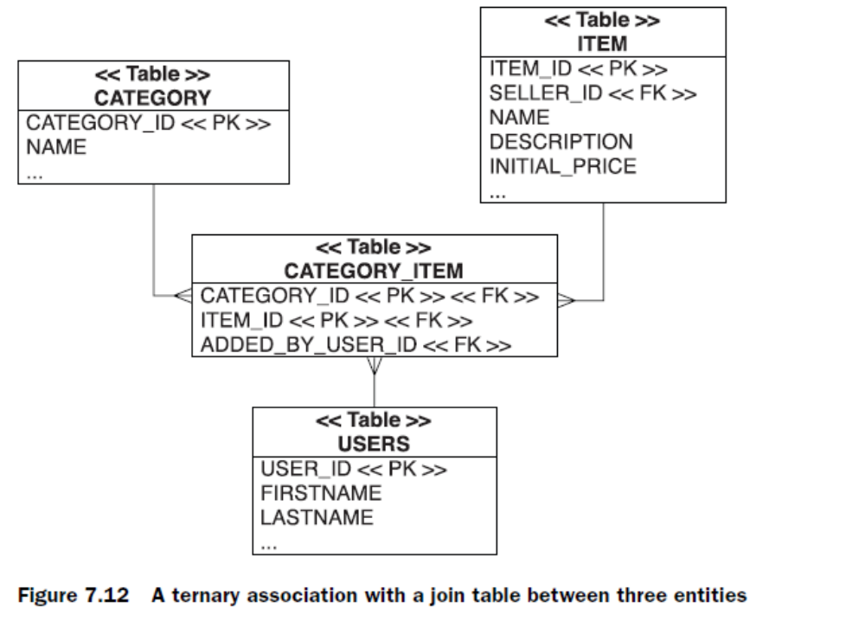

A Category has a Map of Item instances—the key of each map entry is a reference
to an Item. The value of each map entry is the User who added the Item to
the Category.

@ManyToMany
@org.hibernate.annotations.MapKeyManyToMany(
joinColumns = @JoinColumn(name = "ITEM_ID")
)
@JoinTable(
name = "CATEGORY_ITEM",
joinColumns = @JoinColumn(name = "CATEGORY_ID"),
inverseJoinColumns = @JoinColumn(name = "USER_ID")
)
private Map<Item,User> itemsAndUser = new HashMap<Item,User>();

Polymorphic associations

For this example,
consider the defaultBillingDetails property of User. It references one particular
BillingDetails object, which at runtime can be any concrete instance of that
class.

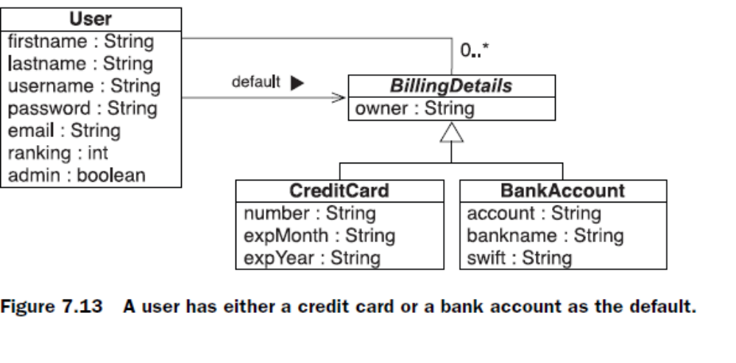
<many-to-one name="defaultBillingDetails"
class="BillingDetails"
column="DEFAULT_BILLING_DETAILS_ID"/>

But because BillingDetails is abstract, the association must refer to an instance
of one of its subclasses—CreditCard or CheckingAccount—at runtime.

The following code demonstrates the creation of an association to an instance
of the CreditCard subclass:

CreditCard cc = new CreditCard();
cc.setNumber(ccNumber);
cc.setType(ccType);
cc.setExpiryDate(ccExpiryDate);
User user = (User) session.get(User.class, userId);
user.addBillingDetails(cc); // Add it to the one-to-many association
user.setDefaultBillingDetails(cc);

Now, when you navigate the association in a second unit of work, Hibernate automatically
retrieves the CreditCard instance:
User user = (User) secondSession.get(User.class, userId);
// Invoke the pay() method on the actual subclass instance
user.getDefaultBillingDetails().pay(amount);
There is just one thing to watch out for: If BillingDetails was mapped with
lazy="true" (which is the default), Hibernate would proxy the defaultBilling-
Details association target. In this case, you wouldn’t be able to perform a typecast
to the concrete class CreditCard at runtime, and even the instanceof
operator would behave strangely:
User user = (User) session.get(User.class, userid);
BillingDetails bd = user.getDefaultBillingDetails();
System.out.println( bd instanceof CreditCard ); // Prints "false"
CreditCard cc = (CreditCard) bd; // ClassCastException!

To perform a proxy-safe typecast, use load():
User user = (User) session.get(User.class, userId);
BillingDetails bd = user.getDefaultBillingDetails();
// Narrow the proxy to the subclass, doesn't hit the database
CreditCard cc =
(CreditCard) session.load( CreditCard.class, bd.getId() );
expiryDate = cc.getExpiryDate();

Polymorphic collections

A User may have references to many BillingDetails, not only a single default
(one of the many is the default). You map this with a bidirectional one-to-many
association.
In BillingDetails, you have the following:
<many-to-one name="user"
class="User"
column="USER_ID"/>

In the Users mapping you have:
<set name="billingDetails"
inverse="true">
<key column="USER_ID"/>
<one-to-many class="BillingDetails"/>
</set>

In the examples so far, we assumed that BillingDetails is a class mapped explicitly
and that the inheritance mapping strategy is table per class hierarchy, or normalized
with table per subclass.
However, if the hierarchy is mapped with table per concrete class (implicit polymorphism)
or explicitly with table per concrete class with union, this scenario requires
a more sophisticated solution.

Polymorphic associations to unions

Now, consider the following collection of BillingDetails mapped for User:
<set name="billingDetails"
inverse="true">
<key column="USER_ID"/>
<one-to-many class="BillingDetails"/>
</set>

<class name="BillingDetails" abstract="true">
<id name="id" column="BILLING_DETAILS_ID" .../>
<property .../>
<many-to-one name="user"
column="USER_ID"
class="User"/>
<union-subclass name="CreditCard" table="CREDIT_CARD">
<property .../>
</union-subclass>
<union-subclass name="BankAccount" table="BANK_ACCOUNT">
<property .../>
</union-subclass>
</class>

Now, consider the following data-access code:
aUser.getBillingDetails().iterator().next();

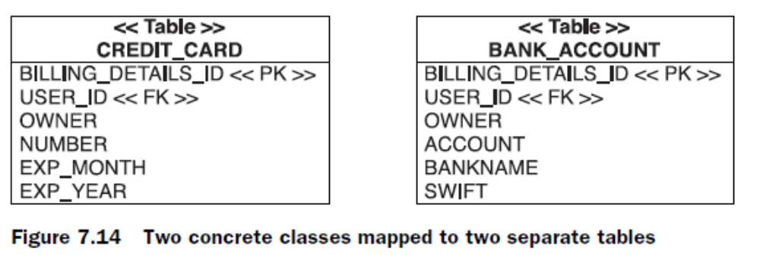

Hibernate executes a UNION query to retrieve all instances that are referenced in
this collection:
select
BD.*
from
( select
BILLING_DETAILS_ID, USER_ID, OWNER,
NUMBER, EXP_MONTH, EXP_YEAR,
null as ACCOUNT, null as BANKNAME, null as SWIFT,
1 as CLAZZ
from
CREDIT_CARD
union
select
BILLING_DETAILS_ID, USER_ID, OWNER,
null as NUMBER, null as EXP_MONTH, null as EXP_YEAR
ACCOUNT, BANKNAME, SWIFT,
2 as CLAZZ
from
BANK_ACCOUNT
) BD
where
BD.USER_ID = ?

The FROM-clause subselect is a union of all concrete class tables, and it includes the
USER_ID foreign key values for all instances. The outer select now includes a
restriction in the WHERE clause to all rows referencing a particular user.

If you manipulate the collection
and association, the noninverse side is used to update the USER_ID column(s) in
the concrete table. In other words, the modification of the inverse collection has
no effect: The value of the user property of a CreditCard or BankAccount
instance is taken.

Now consider the many-to-one association defaultBillingDetails again,
mapped with the DEFAULT_BILLING_DETAILS_ID column in the USERS table.
Hibernate executes a UNION query that looks similar to the previous query to
retrieve this instance, if you access the property. However, instead of a restriction
in the WHERE clause to a particular user, the restriction is made on a particular
BILLING_DETAILS_ID.

Important: Hibernate cannot and will not create a foreign key constraint for
DEFAULT_BILLING_DETAILS_ID with this strategy. The target table of this reference
can be any of the concrete tables, which can’t be constrained easily. You should
consider writing a custom integrity rule for this column with a database trigger.

Polymorphic table per concrete class

Hibernate doesn’t support a polymorphic billingDetails one-to-many collection
in User, if this inheritance mapping strategy is applied on the BillingDetails
hierarchy. If you need polymorphic many-to-one associations with this
strategy, you’ll have to resort to a hack. The technique we’ll show you in this section
should be your last choice.

The USERS table requires a DEFAULT_BILLING_DETAILS_TYPE column in addition
to the DEFAULT_BILLING_DETAILS_ID. This extra column works as an additional
discriminator and requires a Hibernate <any> mapping in User.hbm.xml:
<any name="defaultBillingDetails"
id-type="long"
meta-type="string">
<meta-value value="CREDIT_CARD" class="CreditCard"/>
<meta-value value="BANK_ACCOUNT" class="BankAccount"/>
<column name="DEFAULT_BILLING_DETAILS_TYPE"/>
<column name="DEFAULT_BILLING_DETAILS_ID"/>
</any>
The meta-type attribute specifies the Hibernate type of the DEFAULT_BILLING_
DETAILS_TYPE column; the id-type attribute specifies the type of the DEFAULT_BILLING_DETAILS_ID column (it’s necessary for CreditCard and BankAccount to
have the same identifier type).

The <meta-value> elements tell Hibernate how to interpret the value of the
DEFAULT_BILLING_DETAILS_TYPE column. You don’t need to use the full table
name here—you can use any value you like as a type discriminator. For example,
you can encode the information in two characters:
<any name="defaultBillingDetails"
id-type="long"
meta-type="string">
<meta-value value="CC" class="CreditCard"/>
<meta-value value="CA" class="BankAccount"/>
<column name="DEFAULT_BILLING_DETAILS_TYPE"/>
<column name="DEFAULT_BILLING_DETAILS_ID"/>
</any>

The code to save a new User is as follows:
User user = new User();
user.setUsername("johndoe"); // Assign a primary key value
user.setFirstname("John");
user.setLastname("Doe");
session.saveOrUpdate(user); // Will result in an INSERT
// System.out.println( session.getIdentifier(user) );
session.flush();

keep in mind that Hibernate executes a SELECT to determine what save-
OrUpdate() should do—unless you enable versioning control or a custom Interceptor.
But

<class name="User" table="USER">
<composite-id name="userId" class="UserId">
<key-property name="username"
column="USERNAME"/>
<key-many-to-one name="department"
class="Department"
column="DEPARTMENT_ID"/>
</composite-id>
...
</class>

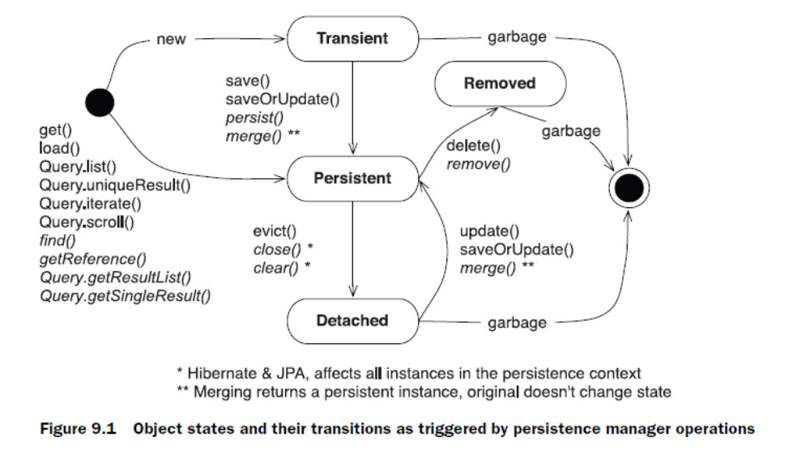

Transient objects
Objects instantiated using the new operator aren’t immediately persistent. Their
state is transient, which means they aren’t associated with any database table row
and so their state is lost as soon as they’re no longer referenced by any other
object.

Hibernate and Java Persistence consider all transient instances to be nontransactional;
any modification of a transient instance isn’t known to a persistence context.
This means that Hibernate doesn’t provide any roll-back functionality for
transient objects.

Persistent objects
A persistent instance is an entity instance with a database identity. Persistent instances are always associated with a persistence context. Hibernate
caches them and can detect whether they have been modified by the application.

Removed objects
An object is in the removed state if it has been scheduled for deletion at the end
of a unit of work, but it’s still managed by the persistence context until the unit of
work completes. In other words, a removed object shouldn’t be reused because it
will be deleted from the database as soon as the unit of work completes.

Detached objects

We refer to these objects as detached, indicating that their state is no longer
guaranteed to be synchronized with database state; they’re no longer attached to
a persistence context. They still contain persistent data (which may soon be stale).
You can continue working with a detached object and modify it. However, at some
point you probably want to make those changes persistent—in other words, bring
the detached instance back into persistent state.

Hibernate offers two operations, reattachment and merging, to deal with this situation.
Java Persistence only standardizes merging.

The persistence context

The persistence context is useful for several reasons:
■ Hibernate can do automatic dirty checking and transactional write-behind.
■ Hibernate can use the persistence context as a first-level cache.
■ Hibernate can guarantee a scope of Java object identity.
■ Hibernate can extend the persistence context to span a whole conversation.

Also notice that the ordering of the SQL statements isn’t the same as the order
in which you set property values. Hibernate uses a sophisticated algorithm to
determine an efficient ordering that avoids database foreign key constraint violations
but is still sufficiently predictable to the user. This feature is called transactional
write-behind.

Automatic dirty checking

Hibernate doesn’t update the database row of every single persistent object in
memory at the end of the unit of work. ORM software must have a strategy for
detecting which persistent objects have been modified by the application. We call
this automatic dirty checking.

The persistence context cache
A persistence context is a cache of persistent entity instances. This means it
remembers all persistent entity instances you’ve handled in a particular unit of
work.

For example, if Hibernate is told to load an object by primary key (a lookup by
identifier), it can first check the persistence context for the current unit of work.
If the entity is found there, no database hit occurs—this is a repeatable read for
an application. The same is true if a query is executed through one of the Hibernate
(or Java Persistence) interfaces. Hibernate reads the result set of the query
and marshals entity objects that are then returned to the application. During this
process, Hibernate interacts with the current persistence context. It tries to
resolve every entity instance in this cache (by identifier); only if the instance can’t
be found in the current persistence context does Hibernate read the rest of the
data from the result set.

Object identity and equality

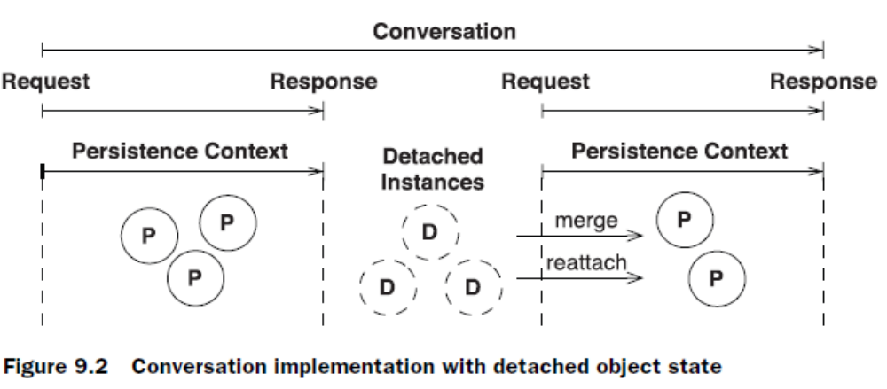

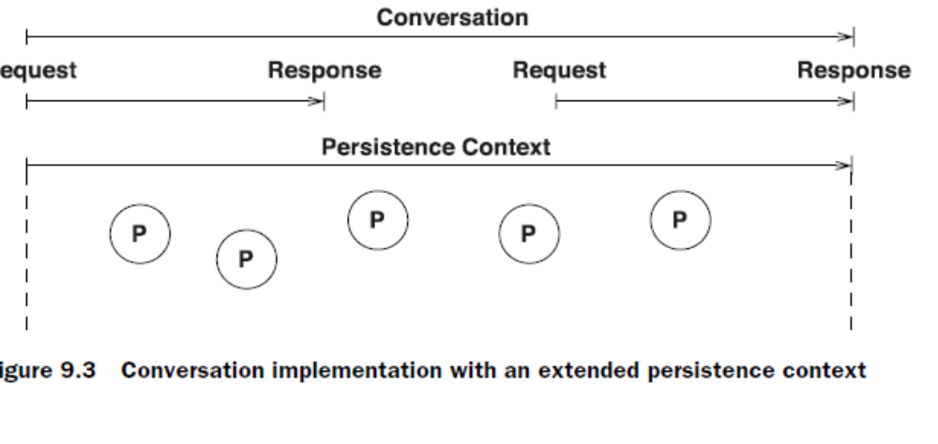

Session session1 = sessionFactory.openSession();
Transaction tx1 = session1.beginTransaction();
// Load Item with identifier value "1234"
Object a = session1.get(Item.class, new Long(1234) );
Object b = session1.get(Item.class, new Long(1234) );
( a==b ) // True, persistent a and b are identical
tx1.commit();
session1.close();
// References a and b are now to an object in detached state
Session session2 = sessionFactory.openSession();
Transaction tx2 = session2.beginTransaction();
Object c = session2.get(Item.class, new Long(1234) );
( a==c ) // False, detached a and persistent c are not identical
tx2.commit();
session2.close();

Understanding equals() and hashCode()

ways. Keep in mind that when you override equals(), you always
need to also override hashCode() so the two methods are consistent. If two objects
are equal, they must have the same hashcode.

public class User {
...
public boolean equals(Object other) {
if (this==other) return true;
if (id==null) return false;
if ( !(other instanceof User) ) return false;
final User that = (User) other;
return this.id.equals( that.getId() );
}
public int hashCode() {
return id==null ?System.identityHashCode(this) :
id.hashCode();
}
}

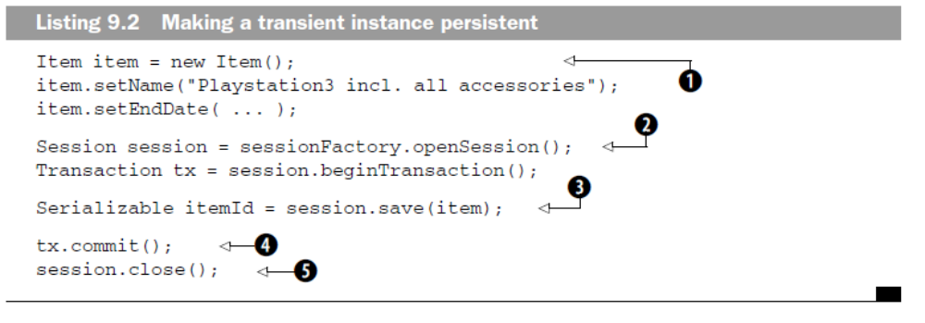

Retrieving a persistent object

Session session = sessionFactory.openSession();
Transaction tx = session.beginTransaction();
Item item = (Item) session.load(Item.class, new Long(1234));
// Item item = (Item) session.get(Item.class, new Long(1234));
tx.commit();
session.close();

The one difference between get() and load() is how they indicate that the
instance could not be found. If no row with the given identifier value exists in the
database, get() returns null. The load() method throws an ObjectNotFound-
Exception. It’s your choice what error-handling you prefer.

More important, the load() method may return a proxy, a placeholder, without
hitting the database. A consequence of this is that you may get an ObjectNotFoundException
later, as soon as you try to access the returned placeholder and force
its initialization (this is also called lazy loading; we discuss load optimization in later
chapters.) The load() method always tries to return a proxy, and only returns an
initialized object instance if it’s already managed by the current persistence context.
In

Modifying a persistent object

Session session = sessionFactory.openSession();
Transaction tx = session.beginTransaction();
Item item = (Item) session.get(Item.class, new Long(1234));
item.setDescription("This Playstation is as good as new!");
tx.commit();
session.close();

Making a persistent object transient

Session session = sessionFactory.openSession();
Transaction tx = session.beginTransaction();
Item item = (Item) session.load(Item.class, new Long(1234));
session.delete(item);
tx.commit();
session.close();

Replicating objects

Session session = sessionFactory1.openSession();
Transaction tx = session.beginTransaction();
Item item = (Item) session.get(Item.class, new Long(1234));
tx.commit();
session.close();
Session session2 = sessionFactory2.openSession();
Transaction tx2 = session2.beginTransaction();
session2.replicate(item, ReplicationMode.LATEST_VERSION);
tx2.commit();
session2.close();

controls the details of the replication procedure:
■ ReplicationMode.IGNORE—Ignores the object when there is an existing
database row with the same identifier in the target database.
■ ReplicationMode.OVERWRITE—Overwrites any existing database row with
the same identifier in the target database.
■ ReplicationMode.EXCEPTION—Throws an exception if there is an existing
database row with the same identifier in the target database.
■ ReplicationMode.LATEST_VERSION—Overwrites the row in the target
database if its version is earlier than the version of the object, or ignores
the object otherwise. Requires enabled Hibernate optimistic concurrency
control.

Working with detached objects
Modifying the item after the Session is closed has no effect on its persistent representation
in the database. As soon as the persistence context is closed, item
becomes a detached instance.
If you want to save modifications you made to a detached object, you have to
either reattach or merge it.

Reattaching a modified detached instance

The update() method forces an update to the persistent state of the object in
the database, always scheduling an SQL UPDATE.

item.setDescription(...); // Loaded in previous Session
Session sessionTwo = sessionFactory.openSession();
Transaction tx = sessionTwo.beginTransaction();
sessionTwo.update(item);
item.setEndDate(...);
tx.commit();

sessionTwo.close();

The important thing here is that the call to update() is reattaching the
detached instance to the new Session

Reattaching an unmodified detached instance

Session sessionTwo = sessionFactory.openSession();
Transaction tx = sessionTwo.beginTransaction();
sessionTwo.lock(item, LockMode.NONE);
item.setDescription(...);
item.setEndDate(...);
tx.commit();
sessionTwo.close();

This method only guarantees that the object’s state changes from
detached to persistent and that Hibernate will manage the persistent object again.

Making a detached object transient

Session session = sessionFactory.openSession();
Transaction tx = session.beginTransaction();
session.delete(item);
tx.commit();
session.close();

Merging the state of a detached object

item.getId(); // The database identity is "1234"
item.setDescription(...);
Session session = sessionFactory.openSession();
Transaction tx = session.beginTransaction();
Item item2 = (Item) session.get(Item.class, new Long(1234));
session.update(item); // Throws exception!
tx.commit();
session.close();

before reattachment, another
instance that represents the same database row has already been loaded into the persistence context of that Session. Obviously, the reattachment through
update() clashes with this already persistent instance, and a NonUniqueObjectException
is thrown. The error message of the exception is A persistent instance with
the same database identifier is already associated with the Session! Hibernate can’t decide
which object represents the current state.

You can let Hibernate merge item and item2 automatically:
item.getId() // The database identity is "1234"
item.setDescription(...);
Session session= sessionFactory.openSession();
Transaction tx = session.beginTransaction();
Item item2 = (Item) session.get(Item.class, new Long(1234));
Item item3 = (Item) session.merge(item);
(item == item2) // False
(item == item3) // False
(item2 == item3) // True
return item3;
tx.commit();
session.close();

Controlling the persistence context cache

The persistence context cache never shrinks automatically. To reduce or
regain the memory consumed by the persistence context in a particular unit of
work, you have to do the following:
■ Keep the size of your persistence context to the necessary minimum.
Often, many persistent instances in your Session are there by accident—
for example, because you needed only a few but queried for many.

You can call session.evict(object) to detach a persistent instance manually
from the persistence context cache. You can call session.clear() to
detach all persistent instances from the persistence context.

With session.setReadOnly(object, true), you can disable dirty checking
for a particular instance. The persistence context will no longer maintain
the snapshot if it’s read-only.

Flushing the persistence context

The Hibernate Session implements write-behind. Changes to persistent objects
made in the scope of a persistence context aren’t immediately propagated to the
database. This allows Hibernate to coalesce many changes into a minimal number
of database requests, helping minimize the impact of network latency.

The synchronization of a persistence context with the database is called flushing.
Hibernate flushes occur at the following times:
■ When a Transaction on the Hibernate API is committed
■ Before a query is executed
■ When the application calls session.flush() explicitly

Hibernate
doesn’t flush before every query. If changes are held in memory that would affect
the results of the query, Hibernate synchronizes first by default.

You can control this behavior by explicitly setting the Hibernate FlushMode via
a call to session.setFlushMode(). The default flush mode is FlushMode.AUTO
and enables the behavior described previously. If you chose FlushMode.COMMIT,
the persistence context isn’t flushed before query execution (it’s flushed only
when you call Transaction.commit() or Session.flush() manually). This setting
may expose you to stale data: Modifications you make to managed objects
only in memory may conflict with the results of the query. By selecting Flush-
Mode.MANUAL, you may specify that only explicit calls to flush() result in synchronization
of managed state with the database

JPA

EntityManager em = emf.createEntityManager();
EntityTransaction tx = em.getTransaction();
tx.begin();
em.persist(item);
tx.commit();
em.close();

Transaction isolation issues

A lost update occurs if two transactions both update a row and then the second
transaction aborts, causing both changes to be lost. This occurs in systems that
don’t implement locking.

A dirty read occurs if a one transaction reads changes made by another transaction
that has not yet been committed. This is dangerous, because the changes made by
the other transaction may later be rolled back,

An unrepeatable read occurs if a transaction reads a row twice and reads different
state each time. For example, another transaction may have written to the row
and committed between the two reads

A special case of unrepeatable read is the second lost updates problem. Imagine
that two concurrent transactions both read a row: One writes to it and commits,
and then the second writes to it and commits. The changes made by the first
writer are lost.

A phantom read is said to occur when a transaction executes a query twice, and
the second result set includes rows that weren’t visible in the first result set or rows
that have been deleted. (It need not necessarily be exactly the same query.) This
situation is caused by another transaction inserting or deleting rows between the
execution of the two queries

■ A system that permits dirty reads but not lost updates is said to operate in
read uncommitted isolation.

■ A system that permits unrepeatable reads but not dirty reads is said to implement
read committed transaction isolation.

■ A system operating in repeatable read isolation mode permits neither unrepeatable
reads nor dirty reads. Phantom reads may occur.

■ Serializable provides the strictest transaction isolation. This isolation level
emulates serial transaction execution, as if transactions were executed one
after another, serially, rather than concurrently. Serializability may not be
implemented using only row-level locks.

Optimistic concurrency control
An optimistic approach always assumes that everything will be OK and that conflicting
data modifications are rare.

Enabling versioning in Hibernate
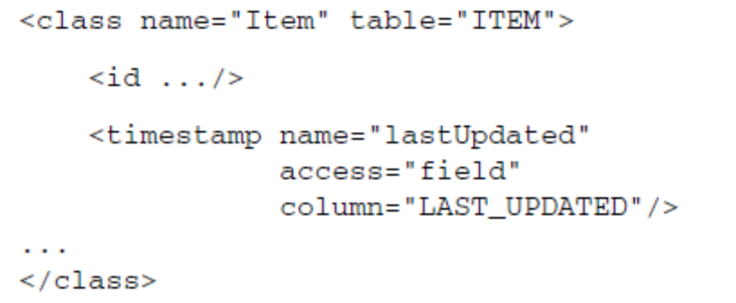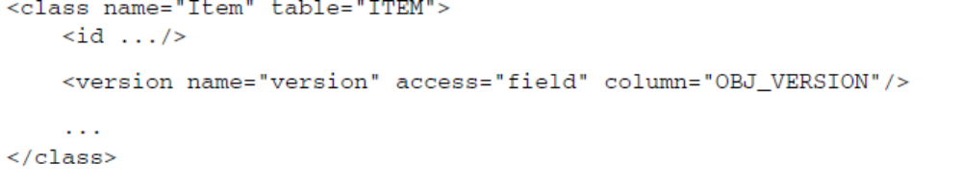

In theory, a timestamp is slightly less safe, because two concurrent transactions
may both load and update the same item in the same millisecond

When the persistence context is flushed, Hibernate detects that modification and increments the version of the Item to 2. It then executes
the SQL UPDATE to make this modification permanent in the database:
update ITEM set INITIAL_PRICE='12.99', OBJ_VERSION=2
where ITEM_ID=123 and OBJ_VERSION=1

throws a
StaleObjectStateException

Versioning without version numbers or timestamps
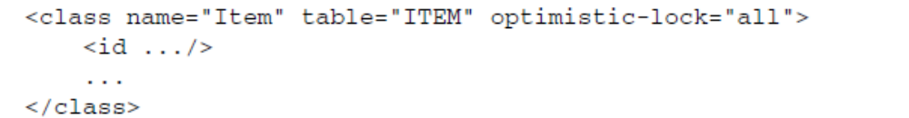

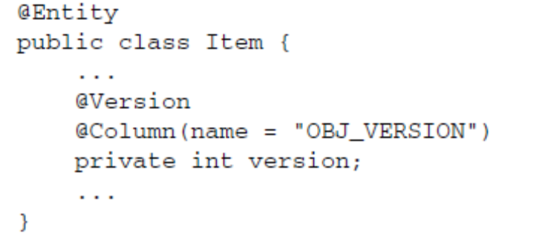

Explicit pessimistic locking

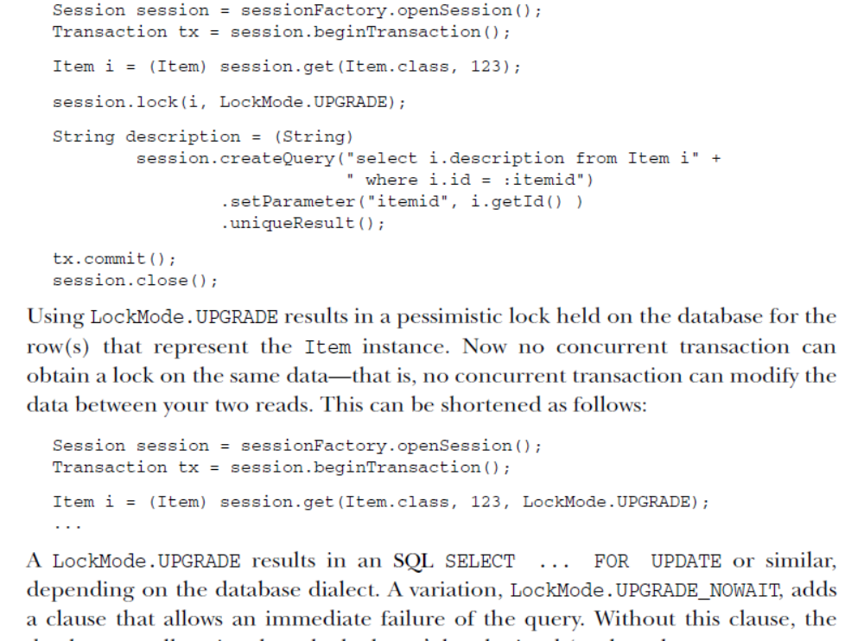

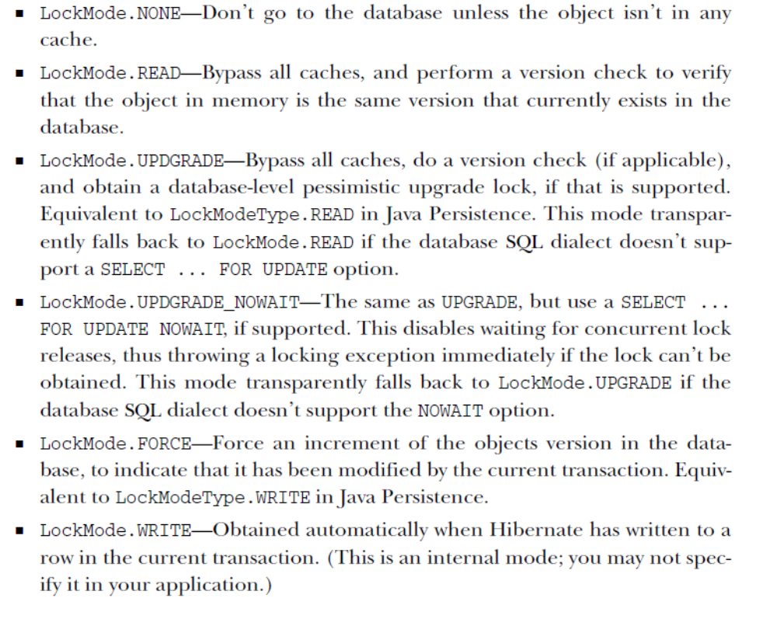

Optimizing fetching
and caching
The lazy default fetch plan
Hibernate defaults to a lazy fetching strategy for all entities and collections. This
means that Hibernate by default loads only the objects you’re querying for. Let’s
explore this with a few examples.
If you query for an Item object (let’s say you load it by its identifier), exactly
this Item and nothing else is loaded into memory:
Item item = (Item) session.load(Item.class, new Long(123));

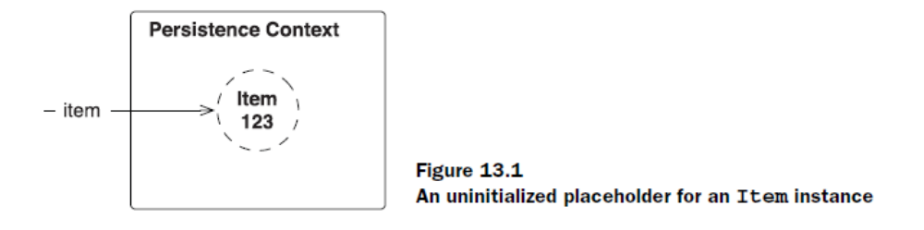

What is available in memory after the load() operation isn’t a
persistent item object. Even the SQL that loads an Item isn’t executed. Hibernate
created a proxy that looks like the real thing.

Understanding proxies
Proxies are placeholders that are generated at runtime. Whenever Hibernate
returns an instance of an entity class, it checks whether it can return a proxy
instead and avoid a database hit. A proxy is a placeholder that triggers the loading
of the real object when it’s accessed for the first time:
Item item = (Item) session.load(Item.class, new Long(123));
item.getId();
item.getDescription(); // Initialize the proxy

The third line in this example triggers the execution of the SQL that retrieves an
Item into memory. As long as you access only the database identifier property, no
initialization of the proxy is necessary.

A proxy is useful if you need the Item only to create a reference, for example:
Item item = (Item) session.load(Item.class, new Long(123));
User user = (User) session.load(User.class, new Long(1234));
Bid newBid = new Bid("99.99");
newBid.setItem(item);
newBid.setBidder(user);
session.save(newBid);

A JPA provider can implement lazy loading with proxies. The method names of
the operations that are equivalent to load() and get() on the EntityManager API
are find() and getReference():
Item item = em.find(Item.class, new Long(123));
Item itemRef = em.getReference(Item.class, new Long(1234));
The first call, find(), has to hit the database to initialize an Item instance. No
proxies are allowed—it’s the equivalent of the Hibernate get() operation. The
second call, getReference(), may return a proxy, but it doesn’t have to—which
translates to load() in Hibernate.

Again, you can see proxies in the picture. This time, these are proxies that
have been generated for all *-to-one associations. Associated entity objects are not
loaded right away; the proxies carry the identifier values only. From a different perspective: the identifier values are all foreign key columns in the item’s row.
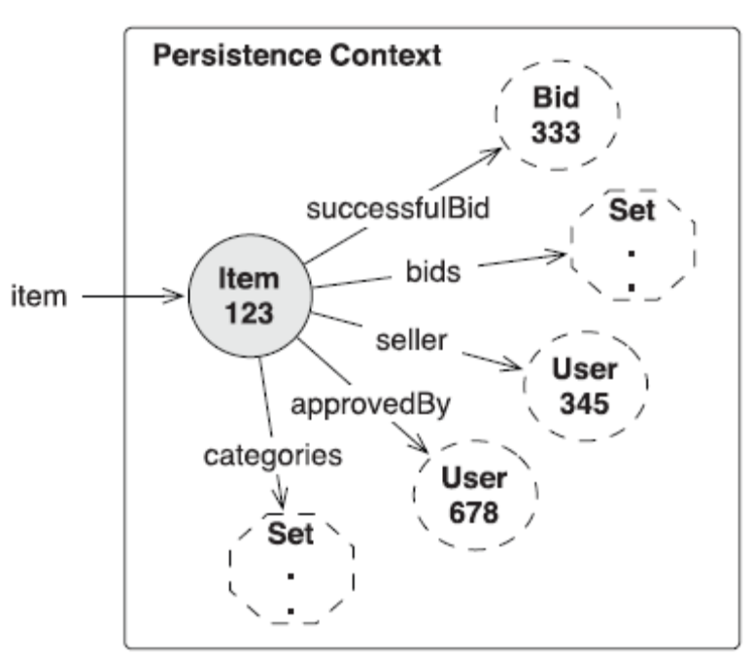

Collections also aren’t loaded right away, but we use the term collection wrapper to
describe this kind of placeholder. Internally, Hibernate has a set of smart collections
that can initialize themselves on demand. Hibernate replaces your collections
with these; that is why you should use collection interfaces only in your
domain model.

The collection wrapper is now smarter than before. The collection is no longer
initialized if you call size(), contains(), or isEmpty()—the database is queried
to retrieve the necessary information. If it’s a Map or a List, the operations containsKey()
and get() also query the database directly. A Hibernate extension
annotation enables the same optimization:
@OneToMany
@org.hibernate.annotations.LazyCollection(
org.hibernate.annotations.LazyCollectionOption.EXTRA
)
private Set<Bid> bids = new HashSet<Bid>();

Disabling proxy generation
The JPA standard doesn’t require an implementation with proxies; the word proxy
doesn’t even appear in the specification. Hibernate is a JPA provider that relies on
proxies by default, so the switch that disables Hibernate proxies is available as a
vendor extension:

User user = (User) session.load(User.class, new Long(123));
User user = em.getReference(User.class, new Long(123));

A load() of a User object can’t return a proxy. The JPA operation getReference()
can no longer return a proxy reference.

Eager loading of associations and collections

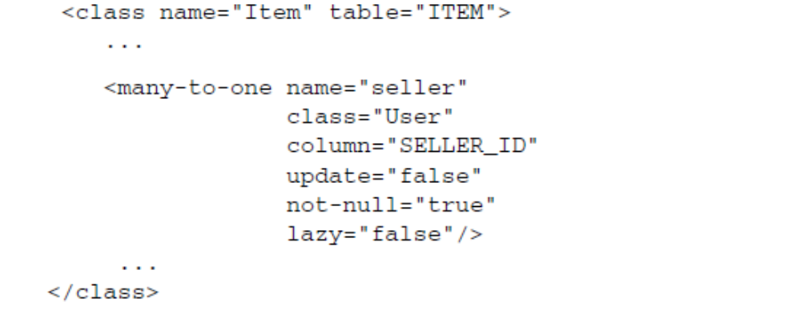

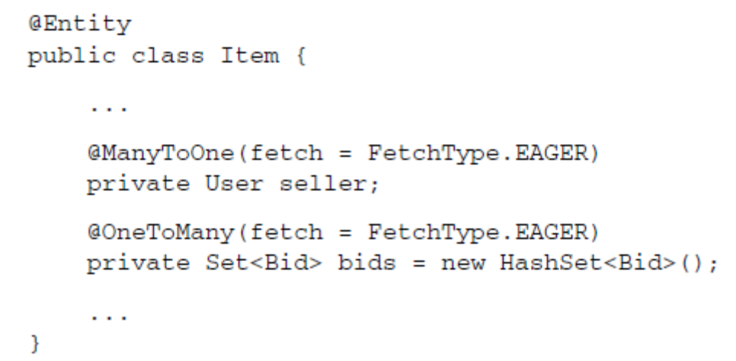

The FetchType.EAGER provides the same guarantees as lazy="false" in Hibernate:
the associated entity instance must be fetched eagerly, not lazily.

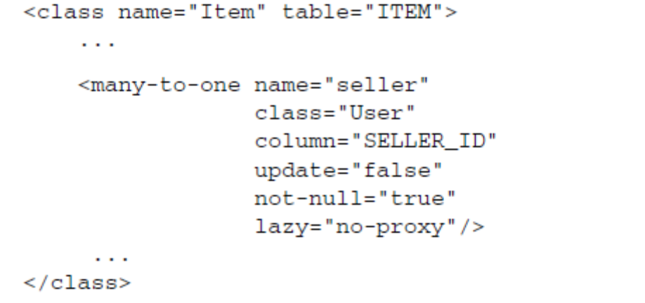

The default of the lazy attribute is proxy. By setting no-proxy, you’re telling
Hibernate to apply interception to this association:
Item item = (Item) session.get(Item.class, new Long(123));
User seller = item.getSeller();
The first line retrieves an Item object into persistent state. The second line
accesses the seller of that Item. This call to getSeller() is intercepted by Hibernate
and triggers the loading of the User in question.

Note how proxies are more
lazy than interception: You can call item.getSeller().getId() without forcing
initialization of the proxy. This makes interception less useful if you only want to
set references, as we discussed earlier.

Selecting a fetch strategy

Hibernate executes SQL SELECT statements to load objects into memory. If you
load an object, a single or several SELECTs are executed, depending on the number
of tables which are involved and the fetching strategy you’ve applied.
Your goal is to minimize the number of SQL statements and to simplify the SQL
statements, so that querying can be as efficient as possible.

By default, Hibernate fetches associated objects and collections lazily whenever
you access them (we assume that you map all to-one associations as FetchType.
LAZY if you use Java Persistence). Look at the following trivial code example:
Item item = (Item) session.get(Item.class, new Long(123));
You didn’t configure any association or collection to be nonlazy, and that proxies
can be generated for all associations. Hence, this operation results in the following
SQL SELECT:
select item.* from ITEM item where item.ITEM_ID = ?

Prefetching data in batches

List allItems = session.createQuery("from Item").list();
processSeller( (Item)allItems.get(0) );
processSeller( (Item)allItems.get(1) );
processSeller( (Item)allItems.get(2) );
Naturally, you use a loop here and iterate through the results, but the problem
this code exposes is the same. You see one SQL SELECT to retrieve all the Item
objects, and an additional SELECT for every seller of an Item as soon as you process
it. All associated User objects are proxies. This is one of the worst-case scenarios
we’ll describe later in more detail: the n+1 selects problem. This is what the SQL
looks like:
select items...
select u.* from USERS u where u.USER_ID = ?
select u.* from USERS u where u.USER_ID = ?

Hibernate offers some algorithms that can prefetch User objects. The first optimization
we now discuss is called batch fetching, and it works as follows: If one proxy
of a User must be initialized, go ahead and initialize several in the same SELECT. In
other words, if you already know that there are three Item instances in the persistence
context, and that they all have a proxy applied to their seller association,
you may as well initialize all the proxies instead of just one.

You make a guess and apply a batch-size fetching strategy to your User
class mapping:
<class name="User"
table="USERS"
batch-size="10">
...
</class>
You’re telling Hibernate to prefetch up to 10 uninitialized proxies in a single SQL
SELECT, if one proxy must be initialized. The resulting SQL for the earlier query
and procedure may now look as follows:
select items...
select u.* from USERS u where u.USER_ID in (?, ?, ?)

Batch fetching is also available for collections:
<class name="Item" table="ITEM">
...
<set name="bids"
inverse="true"
batch-size="10">
<key column="ITEM_ID"/>
<one-to-many class="Bid"/>
</set>
</class>
If you now force the initialization of one bids collection, up to 10 more collections
of the same type, if they’re uninitialized in the current persistence context,
are loaded right away:
select items...
select b.* from BID b where b.ITEM_ID in (?, ?, ?)

Prefetching collections with subselects

<class name="Item" table="ITEM">
...
<set name="bids"
inverse="true"
fetch="subselect">
<key column="ITEM_ID"/>
<one-to-many class="Bid"/>
</set>
</class>
Hibernate now initializes all bids collections for all loaded Item objects, as soon
as you force the initialization of one bids collection. It does that by rerunning the
first initial query (slightly modified) in a subselect:

Eager fetching with joins

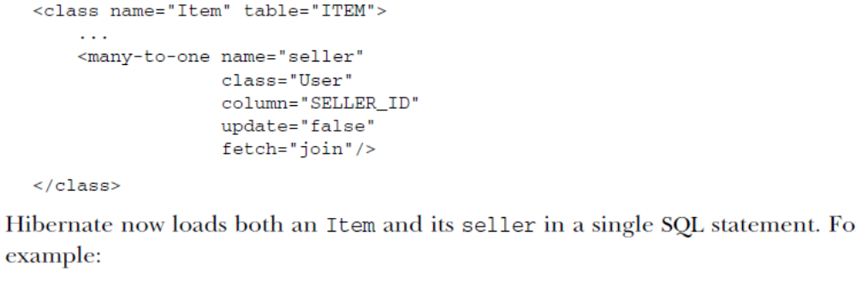

This operation triggers the following SQL SELECT:
select i.*, u.*
from ITEM i
left outer join USERS u on i.SELLER_ID = u.USER_ID
where i.ITEM_ID = ?
Obviously, the seller is no longer lazily loaded on demand, but immediately.
Hence, a fetch="join" disables lazy loading.

The n+1 selects problem

First you retrieve all Item instances
. This query triggers one SQL SELECT that retrieves all rows of the
ITEM table and returns n persistent objects. Next, you iterate through this result
and access each Item object.

What you access is the bids collection of each Item. This collection isn’t initialized
so far, the Bid objects for each item have to be loaded with an additional
query. This whole code snippet therefore produces n+1 selects.

A first solution could be a change of your global mapping metadata for the collection,
enabling prefetching in batches:
<set name="bids"
inverse="true"
batch-size="10">
<key column="ITEM_ID"/>
<one-to-many class="Bid"/>
</set>
Instead of n+1 selects, you now see n/10+1 selects to retrieve the required collections
into memory. This optimization seems reasonable for an auction application:
“Only load the bids for an item when they’re needed, on demand. But if
one collection of bids must be loaded for a particular item, assume that other
item objects in the persistence context also need their bids collections initialized.

With a subselect-based prefetch, you can reduce the number of selects to
exactly two:
<set name="bids"
inverse="true"
fetch="subselect">
<key column="ITEM_ID"/>
<one-to-many class="Bid"/>
</set>

Finally, you can effectively turn off lazy loading of the bids collection and
switch to an eager fetching strategy that results in only a single SQL SELECT:
<set name="bids"
inverse="true"
fetch="join">

The Cartesian product problem
The opposite of the n+1 selects problem are SELECT statements that fetch too much
data. This Cartesian product problem always appears if you try to fetch several
“parallel” collections.

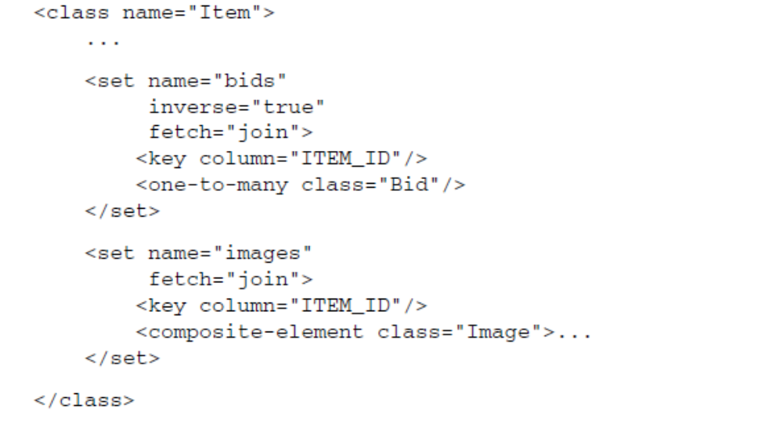

If you map two parallel collections (their owning entity is the same) with an eager
outer-join fetching strategy, and load all Item objects, Hibernate executes an SQL
SELECT that creates a product of the two collections:
select item.*, bid.*, image.*
from ITEM item
left outer join BID bid on item.ITEM_ID = bid.ITEM_ID
left outer join ITEM_IMAGE image on item.ITEM_ID = image.ITEM_ID
Look at the resultset of that query, shown in figure 13.6.

This resultset contains lots of redundant data. Item 1 has three bids and two
images, item 2 has one bid and one image, and item 3 has no bids and no images.
The size of the product depends on the size of the collections you’re retrieving: 3
times 2, 1 times 1, plus 1, total 8 result rows. Now imagine that you have 1,000 items in the database, and each item has 20 bids and 5 images—you’ll see a resultset
with possibly 100,000 rows! The size of this result may well be several megabytes.
Considerable processing time and memory are required on the database
server to create this resultset.

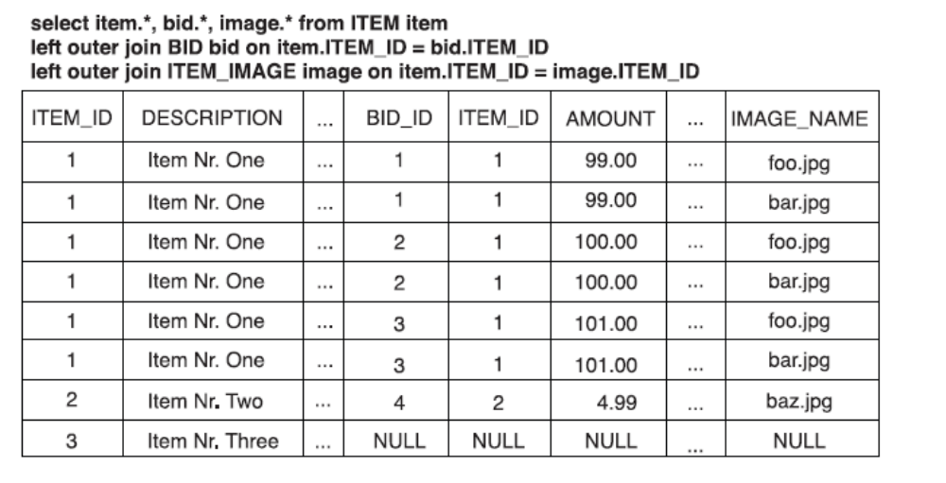

Finally, although Hibernate lets you create Cartesian products with
fetch="join" on two (or even more) parallel collections, it throws an exception
if you try to enable fetch="join" on parallel <bag> collections. The resultset
of a product can’t be converted into bag collections, because Hibernate
can’t know which rows contain duplicates that are valid

Forcing proxy and collection initialization

You can use the static method Hibernate.initialize() for manual initialization
of a proxy:
Session session = sessionFactory.openSession();
Transaction tx = session.beginTransaction();
Item item = (Item) session.get(Item.class, new Long(1234));
Hibernate.initialize( item.getSeller() );
tx.commit();
session.close();
processDetached( item.getSeller() );
...
Hibernate.initialize() may be passed a collection wrapper or a proxy. Note
that if you pass a collection wrapper to initialize(), it doesn’t initialize the target
entity objects that are referenced by this collection. In the previous example,
Hibernate.initalize( item.getBids() ) wouldn’t load all the Bid objects
inside that collection. It initializes the collection with proxies of Bid objects!

Caching fundamentals

A cache keeps a representation of current database state close to the application,
either in memory or on disk of the application server machine. The cache is
a local copy of the data. The cache sits between your application and the database.
The cache may be used to avoid a database hit whenever
■ The application performs a lookup by identifier (primary key).
■ The persistence layer resolves an association or collection lazily.

Caching strategies and scopes

There are three main types of cache:

There are three main types of cache:
■ Transaction scope cache—Attached to the current unit of work, which may be
a database transaction or even a conversation. It’s valid and used only as
long as the unit of work runs. Every unit of work has its own cache. Data in
this cache isn’t accessed concurrently.
■ Process scope cache—Shared between many (possibly concurrent) units of
work or transactions. This means that data in the process scope cache is accessed by concurrently running threads, obviously with implications on
transaction isolation.
■ Cluster scope cache—Shared between multiple processes on the same
machine or between multiple machines in a cluster. Here, network communication
is an important point worth consideration.

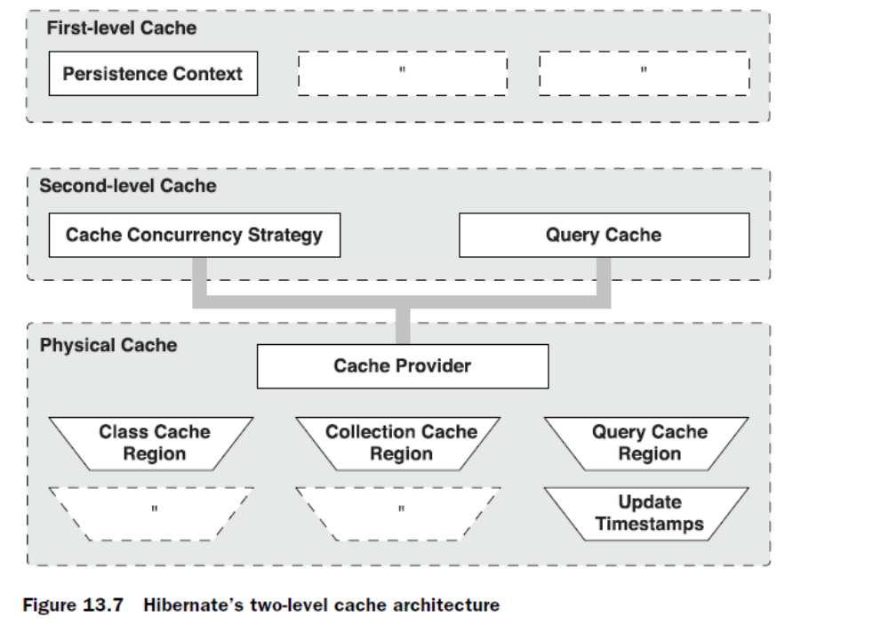

The cache policy involves setting the following:
■ Whether the second-level cache is enabled
■ The Hibernate concurrency strategy
■ The cache expiration policies (such as timeout, LRU, and memory-sensitive)
■ The physical format of the cache (memory, indexed files, cluster-replicated)

The four built-in concurrency strategies represent decreasing levels of strictness
in terms of transaction isolation:
■ Transactional—Available in a managed environment only, it guarantees full
transactional isolation up to repeatable read, if required. Use this strategy for
read-mostly data where it’s critical to prevent stale data in concurrent transactions,
in the rare case of an update.
■ Read-write—This strategy maintains read committed isolation, using a timestamping
mechanism and is available only in nonclustered environments.
Again, use this strategy for read-mostly data where it’s critical to prevent
stale data in concurrent transactions, in the rare case of an update.
■ Nonstrict-read-write—Makes no guarantee of consistency between the cache
and the database. If there is a possibility of concurrent access to the same
entity, you should configure a sufficiently short expiry timeout. Otherwise,
you may read stale data from the cache. Use this strategy if data hardly ever
changes (many hours, days, or even a week) and a small likelihood of stale
data isn’t of critical concern.
■ Read-only—A concurrency strategy suitable for data which never changes.
Use it for reference data only.
Note that with decreasing strictness comes

Choosing a cache provider

EHCache

OpenSymphony OSCache

SwarmCache

JBoss Cache

Selecting a concurrency control strategy

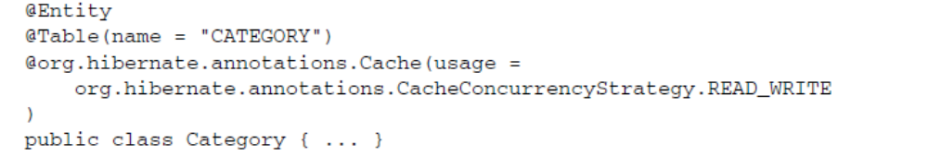

You use read-write instead of nonstrict-read-write because Category is a
highly concurrent class, shared between many concurrent transactions. (It’s clear
that a read committed isolation level is good enough.) A nonstrict-read-write would rely only on cache expiration (timeout), but you prefer changes to categories
to be visible immediately.

Collections
require their own <cache> region. For the items collection you use a read-write
concurrency strategy:
<class name="auction.model.Category"
table="CATEGORY">
<cache usage="read-write"/>
<id ...
<set name="items">
<cache usage="read-write"/>
<key ...
</set>
</class>
The region name of the collection cache is the fully qualified class name plus the
collection property name, auction.model.Category.items.

You apply a read-only strategy for the Bid class:
<class name="Bid"
table="BID" mutable="false">
<cache usage="read-only"/>
<id ...
</class>
Bid data is therefore never expired from the cache, because it can only be created
and never updated.

Understanding cache regions
Hibernate keeps different classes/collections in different cache regions. A region is
a named cache: a handle by which you may reference classes and collections in
the cache provider configuration and set the expiration policies applicable to that
region.

The Hibernate configuration property named hibernate.cache.region_prefix
may be used to specify a region name prefix for a particular SessionFactory
or persistence unit.

Setting up a local cache provider
You need to set the configuration property that selects a cache provider:
hibernate.cache.provider_class = org.hibernate.cache.EhCacheProvider

A cache configuration in ehcache.xml for the Category class may look like
this:
<cache name="auction.model.Category"
maxElementsInMemory="500"
eternal="true"
timeToIdleSeconds="0"
timeToLiveSeconds="0"
overflowToDisk="false"
/>

There are a small number of Category instances. You therefore disable eviction
by choosing a cache size limit greater than the number of categories in the system
and setting eternal="true", disabling eviction by timeout. There is no need
to expire cached data by timeout because the Category cache concurrency strategy
is read-write and because there are no other applications changing category
data directly in the database. You also disable disk-based cache overflow, because
you know there are few instances of Category and so memory consumption
won’t be a problem.

Bids, on the other hand, are small and immutable, but there are many of
them, so you must configure EHCache to carefully manage the cache memory
consumption. You use both an expiry timeout and a maximum cache size limit:

<cache name="auction.model.Bid"
maxElementsInMemory="50000"
eternal="false"
timeToIdleSeconds="1800"
timeToLiveSeconds="100000"
overflowToDisk="false"
/>

The timeToIdleSeconds attribute defines the expiry time in seconds since an element
was last accessed in the cache. You must set a sensible value here, because
you don’t want unused bids to consume memory. The timeToLiveSeconds
attribute defines the maximum expiry time in seconds since the element was
added to the cache. Because bids are immutable, you don’t need them to be
removed from the cache if they’re being accessed regularly. Hence, timeToLive-
Seconds is set to a high number.
The result is that cached bids are removed from the cache if they haven’t been
used in the past 30 minutes or if they’re the least recently used item when the
total size of the cache has reached its maximum limit of 50,000 elements.

You disable the disk-based cache in this example because you anticipate that
the application server will be deployed to the same machine as the database. If the
expected physical architecture was different, you might enable the disk-based
cache to reduce network traffic. Accessing data on the local disk is faster than
accessing the database across a network.

Controlling the second-level cache

You can call evict() to remove an element from the second-level cache by
specifying the class and the object identifier value:
SessionFactory.evict( Category.class, new Long(123) );
You may also evict all elements of a certain class or only evict a particular collection
role by specifying a region name:
SessionFactory.evict("auction.model.Category");

Hibernate also offers CacheMode options that can be activated for a particular
Session. Imagine that you want to insert many objects into the database in one
Session. You need to do this in batches, to avoid memory exhaustion—every
object is added to the first-level cache. However, it’s also added to the second-level
cache, if enabled for the entity class. A CacheMode controls the interaction of
Hibernate with the second-level cache:
Session session = sessionFactory.openSession();
Transaction tx = session.beginTransaction();
session.setCacheMode(CacheMode.IGNORE);
for ( int i=0; i<100000; i++ ) {
Item item = new Item(...);
session.save(item);
if ( i % 100 == 0 ) {
session.flush();
session.clear();

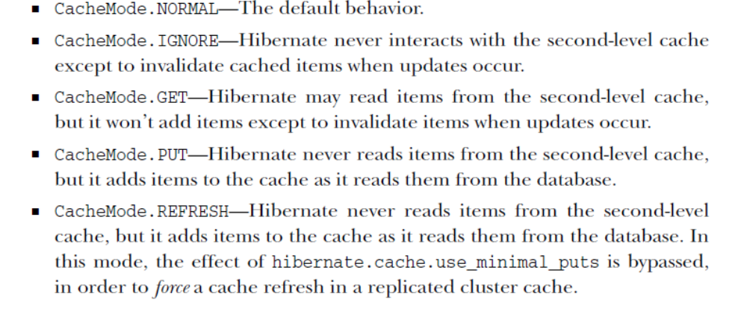

Bulk and batch operations

Updating objects directly in the database

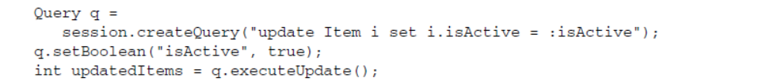

This HQL statement (or JPA QL statement, if executed with the EntityManager)
looks like an SQL statement. However, it uses an entity name (class name) and a
property name. It’s also integrated into Hibernate’s parameter binding API. The
number of updated entity objects is returned—not the number of updated rows.

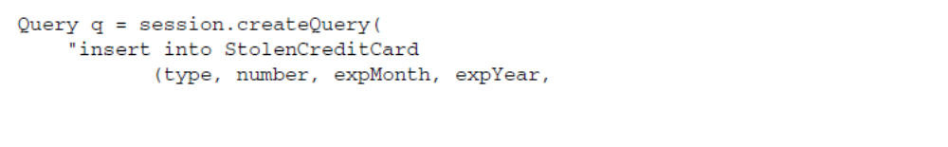

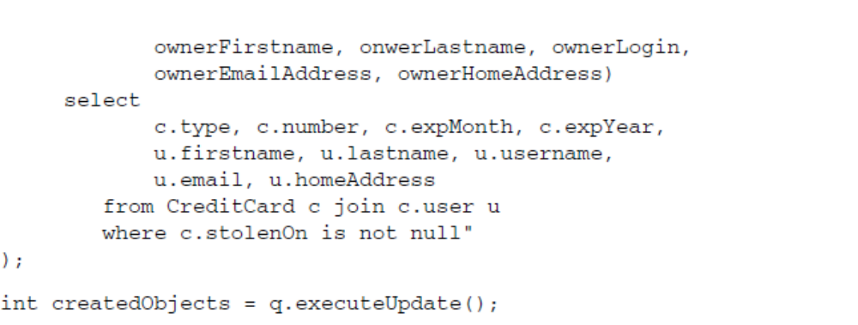

Writing a procedure with batch updates

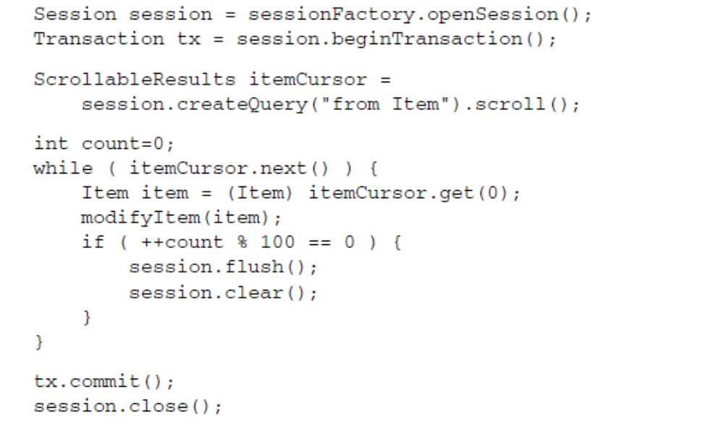

Using a stateless Session

Session session = sessionFactory.openStatelessSession();
Transaction tx = session.beginTransaction();
ScrollableResults itemCursor =
session.createQuery("from Item").scroll();
while ( itemCursor.next() ) {
Item item = (Item) itemCursor.get(0);
modifyItem(item);
session.update(item);
}
tx.commit();
session.close();
The batching is gone in this example—you open a StatelessSession. You no
longer work with objects in persistent state; everything that is returned from the
database is in detached state. Hence, after modifying an Item object, you need to
call update() to make your changes permanent.

Applying and implementing the filter

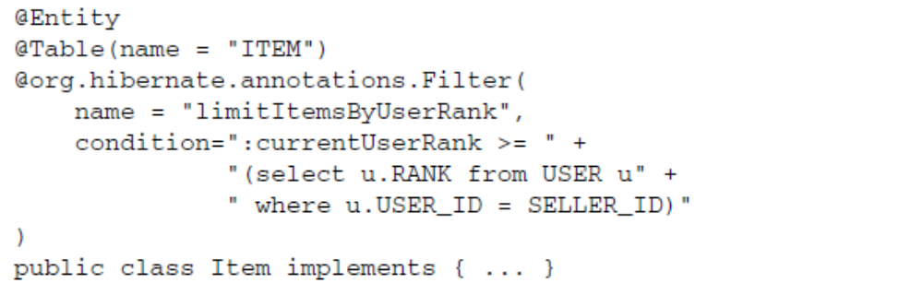

Enabling the filter

Intercepting Hibernate events

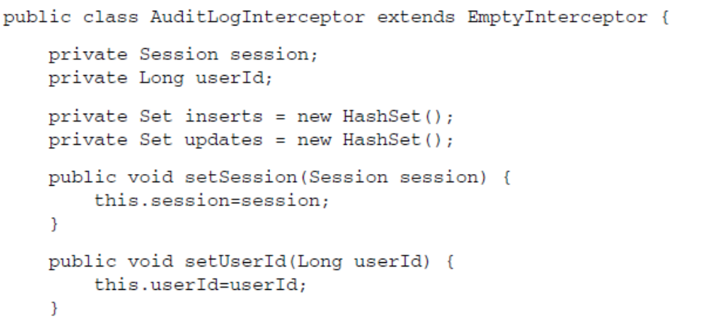

Enabling the interceptor
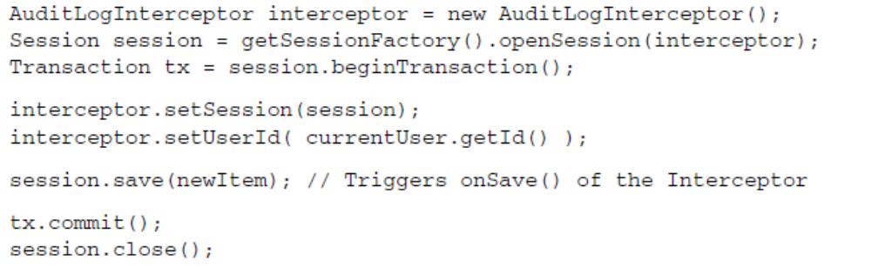

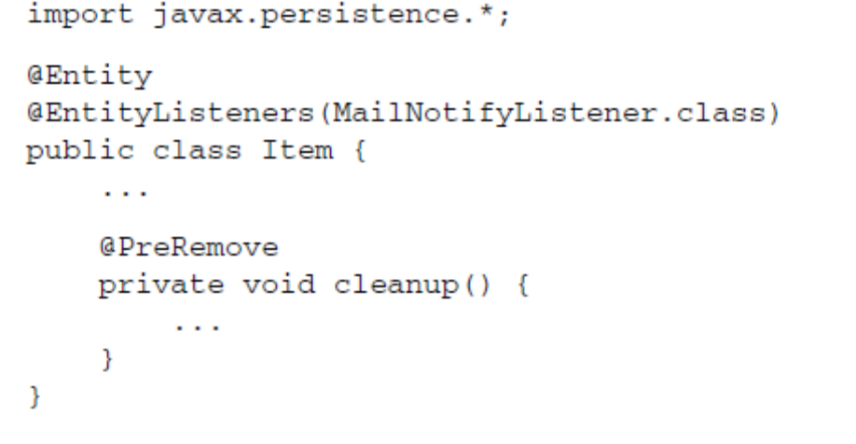

Scrolling with database cursors
Plain JDBC provides a feature called scrollable resultsets. This technique uses a cursor
that is held on the database management system. The cursor points to a particular
row in the result of a query, and the application can move the cursor forward
and backward. You can even jump to a particular row with the cursor.

ScrollableResults itemCursor =
session.createCriteria(Item.class)
.scroll(ScrollMode.FORWARD_ONLY);
... // Scroll only forward
itemCursor.close()

Implicit association joins

The first use is straightforward:
from User u where u.homeAddress.city = 'Bangkok'

Joins expressed in the FROM clause

from Item i
join i.bids b
where i.description like '%Foo%'
and b.amount > 100

Theta-style joins
A product lets you retrieve all possible combinations of instances of two or more
classes. This query returns all ordered pairs of Users and Category objects:
from User, Category
Obviously, this isn’t usually useful. There is one case where it’s commonly used:
theta-style joins.

You can then find all the Users and their
LogRecords with the following theta-style join:
from User user, LogRecord log where user.username = log.username

session.createCriteria(User.class)
.addOrder( Order.asc("lastname") )
.addOrder( Order.asc("firstname") );
You don’t need to have an open Session to create a criteria object; a Detached-
Criteria can be instantiated and later attached to a Session for execution (or to
another Criteria as a subquery):
DetachedCriteria crit =
DetachedCriteria.forClass(User.class)
.addOrder( Order.asc("lastname") )
.addOrder( Order.asc("firstname") );
List result = crit.getExecutableCriteria(session).list();

