HardCore Internet Ltd.

HardCore Internet Ltd.
www.hardcoreinternet.co.uk
info@hardcoreinternet.co.uk

HardCore
Web Content Editor
User & Developer Guide
Easily & Inexpensively
Create, Edit & Post Your Website Content

3. November 2004 Version 5.4.2

Copyright and Proprietary Information
Copyright HardCore Internet Ltd 2002–2004. This user guide constitutes proprietary information of HardCore Internet Ltd. No part of this user guide may be reproduced, transmitted, transcribed, stored in a retrieval system or translated into any language in any form, by any means, without the written permission of HardCore Internet Ltd.

Notice
HardCore Internet Ltd. reserves the right to make changes in this user guide at any time and without notice. HardCore Internet Ltd. makes no warranties, express or implied, in this user guide. In no event shall HardCore Internet Ltd. be liable for any indirect, special, incidental or consequential damages arising out of purchase or use of this user guide or the information contained herein.

Licenses and Trademarks
HardCore Web Content Editor and the HardCore Internet logo are trademarks or registered trademarks of HardCore Internet Ltd. in the United Kingdom and other countries. All other company, product, or trade names are trademarks or registered trademarks of their respective holders.

HardCore Internet Ltd
HardCore Internet Ltd. provides Internet/Web services, consultancy and solutions for businesses and individuals. Registered in England - Company Registration No. 3865324 - www.hardcoreinternet.co.uk

HardCore
Web Content Editor
Easily & Inexpensively
Create, Edit & Post Your Website Content

Introduction
This document is the user guide for the HardCore Web Content Editor. The user guide describes how you, the website developer, install, configure and use the HardCore Web Content Editor to create, edit and post your website content.
The HardCore Web Content Editor is a web solution allowing you easy access to create and edit the content of your websites as well as any web-based applications and services. The system is full-featured but very easy to use and highly flexible.

This user guide is divided into four main parts:

Part 1 describes how to install and configure the HardCore Web Content Editor to run on your website.

Part 2 describes how to use the basic HardCore Web Content Editor to create and edit your website content.

Part 3 describes how your website content is posted from the HardCore Web Content Editor to your website.

Part 4 describes how to customise and integrate the HardCore Web Content Editor hyperlink and media dialog windows to suit your own web applications and databases.

Table of Contents
Introduction 3
Table of Contents 4
1 Installation and Configuration 8
1.1 System Requirements 8
1.2 Download and Installation 9
1.3 Testing 9
1.4 Installed 10
1.5 Configuration 10
1.5.1 Basic Options 11
1.5.2 Advanced Options 12
1.5.3 ASP.NET control 14
1.5.4 Editor with advanced dialog windows 16
1.5.5 Spell checking 18
1.5.6 Multiple editors on the same webpage with separate toolbars 19
1.5.7 Multiple editors on the same webpage with shared toolbar 19
1.5.8 Toolbar and editable web content in HTML FRAMESET FRAMEs 20
1.5.9 Toolbar in HTML IFRAME 20
1.6 Upgrades 21
1.7 Internationalisation 21
1.7.1 HardCore Web Content Editor texts 22
1.7.2 User Language Preferences 23
1.7.3 Right to left editing 24
1.8 Relocation 24
2 HardCore Web Content Editor 26
2.1 Text Formatting and Style 27
2.1.1 Style 27
2.1.2 Format 28
2.1.3 Font Name 28
2.1.4 Font Size 29
2.1.5 Bold 29
2.1.6 Italic 29
2.1.7 Underline 29
2.1.8 Font Formatting 29
2.1.9 Text Colour 30
2.1.10 Background Colour 30
2.1.11 Superscript 31
2.1.12 Subscript 31
2.1.13 Strikethrough 31
2.1.14 Remove Format 31
2.2 Indentation and Alignment 32
2.2.1 Decrease Indent 32
2.2.2 Indent 32
2.2.3 Align Left 32
2.2.4 Align Center 32
2.2.5 Align Right 32
2.2.6 Align Full 32
2.2.7 Do Not Break 32
2.2.8 Numbered List 33
2.2.9 Bullet List 33
2.3 Editing 33
2.3.1 Cut 33
2.3.2 Copy 33
2.3.3 Paste 34
2.3.4 Clean HTML Code 34
2.3.5 Delete 35
2.3.6 Select All 35
2.3.7 Redo 35
2.3.8 Undo 36
2.4 Web Content 36
2.4.1 Insert Special Characters & Codes 36
2.4.2 Insert Media (Image / Flash / Java Applet) 36
2.4.3 Insert Link 39
2.4.4 Insert Frame 41
2.4.5 Insert Mail To Link 42
2.4.6 Insert Anchor/ Bookmark 42
2.4.7 Unlink 43
2.4.8 Insert Horizontal Rule 43
2.5 Table Editing 43
2.5.1 Insert Table 43
2.5.2 Table Properties 45
2.5.3 Insert Caption 46
2.5.4 Insert Header Row 46
2.5.5 Insert Footer Row 47
2.5.6 Row Properties 47
2.5.7 Insert Row Above 48
2.5.8 Insert Row Below 48
2.5.9 Delete Row 48
2.5.10 Split Cell Rows 48
2.5.11 Column Properties 48
2.5.12 Insert Column Left 50
2.5.13 Insert Column Right 50
2.5.14 Delete Column 50
2.5.15 Split Cell Columns 50
2.5.16 Cell Properties 50
2.5.17 Insert Cell Left 52
2.5.18 Insert Cell Right 52
2.5.19 Delete Cell 52
2.5.20 Split Cell 52
2.5.21 Merge Cells 53
2.6 Form Editing 53
2.6.1 Insert Form 53
2.6.2 Insert Button 54
2.6.3 Insert File Input 56
2.6.4 Insert Text Input 57
2.6.5 Insert Password Input 58
2.6.6 Insert Hidden Input 59
2.6.7 Insert Text Area Input 60
2.6.8 Insert Checkbox 61
2.6.9 Insert Radio Button 62
2.6.10 Insert Select List 63
2.7 Positioning 65
2.7.1 Absolute Positioning 65
2.7.2 Bring Forwards 65
2.7.3 Send Backwards 65
2.7.4 Bring To Front 65
2.7.5 Send To Back 65
2.7.6 Bring Above Text 66
2.7.7 Send Below Text 66
2.7.8 Insert Box 66
2.8 Special 67
2.8.1 Help 67
2.8.2 Import File 67
2.8.3 Find 68
2.8.4 Insert Print Page Break 68
2.8.5 Print 68
2.8.6 Preview 69
2.8.7 Save / Submit 70
2.8.8 Show Details 70
2.8.9 Show Hidden Details 70
2.8.10 Show HTML 70
2.8.11 Check Spelling 70
2.9 HTML DOM Inspector 72
3 Handling posted web content 73
3.1 Simple file editor example 73
4 Customising and integrating 75
4.1 Hyperlink and media dialog windows 75
4.1.1 Quicklinks 75
4.1.2 Hyperlink and media managers 76
4.1.3 Additional hyperlink and media dialog window attributes 77
4.1.3.1 Hyperlink 77
4.1.3.2 Media 78
4.2 Toolbar 78
4.2.1 Format, font name and size options 78
4.2.2 Rows, buttons and options 81
4.2.3 Custom functionality 83
4.2.3.1 Toolbar buttons 83
4.2.3.2 Web content editor focus 83
4.3 Custom encoding/decoding and reformatting of HTML content 84
4.3.1 HTML content for use with Macromedia Flash 85
4.3.2 Non-standard HTML-like custom tags 85
4.4 CSS Style Sheet Style Names 86
4.5 Javascript API 87
4.5.1 HardCoreWebEditorGetContent() 87
4.5.2 HardCoreWebEditorGetContentSelection() 87
4.5.3 HardCoreWebEditorSetContent() 88
4.5.4 HardCoreWebEditorPasteContent() 88
4.5.5 HardCoreWebEditorSubmit() 88
4.5.6 HardCoreWebEditorStylesheet() 88
4.5.7 HardCoreWebEditorCleanContent() 88
4.5.8 HardCoreWebEditorCleanContentString() 89

Installation and Configuration
Installing and configuring the HardCore Web Content Editor is easy and should take no more than a few minutes if you are familiar with web servers.

Section 1.1 describes the system requirements and what you need to do and know before you install the HardCore Web Content Editor.

Section 1.2 describes how to download and install the HardCore Web Content Editor program files.

Section 1.3 describes the initial minimal configuration of the HardCore Web Content Editor to get it running on your website.

System Requirements
The HardCore Web Content Editor is very flexible in that it runs on most major website platforms: operating systems, web browsers, web servers and programming/scripting languages. No matter which platform your website runs on it is likely to be supported.

The HardCore Web Content Editor runs on the following website platforms:

Website Platform Component | Supported Products
Operating System | Microsoft Windows  Macintosh  Linux  Unix  (+ other operating systems)
Web Server | Microsoft Internet Information Server  Apache Web Server  (+ any standard compliant web server)
Programming / Scripting Language | Any (for standard hyperlink and media dialog windows)  ASP, ASP.NET/C#, ColdFusion, JSP/Java, PHP (for advanced hyperlink and media manager)  (+ easy adaptation to other languages)
Spell Checking | Aspell (free software download from http://aspell.net).
Web Browser  (web content editors) | Microsoft Windows Internet Explorer (v4.0 or newer)  Mozilla (v1.3 or newer)  Mozilla Firefox (v0.7 or newer)  Netscape (v7.1 or newer)  (+ any standard compliant web browser for standard HTML form textarea content editing)
Web Browser  (web content viewers) | Any standard compliant web browser

Please note that only recent versions of the website platform software are supported by the HardCore Web Content Editor. You should always make sure to keep your website platform software updated to the latest or at least a recent version to avoid functionality and security problems.

Before installing the HardCore Web Content Editor you should make sure that:

- Your operating system, web server, programming/scripting language, database server, database drivers and web browser are installed and working correctly.
- You have access and permissions to copy files to your web server and your website directory/folder through FTP (File Transfer Protocol) or Microsoft Networking or similar.

Download and Installation
The HardCore Web Content Editor is available for download from the HardCore Internet website (www.hardcoreinternet.co.uk). The software is available in a variety of packages and formats. Please check the website for details.

The downloaded package is a compressed file archive, which you must uncompress and extract. The package includes a number of files located under a folder named “hardcore/webeditor” and a folder named “hardcore/dtree”. Depending on the downloaded package the files could be:

hardcore/webeditor/ Files Example
blank.html  empty.html  webeditor1.js  webeditor2.js  webeditor.js  webeditor_contenteditable.js  webeditor_contenteditable_mozilla.js  webeditor_contenteditable_msie.js  webeditor_dhtml_msie.js  webeditor_textarea.js | empty.css  hardcore.css  webeditor.css  cellproperties.html  colour.html  columnproperties.html  help2.html  help.html  hyperlink.html  UserDeveloperGuide.pdf | index.html  index.asp  index.aspx  index.cfm  index.jsp  index.php  media.html  rowproperties.html  table.html  tableproperties.html

Please note that some of the HardCore Web Content Editor files may be named identically to some of your existing website files in which case your existing files will be overwritten. Please make sure to backup all your existing website files before installing the HardCore Web Content Editor.

To install the HardCore Web Content Editor you must copy the “hardcore/webeditor” and “hardcore/dtree” folders and all the files to your website root/home folder on your web server. Your website root/home folder is where your main homepage file is located. (Please see 1.8 Relocation for details on how to install the HardCore Web Content Editor to another folder than “/hardcore/webeditor/”).

Please note that the HardCore Web Content Editor includes simple file editor examples, which you may not want to leave available/unrestricted through your web site as they enable users to view and edit the content of the “simple_file_editor_example_content.html” file. Simply delete all the “simple_file_editor_example” files from the “hardcore/webeditor” folder.

Testing
After installing the HardCore Web Content Editor folder and files to your website root/home directory, access your website using your usual website domain name or IP number followed by “/hardcore/webeditor/” (i.e. http://www.hardcoreinternet.co.uk/hardcore/webeditor/). If your web server and programming/scripting language is working correctly, you should now automatically get access to the default HardCore Web Content Editor web page.

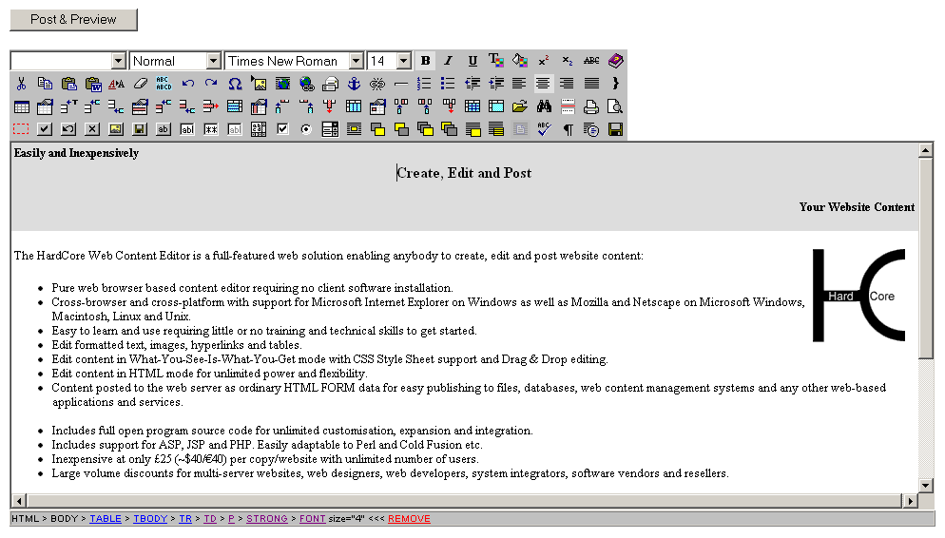

Installed
Once you have installed the HardCore Web Content Editor as described in the previous sections, you are ready to start using and customising/integrating it.

Initially, we recommend you to use the basic web content editor features to get familiar with the basics, which are described in the next chapter.

Once you are familiar with the basics of the web content editor, you need to customise and/or integrate it for use with your own website or web-based application and database.

Configuration
The HardCore Web Content Editor content is included and posted from your web pages as ordinary HTML FORM data. This allows you to easily integrate the HardCore Web Content Editor with any website and web-based applications simply by replacing any existing HTML FORM TEXTAREA field with the HardCore Web Content Editor, which automatically degrades to a TEXTAREA field for web browsers without support for visual web content editing.
For a simple example of how to easily replace a HTML FORM TEXTAREA input field with the HardCore Web Content Editor, please see the “index.example.textarea.html” and “index.example.hardcore.html” files in the “hardcore/webeditor” folder:
- index.example.textarea.html
This HTML web page contains a FORM with a TEXTAREA input field.
- index.example.hardcore.html
This HTML web page contains a FORM with the HardCore Web Content Editor instead of the TEXTAREA input field.

Basic Options
The “hardcore/webeditor” folder includes “index.html”, “index.asp”, “index.aspx”, “index.cfm”, “index.jsp” and “index.php” files with simple examples of how to make a simple HTML FORM with HardCore Web Content Editor. Integrating the HardCore Web Content Editor only requires a few additional lines of HTML code:
<link href="/hardcore/webeditor/webeditor.css" rel="stylesheet" type="text/css" />
The HTML HEAD must include this LINK tag to include the style sheet used by the HardCore Web Content Editor itself for the toolbar (but not for the edited web content).
If the HardCore Web Content Editor is installed to another location than the default ‘/hardcore/webeditor/’ folder, the ‘href’ location must be adjusted to your alternative installation folder.
<script src="/hardcore/webeditor/webeditor.js"></script>
The HTML HEAD must include this SCRIPT tag to include the Javascript program code for the HardCore Web Content Editor.
If the HardCore Web Content Editor is installed to another location than the default ‘/hardcore/webeditor/’ folder, the ‘src’ location must be adjusted to your alternative installation folder.
<script>HardCoreWebEditorToolbar();</script>
The HTML BODY must include this SCRIPT tag to display the HardCore Web Content Editor Toolbar. The toolbar is displayed where this SCRIPT tag is included.
If no parameters are passed to the HardCoreWebEditorToolbar function the default toolbar will be displayed. However, the toolbar can also be customized by passing parameters defining which options to display and in which order. You can even replace the default functionality or add you own functionality. Please see 4.2 Toolbar for details.
<script>content_editor = new HardCoreWebEditor('/hardcore/webeditor/', '', 'content', 'This is my web content');</script>
The HTML BODY FORM must include this SCRIPT tag to display the editable web content for the HardCore Web Content Editor. The editable web content is displayed where this SCRIPT tag is included.
The editable web content is automatically sized to fill the available display area. Surround this SCRIPT tag with TABLE/TR/TD tags or similar to fix or limit the size of the editable web content.
The parameters passed to the HardCoreWebEditor constructor function are:
- Root path URL – for where the HardCore Web Content Editor is installed on your web server. As default this must be ‘/hardcore/webeditor/’. If the HardCore Web Content Editor is installed to another location than the default ‘/hardcore/webeditor/’ folder, the ‘Root path URL’ location must be adjusted to your alternative installation folder.
- Scripting language – the standard HardCore Web Content Editor works with any server-side scripting language and this can be left blank (‘’). Please see 1.5.2 Advanced Options for details on using server-side scripting languages and the HardCore Web Content Editor advanced dialog windows
- HTML FORM data name – for the editable web content. This is the data name used when your editable web content is posted to your web server.
- Initial editable web content – which the HardCore Web Content Editor displays and makes editable. Please note that “’”, carriage return and line feed characters in the content must be “escaped” to “\’”, “\r” and “\n” strings. You need to do this manually or using the built-in features of your preferred scripting language such as:
  - ASP: Replace(Replace(Replace(Replace(content, “\”, “\\”), vbcr, "\r"), vblf, "\n"), "'", "\'")
  - ASP.NET/C#: content.Replace(“\\”, “\\\\”).Replace(“\r”, "\\r").Replace(“\n”, "\\n").Replace("\'", "\\'")
  - ColdFusion: Replace(Replace(Replace(content, "\", "\\", "All"), Chr(13), "\r", "All"), Chr(10), "\n", "All")
  - JSP: content .replaceAll("\\\\", "\\\\\\\\").replaceAll("\r", "\\\\r").replaceAll("\n", "\\\\n").replaceAll("'", "\\\\'")
  - PHP: str_replace("\r", "\\r", str_replace("\n", "\\n", str_replace("\\", "\\\\", addslashes($content))))
The return value from the HardCoreWebEditor constructor function is used by the HardCore Web Content Editor and must be assigned to a Javascript variable named as the HTML FORM data name parameter followed by “_editor” (i.e. “content_editor” if the HTML FORM data name parameter is “content”).
<script>HardCoreWebEditorDOMInspector();</script>
Optionally, the HTML BODY may include this SCRIPT tag to display the HardCore Web Content Editor DOM Inspector. The DOM Inspector is displayed where this SCRIPT tag is included.

Advanced Options
In addition to the basic options as described in the previous section, a number of additional options may be added as parameters for the “HardCoreWebEditor” Javascript constructor function:
<script>content_editor = new HardCoreWebEditor('/hardcore/webeditor/', '', 'content', 'This is my web content', '', '/hardcore/webeditor/hardcore.css', true, '', '', '', '', '', '', '', '', '', '');</script>
The HTML BODY FORM must include this SCRIPT tag to display the editable web content for the HardCore Web Content Editor. The editable web content is displayed where this SCRIPT tag is included.
The editable web content is automatically sized to fill the available display area. Surround this SCRIPT tag with TABLE/TR/TD tags or similar to fix or limit the size of the editable web content.
The parameters passed to the HardCoreWebEditor constructor function are:
- Root path URL – as described in the previous section.
- Scripting language – the standard HardCore Web Content Editor works with any server-side scripting language and this can be left blank (‘’). However, if you use the advanced hyperlink and media manager dialogs (please see below), you must specify the server-side scripting language file extension such as ‘asp’, ‘aspx’, ‘cfm’, ‘jsp’, ‘php’ or ‘cfm’. Examples of advanced hyperlink and media manager dialogs are included for ASP, ASP.NET, ColdFusion, JSP and PHP, and you can easily modify these to other scripting languages such as Perl.
- HTML FORM data name – as described in the previous section.
- Initial editable web content – as described in the previous section.
- ‘’ (deprecated – for backwards compatibility only– always set to empty string).
- Style sheet URL – for style sheet to be loaded and used for the editable web content. Set to empty string if no style sheet is to be loaded and used.
- true (deprecated – for backwards compatibility only– always set to true).
- Manager dialogs suffix – for hyperlink and media dialog windows to be used be the HardCore Web Content Editor. Set to empty string to use the default dialog windows (“hyperlink.html” and “media.html”). Set to ‘basic’ to use our example dialog windows (“hyperlinkbasic.asp”, “hyperlinkbasic.aspx”, “hyperlinkbasic.cfm”, “hyperlinkbasic.jsp”, “hyperlinkbasic.php”, “mediabasic.asp”, “mediabasic.aspx”, “mediabasic.cfm”, “mediabasic.jsp”, “mediabasic.php”). Set to ‘manager’ to use our example dialog windows (“hyperlinkmanager.asp”, “hyperlinkmanager.aspx”, “hyperlinkmanager.cfm”, “hyperlinkmanager.jsp”, “hyperlinkmanager.php”, “mediamanager.asp”, “mediamanager.aspx”, “mediamanager.cfm”, “mediamanager.jsp”, “mediamanager.php”). When using the advanced manager dialogs you must also specify your server-side scripting language (please see above).
- Output On Enter – for output inserted on pressing Enter key. Set to ‘’ for default web browser output. Different web browsers generate different output.
- Output on Shift+Enter – for output inserted on pressing Shift+Enter keys. Set to ‘’ for default web browser output. Different web browsers generate different output.
- Output on Ctrl+Enter – for output inserted on pressing Ctrl+Enter keys. Set to ‘’ for default web browser output. Different web browsers generate different output.
- Output on Alt+Enter – for output inserted on pressing Alt+Enter keys. Set to ‘’ for default web browser output. Different web browsers generate different output.
- Toolbar frame – for toolbar located in iframe or frameset frame. Set to ‘’ if toolbar not located in separate frame. Examples: Set to document.getElementById('toolbarframe') for iframe or parent.document.getElementById('toolbarframe') for frame set frame where ‘toolbarframe’ is the id attribute of the toolbar frame.
- Width – for fixed width of web content editor. Set to ‘’ for default ‘100%’ width to automatically fit to maximum available width.
- Height – for fixed height of web content editor. Set to ‘’ for default ‘100%’ height to automatically fit to maximum available height.
- Format – of the web content editor’s output. Set to ‘’ for default HTML format as entered by the user and generated by the web browser. Set to ‘html’ for the web content editor to reformat (clean up) the default HTML format generated by the web browser into a more HTML standards compliant format. Set to ‘xhtml’ for conversion of the web content to XHTML syntax. (Please note that the web content may be handled as non-XHTML format while in the web content editor, but the web content will be converted to XHTML syntax when the web content is saved/previewed).
- Encoding – character set encoding used for the web content (as used and required for XHTML formatted web content). Set to ‘’ for default ‘UTF-8’ encoding. (Please note that this does not change the encoding of your web content, but only declares which encoding you are using).
- Direction - text editing direction in web content editor. Set to ‘’ for default ‘ltr’ left to right editing. Set to 'rtl' for right to left editing for Arabic and Hebrew languages.

ASP.NET control
As an alternative to using direct HTML and Javascript code to use the HardCore Web Content Editor on a web page, you may prefer to use an ASP.NET control to generate the HTML and Javascript code.
Please see “index.aspx” in the “hardcore/webeditor” folder for details.
<%@ Register tagprefix=”HardCore” tagname=”WebEditor” src=”/hardcore/webeditor/webeditor.ascx” %>
The web page must register the HardCore:WebEditor ASP.NET control before it can be used.
If the HardCore Web Content Editor is installed to another location than the default ‘/hardcore/webeditor/’ folder, the ‘src’ location must be adjusted to your alternative installation folder.
<HardCore:WebEditor ID=”webeditor” Rootpath=”/hardcore/webeditor/” Language=”aspx” Name=”content” Value=”” StyleSheet=”/hardcore/webeditor/hardcore.css” Manager=”” onEnter=”” onShiftEnter=”” onCtrlEnter=”” onAltEnter=”” ToolbarFrame=”” Width=”” Height=”” Format=”” Encoding=”” runat=”server” />
The HTML BODY FORM must include this ASP.NET control tag to display the editable web content for the HardCore Web Content Editor. The editable web content is displayed where this ASP.NET control tag is included.
The editable web content is automatically sized to fill the available display area. Surround this SCRIPT tag with TABLE/TR/TD tags or similar to fix or limit the size of the editable web content.
The parameters passed to the HardCore:WebEditor control are:
- ID – Unique id for each HardCore Web Content Editor control tag to be used by your ASP.NET program code to identify the HardCore Web Content Editor control tag.
- Rootpath – Please see 1.5.1 Basic Options – Root path URL for details.
- Language – Please see 1.5.1 Basic Options – Scripting language for details.
- Name – Please see 1.5.1 Basic Options – HTML FORM data name for details.
- Value – Please see 1.5.1 Basic Options – Initial editable web content for details.
- StyleSheet – Please see 1.5.2 Advanced Options – Style sheet URL for details.
- Manager – Please see 1.5.2 Advanced Options – Manager dialogs suffix for details.
- onEnter – Please see 1.5.2 Advanced Options – Output On Enter for details.
- onShiftEnter – Please see 1.5.2 Advanced Options – Output on Shift+Enter for details.
- onCtrlEnter – Please see 1.5.2 Advanced Options – Output on Ctrl+Enter for details.
- onAltEnter – Please see 1.5.2 Advanced Options – Output on Alt+Enter for details.
- ToolbarFrame – Please see 1.5.2 Advanced Options – Toolbar frame for details.
- Width – Please see 1.5.2 Advanced Options – Width for details.
- Height – Please see 1.5.2 Advanced Options – Height for details.
- Format – Please see 1.5.2 Advanced Options – Format for details.
- Encoding – Please see 1.5.2 Advanced Options – Encoding for details.
- Direction – Please see 1.5.2 Advanced Options – Direction for details.

Editor with advanced dialog windows
The HardCore Web Content Editor can use advanced Insert Hyperlink and Insert Media dialog windows.
See “index.manager.html”, “index.manager.asp”, “index.manager.aspx”, “index.manager.cfm”, “index.manager.jsp” and “index.manager.php” in the “hardcore/webeditor” folder and 4.1 Hyperlink and media dialog windows for details.
For the ASP, ASP.NET, ColdFusion, JSP and PHP versions of the advanced dialog windows, the HardCore Web Content Editor includes ready to use hyperlink and media manager web applications. To enable the hyperlink and media manager applications you must configure the folders and file formats to be used. These are configured in the “config.asp”, “config.aspx”, “config.cfm”, “config.jsp” and “config.php” files in the “hardcore/webeditor” folder.
You must configure the following variables in the configuration file(s):
context | JSP version only.  The Java application server context, which your “images_path” and “files_path” folders are located under.  Set this to blank (“”) if your “images_path” and “files_path” folders are located under your website root context.
root_path | The full path to your website’s root folder (or your Java application server context folder, which your “images_path” and “files_path” folders are located under).  Set this to blank (“”) to use static HTML coded hyperlink and media options in the hyperlink and media manager web applications instead of automatically listing files in folders.
enable_upload | Set this to “yes” to give users access to manage folders and files through the Insert Hyperlink and Insert Media advanced dialog windows. Otherwise set this to “”.
upload_path | The full path to a temporary folder for file uploads.  Set this to blank (“”) to disable file upload through the hyperlink and media manager web applications.  Ideally this folder should be outside your website’s root folder or have access restrictions so that temporary uploaded files cannot be accessed directly through your website.
exclude_paths | List of folder names (separated by commas) which should be hidden from users in the Insert Hyperlink and Insert Media advanced dialog windows.  Please note that all folders must start with “/”.
pages_path | Relative path under your “root_path” to the folder with your website pages.  Please note that the path must start and end with “/”.
images_path | Relative path under your “root_path” to the folder with your website images.  Please note that the path must start and end with “/”.
files_path | Relative path under your “root_path” to the folder with your website pages.  Please note that the path must start and end with “/”.
page_formats | File name extensions (separated by commas) to be used for “pages”. Only files with these extensions can be uploaded to the website.
image_formats | File name extensions (separated by commas) to be used for “images”. Only files with these extensions can be uploaded to the website.
file_formats | File name extensions (separated by commas) to be used for “files”. Only files with these extensions can be uploaded to the website.

Spell checking
The HardCore Web Content Editor supports integrated spell checking of web content through the Aspell (http://aspell.net) spell checking application.
To enable the spell checking functionality you must download and install the Aspell application and dictionaries on your web server. Aspell is free and can be downloaded from http://aspell.net. Please see the Aspell documentation for details on how to install Aspell.
When Aspell has been installed on your web server you must configure the HardCore Web Content Editor and specify where Aspell is installed on your web server and which dictionaries to use. These are configured in the “config.asp”, “config.aspx”, “config.cfm”, “config.jsp” and “config.php” files in the “hardcore/webeditor” folder.
You must configure the following variables in the configuration file(s):
spellcheckCommand | The full path and file name of your installed copy of Aspell to use for spell checking.  Set this to blank (“”) to disable access to spell checking.
spellcheckParameters | The Aspell command line parameters to use for spell checking.  As default this should be:  “–a –H”  Set this to blank (“”) to disable access to spell checking.
spellcheckDictionary | Aspell command line parameter to use to specify which dictionary to use for spell checking.  As default this should be:  “-d”
spellcheckDictionaries | The dictionaries to be made available to users for spell checking.  These must be specified as HTML SELECT OPTION tags. The OPTION values should be Aspell dictionary names such as “en”, “en_GB” and “en_US” language/country codes or “english”, “british” and “american” language names. Please see the Aspell dictionaries documentation for details.

Multiple editors on the same webpage with separate toolbars
Multiple HardCore Web Content Editors can be located on the same webpage. Each editor may have a separate toolbar.
Please see “index.multi.html” in the “hardcore/webeditor” folder for details.
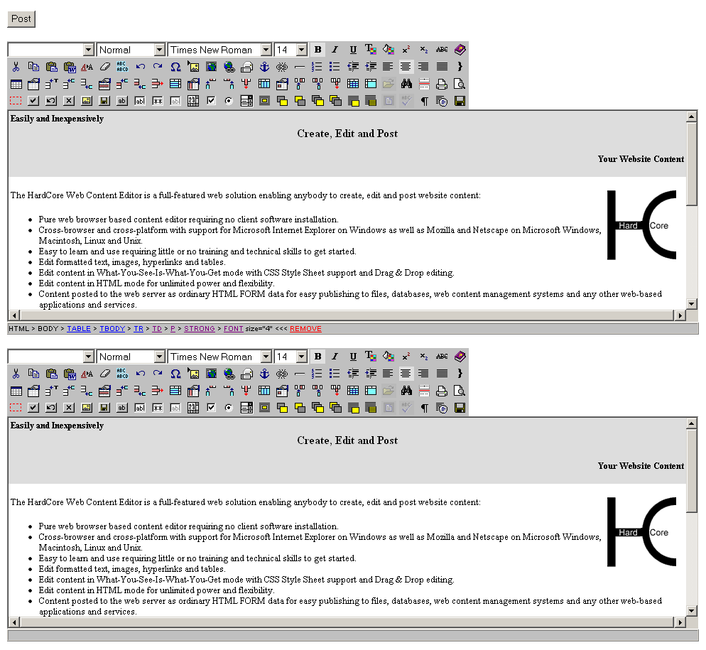

Multiple editors on the same webpage with shared toolbar
Multiple HardCore Web Content Editors can be located on the same webpage. All editors may share a single toolbar.
Please see “index.multi2.html” in the “hardcore/webeditor” folder for details.
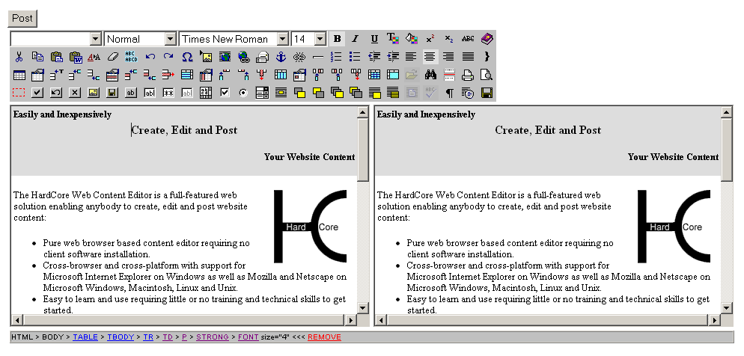

Toolbar and editable web content in HTML FRAMESET FRAMEs
The HardCore Web Content Editor toolbar and the editable web content may be located in separate HTML FRAMEs within a HTML FRAMESET.
Please see “index.frameset.html” in the “hardcore/webeditor” folder for details.
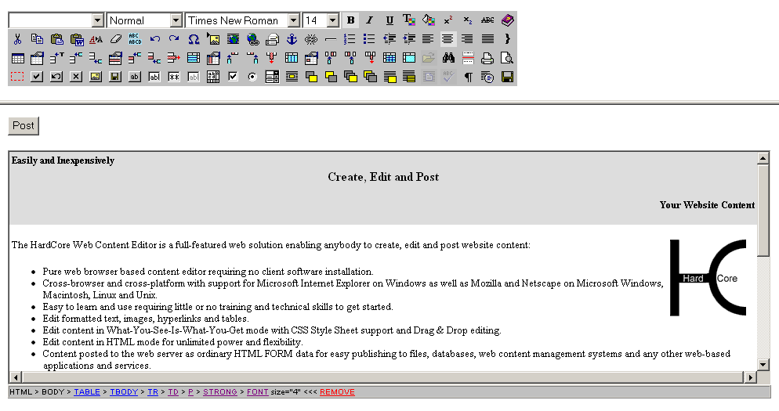

Toolbar in HTML IFRAME
The HardCore Web Content Editor toolbar may be located in a HTML IFRAME with the editable content located in the main web page.
Please see “index.iframe.html” in the “hardcore/webeditor” folder for details.
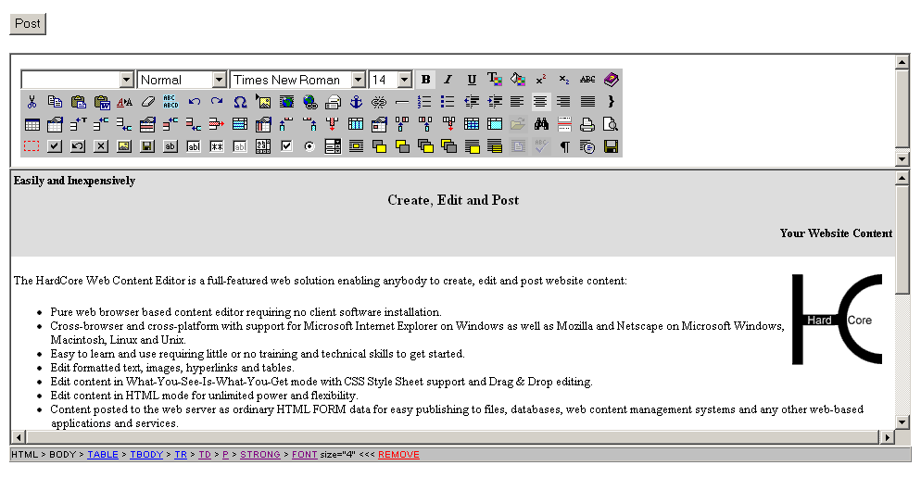

Upgrades
The HardCore Web Content Editor is improved and extended, continuously, and new releases may be made available for download from the HardCore Internet website (www.hardcoreinternet.co.uk).

This section describes the general procedure for upgrading the HardCore Web Content Editor. However, the upgrade procedure may vary for some releases. Please make sure to read and follow any special upgrade instructions on the HardCore Internet website.

Upgrading the HardCore Web Content Editor should usually never cause any of your website content and other data to be modified or deleted. However, before upgrading the HardCore Web Content Editor you should always make a backup copy of your existing program files, data files and database, which you can restore if anything goes wrong with the upgrade.

To download and install a new release of the HardCore Web Content Editor, simply download a package in an appropriate format, unpack it and copy it to your website folder in a similar way to your initial installation. The program files in the new release should replace your existing program files.

Please note that the new release may replace files that you have modified, so you should make sure to have a copy of your modified files and copy your modifications to the new files.

Internationalisation
The HardCore Web Content Editor supports internationalisation with translations of all text to other languages than the default (English) and automatic detection of each user’s language preferences. The HardCore Web Content Editor also supports right to left editing for Arabic and Hebrew languages.

HardCore Web Content Editor texts
All texts in the HardCore Web Content Editor are located in the “/hardcore/webeditor/properties.js” file. This file contains the default texts used if no specific language is selected and available.
Additional language files can be created with translations of all texts to other languages. As default a Danish language translation file is included. The “/hardcore/webeditor/properties_da.js” file contains all texts in the HardCore Web Content Editor translated to Danish.
To add support for other languages, simply copy the “/hardcore/webeditor/properties.js” file and translate its contents (and add the language to the “/hardcore/webeditor/webeditor.properties.js” as described below). The copied file must be named “/hardcore/webeditor/properties_xx.js” where “xx” is the ISO 639 language code such as:
- ar – Arabic
- de – German
- en – English
- es – Spanish
- fr – French
- ja – Japanese
- zh - Chinese

Additional language files for language variations can be created with translations for individual countries. To add support for language variations, simply copy the “/hardcore/webeditor/properties.js” file or another language file and translate its contents. The copied file must be named “/hardcore/webeditor/properties_xx_YY.js” where “xx” is the ISO 639 language code as described above and where “YY” is the ISO 3166 country code such as:
- AU – Australia
- CA – Canada
- GB – United Kingdom
- US – United States

To change the default language, simply replace the default English “/hardcore/webeditor/properties.js” file with a copy of another language file.
To add support for new language files, the “/hardcore/webeditor/webeditor.properties.js” file must be modified. Add the language/country code to the following line at the top of the file:
var webeditor_languages = "|da|en|";
To add support for a new language file name “/hardcore/webeditor/properties_xx.js” modify the line to:
var webeditor_languages = "|da|en|xx|";
To add support for a new language file name “/hardcore/webeditor/properties_xx_YY.js” modify the line to:
var webeditor_languages = "|da|en|xx_YY|";
The language/country codes must be separated and enclosed by | characters.

User Language Preferences
Each individual user can select the language used by the HardCore Web Content Editor through his/her web browser’s language preferences settings.
In Microsoft Internet Explorer language preferences can be selected through the Tools – Internet Options – General – Languages menu/window. Please see the Microsoft Internet Explorer documentation for details.
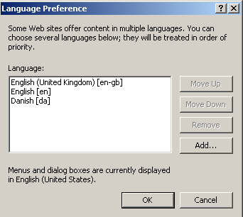
In Mozilla language preferences can be selected through the Edit – Preferences – Navigator – Languages menu/window. Please see the Mozilla documentation for details.
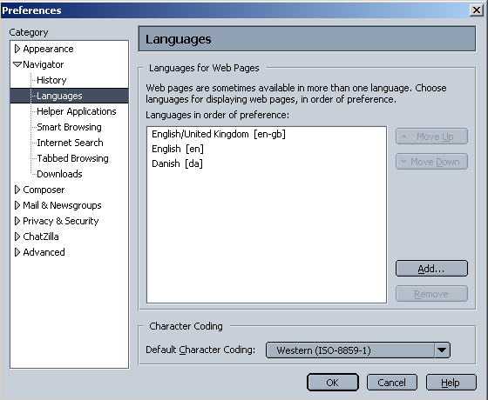
The HardCore Web Content Editor will detect the selected web browser language preferences and use one of the selected languages if available. If none of the selected languages are available the default language will be used.
Currently, web browser language preferences cannot be detected directly by the HardCore Web Content Editor through HTML/Javascript. However, the web browser language preferences are sent to the web server when a web page is requested. To enable the internationalisation feature the web browser language preferences must be copied to a web browser “cookie”, which is sent back to the web browser from the web server. To do this, add the following program lines to the top of your web applications/pages:

ASP:
<!-- #include virtual="/hardcore/webeditor/language.asp" -->

ASP.NET:
<!-- #include virtual="/hardcore/webeditor/language.aspx" -->

ColdFusion:
<cfinclude template="/hardcore/webeditor/language.cfm" >

JSP:
<%@ include file="/hardcore/webeditor/language.jsp" %>

PHP:
<?php include "hardcore/webeditor/language.php"; ?>

Right to left editing
The HardCore Web Content Editor supports right to left editing for Arabic and Hebrew languages (as well as the default left to right editing).
Pease see 1.5.2 Advanced Options – Direction for details on how to specify a parameter to make the web content editor use right to left editing instead of the default left to right editing.
You may also want to add toolbar buttons for switching between left to right editing and right to left editing. As default these two toolbar buttons are not displayed. To display these two toolbar buttons you need to use a custom toolbar with two toolbar buttons named "BlockDirLTR" and "BlockDirRTL". Please see 4.2 Toolbar for details.

Relocation
As default the HardCore Web Content Editor must be installed as the “/hardcore/webeditor/” folder under your website. However, the files can also be moved to another location if you need to do so.
To use the HardCore Web Content Editor located in another folder than “/hardcore/webeditor/” you must edit the “webeditor.js”, “webeditor1.js” and “webeditor2.js” files and change “/hardcore/webeditor/” at the top of the files:
webeditor.rootpath = "/hardcore/webeditor/";

If you are using the internationalisation feature with web browser language preferences detection, you must change the “/hardcore/webeditor/” include address at the top of the “index.asp/.aspx/.cfm/.jsp/.php” files etc. and your own web pages to load the required “language.asp/.aspx/.cfm/.jsp/.php” file. Please see 1.7.2 User Language Preferences for details.
You must also change the “/hardcore/webeditor/” addresses at the top of the “index.html/.asp/.aspx/.cfm/.jsp/.php” files etc. and your own web pages to load the required HardCore Web Content Editor CSS style sheet and Javascript files:
<link href="/hardcore/webeditor/webeditor.css" rel="stylesheet" type="text/css" />

<script src="/hardcore/webeditor/webeditor.js"></script>

Finally, you need to change the “/hardcore/webeditor/” addresses passed to the “HardCoreWebEditor” Javascript function on the “index.html/.asp/.aspx/.cfm/.jsp/.php” files etc. and your own web pages:
content_editor = new HardCoreWebEditor('/hardcore/webeditor/', '', 'content', content, '', '/hardcore/webeditor/hardcore.css', true, '', '', '', '', '', '', '', '');

HardCore Web Content Editor
Due to differences in supported web browser technologies, there are different versions of the HardCore Web Content Editor for different web browsers. Some web editor functionality varies between the different HardCore Web Content Editor versions and some web content editor functionality is not available in all HardCore Web Content Editor versions. See the following sections for details.

As default the HardCore Web Content Editor auto-detects the web browser you are using and automatically selects the best HardCore Wed Content Editor version for your web browser.

The HardCore Web Content Editor can be used for creating and editing text, images, hyperlinks or HTML code for your website and web-based applications and databases. The HardCore Web Content Editor screens are displayed below.

HardCore Web Content Editor v1 (for Microsoft Internet Explorer 4.0-5.0):
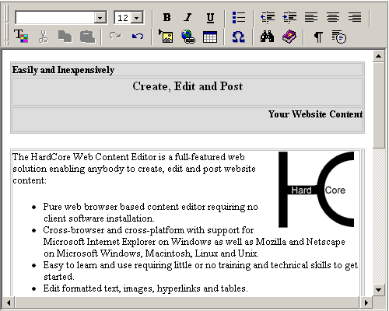

HardCore Web Content Editor v2+ (for Microsoft Internet Explorer v5.5 and newer as well as Netscape 7.1 and Mozilla 1.3 and newer):
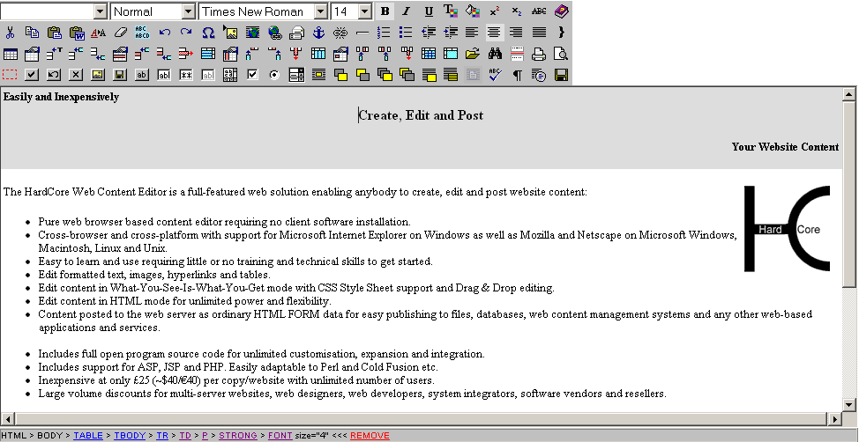

Write text in the work area in the middle and select the toolbar buttons to format the text and insert images, hyperlinks and HTML code. Optionally, the HTML DOM Inspector located below the editable content displays details about the currently selected content. The toolbar buttons and the HTML DOM Inspector are described in the following sections.

Text Formatting and Style

Style
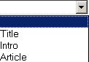
HardCore Web Content Editor v2+ only.

The HardCore Web Content Editor offers support for Cascading Style Sheets. Defined styles/classes are extracted automatically from any Style Sheet assigned to the content.
To apply a style select the text you want to change and then select the style from the Style list in the toolbar. The actual formatting for the styles can be defined in the Style Sheet assigned to the content.

Format
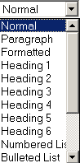

The HardCore Web Content Editor offers standard predefined HTML text formats.
- Normal
- Formatted
- Address
- Heading 1
- Heading 2
- Heading 3
- Heading 4
- Heading 5
- Heading 6
- Numbered List
- Bulleted List
- Directory List
- Menu List
- Definition Term
- Definition
- Paragraph

To apply a format select the text you want to change and then select the format from the Format list in the toolbar. The actual formatting for the format can be defined in the Style Sheet assigned to the content.

Font Name
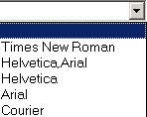

HardCore Web Content Editor v2+ only. See Font Formatting for HardCore Web Content Editor v1.

To change the Font Name select the text you want to change and then select a Font Name from the Font Name list in the toolbar.

Font Size
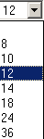

To change the Font Size select the text you want to change and then select a Font Size from the Font Size list in the toolbar.

Bold

To apply bold formatting to text select the text you want to change and then select the Bold toolbar button.

Italic

Apply italic formatting to text by selecting the text you want to change and then select the Italic toolbar button.

Underline

Apply underline formatting to text by selecting the text you want to change and then select the Underline toolbar button.

Font Formatting

HardCore Web Content Editor v1 only. See Text Colour for HardCore Web Content Editor v2+.

The Font toolbar button provides several formatting options that will override the formatting styles defined by your Style and Style Sheet selection. To format text select the text you want to change and then select the Font toolbar button. The following screen will appear:

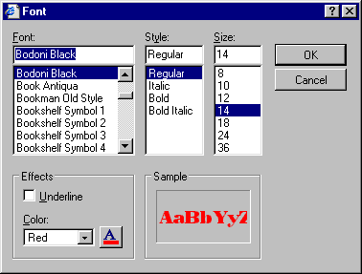

- Font - Select the font you want to apply to the selected text.
- Style - Select the style you want to apply to the selected text.
- Size - Select the Font Size you want to apply to the selected text.
- Underline - If you want to underline the selected text check the Underline checkbox.
- Color - Select the Font Color from the color list or select the button and select the Font Color.

Select OK when the Sample box displays the formatting you want to apply to the selected text or select Cancel.

Text Colour
HardCore Web Content Editor v2+ only.

Apply text colour formatting to text by selecting the text you want to change and then select the Text Colour toolbar button. The following screen will appear:

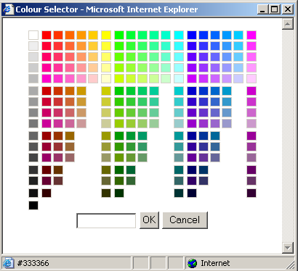

Select a colour from the palette or enter a HTML colour code. Select OK to apply to the selected text or select Cancel.

Background Colour
HardCore Web Content Editor v2+ only.

Apply background colour formatting to text by selecting the text you want to change and then select the Background Colour toolbar button. The following screen will appear:

Select a colour from the palette or enter a HTML colour code. Select OK to apply to the selected text or select Cancel.

Superscript

HardCore Web Content Editor v2+ only.

Apply superscript formatting to text by selecting the text you want to change and then select the Superscript toolbar button.

Subscript

HardCore Web Content Editor v2+ only.

Apply subscript formatting to text by selecting the text you want to change and then select the Subscript toolbar button.

Strikethrough

HardCore Web Content Editor v2+ only.

Apply strikethrough formatting to text by selecting the text you want to change and then select the Strikethrough toolbar button.

Remove Format

HardCore Web Content Editor v2+ only.

Remove formatting from text by selecting the text you want to change and then select the Remove Format toolbar button.

Indentation and Alignment

Decrease Indent

To decrease the indent of a paragraph select the text you want to change and then select the Decrease Indent toolbar button.

Indent

To apply indent to a paragraph select the text you want to change and then select the Indent toolbar button.

Align Left

To align left select the text you want to align left and then select the Align Left toolbar button.

Align Center

To center text select the text you want to center and then select the Align Center toolbar button.

Align Right

To align right select the text you want to align and then select the Align Right toolbar button.

Align Full

HardCore Web Content Editor v2+ only.

To align left and right select the text you want to align and then select the Align Full toolbar button.

Do Not Break

HardCore Web Content Editor v2+ only.

To prevent text from being broken by automatic line breaks select the text you want to keep together and then select the Do Not Break toolbar button.

Numbered List

HardCore Web Content Editor v2+ only.

To apply numbers select the items you want to add numbers to. Then select the Numbered List toolbar button.

Bullet List

To apply bullets select the items you want to add bullets to. Then select the Bullet List toolbar button.

Editing

Cut

To remove selected content from the HardCore Web Content Editor and place it on the clipboard select the Cut toolbar button.

Your web browser may not support this functionality, in which case you will be prompted to use your web browser’s menu/keyboard functionality for this instead.

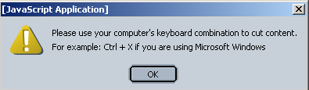

Copy

To copy selected content from the HardCore Web Content Editor and place it on the clipboard select the Copy toolbar button.

Your web browser may not support this functionality, in which case you will be prompted to use your web browser’s menu/keyboard functionality for this instead.

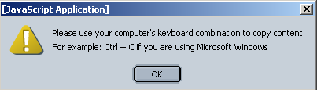

Paste

To paste content from the clipboard into the HardCore Web Content Editor select the Paste toolbar button.

Your web browser may not support this functionality, in which case you will be prompted to use your web browser’s menu/keyboard functionality for this instead.

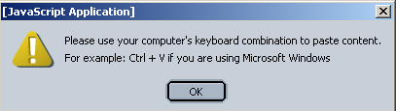

Clean HTML Code
HardCore Web Content Editor v2+ only.

Content pasted from other applications such as Microsoft Word may contain unneeded/unwanted HTML codes. Select the Clean HTML Code toolbar button to clean the content for such unneeded/unwanted HTML codes. The following screen will appear:
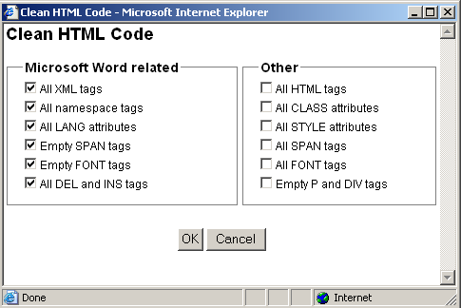
- Microsoft Word related (selected by default and “safe” to clean):
  - All XML tags
Delete all XML tags from content.
  - All namespace tags
Delete all XML namespace tags from content.
  - All LANG attributes
Delete all LANG attributes from content.
  - Empty SPAN tags
Delete empty and double SPAN tags.
  - Empty FONT tags
Delete empty and double FONT tags.
  - All DEL and INS tags
Delete all DEL and INS tags.
- Other (only select these if you are sure you want to delete these HTML tags and attributes or your content may be altered significantly):
  - All HTML tags
Delete all HTML tags from content.
  - All CLASS attributes
Delete all CLASS attributes from content.
  - All STYLE attributes
Delete all STYLE attributes from content.
  - All SPAN tags
Delete all SPAN tags.
  - All FONT tags
Delete all FONT tags.
  - Empty P and DIV
Delete all empty P and DIV tags.

Select OK to clean the content in the web editor work area.

Delete

HardCore Web Content Editor v2+ only.

To delete content from the HardCore Web Content Editor select the content to be deleted and select the Delete toolbar button.

Select All

HardCore Web Content Editor v2+ only.

To select all content in the HardCore Web Content Editor select the Select All toolbar button.

Redo

Select the Redo toolbar button to reverse an action of the Undo command.

Undo

Select the Undo toolbar button to reverse the last command or delete the last entry you typed.

Web Content

Insert Special Characters & Codes

To insert special characters and codes into the web editor work area select the Insert Special Characters & Codes toolbar button. The following screen will appear:

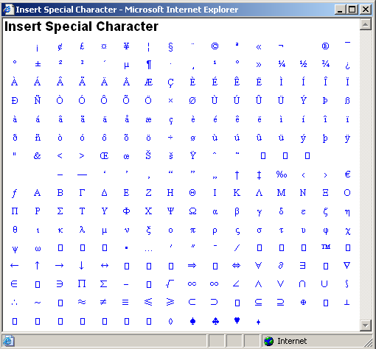

Select the special character you want to insert and the special character will be inserted into the web editor work area.

Insert Media (Image / Flash / Java Applet)

To insert an image (or Flash animation or Java Applet) into the HardCore Web Content Editor select the Insert Media toolbar button. One of the following windows will appear:

Basic dialog window:
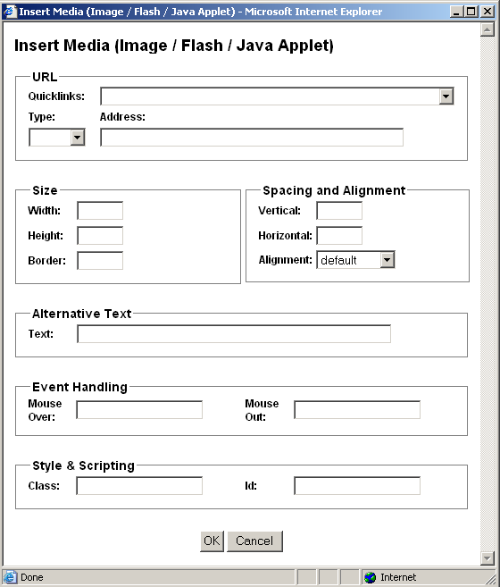
Advanced dialog window:
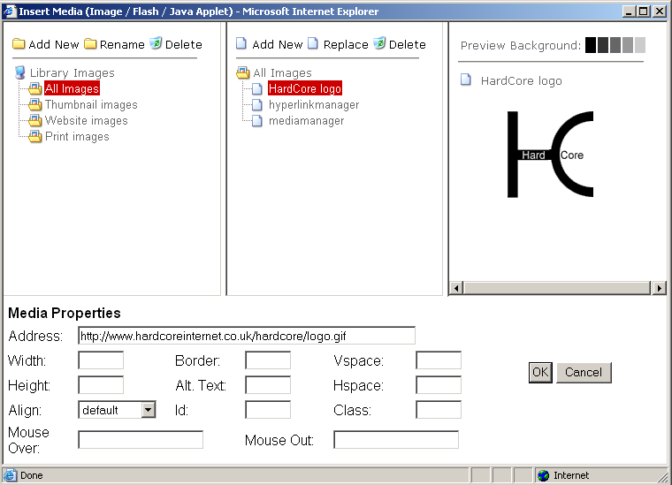

The first window shows the basic media dialog. The second window shows the advanced media manager dialog. Please see “1.5 Configuration” for details on how to configure which dialog window to use.

- Quicklinks
List of pre-defined images, which you can select from.
- URL Type
Type of URL address (“http://”, “https://”).
- URL Address
Web address domain, path and file name.
- Address
Full web address including Type and URL domain, path and file name.
- Width
Number of pixels or percentage for how the image is to be displayed.
- Height
Number of pixels or percentage for how the image is to be displayed.
- Border
Number of pixels for border to be displayed around the image.
- Alignment / Align
Defines the image alignment in relation to surrounding text.
  - Left
  - Right
  - Top
  - Bottom
  - Middle
  - Absmiddle
- Vertical spacing / Vspace
Number of blank pixels to be displayed above and below the image.
- Horizontal spacing / Hspace
Number of blank pixels to be displayed to the left and right of the image.
- Text
Alternative text description to be displayed instead of the image.
- Id
Unique HTML code id for use with Javascript.
- Class
HTML class name for use with CSS style sheet.
- Mouse Over
Javascript event handler triggered when the caret/cursor is moved over the image.
- Mouse Out
Javascript event handler triggered when the caret/cursor is moved away from image.

Select OK to insert the image (or Flash animation or Java Applet) into the Content Editor or select Cancel to return to the Content Editor without inserting the image (or Flash animation or Java Applet) into the Content Editor.

Whether an image, Flash animation or Java Applet is selected and inserted into the Content Editor is detected automatically based on the URL/filename extension where “.swf” identifies a Flash animation and “.class” identifies a Java Applet. All other extensions are handled as an image.

Insert Link

Select the Insert Link toolbar button to insert a link into the work area. One of the following windows appear:

Basic dialog window:
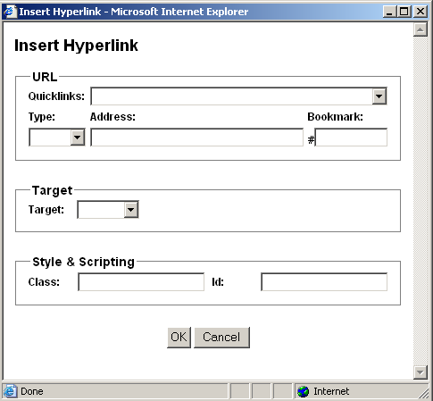

Advanced dialog window:
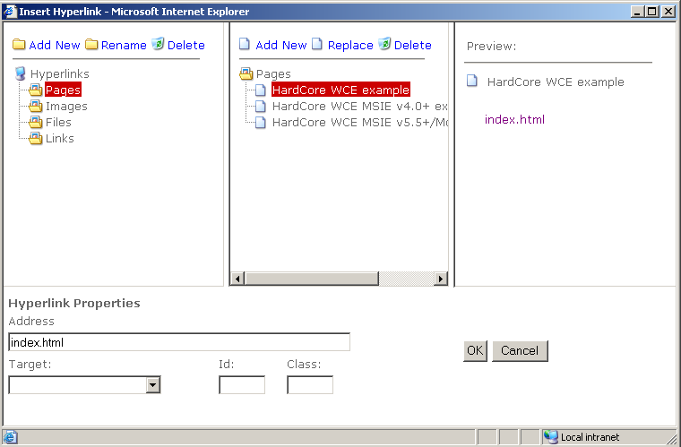

The first window shows the standard hyperlink dialog. The second window shows the advanced hyperlink manager dialog. Please see “1.5 Configuration” for details on how to configure which dialog window to use.

- Quicklinks
List of pre-defined hyperlinks, which you can select from.
- URL Type
Type of URL address (“http://”, “https://”).
- URL Address
Web address domain, path and file name.
- URL Bookmark
Web page bookmark name.
- Address
Full web address including Type, URL and Bookmark
- Target
Defines how the hyperlink is to be opened.
  - Same Window (_self)
The link will be opened in the current window.
  - Parent Window (_parent)
The link will be opened in the parent window.
  - Browser Window (_top)
The link will be opened on the top level of the window.
  - New Window (_blank)
The link will be opened in a new window.
- Id
Unique HTML code id for use with Javascript.
- Class
HTML class name for use with CSS style sheet.

When you are done, select OK to insert the link into your web editor.

Insert Frame
HardCore Web Content Editor v2+ only.

Select the Insert Frame toolbar button to insert a content frame containing another web page in the work area. The following screen will appear:
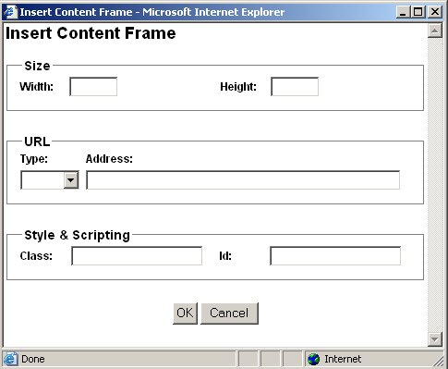
- Width
Enter the width of the box as a percentage (for example “100%”) or in pixels (for example “100” pixels).
- Height
Enter the height of the box as a percentage (for example “100%”) or in pixels (for example “100” pixels.
- URL Type
Type of URL address (“http://”, “https://”).
- URL Address
Web address domain, path and page name.
- Id
Unique HTML code id for use with Javascript.
- Class
HTML class name for use with CSS style sheet.

Select OK to insert the content frame into the web editor work area.

Insert Mail To Link

HardCore Web Content Editor v2+ only.

Select the Insert Mail To Link toolbar button to insert a link into the work area. The following screen will appear:

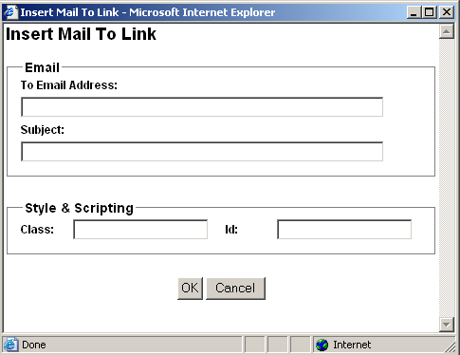

- To Email Address
Default email address to which the email should be sent.
- Subject
Default subject for the email to be sent.
- Id
Unique HTML code id for use with Javascript.
- Class
HTML class name for use with CSS style sheet.

When you are done, select OK to insert the link into your web editor.

Insert Anchor/ Bookmark

HardCore Web Content Editor v2+ only.

Select the Insert Anchor / Bookmark toolbar button to insert an anchor/bookmark into the work area. The following screen will appear:

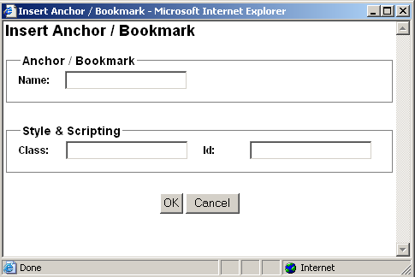

- Name
Name of the anchor/bookmark.
- Id
Unique HTML code id for use with Javascript.
- Class
HTML class name for use with CSS style sheet.

When you are done, select OK to insert the anchor/bookmark into your web editor.

Unlink

HardCore Web Content Editor v2+ only.

To remove a link (without deleting the content) select the link and select the Unlink toolbar button.

Insert Horizontal Rule

HardCore Web Content Editor v2+ only.

To insert a horizontal rule select the Insert Horizontal Rule toolbar button.

Table Editing

Insert Table

Select the Insert Table toolbar button to insert a table in the work area. The following screen will appear:

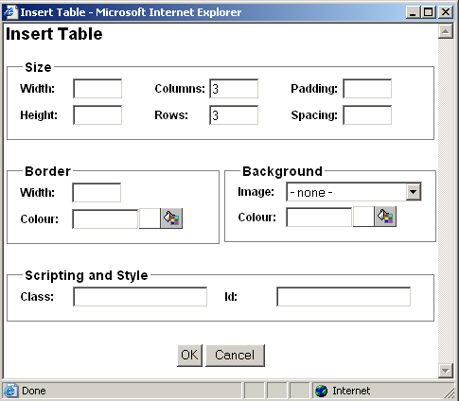

- Width
Enter the width of the table as a percentage (for example “100%”) or in pixels (for example “100” pixels). You can leave the field blank and the browser will determine the width.
- Height
Enter the height of the table as a percentage (for example “100%”) or in pixels (for example “100” pixels. You can leave the field blank and the browser will determine the height.
- Columns
Enter the number of columns in the table.
- Rows
Enter the number of rows in the table.
- Cell padding
Enter the distance between the border and content of the table in pixels (for example “2” pixels). You can leave the field blank and the browser will determine the cell padding.
- Cell spacing
Enter the distance between the cells in pixels (for example “2” pixels). You can leave the field blank and the browser will determine the cell spacing.
- Border Width
Select the border width of the table in pixels from the list. If you select 0 there will be no border. If you select “- default -“ the browser will determine the border width.
- Border Colour
Enter the border colour as an html colour name or as an html colour code. The actual colour is displayed in the square next to the input field. Select the colour square for access to the colour selector.
- Background Colour
Enter the background colour as an html colour name or as an html colour code. The actual colour is displayed in the square next to the input field. Select the colour square for access to the colour selector.
- Background Image
In the Background image section of the screen select “- none -“ if no background image is required or select a background image from the list of background images.
- Id
Unique HTML code id for use with Javascript.
- Class
HTML class name for use with CSS style sheet.

When all the details for the table have been entered, select OK to insert the table into the content editor.

Table Properties

HardCore Web Content Editor v2+ only.

Select or position the claret/cursor inside a table and select the Table Properties toolbar button to edit the table’s properties. The following screen will appear:

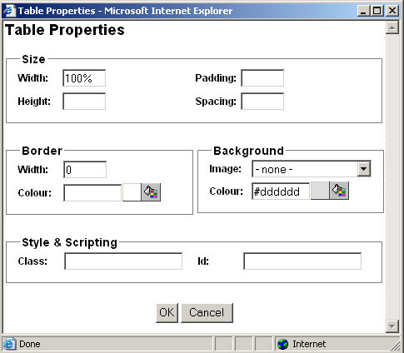

- Width
Enter the width of the table as a percentage (for example “100%”) or in pixels (for example “100” pixels). You can leave the field blank and the web browser will determine the width.
- Height
Enter the height of the table as a percentage (for example “100%”) or in pixels (for example “100” pixels. You can leave the field blank and the web browser will determine the height.
- Cell padding
Enter the distance between the border and content of the table in pixels (for example “2” pixels). You can leave the field blank and the browser will determine the cell padding.
- Cell spacing
Enter the distance between the cells in pixels (for example “2” pixels). You can leave the field blank and the browser will determine the cell spacing.
- Border Width
Enter the border width of the table in pixels. If you enter 0 there will be no border. If you leave it blank the browser will determine the border width.

- Border Colour
Enter the border colour as an html colour name or as an html colour code. The actual colour is displayed in the square next to the input field. Select the colour square for access to the colour selector.
- Background Colour
Enter the background colour as an html colour name or as an html colour code. The actual colour is displayed in the square next to the input field. Select the colour square for access to the colour selector.
- Background Image
In the Background image section of the screen select “- none -“ if no background image is required or select a background image from the list of background images.
- Id
Unique HTML code id for use with Javascript.
- Class
HTML class name for use with CSS style sheet.

When all the details for the table have been entered, select OK to update the table in the content editor.

Insert Caption

HardCore Web Content Editor v2+ only.

Select or position the claret/cursor inside a table and select the Insert Caption toolbar button to insert a caption for the table. As default the caption is displayed above the table.

Insert Header Row

HardCore Web Content Editor v2+ only.

Select or position the claret/cursor inside a table and select the Insert Header Row toolbar button to insert a new table header row at the top of the table.

Insert Footer Row

HardCore Web Content Editor v2+ only.

Select or position the claret/cursor inside a table and select the Insert Footer Row toolbar button to insert a new table footer row at the bottom of the table.

Row Properties

HardCore Web Content Editor v2+ only.

Select or position the claret/cursor inside a table row and select the Row Properties toolbar button to edit the row’s properties. The following screen will appear:

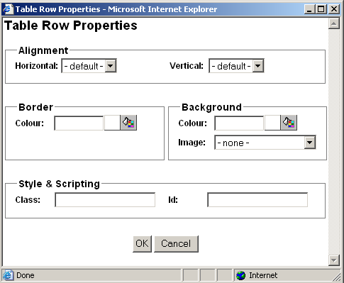

- Horizontal Alignment
Select default, left, center or right to horizontally align the row’s cell’s contents. This row alignment is overruled by any defined column and cell horizontal alignment.
- Vertical Alignment
Select default, top, middle, baseline or bottom to vertically align the row’s cell’s contents. This row alignment is overruled by any defined column and cell vertical alignment.
- Border Colour
Enter the border colour as an html colour name or as an html colour code. The actual colour is displayed in the square next to the input field. Select the colour square for access to the colour selector.
- Background Colour
Enter the background colour as an html colour name or as an html colour code. The actual colour is displayed in the square next to the input field. Select the colour square for access to the colour selector.
- Background Image
In the Background image section of the screen select “- none -“ if no background image is required or select a background image from the list of background images.
- Id
Unique HTML code id for use with Javascript.
- Class
HTML class name for use with CSS style sheet.

When all the details for the table row have been entered, select OK to update the table row in the content editor.

Insert Row Above

HardCore Web Content Editor v2+ only.

Select or position the claret/cursor inside a table row and select the Insert Row Above toolbar button to insert a new row above the selected row.

Insert Row Below

HardCore Web Content Editor v2+ only.

Select or position the claret/cursor inside a table row and select the Insert Row Below toolbar button to insert a new row below the selected row.

Delete Row

HardCore Web Content Editor v2+ only.

Select or position the claret/cursor inside a table row and select the Delete Row toolbar button to delete the selected row.

Split Cell Rows

HardCore Web Content Editor v2+ only.

Position the claret/cursor inside a merged table cell and select the Split Cell Rows toolbar button to split the cell back into rows again.

Column Properties

HardCore Web Content Editor v2+ only.

Position the claret/cursor inside a table cell and select the Column Properties toolbar button to edit the column’s properties. The following screen will appear:

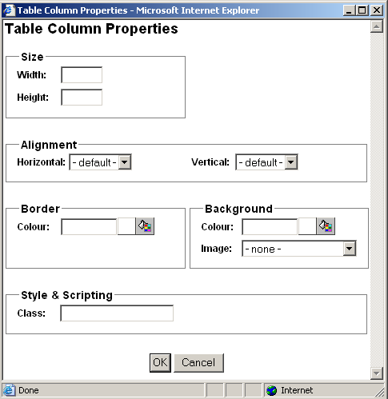

- Width
Enter the width of the column as a percentage (for example “100%”) or in pixels (for example “100” pixels). You can leave the field blank and the web browser will determine the width.
- Height
Enter the height of the column as a percentage (for example “100%”) or in pixels (for example “100” pixels. You can leave the field blank and the web browser will determine the height.

- Horizontal Alignment
Select default, left, center or right to horizontally align the column’s cell’s contents. This column alignment overrules/overwrites any defined row/cell horizontal alignment.
- Vertical Alignment
Select default, top, middle, baseline or bottom to vertically align the column’s cell’s contents. This column alignment overrules/overwrites any defined row/cell vertical alignment.
- Border Colour
Enter the border colour as an html colour name or as an html colour code. The actual colour is displayed in the square next to the input field. Select the colour square for access to the colour selector.
- Background Colour
Enter the background colour as an html colour name or as an html colour code. The actual colour is displayed in the square next to the input field. Select the colour square for access to the colour selector.
- Background Image
In the Background image section of the screen select “- none -“ if no background image is required or select a background image from the list of background images.

- Class
HTML class name for use with CSS style sheet.

When all the details for the table column have been entered, select OK to update the table column in the content editor.

Insert Column Left

HardCore Web Content Editor v2+ only.

Position the claret/cursor inside a table cell and select the Insert Column Left toolbar button to insert a new column to the left of the selected column.

Insert Column Right

HardCore Web Content Editor v2+ only.

Position the claret/cursor inside a table cell and select the Insert Column Right toolbar button to insert a new column to the right of the selected column.

Delete Column

HardCore Web Content Editor v2+ only.

Position the claret/cursor inside a table cell and select the Delete Column toolbar button to delete the selected column.

Split Cell Columns

HardCore Web Content Editor v2+ only.

Position the claret/cursor inside a merged table cell and select the Split Cell Columns toolbar button to split the cell back into columns again.

Cell Properties

HardCore Web Content Editor v2+ only.

Position the claret/cursor inside a table cell and select the Cell Properties toolbar button to edit the cell’s properties. The following screen will appear:

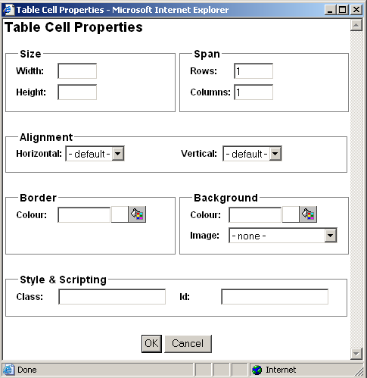

- Width
Enter the width of the cell as a percentage (for example “100%”) or in pixels (for example “100” pixels). You can leave the field blank and the web browser will determine the width.
- Height
Enter the height of the cell as a percentage (for example “100%”) or in pixels (for example “100” pixels. You can leave the field blank and the web browser will determine the height.
- Span Rows
Enter the number of rows the (merged) cell spans. Changing this row span will not actually merge/split the cell, but only change how it is displayed.
- Span Columns
Enter the number of columns the (merged) cell spans. Changing this column span will not actually merge/split the cell, but only change how it is displayed.

- Horizontal Alignment
Select default, left, center or right to horizontally align the cell’s contents. This cell alignment overrules/overwrites any defined row/column horizontal alignment.
- Vertical Alignment
Select default, top, middle, baseline or bottom to vertically align the cell’s contents. This cell alignment overrules/overwrites any defined row/column vertical alignment.

- Border Colour
Enter the border colour as an html colour name or as an html colour code. The actual colour is displayed in the square next to the input field. Select the colour square for access to the colour selector.
- Background Colour
Enter the background colour as an html colour name or as an html colour code. The actual colour is displayed in the square next to the input field. Select the colour square for access to the colour selector.
- Background Image
In the Background image section of the screen select “- none -“ if no background image is required or select a background image from the list of background images.

- Id
Unique HTML code id for use with Javascript.
- Class
HTML class name for use with CSS style sheet.

When all the details for the table cell have been entered, select OK to update the table cell in the content editor.

Insert Cell Left

HardCore Web Content Editor v2+ only.

Position the claret/cursor inside a table cell and select the Insert Cell Left toolbar button to insert a new cell to the left of the selected cell.

Insert Cell Right

HardCore Web Content Editor v2+ only.

Position the claret/cursor inside a table cell and select the Insert Cell Right toolbar button to insert a new cell to the right of the selected cell.

Delete Cell

HardCore Web Content Editor v2+ only.

Position the claret/cursor inside a table cell and select the Delete Cell toolbar button to delete the selected cell.

Split Cell

HardCore Web Content Editor v2+ only.

Position the claret/cursor inside a merged table cell and select the Split Cell toolbar button to split the cell back into rows and columns again.

Merge Cells

HardCore Web Content Editor v2+ only.

Select a number of table cells across rows and/or columns and select the Merge Cells toolbar button to merge the cells into a single cell.

Your web browser may not support selection of cells across rows properly as a square of selected cells. Some additional cells to the left and right of the intended square of cells selection may be selected as well. The HardCore Web Content Editor adjusts this non-square cell selection by ignoring any selected cells outside the square of selected cells defined by the top-left and the bottom-right selected cells.

Form Editing

Insert Form

HardCore Web Content Editor v2+ only.

Select the Insert Form toolbar button to insert a form in the work area. The following screen will appear:

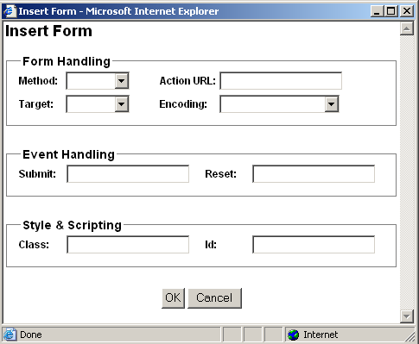

- Method
Method used to submit form data to the web server. GET (default) submits data as part of the URL web address. POST submits data as attachments and is required for file upload and larger amounts of data.
- Action URL
Website address to which the form data is submitted.
- Encoding
Encoding format for form data when submitted to the web server. The default encoding is “URL encoded”. “Multi-part form-data” encoding is required for file upload.
- Target
Defines how the submitted form is to be opened.
  - Same Window (_self)
The form will be opened in the current window.
  - Parent Window (_parent)
The form will be opened in the parent window.
  - Browser Window (_top)
The form will be opened on the top level of the window.
  - New Window (_blank)
The form will be opened in a new window.
- Submit
Javascript event handler triggered when the form is submitted.
- Reset
Javascript event handler triggered when the form is reset.
- Id
Unique HTML code id for use with Javascript.
- Class
HTML class name for use with CSS style sheet.

Select OK to insert the form into the web editor work area.

Insert Button

HardCore Web Content Editor v2+ only.

Select one of the Insert Button toolbar buttons to insert a button of that type in the work area. The following screen will appear:

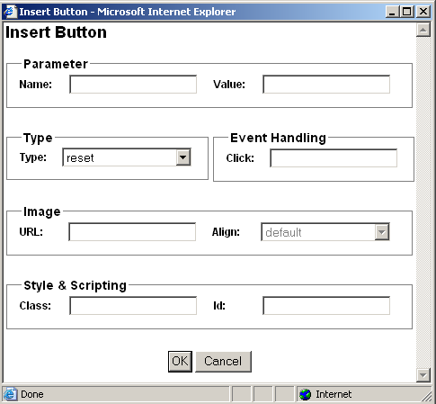

- Name
Name of parameter submitted to the web server.
- Value
Value of parameter submitted to the web server.
- Type
Type of button to be inserted:
  - Submit
Submits the form to the web server.
  - Button
Does not do anything unless used with Javascript event handler.
  - Reset
Resets the form to the default values.
  - Image
Submits the form to the web server.
- Click
Javascript event handler triggered when the button is clicked.
- Image URL
Website address for image to be used for image button.
- Image Align
Alignment of image in relation to surrounding text.
- Id
Unique HTML code id for use with Javascript.
- Class
HTML class name for use with CSS style sheet.

Select OK to insert the button into the web editor work area.

Insert File Input

HardCore Web Content Editor v2+ only.

Select the Insert File Input toolbar button to insert a file selector button for file upload to the web server in the work area. The following screen will appear:

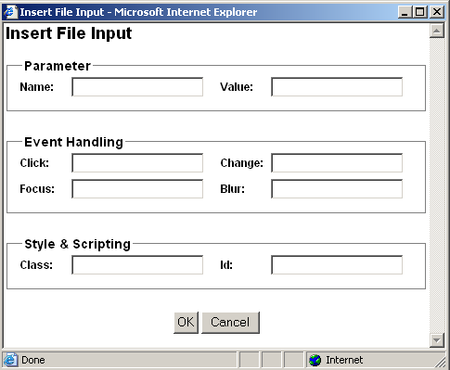

- Name
Name of parameter submitted to the web server.
- Value
Default value of parameter submitted to the web server.
- Click
Javascript event handler triggered when the file input field/button is clicked.
- Change
Javascript event handler triggered when the file input is changed.
- Focus
Javascript event handler triggered when the file input is focused.
- Blur
Javascript event handler triggered when focus is removed from the file input.
- Id
Unique HTML code id for use with Javascript.
- Class
HTML class name for use with CSS style sheet.

Select OK to insert the file input field/button into the web editor work area.

Insert Text Input

HardCore Web Content Editor v2+ only.

Select the Insert Text Input toolbar button to insert a text input field in the work area. The following screen will appear:

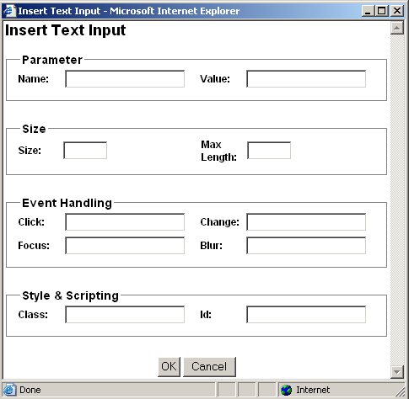

- Name
Name of parameter submitted to the web server.
- Value
Default value of parameter submitted to the web server.
- Size
Display size of input field.
- Max Length
Maximum number of characters to be entered into the input field.
- Click
Javascript event handler triggered when the input field is clicked.
- Change
Javascript event handler triggered when the input field is changed.
- Focus
Javascript event handler triggered when the input field is focused.
- Blur
Javascript event handler triggered when focus is removed from the input field.
- Id
Unique HTML code id for use with Javascript.
- Class
HTML class name for use with CSS style sheet.

Select OK to insert the input field into the web editor work area.

Insert Password Input

HardCore Web Content Editor v2+ only.

Select the Insert Password Input toolbar button to insert a password input field in the work area. The following screen will appear:

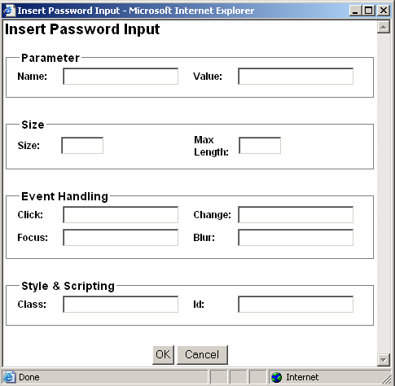

- Name
Name of parameter submitted to the web server.
- Value
Default value of parameter submitted to the web server.
- Size
Display size of input field.
- Max Length
Maximum number of characters to be entered into the input field.
- Click
Javascript event handler triggered when the input field is clicked.
- Change
Javascript event handler triggered when the input field is changed.
- Focus
Javascript event handler triggered when the input field is focused.
- Blur
Javascript event handler triggered when focus is removed from the input field.
- Id
Unique HTML code id for use with Javascript.
- Class
HTML class name for use with CSS style sheet.

Select OK to insert the input field into the web editor work area.

Insert Hidden Input

HardCore Web Content Editor v2+ only.

Select the Insert Hidden Input toolbar button to insert a hidden input field in the work area. The following screen will appear:

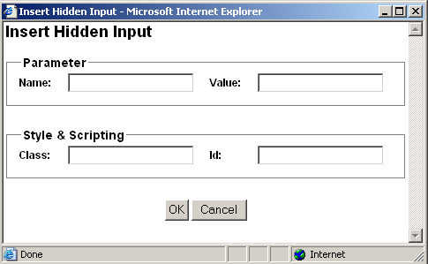

- Name
Name of parameter submitted to the web server.
- Value
Default value of parameter submitted to the web server.
- Id
Unique HTML code id for use with Javascript.
- Class
HTML class name for use with CSS style sheet.

Select OK to insert the input field into the web editor work area.

Insert Text Area Input

HardCore Web Content Editor v2+ only.

Select the Insert Text Area Input toolbar button to insert a text area input field in the work area. The following screen will appear:

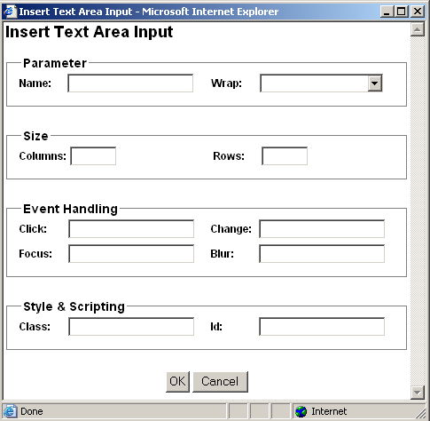

- Name
Name of parameter submitted to the web server.
- Wrap
Defines if and how content entered into the text area input should be word wrapped with automatic insertion of line breaks:
  - Off
Do not wrap.
  - Soft / Virtual
Display automatic word wrapping but do not submit automatic word wrapping to the web server.
  - Hard / Physical
Display and submit automatic word wrapping to the web server.
- Columns
Width of the input field.
- Rows
Height the input field.
- Click
Javascript event handler triggered when the input field is clicked.
- Change
Javascript event handler triggered when the input field is changed.
- Focus
Javascript event handler triggered when the input field is focused.
- Blur
Javascript event handler triggered when focus is removed from the input field.
- Id
Unique HTML code id for use with Javascript.
- Class
HTML class name for use with CSS style sheet.

Select OK to insert the input field into the web editor work area.

Insert Checkbox

HardCore Web Content Editor v2+ only.

Select the Insert Checkbox toolbar button to insert a checkbox input field in the work area. The following screen will appear:

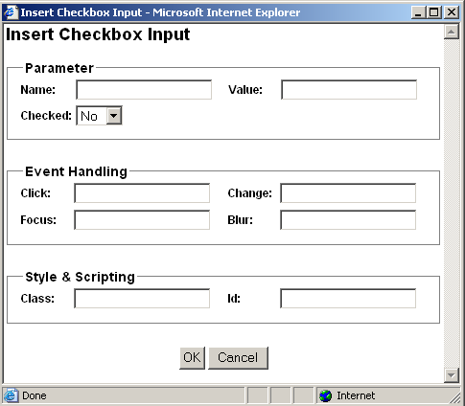

- Name
Name of parameter submitted to the web server.
- Value
Default value of parameter submitted to the web server.
- Checked
Default state of input field.
- Click
Javascript event handler triggered when the input field is clicked.
- Change
Javascript event handler triggered when the input field is changed.
- Focus
Javascript event handler triggered when the input field is focused.
- Blur
Javascript event handler triggered when focus is removed from the input field.
- Id
Unique HTML code id for use with Javascript.
- Class
HTML class name for use with CSS style sheet.

Select OK to insert the input field into the web editor work area.

Insert Radio Button

HardCore Web Content Editor v2+ only.

Select the Insert Radio Button toolbar button to insert a radio button input field in the work area. The following screen will appear:

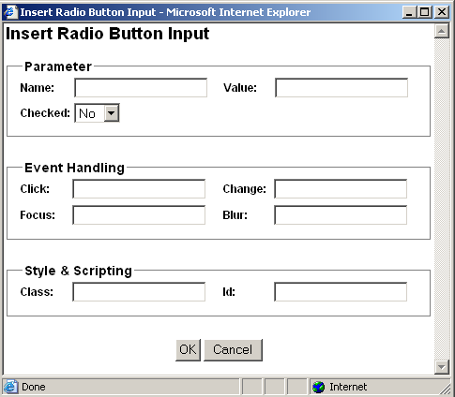

- Name
Name of parameter submitted to the web server.
- Value
Default value of parameter submitted to the web server.
- Checked
Default state of input field.
- Click
Javascript event handler triggered when the input field is clicked.
- Change
Javascript event handler triggered when the input field is changed.
- Focus
Javascript event handler triggered when the input field is focused.
- Blur
Javascript event handler triggered when focus is removed from the input field.
- Id
Unique HTML code id for use with Javascript.
- Class
HTML class name for use with CSS style sheet.

Select OK to insert the input field into the web editor work area.

Insert Select List

HardCore Web Content Editor v2+ only.

Select the Insert Select List toolbar button to insert a select list input field in the work area. The following screen will appear:

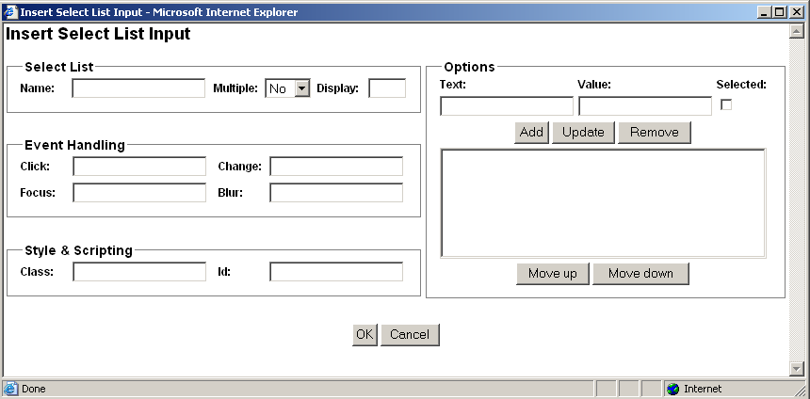

- Name
Name of parameter submitted to the web server.
- Multiple
Define if users can select multiple options or only a single option.
- Display
Number of options to be displayed (default 1).
- Options
Define the options which users can select from:
  - Text
Label to be displayed for option.
  - Value
Value submitted to the web server if selected.
  - Selected
Define if option should be selected as default.
  - Add
Add entered Text and Value as option.
  - Update
Change selected option to entered Text and Value
  - Delete
Delete selected option.
  - Move Up
Move selected option up.
  - Move Down
Move selected option down.
- Click
Javascript event handler triggered when the input field is clicked.
- Change
Javascript event handler triggered when the input field is changed.
- Focus
Javascript event handler triggered when the input field is focused.
- Blur
Javascript event handler triggered when focus is removed from the input field.
- Id
Unique HTML code id for use with Javascript.
- Class
HTML class name for use with CSS style sheet.

Select OK to insert the input field into the web editor work area.

Positioning

Absolute Positioning
HardCore Web Content Editor v2+ only.

Select a positionable content element or place the caret/cursor inside a positionable content element and select the Absolute Positioning toolbar button to toggle absolute positioning for the selected content element.
Positionable content elements include images, tables, P and DIV tags, IFRAMEs, form input fields and OBJECTs (Flash and Java applets).

Bring Forwards
HardCore Web Content Editor v2+ only.

Bring the currently selected absolute positioning enabled content element further forwards in front of other absolute positioning content elements.

Send Backwards
HardCore Web Content Editor v2+ only.

Send the currently selected absolute positioning enabled content element further backwards behind of other absolute positioning content elements.

Bring To Front
HardCore Web Content Editor v2+ only.

Bring the currently selected absolute positioning enabled content element in front of all other absolute positioning content elements.

Send To Back
HardCore Web Content Editor v2+ only.

Send the currently selected absolute positioning enabled content element behind of all other absolute positioning content elements.

Bring Above Text
HardCore Web Content Editor v2+ only.

Bring the currently selected absolute positioning enabled content element in front of the general page content.
Microsoft Internet Explorer for Windows only. Mozilla/Netscape content is always above text or invisible.

Send Below Text
HardCore Web Content Editor v2+ only.

Send the currently selected absolute positioning enabled content element behind of the general page content.
Microsoft Internet Explorer for Windows only. Mozilla/Netscape content is always above text or invisible.

Insert Box
HardCore Web Content Editor v2+ only.

Select the Insert Box toolbar button to insert an absolute positioning content box in the work area. The following screen will appear:

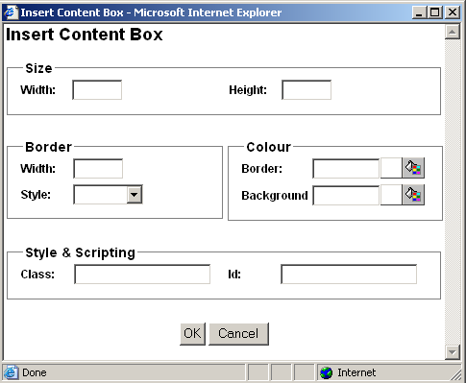

- Width
Enter the width of the box as a percentage (for example “100%”) or in pixels (for example “100” pixels).
- Height
Enter the height of the box as a percentage (for example “100%”) or in pixels (for example “100” pixels.
- Border Width
Enter the border width in pixels. If you enter 0 there will be no border. If you leave it blank the browser will determine the border width.

- Border Style
Select the border style to be used for the box.

- Border Colour
Enter the border colour as an html colour name or as an html colour code. The actual colour is displayed in the square next to the input field. Select the colour square for access to the colour selector.
- Background Colour
Enter the background colour as an html colour name or as an html colour code. The actual colour is displayed in the square next to the input field. Select the colour square for access to the colour selector.
- Id
Unique HTML code id for use with Javascript.
- Class
HTML class name for use with CSS style sheet.

Select OK to insert the content box into the web editor work area.

Special

Help

Select the Help toolbar button when you need help and a help screen will open.

Import File
HardCore Web Content Editor v2+ only.

Select the Import File toolbar button to upload and import a text or HTML format file from your local computer to the web editor work area. The imported file will replace the current content in the web editor work area.
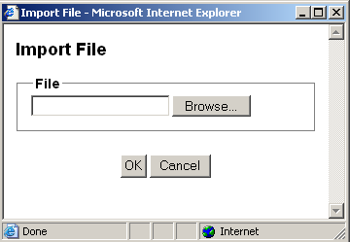

Find

To search for characters in the work area select the Find toolbar button. The following sub-session will appear. Type the characters in the Find what field and select additional search criteria.

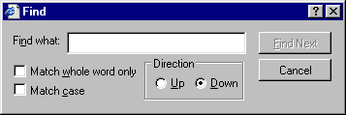

Select the Find Next button to search the work area or select Cancel.

Your web browser may not support this functionality, in which case you will be prompted to use your web browser’s menu/keyboard functionality for this instead.

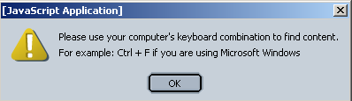

Insert Print Page Break

HardCore Web Content Editor v2+ only.

Position the claret/cursor where you want to define a page break (when the content is printed) and select the Insert Print Page Break button to insert a (hidden) print page break code into the web editor work area.

Print

HardCore Web Content Editor v2+ only.

To print the content in the work area select the Print toolbar button. This will open your web browser’s Print dialog window. Please see your web browser and operating system documentation for details on the Print dialog window.

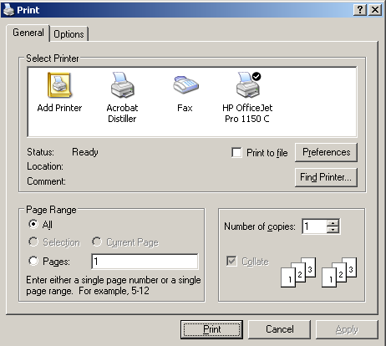

Preview

HardCore Web Content Editor v2+ only.

To preview the content in the work area select the Preview toolbar button. This will open a new web browser window with the content from the web editor work area.

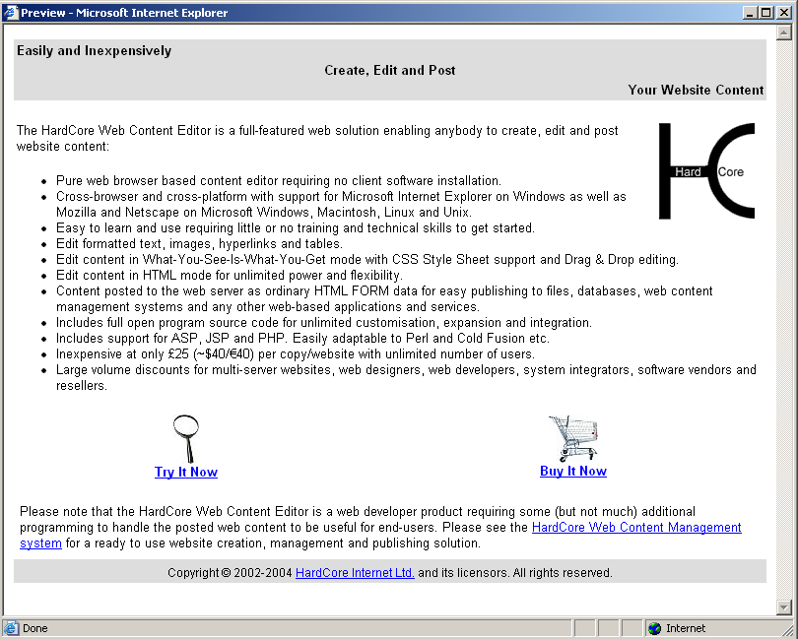

Save / Submit

HardCore Web Content Editor v2+ only.

To save the content in the work area, select the Save toolbar button. This will submit the web page form, which the web editor work area is part of, to the web server.

Show Details

HardCore Web Content Editor v1 only.

Select the Show Details toolbar button to see formatting marks and hidden text.

Show Hidden Details

HardCore Web Content Editor v2+ only.

Select the Show WYSIWYG / Plain toolbar button to see toggle between displaying the content in WYSIWYG (What-You-See-Is-What-You-Get) and Plain modes.

- WYSIWYG mode - displays content (approximately) as it will be displayed on your websites including application of Style Sheet formatting.
- Plain mode – displays content with table border, image and form outlines and without application of Style Sheet formatting.

Show HTML

Select the Show HTML toolbar button to see and edit the content as HTML code in the work area.

Check Spelling

HardCore Web Content Editor v2+ only.

Select the Check Spelling toolbar button to check the spelling of the content in the currently selected web content editor input field. This will open a new web browser window.
Depending on how your system has been configured, you may have access to select which dictionary to use for the spell checking. Alternatively, your system may have been configured to always use a specific dictionary.
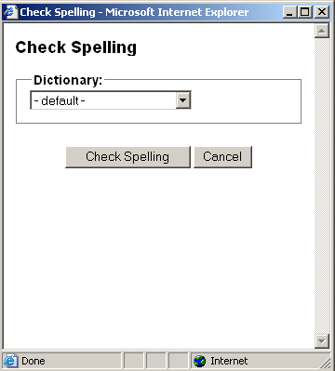
Spell checking your web content may take a little while depending on the size of your content and the size of the dictionary used for the spell checking.
When you web content has been spell checked any identified misspellings would be displayed with a number of suggestions for corrections. Please note that any identified misspellings and suggestions may be wrong. You should never simply accept all spell checking suggestions.
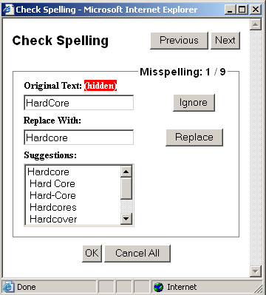
The total number of identified misspellings and details of the currently select misspelling are displayed.
- Previous
Displays the details of the previous identified misspelling.
- Next
Displays the details of the next identified misspelling.
The misspelling is also highlighted and focused in the web content editor input field if possible – i.e. if the misspelling is not in hidden text in the web content.
A number of suggestions for replacements of the original text may be listed. As default the best suggestion is selected automatically or you can select any of the other listed suggestions or enter your own correction manually.
- Ignore
Skips the current misspelling without making any changes to your web content and displays the next misspelling.
- Replace
Replaces the identified misspelling in your web content with the selected/entered correction and displays the next misspelling.
When done with the spell checking please select “OK” or “Cancel” to return to the web content editor input field.
- OK
Applies your spell checking corrections to your web content.
- Cancel All
Undo all your spell checking corrections.
Please note that you should not simply close the spell checking window as this may leave some of your web content highlighted.

HTML DOM Inspector
HardCore Web Content Editor v2+ only.

Optionally, a HTML DOM Inspector may be displayed below your editable web content.

The HTML DOM Inspector displays the hierarchy of HTML codes the currently selected content is located within. The HTML attributes of the innermost surrounding HTML code are also displayed. In the example graphic above, the currently selected content is enclosed by a FONT code with the attribute “size=4”, which in turn is enclosed by a STRONG code etc.

Each of the displayed surrounding HTML codes may be clicked to make that content block the currently selected content in the web content editor. In the example graphic above, the TABLE link may be clicked to make the entire table the currently selected content.

The HTML DOM Inspector may also display a “REMOVE” link, which deletes the innermost HTML code surrounding the currently selected content. In the example graphic above, “REMOVE” will delete the FONT code, which encloses the currently selected content.

Handling posted web content
The HardCore Web Content Editor content is included and posted from your webpage as ordinary HTML FORM data. This makes it very simple to handle the posted web content. It also allows you to easily integrate the HardCore Web Content Editor with any website and web-based applications and databases simply by replacing any existing HTML FORM TEXTAREA field with the HardCore Web Content Editor, which automatically degrades to a TEXTAREA field for web browsers without support for visual web content editing.
The “hardcore/webeditor” folder includes “preview.asp”, “preview.aspx”, “preview.cfm”, “preview.jsp” and “preview.php” files with simple examples of how to extract and display posted web content from the HardCore Web Content Editor. Integrating the HardCore Web Content Editor only requires accessing automatically handled HTML FORM data variables using the built-in features of your preferred scripting language such as:
- ASP: Request.Form("content")
- ASP.NET/C#: Request.Form.Get("content")
- ColdFusion: Form.content
- JSP: request.getParameter("content")
- PHP: stripslashes($HTTP_POST_VARS["content"])
On the web server you have to handle the posted web content just like any other posted HTML FORM data to store it in files, databases, web content management systems and any other web-based applications and services. How this is done is up to you and your web-based application and database.
Alternatively, you may also use the HardCore Web Content Editor Javascript API to get and handle the content instead of simply posting the content to your web server as ordinary HTML FORM data. Please see 4.5 Javascript API for details.

Simple file editor example
Even if you only have a static website consisting of pure HTML web pages without any additional web applications, you can easily use the HardCore Web Content Editor to update parts of your website.
The “hardcore/webeditor” folders contains a number of “simple_file_editor_example” files:

- simple_file_editor_example.html
Partial HTML file where your editable web content is stored.
- simple_file_editor_example_view.asp/.aspx/.cfm/.jsp/.php
Simple ASP/ASP.NET/ColdFusion/JSP/PHP script file which includes and displays the content of the “simple_file_editor_example.html“ file.
- simple_file_editor_example_edit.asp/.aspx/.cfm/.jsp/.php
Simple ASP/ASP.NET/ColdFusion/JSP/PHP script file which opens the content of the “simple_file_editor_example.html“ file in the HardCore Web Content Editor.

Simply copy and modify these files to make your own simple file editors to update and display dynamic content on your website. If you only want to make parts of a web page editable, you can add your own non-editable HTML code to your copies of the “simple_file_editor_view.asp/.aspx/.cfm/.jsp/.php” file.

Please note that you should restrict access to your copies of the “simple_file_editor_edit.asp/.aspx/.cfm/.jsp/.php” file (i.e. using your web server’s access control features or by keeping the file names secret), or any Internet user with access to your website and knowledge of your “edit” file names may be able to update that content of your website.

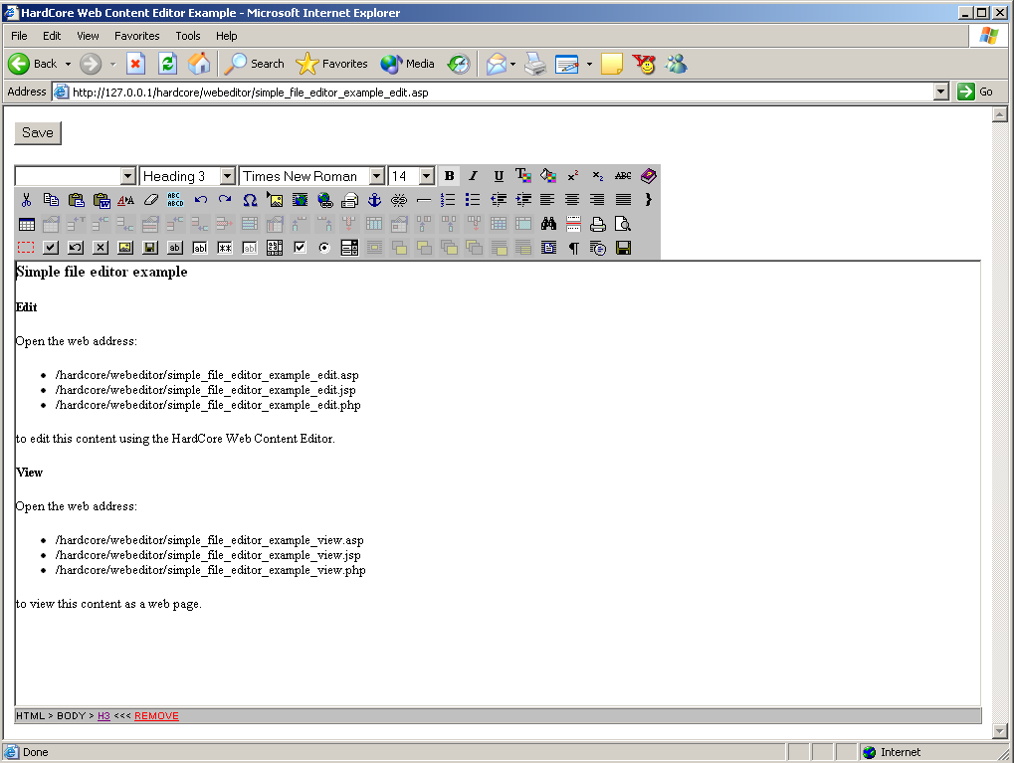

Customising and integrating
The HardCore Web Content Editor includes several features that enable you to customise it and integrate it with other web applications:
- Customisable hyperlink and media dialog windows
- Customisable and extendable toolbar
- Javascript API for setting, modifying and getting editable web content

Hyperlink and media dialog windows
As described earlier in this document, the HardCore Web Content Editor includes both simple standard hyperlink and media dialog windows as well as advanced hyperlink and media manager dialog windows. You probably want to customise these and integrate them with your website and web-based application and database.
You can do this by modifying the default standard hyperlink and media dialog windows (“hyperlink.html” and “media.html”). You can also make your own basic hyperlink and media “manager” scripts (“hyperlinkbasic.asp”, “hyperlinkbasic.aspx”, “hyperlinkbasic.cfm”, “hyperlinkbasic.jsp”, “hyperlinkbasic.php”, “mediabasic.asp”, “mediabasic.aspx”, “mediabasic.cfm”, “mediabasic.jsp”, “mediabasic.php”) and advanced hyperlink and media “manager” scripts (“hyperlinkmanager.asp”, “hyperlinkmanager.aspx”, “hyperlinkmanager.cfm”, “hyperlinkmanager.jsp”, “hyperlinkmanager.php”, “mediamanager.asp”, “mediamanager.aspx”, “mediamanager.cfm”, “mediamanager.jsp”, “mediamanager.php”) and configure the HardCore Web Content Editor to use them instead of the default standard hyperlink and media dialog window scripts by using the ‘scripting language’ and ‘basic’ or ‘manager’ parameter as described in the first part of this document. Examples of advanced hyperlink and media manager dialog windows are included in ASP, ASP.NET, ColdFusion, JSP and PHP. You can easily modify these to other scripting languages such as Perl.

Quicklinks
You may simply want to use default hyperlink and media dialog window scripts but add your own hyperlinks and images to the “Quicklinks”. This is easily done by locating the
<option value="http://www.hardcoreinternet.co.uk/">www.hardcoreinternet.co.uk
and
<option value="http://www.hardcoreinternet.co.uk/hardcore/logo.gif">HardCore Internet logo
program lines in the “hyperlink.html” and “media.html” files and replace them with your own options depending on your websites and web-based applications and databases:
- Simply add static options as direct HTML OPTION tags.
- Write a small script to list the images in your own website image library folder and generate HTML OPTION tags for each of your images.
- Write a small script to extract hyperlink and media lists from your web-based applications and generate HTML OPTION tags for each of them.
- Write a small script to extract hyperlink and media lists from your databases and generate HTML OPTION tags for each of them.
Exactly how to do this is out of the scope of this document. Please see one of the many available books and websites about ASP, ASP.NET, ColdFusion, JSP, PHP and database programming.

Hyperlink and media managers
You may also want to make your own complete hyperlink and media managers for handling large amounts of options and dynamically creating, modifying and deleting options. Examples of advanced hyperlink and media manager dialog windows are included in ASP, ASP.NET, ColdFusion, JSP and PHP. You can easily modify these to other scripting languages such as Perl.
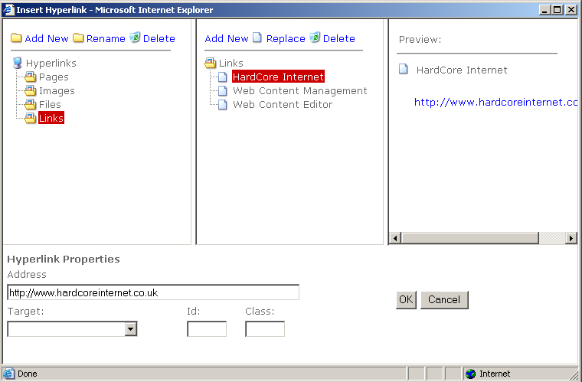
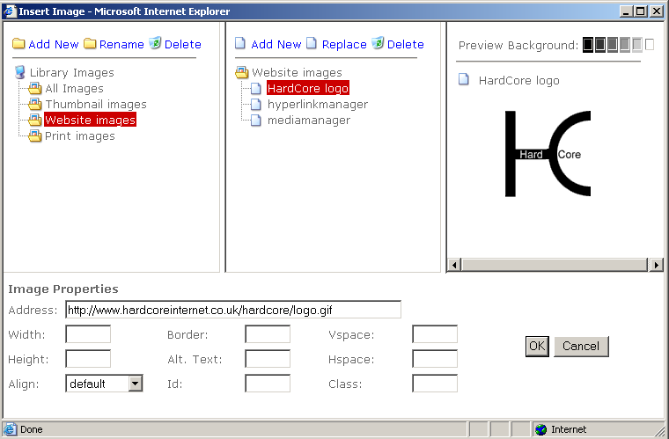
Examples of advanced hyperlink and media manager dialog windows are included in ASP, ASP.NET, ColdFusion, JSP and PHP. You can easily modify these to other scripting languages such as Perl.
For the advanced hyperlink and media manager dialog windows to be useful, they must be integrated with your web applications. I.e. to list, create and delete content categories and content items in your web content management system. How this is done depends on your web applications. For an example of how the HardCore Web Content Editor is integrated with a web content management system, please see our HardCore Web Content Management system: http://wcm.hardcoreinternet.co.uk/.

Additional hyperlink and media dialog window attributes
The default “hyperlink.html” and “media.html” standard dialog windows include the typical attributes used for hyperlinks and images. However, the HardCore Web Content Editor also supports some additional attributes, which you may want to use.

Hyperlink
A couple of optional additional form data can be used in relation to advanced scripting and style sheets:
- HTML ID attribute – for unique identification of each individual hyperlink or image in your web content.
- HTML CLASS attribute – for classification of different classes of hyperlinks and images.
To use these you must add HTML FORM INPUT fields for them and modify the “linkit” Javascript function (in “hyperlink.html”) to pass them to the HardCore Web Content Editor. The “linkit” Javascript function includes the program lines:
var htmlid = '';
var htmlclass = '';
These should be changed to get their value from your additional HTML FORM INPUT fields instead of simply being set to empty strings.

Media
A couple of optional additional form data can be used in relation to advanced scripting and style sheets and a number of additional image attributes can be defined:
- HTML ID attribute – for unique identification of each individual hyperlink or image in your web content.
- HTML CLASS attribute – for classification of different classes of hyperlinks and images.
- HTML IMG VSPACE attribute – for setting vertical spacing for images.
- HTML IMG HSPACE attribute – for setting horizontal spacing for images.
- HTML IMG ALIGN attribute – for setting alignment for images.
To use these you must add HTML FORM INPUT fields for them and modify the “linkit” Javascript function (in “media.html”) to pass them to the HardCore Web Content Editor. The “linkit” Javascript function includes the program lines:
var vspace = '';
var hspace = '';
var align = '';
var htmlclass = '';
var htmlid = '';
These should be changed to get their value from your additional HTML FORM INPUT fields instead of simply being set to empty strings.

Toolbar
If no parameters are passed to the HardCoreWebEditorToolbar function the default toolbar will be displayed. However, the toolbar can be customized by passing parameters defining which options to display and in which order.

Format, font name and size options
The HardCoreWebEditorToolbar function’s first parameter must be null to display the default format, font name and size options. Alternatively, a Javascript array with your customised format, font name and size options may be passed as the first parameter. The support options are:
  - formatblock
  - fontname
  - fontsize

Example - To generate the default toolbar format, font name and size options use:
<script>
options = new Array();
i=0;
options['formatblock'] = new Array();
options['formatblock'][i] = new Object();
options['formatblock'][i].name='Normal';
options['formatblock'][i++].value='<p>';
options['formatblock'][i] = new Object();
options['formatblock'][i].name='Paragraph';
options['formatblock'][i++].value='<p>';
options['formatblock'][i] = new Object();
options['formatblock'][i].name='Formatted';
options['formatblock'][i++].value='<pre>';
options['formatblock'][i] = new Object();
options['formatblock'][i].name='Heading 1';
options['formatblock'][i++].value='<h1>';
options['formatblock'][i] = new Object();
options['formatblock'][i].name='Heading 2';
options['formatblock'][i++].value='<h2>';
options['formatblock'][i] = new Object();
options['formatblock'][i].name='Heading 3';
options['formatblock'][i++].value='<h3>';
options['formatblock'][i] = new Object();
options['formatblock'][i].name='Heading 4';
options['formatblock'][i++].value='<h4>';
options['formatblock'][i] = new Object();
options['formatblock'][i].name='Heading 5';
options['formatblock'][i++].value='<h5>';
options['formatblock'][i] = new Object();
options['formatblock'][i].name='Heading 6';
options['formatblock'][i++].value='<h6>';
options['formatblock'][i] = new Object();
options['formatblock'][i].name='Numbered List';
options['formatblock'][i++].value='<ol>';
options['formatblock'][i] = new Object();
options['formatblock'][i].name='Bulleted List';
options['formatblock'][i++].value='<ul>';
options['formatblock'][i] = new Object();
options['formatblock'][i].name='Directory List';
options['formatblock'][i++].value='<dir>';
options['formatblock'][i] = new Object();
options['formatblock'][i].name='Menu List';
options['formatblock'][i++].value='<menu>';
options['formatblock'][i] = new Object();
options['formatblock'][i].name='Definition Term';
options['formatblock'][i++].value='<dt>';
options['formatblock'][i] = new Object();
options['formatblock'][i].name='Definition';
options['formatblock'][i++].value='<dd>';
options['formatblock'][i] = new Object();
options['formatblock'][i].name='Address';
options['formatblock'][i++].value='<address>';
i=0;
options['fontname'] = new Array();
options['fontname'][i] = new Object();
options['fontname'][i].name='Times New Roman';
options['fontname'][i++].value='Times New Roman';
options['fontname'][i] = new Object();
options['fontname'][i].name='Helvetica,Arial';
options['fontname'][i++].value='Helvetica,Arial';
options['fontname'][i] = new Object();
options['fontname'][i].name='Helvetica';
options['fontname'][i++].value='Helvetica';
options['fontname'][i] = new Object();
options['fontname'][i].name='Arial';
options['fontname'][i++].value='Arial';
options['fontname'][i] = new Object();
options['fontname'][i].name='Courier';
options['fontname'][i++].value='Courier';
i=0;
options['fontsize'] = new Array();
options['fontsize'][i] = new Object();
options['fontsize'][i].name='8';
options['fontsize'][i++].value='1';
options['fontsize'][i] = new Object();
options['fontsize'][i].name='10';
options['fontsize'][i++].value='2';
options['fontsize'][i] = new Object();
options['fontsize'][i].name='12';
options['fontsize'][i++].value='3';
options['fontsize'][i] = new Object();
options['fontsize'][i].name='14';
options['fontsize'][i++].value='4';
options['fontsize'][i] = new Object();
options['fontsize'][i].name='18';
options['fontsize'][i++].value='5';
options['fontsize'][i] = new Object();
options['fontsize'][i].name='24';
options['fontsize'][i++].value='6';
options['fontsize'][i] = new Object();
options['fontsize'][i].name='36';
options['fontsize'][i++].value='7';
HardCoreWebEditorToolbar(options);
</script>

Rows, buttons and options
The HardCoreWebEditorToolbar function’s second parameter and additional parameters can be used to define the number of toolbar rows and their buttons and options.
The second and each additional parameter defines a toolbar row. Each parameter must be a string with the options to be displayed in the toolbar row. Each option must be separated by a blank. The supported options are:
  - formatclass
  - formatblock
  - fontname
  - fontsize
  - bold
  - italic
  - underline
  - forecolor
  - backcolor
  - superscript
  - subscript
  - strikethrough
  - help
  - cut
  - copy
  - paste
  - clean
  - removeformat
  - delete
  - selectall
  - undo
  - redo
  - specialcharacter
  - insertmedia
  - iframe
  - createlink
  - mailto
  - anchor
  - unlink
  - inserthorizontalrule
  - insertorderedlist
  - insertunorderedlist
  - outdent
  - indent
  - justifyleft
  - justifycenter
  - justifyright
  - justifyfull
  - nobr
  - createtable
  - tableproperties
  - insertcaption
  - insertrowhead
  - insertrowfoot
  - rowproperties
  - insertrowabove
  - insertrowbelow
  - deleterow
  - splitcellrows
  - columnproperties
  - insertcolumnleft
  - insertcolumnright
  - deletecolumn
  - splitcellcolumns
  - cellproperties
  - insertcellleft
  - insertcellright
  - deletecell
  - splitcell
  - mergecells
  - find
  - printbreak
  - print
  - preview
  - form
  - submitbutton
  - resetbutton
  - backbutton
  - imagebutton
  - file
  - button
  - text
  - password
  - hidden
  - textarea
  - checkbox
  - radio
  - select
  - position
  - forwards
  - backwards
  - front
  - back
  - abovetext
  - belowtext
  - box
  - viewdetails
  - viewsource
  - save
  - import
  - spellcheck
  - BlockDirLTR
  - BlockDirRTL

Example - To generate the HardCore Web Content Editor v4.2 default toolbar use:
<script>HardCoreWebEditorToolbar(null, "formatclass formatblock fontname fontsize bold italic underline forecolor backcolor removeformat help", "cut copy paste delete selectall undo redo specialcharacter insertmedia createlink unlink inserthorizontalrule insertorderedlist insertunorderedlist outdent indent justifyleft justifycenter justifyright justifyfull strikethrough superscript subscript find", "createtable tableproperties insertcaption insertrowhead insertrowfoot rowproperties insertrowabove insertrowbelow deleterow splitcellrows columnproperties insertcolumnleft insertcolumnright deletecolumn splitcellcolumns cellproperties insertcellleft insertcellright deletecell splitcell mergecells print viewdetails viewsource");</script>

Custom functionality
In addition to the built-in functionality, you can also add your own functionality or replace the built-in functionality.

Toolbar buttons
To replace the built-in functionality, simply define your own Javascript functions named “webeditor_custom_xxx”. Replace “xxx” with one of the toolbar option names as listed above.
Example – To replace the built-in “help” functionality use:
<script>
function webeditor_custom_help() {
alert(‘Please see the user guide’);
}
HardCoreWebEditorToolbar();
</script>
To add your own functionality, simply define your own Javascript functions named “webeditor_custom_xxx”, add “xxx” as an option to your toolbar, and add your own “xxx.gif” button image file to the “hardcore/webeditor” folder. Replace “xxx” with a toolbar option name of your own choice.
Example – To add your own “helloworld” functionality and display it as your only toolbar option use:
<script>
function webeditor_custom_helloworld() {
alert(‘Hello World’);
}
HardCoreWebEditorToolbar(null, “helloworld”);
</script>

Web content editor focus
Two special functions for “focusing” and “blurring” the web content editor input field(s) are also supported:
<script>
function webeditor_custom_onfocus(name) {
alert(‘Focused ’+name);
}
function webeditor_custom_onblur(name) {
alert(‘Blurred ’+name);
}
</script>
These two functions are called when the web content editor input field is “focused” and “blurred”.
The functions can be used to only display the toolbar and the DOM inspector when the web content editor input field is focused and otherwise hide the toolbar and DOM inspector when the web content editor input field is not focused.
Please see “index.onfocus-onblur.html” in the “hardcore/webeditor” folder for details

Custom encoding/decoding and reformatting of HTML content
For various reasons you may need/want to custom encode your content while it is being edited in the web content editor or modify the content when/before it is being submitted to the web server:
  - Web browsers and the HardCore Web Content Editor may generate HTML code, which is not compatible with your web applications, or which you do not allow users to submit to the web server. To avoid this you may want to “custom decode” (to clean up or otherwise modify) your HTML content before it is submitted to the web server.
  - Your web content management system or other web applications may use non-standard HTML-like custom tags which web browsers may not handle correctly and which web browser may modify. To avoid this you may want to “custom encode” your HTML content into another format while it is being edited to avoid it being incorrectly modified by the web browsers (and “custom decode” the content again before it is submitted to the web server).

If your web pages with the HardCore Web Content Editor include a Javascript function named “webeditor_custom_encode”, that function will be called when/before your HTML content is inserted into the web content editor. Your HTML content is passed as a parameter to the Javascript function, which may modify the HTML content before it is returned (and inserted into the web content editor).
If your web pages with the HardCore Web Content Editor include a Javascript function named “webeditor_custom_decode”, that function will be called when/before your HTML content is submitted to your web server. Your HTML content is passed as a parameter to the Javascript function, which may modify the HTML content before it is returned (and submitted to the web server).
For example to custom encode/decode your HTML content, the following two functions could be used:
<script>
function webeditor_custom_encode(content) {
// Place your own Javascript code here to modify the content
// before the content is inserted into the web content editor
return content;
}
function webeditor_custom_decode(content) {
// Place your own Javascript code here to modify the content
// before the content is submitted to the web server
return content;
}
</script>

Exactly, what needs to be encoded/decoded and how to encode/decode it, depends on your web application, so you need to customise these functions for your web application.

HTML content for use with Macromedia Flash
You may want to use the HardCore Web Content editor to edit content to be used in Macromedia Flash applications. Macromedia Flash applications may handle HTML content but may not handle all HTML content. For example Macromedia Flash applications may use absolute point/pixel font sizes while standard HTML uses pre-defined, relative font sizes.
For example to custom encode/decode Macromedia Flash HTML content, the following two functions could be used:
<script>
function webeditor_custom_encode(content) {
RegExp.global = true;
RegExp.multiline = true;
content = content.replace(/<font([^>]*)size="8"([^>]*)>/gi, "<font$1size=\"1\"$2>");
content = content.replace(/<font([^>]*)size="10"([^>]*)>/gi, "<font$1size=\"2\"$2>");
content = content.replace(/<font([^>]*)size="12"([^>]*)>/gi, "<font$1size=\"3\"$2>");
content = content.replace(/<font([^>]*)size="14"([^>]*)>/gi, "<font$1size=\"4\"$2>");
content = content.replace(/<font([^>]*)size="18"([^>]*)>/gi, "<font$1size=\"5\"$2>");
content = content.replace(/<font([^>]*)size="24"([^>]*)>/gi, "<font$1size=\"6\"$2>");
content = content.replace(/<font([^>]*)size="36"([^>]*)>/gi, "<font$1size=\"7\"$2>");
return content;
}
function webeditor_custom_decode(content) {
RegExp.global = true;
RegExp.multiline = true;
content = content.replace(/<font([^>]*)size="1"([^>]*)>/gi, "<font$1size=\"8\"$2>");
content = content.replace(/<font([^>]*)size="2"([^>]*)>/gi, "<font$1size=\"10\"$2>");
content = content.replace(/<font([^>]*)size="3"([^>]*)>/gi, "<font$1size=\"12\"$2>");
content = content.replace(/<font([^>]*)size="4"([^>]*)>/gi, "<font$1size=\"14\"$2>");
content = content.replace(/<font([^>]*)size="5"([^>]*)>/gi, "<font$1size=\"18\"$2>");
content = content.replace(/<font([^>]*)size="6"([^>]*)>/gi, "<font$1size=\"24\"$2>");
content = content.replace(/<font([^>]*)size="7"([^>]*)>/gi, "<font$1size=\"36\"$2>");
return content;
}
</script>

Exactly, what needs to be encoded/decoded and how to encode/decode it, depends on your web application, so you need to customise these functions for your web application.

Non-standard HTML-like custom tags
To use the HardCore Web Content Editor with some web content management systems and other web applications, you may need to encode/decode your content.
Some web content management systems, template languages and scripting languages etc. use HTML-like tags (i.e. <if condition=”true”>Content A<else>Content B</if>), which web browsers may not be able to edit and preserve unmodified.
To edit and preserve content containing such HTML-like tags, the tags need to be encoded into a HTML-compliant editable format before editing the content, and the tags need to be decoded into the original format again after editing the content.
For example:
<if condition=”true”>Content A<else>Content B</if>
may be encoded into:
[if condition=”true”]Content A[else]Content B[/if]
or something completely different.
To make such encoding and decoding easy to add for your web applications, the HardCore Web Content Editor supports two custom Javascript functions: “webeditor_custom_encode” and “webeditor_custom_decode”. If functions with these names are included on your web pages where the HardCore Web Content Editor is used, the HardCore Web Content Editor will call the functions to encode and decode the content, automatically.
For example to encode/decode the example above, the following two functions could be used:
<script>
function webeditor_custom_encode(content) {
RegExp.global = true;
RegExp.multiline = true;
content = content.replace(/<if([^>]*)>/gi, "[if$1]");
content = content.replace(/<else>/gi, "[else]");
content = content.replace(/<\/if>/gi, "[/if]");
return content;
}
function webeditor_custom_decode(content) {
RegExp.global = true;
RegExp.multiline = true;
content = content.replace(/\[if([^\]]*)]/gi, "<if$1>");
content = content.replace(/\[else]/gi, "<else>");
content = content.replace(/\[\/if]/gi, "</if>");
return content;
}
</script>

Exactly, what needs to be encoded/decoded and how to encode/decode it, depends on your web application and the HTML-like format and tags it uses, so you need to customise these functions for your web application.

CSS Style Sheet Style Names
As default the extracted CSS style sheet names are displayed for the available styles.
You may want to replace the possibly abbreviated CSS style sheet names with more user friendly names. This can be done by adding a “webeditor_custom_formatclass_option” custom Javascript function to your web pages where the HardCore Web Content Editor is used.
This Javascript function is called for each CSS style sheet name with the name as parameter, and the function must return the (modified) name to be displayed instead of the CSS style sheet name or an empty string to ignore the CSS style sheet name option. For example:
function webeditor_custom_formatclass_option(name) {
switch (name) {
case "head1":
return "Heading 1";
break;
case "head2":
return "Heading 2";
break;
case "ignore":
return "";
break;
default:
return name;
break;
}
}

Javascript API
Instead of simply using the HardCore Web Content Editor as a HTML FORM TEXTAREA replacement and POST the editable web content to your web server, you may use the HardCore Web Content Editor Javascript API for more advanced integration with your web applications.
The following built-in Javascript functions are available for getting and setting your HardCore Web Content Editor editable web content:

HardCoreWebEditorGetContent()
Use “HardCoreWebEditorGetContent()” to get the full content from the currently focused editable web content area.
If you have multiple editable web content areas you may pass the name of an editable web content area to get the full content from that editable web content area (i.e. use “HardCoreWebEditorGetContent(‘content’)” to get the full content from the editable web content named “content”).

HardCoreWebEditorGetContentSelection()
Use “HardCoreWebEditorGetContentSelection()” to get the current content selection from the currently focused editable web content area.
If you have multiple editable web content areas you may pass the name of an editable web content area to get the content selection from that editable web content area (i.e. use “HardCoreWebEditorGetContentSelection(‘content’)” to get the content selection from the editable web content named “content”).

HardCoreWebEditorSetContent()
Use “HardCoreWebEditorSetContent(‘<h1>Hello World</h1>’)” to replace the full content of the currently focused editable web content.
If you have multiple editable web content areas you may pass the name of an editable web content area to replace the full content of that editable web content area (i.e. use “HardCoreWebEditorSetContent(‘<h1>Hello World</h1>’,’content’)” to replace the full content of the editable web content named “content”).

HardCoreWebEditorPasteContent()
Use “HardCoreWebEditorPasteContent(‘<h1>Hello World</h1>’)” to insert content into the currently focused editable web content area at the current position of the caret/cursor.
If you have multiple editable web content areas you may pass the name of an editable web content area to insert content into that editable web content area (i.e. use “HardCoreWebEditorPasteContent(‘<h1>Hello World</h1>’,’content’)” to insert content into the editable web content named “content”).

HardCoreWebEditorSubmit()
Use “HardCoreWebEditorSubmit()” to prepare the web content area to be submitted to the web server by moving the edited content from the web content area to a hidden HTML FORM input field. As default the web content editor attaches as a HTML FORM SUBMIT handler and this function is called automatically when the form is submitted. However, if you override the HTML FORM SUBMIT handler you must call this function manually before the form is submitted.

HardCoreWebEditorStylesheet()
Use “HardCoreWebEditorStylesheet(URL)” to load another CSS style sheet for the web content editor. Set the style sheet URL to ‘’ to unload any loaded CSS style sheet.

HardCoreWebEditorCleanContent()
Use “HardCoreWebEditorCleanContent(all_html, all_xml, all_namespace, all_lang, all_class, all_style, empty_span, all_span, empty_font, all_font, all_del_ins, empty_p_div)” to clean the content for unwanted HTML tags and attributes.
Each parameter should be true or false to clean or ignore the different types of content:
  - All HTML – Delete all HTML tags from content.
  - All XML – Delete all XML tags from content.
  - All namespace – Delete all XML namespace tags from content.
  - All LANG – Delete all LANG attributes from content.
  - All CLASS – Delete all CLASS attributes from content.
  - All STYLE – Delete all STYLE attributes from content.
  - Empty SPAN – Delete empty and double SPAN tags.
  - All SPAN – Delete all SPAN tags.
  - Empty FONT – Delete empty and double FONT tags.
  - All FONT – Delete all FONT tags.
  - All DEL and INS – Delete all DEL and INS tags.
  - Empty P and DIV – Delete all empty P and DIV tags.

HardCoreWebEditorCleanContentString()
Use “content = HardCoreWebEditorCleanContentString(content, all_html, all_xml, all_namespace, all_lang, all_class, all_style, empty_span, all_span, empty_font, all_font, all_del_ins, empty_p_div)” for to clean the content string variable for unwanted HTML tags and attributes.
For example, use this from your own “webeditor_custom_decode” Javascript function to automatically clean the content when/before it is submitted to the web server. (Please see 4.3 Custom encoding/decoding and reformatting of HTML content for details).
Each parameter should be true or false to clean or ignore the different types of content:
  - All HTML – Delete all HTML tags from content.
  - All XML – Delete all XML tags from content.
  - All namespace – Delete all XML namespace tags from content.
  - All LANG – Delete all LANG attributes from content.
  - All CLASS – Delete all CLASS attributes from content.
  - All STYLE – Delete all STYLE attributes from content.
  - Empty SPAN – Delete empty and double SPAN tags.
  - All SPAN – Delete all SPAN tags.
  - Empty FONT – Delete empty and double FONT tags.
  - All FONT – Delete all FONT tags.
  - All DEL and INS – Delete all DEL and INS tags.
  - Empty P and DIV – Delete all empty P and DIV tags.

