Example 2 : Ecommerce Platform Search

public class Product {

    int id;

    String name;

    public Product(int id, String name) {

        this.id = id;

        this.name = name;

    }

    public String toString() {

        return id + " - " + name;

    }

}

public class LinearSearch {

    public static Product search(Product[] products, String TargetName) {

        for (Product product : products) {

            if (product.name.equalsIgnoreCase(TargetName)) {

                return product;

            }

        }

        return null;

    }

}

import java.util.Arrays;

public class BinarySearch {

public static Product search(Product[] products, String name) {

Arrays.sort(products, (a, b) -> a.name.compareTo(b.name));

        int low = 0;

        int high = products.length - 1;

        while (low <= high) {

            int mid = (low + high) / 2;

            int compare = name.compareTo(products[mid].name);

            if (compare == 0) return products[mid];

            else if (compare < 0) high = mid - 1;

            else low = mid + 1;

        }

        return null;

    }

}

public class Main {

    public static void main(String[] args) {

        Product[] products = {

            new Product(1, "Laptop"),

            new Product(2, "Phone"),

            new Product(3, "Shoes"),

            new Product(4, "Book"),

            new Product(5, "Shirt")

        };

        Product result = BinarySearch.search(products, "Phone");

if (result != null)

            System.out.println("Product found: " + result);

        else

            System.out.println("Not found");

    }

}

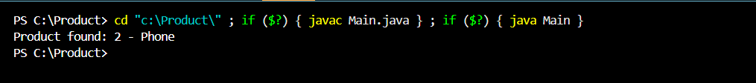

Example 7 : Financial Forecasting

public class FinancialForecast {

    public static double Futurevalue(double money, double rate, int years) {

        if (years == 0) {

        return money;

    }

    return Futurevalue(money, rate, years - 1) \* (1 + rate) ;

}

}

public class Main {

    public static void main (String [] args) {

        double startingmoney = 1000;

        double rate = 0.1;

        int years = 5;

        double FinalAmount = FinancialForecast.Futurevalue(startingmoney , rate, years);

        System.out.printf("Money after %d years: %.2f", years, FinalAmount );

    }

}

