Example 1 : Singleton Pattern

Logger.java

public class Logger {

   private static Logger instance;

   private Logger() {

      System.out.println("Logger created");

   }

public static Logger getInstance() {

      if (instance == null) {

         instance = new Logger();

      }

return instance;

   }

 public void log(String var1) {

      System.out.println("Log: " + var1);

   }

}

public class Main {

    public static void main (String[] args) {

        Logger logger1 = Logger.getInstance() ;

        logger1.log("First log") ;

        Logger logger2 = Logger.getInstance() ;

        logger2.log("Second log") ;

        if (logger1 == logger2) {

            System.out.println("Same logger") ;

        } else {

            System.out.println("Different logger") ;

        }

    }

}

OUTPUT :

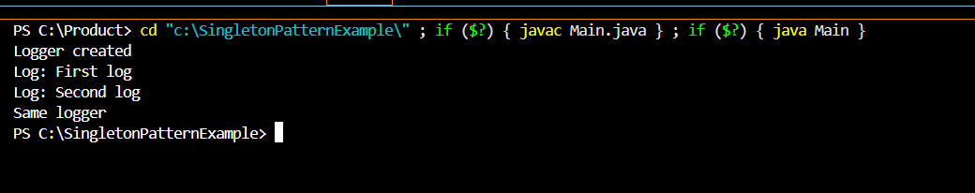

Example 2 : Factory Method Example

public interface Doc {

    void open();

    }

public class WordDoc implements Doc {

    public void open () {

        System.out.println("Open Word");

    }

}

public class PdfDoc implements Doc {

    public void open () {

        System.out.println("Open Pdf");

    }

}

public class ExcelDoc implements Doc {

    public void open () {

        System.out.println("Open Excel");

    }

}

public abstract class DocFactory {

    public abstract Doc createDoc();

}

public class WordDocFactory extends DocFactory {

    public Doc createDoc() {

        return new WordDoc();

    }

}

public class PdfDocFactory extends DocFactory {

public Doc createDoc () {

    return new PdfDoc ();

}

}

public class ExcelDocFactory extends DocFactory {

    public Doc createDoc () {

        return new ExcelDoc();

    }

}

public class Main {

    public static void main (String [] args) {

        DocFactory wordFactory = new WordDocFactory();

        Doc word = wordFactory.createDoc();

        word.open();

        DocFactory pdfFactory = new PdfDocFactory();

        Doc pdf = pdfFactory.createDoc();

        pdf.open();

        DocFactory excelFactory = new ExcelDocFactory();

        Doc excel = excelFactory.createDoc();

        excel.open();

}

}

