Exercise 1 : Control Structures

Scenario 1 -

BEGIN

  UPDATE customers

  SET interest_rate = interest_rate - 1

  WHERE age > 60;

COMMIT;

END;

Scenario 2 -

BEGIN

  UPDATE customers

  SET isVIP = 'TRUE'

  WHERE balance > 10000;

  COMMIT;

END;

Scenario 3 –

BEGIN

  FOR loan IN (

    SELECT customer_id, loan_due_date

    FROM loans

    WHERE loan_due_date <= SYSDATE + 30

  ) LOOP

    DBMS_OUTPUT.PUT_LINE('Reminder: Loan for customer ID ' || loan.customer_id || ' is due on ' || loan.loan_due_date);

  END LOOP;

END;

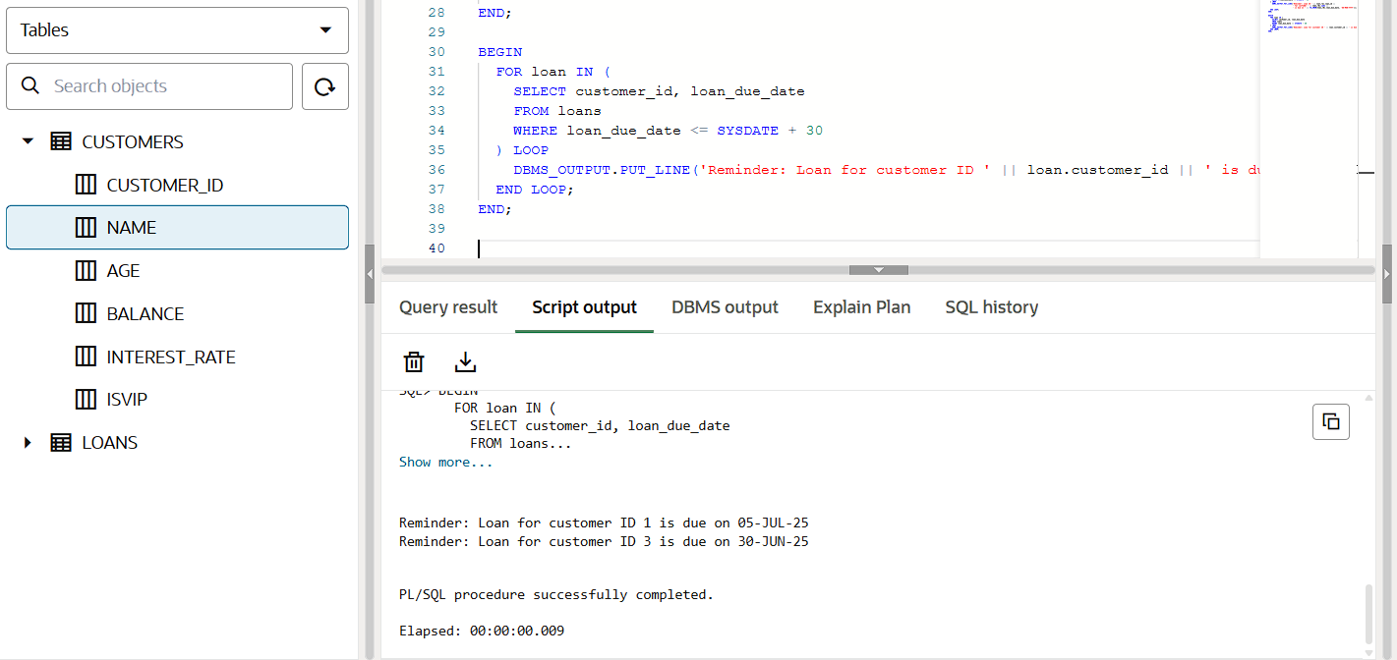

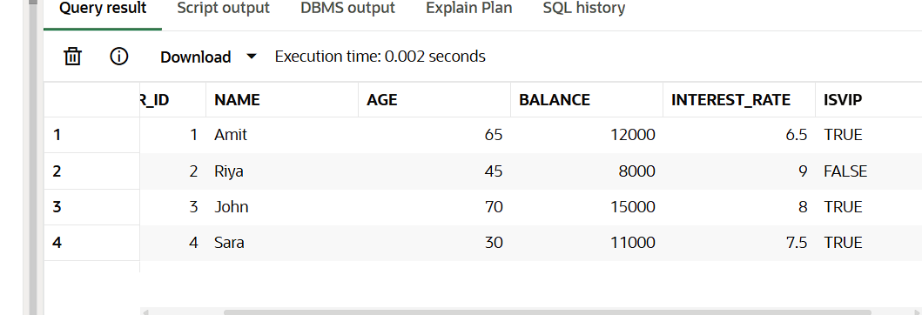

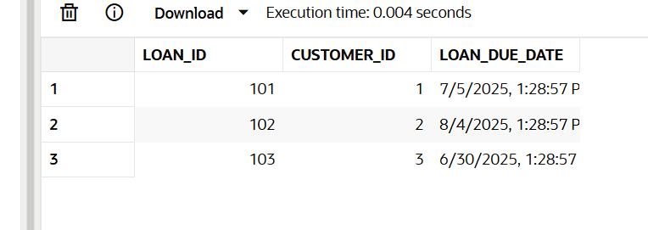

Exercise – 3 : Stored Procedures

Scenario – 1

CREATE OR REPLACE PROCEDURE ProcessMonthlyInterest

IS

BEGIN

  UPDATE accounts

  SET balance = balance + (balance * 0.01)

  WHERE account_type = 'SAVINGS';

  COMMIT;

END;

Scenario – 2

CREATE OR REPLACE PROCEDURE UpdateEmployeeBonus (

  dept_id IN NUMBER,

  bonus_percent IN NUMBER

) IS

BEGIN

  UPDATE employees

  SET salary = salary + (salary * bonus_percent / 100)

  WHERE department_id = dept_id;

  COMMIT;

END;

//By adding 10% bonus as parameter..

BEGIN

  UpdateEmployeeBonus(10, 10);

END;

Scenario – 3

CREATE OR REPLACE PROCEDURE TransferFunds (

  from_acc IN NUMBER,

  to_acc IN NUMBER,

  amount IN NUMBER

) IS

  from_balance NUMBER;

BEGIN

  SELECT balance INTO from_balance FROM accounts WHERE account_id = from_acc;

IF from_balance >= amount THEN

    UPDATE accounts

    SET balance = balance - amount

    WHERE account_id = from_acc;

    UPDATE accounts

    SET balance = balance + amount

    WHERE account_id = to_acc;

COMMIT;

  ELSE

    DBMS_OUTPUT.PUT_LINE('Insufficient balance!!');

  END IF;

END;

BEGIN

  TransferFunds(103, 104, 2000);

END;

