Exercise – 1

Calculator.java // CalculatorTest.java

package com.example;  
  
public class Calculator {  
 public int add(int a, int b) {  
 return a + b;  
 }

package com.example;  
  
import org.junit.Test;  
import static org.junit.Assert.*assertEquals*;  
  
public class CalculatorTest {  
  
 @Test  
 public void testAdd() {  
 Calculator calc = new Calculator();  
 int result = calc.add(2, 3);  
 *assertEquals*(5, result);  
 }  
}

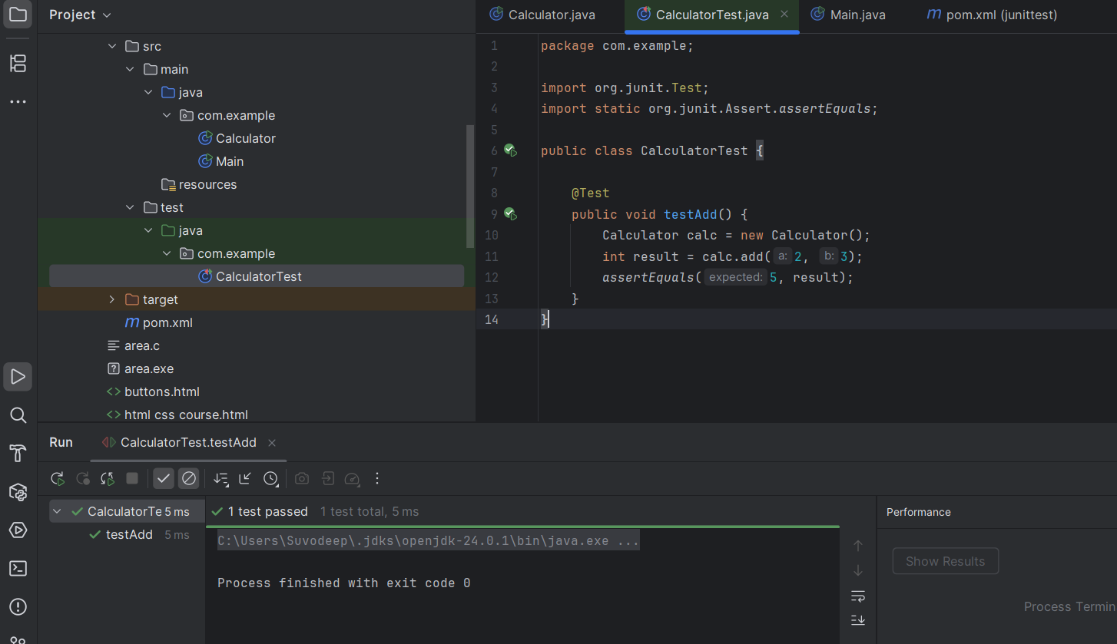

Exercise – 3

ASSERTIONS

Solution Code:

public class AssertionsTest {

@Test

public void testAssertions() {

// Assert equals

assertEquals(5, 2 + 3);

// Assert true

assertTrue(5 > 3);

// Assert false

assertFalse(5 < 3);

// Assert null

assertNull(null);

// Assert not null

assertNotNull(new Object());

}

}

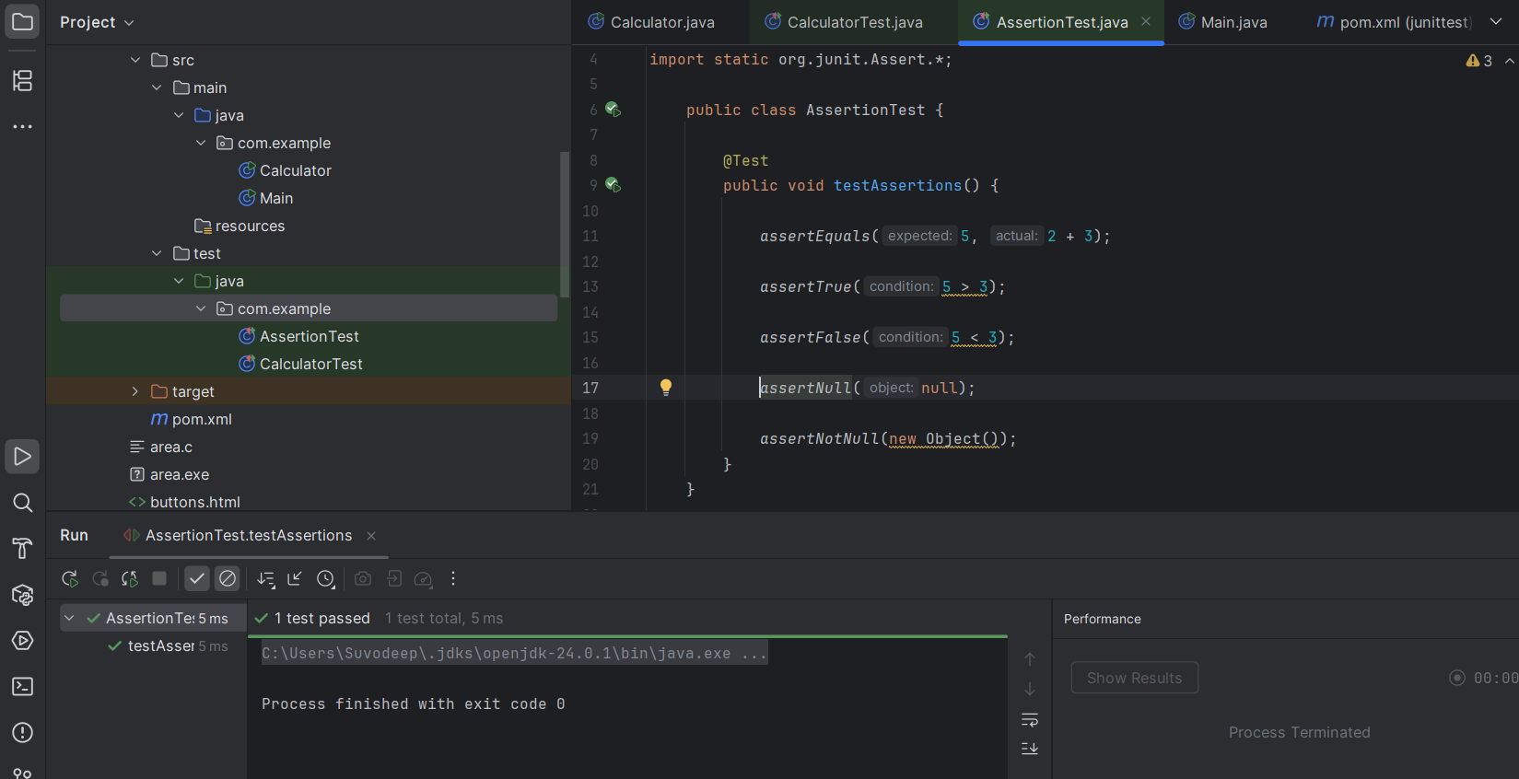

Exercise – 4

AAA,BEFORE,TEARDOWN,ETC..

package com.example;  
  
public class Calculator {  
  
 public int add(int a, int b) {  
 return a + b;  
 }  
  
 public int subtract(int a, int b) {  
 return a - b;  
 }  
}

package com.example;  
  
import org.junit.Before;  
import org.junit.After;  
import org.junit.Test;  
import static org.junit.Assert.\*;  
  
public class CalculatorTest {  
 private Calculator calculator;  
  
 @Before  
 public void setUp() {  
  
 calculator = new Calculator();  
 System.*out*.println("Setup done");  
 }  
  
 @After  
 public void tearDown() {  
  
 calculator = null;  
 System.*out*.println("Teardown done");  
 }  
  
 @Test  
 public void testAddition() {  
  
 //Arrange

int a = 2, b = 3;  
  
 //Act

int result = calculator.add(a, b);  
  
 //Assert

*assertEquals*(5, result);  
 }  
  
 @Test  
 public void testSubtraction() {  
  
 //Arrange

int a = 5, b = 2;  
  
 //Act

int result = calculator.subtract(a, b);  
  
 //Assert

*assertEquals*(3, result);  
 }  
}

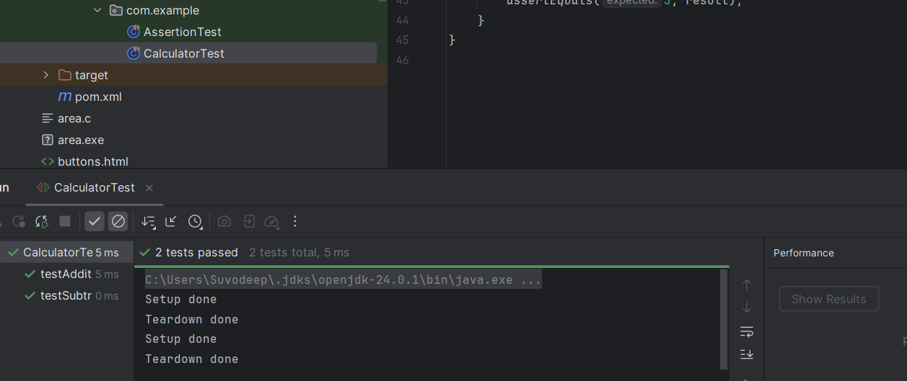

Exercise – 1 MOCKITO

package com.example;  
  
public interface ExternalAPI {  
 String getData();  
}

package com.example;  
  
public class MyService {  
 private ExternalAPI api;  
  
 public MyService(ExternalAPI api) {  
 this.api = api;  
 }  
  
 public String fetchData() {  
 return api.getData();  
 }  
}

package com.example;  
  
import org.junit.jupiter.api.Test;  
import org.mockito.Mockito;  
  
import static org.mockito.Mockito.\*;  
import static org.junit.jupiter.api.Assertions.\*;  
  
public class MyServiceTest {  
  
 @Test  
 public void testExternalAPI() {  
 ExternalAPI mockApi = Mockito.*mock*(ExternalAPI.class);  
 *when*(mockApi.getData()).thenReturn("Mock Data");  
  
 MyService service = new MyService(mockApi);  
 String result = service.fetchData();  
  
 *assertEquals*("Mock Data", result);  
 }  
}

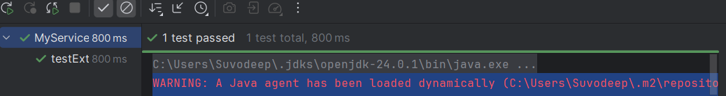

Exercise – 2

package com.example;  
  
import static org.mockito.Mockito.\*;  
import org.junit.jupiter.api.Test;  
import org.mockito.Mockito;  
  
public class MyServiceTest {  
  
 @Test  
 public void testVerifyInteraction() {  
 ExternalApi mockApi = Mockito.*mock*(ExternalApi.class);  
 MyService service = new MyService(mockApi);  
 service.fetchData();  
 *verify*(mockApi).getData();  
 }  
}

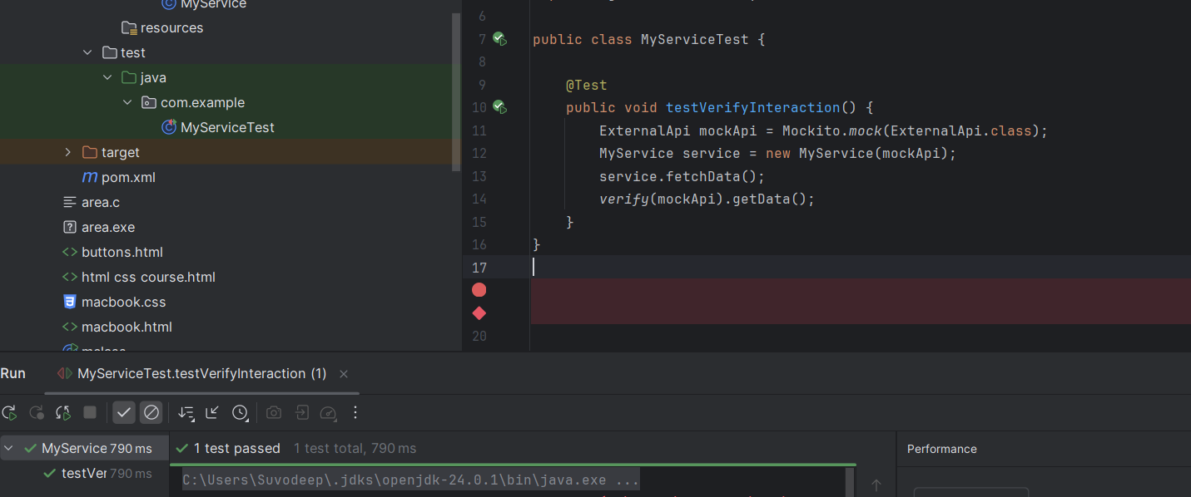

SL4J LOGGING

package com.example;  
  
import org.slf4j.Logger;  
import org.slf4j.LoggerFactory;  
  
public class LoggingExample {  
 private static final Logger *logger* = LoggerFactory.*getLogger*(LoggingExample.class);  
  
 public static void main(String[] args) {  
 *logger*.error("ERROR message");  
 *logger*.warn("WARNING message");  
 *logger*.info("INFO message");  
 *logger*.debug("DEBUG message");  
 }  
}

