* 1. Spring Web Project

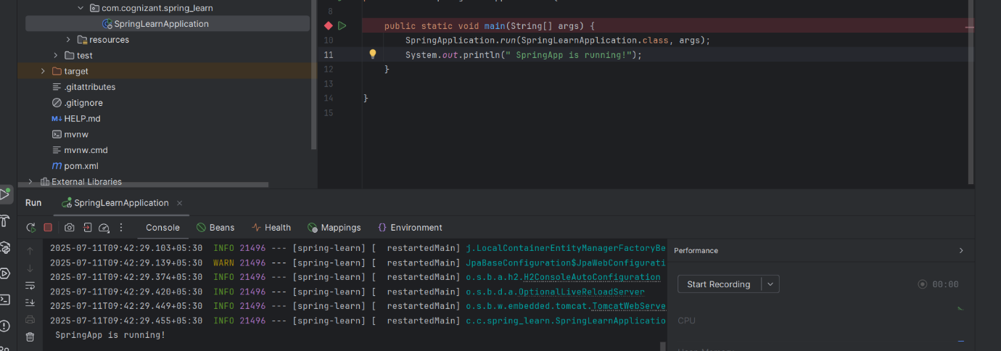

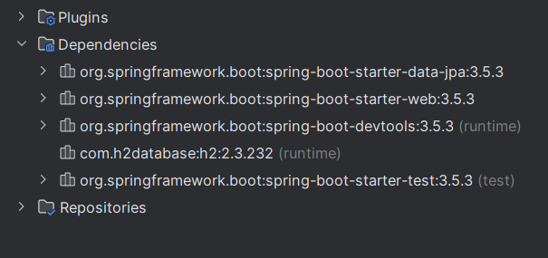

* 1. SimpleDateFormat

Created date-format.xml

<?xml version="1.0" encoding="UTF-8"?>  
<beans xmlns="http://www.springframework.org/schema/beans"  
 xmlns:xsi="http://www.w3.org/2001/XMLSchema-instance"  
 xsi:schemaLocation="http://www.springframework.org/schema/beans  
 https://www.springframework.org/schema/beans/spring-beans.xsd">  
  
 <bean id="dateFormat" class="java.text.SimpleDateFormat">  
 <constructor-arg value="dd/MM/yyyy" />  
 </bean>  
  
</beans>

For the date format in SpringLlearnApplication

package com.cognizant.spring_learn;  
  
import org.springframework.boot.SpringApplication;  
import org.springframework.boot.autoconfigure.SpringBootApplication;  
import org.springframework.context.ApplicationContext;  
import org.springframework.context.support.ClassPathXmlApplicationContext;  
  
import java.text.ParseException;  
import java.text.SimpleDateFormat;  
import java.util.Date;  
  
@SpringBootApplication  
public class SpringLearnApplication {  
  
 public static void main(String[] args) throws ParseException {  
 SpringApplication.*run*(SpringLearnApplication.class, args);  
  
 *displayDate*();  
 }  
  
 public static void displayDate() throws ParseException {  
 ApplicationContext context = new ClassPathXmlApplicationContext("date-format.xml");  
  
 SimpleDateFormat format = context.getBean("dateFormat", SimpleDateFormat.class);  
  
 String dateString = "11/07/2025";  
 Date date = format.parse(dateString);  
  
 System.*out*.println("Formatted Date: " + date);  
 }  
}

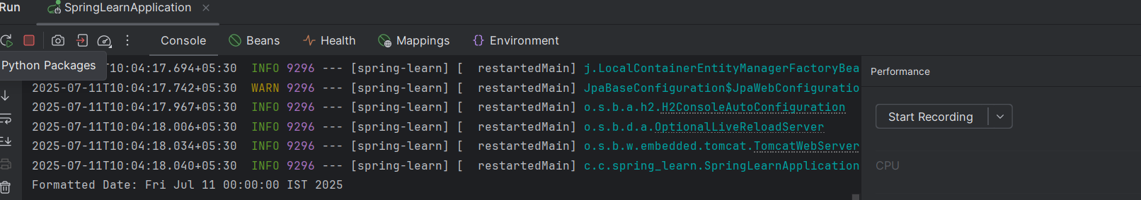

2.2 Hello World API

Hello Controller  
  
package com.cognizant.spring_learn.controller;  
  
import org.slf4j.Logger;  
import org.slf4j.LoggerFactory;  
import org.springframework.web.bind.annotation.GetMapping;  
import org.springframework.web.bind.annotation.RestController;  
  
@RestController  
public class HelloController {  
  
 private static final Logger *LOGGER* = LoggerFactory.*getLogger*(HelloController.class);  
  
 @GetMapping("/hello")  
 public String sayHello() {  
 *LOGGER*.info("START: sayHello()");  
 String message = "Hello Everyone!!";  
 *LOGGER*.info("END: sayHello()");  
 return message;  
 }  
}

added the local host to 8083.  
  
server.port = 8083  
in application properties..

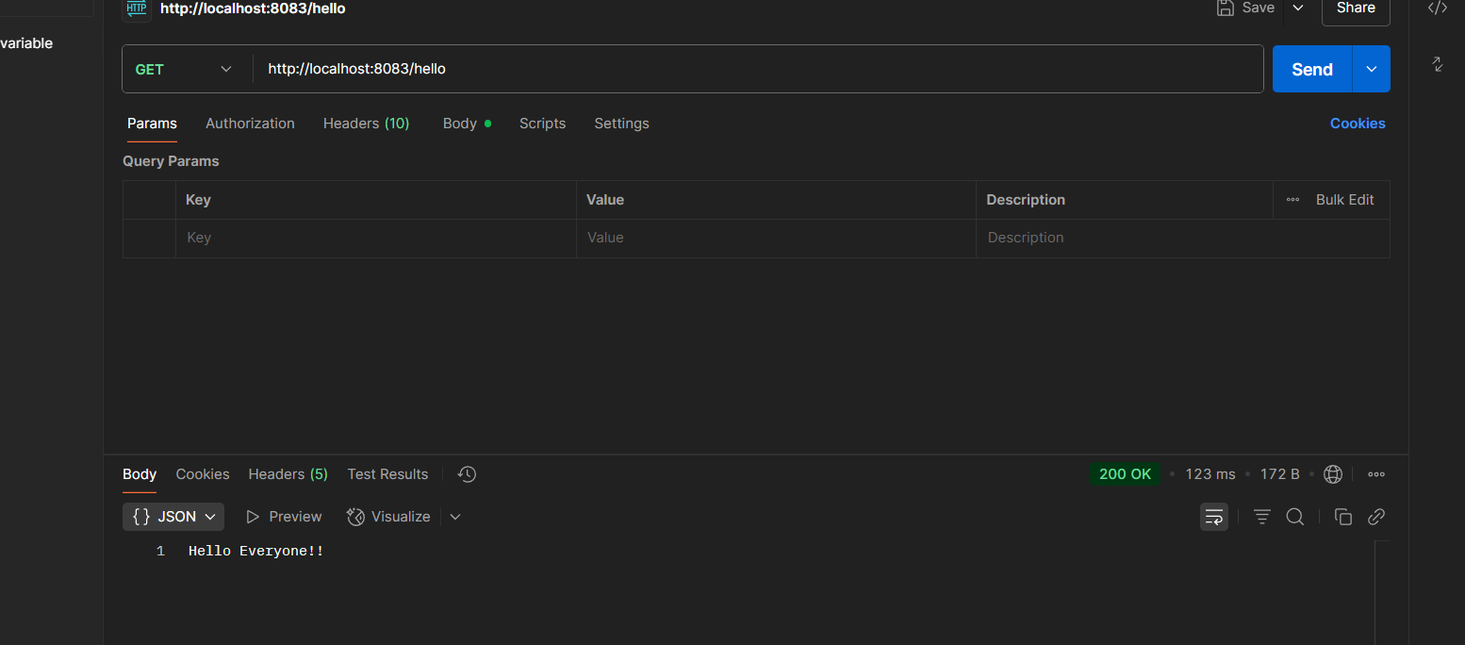

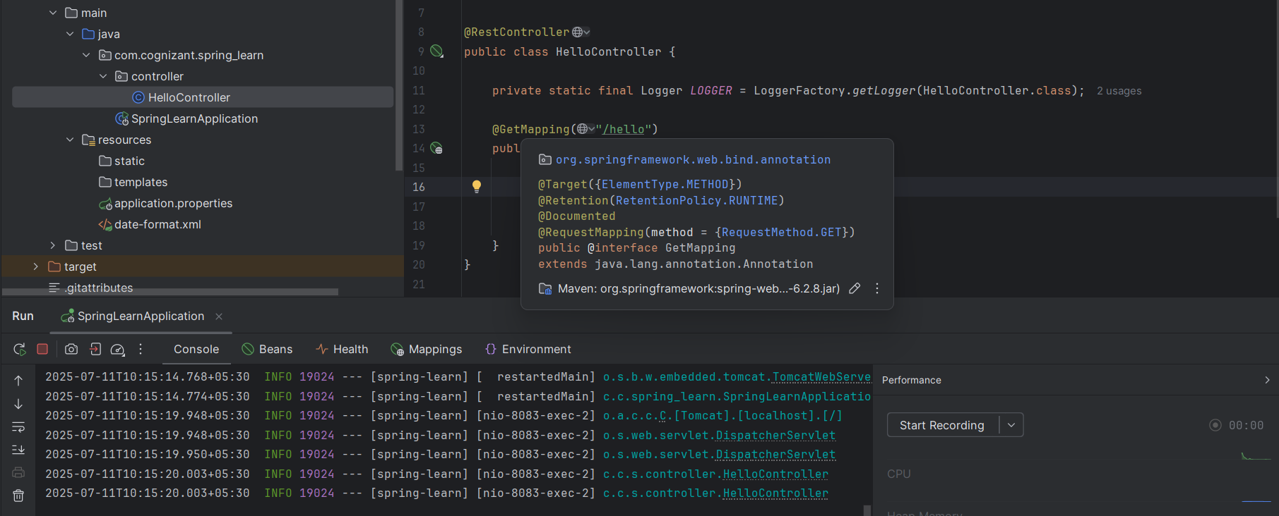

REST Country  
  
country.java  
package com.cognizant.spring_learn.model;

public class Country {

private String code;

private String name;

// Getters & Setters

public String getCode() {

return code;

}

public void setCode(String code) {

this.code = code;

}

public String getName() {

return name;

}

public void setName(String name) {

this.name = name;

}

}  
  
CountryController  
  
package com.cognizant.spring_learn.controller;

import com.cognizant.spring_learn.model.Country;

import org.slf4j.Logger;

import org.slf4j.LoggerFactory;

import org.springframework.context.ApplicationContext;

import org.springframework.context.support.ClassPathXmlApplicationContext;

import org.springframework.web.bind.annotation.RequestMapping;

import org.springframework.web.bind.annotation.RestController;

@RestController

public class CountryController {

private static final Logger LOGGER = LoggerFactory.getLogger(CountryController.class);

@RequestMapping("/country")

public Country getCountryIndia() {

LOGGER.info("START: getCountryIndia");

ApplicationContext context = new ClassPathXmlApplicationContext("country.xml");

Country country = context.getBean("country", Country.class);

LOGGER.info("END: getCountryIndia");

return country;

}

}  
  
country.xml  
  
<?xml version="1.0" encoding="UTF-8"?>

<beans xmlns="http://www.springframework.org/schema/beans"

xmlns:xsi="http://www.w3.org/2001/XMLSchema-instance"

xsi:schemaLocation="

http://www.springframework.org/schema/beans

https://www.springframework.org/schema/beans/spring-beans.xsd">

<bean id="country" class="com.cognizant.spring_learn.model.Country">

<property name="code" value="IN"/>

<property name="name" value="India"/>

</bean>

</beans>  
  
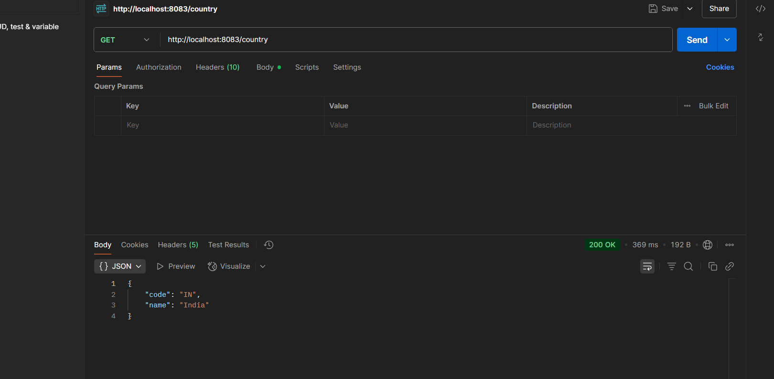

REST Country Code

updated country.xml

<?xml version="1.0" encoding="UTF-8"?>

<beans xmlns="http://www.springframework.org/schema/beans"

xmlns:xsi="http://www.w3.org/2001/XMLSchema-instance"

xsi:schemaLocation="

http://www.springframework.org/schema/beans

https://www.springframework.org/schema/beans/spring-beans.xsd">

<bean id="country1" class="com.cognizant.spring_learn.model.Country">

<property name="code" value="IN"/>

<property name="name" value="India"/>

</bean>

<bean id="country2" class="com.cognizant.spring_learn.model.Country">

<property name="code" value="US"/>

<property name="name" value="United States"/>

</bean>

<bean id="countryList" class="java.util.ArrayList">

<constructor-arg>

<list>

<ref bean="country1"/>

<ref bean="country2"/>

</list>

</constructor-arg>

</bean>

</beans>

CountryService

package com.cognizant.spring_learn.service;  
  
import com.cognizant.spring_learn.model.Country;  
import org.springframework.context.ApplicationContext;  
import org.springframework.context.support.ClassPathXmlApplicationContext;  
import org.springframework.stereotype.Service;  
  
import java.util.List;  
  
@Service  
public class CountryService {  
  
 public Country getCountry(String code) {  
 ApplicationContext context = new ClassPathXmlApplicationContext("country.xml");  
 List<Country> countries = context.getBean("countryList", List.class);  
  
 return countries.stream()  
 .filter(c -> c.getCode().equalsIgnoreCase(code))  
 .findFirst()  
 .orElse(null);  
 }  
}

