Microservices for API Gateway. Account & Loan

For account   
import org.springframework.web.bind.annotation.\*;  
  
import java.util.Map;  
  
@RestController  
@RequestMapping("/accounts")  
public class AccountController {  
  
 @GetMapping("/{number}")  
 public Map<String, Object> getAccount(@PathVariable String number) {  
 return Map.*of*(  
 "number", number,  
 "type", "savings",  
 "balance", 234343  
 );  
 }  
}

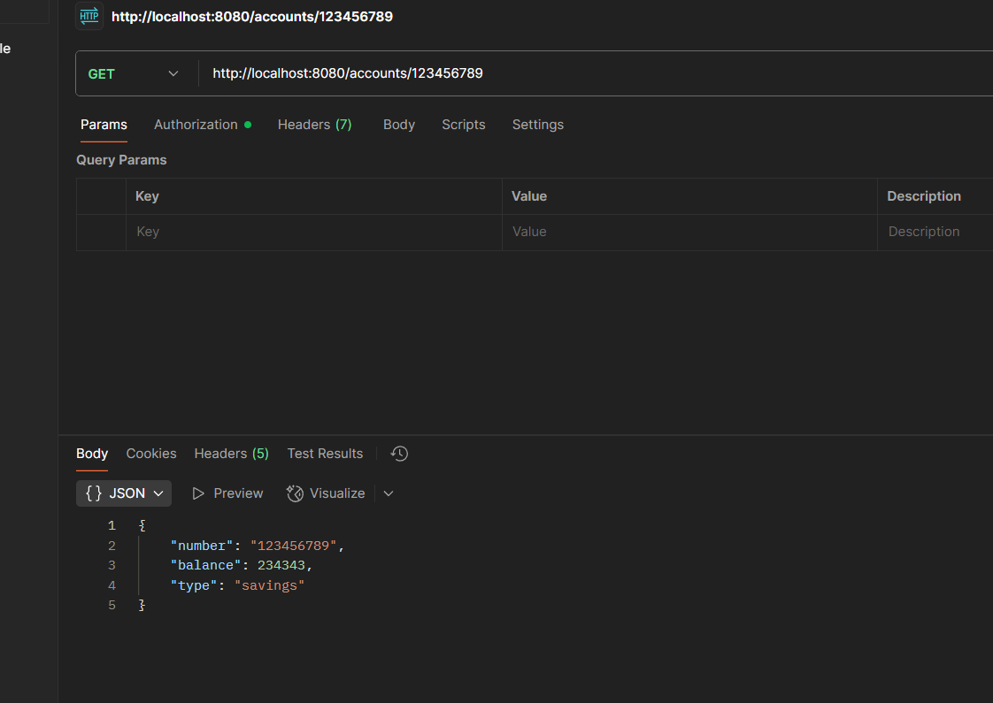

For loan

package com.cognizant.loan.controller;  
  
import org.springframework.web.bind.annotation.\*;  
  
import java.util.Map;  
  
@RestController  
@RequestMapping("/loans")  
public class LoanController {  
  
 @GetMapping("/{number}")  
 public Map<String, Object> getLoan(@PathVariable String number) {  
 return Map.*of*(  
 "number", number,  
 "type", "car",  
 "loan", 40000,  
 "emi", 3250,  
 "tenure", 18  
 );  
 }  
}

