REACT Exercise – 1  
  
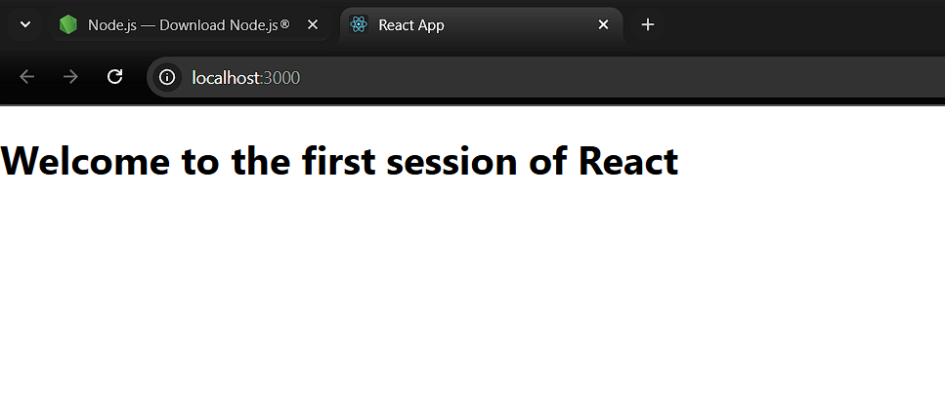

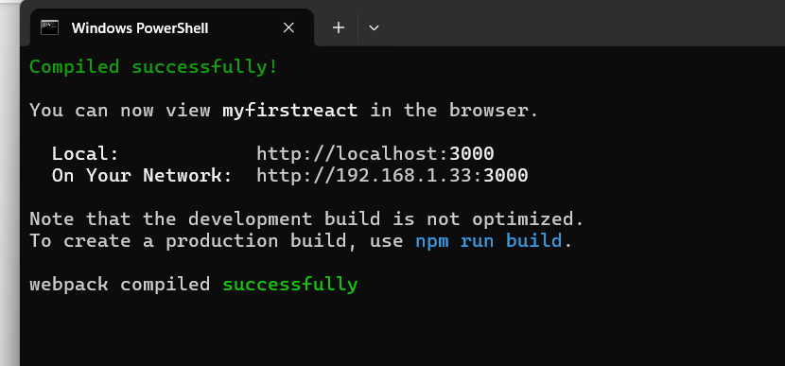  
  
2.

import React, { Component } from 'react';

class Home extends Component {

render() {

return (

<div>

<h3>Welcome to the Home Page of Student Management Portal</h3>

</div>

);

}

}

export default Home;  
  
import React, { Component } from 'react';

class About extends Component {

render() {

return (

<div>

<h3>Welcome to the About Page of Student Management Portal</h3>

</div>

);

}

}

export default About ;  
  
import React, { Component } from 'react';

class Contact extends Component {

render() {

return (

<div>

<h3>Welcome to the Contact Page of Student Management Portal</h3>

</div>  
);

}

}

export default Contact;

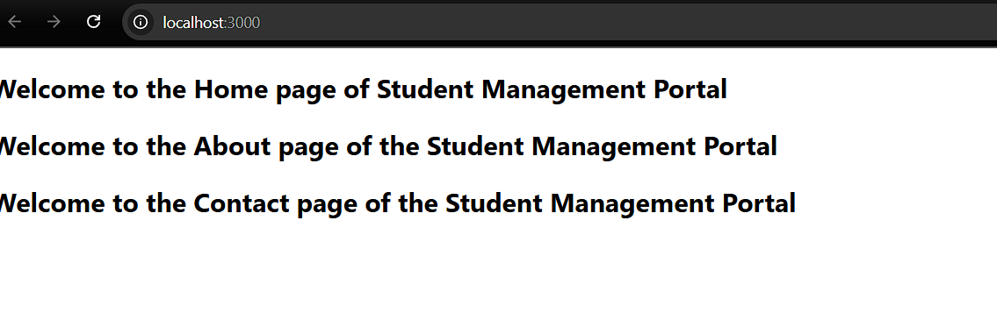  
3. ScoreCalculator

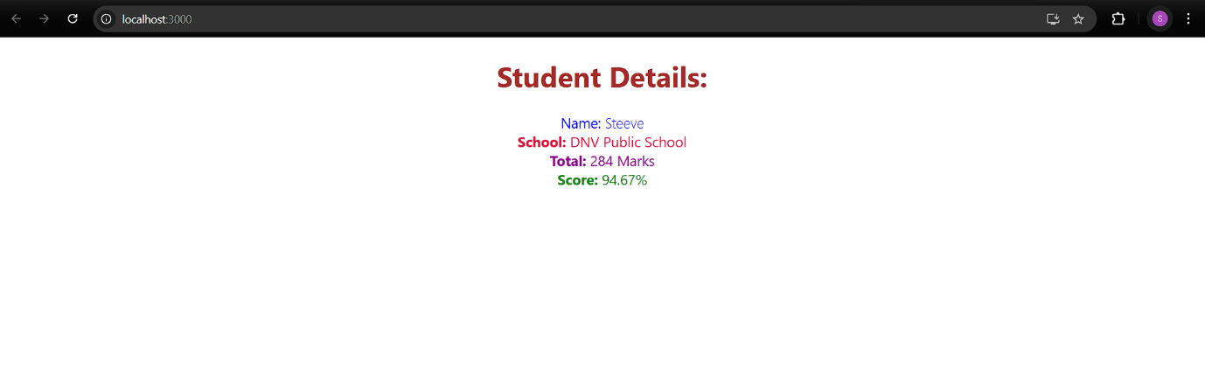

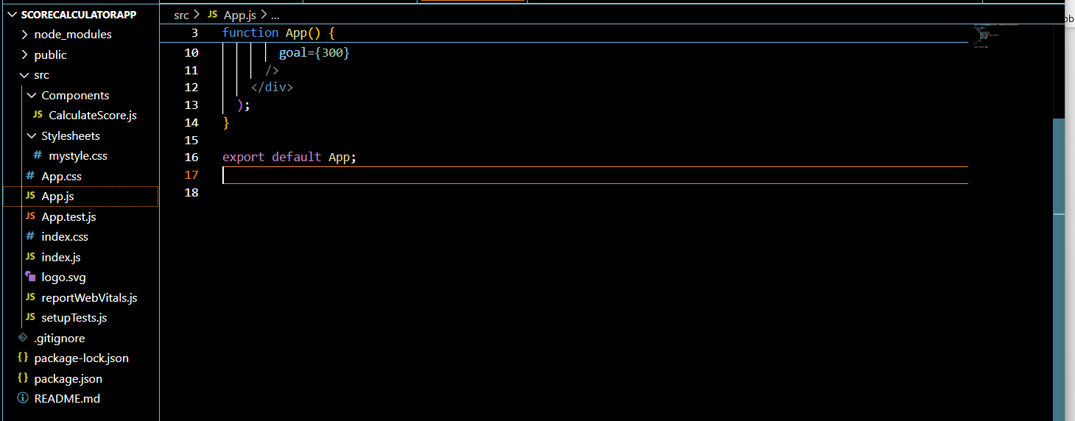  
  
4.BLOGAPP  
  
Posts.js  
  
import React from 'react';

import Post from './Post';

class Posts extends React.Component {

constructor(props) {

super(props);

this.state = {

posts: [],

error: null

};

}

loadPosts() {

fetch('https://jsonplaceholder.typicode.com/posts')

.then(response => {

if (!response.ok) throw new Error('Failed to fetch posts');

return response.json();

})

.then(data => {

const postList = data.map(post => new Post(post.id, post.title, post.body));

this.setState({ posts: postList });

})

.catch(error => {

this.setState({ error });

});

}

componentDidMount() {

this.loadPosts();

}

render() {

const { posts, error } = this.state;

if (error) {

return <h2>Error loading posts: {error.message}</h2>;

}

return (

<div>

<h1>Blog Posts</h1>

{posts.map(post => (

<div key={post.id}>

<h2>{post.title}</h2>

<p>{post.body}</p>

<hr />

</div>

))}

</div>

);

}

componentDidCatch(error, info) {

alert('An error occurred: ' + error.message);

}

}

export default Posts;  
  
For app.js  
  
import React from 'react';

import Posts from './Posts';

function App() {

return (

<div className="App">

<Posts />

</div>

);

}

export default App;

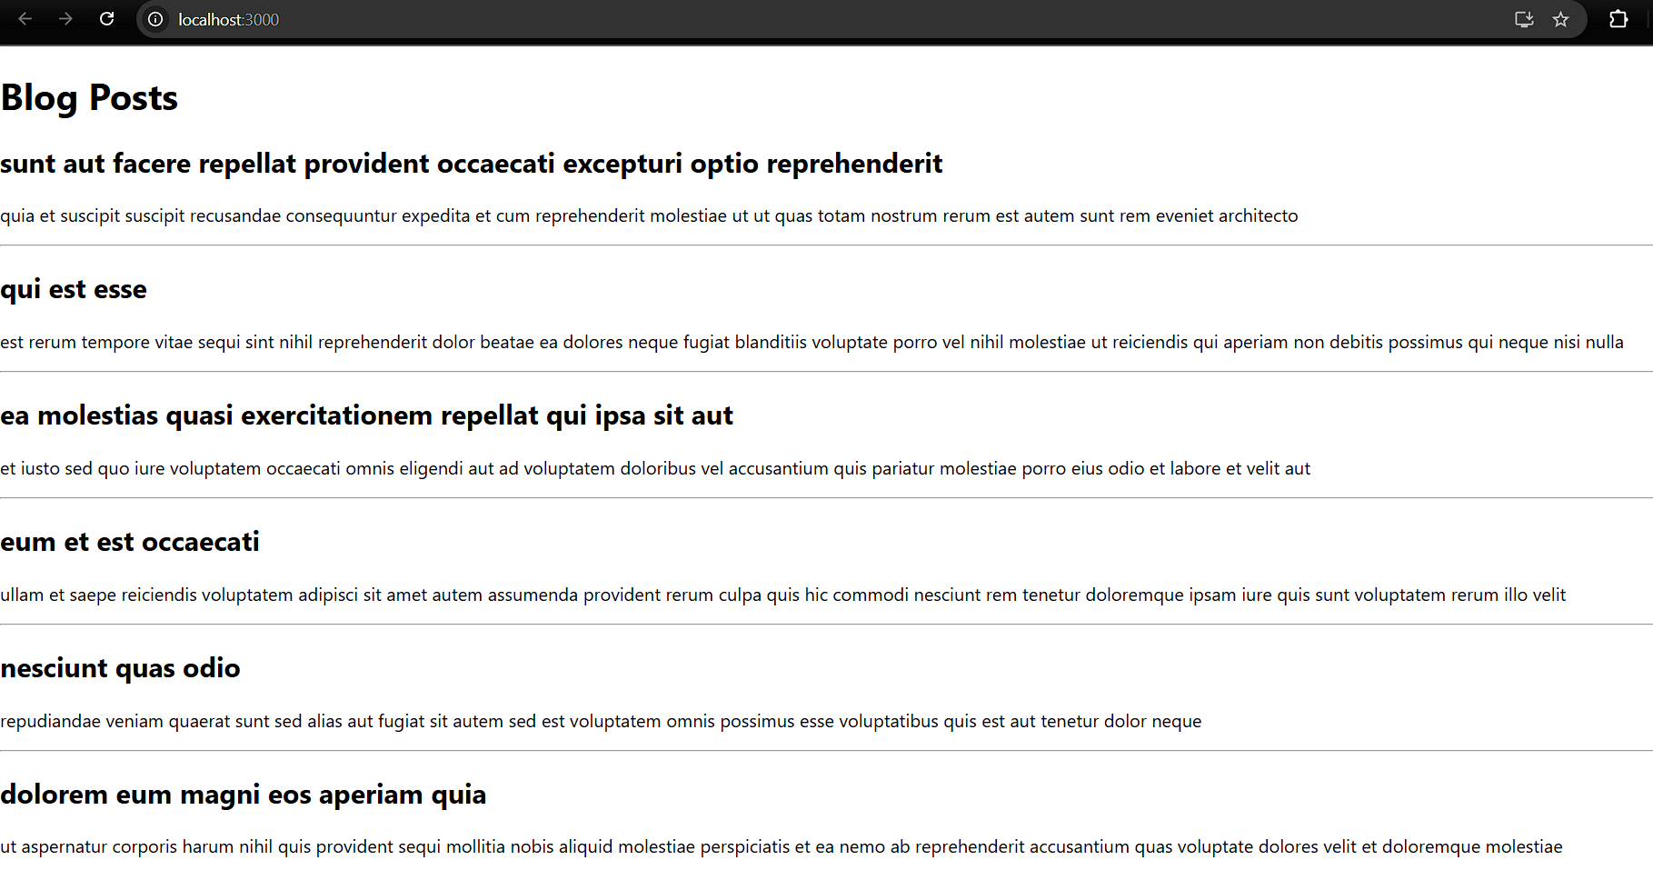  
  
5. CohortDetails  
  
CohortDetails.js  
  
import React from 'react';

import styles from './CohortDetails.module.css';

function CohortDetails({ cohort }) {

  const isOngoing = cohort.status.toLowerCase() === 'ongoing';

  return (

    <div className={styles.box}>

      <h3 className={isOngoing ? styles.greenTitle : styles.blueTitle}>

        {cohort.name}

      </h3>

      <dl>

        <dt>Started On</dt>

        <dd>{cohort.startDate}</dd>

        <dt>Current Status</dt>

        <dd>{cohort.status}</dd>

        <dt>Coach</dt>

        <dd>{cohort.coach}</dd>

        <dt>Trainer</dt>

        <dd>{cohort.trainer}</dd>

      </dl>

    </div>

  );

}

export default CohortDetails;  
  
CohortDetails.css  
  
.box {

  width: 300px;

  display: inline-block;

  margin: 10px;

  padding: 10px 20px;

  border: 1px solid black;

  border-radius: 10px;

}

dt {

  font-weight: 500;

}

.greenTitle {

  color: green;

}

.blueTitle {

  color: blue;

}

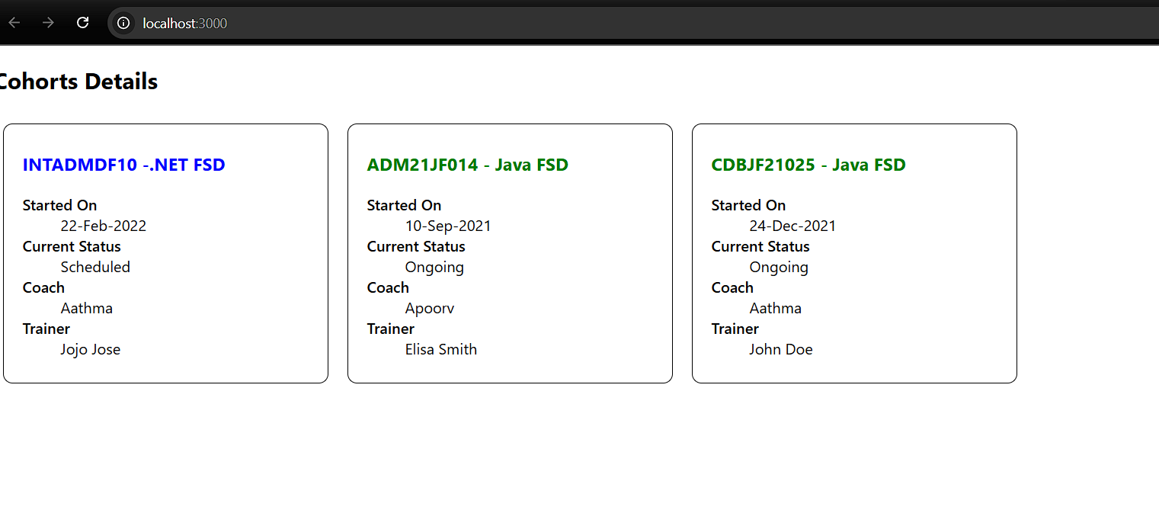  
  
6. Trainers App  
TrainerDetail.js  
  
import React from 'react';

import { useParams } from 'react-router-dom';

import trainers from './trainersMock';

const TrainerDetail = () => {

  const { id } = useParams();

  const trainer = trainers.find((t) => t.trainerId === id);

  if (!trainer) return <h3>Trainer not found</h3>;

  return (

    <div>

      <h3>Trainer Detail</h3>

      <p><strong>Name:</strong> {trainer.name}</p>

      <p><strong>Email:</strong> {trainer.email}</p>

      <p><strong>Phone:</strong> {trainer.phone}</p>

      <p><strong>Technology:</strong> {trainer.technology}</p>

      <p><strong>Skills:</strong> {trainer.skills}</p>

    </div>

  );

};

export default TrainerDetail;

App.js  
import React from 'react';

import { BrowserRouter, Routes, Route, Link } from 'react-router-dom';

import Home from './Home';

import TrainerList from './TrainerList';

import TrainerDetail from './TrainerDetail';

import trainers from './trainersMock';

function App() {

  return (

    <BrowserRouter>

      <div>

        <h2>My Academy Trainers App</h2>

        <nav>

          <Link to="/">Home</Link> | <Link to="/trainers">Show Trainers</Link>

        </nav>

        <Routes>

          <Route path="/" element={<Home />} />

          <Route path="/trainers" element={<TrainerList trainers={trainers} />} />

          <Route path="/trainer/:id" element={<TrainerDetail />} />

        </Routes>

      </div>

    </BrowserRouter>

  );

}

export default App;

TarinerList.js  
import React from 'react';

import { Link } from 'react-router-dom';

const TrainerList = ({ trainers }) => {

  return (

    <div>

      <h3>Trainers List</h3>

      <ul>

        {trainers.map((trainer) => (

          <li key={trainer.trainerId}>

            <Link to={`/trainer/${trainer.trainerId}`}>{trainer.name}</Link>

          </li>

        ))}

      </ul>

    </div>

  );

};

export default TrainerList;

