Study Hours and Marks Prediction Using Linear Regression
  - A Simple Machine Learning Study for New Learners

Research Paper

Paper Detail | Value
Author | Suvodeep Roy
Project | Study Hours vs Marks Prediction
Field | Machine Learning
Method | Linear Regression
Date | June 25, 2026

This paper uses simple English so that a new learner can read it with ease.

Abstract
This paper explains a small machine learning project that predicts marks from study hours. The project uses Linear Regression. It uses 20 sample records. Each record has study hours and marks. The data is split into a training part and a test part. The model learns from the training part. The test part is then used to check the model. The model gives an R-squared score of 0.997. It gives a Mean Absolute Error of 1.69 marks and a Mean Squared Error of 3.47. For five study hours, the model gives a result of 51.30 marks. The result shows that the model can learn the clear line pattern in this sample data. The paper also explains an important limit. The data is small and made for study. It is not real school data. So, this work must not be used to judge a real student. The main aim is to help a new learner understand data, model training, model tests, input checks, and graphs.
Key words: study hours, marks, machine learning, Linear Regression, prediction, Python, beginner project.

Paper Contents
- 1. Introduction
- 2. Problem Statement
- 3. Aim and Objectives
- 4. Research Questions
- 5. Basic Review of Ideas
- 6. Research Method
- 7. Project Design
- 8. Data Used in the Study
- 9. Model Training and Testing
- 10. Results
- 11. Discussion
- 12. Program Safety and Input Checks
- 13. Test Plan
- 14. Limits of the Study
- 15. Future Work
- 16. Conclusion
- 17. References
- Appendix A. Main Program Flow
- Appendix B. Simple Viva Questions

1. Introduction
Machine learning helps a computer learn a pattern from data. It can then use the pattern to give a new result. A mark is a number. This means that mark prediction is a regression task. Regression is used when the result is a number, such as marks, price, age, or time.
This project studies one simple link: study hours and marks. Study hours are used as the input. Marks are used as the output. A Linear Regression model is used because it is easy to learn, easy to show on a graph, and easy to explain in a viva.
The project is made for a new learner. The code uses clear names, small functions, short notes, input checks, model tests, and a graph. It also avoids a false claim. More study may help marks, but marks can also change due to sleep, health, class skill, past study, stress, and many other facts.

2. Problem Statement
A new machine learning learner may know Python but may not know how a full prediction task works. The learner needs a small project that shows each step in a clear order. The project must show how to make data, split data, train a model, test a model, take safe user input, make a prediction, and show a graph.
The main problem is to build a simple model that can estimate marks from study hours while keeping the code and result easy to understand.

3. Aim and Objectives
The main aim is to build and study a small Linear Regression model for marks prediction.
- Create a small sample data set with study hours and marks.
- Use study hours as the input and marks as the output.
- Split the data into training data and test data.
- Train a Linear Regression model.
- Check the model with R-squared, Mean Absolute Error, and Mean Squared Error.
- Take study hours from the user in a safe way.
- Keep the result from 0 to 100 marks.
- Show the data and model line on a graph.
- Write code that a new learner can read and explain.

4. Research Questions
- Can a simple Linear Regression model learn the pattern in the sample data?
- How close are the model results to the test marks?
- Can the program stop wrong study-hour input?
- Can the full work be explained in simple English?

5. Basic Review of Ideas

5.1 Machine Learning
Machine learning is a way to let a computer learn from examples. The computer is not given one fixed answer for each new case. It finds a pattern in old data and uses that pattern for a new case.

5.2 Supervised Learning
This project uses supervised learning. In supervised learning, each old record has an input and a known output. Here, the input is study hours and the known output is marks.

5.3 Regression
Regression is used when the output is a number. This project predicts a mark value, so regression is the right task type.

5.4 Linear Regression
Linear Regression finds a straight line that stays as close as it can to the data points. The line is written in this simple form:
Predicted Marks = (Line Slope x Study Hours) + Line Start
The line slope shows the change in predicted marks when study hours rise by one hour. The line start is the value where the line begins.

5.5 Tools Used
Tool | Use in This Work
Python | Runs the full program.
Pandas | Stores the data in rows and columns.
Scikit-learn | Splits data, trains the model, and checks the model.
Matplotlib | Makes the data and model graph.
unittest | Checks the main code rules.

6. Research Method
This work uses a small test-based method. The steps are simple and can be done again on the same computer.
- Create 20 sample records.
- Place the records in a Pandas DataFrame.
- Select Hours as the input column.
- Select Marks as the output column.
- Keep 25 percent of the records for testing.
- Use random state 42 so the split stays the same.
- Train the Linear Regression model with the training records.
- Predict marks for the test records.
- Find R-squared, Mean Absolute Error, and Mean Squared Error.
- Ask the user for study hours.
- Check the input and make the final mark prediction.
- Save a graph of the data and the model line.

7. Project Design
The program keeps each main task in a small function. This makes the code easy to read and test. It also helps a learner explain one task at a time.
Function | Simple Task
create_student_dataset | Creates the 20 sample records.
prepare_training_and_testing_data | Makes the train and test parts.
train_prediction_model | Builds and trains the model.
evaluate_prediction_model | Finds the three model test values.
validate_study_hours | Checks user input.
predict_student_marks | Makes one safe mark prediction.
save_and_display_graph | Saves and shows the graph.
main | Runs all steps in the right order.

8. Data Used in the Study
The data has 20 sample records. It is made only for learning. It is not taken from a school, college, survey, or real student group. Small changes were added so the points do not form a fully exact line.
Record | Study Hours | Marks
1 | 1.0 | 12
2 | 1.5 | 18
3 | 2.0 | 21
4 | 2.5 | 27
5 | 3.0 | 31
6 | 3.5 | 38
7 | 4.0 | 43
8 | 4.5 | 47
9 | 5.0 | 54
10 | 5.5 | 56
11 | 6.0 | 63
12 | 6.5 | 67
13 | 7.0 | 72
14 | 7.5 | 76
15 | 8.0 | 81
16 | 8.5 | 85
17 | 9.0 | 88
18 | 9.5 | 92
19 | 10.0 | 95
20 | 10.5 | 98

The input range in the sample is 1.0 to 10.5 hours. The mark range is 12 to 98. A result far outside this range is less safe because the model has not learned from many such cases.

9. Model Training and Testing
The program uses 75 percent of the records for training and 25 percent for testing. The model sees only the training part while it learns. The test part is used after training. This gives a fair basic check.
The fixed random state is 42. This does not make the model better. It only keeps the same split each time, which helps repeat the study.

9.1 Test Values
Real Marks | Model Marks | Gap
12 | 14.48 | 2.48
92 | 92.72 | 0.72
85 | 83.52 | 1.48
18 | 19.09 | 1.09
54 | 51.30 | 2.70

10. Results
Measure | Result | Simple Meaning
R-squared | 0.997 | The line fits this sample pattern very well.
Mean Absolute Error | 1.69 marks | The mean gap is about 1.69 marks.
Mean Squared Error | 3.47 | Large gaps are low in this test set.
Five-hour result | 51.30 marks | The model gives 51.30 marks for 5 hours.

The model learned this line:
Predicted Marks = (9.20 x Study Hours) + 5.28
In this sample, one more study hour adds about 9.20 predicted marks. This is only the pattern of the sample. It is not a rule for all students.

10.1 Graph Result
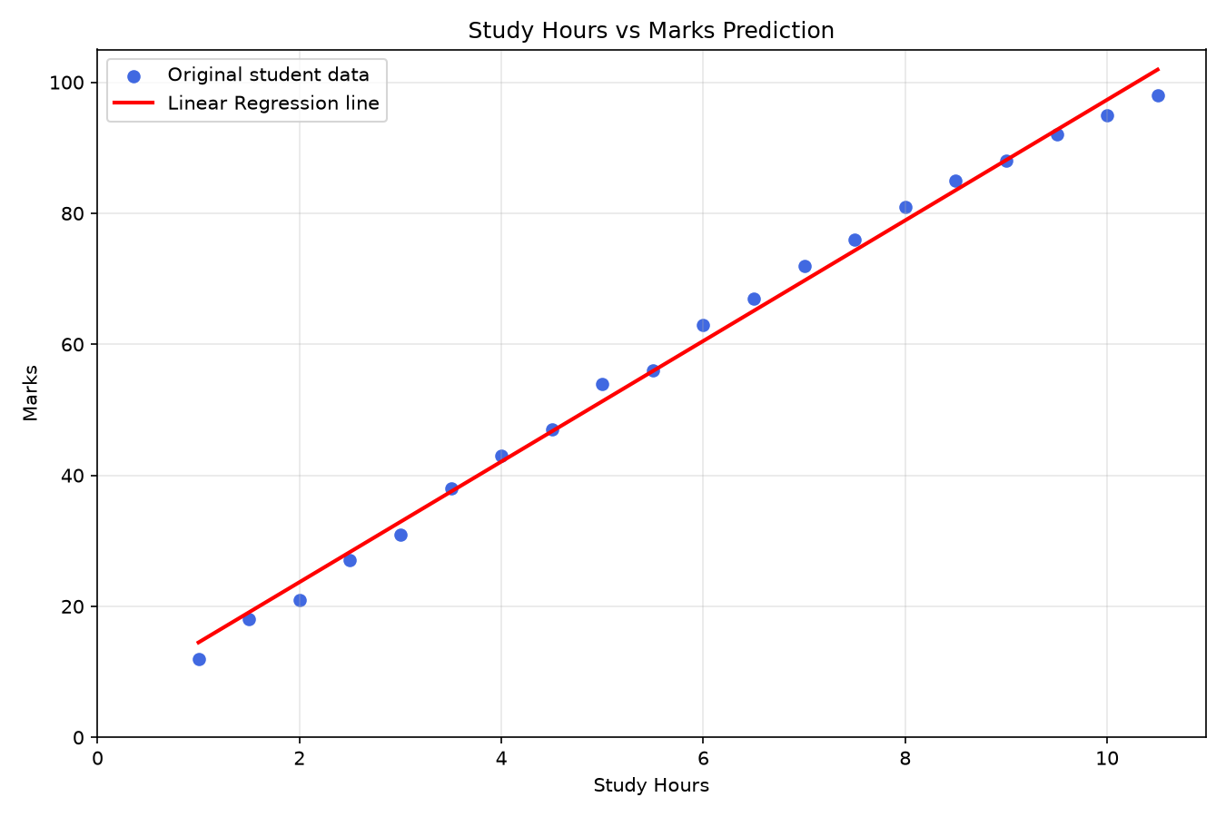
Figure 1. Sample study-hour points and the Linear Regression line.

11. Discussion
The R-squared score is close to 1 because the sample points have a very clear line pattern. The error values are also low. This means the model works well on this small sample.
The high score must be read with care. The data was made for this learning task. It has only one input and only 20 records. A real student data set will have more change and more facts. A high score here does not prove that the model will work with the same score in a real school.
The main value of the project is clear learning. It shows how data moves from a table to a model, from a model to a test, and from a test to a safe user result.

12. Program Safety and Input Checks
The program checks each user value before prediction. This stops common errors and gives a clear message.
Input Type | Result | Reason
Empty value | Not allowed | Study hours cannot be empty.
Text such as five | Not allowed | A number is required.
Less than zero | Not allowed | Hours cannot be negative.
More than 24 | Not allowed | One day has only 24 hours.
NaN or infinity | Not allowed | A normal number is required.
Valid number | Allowed | The model makes a prediction.

The final mark is also kept from 0 to 100. This rule stops a line model from showing a mark below 0 or above 100.

13. Test Plan
The project has ten unit tests. A unit test checks one small rule in the code. All ten tests passed on June 25, 2026.
Test | Expected Work | Status
Data columns | Hours and Marks are present. | Pass
Data size | There are 20 records. | Pass
Whole number | The value 5 is allowed. | Pass
Decimal number | The value 5.5 is allowed. | Pass
Empty value | The value is stopped. | Pass
Text value | The value is stopped. | Pass
Negative value | The value is stopped. | Pass
Above 24 | The value is stopped. | Pass
NaN value | The value is stopped. | Pass
Mark range | The result stays from 0 to 100. | Pass

14. Limits of the Study
- The data has only 20 sample records.
- The records are made for learning and are not real student records.
- The model uses only study hours.
- A line may not show all real student cases.
- The model is less safe far outside the sample range.
- The work does not prove that study hours alone cause marks.
- The model must not be used for real school rank, grade, or action.

15. Future Work
- Use real data with clear consent and safe data care.
- Use more records from more than one class.
- Add class rate, sleep, past marks, and task score.
- Check and clean missing or wrong values.
- Use more than one train and test split.
- Compare the line model with other regression models.
- Make a small web page for easy use.
- Show a clear note when a new input is outside the learned data range.

16. Conclusion
This paper presented a small study-hours and marks prediction project. The project used Python, Pandas, Scikit-learn, and Matplotlib. It used Linear Regression because the output is a number and the method is easy for a new learner.
The model gave an R-squared score of 0.997, a Mean Absolute Error of 1.69 marks, and a Mean Squared Error of 3.47. It gave 51.30 marks for five study hours. All ten code tests passed.
The result is strong only for the small sample pattern. It is not proof about all students. The project is best used as a clear first step in machine learning. It helps a learner understand the full path from data to a model, from a model to a test, and from a test to a user result.

17. References
- Scikit-learn. LinearRegression guide. https://scikit-learn.org/stable/modules/generated/sklearn.linear_model.LinearRegression.html
- Scikit-learn. train_test_split guide. https://scikit-learn.org/stable/modules/generated/sklearn.model_selection.train_test_split.html
- Pandas. DataFrame guide. https://pandas.pydata.org/docs/reference/api/pandas.DataFrame.html
- Matplotlib. Scatter plot guide. https://matplotlib.org/stable/api/_as_gen/matplotlib.pyplot.scatter.html
- Python. Python language guide. https://docs.python.org/3/
- Study Hours vs Marks Prediction project source code and test output, checked on June 25, 2026.

Appendix A. Main Program Flow
- The program starts.
- The sample data is made.
- The data is split into train and test parts.
- The Linear Regression model is trained.
- The test marks are predicted.
- The three model test values are shown.
- The learned line is shown.
- The user enters study hours.
- The input is checked.
- The final marks are predicted.
- The graph is saved and shown.
- The program ends.

Appendix B. Simple Viva Questions
Question | Simple Answer
What is the input? | Study hours.
What is the output? | Predicted marks.
Why use regression? | The output is a number.
Why use Linear Regression? | It is simple and fits a line pattern.
What is training data? | Data used to teach the model.
What is test data? | Data used to check the trained model.
What is R-squared? | A value that shows how well the line fits the data.
Why check input? | It stops wrong values and program errors.
Is the data real? | No. It is sample data made for learning.
Can this judge a student? | No. It is only a beginner project.

