Study Hours and Marks Prediction Using Linear Regression: A Reproducible Beginner Study
Suvodeep Roy
Independent Student Researcher

Abstract—This paper presents a small and reproducible machine learning study that predicts marks from study hours. The work uses a synthetic data set of 20 records and a simple Linear Regression model. A fixed 75:25 train-test split gives an R-squared value of 0.997, a Mean Absolute Error of 1.69 marks, and a Root Mean Squared Error of 1.86 marks. A mean-value baseline performs much worse, with an R-squared value of -0.059 and a Mean Absolute Error of 30.64 marks. Five-fold cross-validation gives a mean R-squared value of 0.989 and a mean Mean Absolute Error of 1.83 marks. The program also checks invalid input, keeps predicted marks between 0 and 100, and includes ten unit tests. The results show that Linear Regression learns the clear line pattern in this sample data. They do not show that study hours alone can predict marks for real students. The main value of the work is a clear, safe, and beginner-friendly example of a full regression process.
Index Terms—educational data mining, Linear Regression, machine learning, marks prediction, reproducible study, study hours.

I. INTRODUCTION
Educational data mining uses data and computer methods to study learning and student results. It can support tasks such as finding students who may need help, studying learning habits, and testing prediction methods [1]. Student performance prediction has been studied with decision trees, regression methods, and deep learning models [2]-[5].
Many published studies use large real data sets with many input fields. Such studies are useful, but they can be hard for a first-time learner to follow. This paper studies a much smaller question: can a single-input Linear Regression model learn a clear relation between study hours and marks in a synthetic teaching data set?
The contribution is educational rather than a new prediction method. The paper gives a full and repeatable process, reports a baseline, uses a fixed test split and five-fold cross-validation, states all limits, and links the reported results to tested source code.

II. RELATED WORK
Romero and Ventura described educational data mining as a broad field that includes prediction, grouping, relation study, and data display [1]. Cortez and Silva used school, social, grade, and study data to model student results with both regression and classification methods [2]. Their public data set contains hundreds of records and many input fields [6].
Yadav and Pal used decision-tree methods to group engineering students by likely result [3]. Kim, Vizitei, and Ganapathi used deep learning to predict online course outcomes from student event sequences [4]. Abd Elrahman et al. compared several classification and regression methods using eTextbook use data [5]. These studies show that real performance prediction often needs many records, many features, and careful model checks.
The present study does not try to match those systems. It uses one feature and synthetic data so that a new learner can inspect each step. This clear scope is important because a simple teaching model must not be presented as a tool for real student decisions.

III. RESEARCH DESIGN

A. Research Questions
The study asks three questions. First, can Linear Regression learn the line pattern in the synthetic data? Second, does it perform better than a simple mean-value baseline? Third, does its result stay stable across five data folds?

B. Data
The data set contains 20 synthetic records. Study hours range from 1.0 to 10.5, and marks range from 12 to 98. Small changes were added to the marks so that the data does not form a perfect line. No real person, school record, private value, or survey answer is used.
TABLE I
SAMPLE DATA RECORDS
Hours | Marks | Use
1.0 | 12 | Sample
3.0 | 31 | Sample
5.0 | 54 | Sample
7.0 | 72 | Sample
9.0 | 88 | Sample
10.5 | 98 | Sample

C. Model
Linear Regression estimates a straight line between an input x and an output y. In this study, x is study hours and y is marks. The model is
y_hat = b_0 + b_1 x (1)
where y_hat is the predicted mark, b_0 is the line start, and b_1 is the line slope. The implementation uses the Scikit-learn LinearRegression class [7]. Pandas stores the data [8], and Matplotlib creates the graph [9].

D. Test Process
The main test keeps 25 percent of the records for testing and uses random state 42. The same test records are also used with a DummyRegressor that always predicts the mean training mark. This gives a clear baseline. A five-fold cross-validation test then trains and tests the Linear Regression model five times with different folds.
The reported measures are R-squared, Mean Absolute Error, and Root Mean Squared Error. They are defined as
R^2 = 1 - SS_res / SS_tot (2)
MAE = (1/n) sum |y_i - y_hat_i| (3)
RMSE = sqrt[(1/n) sum (y_i - y_hat_i)^2] (4)
A higher R-squared value is better. Lower MAE and RMSE values are better. RMSE gives more weight to large errors.

IV. IMPLEMENTATION
The program is written in Python. Each main task is placed in a small function. Separate functions create data, split data, train the model, evaluate the model, check user input, predict marks, and save the graph. The prediction input uses the same named Hours column used during training. This avoids the Scikit-learn feature-name warning.
The input check rejects an empty value, text, a negative value, a value above 24, NaN, and infinity. The final mark is limited to the valid range from 0 to 100. Ten unit tests check the data shape, valid input, invalid input, model measures, and prediction range.

V. RESULTS
TABLE II
FIXED-SPLIT MODEL COMPARISON
Model | R-squared | MAE | RMSE
Linear Reg. | 0.997 | 1.69 | 1.86
Mean base | -0.059 | 30.64 | 33.97
Table II shows that Linear Regression performs far better than the mean baseline on the fixed test split. The model equation learned from the training part is
y_hat = 5.28 + 9.20x (5)
For five study hours, this model predicts 51.30 marks. The five test marks have absolute errors from 0.72 to 2.70 marks.
TABLE III
FIVE-FOLD CROSS-VALIDATION
Measure | Mean | Std. Dev.
R-squared | 0.989 | 0.006
MAE | 1.83 | 0.19
RMSE | 2.12 | 0.37
The five-fold results remain strong across all folds. The mean R-squared value is 0.989. The small standard deviation shows low change across the five folds. This is expected because the synthetic data follows a clear near-linear pattern.
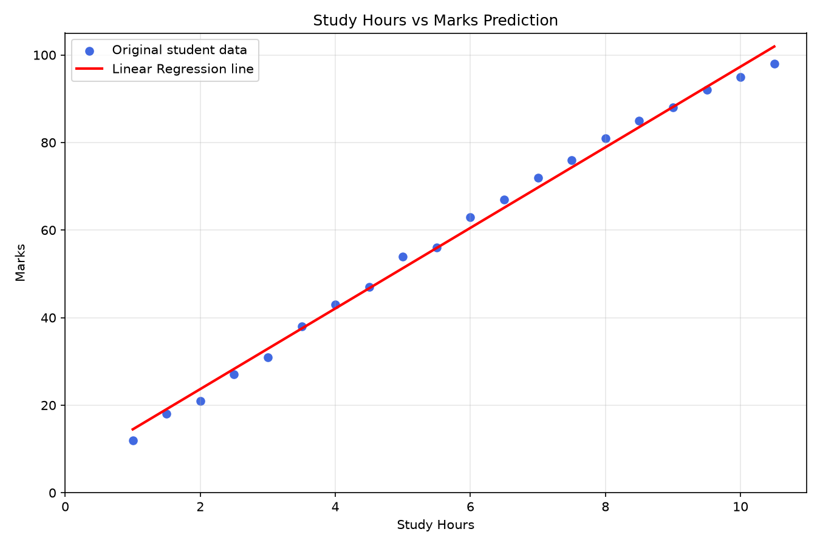
Fig. 1. Synthetic data points and the fitted regression line.

VI. DISCUSSION
The fixed split, baseline comparison, and cross-validation all show the same result: a straight-line model matches this synthetic data very well. The baseline result is important because it shows that the model learns more than a simple average. Cross-validation reduces the risk that one favorable split alone caused the reported score.
However, the high score is mainly a property of the data design. The data has only 20 records, one input, and a clear line pattern. Real marks can also depend on prior knowledge, class attendance, sleep, health, teaching quality, assessment type, and many social factors. The model therefore shows a method, not a general rule about students.
The study also does not prove cause. It shows an association inside the sample data. It does not prove that adding one study hour will cause a fixed increase of 9.20 marks for a real student.

VII. ETHICS, SAFETY, AND REPRODUCIBILITY
No human data was collected, so this study creates no direct privacy risk. If the work is extended with real student records, informed consent, data minimization, secure storage, access control, and institutional approval may be needed. A prediction must not be used alone to rank, punish, or deny help to a student.
The data, fixed random state, source code, tests, model settings, and exact reported measures are included in the project. This supports repeat work. The program was checked with Python syntax tests, dependency checks, ten unit tests, invalid-input tests, and graph generation.

VIII. LIMITATIONS AND FUTURE WORK
The main limits are the synthetic data, small sample size, single input, limited data range, and use of one model type. A future study should use a larger real data set with consent, define the target and study period before data collection, check missing data and bias, compare several models, use a held-out test set, and report confidence ranges.
A suitable next step is the UCI Student Performance data set [6]. It has hundreds of records and includes study time, grades, school facts, and social facts. Such work would require stronger ethics, feature study, and model validation than the present teaching project.

IX. CONCLUSION
This paper presented a simple and reproducible Linear Regression study for marks prediction. Linear Regression clearly outperformed a mean baseline and gave stable five-fold results on the synthetic data. The program also adds safe input checks, a bounded output, a graph, and unit tests.
The work is professional as a teaching and portfolio study, but it is not a validated real-student prediction system. Its main result is a clear example of correct regression practice: define the scope, keep test data separate, compare with a baseline, report more than one measure, state limits, and avoid claims that the data cannot support.

REFERENCES
[1] C. Romero and S. Ventura, "Educational data mining: A review of the state-of-the-art," IEEE Trans. Syst., Man, Cybern. C, vol. 40, no. 6, pp. 601-618, Nov. 2010.
[2] P. Cortez and A. M. G. Silva, "Using data mining to predict secondary school student performance," in Proc. 5th Future Bus. Technol. Conf., Porto, Portugal, 2008, pp. 5-12.
[3] S. K. Yadav and S. Pal, "Data mining: A prediction for performance improvement of engineering students using classification," arXiv:1203.3832, 2012, doi: 10.48550/arXiv.1203.3832.
[4] B.-H. Kim, E. Vizitei, and V. Ganapathi, "GritNet: Student performance prediction with deep learning," arXiv:1804.07405, 2018, doi: 10.48550/arXiv.1804.07405.
[5] A. Abd Elrahman, T. H. A. Soliman, A. I. Taloba, and M. F. Farghally, "A predictive model for student performance in classrooms using student interactions with an eTextbook," arXiv:2203.03713, 2022, doi: 10.48550/arXiv.2203.03713.
[6] P. Cortez, "Student Performance," UCI Machine Learning Repository, 2008, doi: 10.24432/C5TG7T.
[7] F. Pedregosa et al., "Scikit-learn: Machine learning in Python," J. Mach. Learn. Res., vol. 12, pp. 2825-2830, 2011.
[8] W. McKinney, "Data structures for statistical computing in Python," in Proc. 9th Python Sci. Conf., 2010, pp. 56-61.
[9] J. D. Hunter, "Matplotlib: A 2D graphics environment," Comput. Sci. Eng., vol. 9, no. 3, pp. 90-95, 2007.

