# Suvodip Chakraborty

+91- 7363908846 | suvodipcb@gmail.com|

Nischintapur, Kulpi, West Bengal 743374

**D.O.B:** 28/11/2003

**Branch:** B.Tech CSE (AIML)

# Career Objective

My objective is to achieve a responsible position and explore myself more efficiently in an industry. My goal also includes learning new technologies which will be introduced in upcoming years and contribute my best skills to the company. I would like to expand my knowledge by working hard and learning as much as possible.

# Academic Details

# WBCHSE - 91.8%

# Nischintapur R.D High School(XI-XII)

# WBBSE - 82%

# Nischintapur R.D High School(XI-XII)

# Computer Skills

* Programming Language - C, Python, Java.
* Database- My SQL
* Web development – HTML, CSS

**Seminars and Workshops:-**

* 5 days workshop on Emerging Trends
* Webinar on "Water Processing in Industries and Its Use in Power Generation"
* Advances in Energy Storage Technologies for Energy Engineering and High Power Application
* Celebration of Computer Security Day

# Extra-curricular Activities:-

* National Cadet Corps(NCC) student at school level in Nischintapur.

**Place:**

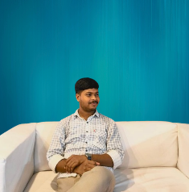

# Project Details:-

# Bank Management System:-

# A java-based application allowing users to manage bank accounts with features like account opening, deposit, withdrawal, balance inquiry, and transaction history

# Zomato Clone :-

# Developed a clone of the Zomato website using HTML, CSS

**Hobbies and Interests:-**

* Solving general problem statements of C, Python and Java .
* Playing cricket .
* Reading newspapers .

**Date:**