A note on the CUPRSYS logic

Signals of interest

- FDIR signals: ID_flag (0/1), R_ALLOC_in (pulse)
- Pilot pushbutton signals: B_DOUB_Y, B_DOUB_N, B_ALLOC_Y, B_ALLOC_N (all pulses)
- Pilot cueing signals: R_DOUB, R_ALLOC, REALLOC_COMPLETE, NEW_CSC (all 0/1)

FDIR signal logic

For the first 10 seconds of every simulation, ID_flag is set to 0 (ignore initial transients). ID_flag is set to 1 when ID_signal is greater than ID_threshold. ID_flag is set back to 0 when ID_signal is smaller than threshold_ratio (a positive number smaller than one) times ID_threshold (hysteresis).

The RLS estimator is reset when ID_flag is equal to 0. When ID_flag is equal to 1, the controller’s coefficient matrix is set to the nominal coefficient matrix, and kernel injection is switched on.

R_ALLOC_in is set to 1 for a single time step (pulse) when
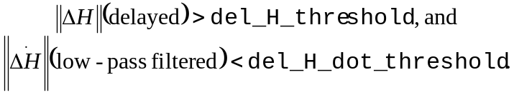

Effects of pilot pushbuttons (effects not related to pilot cueing)

Doublets are injected when the pilot pushes B_DOUB_Y. The doublet sequence is pitch, yaw, roll, and thrust. The duration and magnitude of the doublets are set by doublet_length and input_magnitudes respectively. If the pilot pushes B_DOUB_Y during doublet injection, then the doublet sequence will be repeated from the beginning. (Is this desired?)

When the pilot pushes B_ALLOC_Y, the following events happen:
- The states of the two low-pass filters used to compute ID_signal are reset to zero;
- The RLS estimator is reset;
- The controller’s coefficient matrix is updated; (Is this desired?)
- If ID_flag is equal to 0 (and it will be because of 1 above), then the coefficient matrix in the fault detection model is updated; and
- The controller integrator states are reset to zero.

Pilot cueing logic

The following two tables summarize the R_DOUB and R_ALLOC logic.

Input | Input | Input | Output
ID_flag | B_DOUB_Y | B_DOUB_N | R_DOUB
0 | 1/0 | 1/0 | 0
1 | 0 | 0 | 1
1 | 1/0 | 1/0 | 0

Input | Input | Input | Output
R_ALLOC_in | B_ALLOC_Y | B_ALLOC_N | R_ALLOC
0 | 1/0 | 1/0 | 0
1 | 0 | 0 | 1
1 | 1/0 | 1/0 | 0

REALLOC_COMPLETE is set to 1 for 30 seconds after the pilot pushes the B_ALLOC_Y button. During the 30 second interval, pushing the B_ALLOC_Y button has not effect.

NEW_CSC is set to 1 when the pilot pushes B_ALLOC_Y.

There is no logic to revert to the original CSC.

